Fall 2017 Syllabus
for PHIL.122: Political Philosophy
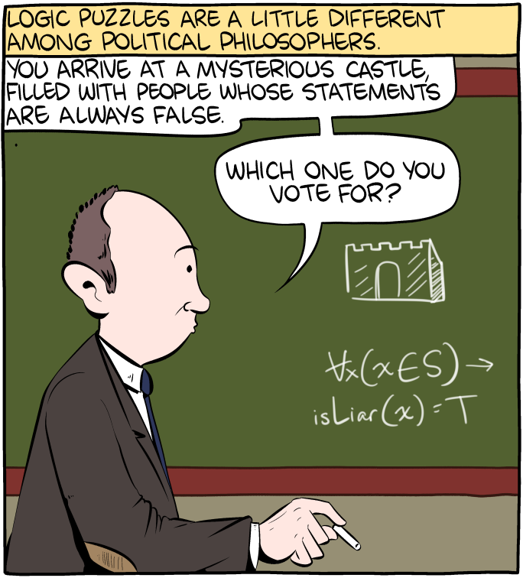

Class time and location: 10:30-11:45 pm in MND 3009
Instructor: Dr. Garret Merriam
Office Location: Mendocino 3028
Office Phone: 916-278-7588
Office hours: TuTh: 12-1:20 pm and by Appointment
Email Address: merriam@csus.edu

Course Description: A philosophical examination of the individual, the community, and rights; the conflict between individual rights and the common good; various conceptions of justice, equality, liberty and the public good; and the relationship of politics to ethics, economics, law; war and peace.

Required Textbook: An Introduction to Political Philosophy, 3rd edition, Jonathan Wolff. The textbook is available at the bookstore. This book will be our textbook for the first part of the course. The readings for the remaining weeks will be available on BlackBoard.

Learning Objectives: Upon completion of the course students should be able to:
- Identify key concepts and arguments pertaining to competing political philosophies.
- Analyze those arguments from multiple perspectives, finding both strengths and weaknesses.
- Develop your own ideas and arguments in response to those we cover in class.
- Challenge those ideas, considering them from competing viewpoints.
- Express your ideas and arguments, both verbally and in writing, in a manner that is clear, coherent and compelling.

This course satisfies the Humanities (Area C2) General Education/Graduation requirement. For more info, see: http://www.csus.edu/acaf/ge/ge%20assessment/area%20c2%20learning%20outcomes.pdf
Slides: I will post the PowerPoint slides on Blackboard for this class. I strongly advise you to download these slides and bring them to class.
Assessments
Reading Quizzes: Before we begin talking about each reading you will have to log on to BlackBoard and take a quiz. It will be a basic reading quiz to show that you (a) read the chapter (b) have a basic understanding of the content. The quizzes will be 5 questions each, timed and open book.

Reading Reflections: After completing each reading you will be required to use the discussion boards on BlackBoard to write up a short (~100-200 words) responding to it. You should address anything that stood out to you as interesting, incorrect, unclear or thought-provoking. You should ask at least one substantive question (e.g.--more than just ‘what do you guys think?’) to the rest of the class in each post. To get full credit you must post at least once BEFORE we discuss the reading in class, but the boards will be open for further discussion afterwards.

Papers: There will be two writing assignments, minimum 1,200 words (about four pages double-spaced.) You will need to demonstrate both an understanding of what you’ve read and an ability to think about it and criticize it in your own terms. Papers will be submitted through SafeAssign on BlackBoard.

Grade Breakdown:
Reading Quizzes: 250 points
Reading Reflections: 250 points
First Paper: 200 points (Due October 13th)
Second Paper: 300 points (Due November 29th)
Total: 1,000 points

Your final grade will be determined by the amount of points you have out of a possible 1000. You will be graded on a fixed scale rather than a curve: 900 and above is an “A,” 899 to 800 is a “B,” 799-700 is a "C," etc.

Attendance Bonus and Penalty: To give you an incentive to show up, each one of you starts with 60 bonus points (out of 1000) that will be attributed to your final grade. Every time you miss a class, I take 30 points away from your grade. Hence, you can miss two classes before your extra points run out; after that, it starts eating into your earned points.

Extra Credit: There are a number of political philosophy related talks on campus this semester, including the departments’ Fall Ethics Symposium (November 20-21st). I will announce and list these talks on Blackboard and in class. If you attend one of these talks and write a short (300 word) reflection on the talk and its relevance to our course material you may get up to 30 extra credit points (subject to my grading). You may attend as many of these talks as you wish, but there is a maximum of 60 total extra credit points possible.

- Academic Dishonesty: I do not expect this problem to arise, but should you be caught cheating on a paper, or an exam, this may be grounds for your immediate failure of the course. Everyone must complete the Plagiarism Tutorial at http://www.lib.usm.edu/legacy/plag/plagiarismtutorial.php before I will grade your papers and have a copy of your results sent to me.

ALL incidents of cheating and plagiarism will be reported both to the Department Chair and to the Judicial Officer in the Office of Student Affairs for possible further administrative sanction. It is your responsibility to know and comply with the University’s Stated Policy: http://www.csus.edu/umanual/AcademicHonestyPolicyandProcedures.htm

- Reasonable Accommodations: If you have a documented disability (visible or invisible) and require accommodation or assistance with assignments, tests, attendance, note taking, etc., please see the instructor by the end of the third week of semester so that arrangements can be made. Failure to notify and consult with the instructor by this date may impede my ability to offer you the necessary accommodation and assistance in a timely fashion. Also be sure to consult with the Services to Students with Disabilities (Lassen Hall; http://www.csus.edu/sswd/index.html) to see what other campus services and accommodation options are available for you. Students with other types of accommodation requirements, such as English as a second language, are invited to discuss them with the instructors to facilitate understanding and the best learning experience for all. All information will remain confidential.

- Late Work Policy
Papers: I am usually willing to give short extensions, provided the request is made BEFORE the paper is due. Otherwise, no late papers will be accepted.

Quizzes and Reading Reflections: If you know you will miss a quiz or a reading reflection notify me in advance and we can make arrangements for a make up at a later date. Otherwise, no late quizzes will be accepted.
- If You’re Having Difficulty: Please contact me. I would like to give everyone an “A” and, to help make that possible, I’m also available to give tutorial help to anyone who needs and wants it. You must, however, let me know that you want the extra help.

This course demands that your reading skills be at least the level of a first-year college student, and even then you may need to read with your dictionary handy. If your reading or study skills are lacking, you may need extra help and extra effort. My goal is not for you or anyone to fail, but for you to succeed as well as you possibly can. You will have to do the work to meet the standards of the course, but I will be there in any way possible to help you do this--all you need do is call or email me for help.

Contact Information for the Chair of the Department: If you have a problem with either the class or with me I would appreciate it if you talked to me about it first. But if you feel you cannot talk to me for some reason, you can talk to my department Chair, Dr. Russell DiSilvestro at rdisilv@csus.edu.

