Fall 2017 Syllabus
for PHIL.2: Ethics

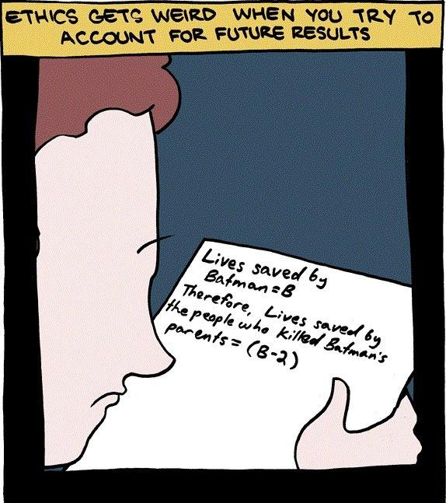
Class time and location: 3-4:15 pm in LIB 53
Instructor: Dr. Garret Merriam
Office Location: Mendocino 3028
Office Phone: 916-278-7588
Office hours: TuTh: 12-1:20 pm and by Appointment
Email Address: merriam@csus.edu

Course Description: Examination of the concepts of morality, obligation, human rights, and the good life. Competing theories about the foundations of morality will be investigated.

This course explores the major problems and questions of moral philosophy by applying various ethical theories and principles to historical and contemporary moral dilemmas.

Required Textbook: Morality and Moral Controversies, 9th edition, Scalet & Arthur (ed.) The textbook is available at the bookstore. The readings on reading schedule that are marked with asterisks (***) are not in your textbook; I will post them on Blackboard in advance of the assignment.

Learning Objectives: Upon completion of the course, each student should be able to:
- Identify key concepts and arguments pertaining to the major moral theories and moral controversies.
- Apply those moral theories to novel circumstances.
- Contrast strengths/weaknesses of major arguments on controversial topics.
- Develop creative solutions to novel, challenging moral problems.
- Question/Challenge their own ideas about moral controversies.
- Debate core points of moral controversies.
This course satisfies the Humanities (Area C2) General Education/Graduation requirement. For more info, see: http://www.csus.edu/acaf/ge/ge%20assessment/area%20c2%20learning%20outcomes.pdf
Slides: I will post the PowerPoint slides on Blackboard for this class. I strongly advise you to download these slides, print them out, and bring them to class.
Applied Topics: After a few weeks discussing moral theory and metaethics we will cover several issues in applied ethics. The class will vote on the topics from a list of options. The most popular topics will be the ones we cover in the remaining weeks of the course. You will choose between: euthanasia, capital punishment, abortion, torture, animal ethics, drugs, war and global poverty.

Top Hat: We will be using the Top Hat app to help manage classroom participation. You can download the app in the Apple and Google stores, or access it at: https://app.tophat.com/e/018856 (If you don’t have a smartphone, tablet, or laptop that can access the internet in class, please come talk to me.) There is a nominal fee, and you can choose to subscribe for the semester, a year, or four years.
Assessments
Reading Quizzes: Before we begin talking about each reading you will have to log on to BlackBoard and take a quiz. It will be a basic reading quiz to show that you (a) read the chapter (b) have a basic understanding of the content. The quizzes will be 5 questions each, timed and open book.

Papers: There will be two writing assignments, each to be about 4 pages, double-spaced. You will need to demonstrate both an understanding of what you’ve read and an ability to think about it and criticize it in your own terms. Papers will be submitted through SafeAssign on BlackBoard.

Paper Outline: Before you turn in your first paper you will need to type up an outline of how you see your paper developing. This can take either the form of a formal outline, or just an informal list of thoughts. (If you’re feeling confident, it can even be a rough draft.) You must meet with me in person to get credit for this assignment.

Final: The final will be relatively difficult will require not only familiarity with the material but the ability to use the material to draw practical conclusions from it. You will be expected to have read and studied the textbook and will be tested on the material in it and whatever I cover in the lectures. The final will be online via blackboard; there will be a final review in the time scheduled for the final itself.

Grade Breakdown:
Reading Quizzes: 250 points
First Paper: 200 points (Due October 6th)
Second Paper: 300 points (Due November 22nd)
Final Exam: 250 points
Total: 1,000 points

Your final grade will be determined by the amount of points you have out of a possible 1000. You will be graded on a fixed scale rather than a curve: 900 and above is an “A,” 899-800 is a “B,” 799-700 is a "C," etc.

Attendance Bonus and Penalty: To give you an incentive to show up, each one of you starts with 60 bonus points (out of 1000) that will be attributed to your final grade. Every time you miss a class, I take 20 points away from your grade. Hence, you can miss three classes before your extra points run out; after that, it starts eating into your earned points.

Academic Dishonesty: I do not expect this problem to arise, but should you be caught cheating on a paper, or an exam, this may be grounds for your immediate failure of the course. Everyone must complete the Plagiarism Tutorial at http://www.lib.usm.edu/legacy/plag/plagiarismtutorial.php before I will grade your papers and have a copy of your results sent to me.

ALL incidents of cheating and plagiarism will be reported both to the Department Chair and to the Judicial Officer in the Office of Student Affairs for possible further administrative sanction. It is your responsibility to know and comply with the University’s Stated Policy: http://www.csus.edu/umanual/AcademicHonestyPolicyandProcedures.htm

Reasonable Accommodations: If you have a documented disability (visible or invisible) and require accommodation or assistance with assignments, tests, attendance, note taking, etc., please see the instructor by the end of the third week of semester so that arrangements can be made. Failure to notify and consult with the instructor by this date may impede my ability to offer you the necessary accommodation and assistance in a timely fashion. Also be sure to consult with the Services to Students with Disabilities (Lassen Hall: http://www.csus.edu/sswd/index.html) to see what other campus services and accommodation options are available for you. Students with other types of accommodation requirements, such as English as a second language, are invited to discuss them with the instructors to facilitate understanding and the best learning experience for all. All information will remain confidential.

Late Work Policy

Papers: I am usually willing to give short extensions, provided the request is made
BEFORE the paper is due. Otherwise, no late papers will be accepted.

Quizzes: If you know you will miss a quiz, notify me in advance and we can make arrangements for a make up at a later date. Otherwise, no late quizzes will be accepted.
If You’re Having Difficulty: Please contact me. I would like to give everyone an “A” and, to help make that possible, I’m also available to give tutorial help to anyone who needs and wants it. You must, however, let me know that you want the extra help.

This course demands that your reading skills be at least the level of a first-year college student, and even then you may need to read with your dictionary handy. If your reading or study skills are lacking, you may need extra help and extra effort. My goal is not for you or anyone to fail, but for you to succeed as well as you possibly can. You will have to do the work to meet the standards of the course, but I will be there in any way possible to help you do this--all you need do is call or email me for help.

Contact Information for the Department Chair: If you have a problem with either the class or with me I would appreciate it if you talked to me about it first. But if you feel you cannot talk to me for some reason, you can talk to my department Chair, Dr. Russell DiSilvestro at rdisilv@csus.edu.

Reading Schedule for the first three weeks:
Introduction
8/29—Intro: Opening and Greetings
8/31—Syllabus, Course Overview

Moral Theory
9/5— J. S. Mill—“Utilitarianism” (p. 90-97)
9/7— O’ Neill—“Kant and Utilitarianism Contrasted” (p. 103-107)
9/12—Aristotle—“Nicomachean Ethics” (p. 74-80)

Metaethics
9/14—Shaw—“Relativism in Ethics” (p.47-50)
9/19—Arthur—“Morality, Religion and Conscience” (p.25-32)

