Fall 2023 Syllabus
for PHIL.199: Ethics Bowl

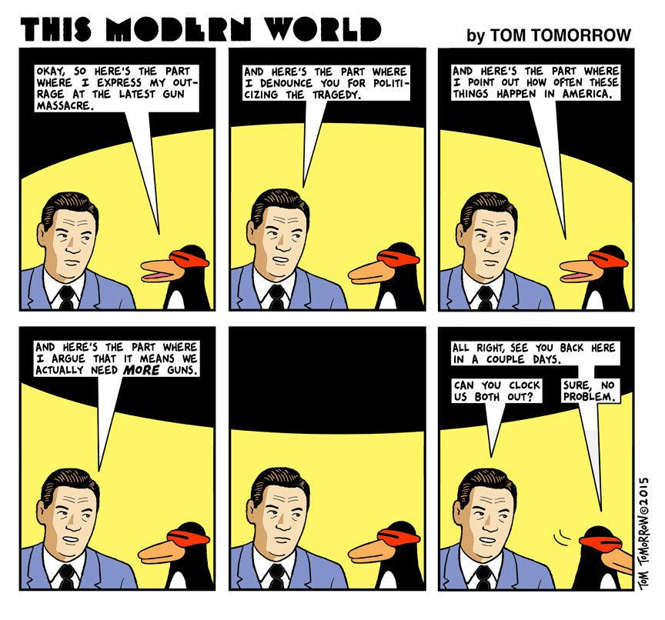
Class time and location: TTh 12-1:15 pm in EUR 315
Instructor: Dr. Garret Merriam
Office Location: Mendocino 3028
Office Phone: 916-278-7588
Office hours: TTh 2pm-3:15pm and by Appointment
Email Address: merriam@csus.edu

Course Description: Ethics Bowl is a national academic competition. Schools organize teams of 5 students and practice verbal debate over a series of assigned cases of moral dispute. Preparation for each case involves researching relevant history, science, and moral theories, anticipating potential questions, organizing arguments in response to those questions, considering counterpoints and replying to them, and practicing delivering all of these from memory in a structured debate format.

Learning Objectives: Upon completion of the course students should be able to:
- Research morally complicated topics using academic sources.
- Consider morally challenging cases from multiple perspectives.
- Work with a team to organize and refine a rationally compelling oral argument drawing on research, moral theory and competing perspectives.
- Deliver an oral presentation to a panel of judges in a timed, structured format involving objections from the competing team, and questions from the judges.
Assessments
Research write ups: For each case you are primary or secondary on you will need to do background research. That should begin by investigating the sources given in the case itself but should also include more sources that you dig up on your own. You will be sharing your sources to the google docs file for the relevant case, along with a short summary of the key points of each source. These can be updated over the semester but must be completed before the competition.

Written Case Prep: Each case will require a crafted, structured argument anticipating different possible questions, and highlighting 2-3 main arguments on both sides of the issue. This write up will be the basis for the oral presentation, so it should be clear, organized, and comprehensive. You will share them on the google docs file for the relevant case. These can be updated over the semester, but a first draft should be posted before the first class where we address the case, and the final draft must be posted before the competition.
Feedback to Team Members: Your team members rely on you to backstop them, notice flaws in their arguments, help them improve their presentation. When the case being discussed is one where you’re neither primary nor secondary on you will be required to give them feedback to those who are.

Recorded Test Runs: For each case that you are primary on you must record a live, real-time practice run of your full case. You can submit this any time (and multiple times, but at least once) before the competition, but I recommend submitting it about two weeks before.

Dress Rehearsal: 1-2 weeks before the competition we will organize a series of final practices that will mimic, as close as possible, the actual conditions of the real competition. Members of the faculty will serve as judges.
Competition Performance: The competition will be on December 2nd. Your grade will be a function of your score from the judges, your placement in the rankings and the assessment of your coaches.

Grade Breakdown:
Research Write Up: 100 points
Written Case Prep: 200 points
Feedback to Team Members: 100 points
Recorded Test Runs: 150 points
Dress Rehearsal: 150 points
Competition Performance: 300 points
Total: 1,000 points

Your final grade will be determined by the number of points you have out of a
possible 1000. You will be graded on a fixed scale rather than a curve: A = 93-
100%; A- = 92-90%; B+ = 89-87%; B = 86-83%; B- = 82-80%; C+ = 79-77%; C =
76-73%; C- = 72-70%; D+ = 69-67%; D = 66-63%; D- = 62-60%; F = 59-0%.

Attendance Policy: This is a team competition. Your teammates are relying on you to help them make their cases. You can’t do that if you’re not here. If you know you can’t make class, let us know beforehand. We can try to schedule around if we know in advance. Failure to notify us, or chronic absenteeism will result in you being dropped from the class.

Reasonable Accommodations: If you have a documented disability (visible or invisible) and require accommodation or assistance with assignments, tests, attendance, note taking, etc., please see the instructor by the end of the third week of the semester so that arrangements can be made. Failure to notify and consult with the instructor by this date may impede my ability to offer you the necessary accommodation and assistance in a timely fashion. Also be sure to consult with the Services to Students with Disabilities (Lassen Hall; http://www.csus.edu/sswd/index.html) to see what other campus services and accommodation options are available for you. Students with other types of accommodation requirements, such as English as a second language, are invited to discuss them with the instructors to facilitate understanding and the best learning experience for all. All information will remain confidential.

Contact Information for the Chair of the Department: If you have a problem with either the class or with me I would appreciate it if you talked to me about it first. But if you feel you cannot talk to me for some reason, you can talk to my department Chair, Dr. Russell DiSilvestro at rdisilv@csus.edu.

Student Health & Counseling Services

Due to the current and ongoing events faced by many during this public health crisis and era of civil unrest, the University recognizes that many of you may be in need of support. Please be aware that Health and Counseling Services staff are available for virtual and in-person services.

Additionally, if you are experiencing any COVID-like symptoms (fever, cough, sore throat, muscle aches, loss of smell or taste, nausea, diarrhea, or headache) or have had exposure to someone who has tested positive for COVID contact Student Health & Counseling Services (SHCS) at 916-278-6461 to receive guidance and/or medical care. You are asked to report any possible COVID-related illnesses or exposures to SHCS via this link COVID-19 Illness/Exposure Report Form. You should expect a call from SHCS within 24 hours. As an FYI, the Sac State Mobile App also has a self-assessment tool, in case you would like to screen yourself for symptoms of COVID-19. Feel free to utilize it, especially if you plan on going somewhere where others may be exposed (such as going to campus). The app will also have information on the University’s latest on-campus protocols.

Tentative Schedule

Week of 8/28: Introduction, overview, rules of the competition,
- Analysis of previous performances

Week of 9/4: General advice and strategy; tryouts (if necessary)
- Reading: selections from Mehdi Hasan’s “How to Win Every Argument”

Week of 9/11: First four cases (lose timing, notes allowed)

Week of 9/18: Second four cases (lose timing, notes allowed)

Week of 9/25: Third four cases (lose timing, notes allowed)

Week of 10/2: Fourth four cases (lose timing, notes allowed)

Week of 10/9: First four cases (tighter timing, no notes)

Week of 10/16: Second four cases (tighter timing, no notes)

Week of 10/23: Third four cases, take two (tighter timing, no notes)

Week of 10/30: First four cases, take three (tighter timing, no notes)

Week of 11/6: Second four cases, take three (tight timing, no notes)

Week of 11/13: Third four cases, take three (tight timing, no notes)

Week of 11/20: Weak cases (tight timing, no notes)

Week of 11/27: Dress rehearsals
● Extra hours are a possibility

12/2: Competition (Cal Poly)

