California State University, Sacramento
School of Business and Administration
Department of Management Information Systems

MIS 1B - Excel 97

Homework 1 - Due Next Tuesday
Before you begin this exercise, you need to retrieve the file needed for this exercise from my web site. The file Homework 2.xls can be downloaded at from the MIS 1B web page. A link for that web page is located on my homepage at www.csus.edu/indiv/b/benveniste. Next, if you are using Netscape Navigator, you should be prompted with an unknown file type dialog box. Once you get this box, click on the Save File button. Then, change to the A: drive and click on save. Now, open Excel 97 and open the Homework2.xls file. Note: If you are using Internet Explorer 4.0 and Excel 97, Excel should automatically start and open the Homework2.xls file.

- Open the workbook HOMEWORK1.XLS from the 3.5” disk. Open the worksheet GROUP and perform the following tasks:

  - Insert a new worksheet.
  - Copy the range A1:E9 from the GROUP worksheet to the new worksheet (start at cell A1).
  - Rename the new worksheet to CAL-TECH.
  - Autoformat the data in the CAL-TECH worksheet. Use the LIST-1 table format. Be sure to select the data (A1:E9) before using the Autoformat feature.
  - You are done with the CAL-TECH worksheet. Perform the following steps in the GROUP worksheet.
  - Select the GROUP worksheet. Change the font of the main title, “Cal-Tech Group,” to 18 point, bold, and white in color.
  - Center both the main title and sub-title “Cost Analysis 1998” over columns A through E.
Hint: Center the main title over columns A through E first. Then, center the sub-title. Do not center both at the same time.
  - Change the cell background of the main title and sub-title to blue.
  - Change the cell background of A3:E3 and A10:E10 to red.
  - Italicize and underline the sub-title “Sales Analysis 1998.” Change the font color of the sub-title to a white color.
  - Create a blue double-lined border for the range B5:E9.
  - Center all the column headings within their respective cells.
  - Change the height of row 3 and row 10 to 3 points.
  - Format all the numbers (B5:E9) into currency format. Once applied, there should be two decimal places.
  - Insert two rows above row 8. Type the word Scanner in A8. Type 500 in B8. Type 600 in C8. Type 700 in D8. Type 800 in E8. Type the word Modem in A9. Type 200 in B9. Type 300 in C9. Type 400 in D9. Type 500 in E9.
  - Attempt to insert a column to the left of Column B. What's the problem? Step g prevented you from doing so.
  - From Page Setup, change the print orientation from portrait to landscape.
  - Make sure gridlines will be printed.
  - From Page Setup, center the worksheet horizontally and vertically.
  - Add a custom header to the GROUP worksheet. In the left section, type your name. In the center section, type the day and time of the section you are enrolled in. In the right section, add the system date and time (do not type it in, use the toolbar buttons). Use a 12 size font and add a bold format.

  - Your updated GROUP worksheet should look like the following:
(Headers are not shown. Colors are also not shown.)
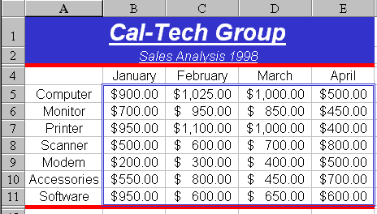

Save the workbook as Answers to Homework 1.xls on your 3.5" floppy disk.
Saving the workbook will save all the worksheets that reside in the workbook.

- From the HOMEWORK1.XLS workbook, open the JASPER worksheet and perform the following:

  - Fill in the years in cells D4:I4. Do not type it in. Use the fill handle or the menu option (Edit → Fill → Series) to perform this task.
  - Calculate the expenses, gross income, income tax, and the net income. Use the following guidelines in your calculations:

    - Expenses = Fixed Expenses + (Revenue * Variable Expense in percentage)
    - Gross Income = Revenue - Expenses
    - Using the IF-FUNCTION (use the function wizard), calculate the Income Tax.
Income Tax = Gross Income * Tax Rate in cells C13 or C14
Thus, if the gross income is from 0 to 249, use the tax rate in C13 and multiply it to the Gross Income to derive the Income Tax. Otherwise, use the tax rate in C14 and multiply it to the Gross Income to derive the Income Tax.
    - Net Income = Gross Income - Income Tax

  - Determine the income analysis for each year. Place the results in the appropriate cells in row 11. Use the following guidelines: If the net income of a particular year is equal or less than 200, put the label BAD in the cell. Otherwise, put the label GOOD in the cell.

  - If done correctly, your CASPER worksheet should look like the following:

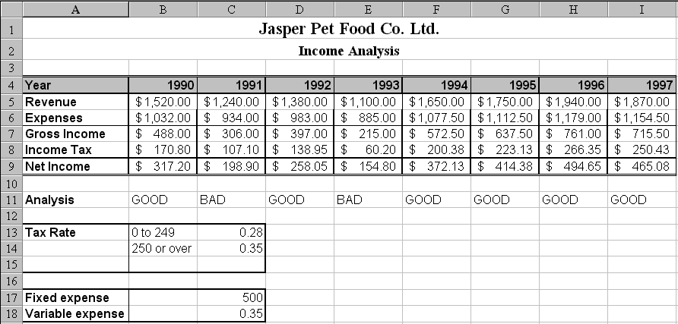

  - From Page Setup, change the print orientation from portrait to landscape.
  - Make sure gridlines will be printed.
  - From Page Setup, center the page horizontally and vertically.
  - Add a custom header to the JASPER worksheet. In the left section, type your name. In the center section, insert the sheet name (Use the far right toolbar button). In the right section, type the day and time of the section you are enrolled in.
  - Insert a new worksheet.
  - Go back to the JASPER worksheet. Highlight A1:I18. Copy the range and paste it into the new worksheet you have just inserted.
  - Rename the new worksheet to RECESSION.
  - Suppose there is a recession in the 1990's. Both fixed expense and variable expense increased to 650 (Type 650 in C17) and 40% (Type 0.4 in C18), respectively. The US government decided to have a tax cut in business. The new tax rate for gross income below 249 is 20% (Type 0.2 in C13) and gross income is 250 or over is 25% (Type 0.25 in C14). How do the changes affect the income analysis for Jasper Pet Food? Make the above changes in the RECESSION worksheet. The figures (i.e. Net Income, Analysis) should automatically update itself.
  - From Page Setup, change the print orientation from portrait to landscape.
  - Make sure gridlines will be printed.
  - From Page Setup, center the page horizontally and vertically.
  - Add a custom footer to the RECESSION worksheet. In the left section, type your name. In the center section, insert the workbook name (Use the second toolbar button from the right). In the right section, type the day and time of the section you are enrolled in.
  - If done correctly, your RECESSION worksheet should look like the following:

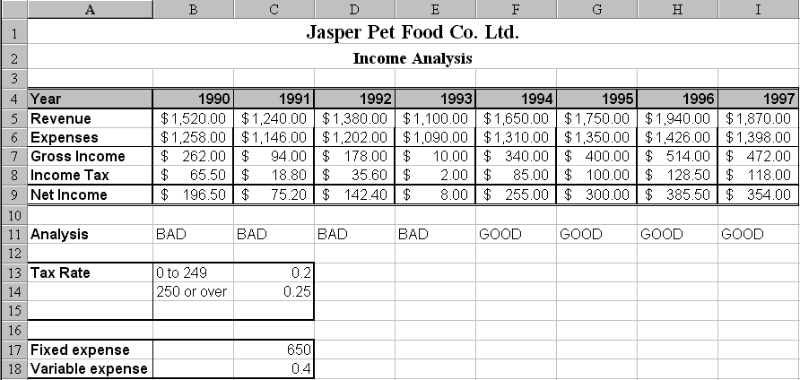

Save the workbook as Answers to Homework 1.xls on your 3.5" floppy disk.
Saving the workbook will save all the worksheets that reside in the workbook.

- From the HOMEWORK1.XLS workbook, select the GRADE worksheet, and perform the following tasks:

  - Autofit all columns (Use the select all and double-click method).
  - From page setup, set the worksheet to be printed without the grid lines.
  - From page setup, set the top margin to 1.5" and the bottom margin to 2".
  - Create a custom page footer. Include an automatic page numbering in the center section of the footer. The page number should follow the format Page 1, Page 2, etc. Place the system date, in the right section of the footer.
  - Sort the worksheet using Last_Name as the primary key in ascending order and First_Name as the secondary key in ascending order.
  - Use the AutoFilter function to search for the names of students who score 70 points or higher and major in MIS or Accounting. There should be 14 students who match the above search criteria.

Print the GRADE worksheet. It should contain the results you found in 3e.

Save the workbook as Answers to Homework 1.xls to your 3.5" floppy disk.

Saving the workbook will save all the worksheets that reside in the workbook.

- You should be comfortable with performing the above exercises. If you are not, be sure to practice these exercises again! Expect similar types of questions on the final exam (we have yet to discuss graphs and charts).

- Submit a floppy disk that contains the Answers to Homework 1.xls workbook. Include the following on the label of your disk:
- Your Name
- Your Section Number
- Homework 1

