Time Series Regression

Exploratory Analysis

Time Series

Observations on a variables taken at regular intervals of time (daily, monthly, yearly, etc.) involve time-series. This contrasts with observations all taken at the same time, such as the data on individual houses used in earlier notes, which is termed cross-sectional.

The regression of time series is similar to other types of regression with two important differences. Firstly, time variables themselves: trend over time, seasonality, and business cycles, are often useful in describing and/or predicting the behavior of a time series. Secondly, the order in which the data occurs in the spreadsheet is important because, unlike cross-sectional data, the ordering is not arbitrary but rather represents the order in which the data were collected. We will have to take these two differences into consideration when we attempt to construct regression models for a time series.

Exploratory Analysis

When dealing with time series, it is always a good idea to begin by graphing the dependent variable against time and looking for patterns in the graph. To do this in Statgraphics, go to Describe > Time Seies Analysis > Descriptive Methods. Enter the dependent variable in the data field, select the appropriate sampling interval: yearly, daily, hourly, etc., and complete the “Starting At” field. Upon clicking OK at the bottom of the Input Dialog box you will see the Time Series Plot and the graph of the Estimated Autocorrelations. These are the two graphs we will be discussing in this tutorial.

Example 1: The ABX Company sells winter sports merchandise including skis, ice skates, sleds, etc.. Quarterly sales, in thousands of dollars, are recorded in the file ABX, beginning in the first quarter of 1990 and ending in the last quarter of 1999. Below are the Time Series Plot and the graph of the Estimated Autocorrelations for ABX.

We will restrict our attention to the Time Series Plot for now. Looking at this plot, it should be immediately obvious that the series displays a linear trend over time and seasonality over the four quarters of the year. These observations lead us to suspect that time, in the form of successive quarters, and the season affect sales. We then use this information to define a model for predicting future sales for ABX.

Creating Variables for Trend and Seasonality

Trend

To account for the linear trend observed in the Time Series Plot create a new variable that represents the successive periods (quarters) over which the data was collected. To do this return to the spreadsheet and select an unused column. Use the right mouse button to access the Column Menu and select Generate Data. Either type “Count” into the expression field or select Count(?,?,?) from among the available operators to the right of the dialog box. The count operator requires three arguments: (i) the number of the first row, usually “1”, (ii) the number of the last row in the data, in this case “40”, and (iii) the size of the increment, always “1” for this class. For ABX we would type Count(1,40,1). You may also wish to select Modify Column from the Column Menu and rename the column. I’ve called it Time.

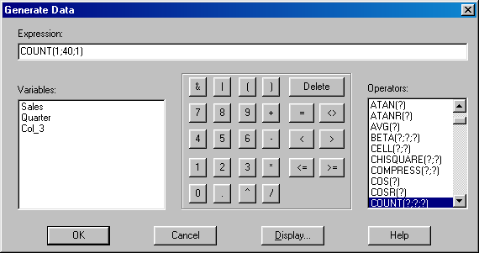

Seasonality

To account the seasonality observed in the exploratory analysis of the the time series for ABX sales, create dummy variables for three of the four quarters. In the spreadsheet, Copy the column “Quarter” and paste it into three available columns. Then, for the first new column, select Recode Data from the Column Menu. The picture below shows how to recode the column to create a dummy variable for the first quarter of every year. The remaining two columns are then recoded for the second and third quarters of the year, respectively.

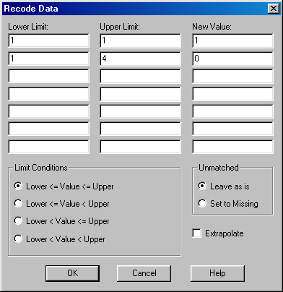

Upon completion, the spreadsheet will look like the one below.

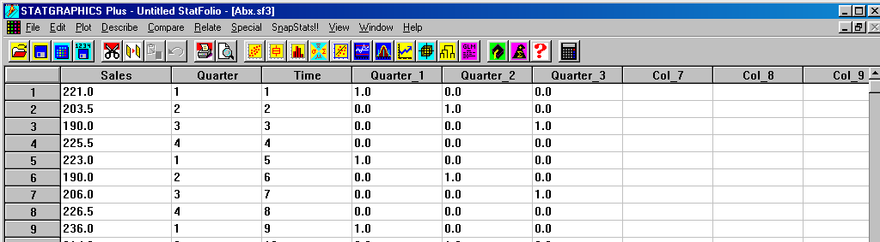

Including Trend and Seasonality in Regression

The initial regression model for ABX sales is Sales_{t} = β₀ + β₁Q₁ + β₂Q₂ + β₃Q₃ + β₄Time + ε, where the subscript _{t} for Sales indicates that the sales are for time period t. Below is the resulting Statgraphic’s multiple regression output.

In the output above, only quarter 1 in not considered significant. A quick look back at the Time Series Plot reveals the reason; the first and last quarters of the year both fall during the winter season when the sales of winter sporting goods are at their highest. Since dummy variables for a characteristic (seasons here) are always compared to the missing value (quarter 4 here), the high p-value for quarter 1 implies that first quarter sales are not significantly different, on average, than fourth quarter sales. Although we could remove quarter 1 from the model without much losss of information, I will retain it for the remainder of the discussion.

Interpreting Trend and Seasonality

The seasonal dummy variables are interpreted by comparing them to the missing quarter, quarter 4, while holding the other variable Time constant. Time, representing successive quarters, is interpreted as the effect of the linear trend in sales over time, holding the effect of the seasons constant. The intercept doesn’t have a useful interpretation.

b₁: After accounting for the trend, sales in the first quarter average about $3,700 more than fourth quarter sales, although the effect may not be statistically significant.
b₂: After adjusting for the trend, sales in the second quarter average around $26,100 less than fourth quarter sales.
b₃: Third quarter sales average $25,800 less than fourth quarter sales after accounting for the trend component time.
b₄: Each additional quarter sees an average increase of $2,600 in sales, after adjusting for the season. (Alternative wording: The sales increases, on average, by $10,300 (4 x $2,566) per quarter year to year)

Residual Analysis

You should always perform an analysis of the residuals prior to using a regression model. Among the assumptions made about the error variable in regression is that successive errors are unrelated. While this assumption is rarely violated for cross-sectional variables, it frequently is for time series.Stock prices, for example, don’t usually fluctuate much from day-to-day. Therefore, if a company’s stock price is greater than the model predicts today, it will probably be higher than predicted tomorrow as well. Hence successive errors are related, i.e., they tend to have the same sign. For a time series, therefore, we should look for patterns in successive residuals that would indicate the presence of correlated errors. The Plot of Residuals versus Row Number (time period) is used for this purpose. Below is the graph for the ABX model considered.

There are no obvious patterns in the plot indicating that correlsted errors are not a problem with this model. The plot Residuals versus Predicted and the histogram of the studentized residuals likewise satisfy the requirements of constant variance and normality, respectively.

Prediction

Predictiong sales of ABX for 2000 follows the procedure employed in any multiple regression. Enter the proper values for the first three quarters and time into unused rows in the spreadsheet and select Reports under Tabular Options. The results for the four quarters of 2000 appear below. Prediction for time series differs slightly from prediction for cross-sectional data in two respects. First, prediction in time series necessarily involves extrapolation. Second, interval estimates nearly always involve forecast intervals rather than mean intervals. The latter makes sense because we are predicting for the next individual time period. (All predictions for ABX are in thousands of dollars.)

The Influence of Previous Periods in Time Series

The value of a time series in a time period is often affected by the values of variables in preceeding periods. For example, monthly retail sales may by affected by the sales in previous months or by the amount spent in a previous month on advertising. In such cases we need to incorporate information from earlier time periods (earlier rows in the spreadsheet) in the model. This can be accomplished using the LAG operator in Statgraphics.

Example 2: The file PINKHAM involves data on sales and advertising for a small family-owned company that marketed a product called “Lydia Pinkham’s Vegetable Compound” to women through catalogs from 1907 until the company’s demise in 1960. The National Bureau of Economic Research recommended in 1943 that the Pinkham data set be used to evaluate economic models because the data was unusually “clean”, i.e., contained no product or marketing discontinuities.

Although certainly not random, the times series for yearly sales shows no systematic trend. (Why do you suppose that there isn’t a trend over time due to inflation?)

Let Sales_{t} = β₀ + β₁Advertise_{t} + ε, where the subscript _{t} indicates that sales and advertising values are for the same period. Below is the output for this model.

The clumps of adjacent residuals above and below the model in the plot of Residuals versus Row Number are evidence of correlated errors. To reduce this correlation, we revise the model by including information on sales from the previous year. Symbolically, the revised model is Sales_{t} = β₀ + β₁Advertise_{t} + β₂Sales_{t-1} + ε. To add information on sales from the previous year in Statgraphics, open the Input Dialog box (red button) and, after selecting the Independent Variables field, use the transform button to access the Generate Data dialog box. Choose “LAG(?,?)” from among the available operators. The two arguments of the LAG operator are for the variable to be “lagged” and the number of previous periods to be “lagged”. Since our model uses values of the variable Sales from the previous year, enter LAG(Sales,1) and click OK to place the new variable in the Independent Variables field.. Click OK again to view the following output for the second model. Notice that the new model performs better. In particular, the the new variable Sales_{t-1} has a low p-value of 0.0000, indicating that it is highly significant to sales in period t. Also, the problem of correlated errors has been reduced.

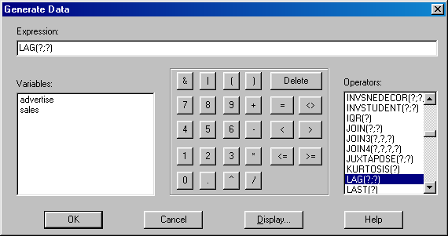 | 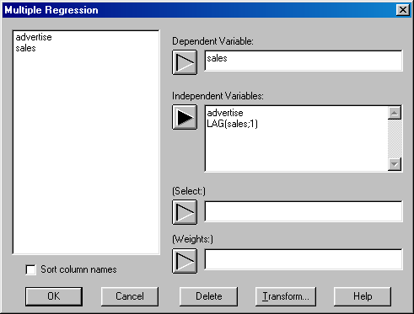

There is still some evidence of correlated errors, so we consider the possibility that advertising from the previous year might be useful in predicting sales. The model is now Sales_{t} = β₀ + β₁Advertise_{t} + β₂Sales_{t-1} + β₃Advertise_{t-1} + ε. The output below looks encouraging. All variables are significant and the plot of residuals versus time is random.

Autocorrelation

Autocorrelation exists in a model when errors are correlated because values of the dependent variable in one period are correlated to values of the dependent variable in previous periods. The original model for the Pinkham family business, Sales_{t} = β₀ + β₁Advertise_{t} + ε, exhibited autocorrelation. The independent variable Sales_{t-1} was introduced in the second model in response to the autocorrelation in the first model. In the example, we introduced a lag of one year for sales because it seemed reasonable to suspect that previous year’s sales could affect current sales. Is there another way to anticipate significant lags of the dependent variable? The answer lies in the graphs of the Autocorrelation Function and the Partial Autocorrelation Function found in a time series analysis (see page 1 of these notes). Below are the Time Series Plot and Autocorrelation Function for Pinkham.

The graph of the autocorrelation function can be used to determine which lags of the dependent variable may be significant to a model. Note that a lag of one for sales is highly correlated to sales.

The plot for Partial Autocorrelations is more helpful in spotting autocorrelations for other lags. This is because the partial correlations are evaluated after the effects of smaller lags are accounted for. Since the first lag of sales was significant, the partial correlation for sales lagged two years will describe the correlation for sales with sales-lagged-twice after the first lag has been included. Below are the table and plot of the partial autocorrelations found in StatGraphics under the Tables and Graphs button in Time Series.

 | Partial |  | Lower 95.0% | Upper 95.0%
Lag | Autocorrelation | Stnd. Error | Prob. Limit | Prob. Limit
1 | 0.909642 | 0.136083 | -0.266718 | 0.266718
2 | -0.39045 | 0.136083 | -0.266718 | 0.266718
3 | -0.0569341 | 0.136083 | -0.266718 | 0.266718
4 | -0.11951 | 0.136083 | -0.266718 | 0.266718
5 | -0.211371 | 0.136083 | -0.266718 | 0.266718
6 | -0.100744 | 0.136083 | -0.266718 | 0.266718
7 | 0.0146624 | 0.136083 | -0.266718 | 0.266718

From the plot and table above, it appears that sales-lagged-twice may be negatively correlated to sales. Adding this to the previous model we arrive at the following:

 |  | Standard | T
Parameter | Estimate | Error | Statistic | P-Value
CONSTANT | 192.103 | 78.5958 | 2.44418 | 0.0183
advertise | 0.513143 | 0.137214 | 3.73973 | 0.0005
LAG(sales,1) | 1.21838 | 0.125988 | 9.67062 | 0.0000
LAG(advertise,1) | -0.513021 | 0.14339 | -3.57781 | 0.0008
LAG(sales,2) | -0.319988 | 0.114172 | -2.80268 | 0.0073

Analysis of Variance
Source | Sum of Squares | Df | Mean Square | F-Ratio | P-Value
Model | 1.81793E7 | 4 | 4.54482E6 | 142.83 | 0.0000
Residual | 1.49557E6 | 47 | 31820.7
Total (Corr.) | 1.96748E7 | 51

R-squared = 92.3985 percent
R-squared (adjusted for d.f.) = 91.7516 percent
Standard Error of Est. = 178.384

Interpreting Coefficients of Lagged Variables

The final model for Pinkham uses values for sales and advertising from the previous year as independent variables (both are in thousands of dollars). However, we would probably not interpret the coefficients for the independent variables in the model because they are almost certainly correlated with one another, producing severe multicollinearity. The following, therefore, is only intended to provide an example of how lagged variables might be interpreted in a model. Interpreting the coefficients of Advertise_{t} and the lagged variables Sales_{t-1} and Advertise_{t-1} in the initial model.

b₁: Mean sales increases by $589 for each additional $1,000 in adverting, after the effects of sales and advertising in the previous year have been accounted for.
b₂: Sales increases by $955, on average, for each additional $1,000 in sales the previous year, after accounting for advertising and advertising in the previous year.
b₃: Sales decreases by $660, on average, for every additional $1,000 in advertising the previous year, after the effects of advertising and the previous year’s sales have been accounted for.

Note that the negative value of the coefficient for Advertise_{t-1} is probably due to multicollinearity, and reminds us that interpreting coefficients in the presence of severe multicollinearity can be misleading

Warning

WARNING: Observations are lost in the least squares estimation of the regression coefficients when lags are used. For example, if a lag of 4 periods for dependent variable is used in the model then the first four observations are effectively lost. (Why?) Consequently, you must decide if the improvement in the model justifies the loss in information incurred, i.e., including important autocorrelations incorporates information into the model, while the effective loss of observations (rows) loses information. It’s up to you to judge whether it’s a net loss or gain of information. The same comments apply to lags of the independent variable used in the model.

Example 2 (continued): A closer look at the Analysis Summary window for the original (first) and final (third) model for Pinkham reveals that the degrees of freedom have changed in the ANOVA Table. df_{SST} = 53 for the first model, but df_{SST} = 52 for the second and third models because the latter contain variables with a lag of 1. A closer look at the plot Residuals versus Row Number for the second and third models likewise reveals that no residual is plotted for the first year, 1907, because there is no previous year in the data, and hence no values for Sales₁₉₀₇₋₁ or Advertise₁₉₀₇₋₁.

Forecasting

To forecast sales for 1961 in the Pinkham example we need only enter a value for advertising in 1961. (Why?) The resulting output for a projected $850,000 in advertising is

Conclusion

In business applications it is not uncommon to use several of the techniques discussed in these notes in the construction of a model. Variables for time and seasonality may be combined with significant lags of the dependent and/or independent variables. Transformations of the dependent and/or of one or more of the independent variables may also be required in order to properly fit the data or to stabilize the variance.
Obviously, such models may take some time to develop.

XIII. Stationarity

The graph of the autocorrelation function can be used to determine which lags of the dependent variable may be significant to a model. The autocorrelation function is most useful, however, if it is plotted after any nonrandom pattern in the time series has been removed. For Pinkham, although there is no systematic trend or seasonality to remove, there is definitely a pattern involving long term cycles. The quickest way to remove it is by looking at the First Differences for sales, defined as Diff(Sales_{t}) = Sales_{t} – Sales_{t-1}. The first differences for sales represent the increase (or decrease) in sales from year t–1 to year t. The Statgraphics operator Diff(?) calculates the first differences of the variable in the argument of the operator. Use the Input Dialog button and the transform button to enter Diff(Sales) into the Data field and click OK. You should see the graphs below.

The Time Series Plot is now free of any discernible pattern, i.e., it is random (or Stationary). Returning to the graph of the Autocorrelation Function, any rectangle extending beyond the red curves provides evidence of significant autocorrelation. For Diff(Sales) the rectangle associated with a lag of 1 is significant. This may indicate that Sales_{t-1} is an important independent variable in a regression model. In fact, we already know this is the case. It is important to remember that the analysis just conducted would normally have occurred before building the regression model for the sales of the Pinkham business. In fact, all of the time series analysis done here is exploratory and intended only to provide information about potentially significant factors to sales. Finally, below I've included the plot of the sample partial autocorrelations for the stationary time series Diff(sales). Although the lag at 13 appears significant, this applies explicitly only to the series Diff(sales), and there doesn't appear to be any justification for adding a Sales_{t-13} term to our model.

