Groundwater Gradient Exercise Geology 210

Objectives:

In this lab we will perform the following tasks:

1) Measure water levels in six wells located on the edge of the CSUS campus.
2) Plot the results from shallow and deep wells on two different maps.
3) Construct three point problems to determine the direction of groundwater flow in shallow and deep wells.
4) Write a technical report that summarizes results.

Equipment needed:

Ruler or engineering scale, calculator

Today’s exercise:

1) Measure water levels in the three shallow wells and three deep wells. These water levels must then be converted to elevations above or below sea level (note: the common abbreviation for sea level is MSL or “Mean Sea Level”). Use the following formula to calculate the elevation of the water table above or below sea level:

(Land surface elevation) - (Measured water level) = Elevation (MSL)

Record your results on this table:

Well number | Land surface elevation (surveyed elevation at top of casing) | Measured water level in well (from land surface to water table) | Elevation of water table (MSL)
MW-1
MW-1A
MW-2
MW-2A
MW-3A
MW-3A

2) Plot the water levels (MSL) for the shallow wells on the map labeled “Shallow wells". Plot the water levels (MSL) for the deep wells on the map labeled “Deep wells".

3) Construct a graphical three-point problem to determine the direction of groundwater flow for each of the maps. Remember that groundwater flows down-gradient (“down-hill”), so the water will flow from a higher elevation toward a lower elevation. Be careful with positive and negative numbers in this part of the exercise. A positive number is an elevation above sea level, and a negative number is an elevation below sea level.

The three point problem is based on a simple principle of geometry: three points define a plane, and if you can define the position of a plane in space you can also determine the dip (inclination) of the plane. Because groundwater flows down-gradient, it will flow in the direction of dip of the plane. Use the following example to help you work through your three point problems for the shallow and deep wells:

Sample problem: Follow steps 1-4 to solve this example of a three point problem:

Step1) Draw a line between the highest and lowest groundwater elevations. Remember to use elevations that are corrected (compared) to sea level.

Step 2) Determine the position where the intermediate groundwater elevation would project along this line. Use measured distances on the map and differences between water level elevations to construct a ratio and determine this position:

Example ratio equation:

(highest elevation - intermediate elevation) = unknown distance
(highest elevation - lowest elevation) (measured distance between highest and lowest elevations)

Read the highest elevation, lowest elevation and intermediate elevation from your map, and plug these values into the ratio equation. Use your ruler to measure the distance between the highest and lowest elevations on your map and plug this value into the equation. Any units are will work, but millimeters or metric units are often easiest to use. Solve for the unknown distance. The unknown distance is the map distance from the highest elevation to the intermediate elevation.

Step 3) Mark the unknown distance that you calculated in step 2 along the line that connects the highest and lowest elevations. Make sure that you start measuring from the highest elevation.

200 ft
50 ft
75 ft
Highest elevation
Intermediate elevation
Equipotential line
Lowest elevation

Step 4) Draw a line between the intermediate elevation and the unknown point that you marked in step 3. This new line is perpendicular to the dip (inclination) of the groundwater surface. It is essentially an equipotential line (a line in an two-dimensional field where the total hydraulic head or water level is constant for all points on the line). Draw a large arrow perpendicular to your new line to represent the dip of the groundwater surface and the direction of groundwater flow. The direction of groundwater flow is 90° to the equipotential line.

Repeat these steps for the shallow and deep well maps to determine the direction of groundwater flow in each water-bearing unit.

Questions to ponder in the field:

• Does groundwater flow the same direction in the shallow and deep aquifers?

• Do you think that groundwater flows at the same velocity in the shallow and deep aquifers? Why or why not?

• If you were trying to protect this wellfield from contaminants, which area of campus would be the biggest concern? Can you see any potential sources of contaminants in this direction?

- What is the vertical hydraulic gradient between the shallow and deep water bearing interval? What does this indicate?

- What is the horizontal hydraulic gradient in the shallow water-bearing interval? Given a porosity of 15% and a hydraulic conductivity of 45 ft/d, how long would it take for a contaminant to travel 200 ft in this interval?

- What is the horizontal hydraulic gradient in the deeper water bearing interval? Given a porosity of 25% and a hydraulic conductivity of 220 ft/d, how long would it take for a contaminant to travel 200 ft in this interval?

Schematic cross section of on-campus wellfield at California State University, Sacramento

Figure 1: Cross-section of the CSUS wellfield, showing location and depths of shallow and deep wells.
= coarse sandy interval
= silty clay confining layer
Deep Monitoring
Wells
Extraction
Well
Deep confined aquifer
0
50
100
200
150
Feet
Feet
0
50
100
Shallow Monitoring
Wells
Shallow unconfined aquifer
Confining layer
= fine sandy unconfined aquifer

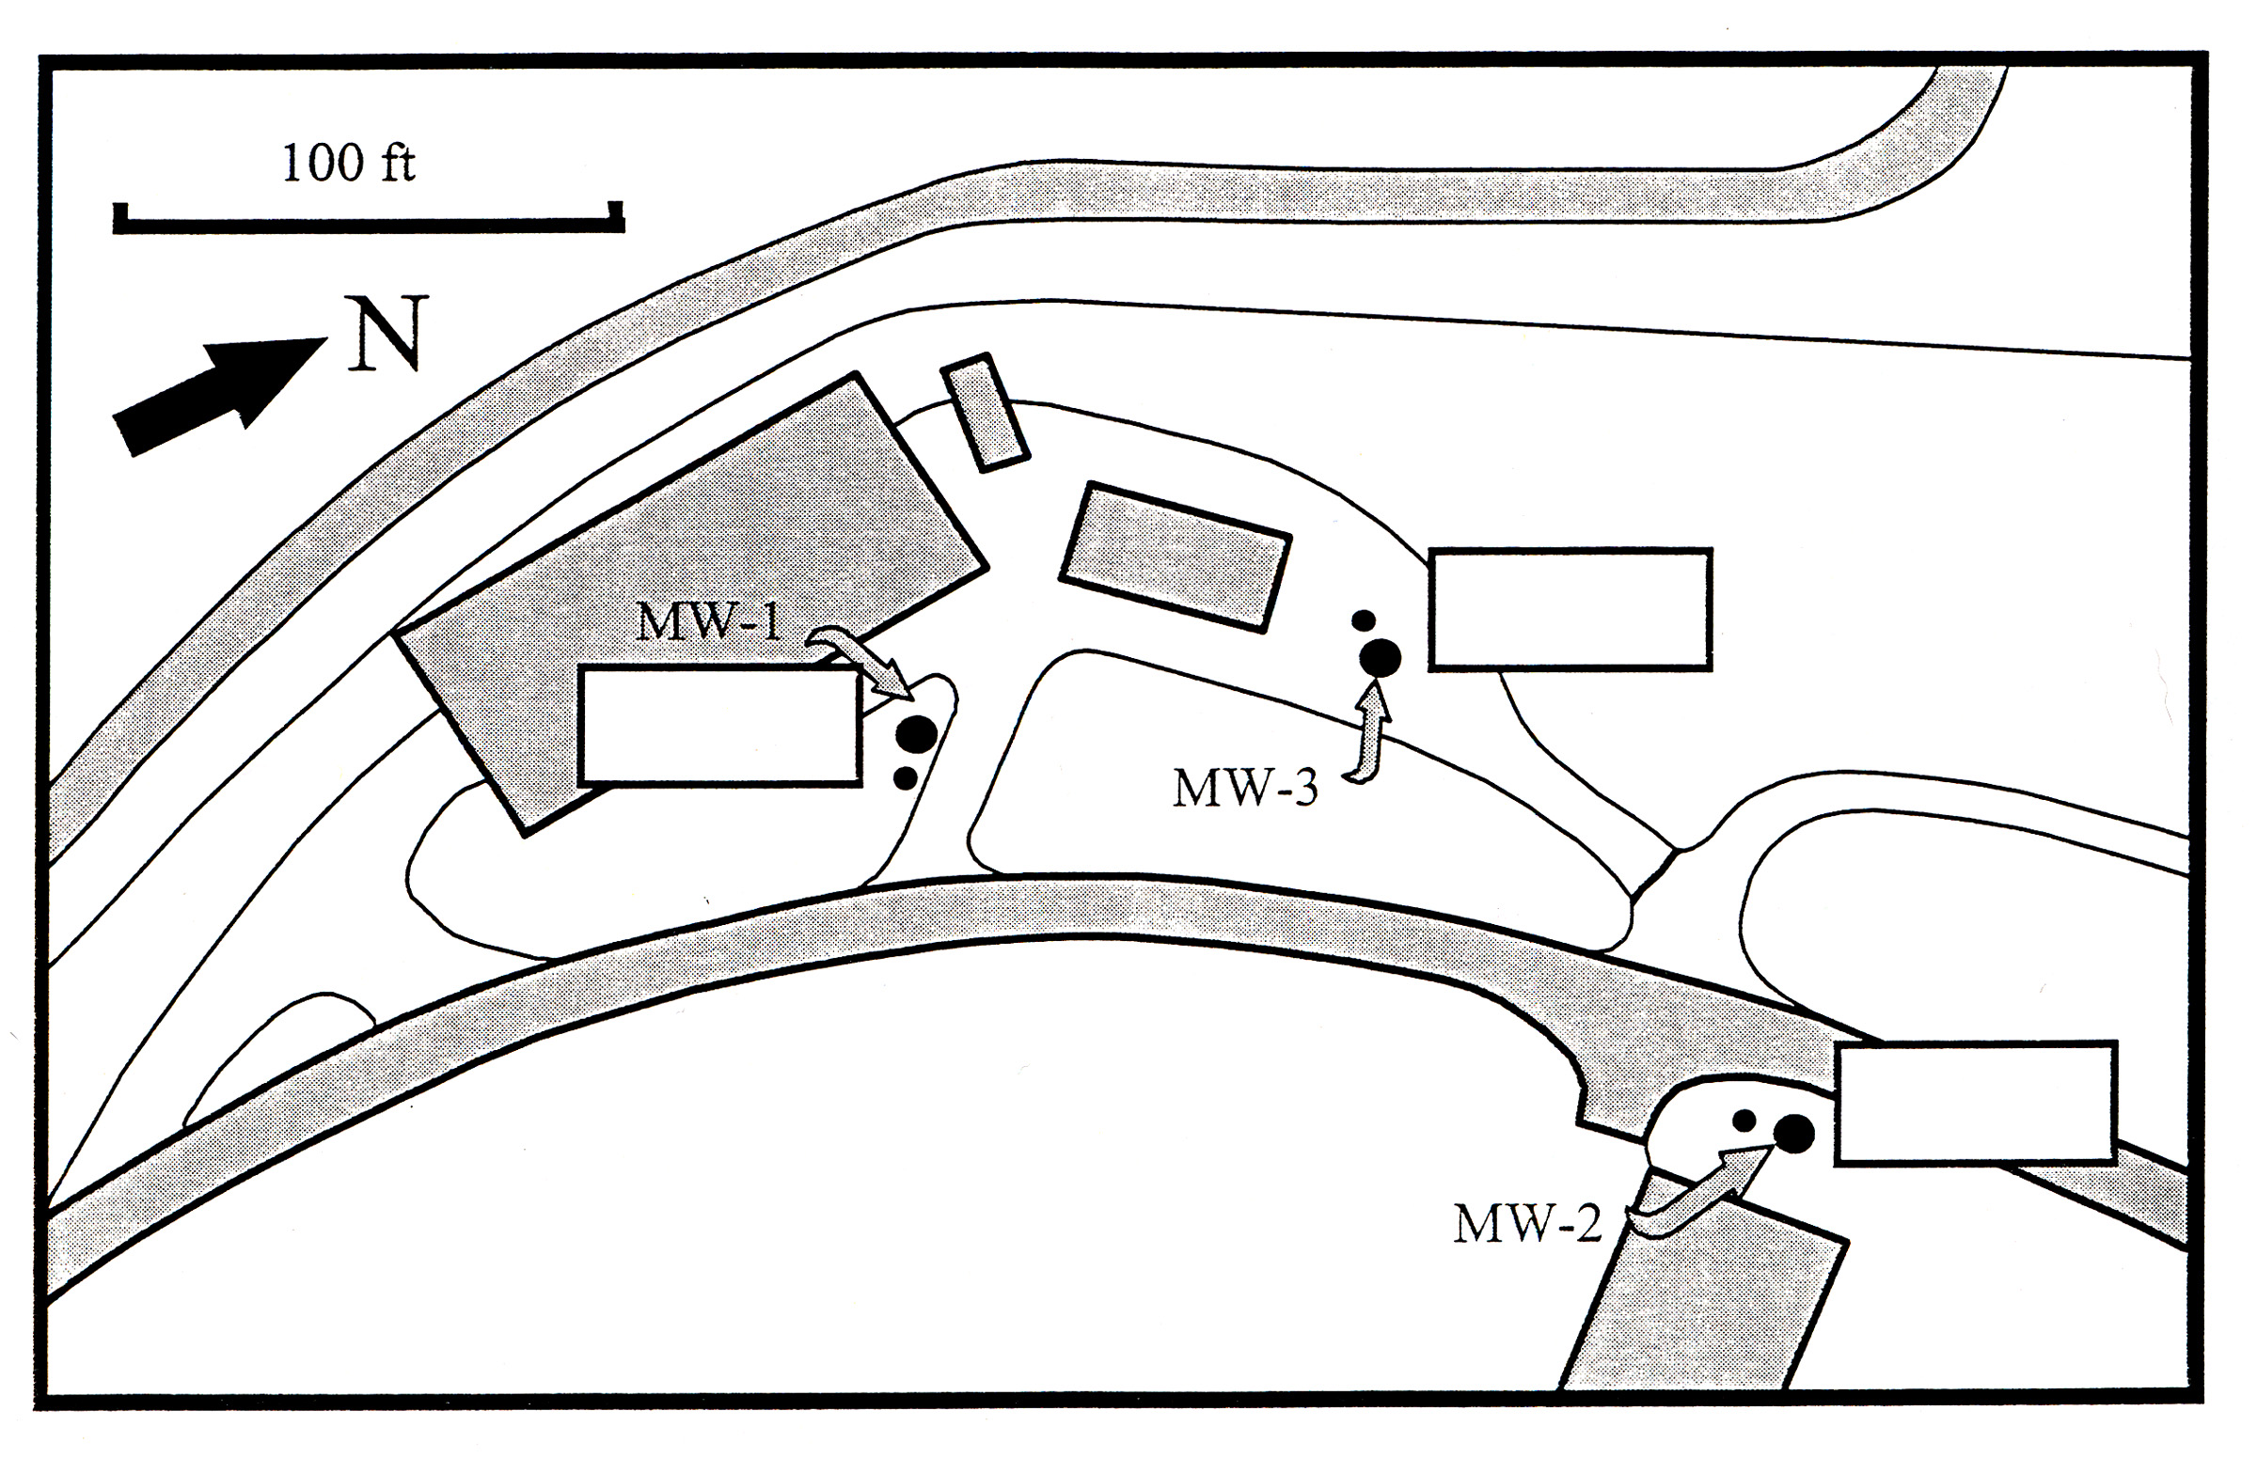

Figure 2: Map of shallow wells, CSUS wellfield.

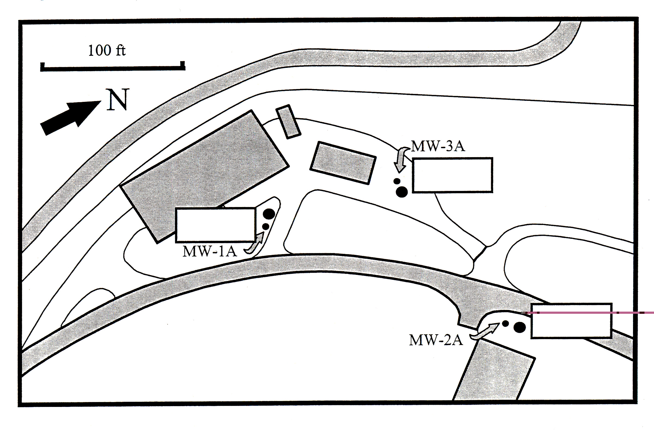

Figure 3: Map of deep wells, CSUS wellfield.

