Sample Exam 1. Note there are 8 more multiple choice questions than will appear on a live exam.
1) Microeconomics studies the allocation of
A) decision makers.
B) scarce resources.
C) models.
D) unlimited resources.

2) The Oregon Health Care Plan is an example of how policy makers cope with
A) scarcity of medical treatment.
B) scarcity of patients.
C) scarcity of policy makers.
D) answering the question of how to produce.

3) “Anything worth doing is worth doing well,” ignores which of the following?
- concern with quality
- opportunity cost
- marginal utility
- both “b” and “c”

4) The purpose of making assumptions in economic model building is to
A) force the model to yield the correct answer.
B) minimize the amount of work an economist must do.
C) simplify the model while keeping important details.
D) express the relationship mathematically

5) Which of the following is an example of a positive statement?
A) Since this good is bad for you, you should not consume it.
B) If this good is bad for you, you should not consume it.
C) If you consume this good, you will get sick.
D) None of the above.

6) According to the Law of Demand, the demand curve for a good will
A) shift leftward when the price of the good increases.
B) shift rightward when the price of the good increases.
C) slope downward.
D) slope upward.

7) If the price of automobiles were to decrease substantially, the demand curve for public transportation would most likely
A) shift rightward.
B) shift leftward.
C) remain unchanged.
D) remain unchanged while quantity demanded would change.

8) If the demand for oranges is written as Q = 100 - 5p, then the inverse demand function is
A) Q = 5p - 100.
B) Q = 20 - .2p.
C) p = 20 - 5Q.
D) p = 20 - .2Q.

9) Suppose there are 100 identical firms in the rag industry, and each firm is willing to supply 10 rags at any price. The market supply curve will be a(n)
A) vertical line where Q = 10.
B) vertical line where Q = 100.
C) vertical line where Q = 1000.
D) horizontal line where Q = 1000.

10) The expression “increase in quantity supplied” is illustrated graphically as a
A) leftward shift in the supply curve.
B) rightward shift in the supply curve.
C) movement up along the supply curve.
D) movement down along the supply curve.

11) Equilibrium is defined as a situation in which
A) neither buyers nor sellers want to change their behavior.
B) no government regulations exist.
C) demand curves are perfectly horizontal.
D) suppliers will supply any amount that buyers wish to buy.

12) A drought in the Midwest will raise the price of wheat because of a
A) leftward shift in the supply curve.
B) rightward shift in the supply curve.
C) leftward shift in the demand curve.
D) rightward shift in the demand curve.

13) Suppose a market were currently at equilibrium. A rightward shift of the demand curve would cause
A) an increase in price but a decrease in quantity.
B) a decrease in price but an increase in quantity.
C) an increase in both price and quantity.
D) a decrease in both price and quantity.

14) When two goods are substitutes, a shock that raises the price of one good causes the price of the other good to
A) remain unchanged.
B) decrease.
C) increase.
D) change in an unpredictable manner.

15) Suppose the demand curve for a good is expressed as Q = 50 - 2p. If the good currently sells for $3, then the price elasticity of demand is
A) -3 * (2/50).
B) -2 * (50/3).
C) -2 * (3/44).
D) -3 * (44/2).

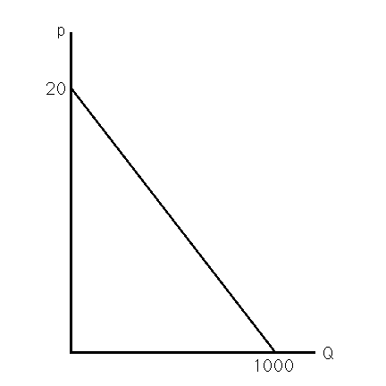
16) Figure 3.2 shows the demand curve for crude oil. If the market price is $10 a barrel, what is the price elasticity of demand?
A) -.02
B) -1
C) -10
D) -500

17) Figure 3.2 shows the demand curve for crude oil. The demand curve has unitary price elasticity when price equals
A) $0.
B) $1.
C) $10.
D) $20.

18) If the price of orange juice rises 10%, and as a result the quantity demanded falls by 8%, the price elasticity of demand for orange juice is
A) -1.25.
B) inelastic.
C) Both A and B above.
D) Neither A nor B above.

19) If a consumer doubles her quantity of ice cream consumed when her income rises by 25%, then her income elasticity of demand for ice cream is
A) 8.0.
B) 4.0.
C) .25.
D) .08.
20) If a good has an income elasticity of demand greater than 1, one might classify that good as
A) a necessity.
B) a luxury.
C) unusual.
D) inelastic.

21) The cross price elasticity of demand between two goods will be positive if
A) the two goods are complements.
B) the two goods are substitutes.
C) the two goods are luxuries.
D) one of the goods is a luxury and the other is a necessity.

22) If the supply curve for orange juice is estimated to be Q = 40 + 2p, then, at a price of $2, the price elasticity of supply is
A) .01.
B) .09.
C) 1.
D) 11.

23) The short-run elasticity of supply is less than the long-run elasticity of supply
A) because consumers' tastes and preferences change in the long run but not in the short run.
B) because producers can adjust the amount of machinery in the long run but not in the short run.
C) only for durable goods.
D) only for nondurable goods.

24) For a given positively sloped supply curve, the price increase to consumers resulting from a specific tax imposed on sellers will be
A) greater the more price elastic demand is.
B) greater the less price elastic demand is.
C) equal to the entire tax when demand is perfectly elastic.
D) equal to half of the tax whenever demand is unit elastic.

25) A specific tax on sellers will
- shift the demand curve to the right.
- shift the demand curve to the left.
- shift the supply curve to the right.
- shift the supply curve to the left.

26) Consumers will always pay the entire amount of a specific tax whenever
A) demand is perfectly inelastic.
B) supply is perfectly elastic.
C) Both A and B above.
- Either A or B above but not at the same time.
27) The tax incidence of a specific tax or ad valorem tax is influenced by
A) who pays the tax.
B) the amount of the tax.
C) the price elasticities of supply and demand.
D)All of the above.

28) An indifference curve represents bundles of goods that a consumer
A) views as equally desirable.
B) ranks from most preferred to least preferred.
C) prefers to any other bundle of goods.
D) All of the above.

29) There is an indifference curve through every bundle because of the assumption of
A) transitivity.
B) completeness.
C) rationality.
D) nonsatiation.

30) If two indifference curves were to intersect at a point, this would violate the assumption of
A) transitivity.
B) completeness.
C) Both A and B above.
DNeither A nor B above.

31) Convexity of indifference curves implies that consumers are willing to
A) give up more "y" to get an extra "x" the more "x" they have.
B) give up more "y" to get an extra "x" the less "x" they have.
C) settle for less of both "x" and "y".
D) acquire more "x" only if they do not have to give up any "y".

32) For which of the following pairs of goods would most people likely have convex indifference curves?
A) nickels and dimes
B) left shoes and right shoes
C) movie tickets and concert tickets
D) None of the above.

33) If two bundles are on the same indifference curve, then
A) the consumer derives the same level of utility from each.
B) the consumer derives the same level of ordinal utility from each but not the same level of cardinal utility.
C) no comparison can be made between the two bundles since utility cannot really be measured.
D) the MRS between the two bundles equals one.

34) If Fred's marginal utility of pizza equals 10 and his marginal utility of salad equals 2, then
A) he would give up 5 pizzas to get the next salad.
B) he would give up 5 salads to get the next pizza.
C) he will eat five times as much pizza as salad.
- he will eat five times as much salad as pizza.

35) If the utility for two goods "x" and "y" is measured as U = x + y, then it can be concluded that
A) "x" and "y" are perfect substitutes.
B) "x" and "y" are perfect complements.
C) "x" and "y" are both bads.
D) the indifference curves on the x,y graph will be upward sloping.

36) If the utility for two goods "x" and "y" can be measured as U = x, then it can be concluded that
A) "x" and "y" are perfect complements.
B) "y" is a "bad".
C) the indifference curves on the x,y graph are upward sloping where "x" is measured on the horizontal axis.
D) the indifference curves on the x,y graph are vertical where "x" is measured on the horizontal axis.

37) Joe's income is $500, the price of food (F) is $2 per unit and the price of shelter (S) is $100. Which of the following represents his budget constraint?
A) 500 = 2F + 100S
B) F = 250 - 50S
C) S = 5 - .02F
D) All of the above

38) The marginal rate of transformation of y for x represents
A) the slope of the budget constraint.
B) the rate at which the consumer must give up x to get one more y.
C) - P_{y}/P_{x}.
D) All of the above.

39) If the price of one good increases while the price of the other good and the consumer's income remain unchanged, what will happen to the budget line?
A) The budget line rotates inward from the intercept on the axis of the good that did not change in price.
B) The budget line rotates outward from the intercept on the axis of the good that did not change in price.
C) The budget line shifts inward without a change in slope.
D) The budget line shifts outward without a change in slope.

40) If the consumer's income increases while the prices of both goods remain unchanged, what will happen to the budget line?
A) The budget line rotates inward from the intercept on the horizontal axis.
B) The budget line rotates outward from the intercept on the vertical axis.
C) The budget line shifts inward without a change in slope.
D) The budget line shifts outward without a change in slope.

41) The consumer is in equilibrium when
A) MRT = MRS.
B) P_{x}/P_{y} = MU_{x}/MU_{y}.
C) the budget line is tangent to the indifference curve at the bundle chosen.
D) All of the above.

Figure 4.1
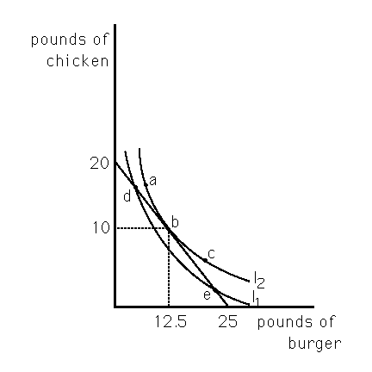

42) Max has allocated $100 toward meats for his barbecue. His budget line and an indifference map are shown in Figure 4.1. Which bundle will Max choose?
A) a
B) b
C) c
D) d

43) Max has allocated $100 toward meats for his barbecue. His budget line and an indifference map are shown in Figure 4.1. What is the price of chicken?
A) $0.80/lb
B) $1.25/lb
C) $4/lb
D) $5/lb

Short Answer/ Problem Section

1) Explain why when the demand curve for a good is elastic, a one percent reduction in the price of the good will increase a consumer's expenditure on the good. Whenever Price elasticity of demand exceeds absolute value of 1, then a drop in price (the multiplier) times the quantity demanded (the multiplicand) leads to a larger total revenue (algebraic product).

2) Lisa views pizzas and burritos as goods. If she prefers a bundle of 4 burritos and 4
pizzas to a bundle of 4 burritos and 5 pizzas, which property of consumer preference is violated? Transitivity. What change in the assumptions could lead a rational consumer to prefer the first bundle? She prefers a bundle of 4 burritos and 5 pizzas to a bundle of 4 burritos and 4 pizzas.

- Compare the tax revenue to government of a 10 cent per gallon tax on sasafrass oil versus an ad valorem tax of 05% when the oil sells for $2.00 per gallon without the tax. Assume that the impact is shown as a supply shift in each case and that the pre tax supply curve passes through the origin and has a slope of +1. Demand in the neighborhood of the equilibrium price has both a price elasticity of demand value of –1 and a slope value of -1. Draw a graph and show the forward shifting of each tax.

Tax bill at 5% = $2 * .05. Tax collection will be 10 cents per gallon. Tax bill at 10 cents per gallon is identical in this case.
S and St should be parallel lines. The vertical distance is 10 cents.

$2.05 price to consumers after the tax.
$1.95 net price to suppliers after the tax.

S after advalorem tax

Tax wedge is 10 cents at a $ 2 pretax supply price

