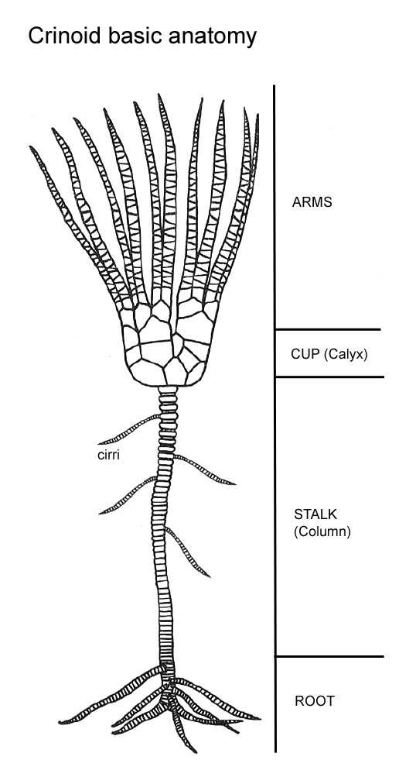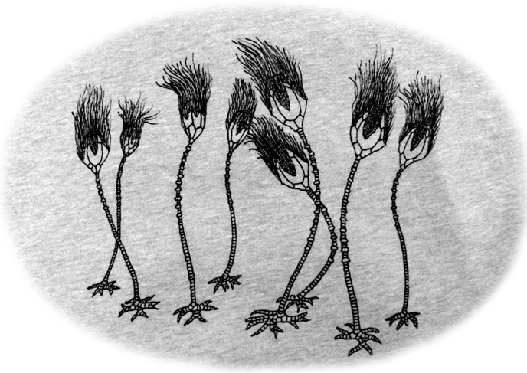

Blastoids

http://www.thefossilforum.com/uploads/monthly_09_2011/post-296-0-48364900-1316133906.jpg

http://northtexasfossils.com/crinoidea/crinoid-basic-anatomy.jpg