Eugène Delacroix, Letters and Notes from His Voyage to North Africa

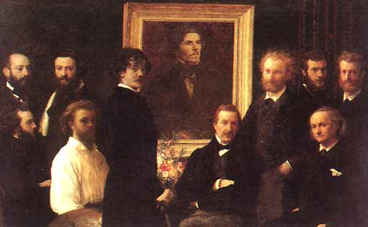
Figure 1.62. Henri Fantin-Latour. Homage to Delacroix. 1864. Oil on canvas. 63 x 98 ¼” (160 x 250 cm). Musée d'Orsay, Paris.

I’m like a man in a dream,
seeing things he’s afraid will vanish from him.

Eugène Delacroix, Tangier, 1832

For the Orient is no longer the dreamland.
Since the middle of the nineteenth century,
it has inched closer….
Armies, among them the one that landed
one fine 5 July 1830 a little to the east of Algiers,
bring missionaries and scholars with their
impedimenta as well as painters and photographers
ever thirsty for exoticism, folklore, Orientalism.

Malek Alloula, 1986

The rise and fall of Europe’s empires coincides with the history of modern art whose radical new forms are so much the mixed offspring of colonialism. The contexts of modern colonialism, from both Western and non-Western perspectives, are an essential part of our study and are introduced here by the 1832 letters from North Africa, the Orientalist dreams, of Eugène Delacroix (1798-1863), chef de l’école of Romantic painting.
Two years after the 1830 French military conquest of Algeria, Delacroix joined the diplomatic delegation of Count Charles de Mornay, ambassador extraordinary from Louis-Philippe of France to the ruler of Morocco. The painter was brought to document the mission, and during the six months he spent in Morocco Delacroix produced hundreds of watercolors and filled at least seven notebooks with sketches and detailed descriptions. European art and literature had shown him the Orientalist dreamland long before his actual journey, and he had already produced such icons of the genre as the vast, Byronic Scenes from the Massacres at Chios (1824) and Death of Sardanapalus (1827-8) (Figure 1.63). But the North African sojourn marks a definitive turning point in Delacroix’s oeuvre. The letters that follow display the deep impressions that forever altered his art. To us, they offer insights into the larger culture of modernity and serve as an apt introduction to the theme of cultural imperialism and hybridity that runs predominantly through this book.
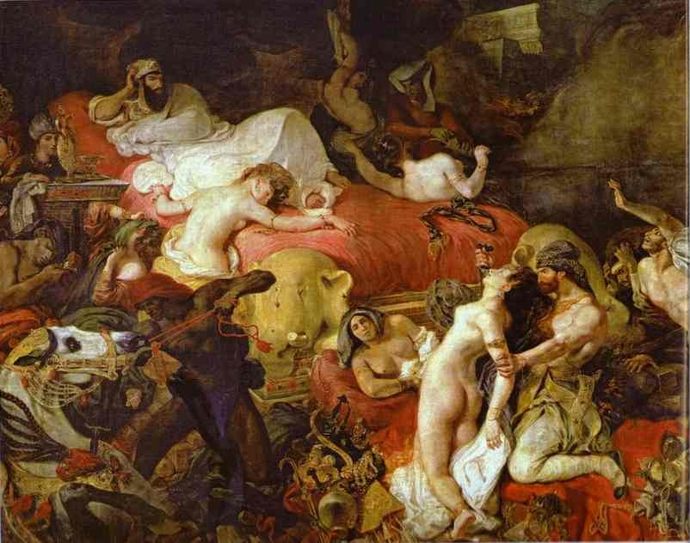
Figure 1.63. Eugène Delacroix. The Death of Sardanapalus. 1827-1828. Oil on canvas, 12’ 11 ½” x 19’ 2 ¾” (395 x 495 cm). Musée du Louvre, Paris.
Delacroix was a gifted writer whose journals are still considered a “painter’s bible” and are nearly as famous as his paintings. The 1832 letters from North Africa offer a direct path to the force of Orientalist ideology in Modern art because of Delacroix’s enormous influence on Modern painting in general. Charles Baudelaire, Edouard Manet, Auguste Renoir, Claude Monet, Paul Cézanne, Paul Gauguin, Vincent van Gogh, Odilon Redon, Georges Seurat, Henri Matisse, Pablo Picasso, Sonia and Robert Delaunay, and Paul Klee all acknowledged their debt to him.
The artist’s evident Eurocentrism is characteristically modernist. In these letters the people of Tangier and Meknès are depicted as exotic, picturesque, childlike, and irredeemably different. Delacroix’s Moroccans (Figure 1.64) are Romans brought up to date. To him, “The cloaks and togas and a thousand details are quite typical of antiquity. The rascal who’ll mend the vamp of your shoe for a few coppers has the dress and bearing of a Brutus or Cato of Utica.” Like other artists of his generation Delacroix had studied from Greek and Roman sculptures. He had seen Napoleon’s Egyptian collection before it was dispersed with the fall of the Empire, and he had seen the Parthenon marbles in London. The artist’s living-tableau Orient was a land where time had stopped, an authentic antiquity. “I have Romans and Greeks on my doorstep.” he writes, “…it makes me laugh heartily at [Jacques-Louis] David’s Greeks, apart, of course, from his sublime skill as a painter. I know now what they were really like; their marbles tell the exact truth, but one has to know how to interpret them...” Delacroix returned to Paris believing he was the genuine renovator of the classical tradition.
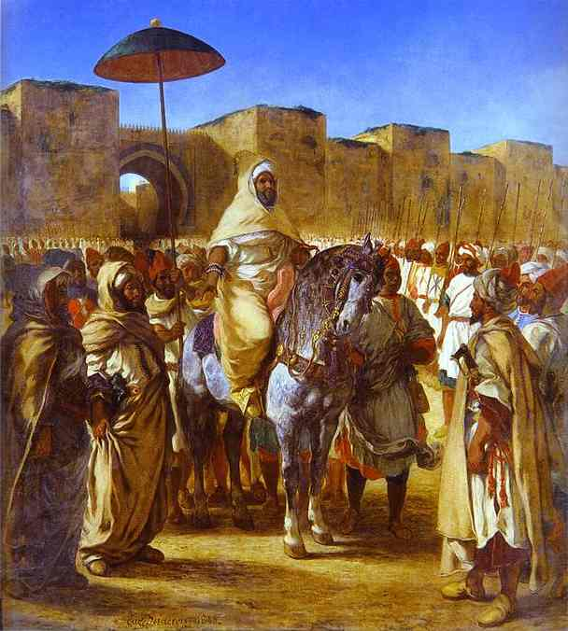
Figure 1.64. Eugène Delacroix. The Sultan of Morocco and His Entourage, 1845. 12’ 6” x 11’ 2” (384 x 343 cm). Augustins Museum, Toulouse.
Paradigmatically Orientalist as well is his idealization of the beauty of North African women and their sequestered lives, as evident in the lush 1834 Women of Algiers in their Harem (Figure 1.65), painted after his return to France. Delacroix’s dream of a passive sexual and domestic femininity is a trope of Orientalism and Modern art. Paul Gauguin takes it up most famously perhaps at the end of the nineteenth century in Primitivist dream paintings of the French South Pacific “New Eve.” [See Chapter 11 of this volume.] The subtext of such colonialist Edenic fantasies is deep antipathy toward European Modernity and Modernism. “We are about to leave for poor France,” Delacroix writes from Tangier at the end of the expedition, “Your newspapers, your cholera, your politics, all these things unfortunately detract me from the pleasure of going home. If you knew how peacefully men live here under the scimitar of tyrants; above all, how little they are concerned about all the vanities that fret our minds!”
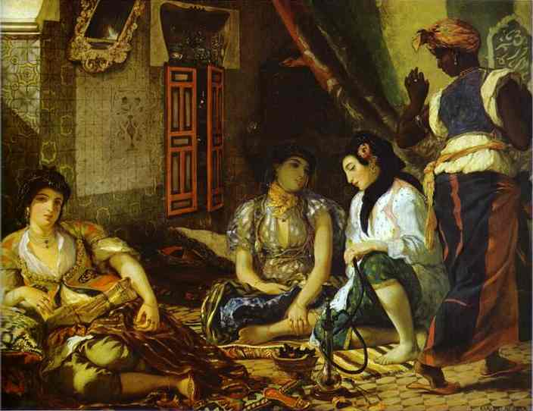
Figure 1.64. Eugène Delacroix. Women of Algiers in Their Harem, 1834. Oil on canvas, 70 ¾” x 90 ¼” (180 x 229 cm). Musée du Louvre, Paris.
Delacroix appears blind to the fact that these were years of violent change for North Africans as well, changes caused primarily by Western power – technological, military, economic, and cultural. Blinkered by clichés of Orientalist ideology, he sees a Morocco untouched by the historical processes that were drastically altering Western societies in the mid-nineteenth century. His letters from Meknès register the North Africans’ extreme hostility toward the French presence, but with little or no grasp of the cause:

…. these people have such a loathing for the dress and appearance of Christians that one must always be escorted by soldiers …. Every time I go out I am escorted by a huge gang of curious onlookers, who lavish insults on me - dog, infidel, caracco, etc., and jostle one another to get near me and make contemptuous grimaces in my face. You cannot imagine how one itches to lose one’s temper, and only my keen desire to see things induces me to submit to such infamous treatment.

Ten years later, Moulay Abd-al-Rahman (1778-1859), the very ruler [“Sultan” or “Emperor” in text] with whom Mornay successfully negotiated and whom Delacroix pictured so vividly in his sketches, notebooks, and letters from Meknès, will help lead Algerian rebel forces against the French. From a twenty-first century perspective, we can detect hostile figures in the shadows of Delacroix’s gorgeous Orientalist paintings because we know the history of colonial resistance that has shaped world politics from the mid-nineteenth century to the violent present. As you read Delacroix’s letters, consider the artist’s role in the creation and perpetuation of myths of cultural identity. How powerful is that social role? Is it good or bad? What responsibilities come with it? Do contemporary artists – in fine or commercial art – create work that perpetuates or challenges Orientalist stereotypes?

Our selection is from Eugène Delacroix: Selected Letters, 1814-1863. With an introduction by John Russell. Edited and Translated by Jean Stewart. New York: St. Martin’s Press, 1970.

For Further Reading:

Alloula, Malek. The Colonial Harem. Minneapolis: Minnesota University Press, 1986.

Delacroix, Eugène. The Journal of Eugène Delacroix. Edited by Hubert Wellington. Translated by Lucy
Norton. Ithaca, New York: Cornell University Press, 1951.

Jobert, Barthélémy. Delacroix. Translated by Terry Grabar and Alexandra Bonfante-Warren. Princeton,
New Jersey: Princeton University Press, 1998.

To J. B. Pierret
Off Tangier, 24 January 1832

At last we’re off Tangier! After thirteen excessively long days and a crossing that was alternately amusing and exhausting [….] this morning at nine o’clock we dropped anchor off Tangier. I greatly enjoyed the sight of this African town. It was quite another matter when, after the usual signals, the consul came on board in a boat rowed by a score of black, green and yellow marabouts, who started climbing over the whole ship like cats and mingling with us. I could not take my eyes off these peculiar visitors. My dear good friend, you can imagine my delight on seeing for the first time, in their own land, these people whom I’ve come such a long way to see. […]
Tomorrow we are to make our grand entry. We shall be received by the consuls of the other powers, by the Pasha, etc.

To J. B. Pierret
Tangier, 25 January [1832]

I’ve just arrived in Tangier. I have rushed through the town. I am quite bewildered by all that I’ve seen. I can‘t let the mail boat go – it’s leaving shortly for Gibraltar – without telling you something of my amazement at all the things I’ve seen. We landed in the midst of the strangest crowd of people. The Pasha of the city received us, surrounded by his soldiers. One would need to have twenty arms and forty-eight hours a day to give any tolerable impression of it all. The Jewesses are quite lovely. I’m afraid it will be difficult to do more than paint them: they are real pearls of Eden. We were given a superb reception, by local standards. They treated us to the most peculiar military music. At the moment I’m like a man in a dream, seeing things he’s afraid will vanish from him.

To J.B. Pierret and Félix Guillemardet
Tangier, 8 February [1832]

My dear friends,
[…] I am really in a most curious country. My health is good here, I am only a little anxious about my eyes. Although the sun isn’t very strong yet, the glare and the reflected light from the houses, which are all painted white, tire my eyes excessively. I am gradually insinuating myself into the customs of the country, so as to be able to draw many of these Moorish figures quite freely. They have very strong prejudices against the noble art of painting, but a few coins slipped here and there settle their scruples. I go for rides in the surrounding country, which I find infinitely delightful, and I enjoy moments of delicious idleness in a garden by the city gates, under a profusion of orange trees in full bloom and covered with fruit. Amid these lush natural surroundings I experience feelings like those I had in childhood. Perhaps some vague memory of the southern sunshine which I saw in my earliest youth is astir within me. Anything I may accomplish will be insignificant in comparison with what might be done here. Sometimes I feel quite baffled, and I’m sure I shall bring back only a faint shadow of it all.
I don’t remember whether in my last letter I told you about our reception by the Pasha, three days after the one he held for us in the harbor; I should only weary you with it in any case. And I don’t think I have written to you since an excursion we made in the neighborhood of the town with the English consul, who has a mania for riding the most unmanageable horses in the country, and that’s saying something, for the gentlest are all absolute devils. Two of these horses fell out with one another, and I witnessed the fiercest battle you can imagine: all the furies invented by Gros and Rubens are tame in comparison. After biting one another in every conceivable way, climbing on top of each other and prancing on their hind legs like men - having first, needless to say, got rid of their riders - they then plunged into a stream and went on fighting there with unheard-of ferocity. It was the deuce of a business getting them out of it.
The emperor is preparing the most magnificent reception for us. He intends to give us a high opinion of his power. We’re beginning to be afraid that he may take a fancy to hold his reception at Marrakech, which would involve a journey on horseback of four hundred leagues there and back. It’s true that it is an extremely interesting journey and one which few Christians can boast of having made.
Most likely he will receive us at Meknès, one of the capitals of his empire. The best way of writing to me is as follows: frank the letter as far as the frontier and address it to M. Thibaudeau, French consular agent, at Gibraltar, to be delivered to M. Delacroix at Tangier. Or rather, send your letters to Piron, who will forward them post free. I’m writing to him to this effect; I think this is a safer way than through Fenillet, since the Ministry of Foreign Affairs is sometimes rather remiss. […]

To Théodore Gudin
Painter, rue de la Ville-l’évêque
Near the rue de la Pépinière, Paris
Tangier, 23 February [1832]

My dear Gudin,
Amidst all the curious and unfamiliar things that surround me I have not forgotten my promise to you, which I am happy to fulfil. You wanted me to send you a reminder of Africa; and you, who have caught its character so well, will, I hope, be glad to learn of all the enjoyment I am finding here amidst a people so different in many respects from other Mahometan peoples. I was above all surprised by the extreme simplicity of their dress, and at the same time by the variety of ways in which they arrange the articles that compose it. The season is too early as yet for me to judge of the full beauty of the country. We have been here about a month, and we are all leaving for Meknès, where the emperor is at present, and where he is going to receive us with all sorts of Moorish courtesies, rifle shots, horse races, etc., etc. You can imagine how wonderful I shall find it all: you are, of all people, the man best qualified to appreciate the striking character of such spectacles. I am really sorry, now, for those artists, endowed with any degree of imagination, who are fated never to get a glimpse of the marvelous grace and beauty of these unspoiled, sublime children of nature. I have left in Paris a number of friends of whom I am sincerely fond, I left them with regret, and yet I shall be sad when the time comes to leave, probably forever, this land of fine orange trees, covered with flowers and fruit, of fine sunshine, fine eyes and all the other beauties with which you are familiar. […]

To M. Duponchel
Director of the Opéra
Tangier, 23 February [1832]

My dear friend,
You are the person to whom, next to God, I am indebted for the delightful journey I am now making. This alone would entitle you, even if you had not a thousand other claims to my grateful remembrance, to be kept informed as to what I have been doing in this part of the world.
You ought to hang yourself for not having come too. You dislike, quite rightly, whatever smacks of the bourgeois. Here you would be excellently placed to meet at every turn the exact opposite of that. The people of this country are quite exceptional; they differ in many respects from other Mahometan nations. Their dress is quite uniform and very simple, and yet the various ways of arranging it confer on it a kind of beauty and nobility that leave one speechless.
I plan to bring back enough sketches to give some idea of these gentlemen’s appearance. Moreover, I shall bring back actual specimens of most of their articles of dress. I’ll gladly ruin myself for this purpose, and for the sake of the pleasure you will get from seeing them.
And then it’s hopeless to try and give an idea of the delightful details of the painting on their buildings and the charming proportions of their architecture. That’s where a man like yourself would have been invaluable on our expedition. I fancy that by studying engravings of Granada, with the help of the indications I shall bring back, you will be able to reconstruct the sort of thing one sees here.
The Jewish women are also very handsome and their dress is most picturesque. I have witnessed a number of their ceremonies; there are subjects for pictures at every street corner. I must admit that we have no boulevards here, no opera house, nor anything resembling these. The rue Vivienne of the place is a huddle of huts like those of the lunatics at Bicêtre, in which crouch and squat solemn Moors, hooded like Carthusian monks, surrounded by the rancid lard and six-months-old butter that they sell to people. All this scarcely smells of ambergris or frankincense, but I didn’t come here to gratify my senses, and the pure love of beauty makes one overlook many discomforts. […]

To Frédéric Villot
Rue de la Ferme des Mathurins, No. 26
Tangier, 29 February [1832]

Thank you very much, my dear friend, for your kind thought in writing to me. Your letter was in the first packet that reached me from Europe, and it’s a great joy to get letters: if you have ever been far from those you love, you must know how sweet it is. Pierret will no doubt have given you news of my journey, of the sea, the country, etc. This place is made for painters. Economists and Saint-Simonians might find much to criticize as regards human rights and equality before the law, but beauty abounds here; not the over-praised beauty of fashionable paintings. The heroes of David and Co. with their rose-pink limbs would cut a sorry figure beside these children of the sun, who moreover wear the dress of classical antiquity with a nobler air, I dare assert. If you ever have a few months to spare, come to Barbary and there you will see those natural qualities that are always disguised in our countries, and you’ll feel moreover the rare and precious influence of the sun, which gives intense life to everything. I shall doubtless bring back some sketches, but they will convey very little of the impression that all this makes on one.
The day after tomorrow we are leaving for Meknès, where the emperor is; he’ll welcome us with every sort of Moorish courtesy, horse racing, rifle firing, etc. The weather is kind to us, we were afraid of rain but apparently the worst of that is over.
When I see these unfamiliar sights I feel as if I’d already spent a year amongst it all and had not seen my friends for centuries. Remember me to those friends of yours who are mine too. […]

To J.B. Pierette
Tangier, 29 February 1832

[….] I gladly spend part of my time working, and another quite considerable part just letting myself live; but the thought of my reputation, of that Salon which I was supposed to be missing, never occurs to me. I’m even sure that the considerable sum of curious information that I shall bring back from here will be of little use to me. Away from the land where I discovered them, such particulars will be like trees torn from their native soil; my mind will have forgotten its impressions, and I shall disdain to give a cold and imperfect rendering of the living and striking sublimity that lies all about one here, and staggers one with its reality. Imagine, my friend, what it is to see lying in the sun, walking about the streets, cobbling shoes, figures like Roman consuls, like Cato or Brutus, not even lacking that disdainful look which those rulers of the world must have worn; these people possess only a single blanket, in which they walk about, sleep or are buried, and they look as satisfied as Cicero must have been in his curule chair. I tell you, you’ll never be able to believe what I shall bring back, because it will be far removed from the natural truth and nobility of these men. There’s nothing finer in classical art. Yesterday a peasant came by, got up like this [a sketch]. And this was what a wretched Moor looked like, begging for a handful of coppers a couple of days ago. All of them in white, like Roman senators or Greeks at the Panathenaean festival.

To J.B. Pierret
Meknès, 16 March 1832

Yesterday we reached this town, the goal of our journey. We had taken ten days to cover fifty
leagues. That seems nothing much. But it’s nonetheless a tiring business when you jog along in the hot sun on uncomfortable saddles. How are you, my dear friends? Everything is tremendously African now. Our entry here was of the utmost beauty, and the sort of pleasure one may well hope to experience only once in one’s life. All that happened to us that day was only the complement to what the journey had led us to expect. At every moment we were met by fresh-armed tribes, who fired an extravagant amount of gunpowder in honor of our arrival. Each provincial governor passed us on to the next, whose guards came to augment our already sizable escort. From time to time we heard a few belated bullets whistling past in the midst of the rejoicings. We had, among other adventures, a river crossing, without bridges or boats, needless to say, which might be compared to the crossing of the Rhine, such was the quantity of rifle fire that greeted us. But all this was as nothing beside our reception in the capital. To begin with we were made to take the longest way in, so as to travel all round the city and appreciate its importance. The emperor had given orders for everyone to keep holiday and give us a festive welcome, under pain of the severest penalties, so that the crowds and the chaos were extreme. We knew that when the Austrians were welcomed here six months ago twelve men and fourteen horses were accidentally killed. Our small company thus had great difficulty in keeping together, and finding its bearings, amidst the thousands of rifle shots being fired in our faces. We were led in by a band of musicians and over twenty flags carried by men on horseback. The band was mounted, too; each horseman carried a kind of bagpipe hung round his neck, with a drum which he beat with two sticks, a large and a small one, alternately and on either side. This made an extremely deafening din, mingled with the volleys of the cavalry and infantry and the enthusiasts who darted forth all round us to fire into our faces. We found it all infuriating and yet comical, and I look back on it now with less ill-temper. This triumphal entry, which resembled the ordeal of some wretched victims being led to the gallows, lasted from early morning until four in the afternoon. Nota bene that we had taken a light snack by way of breakfast at seven that morning in our tents. In the midst of my fury I noticed some very curious buildings in this town, in the Moorish style of course, but more impressive than those at Tangier.

20 March
We have been held prisoner for the past five or six days in a house in the city, pending the time for our audience. As we are continually in one another’s presence we are less inclined to gaiety and the hours seem very long, although the house we are in is a very curious specimen of Moorish architecture, which is that of all the palaces in Granada, of which you have seen engravings. But I am learning by experience that one’s sensations are dulled in course of time, and the picturesque stares you in the face so much all around that one ends by becoming insensitive to it. […]

23 March
Yesterday we were received in audience by the emperor. He granted us a favor which he never grants to anybody, that of visiting his private apartments and his gardens. It is all exceedingly curious. He receives his visitors on horseback, with all his guard around him on foot. He suddenly appears through a doorway and comes towards you, with a parasol behind him.’ He’s a rather handsome man. He looks very like our own king, only with a beard and somewhat younger. He is between forty-five and fifty. He was followed by his state coach, a sort of wheelbarrow drawn by a mule. So I’ve reached the goal of my journey. Our main concern now is not to molder away too long in Africa. I’m afraid we may be held up some time in Tangier. [….]

To J.B. Pierret
Meknès, 2 April

Dear friends,

I’m still here; you see that we weren’t far wrong when we reckoned that three months at least would be spent on the journey. Fortunately our business is settled and we shall set off the day after tomorrow to return to Tangier, where I suppose we shall presently take ship. The prospect of being in quarantine is not attractive; but once one has touched land, above all the land where all one’s memories dwell, it’s not so harsh an ordeal as that which I have been undergoing during the past three weeks, imprisoned here. I told you in my last letter that we had been granted an audience with the emperor. From that moment we were supposed to have permission to walk freely about the town; but I was the only member of our party to take advantage of this privilege, since these people have such a loathing for the dress and appearance of Christians that one must always be escorted by soldiers, which did not prevent two or three quarrels which might have proved extremely unpleasant, in view of our position as envoys. Every time I go out I am escorted by a huge gang of curious onlookers, who lavish insults on me - dog, infidel, caracco, etc., and jostle one another to get near me and make contemptuous grimaces in my face. You cannot imagine how one itches to lose one’s temper, and only my keen desire to see things induces me to submit to such infamous treatment. I have spent most of my time here in utter boredom, because it was impossible to draw anything from nature openly, even the meanest hovel; if you so much as go on to the terrace you run the risk of being stoned or shot at. The Moors are fantastically jealous, and it is on these terraces that their women usually take the air or visit one another.
The other day we were presented with some horses from the king (I’ve just been sent one), a lioness, a tiger, ostriches, antelopes, a gazelle and a kind of stag which is a savage beast; it took a dislike to one of the poor ostriches and ran it through with its horns, from which the ostrich died this morning. Such are the events that bring variety to our existence. Otherwise, no news.
I’ve not told you about all the strange things I see. They end by seeming quite natural to a Parisian staying in a Moorish palace adorned with porcelain and mosaics. Here is something typical of the country: yesterday the prime minister, who is negotiating with Mornay, sent to ask us for a sheet of paper in order to give us the emperor’s answer. The day before yesterday Mornay had been sent a saddle of velvet and gold, of inestimable value.

To Auguste Jal
Tangier, 4 June [1832]

I was very happy to get news of you, my dear friend, your kind letter reached me on my return from Spain, where I had been for a brief visit. We are at last about to sail for poor France, and I was anxious not to leave Africa without sending you a word of thanks.
Your newspapers, your cholera, your politics, all these things unfortunately detract from the pleasure of going home. If you knew how peacefully men live here under the scimitar of tyrants; above all, how little they are concerned about all the vanities that fret our minds! Fame, here, is a meaningless word; everything inclines one to delightful indolence; nothing suggests that this is not the most desirable state in the world. Beauty lies everywhere about one. It drives one to despair, and painting, or rather the frantic desire to paint, seems the greatest of follies. You have seen Algiers, and you can imagine what the natives of these regions are like. Here there is something even simpler and more primitive; there is less of the Turkish alloy; I have Romans and Greeks on my doorstep: it makes me laugh heartily at David’s Greeks, apart, of course, from his sublime skill as a painter. I know now what they were really like; their marbles tell the exact truth, but one has to know how to interpret them, and they are mere hieroglyphs to our wretched modern artists. If painting schools persist in setting Priam’s family and the Atrides as subjects to the nurslings of the Muses, I am convinced, and you will agree with me, that they would gain far more from being shipped off as cabin boys on the first boat bound for the Barbary coast than from spending any more time wearing out the classic soil of Rome. Rome is no longer to be found in Rome. […]

To Félix Feuillet
Toulon, France, 7 July 1832 [in quarantine]

[….] Alas! What shall I find in that Paris which was our distant lodestar on our travels? Barricades again, or perhaps only ruins, those ultimate barricades, a throne worthy of our modern reformers. What has become of art, poor art, amidst these disorders? The arts are now, and will probably be for a long time to come, the worst of professions for those who practice them, and a feeble pastime for the rest, a feeble compensation for the miseries of the age into which heaven has caused us to be born.
[End of Moroccan journey]

To Frédéric Villot
[At Champrosay, France]
30 August [postmark 1832]

[….] I’m working fairly hard; I’ve got down to it again quite eagerly. I suppose you are busy too. Paris bores me profoundly; men and things appear to me in a very special light ever since my journey; very few people seem to me to have good sense; the plays at the Vaudeville are neither amusing nor very moral, and the Opera, particularly the ballet, doesn’t seem to me to reproduce nature very closely. If it weren’t for the pirouettes, I’d prefer the dancing of the Jewish girls at Tangier.

Jean-Baptiste Pierret was an intimate friend from childhood, as was Félix Guillemardet, to whom Delacroix writes, below.
Théodore Gudin was an influential and celebrated marine painter.
Frédéric Villot was an engraver, later curator of paintings at the Louvre, and one of Delacroix’s closest friends.
Auguste Jal witnessed the capture of Algiers in 1830 as correspondent for Le Constitutionnel.

