Nomfanekiso Who Paints at Night: The Art of Gladys Mgudlandlu

Elza Miles

I think I can claim to be the first African woman in the country to hold an exhibition.

Gladys Mgudlandlu, 1962

South African painter Gladys Mgudlandlu (1923 - 1978), born twenty years before Helen Sebidi, the only other female artist mentioned in Steven Sack’s “From Country to City: The Development of an Urban Art,” was perhaps the most celebrated black township artist of the nineteen sixties. Her saturated color and expressive brushstroke describe landscapes, plants, animals, and scenes of southern African village and township life. Brightly colored and magical narratives shaped by Xhosa folklore, the paintings were, remarkably, made at night by the light of a paraffin lamp. There was no electricity in Nyanga, the township where she lived and worked as a primary school teacher. Admired by the white liberal art gallerists and patrons of Cape Town who exhibited and collected her work, Mgudlandlu has been criticized for not showing the harsh inequities suffered under apartheid. How would you account for and measure the rare artistic achievement and art world success of this artist? What were her artistic sources? Did her affirmative imagination, however much it failed to confront real conditions, nevertheless help redefine African identity and artistic expression for modern times?

Source: Elza Miles. Nomfanekiso Who Paints at Night: The Art of Gladys Mgudlandlu. Vlaeberg, South Africa: Fernwood Press, 2002.

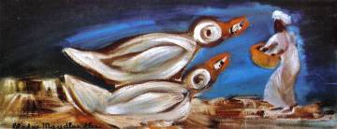
Gladys Nomfanekiso Mgudlandlu achieved success as a professional artist from the start of her career. Her rise was phenomenal and newspaper headlines announced: 'SA art record for Africa', 'Even critics buy her work', 'Stampede to buy African's pictures', 'Native artist's success', 'African artist scores a hit - may paint in US', 'R105 work by Gladys sells in 3 minutes' and 'Gladys Mgudlandlu's work fetches Rl000'. Yet, her death on 17 February 1979 went unnoticed, as did her funeral on 3 March. Months later, artist Eduard Ladan paid tribute to her in The Cape Times: 'Black artist's death leaves a void in Cape art scene'. (…)
2 Mgudnaldlu, Feeding Time, oil on canvas, 34 x 81cm (13.5 x 32 in) c.1963, De Beers Centenary Art Gallery, University of Fort Hare, Alice, South Africa.
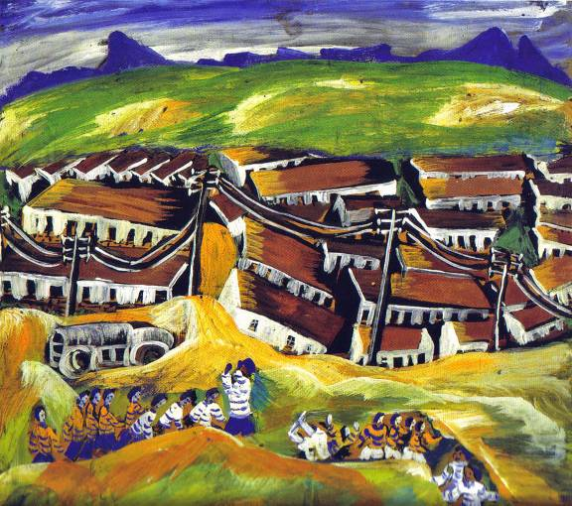
4 Mgudlandlu, Nyanga Landscape, gouache on board, 57 x 60 cm, 1962
At a time when apartheid permeated every aspect of South African life, Gladys Mgudlandlu, known by the people of Nyanga, as 'the African queen', appeared on the Cape Town art scene. She held her first exhibition in the offices of the Liberal Party in 1961. (…)

For eleven years, from September 1961 to January 1972, Mgudlandlu's vibrant personality and pristine form of expressionism enchanted journalists, artists and art lovers. Art critics not only reviewed her exhibitions, they also bought her paintings. Paging through newspaper cuttings, it is evident that, from her debut to her last solo exhibition in 1972, she was, with the exception of 1969 and 1970, in the news every year. In 1971, she suffered severe injuries in a car accident while she was on her way to the school where she taught. Her work fell into oblivion because she stopped painting and exhibiting her works during the last eight years of her life. (…)

. . . Mgudlandlu's work does not lend itself to pigeonholing. She is primarily an expressionist (…) [whose] expressionism evolved by drawing on indigenous sources, independent observation and the guidance of fellow artists and critics. (…)

[Her] initiation into the art of mural painting as a child influenced her profoundly.
Her Fingo grandmother taught her the rudiments of this art form. When requested by the South African Association of Arts, for biographical purposes, to name her most important commission, Mgudlandlu replied: ‘The painting of the murals on my hutment.' (…)

(…) Mgudlandlu emphasized detail and textual differences in her early work, evoking the rich textile surfaces of tapestries and embroideries. Over the years, her brushwork became broader, to conjure up broad, simple planes and shapes. Her emphasis shifted from pictorial storytelling to scenes of documentary expression. (…)

[The artist] was autodidactic in terms of Western painting techniques, but her experience of indigenous mural painting filtered through in her application of paint. She said the use of 'thick, opaque colours' in her paintings probably resulted from 'making designs in different coloured clays when she was a little girl'. (…)

[Her] first attempts at fine art were painting in watercolour and gouache. She recalls: 'One day I went to a shop in Cape Town and asked for watercolours ... I asked the shop assistant how to use them. Since then I have painted.' Mgudlandlu found a means to express herself in the essential quality of paint. [As one Cape Town art critic] aptly noted: 'In the first and last instances, her creations are in paint.'

South African Rand in 1970 was valued at 1.39R against the US Dollar.
Nyanga is a black township on the outskirts of Cape Town, South Africa. Such townships were artificial creations of the Group Areas Act of 1950 (repealed in 1991) created under the Apartheid government of South Africa that assigned races to different and extremely unequal residential and business sections in urban areas
Anon, Eastern Province Herald, 27 August 1962.
Anon, The Cape Times, 31 August 1962.
Anon, Eastern Province Herald, 13 November 1963.
Anon, The Cape Argus, 19 November 1963.
Anon, Eastern Province Herald, 4 December 1963.
Anon, The Cape Argus, 14 November 1963.
Anon, The Cape Argus, 16 August 1967.
E. Laden, The Cape Times, 26 June 1979.
Fingo or Mfengu people of the Eastern Cape in South Africa and the Xousa / Bantu language group
The Daily Dispatch, 19 January 1972.
Eastern Province Herald, 7 November 1962.
C.A. Bücher, “Aardse eenvoud hou haar by waarheid,” Die Burger, 22 August 1962.

