A Historic Confrontation between Jean Rouch and Ousmane Sembène in 1965: "You Look at Us as if We Were Insects"

This 1965 conversation is between two great cinematographers - one Senegalese, the other French – whose primary film subject is Africa. At the time of the talk, the Frenchman Jean Rouch (1917-2004) was at the forefront of European filmmaking. Acclaimed as an ethnographic director, Rouch was first to use the term cinéma vérité, applying it to Chronicle of a Summer (1960), his best known film. Literally meaning "cinema truth,” cinéma vérité is a genre that blurs fact and fiction and an influential film movement of the nineteen fifties and ‘sixties. Rouch’s lifelong attachment to African subjects began in 1941. His West African documentaries, such as Les Hommes Qui Font La Pluie (Men Who Make the Rain, 1951), Les Maîtres Fous (Masters of Madness, 1955), and La Pyramide Humaine (The Human Pyramid, 1961) show his fascination with magic and ritual. They also exemplify the ethnographic gaze associated with a primitivism couched in the rationale of the archive and Western science. “You look at us as if we were insects,” Ousmane Sembène objects in this conversation.

Senegalese film director, producer, and writer of first importance, Ousmane Sembène (b.1923) helped define modern Africa for the post-colonial era. The prize-winning success of his film Borom Sarret at the 1963 Tours International Festival in France, two years before this conversation took place, brought African film to the world stage. The previous commentary by Nwachukwu Frank Ukadike considered Sembène’s films in the context of revisionist cinematography by Black Africans and their aim to give an authentic voice to modern Africa. In this “historic confrontation” between Sembène and Rouch the question of authenticity – of who can represent Africa truly – is again emphatically underlined. What are Rouch’s arguments in favor of the ethnographic viewpoint? How does Sembène counter? What is the dilemma for the artist and audience? How would you resolve it?

Source: The Short Century: Independence and Liberation Movements in Africa 1945-1994, edited by Okwui Enwezor, p.440. Munich, London, New York: Prestel, 2001. Transcribed by Albert Cervoni and translated by Muna El Fituri.

Ousmane Sembène: Will European cinematographers, you for example, continue to make films about Africa once there are a lot of African cinematographers?

Jean Rouch: This will depend on a lot of things but my point of view, for the moment, is that I have an advantage and disadvantage at the same time. I bring the eye of the stranger. The very notion of ethnology is based on the following idea: someone confronted with a culture that is foreign to him sees certain things that the people on the inside of this same culture do not see.

Ousmane Sembène: You say seeing. But in the domain of cinema, it is not enough to see, one must analyze. I am interested in what is before and after that which we see. What I do not like about ethnography, I'm sorry to say, is that it is not enough to say that a man we see is walking; we must know where he comes from, where he is going.

Jean Rouch: You are right on this point because we have not arrived at the goal of our knowledge. I believe as well that in order to study French culture, ethnology having to do with France must be practiced by people on the outside. If one wants to study Auvergne or Lozere, one must be a Briton. My dream is that Africans will be producing films on French culture. As a matter of fact, you have already started. When Paulin Vieyra did Afrique sur Seine (Africa on the Seine) his purpose was indeed to show African students, but he was showing them in Paris and he was showing Paris. There could be a dialogue, and you could show us what we ourselves are incapable of seeing. I am certain that the Paris or Marseilles of Ousmane Sembène is not my Paris, my Marseilles, that they have nothing in common.

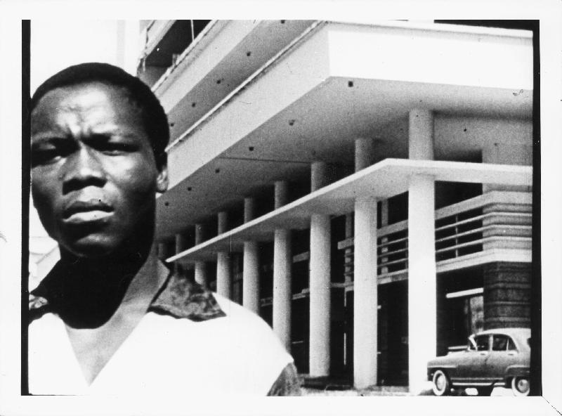
Ousmane Sembène: There's a film of yours that I love, that I've defended and will continue to defend. It's Moi, un Noir. In principle, an African could have done it, but none of us at the time had the necessary conditions to realize it. I believe that there needs to be a sequel to Moi, un Noir, to continue—I think about it all the time—the story of this young man who, after Indochina, does not have a job and ends up in jail. After Independence, what becomes of him? Has something changed for him? I don't believe so. A detail: this young man had his diploma, now it so happens that most delinquent youth have their school diplomas. Their education doesn’t help them, doesn't allow them to manage normally. And, finally, I feel that up to now two films of value have been made on Africa: your, Moi, un Noir and Come Back Africa, which you do not like. And then there's a third one, of a particular order, I'm talking about Les Statues Meurent Aussi (Statues Die Too).
1. Still from Moi, un Noir by Jean Rouch, 1958

Jean Rouch: I would like you to tell me why you don't like my purely ethnographic films, those in which we show, for instance, traditional life?

Ousmane Sembène: Because you show, you fix a reality without seeing the evolution. What I hold against you and the Africanists is that you look at us as if we were insects.

Jean Rouch: As Fabre would have done. I will defend the Africanists. They are men that can certainly be accused of looking at black men as if they were insects. But there might be Fabres out there who, when examining ants, discover a similar culture, one that is as meaningful as their own.

Ousmane Sembène: Ethnographic films have often done us a disservice.

Jean Rouch: That is true, but it's the fault of the authors, because we often work poorly. It doesn't change the fact that in today's situation we can provide testimonies. You know that there's a ritual culture in Africa that is disappearing: griots die. One must gather the last living traces of this culture. I don't want to compare Africanists with saints, but they are the unfortunate monks undertaking the task of gathering fragments of a culture based on an oral tradition that is in the process of disappearing, a culture that strikes me as having a fundamental importance.

Ousmane Sembène: But ethnographers don't collect fables and legends only of the griots. It is not solely about explaining African masks. Let's take, for example, the case of another one of your films. Les Fils de I'Eau. I believe that a lot of European viewers didn't understand it because, for them, these rites of initiation didn't have any meaning. They found the film beautiful, but didn't learn anything.

Jean Rouch: While filming Les Fils de I'Eau, I thought that by seeing the film European viewers could do just that, go beyond the old stereotype of blacks being "savages." I simply showed that just because someone doesn't participate in a written culture doesn't mean they do not think. There's also the case of Maitres Fous, one of my films that provoked heated debates among African colleagues. For me, it testifies to the spontaneous manner in which the Africans shown In the film, once out of their milieu, get rid of this industrial and metropolitan European ambiance by playing it, giving it as spectacle. I believe, however, that problems of reception do come up. One day, I showed the film in Philadelphia at an anthropological congress. A lady came to see me and asked: "can I have a copy?" I asked her why. She told me she was from the South and . . . . she wanted to show . . . this film to prove that blacks were indeed savages! I refused. You see, I gave you an argument.

In agreement with the producers, the showing of Maitres Fous has been reserved for art houses and cinema clubs. I believe that one should not bring such films to an audience that is too large, ill-informed, and without proper presentation and explanation. I also believe that the unique ceremonies of the people in Maitres Fous make a primordial contribution to world culture.

Jean Henri Fabre (1823-1915), famous for his study of the behavior and anatomy of insects.

