Natural Synthesis

Uche Okeke

The key work is synthesis, and I am often tempted to describe it as natural synthesis, for it should be unconscious not forced.
Uche Okeke, 1960

Uche Okeke (b. 1933) was the leading theoretician among the so-called Zaria Rebels, the students at the newly founded art academy in Zaria, Nigeria, who questioned the European syllabus there. Nigeria gained independence from Britain in 1960. Written the same year, we should perhaps read this manifesto 'Natural Synthesis' against the background of Nigeria as a nation in making, which would have to be forged together out of a great number of different ethnic and religious groups. While Okeke clearly states that an attempted revival of "traditional African art" would represent a lost opportunity in a world of change, the existing multitude of local strands of visual and oral traditions challenged the young artists in Zaria. The function of the "natural synthesis" that Okeke envisioned seems to have had to do both with this rich variety of popular cultures and with the poetic procedures of international modernism in honoring them. As a testimony from a group of young artists discussing at a crucial moment the role of the modern African artist, in what way do you think Uche Okeke’s manifesto confirms the general account given in the preceding essay by Chika Okeke (no family relation), where the Zaria Art Society is put in context? EN

Source: Seven Stories about Modern Art in Africa, Whitechapel Art Gallery, London, pp. 208-9. Paris, New York: Flammarion, 1995.

Young artists in a new nation, that is what we are! We must grow with the new Nigeria and work to satisfy her traditional love for art or perish with our colonial past. Our new nation places huge responsibilities upon men and women in all walks of life and places, much heavier burden on the shoulders of contemporary artists. I have strong belief that with dedication of our very beings to the cause of art and with hard work, we shall finally triumph. But the time of triumph is not near, for it demands great change of mind and attitude toward cultural and social problems that beset our entire continent today. The very fabric of our social life is deeply affected by this inevitable change. Therefore the great work of building up new art culture for a new society in the second half of this century must be tackled by us in a very realistic manner.
This is our age of enquiries and reassessment of our cultural values. This is our renaissance era! In our quest for truth we must be firm, confident and joyful because of our newly won freedom. We must not allow others to think for us in our artistic life, because art is life itself and our physical and spiritual experiences of the world. It is our work as artists to select and render in pictorial or plastic media our reactions to objects and events. The art of creation is not merely physical, it is also a solemn act. In our old special order the artist had a very important function to perform. Religious and social problems were masterly resolved by him with equal religious ardor. The artist was a special member of his community and in places performed priestly functions because his noble act of creation was looked upon as inspired.
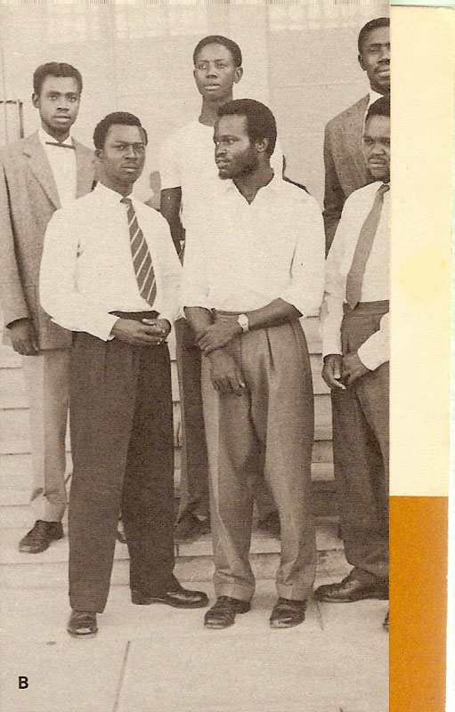
Nigeria needs a virile school of art with new philosophy of the new age — our renaissance period. Whether our African writers call the new realization Negritude, or our politicians talk about the African Personality, they both stand for the awareness and yearning for freedom of black people all over the world. Contemporary Nigerian artists could and should champion the cause of this movement. With great humility I beg to quote part of my verse, Okolobia, which essayed to resolve our present social and cultural chaos. The key work is synthesis, and I am often tempted to describe it as natural synthesis, for it should be unconscious not forced.
1. Some members of the Zaria Art Society 1960. Left to right: Bruce Onobrakpeya, S.O.Okeke, Uche Okeke; 2nd row Odechukwu Odita, Demas Nwoko and Oseloka Osabede.
Okolobia's sons shall learn to live from father's failing; blending diverse culture types, the cream of native kind adaptable alien type; the dawn of an age — the season of salvation.
The artist is essentially an individual working within a particular social background and guided by the philosophy of life of his society. I do not agree with those who advocate international art philosophy; I disagree with those who live in Africa and ape European artists. Future generations of Africans will scorn their efforts. Our new society calls for a synthesis of old and new, of functional art and art for its own sake. That the greatest works of art ever fashioned by men were for their religious beliefs go a long way to prove that functionality could constitute the base line of most rewarding creative experience.
Western art today is generally in confusion. Most of the artists have failed to realize the artists' mission to mankind. Their art has ceased to be human. The machine, symbol of science, material wealth and of the space age has since been enthroned. What form of feelings, human feelings, can void space inspire in a machine artist? It is equally futile copying our old art heritages, for they stand for our old order. Culture lives by change. Today's social problems are different from yesterday's, and we shall be doing grave disservice to Africa and mankind by living in our fathers' achievements. For this is like living in an entirely alien cultural background.

