Long Shot, Medium Shot, Medium Close Up, Close Up, Two Shot, Over the Shoulder, High Angle, Low Angle, Pan and Tilt
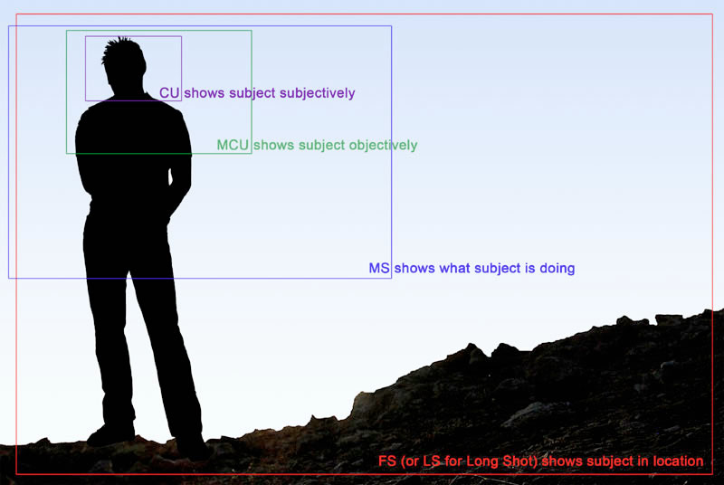

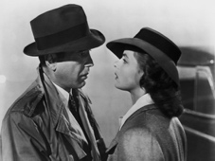

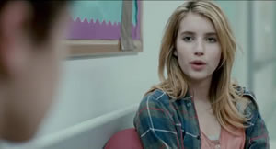

Each shot will be ten seconds long (except for pan and tilt which will be the appropriate length for the move--up to you) with a 15 frame cross dissolve on either end. The titles will also have a 15 frame cross dissolve on either end.

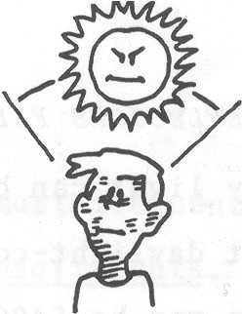

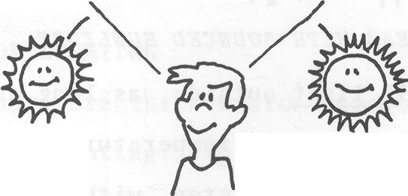

Watch out for direction of light

Editing Shortcuts (useful for this project)

+ 300 (to move forward 3 seconds)
+1000 (to move forward 10 seconds)

Change default transition through preferences
Apply video transition

