VOL.3 | ISSUE 1 | SUMMER 2009
Welcome to the first online edition of ABA FOCUS, the newsletter for Administration & Business Affairs staff professionals. The transition to an electronic newsletter is an important step for ABA, signifying our commitment to a leaner workplace. We hope you enjoy the photos of and articles about division people and events, and the insights of your ABA colleagues. The electronic edition contains links to websites of interest, including the ABA calendar, the ABA recognition program, and the new ABA thank-you blog. To ensure distribution to those without easy access to a computer, the newsletter is available in printable format. We welcome your feedback on the contents and the new format.

INSIDE
Front Page
ABA Goes Lean
ABA Presents Awards
ABA News
Behind the Scenes
Destination 2010
LEAN Pays Off
Message from the VP
New Faces
On Leadership
Roving Reporter
Why Lean?

ABA Presents Awards

Dates to Remember
All Staff Professionals Meetings
September 14, 2009
1:30 to 2:30 p.m.
UU Ballroom II 1st Floor
September 15, 2009
10:30 to 11:30 a.m.
UU Hinde Auditorium 1st Flr.
November 2, 2009
10 a.m. to 12 Noon
November 3, 2009
2 to 4 p.m.
Vice President's Coffees
November 19, 2009
Custodial Breakroom
10 to 11 a.m.
March 11, 2010
SAC 275
3 to 5 p.m.

Nominees for the Problem Solver Award, L to R: Joel Lumsden,
Debra Deakin, Sara Niekamp, Arturo Perez Jr., and winner Gerry Lopez
Vice President Garcia presented ABA’s annual Staff Peer awards in May, recognizing employees who have demonstrated superior performance, outstanding customer service, or who have contributed to a positive image of the University through their work. Award recipients are nominated by fellow ABA staff members. "The quality of the organization is demonstrated by its people," said Vice President Garcia. “These honorees are not only skilled
individuals, but good people.” Over 200 staff attended the event. For more information about award recipients and ABA’s recognition program, click on the link at the top of the page. Read more

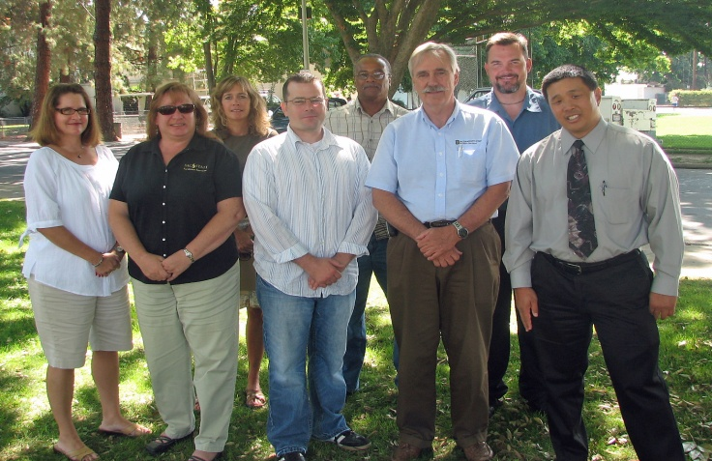
ABA FOCUS is published by the Administration & Business Affairs
Office of Strategic Planning & Quality Improvement
California State University,
Sacramento
PRESIDENT
Alexander Gonzalez
VICE PRESIDENT FOR
ADMINISTRATION
Stephen G. Garcia
EDITOR
Sarah Whyte
WRITERS
Gina Curry
Sarah Whyte
Annette Karle
Steve Garcia
PHOTOGRAPHY
Annette Karle
Maleeha Mir
Sam Parsons
Sarah Whyte
Kevin Brisco
want to be sure to properly introduce all of those who have joined us since our last newsletter was published. To help you get to know them better, we have included their start dates and the departments in which they work, along with their photos. See More.
Rene Ibarrientos, Custodian
Facilities Services
New Faces is our way of introducing ABA's new staff employees to the family. You may already know some of the staff pictured, but we
New Faces
Facilities Services Capital Planning, Design & Construction Team, L to R: Susan McGuire, Rechelle Arnold, Robin Eicher, Mark Perry, TJ Moon, Robin Lovering, Todd McComb, Victor Takahashi. Not shown: Don Hendricks

Behind the Scenes: Capital
Planning, Design & Construction
Message
from the
Vice President
ABA’s focus on communication and teamwork has never been more critical. As today’s economic
These ABA employees are pros when it comes to multi-tasking. Nine professionals with umpteen years of experience under their collective belts, they know what it takes to manage a building project or two. Good thing, too, because Destination 2010 set in motion a capital improvement program of unprecedented proportions at Sacramento State. Now, juggling multiple projects simultaneously is routine for Sac State’s Capital Planning, Design & Construction (PDC) Office. Read More.

Stephen G. Garcia
VP for Administration
challenges persist, the country, the state, the University, and each of us faces unprecedented change. Adapting to change is rarely easy. As we wrestle with reduced budgets, staffing deficiencies, furloughs and their impacts, it is in our best interests and that of our students to practice teamwork – working together toward the most positive outcomes. It is important to remember that virtually no-one is untouched by these challenges, and that maintaining open lines of communication will create the best climate to help us weather the storm. ABA’s Shared Code of Conduct, a reminder of our core values, is now more important than ever. Read more.

Why Lean?

cutting out things I like. But … we all know diets can be good for us, right? Successful diets help us think about what we eat, so that we can eat more wisely -- to increase energy, shrink the waistline and, ultimately, improve our health. Read more.

LEAN -- sound like the latest diet? Well, it is -- it's a workplace diet.
Yuck, you think. I hate diets! Diets mean

VOL.3 | ISSUE 1 | SUMMER 2009

Message from the Vice President
ABA’s focus on communication and teamwork has never been more critical. As today’s economic challenges persist, the country, the state, the University, and each of us faces unprecedented change. Adapting to change is rarely easy. As we wrestle with reduced budgets, staffing deficiencies, furloughs and their impacts, it is in our best interests and that of our students to practice teamwork – working together toward the most positive outcomes. It is important to remember that virtually no-one is untouched by these challenges, and that maintaining open lines of communication will create the best climate to help us weather the storm. ABA’s Shared Code of Conduct, a reminder of our core values, is now more important than ever.
Stephen G. Garcia
VP for Administration
ABA will continue to focus on its goals, with a particular emphasis on communication and the sharing of strategies to improve our processes. This will help us provide the best quality service to students and lessen the impact of “waste” on employee workloads. This means eliminating redundancies, re-work and other forms of “non-value added” activities, where we can: In other words, streamlining operations through LEAN practices.
In this issue, you can read more about LEAN, including suggestions proposed by ABA Staff Professionals, practices adopted by ABA units, and articles featuring the thoughts, ideas and accomplishments of your ABA colleagues.
There is no doubt that the current environment will test us beyond measure – both personally and professionally. The key to our success is in the competence and integrity of ABA’s staff and the cohesive team that we have built. We will continue to seek your input, through coffees, staff professional meetings, and unit and department meetings, to help us meet the challenges ahead.

Stephen G. Garcia
Vice President for Administration

VOL.3 | ISSUE 1 | SUMMER 2009

ABA Goes LEAN
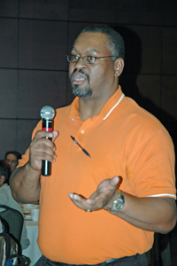
Last fall, staff professionals proposed a host of valuable ways for ABA to become leaner. Since then, ABA units have implemented a number of LEAN practices. For those who have not, here are some staff ideas for conserving resources that can be applied across the board.
- Use more recycled paper
- Print two-sided copies
- Use the blank side of unwanted documents to print drafts
- Reduce paper copies:
  - Scan hard-copy documents and send electronically
  - Distribute announcements via e-mail, not flyers
  - Use shared drives to post and retrieve documents
  - Implement digital filing using flash drives
  - Use projection screens at meetings instead of paper copies
  - Share information using electronic bulletin boards
- Reduce variation by using templates
- Proof-read to reduce rework
- Reduce errors through training
- Find uninterrupted time to focus on projects
- Turn off lights
Darnell Cooper, Accounting Services, reports results of LEAN table exercise at ABA’s October Staff Professionals meeting

- Turn off machines at night
- Encourage full participation in direct deposit to reduce staffing needs
Other ABA LEAN initiatives include: equipping campus information booths with laptops to reduce the printing of daily reports and improve services, and a streamlined check review process that eliminates the transit of checks to and from multiple campus locations. Administrative Operations and other ABA offices now project information at meetings using a laptop to eliminate copying documents for individual committee members. These are just a few ways that demonstrate ABA’s commitment to a LEAN organization.

VOL.3 | ISSUE 1 | SUMMER 2009
ABA Presents Awards
In May, Vice President Garcia presented ABA’s annual Staff Peer awards, recognizing employees who have demonstrated superior performance, outstanding customer service, or who have contributed to a positive image of the University through their work. Award recipients are nominated by fellow ABA staff members. "The quality of the organization is demonstrated by its people," said Vice President Garcia. “These honorees are not only skilled individuals, but good people.” Over 200 staff attended the event. For more information about ABA’s recognition program, visit www.csus.edu/aba/recognitionhome.htm.
Customer Service Award Nominees, L to R: Winner Larry Rich, Brittini Collins, Patrick Carboni | Teamwork Award Nominees, L to R: Ronald White, Brian Geimer, Matthew Perrin, Cacee Belton.  Missing: Winner Candace Ensley | Positive Attitude Award, L to R: Brian Sarantopulos, Julie Carroll, winner Clarita Casipit, and Priscilla Llamas-McKaughan
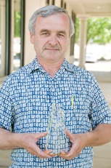  Award for Excellence  Gavril Sarcadi, UTAPS | 20 Years of Service  John Irwin, Facilities Services | 25 Years of Service  Kevin Simpson, Facilities Services | 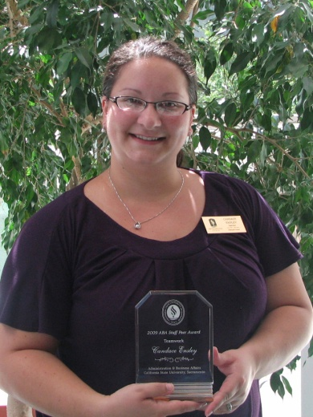  Teamwork Award  Candace Ensley, One Card

Ice Cream Team, L to R: Ken Barnett, Abbi Stone, Ron  Richardson, Stacy Hayano, Mike Christensen, Justine Heartt  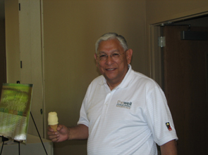 | 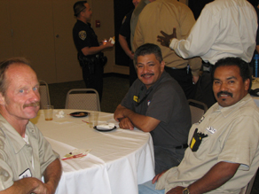  Facilities Services staff, L to R: Patrick Yager, Joseph Kelly,  Arturo Perez Sr.
Vice President Garcia enjoying the award ceremony | Service awards and staff peer awards

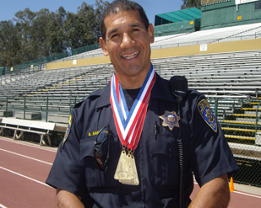
VOL.3 | ISSUE 1 | SUMMER 2009
ABA News
SANCHEZ WINS GOLD
Congratulations to Sac State Police Officer Sam Sanchez, pictured wearing three gold medals won at the Western States Police and Fire Games in Southern California this summer. Sanchez joined the University police force two years ago after serving with the Contra Costa Sheriff’s Department for 21 years. He is most proud of his 400-meter finish of 56.61 seconds, which broke a 19-year record of 56.62 seconds. “This was a shot in the arm for the department - that Sam Sanchez trained as hard as he did and won gold medals in these high-profile events. He represented Sacramento State well in this competition,” says Sac State's new Police Chief Dan Davis. For the full story, click here.
ABA THANK YOU BLOG
What better time than now to say thank-you. It's been a busy summer, and the ABA Thank You Blog is up and running! Now you can thank that special someone with the click of a button. Who always comes through for you, or went the extra mile? Visit the blog and submit your "thanks." Be sure to check monthly for new entries. To access the site, click here.
NEW CHIEF APPOINTED

Sac State Lt. Daniel Davis was appointed Chief of Police on September 1st, just in time for the start of Sac State's fall semester. Vice President Garcia announced the appointment following a six-month-long nationwide search. "Dan is a valued member and an integral part of the campus community and is familiar with the internal operations of the campus and its diverse population. He has the right combination of administrative and law enforcement skills to be successful in the role as chief of Police," said Garcia.
As chief, Davis will oversee a staff of 21 sworn officers, five dispatchers, 30 community service officers, eight office staff members and student assistants. He replaces long-time Chief Ken Barnett, who is retiring.

VOL.3 | ISSUE 1 | SUMMER 2009

Behind the scenes: Capital Planning, Design & Construction
These ABA employees are pros when it comes to multi-tasking. Nine professionals with umpteen years of experience under their collective belts, they know what it takes to manage a building project or two. Good thing, too, because Destination 2010 set in motion a capital improvement program of unprecedented proportions at Sacramento State. Now, juggling multiple projects simultaneously is routine for Sac State’s Capital Planning, Design & Construction (PDC) Office.
Facilities Services Capital Planning, Design & Construction Team, L to R: Susan McGuire, Rechelle Arnold, Robin Eicher, Mark Perry, TJ Moon, Robin Lovering, Todd McComb, Victor Takahashi. Not shown: Don Hendricks

Think about it. As the finishing touches were made to the AIRC Building in 2005 and the Telecommunications Infrastructure project was completed, plans were already underway for the new Recreation/Wellness Center. Parking Structure III was in operation by spring 2007, around the time the student housing complex design was approved. In addition that year, the $18.6M campus infrastructure upgrade was completed. The new Hornet Bookstore and the Broad Athletic Field House opened their doors in 2008. During that time, the WayFinder signage system was planned and implemented, and the campus Bike Path was expanded and enhanced. Meanwhile, plenty of routine projects continued unhindered – to improve classrooms, extend the lives of buildings, and meet compliance requirements. In 2008/09 alone, PDC accomplished the following: Field House demolition, Throw Area relocation, Athletic Storage Building design, Capistrano roofing/remodels, various classroom remodels, Lassen Hall and Sac Hall remodels, the placement of trailers in lots 1 and 7.
Facilities Services Capital Planning, Design & Construction Team, L to R: Susan McGuire, Rechelle Arnold, Robin Eicher, Mark Perry, TJ Moon, Robin Lovering, Todd McComb, Victor Takahashi. Not shown: Don Hendricks

PDC professionals are proud of their role in building a destination campus, pleased that they have managed successful outcomes at such a vigorous pace, and eager to see the upcoming completion of two major projects – American River Courtyard (ARC), and the long-awaited Recreation/Wellness Center. According to Director Victor Takahashi, managing the ambitious campus growth has been challenging but exciting, because it’s more than just “growing a university. It’s about changing the culture. I can sense this campus becoming more vibrant and welcoming.”
Takahashi attributes the success of his team to experience, collaboration and commitment to customer service. “Our biggest challenge is to balance scope, budget and time … the project triangle,” he calls it. PDC’s team of problem-solvers provides oversight of major capital projects, such as ARC and the WELL Building, and design and estimating services for projects under $400,000, or minor capital outlay projects. They coordinate with campus departments, architects, engineers, inspectors and Facilities Services colleagues to timely deliver the best project, at the same time assuring that building codes, ADA requirements and CSU energy, seismic, sustainability and safety policies are met, along with the University’s fiscal responsibilities.
As for internal operations – modernization and efficiency improvements have helped PDC meet increasing project demands. Nearly all building and utility drawings have been scanned and electronically indexed for more efficient access, transmission and archiving of documents. New wide-format scanners make it possible to convert old blueprints and maps to electronic documents, and large-scale drawings can be printed in black and white or color. Of broader interest are web cams focused on the University’s major projects, and the development of global positioning system (GPS) maps. Web cams engage the public in building progress, and serve an important safety function. GPS maps will assist campus navigation and boost campus safety and emergency services. Eventual integration of campus reference points into a geographic information system (GIS) data base is planned to enrich the system. In recognition of their fine work, PDC received an ABA Team Award in 2009.
PDC is: Director Victor Takahashi; Manager of Design Services Robin Lovering; Manager of Construction Coordination Don Hendricks; Planner Robin Eicher; Estimator Mark Perry; Drafting Tech Rechelle Arnold; Drafting Tech Todd McComb, Drafting Tech TJ Moon, and Accounting Tech Susan McGuire.

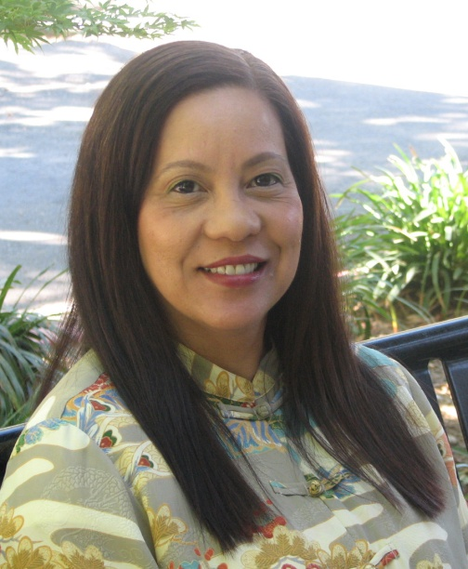
VOL.3 | ISSUE 1 | SUMMER 2009
Destination 2010 Staff Perspective
Name: Kem Gravenberg
How long at Sac State: 30 years
Department: Administrative Operations
Job Title: Executive Assistant to the Vice President/CFO
Responsibilities: As Executive Assistant, I serve as the chief of staff to the Vice President for Administration and Chief Financial Officer, providing executive level administrative operations support services. I relieve the VP/CFO of a variety of responsibilities, and represent him on various committees and to constituents on the campus, in the CSU, and in the community. In addition, I provide leadership and direction for the University Records Management Program, facilitate the development and review of ABA and University policies and procedures, and provide comprehensive services for the VP/CFO’s special projects and initiatives.
What makes you most proud of the work you do? I take pride in being able to relieve the Vice President of the various pressures of his job. I’m proud that he trusts my decision-making ability and knows that I will represent him, the division and the University in a professional manner.
What makes you proud to be a member of the Sac State community? I truly enjoy the dedicated, knowledgeable people that I have had the pleasure to work with over the years. Each one of us has contributed to making this University a place we can be proud of.
In a word, how would you describe Sac State? Energetic
What is the most important or exciting aspect of Destination 2010 to you? Destination 2010 gave the University and its employees a unified focus. The exciting part is seeing the goals accomplished – the new Wayfinder signs, the electronic billboard, Sac State’s logo on Modoc. These are all inviting. They say -- “We are here.”
What is your idea of a welcoming campus? A welcoming campus is easy to navigate and provides excellent customer service. This means courtesy, civility -- all the ways that signify a positive attitude to our internal customers as well as visitors from the surrounding community. A negative attitude sends the wrong message, especially to first-time visitors.
Now that we are nearing our destination, how do you think we have done? We have done an excellent job! We will have made some remarkable accomplishments by next year. The tangibles: We have already completed the Broad Athletic Field House, the student apartment style housing project recently opened, and the Wellness Center is well underway. We have a new bookstore and a new parking structure for students. The intangibles: We have created an identity for ourselves that we can all rally around.
What Destination 2010 accomplishments do you think will have the most impact in the future? I think developing residential options for students, faculty and staff will have the biggest impact in the future. Providing housing options makes it easier to attract good people. This fits well with the president’s vision of Sac State becoming a destination campus. By living on campus, students will be more immersed in college life, have a better experience and feel more connected to the University, increasing the possibility of becoming active alumni and future donors. This is the first step toward building the culture we desire – a campus with college spirit.
Additional comments about ABA, Sac State or Destination 2010? The ABA division has been fortunate to have a leader who is not only progressive but had a clear vision for D2010. He is people-oriented and values the collective knowledge of the ABA staff. Upon his arrival on campus, he launched a division-wide communication and change-management plan to ensure that his principles and vision were communicated clearly and frequently. He enabled all ABA employees to participate in the process and encouraged their input.
VOL.3 | ISSUE 1 | SUMMER 2009

LEAN Pays Off
- The Student Financial Services Center (SFSC) implemented eRefund in May 2008 to provide students an electronic alternative for depositing financial aid and fee refunds. In 2008/09, over 10,000 students chose the online option, saving the University close to $15,000 in postage. Electronic transmission also improved the timeliness of payment by one to two days. Students are happy with the process, as illustrated by this spring 2009 survey comment -- “eRefund is amazing.”
- UTAPS added a new 28-passenger shuttle bus to its fleet this spring. Hornet Express Shuttle #16 features perimeter seating, with room for an additional 20 standing passengers. Selected for its smaller size, fuel economy (it uses compressed natural gas, or CNG) and accessibility (low floor for easy passenger access and 3-position wheelchair accessibility), the bus is also lighter and more maneuverable than larger busses. The purchase of the smaller bus saved the campus close to $90,000. The smaller shuttle maintains close to the same seating capacity, and replaces a diesel fuel bus, making the Hornet Express a 100 percent clean air fleet. The CNG vehicles will help Sac State meet its clean air and sustainability goals. And, since CNG fuel can cost anywhere from $.94/gallon to $3.24/gallon less than diesel, the bus is expected to save the campus money as well.
Hornet Express Shuttle #16
- This year, OneCard launched Hornet Bucks, a new program that permits the deposit of funds to OneCard accounts online. Financial support for students through a Hornet Bucks account can ensure the appropriate expenditure of funds for educational purposes, such as books and meals. Since its inception, the volume of deposits to OneCard accounts has risen, helping to improve the bottom line for the campus OneCard program.

VOL.3 | ISSUE 1 | SUMMER 2009

New Faces
New Faces is our way of introducing ABA's new staff employees to the family. You may already know some of the staff pictured below, but we want to be sure to properly introduce all of those who have joined us since our last newsletter was published. To help you get to know them better, we have included their start dates and the departments in which they work, along with their photos.
Jamie Bratton  Dispatcher, Public Safety  August 2008 | Tiffanni Clark  Info. Svc. Provider, UTAPS  October 2008 | Hernando Esteban  Custodian, Facilities Services  October 2008
Ronie Gagui  Custodian, Facilities Services  October 2008 | Lauren Garrett  Financial Rep., SFSC  June 2008 | Michael Gill  Account Tech., Accounting Services  July 2009
Michael Guisande  Custodian, Facilities Services  March 2008 | Jayme Gutierrez  Office Assistant, UTAPS  July 2008 | 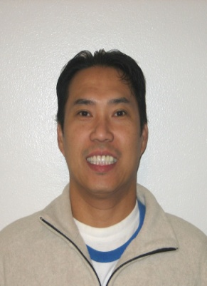  Rene Ibarrientos  Custodian, Facilities Services  April 2008
Lindell Johnson  Custodian, Facilities Services  October 2008 | Jason Johnston  Police Officer, Public Safety  April 2008 | Veronica Liew  ASC, VPA Office  November 2008
Alejandro Raya  Groundskeeper, Facilities Svcs.  October 2008 | Jessica Sanchez  Office Assistant, UTAPS  October 2008 | Brian Sarantopulos  DMO, Reprographics  September 2008
Tiffany Villaber
Dispatcher, Public Safety, August 2008
VOL.3 | ISSUE 1 | SUMMER 2009

On Leadership
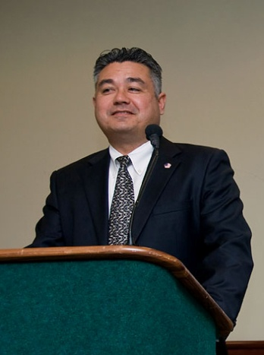
Tony Lucas served as the director of Administrative Services for Sacramento State’s Police Department beginning in 2007, leaving at the end of July 2009 to accept a position with the Department of Defense. With broad experience from many sectors and numerous honors to his credit, Lucas brought a fresh perspective that helped engender many positive changes in the department. The ABA on leadership feature is one of the ways in which ABA promotes the sharing of ideas to help develop leadership capabilities across the division. Lucas discusses his thoughts on leadership below.
Tony Lucas, former director of Administrative Services for Public Safety

……………………………………………………………………………………………………..…………………………

►Leadership is the art of “painting a meaningful vision” that people understand and want to be part of.
►To be a leader is both a tremendous honor and a responsibility. It is an honor to be entrusted with the vision to which many will commit their efforts. A leader is also ethically responsible for supporting employee efforts and helping them realize their potential.
►A successful leader has foresight and intuition, a strong sense of ethics, good listening skills, and is a reflective practitioner. This means reflecting against current and past organizational practice, researching the literature and theory, analyzing emerging processes and practices, then implementing and monitoring performance to evaluate results.
►The most inspirational leaders have the imagination and courage to implement something new and transformational. For example, following the devastation of the 2004 tsunami in Indonesia, Mike Mullen, then the Chief of U.S. Naval Operations, envisioned a Navy that could serve not only as a military fighting force, but as a force for creating peace. As a result, U.S. military vessels and personnel were used to rescue and assist effected citizens, and sailors and marines became goodwill ambassadors for the U.S.
►It is important for each employee to be a leader. If you are performing a task that can be done better, you need to step up, be a leader and advocate for change and improvement.
►Sacramento State helps its students define and articulate their own personal visions. In that way, the University is helping to change the world, one student at a time. Sac State’s tagline -- Leadership begins here – reflects this.
►Favorite leadership quote: “The very essence of leadership is that you have to have vision. You can’t blow an uncertain trumpet,” Theodore M. Hesburgh, president emeritus, Notre Dame.
►Recommended reading:
- Leading Change, by J.P. Kotter
- Managing with Aloha, by Rosa Say
- Leadership is an Art, by Max Dupree

VOL.3 | ISSUE 1 | SUMMER 2009

ABA’s Roving Reporter
What strategies do you use to effectively do more with less?
Lincoln Beatty, Custodian, Facilities Services  "I coordinate my work routine making sure my priorities are done first, and I team up with my co-workers to achieve work assignments."  Pamela Elbeck, Account Technician, Accounts Payable  "I start with the right attitude and listen to the whole matter. I ask myself, 'How can I make this better?' instead of pointing the finger at someone. I look for alternatives to effectively do something differently; there are many ways to go around the mountain."  Leah Davis, Administrative Support Coordinator, Procurement  "Communicate via email to reduce the cost of printing. Use common sense when you're ordering products - order only what you really need. Recycle office supplies by communicating your need with other offices and sharing or exchanging items." | 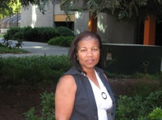
Greg Paul, Help Desk Specialist, Facilities Services
"Work smarter, collaborate with other people. We definitely have team aspects in Facilities Services, which helps."
Suzanne Bracamonte, Admin. Analyst/Specialist, Public Safety
"I verify inconsistencies so I don't have so much rework, I set my priorities for the day and try to keep to them. Teaming up with others always helps."
VOL.3 | ISSUE 1 | SUMMER 2009

Why LEAN?
LEAN -- sound like the latest diet? Well, it is -- it's a workplace diet.
Yuck, you think. I hate diets! Diets mean cutting out things I like. But … we all know diets can be good for us, right? Successful diets help us think about what we eat, so that we can eat more wisely -- to increase energy, shrink the waistline and, ultimately, improve our health.
If that’s the case, how can LEAN help ABA? LEAN helps improve an organization’s health through the conscious elimination of excess, thus increasing energy, i.e., turnaround time, production rates, etc. Better and faster results can help save time and money. LEAN is a smart option in times like these, as demands grow and resources dwindle.
So, how does an ABA department embark on a LEAN diet? Simple … the way one would approach any diet. Start by looking at what you do and how you do it. Nutritional weight-loss plans often recommend a journal to track daily caloric intake. Documenting the current state of your process is a good place to start. From here, you can begin to look for areas of waste – that is, anything unnecessary. Waste could be: steps in a process, approvals, movement, redundant processes, unused space and manpower, errors resulting in rework, etc. Focusing on quick and easy changes will build enthusiasm to help you reach your goals. (In the world of quality improvement, this is called “low hanging fruit.”)
In the fall, ABA Staff Professionals generated many valuable ideas on how to go LEAN. In this newsletter, you will hear about some of those that have been put into action. Don’t stop there! Diets are only successful with long-term commitment and discipline. To get started, check out the Tools section of the Strategic Planning & Quality Improvement website http://www.csus.edu/aba/spqi/. And keep sharing those good ideas with your managers and supervisors. Let’s work together to keep ABA LEAN!

~ Gina Curry, Bursar & Director of Student Financial Services Center

