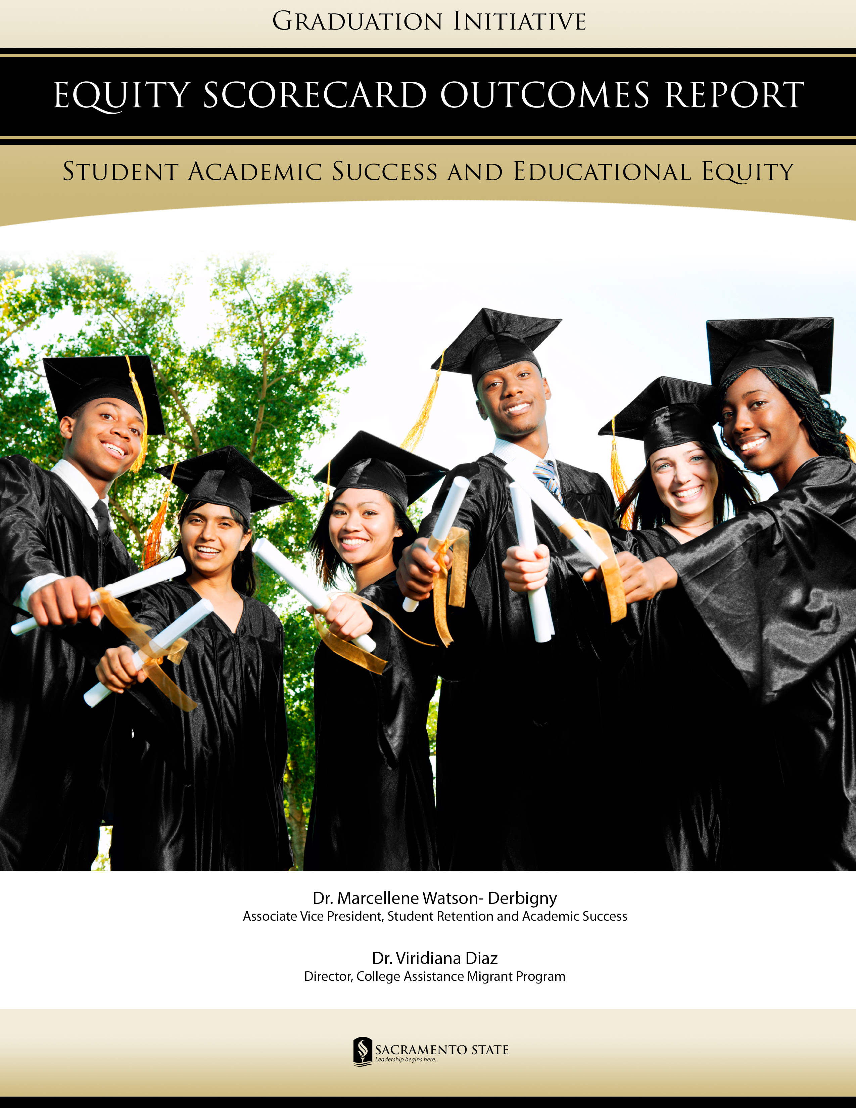
Equity Scorecard Outcome Report

Introduction

Despite having one of the highest college participation rates in the world, large gaps persist in terms of access to and success in higher education in the United States, particularly for low-income, minority, and first-generation students (Johnson & Sengupta, 2009). The baccalaureate degree attainment rate among students from low-income families increased from 6 percent in 1970 to 12 percent in 2005; however, the rate among high-income students increased from 40 percent to 73 percent (Aud, Planty, Snyder, Bianco, Fox, Frohlich, Kemp & Drake, 2010). This means that high-income students are six times more likely to earn a four-year degree than are low-income students, and the gap between them has nearly doubled in the last 35 years. The declining economic competitiveness in the U.S. in comparison to both established and developing nations is a growing concern. The U.S. economy will have 22 million new jobs for college-educated workers by 2018—if we continue at the current pace, the country will be 2 million workers short of filling its capacity (Adelman, 2009). Therefore, to remain a first-class leader in the global economy institutions of higher education must address the barriers impeding the postsecondary completion of this population.

The Graduation Initiative

The CSU Retention & Graduation Initiative: Closing the Achievement Gap was an initiative set forth by the Chancellor's Office in Fall 2009 to challenge all 23 campuses to increase their retention and graduation rates for first-time freshmen and transfer students. The ultimate goal is to reduce the achievement gap between represented and non-represented groups by half by AY 2015/2016. Each CSU campus has worked on an individual plan with specific measures designed to reach their own graduation goal.

Sacramento State

Currently, there is a 10.3% gap in the graduation rate between FTF URM students and FTF ~URM students at Sacramento State. In addition, there is a 5.2% graduation rate gap between URM and ~URM students among the transfer student population. To move Sacramento State into the top quartile of similar institutions in terms of graduation rates, the university must achieve the following outcomes (Increasing Graduation Rates and Closing the Achievement Gap Report, 2010):

TABLE A: CSU Target and Sac State 6-year Graduation Rate Projection 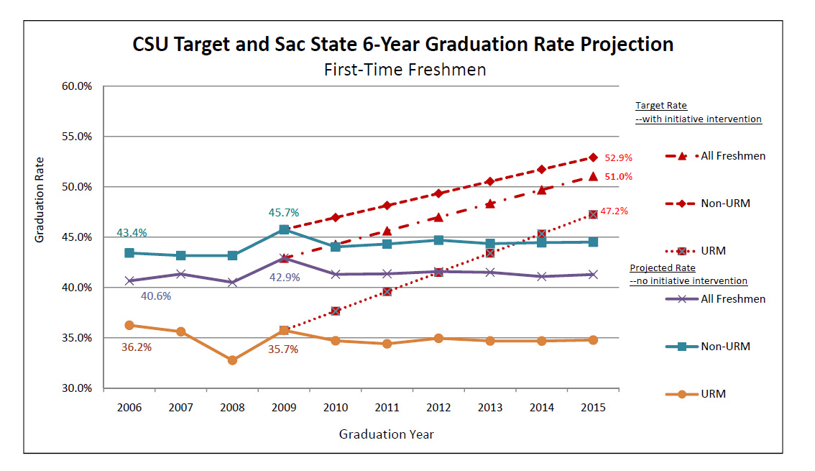

1. Increase the six-year graduation rate of first-time freshmen by 8% by 2015 (i.e., move the current [2003 FTF cohort] rate from 43% to 51%)
2. Increase the four-year graduation rate of transfer students by 5% by 2015 (i.e., move the current [2003 transfer cohort] rate from 63% to 68% [approximate; target rate to be established by the CSU])
3. Close the FTF graduation rate gap between the URM student population (e.g., African American, Latino/Hispanic, Pacific Islander, and American Indian) and our ~URM student population (e.g., Caucasian and Asian American students) by half by 2015 while achieving the targeted aggregate graduation rate increase of 8 points (the current [2003 cohort] gap between FTF URM student graduation rate and ~URM student graduation rate is 10.3%)
4. Close the graduation rate gap between URM transfer students and ~URM transfer students by half by 2015 while achieving the targeted aggregate graduation rate increase of 6 points (the current [2003 cohort] gap between transfer URM student graduation rates and ~URM student graduation rates is 5.2%)

Global Actions Taken by the Institution

In 2010-2011 a Closing the Gap Work Group was formed to devise recommendations for addressing achievement gap concerns. The goal of the group was to work in collaboration with the administration to augment the existing Sacramento State Plan on Increasing Graduation Rates. Given the productivity of this informal team, this working group, with the addition of faculty representatives from the Colleges and other key campus stakeholders became what is now known as the Graduation Initiative (GI) Steering Committee.

The committee’s charge includes making recommendations to the administrative leadership on those strategies that will help to raise the native freshmen and transfer graduation rate. In addition, the committee is charged with developing and revising the campus plan report document and producing an annual strategic plan with focal strategies designed to reach graduation rate improvement goals. The work of the committee builds upon prior campus retention committees (i.e., the Retention Task Force) and has at its core five thematic sub-committees that work bi-weekly on implementation strategies to realize campus-wide change. Unlike prior committees, the Graduation Initiative Steering Committee works to ensure that productive and feasible actions are taken on a continual basis to meet campus retention and graduation benchmarks.

Specific actions of the GI Committee have included the development of the 2011-2012 Strategic Plan. Within the plan, recommendations are made according to the following themes: Theme 1- Services that Support, Theme 2- Learning that Counts, Theme 3- Defining and Developing the Faculty Role in Student Retention and Graduation Efforts, Theme 4- Incentives that Motivate, and Theme 5- Outreach and Recruit Back/University-wide Engagement. Based on the current plan, the following items have been made actionable:

- To address lower persistence rates among male students on campus, a male support and academic enrichment program has been developed called the Male Empowerment Collaborative- Two Point Conversion Challenge. The goal is to assist male students in raising their GPAs and retention rates on campus. The program has been in place since the fall of 2011. (Note: A companion Female Initiative has also been developed so as to reach the entire campus populace in the spring of 2012).

- Degree Roadmaps have been developed for each academic program offered in the University for both freshmen and transfer students

- Sacramento State was selected among institutions around the nation to attend the High Impact Practices Summer Institute. At the Institute our campus developed and was lauded for the creation of a sophomore success curriculum and “Connections Framework,” designed to better retain second year students and beyond.

- The campus established in concert with IRT a preliminary Early Warning System to assist faculty and staff with better documenting the progress of their students. An accompanying draft white paper was developed by the Center for Teaching and Learning to outline the benefits of such practices within academia.

- To increase engagement opportunities for students, the University expanded the work of the Leadership Initiative (LI) to include the involvement of over 800 students. This is a record level of growth given the estimated 300 students that were in the program in the 2010-2011 academic year. The work of the LI program helps to promote hornet pride, diversity, wellness, and overall leadership skill development.

- When students stop-out of the University, it is important that they maintain connection to the campus to ensure re-enrollment and future success. With the help of the Enrollment Management Team, letters were sent out to recruit students back to the University who were in good academic standing and eligible to come back after one semester of non-enrollment. This strategy represents the first attempt of this kind to engage in recruit back, which was found to be very effective.

In direct response to the paramount role that student success plays on the campus, an Associate Vice President of Student Retention and Academic Success was appointed to provide leadership and oversight of student success university-wide. With the creation of this position, retention programs across the campus have been coordinated with clear retention goals in mind. A University-wide Retention Tracking Tool has also been developed to assist programs to track and document their work with students, as a way to improve assessment and service utilization. The tool serves as a model in the CSU system of strategic approaches that can be used to better document daily retention work using technology.

On an informational front, a brochure chronicling all campus retention programs “The Student Success Brochure” has been created to better inform students of the services available to them. Copies have been put in circulation to all incoming freshmen and transfer students via University Orientation and in the Sac State portal of every student for ease of reference. This marketing piece has been a key feature of the Graduation Initiative effort.

With the emergence of work completed on the CSU Graduation Initiative, structural mechanisms have been put in place to fortify campus student success goals. In addition to the Graduation Initiative Steering Committee, the campus developed a long term approach to retention planning and worked to ensure faculty engagement in retention endeavors. To this end, the Faculty Senate Executive Committee proposed the establishment of a Student Services Committee that is faculty driven that will work in tandem with the Academic Policies Committee (APC), as a sub-committee of APC to yield retention work that will lend to the longevity and momentum that has been built to increase campus graduation rates long after the Initiative is completed.

The efforts delineated represent a valiant attempt to address the longstanding need to institutionalize involvement in retention work on a greater level. The establishment of committees and informational and assessment devices has also helped to build a foundation for student success work as a whole for the University.

Most recently, the University unveiled a Peer and Academic Resource Center (PARC). The mission of PARC is to create a home base of support in which students are united for a common cause of excellence and student success. Services of the Center are accomplished through peer led and student driven components that work to increase course passage, student retention, build on academic support services, and rates to graduation. The PARC includes supplemental instruction offerings, a university peer advising program, individual and group tutoring, specialized workshops, and services to support students at the junior and senior class levels.

TABLE B: Sacramento Action Map
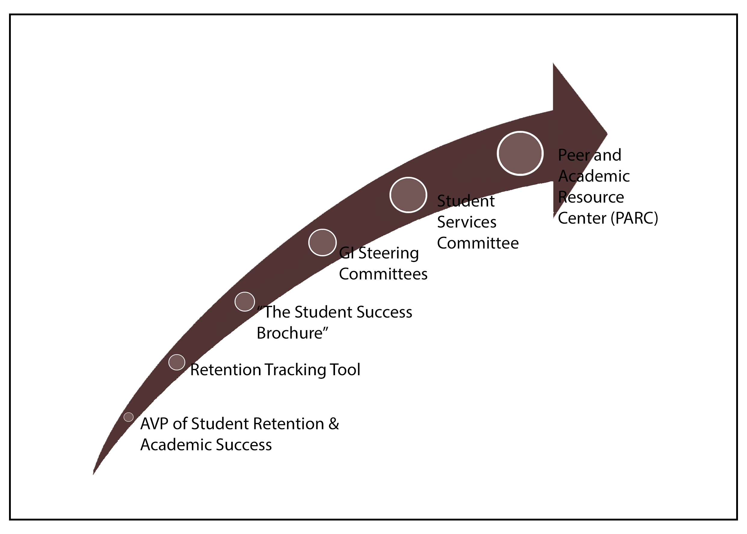

Equity Scorecard

In tandem with the Retention Task Force, a prior committee to the GI Steering Committee, the Campus Educational Equity Committee (CEEC) compiled a template to guide Deans and Associate Deans of Colleges to formulate retention plans for the ultimate improvement of the academic performance of underrepresented students. The Office of Institutional Research (OIR) was then commissioned to provide disaggregated data by College segmenting the performance of students based on their entry characteristics (i.e., HS GPA, SAT, etc.), baseline performance, first year retention rates, and graduation rates. The data was then used to determine the level of equity or to assess achievement gaps among students in the Colleges. In response to the data, each College devised a plan of action to address barriers to student success within their respective areas. With the formulation of Equity Score Card Plans, each College was then asked to provide an update of progress to CEEC via their Educational Equity Coordinator. The goal of the Equity Scorecard is to identify gaps in achievement among URM and ~URM students throughout the seven colleges. Nonetheless, the existing three years of data is insufficient to measure graduation rates. Therefore, at this time, the report will focus on first year retention rates of Native Freshmen and Transfer students. In this next section of the report, the retention actions and initiatives reported by each College will be discussed in greater detail. Please note that equity scorecard plans were reported in 2009 and since then, changes may have occurred in each College. Also see Table. L

TABLE C: Equity Scorecard Map
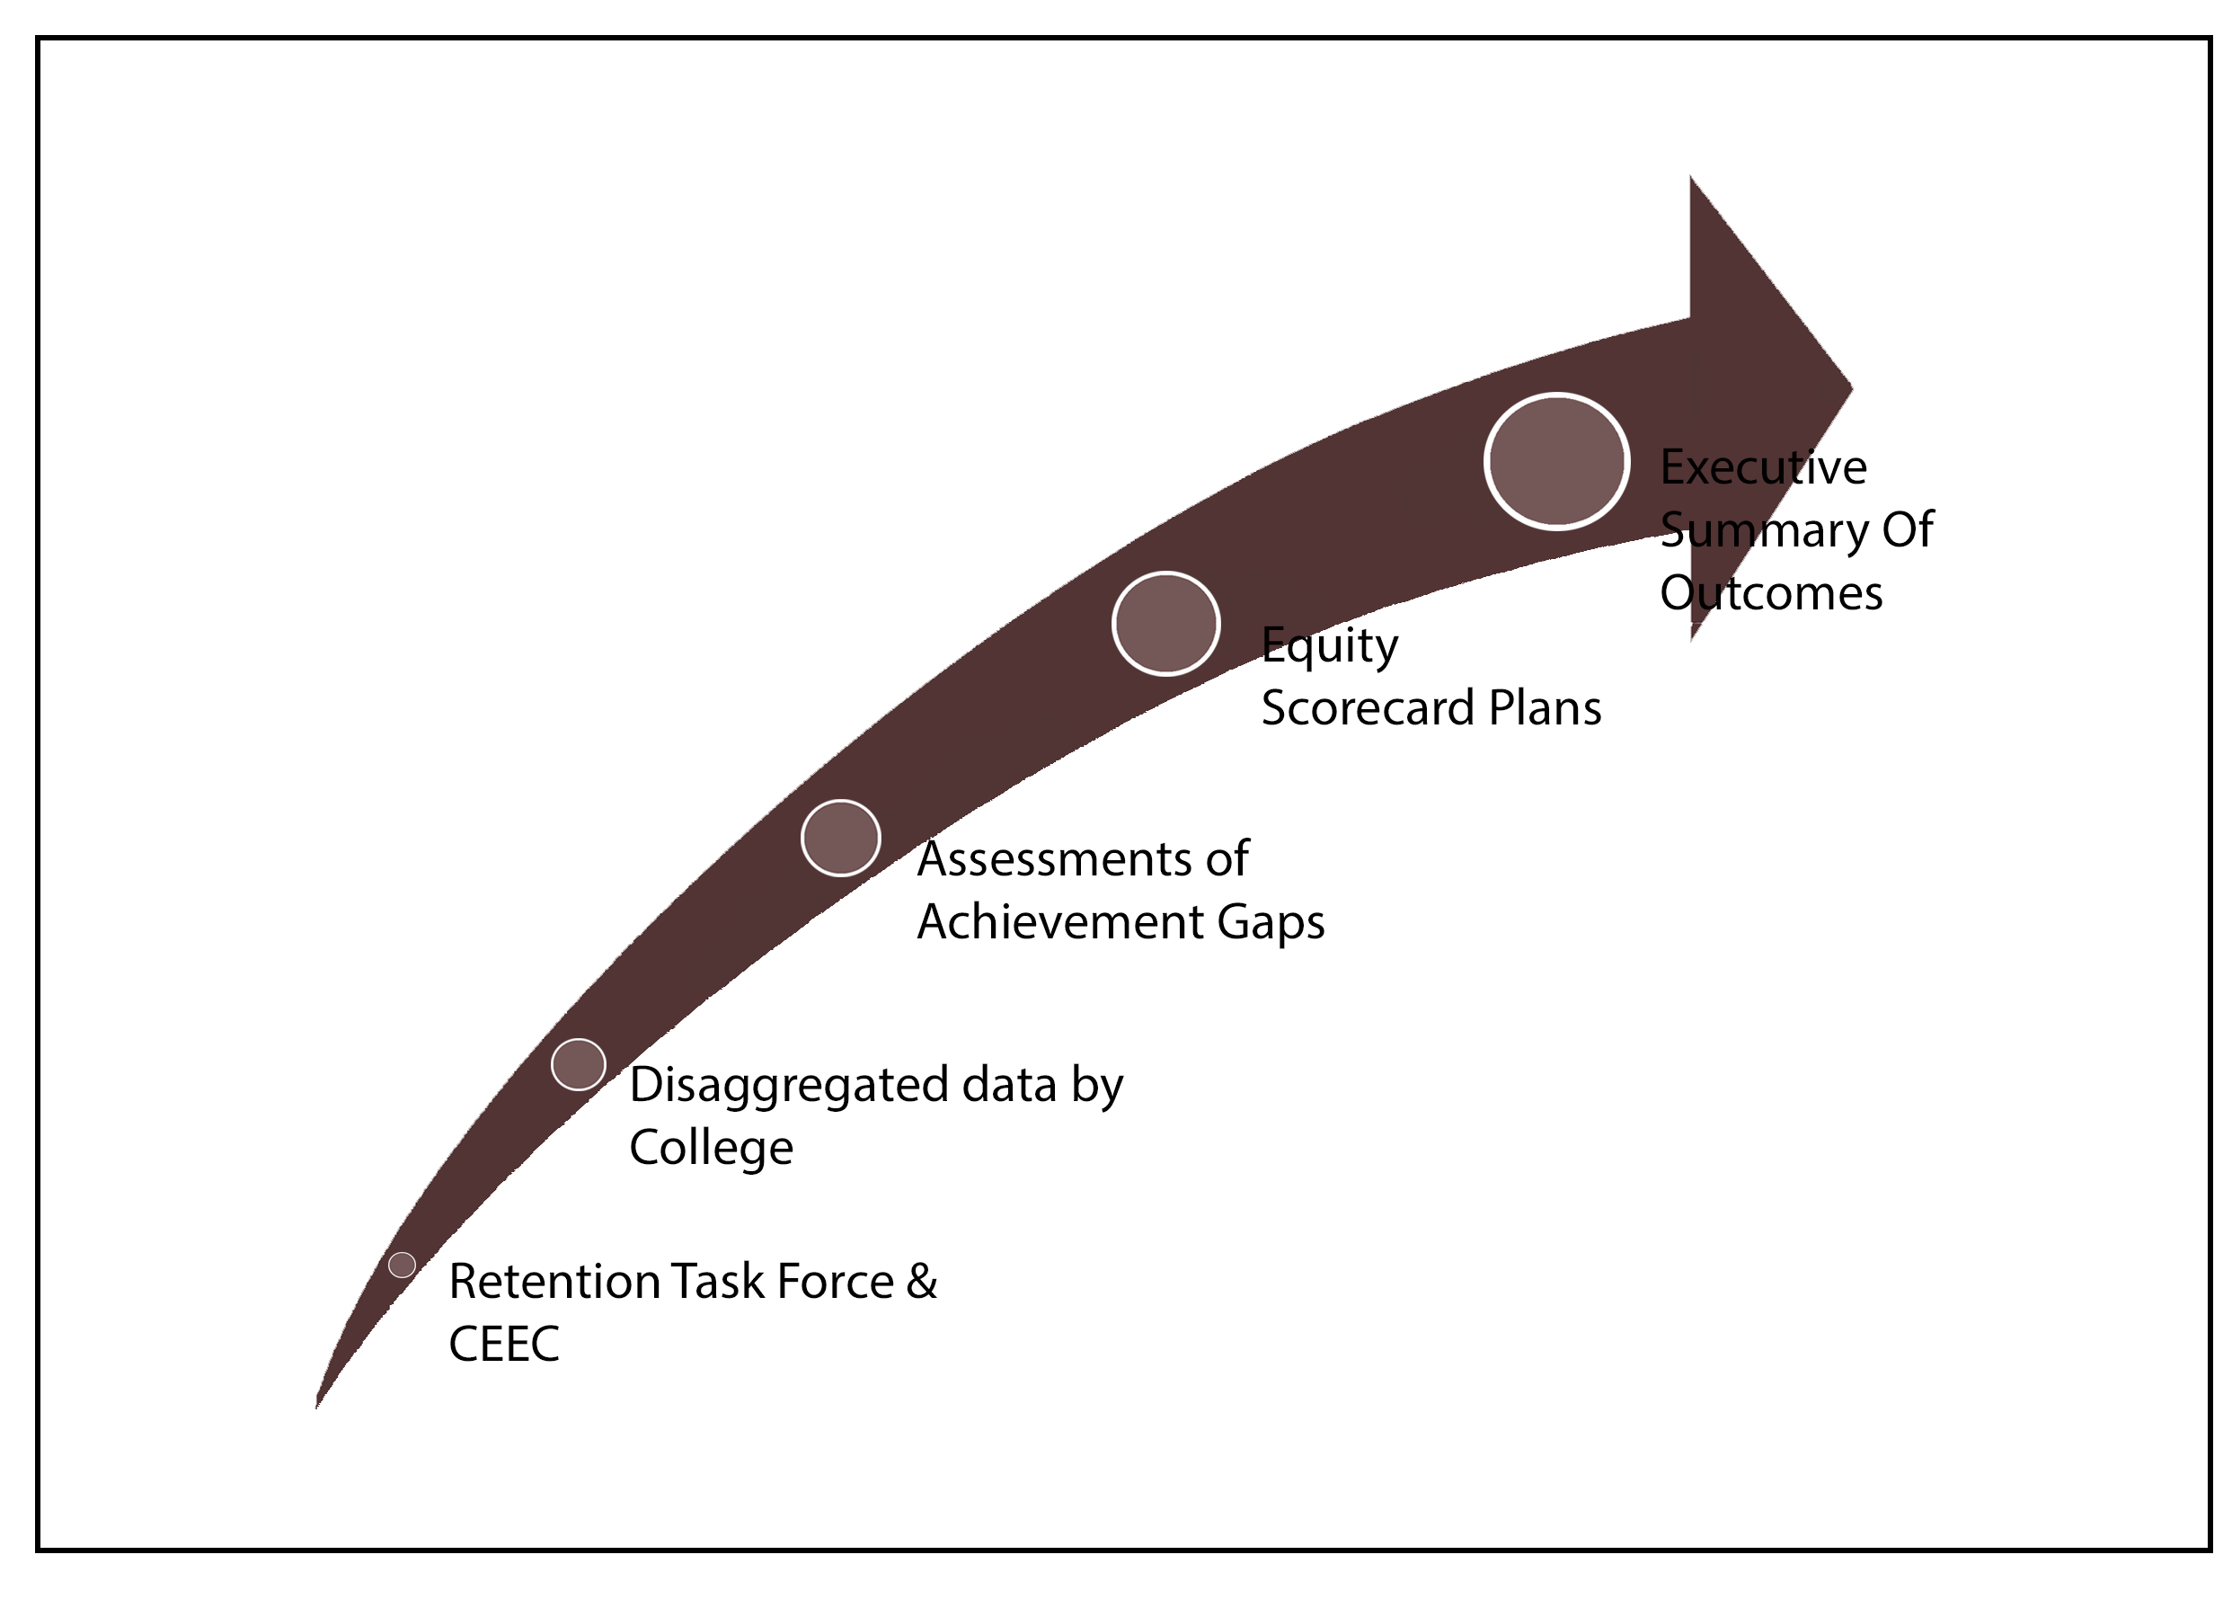

College of Arts and Letters
The College of Arts and Letters brings together programs in the arts and humanities. Virtually every undergraduate in the university takes at least one General Education course through Arts and Letters, and the overall enrollment is the highest of the seven colleges, constituting over 28% of the university total. The College serves over 3700 undergraduate majors and 400 graduate students. To increase the retention and graduation rates of underserved students, the College aims to 1) increase student performance in historically difficult GE and service courses; 2) improve time to graduation by streamlining major requirements and simplifying department procedures; and 3) expand department based tutorial support for students in academic difficulty. Existing and new retention programs directed to achieve these goals include: 1) adjunct sections supplementary to GE and Service Courses; 2) Learning Skills ESL language development tutorials and 3) Faculty Student Mentor Program ALS—a self-directed study group training focused on targeting sophomores and junior level courses. In the college, the gap between URM and ~URM students (both Native Freshmen and Transfer) has persistently narrowed (3.8% for Native Freshmen and 4.0% for Transfer Students). Nonetheless, an achievement gap still exists among URM and ~URM students.

Table D. College of Arts and Letters First-Year Retention Rates

 | URM |  |  | Non-URM |  |  | Gap
 | Total # | Retained | Rate | Total # | Retained | Rate | Gap
Native Freshmen Cohort
2008 | 106 | 82 | 77.4% | 187 | 159 | 85.0% | -7.7%
2009 | 112 | 88 | 78.6% | 291 | 239 | 82.1% | -3.6%
2010 | 126 | 102 | 81.0% | 210 | 172 | 81.9% | -1.0%
Total | 344 | 272 | 79.1% | 688 | 570 | 82.8% | -3.8%
Transfer Cohort
2008 | 108 | 86 | 79.6% | 424 | 354 | 83.5% | -3.9%
2009 | 132 | 104 | 78.8% | 517 | 435 | 84.1% | -5.4%
2010 | 120 | 103 | 85.8% | 457 | 405 | 88.6% | -2.8%
Total | 360 | 293 | 81.4% | 1,398 | 1,194 | 85.4% | -4.0%

College of Business Administration
For more than five decades, the College of Business Administration at Sacramento State has consistently achieved its fundamental goal - to cultivate excellence in its graduates and to develop business leaders possessing not only top management skills, but also a broad understanding of their responsibilities to business and their community. The College serves over 4,500 undergraduate and 156 graduate students. To increase the retention and graduation rates of URM students, the college aims to improve 1) advising at all levels; 2) outreach to students in low pass rate upper and lower division courses; and 3) reinforce tutoring. Existing and new retention programs designed to advance the goals of the College include the Undergraduate Business Advising Center (UBAC) which provides program advising, career advising coordination, graduation evaluation approval and clearinghouse activities related to most types of petitions; 2) The Business Educational Equity Program (BEEP)—designed to target low performing male student groups and other URM population through academic support beyond the classroom including probationary student interventions. Among Native Freshmen, the gap between URM and ~URM students has widened between the 2008 cohort and 2010 cohort (6.2%). Among the Transfer Cohort, currently URM students are out performing ~URM transfer students (5.6%).

Table E. College of Business Administration First-Year Retention Rates
 | URM |  |  | Non-URM |  |  |  |  | Gap
 | Total # | Retained | Rate | Total # |  | Retained |  | Rate | Gap
Native Freshmen Cohort
2008 | 126 | 92 | 73.0% | 285 |  | 214 |  | 75.1% | -2.1%
2009 | 143 | 102 | 71.3% | 290 |  | 233 |  | 80.3% | -9.0%
2010 | 95 | 73 | 76.8% | 221 |  | 186 |  | 84.2% | -7.3%
Total | 364 | 267 | 73.4% | 796 |  | 633 |  | 79.5% | -6.2%
Transfer Cohort
2008 | 144 | 115 | 79.9% | 587 |  | 483 |  | 82.3% | -2.4%
2009 | 146 | 125 | 85.6% | 645 |  | 560 |  | 86.8% | -1.2%
2010 | 144 | 135 | 93.8% | 608 |  | 536 |  | 88.2% | 5.6%
Total | 434 | 375 | 86.4% | 1,840 |  | 1,579 |  | 85.8% | 0.6%

College of Education

The College of Education is responsible for the professional development of teachers, administrators, and counselors to meet the needs of California's diverse schools, families, and communities in the 21st Century. The College serves 689 undergraduate and 1,326 graduate students. The college’s original six departments are now combined into three program areas: Undergraduate Studies in Education; Teaching Credentials; and Graduate and Professional Studies. To increase the graduation rate of URM students the college aims to 1) decrease the number of URM students that continue on probation after initial identification; 2) increase the GPA of URM students in danger of falling into probation; 3) increase the graduation rate (meet requirements for credential) of URM post-bachelor credential students; and 4) increase the retention rate of second year URM students to a level commensurate with non-URM students.

The existing and new strategies designed to meet the goals of the college include maximizing advising for all students including probationary and at-risk (GPA 2.0 – 2.5) through the Faculty Student Mentor Program (FSMP) and the College of Education Equity Advising (CEEA). Additional initiatives design at increasing the number and diversity of candidates include 1) CSET/CBEST Study Sessions and Workshops for students in the credential program and those interested in applying for the credential program; and 2) Math and Science Teacher Initiative (MSTI)—a system-wide plan of action that has as one of its goals to recruit with intent and expand the number and diversity of candidates. Currently, both cohorts, Native Freshmen and Transfer are out-performing ~URM students. Nonetheless, the large variation among each cohort makes it difficult to interpret the data. For example, with the 2009 Native Freshmen Cohort, the gap closed completely and URM out-performed ~URM students (10.2%). Yet, with the 2010 Native Freshmen Cohort the gap widen again by 2%. In the Transfer Cohort, URM students out performed ~URM in all cohorts with the exception of cohort 2009 (10.1%).

Table F: College of Education First-Year Retention Rates
 | URM |  |  |  | Non-URM |  |  |  | Gap
 | Total # | Retained | Rate |  | Total # |  | Retained | Rate | Gap
Native Freshmen Cohort
2008 | 21 | 16 | 76.2% |  | 44 |  | 36 | 81.8% | -5.6%
2009 | 18 | 15 | 83.3% |  | 41 |  | 30 | 73.2% | 10.2%
2010 | 19 | 15 | 78.9% |  | 42 |  | 34 | 81.0% | -2.0%
Total | 58 | 46 | 79.3% |  | 127 |  | 100 | 78.7% | 0.6%
Transfer Cohort
2008 | 10 | 10 | 100.0% |  | 67 |  | 58 | 86.6% | 13.4%
2009 | 18 | 13 | 72.2% |  | 102 |  | 84 | 82.4% | -10.1%
2010 | 23 | 23 | 100.0% |  | 82 |  | 70 | 85.4% | 14.6%
Total | 51 | 46 | 90.2% |  | 251 |  | 212 | 84.5% | 5.7%

College of Engineering and Computer Sciences

The College of Engineering and Computer Science is dedicated to providing high quality education that will transform students into professionals and leaders capable of contributing to the advancement of technological knowledge, progress, wellbeing and sustainable growth of our Capital region and the State of California. The College serves approximately 2,300 undergraduate and 400 graduate students.
The retention initiative within the college is coordinated by the MESA Engineering Program (MEP). MEP’s mission is to recruit, retain, professionally develop, and graduate students in engineering, computer science and construction management. As a MESA (Mathematics, Engineering, Science Achievement) program, MEP serves students that are financially and educationally underserved, including communities that are historically underrepresented in engineering. MEP also aims to increase the representation of women, the group most underrepresented in engineering. Efforts to meets these goals are contingent upon availability of financial and human resources. MEP is not institutionalized within the university and its continued existence largely depends upon external funding. Sources of external funding have become increasingly scarce. The Statewide MESA Program only provides enough funding for student assistants or a small portion of an MEP staff member’s salary. With an enrollment of 400 MEP students and the goals established to ensure student success, an MEP staff of four full-time members is required. MEP has been operating at nearly half of the required staffing level for two years which is not sustainable.
MEP offers intensive academic intervention prior to matriculation. This includes utilizing existing pre-matriculation programs such as the MEP Family Orientation Night, an MEP Open House, MEP’s PRISM (Principle Review for Incoming Students in Mathematics),and the Louis Stokes Alliance for Minority Participation (AMP).
MEP’s retention program includes: a semester-long workshop and a multi-layered mentor program. The workshop and mentor program focus on academic success, professional development and encouraging graduate school attendance. Furthermore, all new MEP students are scheduled to meet on a regular basis with MEP counselors and tutors in order to develop the habit, as continuing students, to seek those services. All MEP students receive information and guidance on study group formation, internships, scholarships, research opportunities and graduate school. MEP maintains a study center that is available for students 24/7 and manages the Academic Success Center and a tutoring services program for all ECS students, including students enrolled in the Faculty Student Mentor Program (FSMP).
(Note: in 2011, MEP became a participation based program. Participation requirements are designed to increase student success. Not all URM students in ECS are in MEP. In order to assess student progress and outcomes, future data analysis must consider those students enrolled in MEP from those that are not.)
Among the Native Freshmen, the data reflects a significant increase between the 2008 and 2009 cohort. In 2010, Native URM Freshmen out-performed non-URM students (3.2%). Among the Transfer Cohort, the gap between URM and non-URM has nearly closed between 2009 and 2010 (1.2%).

Table G: College of Engineering First-Year Retention Rates
 | URM |  |  | Non-URM |  |  | Gap
 | Total # | Retained | Rate | Total # | Retained | Rate | Gap
Native Freshmen Cohort
2008 | 125 | 86 | 68.8% | 212 | 166 | 78.3% | -9.5%
2009 | 110 | 86 | 78.2% | 269 | 211 | 78.4% | -0.3%
2010 | 105 | 88 | 83.8% | 222 | 179 | 80.6% | 3.2%
Total | 340 | 260 | 76.5% | 703 | 556 | 79.1% | -2.6%
Transfer Cohort
2008 | 35 | 26 | 74.3% | 188 | 160 | 85.1% | -10.8%
2009 | 46 | 37 | 80.4% | 242 | 219 | 90.5% | -10.1%
2010 | 46 | 41 | 89.1% | 218 | 197 | 90.4% | -1.2%
Total | 127 | 104 | 81.9% | 648 | 576 | 88.9% | -7.0%

College of Health and Human Services

The mission of the College of Health & Human Services is to provide high quality education and well-prepared graduates who demonstrate proficiency, critical thought, leadership ability, creativity, and commitment, in current and future professional practice. The College serves 6,125 undergraduate and 633 graduate students. The college’s efforts to address gaps in achievement are part of the college’s overall efforts to increase retention and graduation rates for all students. The plan is threefold: strengthen and expand academic advising; provide additional support in mentoring; and course specific tutoring. We have strengthened and extended advising across the college. In addition to affirming that all full time faculty participate in academic advising, programs have expanded advising to meet the needs of pre-majors, first and second year students and others who are interested in becoming a major. Since we offer very few lower division courses in the college this additional outreach to first and second year majors can be critical to their retention early in their academic career. This bears out in the difference graduation rates for native freshman versus transfers in the college (see table below). The graduation rates are significantly higher for URM transfers who are able to benefit from the more focused advising and support provided to who are taking courses in the major. CHHS programs now have a combination of advising strategies in place in addition to traditional one on one advising including cohort advising, drop in advising centers, and pre-major advising. In addition, most of the programs have some form of early alert system and all have a plan for students on probation or those not meeting standards for the major. As for mentoring, we’ve expanded the FSMP by addition additional funding to provide outreach to underserved programs in the college. Lastly, the seven departments of the college identified “target” courses in which students fail at a high rate, thus impeding their progress toward graduation. Each program hired student tutors to provide one on one tutoring to students who were in danger of failing these courses. Among the Native Freshmen Cohort, the gap widened between URM and ~URM students (3.3%). In 2008 and 2009, the Transfer Cohort slightly out-performed ~URM. Among the 2010 Transfer Cohort URM and ~URM students performed at about the same level (1.1%).

TABLE H. College of Health and Human Services First-Year Retention Rates
 | URM |  |  | Non-URM |  |  | Gap
 | Total # | Retained | Rate | Total # | Retained | Rate | Gap
Native Freshmen Cohort
2008 | 207 | 162 | 78.3% | 358 | 286 | 79.9% | -1.6%
2009 | 275 | 214 | 77.8% | 470 | 387 | 82.3% | -4.5%
2010 | 268 | 217 | 81.0% | 456 | 384 | 84.2% | -3.2%
Total | 750 | 593 | 79.1% | 1,284 | 1,057 | 82.3% | -3.3%
Transfer Cohort
2008 | 163 | 138 | 84.7% | 493 | 411 | 83.4% | 1.3%
2009 | 210 | 177 | 84.3% | 632 | 517 | 81.8% | 2.5%
2010 | 183 | 166 | 90.7% | 615 | 559 | 90.9% | -0.2%
Total | 556 | 481 | 86.5% | 1,740 | 1,487 | 85.5% | 1.1%

College of Natural Sciences and Mathematics
The College of Natural Sciences and Mathematics educates a richly diverse scientific workforce and fosters scientific and mathematical literacy in the greater community. The college has committed to recruiting and graduating students from populations typically underrepresented in the sciences. The College serves 2,384 undergraduate and 105 graduate students. The College aims to increase the first year retention rate, three-year graduation rate of transfers and six-year graduation rate of new URM students through various existing and new initiatives. The Science Educational Equity Program (SEE) is charged with the coordination of the college’s educational equity efforts. To address the preparation of incoming students, LSAMP Math Summer Bridge (a 3-week summer program, offered through SEE) prepares students for pre-calculus and calculus. During the semester, a collaboration of SEE with FSMP and EOP involves a section of NSM 21 (taught by an NSM faculty member) in an EOP Learning Community. College-wide mandatory advising for all first-time freshman students is provided by academic departments, the SEE Program, and the new NSM Advising Center. Those students who do not walk in are placed a hold in their registration until advising is completed. “Commit to Study” is an initiative designed to create a college-wide culture that emphasizes the need to devote 25-35 hours per week to studying. Additionally, the Natural Science and Mathematics Joint Council coordinates and supports the activities of many discipline related student clubs (e.g., MOSS, Geology Club, Chemistry Club, Mathematics Soc., Pre-dental Assoc., SIAM, Society of Physics Students). Lastly, the Project PASS (Peer-Assisted Student Success), funded by the NSF, was launched in spring 2012. The goal of this program is to increase retention and graduation rates among students in gate-keeper courses within the STEM disciplines by offering advising, peer-mentoring, and supplementary instruction in these courses. Project PASS spans several departments in NSM including Biological Sciences, Chemistry, Physics, and Mathematics. Among the 2008 and the 2009 Native Freshmen Cohort, the gap was not only eliminated but URM out-performed ~URM by 5.2%. Among the Transfer Cohort, the gap has been eliminated with URM out-performing ~URM students by 1.3%.
Table I. College of Natural Sciences and Mathematics First-Year Retention Rates
 | URM |  |  | Non-URM |  |  | Gap
 | Total # | Retained | Rate | Total # | Retained | Rate | Gap
Native Freshmen Cohort
2008 | 76 | 54 | 71.1% | 190 | 154 | 81.1% | -10.0%
2009 | 92 | 75 | 81.5% | 215 | 164 | 76.3% | 5.2%
2010 | 80 | 67 | 83.8% | 204 | 174 | 85.3% | -1.5%
Total | 248 | 196 | 79.0% | 609 | 492 | 80.8% | -1.8%
Transfer Cohort
2008 | 37 | 23 | 62.2% | 172 | 138 | 80.2% | -18.1%
2009 | 44 | 32 | 72.7% | 217 | 184 | 84.8% | -12.1%
2010 | 37 | 32 | 86.5% | 176 | 150 | 85.2% | 1.3%
Total | 118 | 87 | 73.7% | 565 | 472 | 83.5% | -9.8%

College of Social Science and Interdisciplinary Studies

The mission of the College of Social Sciences and Interdisciplinary Studies is to enhance students' abilities to analyze and make informed decisions regarding issues, problems, and policies in the Capital Region, and at the state, national, and global levels. The College strives to prepare undergraduate and graduate students for productive careers in the highly diverse New California in such occupational sectors as public service, law, and business. The College also prepares students for a variety of teaching careers. The College serves 4,500 undergraduate and 312 graduate students. The College continues support of ongoing efforts designed to improve student retention for both minority and non-minority students through various mentoring programs administered by each department. The Department of Government has an ongoing student mentoring program that provides highly personalized advising to students, including a “teaching plan.” Mentors work closely with faculty, especially those teaching introductory classes. The Department of Family and Consumer Services holds established student peer mentor office hours, presentations, and outreach activities, and more recently mentors and faculty have been working with alumni to help inspire students and provide them with career opportunities. The Department of Sociology has a faculty-student mentorship program, which provides advising and other information targeted especially at underrepresented minority students. This program is designed as a means of “building social capital,” shown to be a key aspect of college success. The Gerontology Program has a “student ambassadors” program design to orient all incoming students and also works closely with community colleges. The Department of Ethnic Studies has a mentoring program for eligible students. This program includes advising during student get-togethers, outside presentations, and development of specific recruitment and advising materials. Among the 2009 Native Freshmen Cohort, there was an out-performance between URM and ~URM students yet the gap widened again by 3.6% with the 2010 cohort. Among the Transfer Cohort, the gap has consistently narrowed between the 2008 and 2010 cohorts (1.0%).

Table J: College of Social Science and Interdisciplinary Studies First-Year Retention Rates
 | URM |  |  | Non-URM |  |  | Gap
 | Total # | Retained | Rate | Total # | Retained | Rate | Gap
Native Freshmen Cohort
2008 | 135 | 102 | 75.6% | 209 | 162 | 77.5% | -2.0%
2009 | 154 | 126 | 81.8% | 246 | 190 | 77.2% | 4.6%
2010 | 117 | 92 | 78.6% | 225 | 185 | 82.2% | -3.6%
Total | 406 | 320 | 78.8% | 680 | 537 | 79.0% | -0.2%
Transfer Cohort
2008 | 152 | 126 | 82.9% | 524 | 449 | 85.7% | -2.8%
2009 | 171 | 142 | 83.0% | 653 | 557 | 85.3% | -2.3%
2010 | 175 | 157 | 89.7% | 623 | 565 | 90.7% | -1.0%
Total | 498 | 425 | 85.3% | 1,800 | 1,571 | 87.3% | -1.9%

Summary of all Colleges (Three-Cohorts)

As a result of the efforts advanced by the Graduation Initiative and documented by the Equity Scorecard, all Colleges have made progress in increasing the first-year retention of URM students across the campus. In fact, in some Colleges, URM students are out-performing ~URM students. The College of Engineering & Computer Science, Natural Sciences & Math and Social Science and Interdisciplinary Studies have seen steady progress in the retention of URM students for three consecutive years. Based on their consistent progress, these practices should be highlighted and broaden by the institution. Existing campus level data show that particular groups of students (e.g., freshmen, EOP participants, athletes, veterans, and probation students) who receive targeted advising, support, tutoring, and mentoring do better than the overall student population in terms of continuation and/or graduation. Therefore, it is necessary to expand many of these “special programs” to a more general student population.

Table K: Summary of all Colleges First-Year Retention Rates

 | URM |  |  | Non-URM |  |  | Gap
 | Total # | Retained | Rate | Total # | Retained | Rate | Gap
Arts & Letters
Native | 344 | 272 | 79.1% | 688 | 570 | 82.8% | -3.8%
Transfers | 360 | 293 | 81.4% | 1398 | 1194 | 85.4% | -4.0%
Business
Native | 364 | 267 | 73.4% | 796 | 633 | 79.5% | -6.2%
Transfers | 434 | 375 | 86.4% | 1840 | 1579 | 85.8% | 0.6%
Engineering & Computer Sci.
Native | 340 | 260 | 76.5% | 703 | 556 | 79.1% | -2.6%
Transfers | 127 | 104 | 81.9% | 648 | 576 | 88.9% | -7.0%
Education
Native | 58 | 46 | 79.3% | 127 | 100 | 78.7% | 0.6%
Transfers | 51 | 46 | 90.2% | 251 | 212 | 84.5% | 5.7%
Health & Human Services
Native | 750 | 593 | 79.1% | 1284 | 1057 | 82.3% | -3.3%
Transfers | 556 | 481 | 86.5% | 1740 | 1487 | 85.5% | 1.1%
Natural Sciences & Math
Native | 248 | 196 | 79.0% | 609 | 492 | 80.8% | -1.8%
Transfers | 118 | 87 | 73.7% | 565 | 472 | 83.5% | -9.8%
Social Sciences
Native | 406 | 320 | 78.8% | 680 | 537 | 79.0% | -0.2%
Transfers | 498 | 425 | 85.3% | 1800 | 1571 | 87.3% | -1.9%
University
Native | 406 | 320 | 78.8% | 680 | 537 | 79.0% | -0.2%
Transfers | 498 | 425 | 85.3% | 1,800 | 1,571 | 87.3% | -1.9%

Feedback and Recommendations: PENDING

Where do we go from here and how can we use this knowledge to maintain momentum or promote further progress on the issue of equity?
- Where do we go from here?

- How can we use this knowledge to create further progress in closing the achievement gap?

- What types of new initiatives could be implemented to retain momentum?

- How can we best highlight progress and promote the sharing of best practices across the campus?

References

Adelman, C. (2009). The spaces between numbers: Getting international data on higher
education. Washington DC: Institute for Higher Education Policy.

Aud, S., Hussar, W., Planty, M., Snyder, T., Bianco, K., Fox, M., Frohlich, L., Kemp, J., Drake,
L. (2010). The Condition of Education 2010. Washington, DC: National Center for Education Statistics, Institute of Education Sciences, U.S. Department of Education.

California State University (CSU). (2011a). Graduation initiative: CSUS closing the achievement gap report. Retrieved from http://graduate.csuprojects.org/
California State University (CSU). (2011b). Graduation initiative: CSUS strategic report. Retrieved from http://graduate.csuprojects.org/
California State University, Sacramento (CSUS). (n.d.). The California State University Graduation Initiative Website. Retrieved on from http://graduate.csuprojects.org/
Johnson, H., & Sengupta, R. (2009). Closing the gap: Meeting California’s need for college graduates. San Francisco: Public Policy Institute of California.
