How to Record a Video Using Zoom
- Log into Zoom. You need to create an account or you might already have an account with the University.
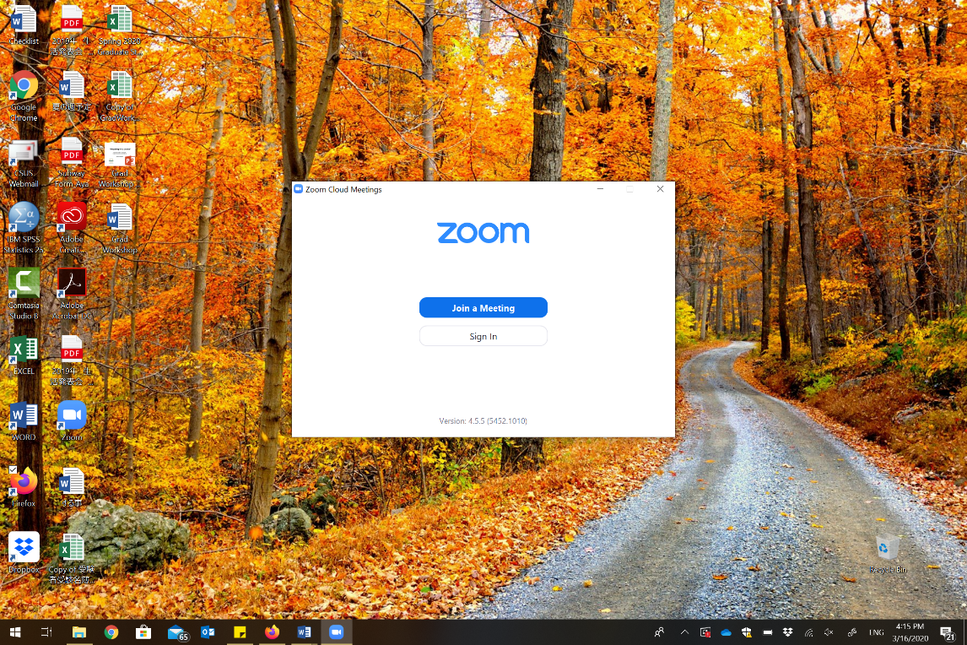
- Then, go ahead and click on “Start” to begin a meeting. 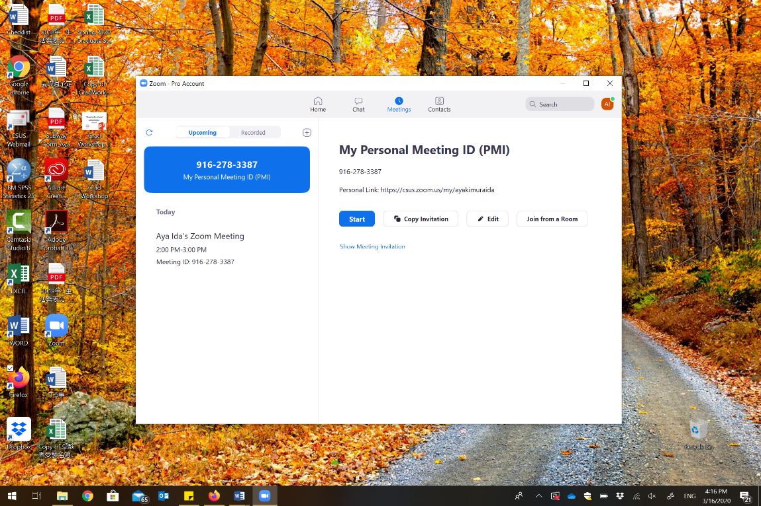

- Click on “Join with Computer Audio.”
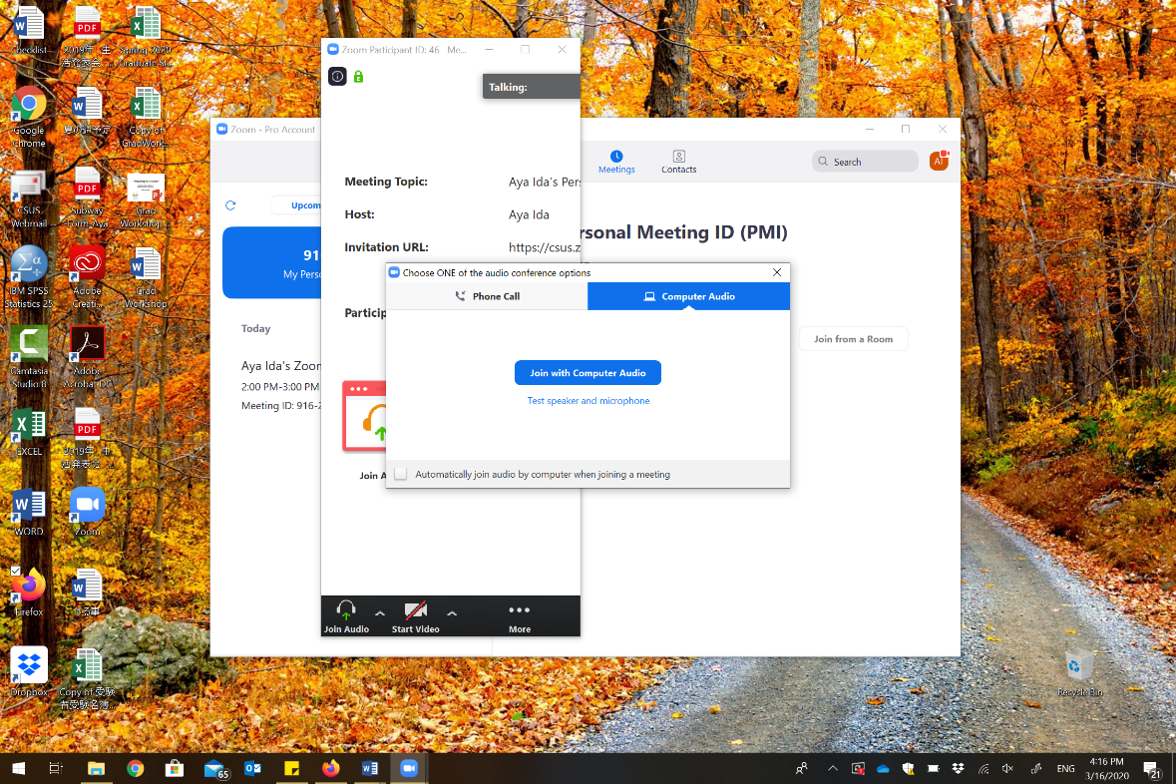
- Whether you want to show your face or not is up to you. If you do choose to show your face, you would want to click on the “Start Video” on the bottom left side.
- Click on “Share” that is in the middle on the bottom (likely green icon).
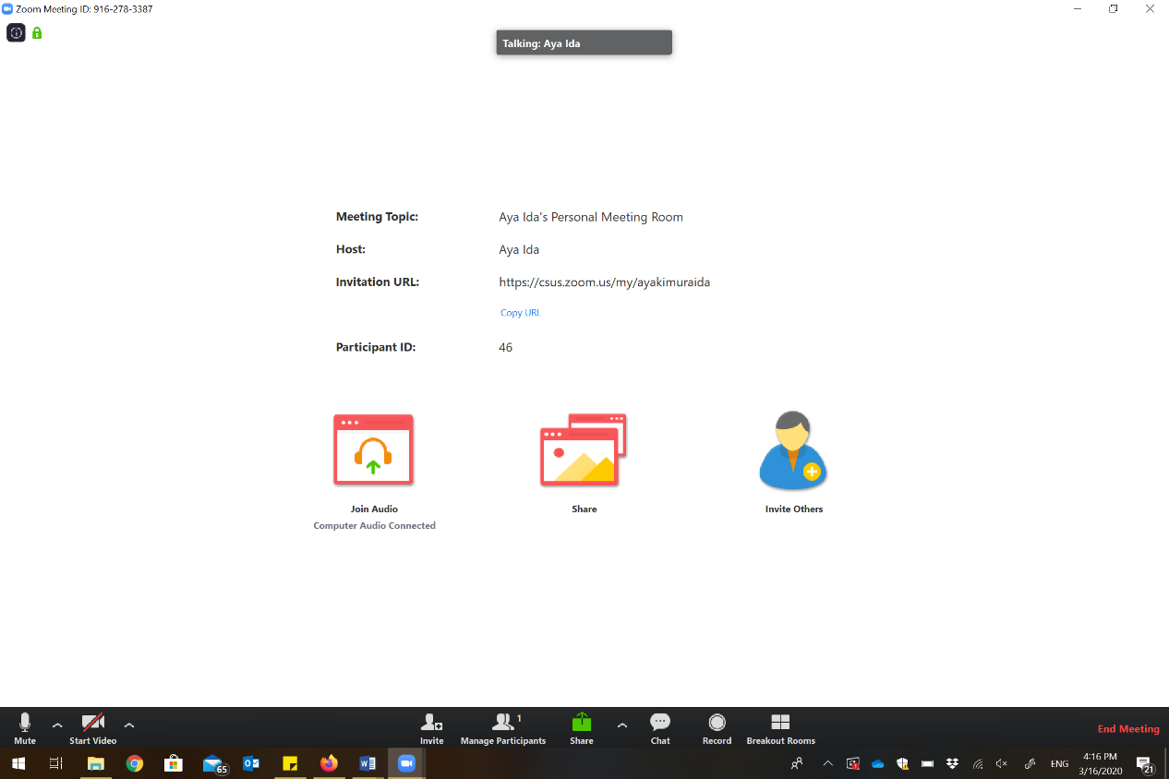
- Then, a small window pops open. Choose the screen you would like to show (e.g., word document, internet browser, spss…etc) and click on “Share” on the bottom right corner.

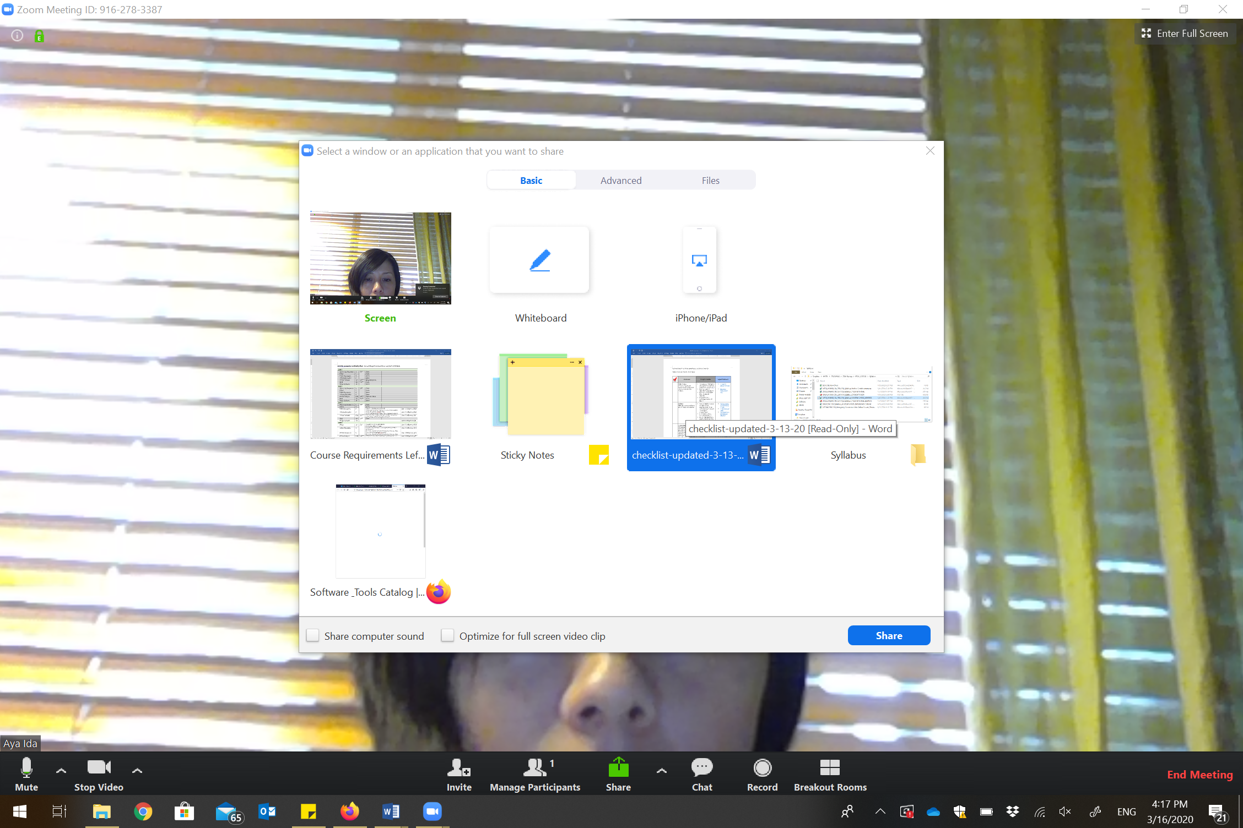

- When you are ready to record, click on “More” and then choose “Record” or Alt + R.
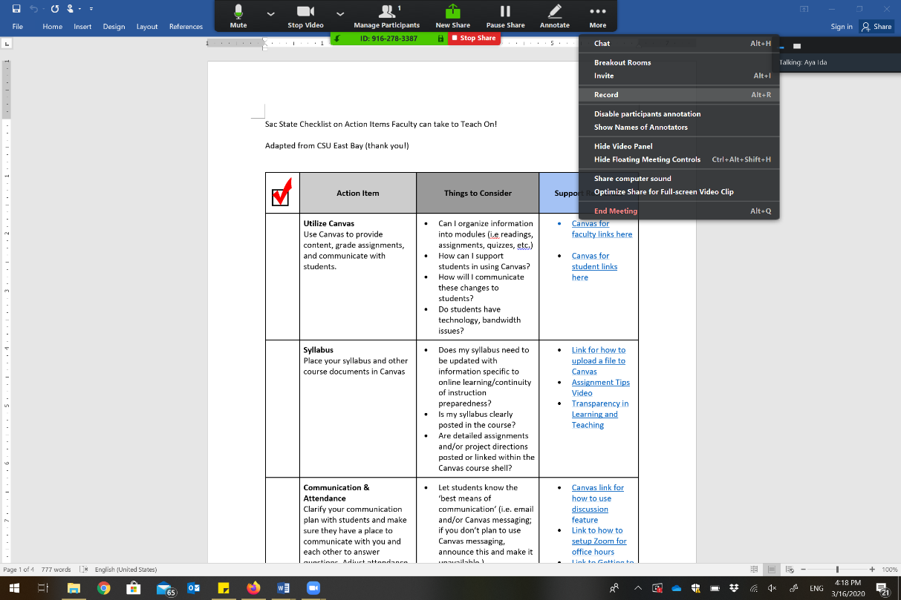

- When you finish recording, you can click on “More” and then choose “Stop recording” or just go ahead and “End Meeting.”
- Once you “End Meeting,” it will start creating an MP4 file.
- You can save it on anywhere you want to save and should be able to upload it on Canvas.
- If you want a closed captions on your video, you should first upload it on Mediasite and request captioning (let me know if you don’t know how to do it, it’s pretty easy and won’t take more than a few days in normal days… not sure how long it takes now… though). Then, you can make a link Mediasite from your Canvas.

