**Instructions for clearing browser cache in Google Chrome**

1. Open Chrome
2. Navigate to Settings here:

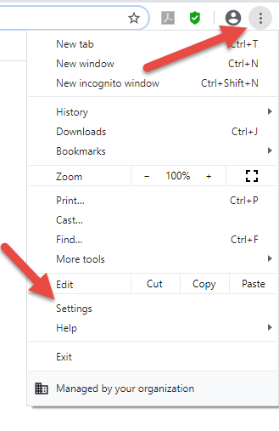

1. Scroll all the way down and click on “Advanced” drop down menu. You will then be able to see the “Clear browsing data” option.

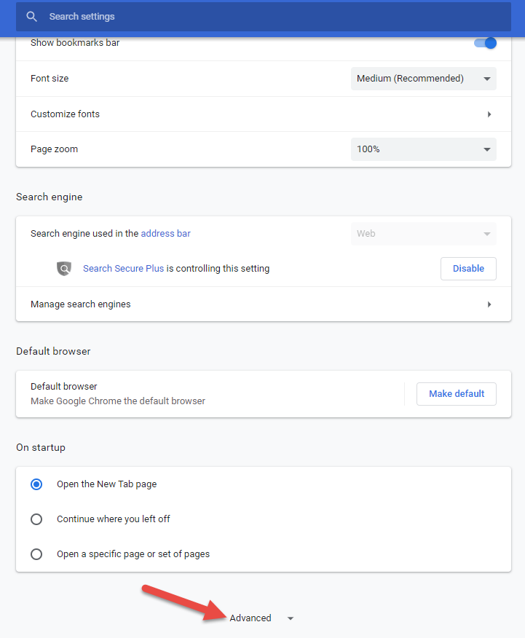

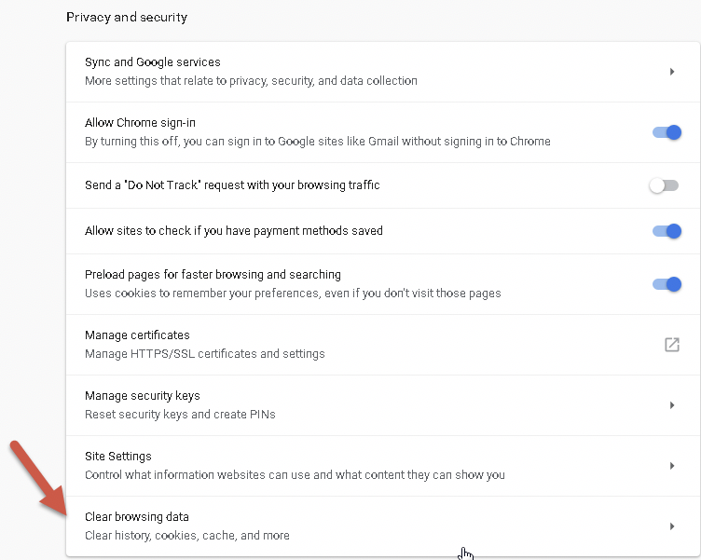

1. Click on “Clear browsing data” and then click on the “Clear data” button.

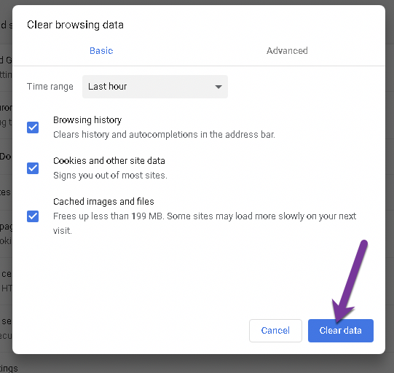

1. Restart your browser and try again.