**Faculty Release Time Request OnBase Form and Workflow User Guide for Dean’s Office Staff**

1. The form is available on the My Sac State portal. On My Sac State, it will be under **OnBase Forms**. In most colleges, department staff will submit forms for faculty members and Dean’s Office staff will perform quality control review of the submissions.

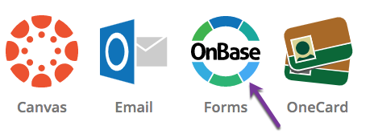

1. Please remember not to instruct your departments to initiate the form until the current year benefits rates have been added to the form, which typically happens in early August OR once you receive notification from Academic Affairs.
2. Instructions for how to complete each field on the form can be found on the Instructions tab of the form.
3. OnBase does not allow you to save a form in progress and return to finish it later so please ensure you have allowed sufficient time to complete the form in its entirety.
4. The Submitter will fill out the form and click **Submit** at the bottom. If any of the required fields are not filled out, the form will not submit. The Submitter should check the entire form to see what was missed and then click **Submit** again.
5. Workflow
   1. Dean’s Office Staff

**Faculty can approve any time after submission and prior to reaching OIREP**

* 1. Dean
  2. Office of Institutional Research, Effectiveness, & Planning
  3. Budget Office
  4. Next stop varies depending on funding source

1. Every Dean’s Office staff will have OnBase Unity Client installed on their computer. They can log-in using their SacState credentials.



1. When the Dean’s Office staff signs into OnBase Unity Client, they are going to see their Queue with all the forms that are waiting their review:

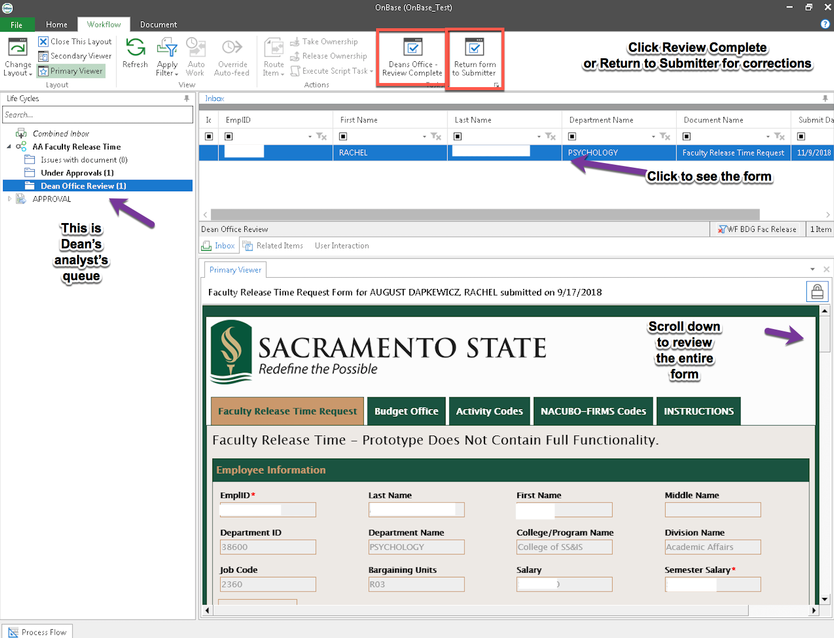

1. They can also access their processing queue on OnBase Web Client. They need to sign into <https://onbase.csus.edu/> ,click on the little “hamburger” button on the top left, and then click Open Workflow.

**For processing/approvals of the Release Time Request, please use Firefox. If you need to use Chrome, you might need to clear cache (see instructions attached). Safari 12+ is NOT compatible with OnBase.**

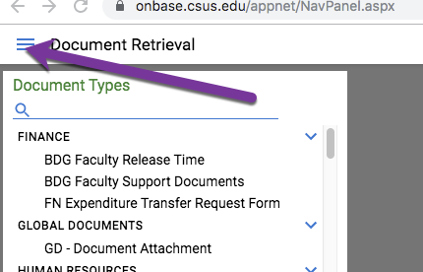

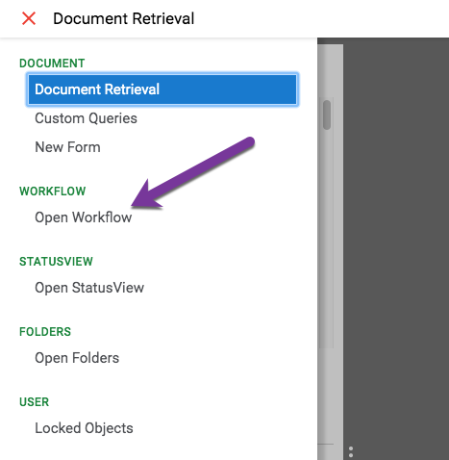

1. The view in the Web Client will be slightly different:

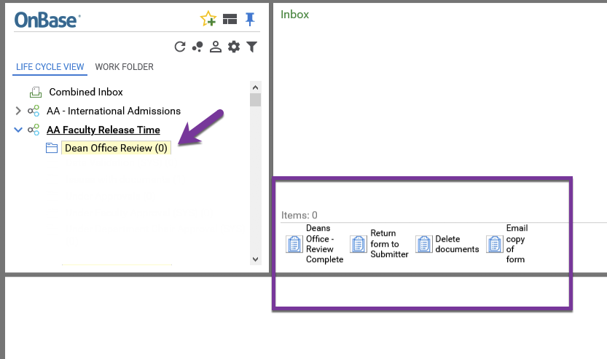

1. When done processing the form, click REFRESH button so the form moves forward.

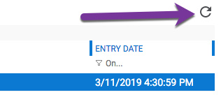

**When using web Client, please close your OnBase browser after you complete reviewing the form(s) to prevent them from getting locked.**

1. The Dean’s Office staff will need to open the form and scroll down to review. They will be able to make corrections and complete their review by clicking **Deans Office Review Complete** or **Return Form to Submitter**. They will be able to add a note – see the screenshot below:

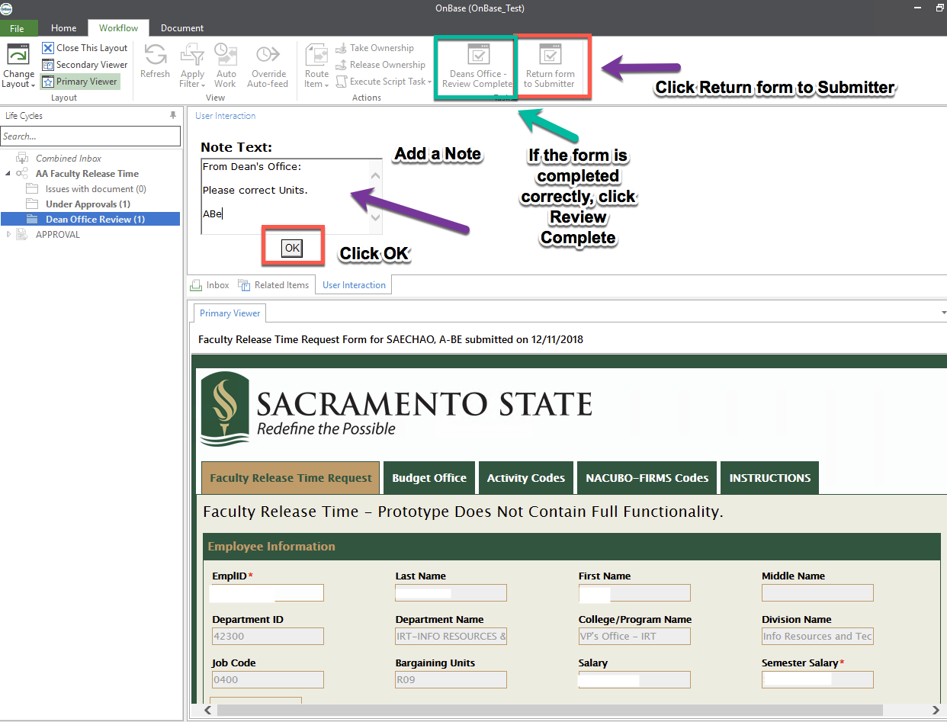

1. If the Dean’s Office staff cannot make corrections themselves, they will send the form back with the note asking for corrections (not encouraged). The Submitter will see the note and correct.
2. After corrections are made by the form Submitter, the form will come back to the Dean’s Office staff.
3. To retrieve a particular form or all forms from your department/college and see their status, go to the OnBase Web Client link from My Sac State. Click the three lines in the upper left hand corner and select Custom Queries. Choose AA Faculty Release Time Document type. You can look up a form for a particular faculty member or all of them in your department in the certain date range.

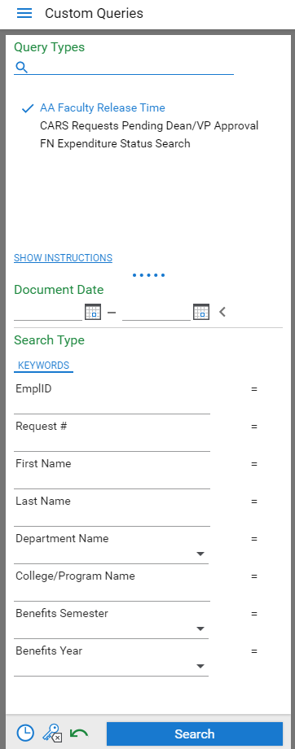

1. When you need to know where the form is located, you can bring it up and see the status of it:

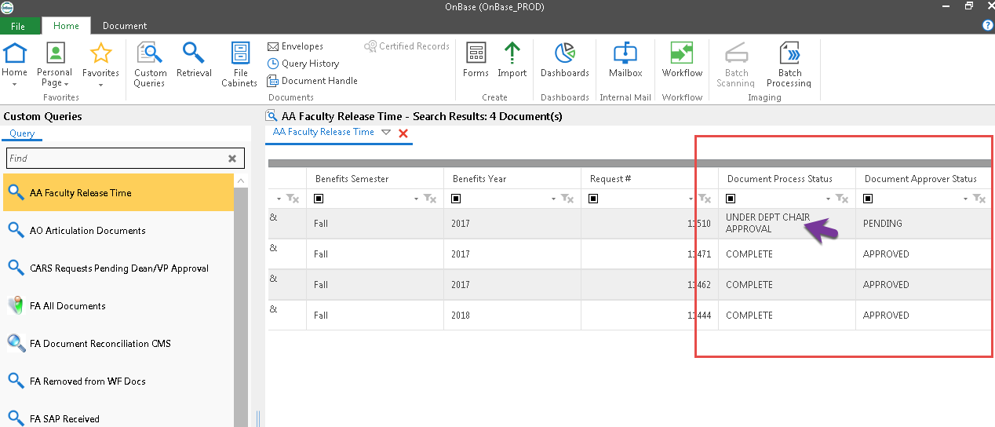

1. To look up the history of the form, right click on the file and choose History:

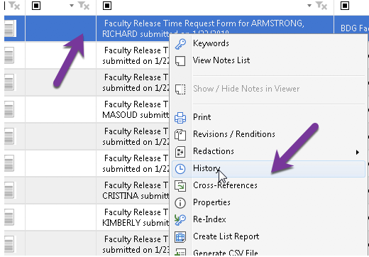

1. If you need to save the form on your desktop (it will save as image) you will have to email it to yourself or the faculty (if they need the copy):
   1. Open up custom query and search for the form you want to send.
   2. Once you have the form selected, click on tasks and then click “Email copy of Form”
   3. Or if you are done processing a particular form and want to send a copy of it, just click a button in your workflow view **Email Copy of a Form**

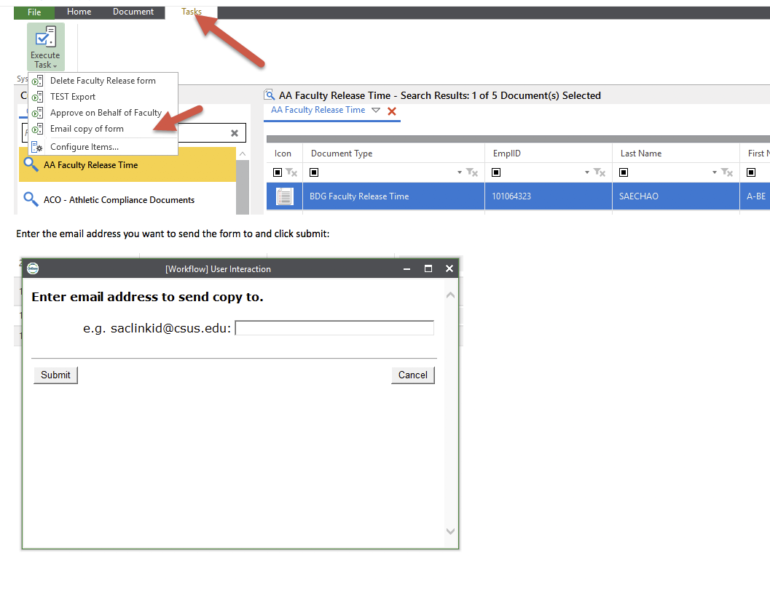

1. In order to access reports - There are 2 types of faculty release reports:
   1. “RPT – Faculty Release Time” is an exportable Excel report.
   2. “RPT – Faculty Release Time Workflow Overview” is a report to show an overview of where all the forms are in the workflow process.

In Web Client, click the top left corner “hamburger” icon and click Gallery

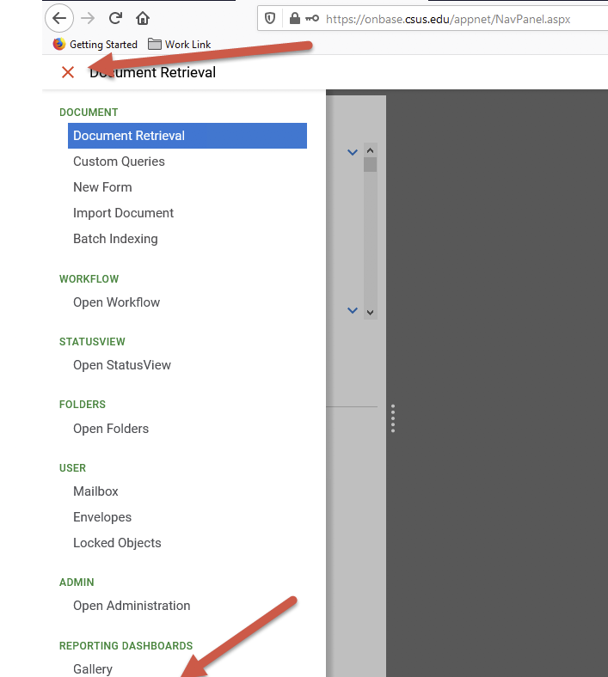

Click on Shared with Me

Click on RPT – Faculty Release Time OR Click on RPT – Faculty Release Time Workflow Overview

Enter Benefits Year and Benefits Semester you wish to retrieve and then click OK

Both reports will display information for all forms in the given parameters you provided

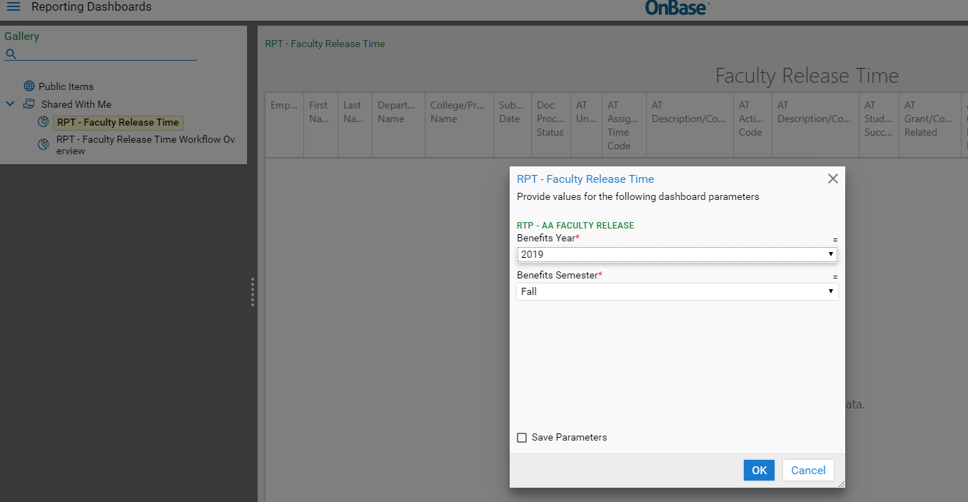

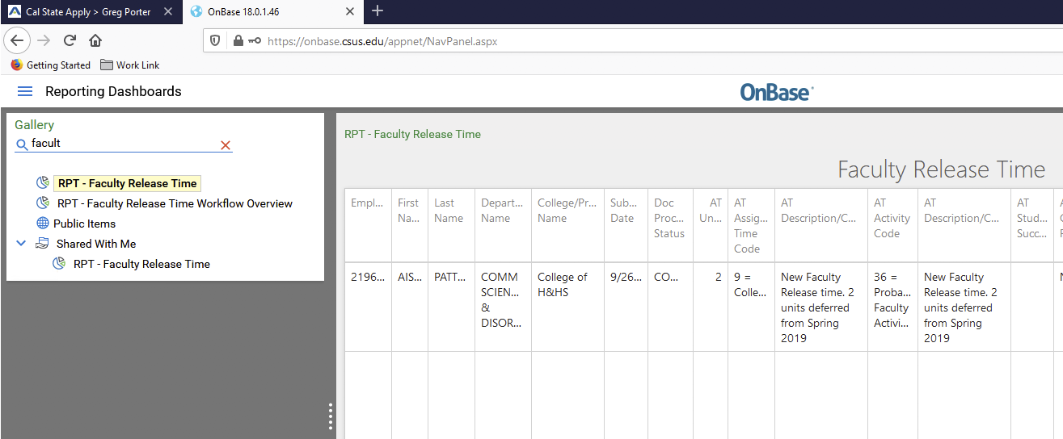

1. All Dean’s Office staff and OFS Analyst will be able to delete the form anywhere in the workflow. To do that, go to Custom Query and search for the form that needs to be deleted. Click on the form to highlight it (see the screen shot below)

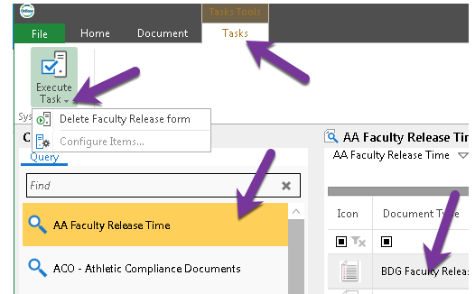

1. Click on **Tasks** and then **Execute Task** – you will see the drop down Delete Faculty Release Form. Click Delete. It will give you this prompt:

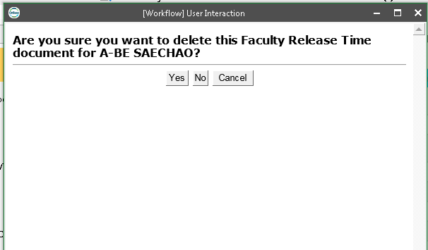

1. Click YES and form will be deleted.
2. Please note that the list of Dean’s Office staff is maintained manually so if there are any changes in your colleges and there are new employees coming in – please let IRT know so we can update the list of Dean’s office staff performing quality control. Please submit a service ticket through IRT website: <https://csus.service-now.com/service/?id=help>

For other questions, please refer to the materials listed below or contact the OFS Analyst:

* Instructions tab of the Faculty Release Time Request form in OnBase
* Clear Cache Instructions
* Faculty Release Time Use Guide for Faculty
* Faculty Release Time Use Guide for Chairs
* Faculty Release Time Use Guide for Deans