**Faculty Release Time Request OnBase Form and Workflow User Guide for Deans**

**\*For all approvals of the Release Time Request, please use Firefox. If you need to use Chrome, you might need to clear cache (see instructions attached). Safari 12+ is NOT compatible with OnBase.**

1. The Faculty Release Time request form will be submitted for the faculty members by the department administrative support staff through My Sac State portal.
2. After the form is submitted, it automatically routes to the appropriate Dean’s Office staff and then to the Dean.
3. Please sign into OnBase - <https://onbase.csus.edu/>. Click on the little “hamburger” button on the top left and then click Open Workflow.

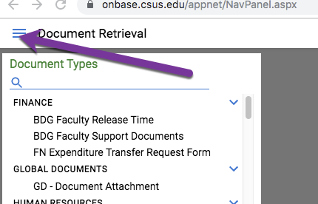

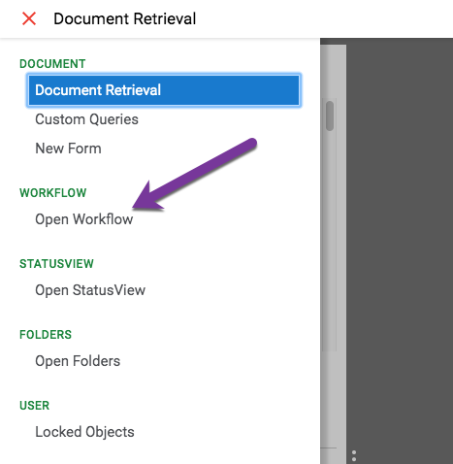

1. In the workflow window, click on the arrow next to the APPROVAL folder to see the Pending Approvals folder (or double-click on the word “APPROVAL”). Then click on the Pending Approvals folder to see the form appear in your inbox to the right.

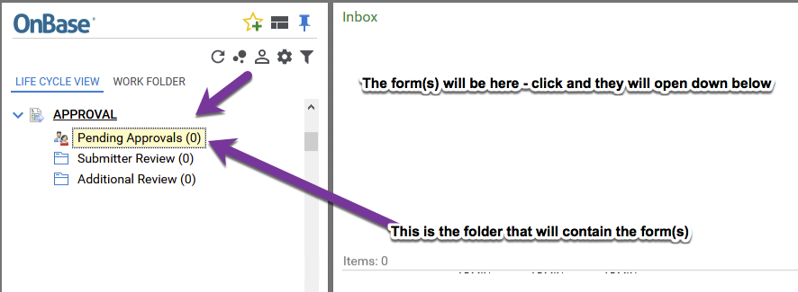

Click on the form in the “Inbox” at the top of the screen to see the form open at the bottom of the screen.

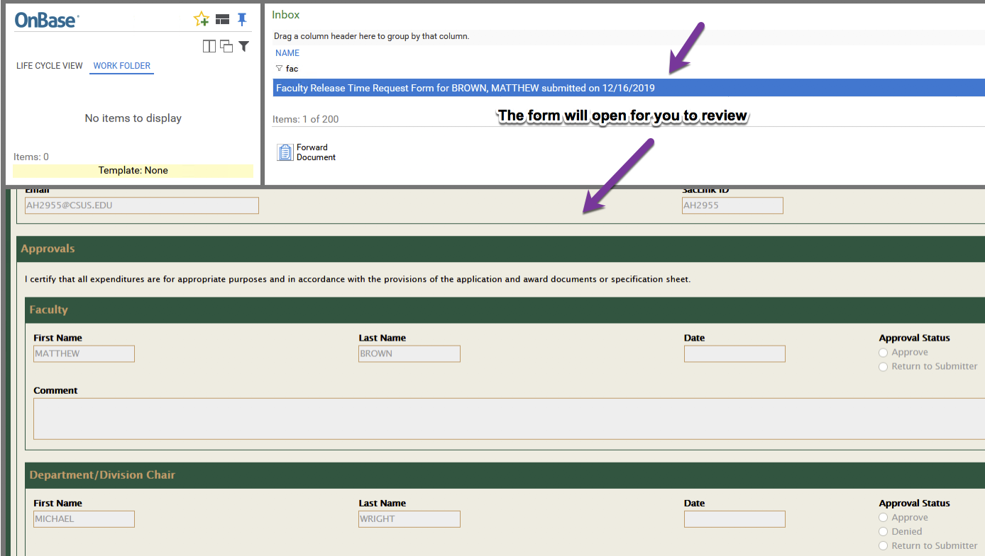

1. Review the form and scroll down to the College Dean approval section:
   1. If the form is correct and you approve the listed time, please select **Approve**, then click **Submit** at the bottom of the form. The form will route to Academic Affairs for review.
   2. If something needs to be corrected on the form, you can select **Return for Correction**. Include a comment in the **Comment** box to let them know what’s wrong. Then, click **Submit** on the bottom of the form after that. The form will route back to your administrative analyst; they will be able to correct and re-submit the form, which will then route back to you.

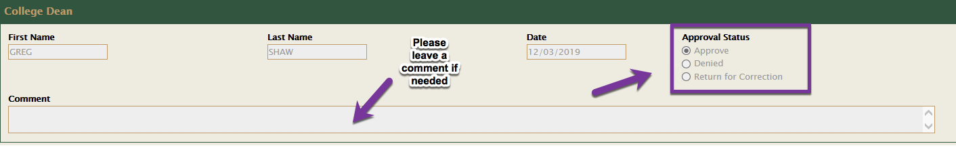

**If the College Dean approval section is greyed out and you’re unable to click on the radio buttons:**

1. Somebody else could have this form open at the same time, which locks the form. You could either try to find out who is looking at the form (e.g., your administrative staff person) and ask them to close it, or close your browser and try again later.
2. If you are using Chrome, you might need to clear your cache (instructions will be attached).
3. After you click the **Submit** button, the form may not automatically disappear from your inbox at the top of the window. In order for it to leave your queue, please click **REFRESH** button on the top right of your OnBase window.

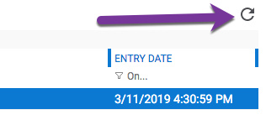

**Please close your OnBase browser after you complete reviewing the form to prevent the form from getting locked.**