**Faculty Release Time Request OnBase Form and Workflow User Guide for Department Staff**

1. To prepare a form, log into the My Sac State portal and click on the **OnBase Forms** icon. A new tab will open with a list of links; select **Faculty Release Time**. In most colleges, department staff will submit forms for faculty members and Dean’s Office staff will perform quality control review of the submissions. If you are unsure if you should submit forms, please check in with your college analyst.

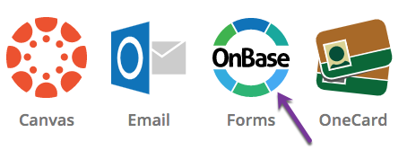

1. Please note: While this link will be active year round, you should wait for instructions from your college analyst before preparing any forms for a given semester. These will typically come in early August for Fall semester, and early January for Spring semester.
2. Instructions for how to complete each field on the form can be found on the Instructions tab of the form.

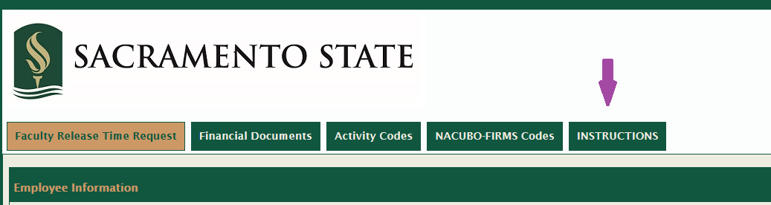

1. Please fill out the form and click **Submit** at the bottom. If any of the required fields are not filled out, the form will not submit. Please check the entire form to see what was missed and then click **Submit** again.

1. After you submit the form, it will move through the following workflow:
   1. Dean’s Office Staff

**Faculty can approve any time after submission and prior to reaching OIREP**

* 1. Dean
  2. Office of Institutional Research, Effectiveness, & Planning
  3. Budget Office
  4. Next stop varies depending on funding source

1. If the Dean’s Office staff find an error on the form, they will have the option to return it to you for corrections. If they do, they should include a comment in the relevant approval section of the form (toward the bottom) indicating why they’ve returned the form. You should receive an email when this happens with a link to the relevant form.  
     
   After you’ve made the necessary corrections, click **Submit** to get the form moving through the workflow process again.  
     
   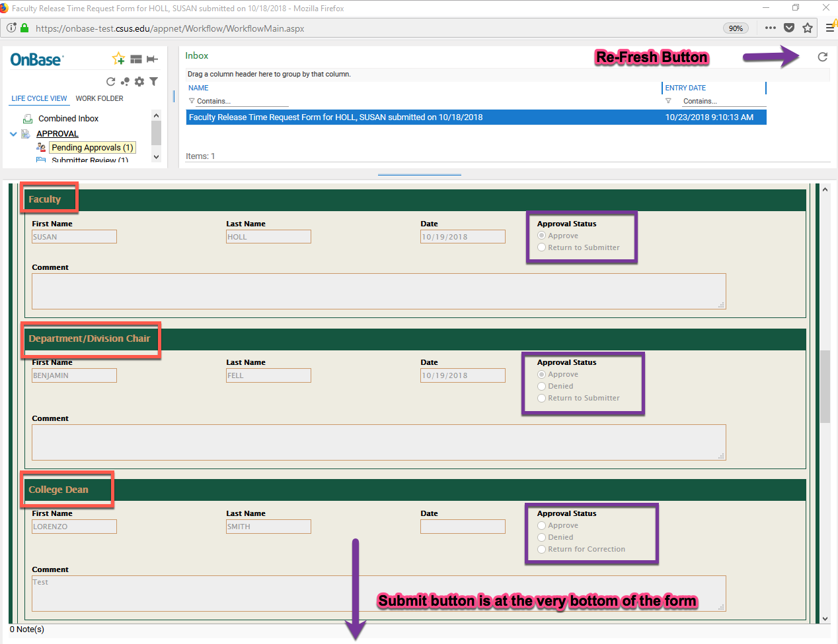
2. To see the status of the forms you’ve submitted for your department, or to review a particular form, log into the OnBase portal at <https://onbase.csus.edu/> (this is separate from the OnBase forms link in MySacState). Click the three lines in the upper left hand corner and select Custom Queries. Choose AA Faculty Release Time Document type.

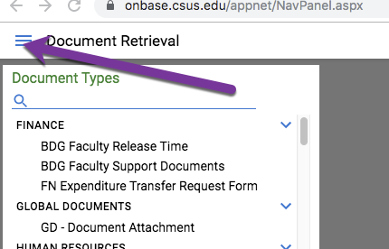  
  
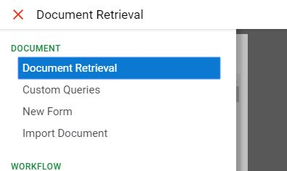  
  
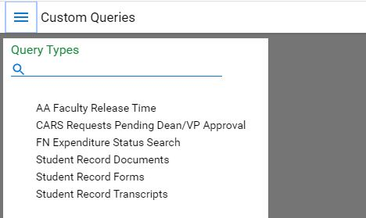

Use the filters at the bottom left of the window to find the forms you’re looking for. Please note:

* The filter terms must match what appears on the form exactly, including spaces and punctuation. It will probably be easiest to search by department (using the drop-down menu) to find all of your forms, or by EMPL ID to find a specific form.
* This query will find every release time form that’s ever been entered in OnBase. Be sure to include Benefits Semester and Benefits Year filters to find the forms you actually want to see.

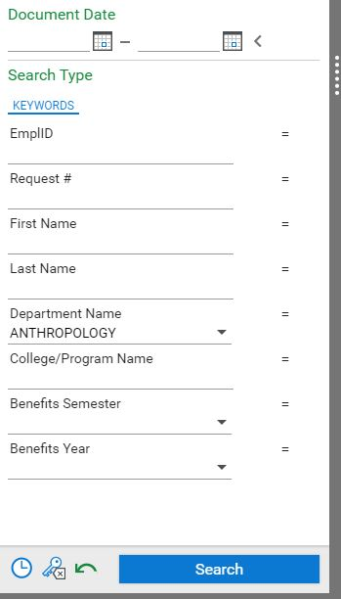

The results of your search will appear in the Custom Query Results pane at the top right of the window. Please note:

* You can double-click on any row in the results to see the selected form/document open at the bottom right of the window.
* You might see multiple rows for the same faculty member. If you attached any supporting documents to a form, each one will appear as a separate row in the results in addition to the release time form. Check the Document Type column to help identify what’s what.
* The Custom Query Results have several columns of data. Scroll to the right to find the Document Process Status column. This will tell you where the form is in the workflow process.
* Only one person can view/edit a given form in OnBase at any given time. Please close your OnBase browser after you complete reviewing what you need to see to ensure you don’t lock the form for someone else (e.g., the next approver in the workflow process).

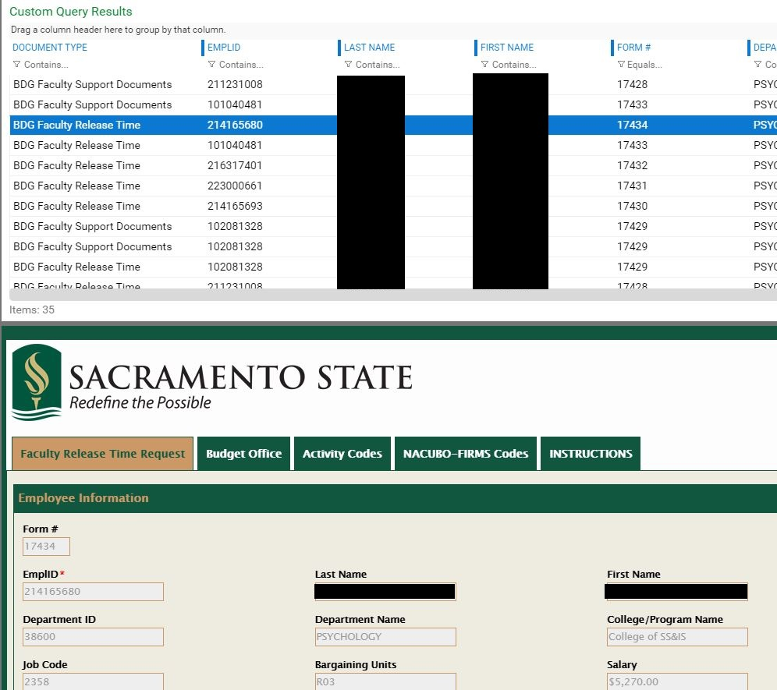

1. For other questions, please refer to the materials listed below or contact your Dean’s Office staff:
   1. Instructions tab of the Faculty Release Time Request form in OnBase
   2. Clear Cache Instructions
   3. Faculty Release Time Use Guide for Faculty
   4. Faculty Release Time Use Guide for Chairs