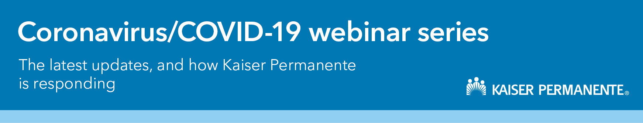

With rapid changes in what we know about COVID-19, we are offering a webinar series focused on the most common questions we hear, the latest clinical news, and the impact of COVID-19 on the mental health and well-being of your workforce. Join us and get information on how to navigate this global crisis.
Updated: October 30, 2020

 | Upcoming Sessions | Registration |  | More Info
 | - November 16, 10:00am PDT – COVID-19 – Updates on the Latest Science: Clinical trial updates, coronasomnia, coronaphobia, and the long-term effects of COVID-19 | Click Here
 | - December 16, 10:00am PDT – COVID-19 – Updates on the Latest Science | Click Here |  | Coming Soon
Recorded Webinars
- Emotional well-being and your workforce in the time of COVID-19: On Demand Here
- Mental health and COVID-19: On Demand Here
- Updates on COVID-19: On Demand Here

Additional Resources
This is a challenging time for everyone. We’re here to help you and your employees get through it. Together, we can work to keep our communities healthy and strong. Coronavirus support for you and your employees
Preparing for the next normal at work playbook: Download PDF
Planning for the next normal at school: Playbook for School Reopening

