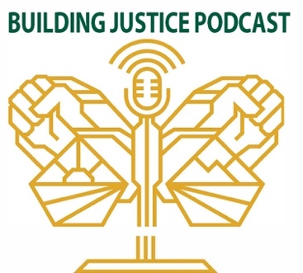

CRISJ Building Justice Podcast
Season X, Episode Y : ADD YOUR EPISODE TITLE
Moderator: ADD
Guests: ADD
Please note: This transcript may be imperfect. Please contact X directly should you have questions.
_____________________________________________________________________________
Music lyrics:
Company under construction, the function, justice for the human family we demand it. Justice, true freedom, equality is a must. Thus, decolonization of the planet. So bust this. People be the power now we’re Building Justice. Pulling out divinations, now we’re Building Justice. Welcome the planet to the Podcast, “Building Justice,” “Building Justice,” “Building Justice.” Building is to add on, or to do away with.

Introduction
Welcome to Building Justice, a podcast by Sacramento State’s Center on Race, Immigration
and Social Justice (CRISJ) . We explore critical issues affecting our communities with the hopes
of creating a healthier and more just world.

ADD YOUR CONTENT HERE

Concluding Language
Thank you for listening. We hope our ongoing conversations spark understandings, empathies, and motivation to join the struggle for a better future for all. {PAUSE......} You just listened to the ‘Building Justice’ podcast. The information contained in this podcast, including its title and description represent the views and opinions of the hosts and guests and do not necessarily represent the views or opinions of the Sacramento State, CRISJ and/or the ‘Building Justice’ podcast committee

Outro Music Lyrics
No more penalties and no more wars. Based on the actions. Now, time for "Building Justice," "Building Justice." Time for building justice, justice.

