
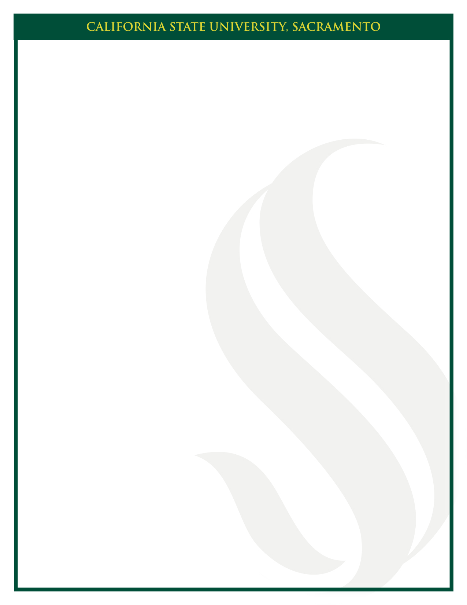
DOCTOR OF AUDIOLOGY
doctoral project
oral defense
Friday, March 7, 2025
2:00 PM
Folsom 1049
Department of Communication Sciences and Disorders

Hearing Screenings for Students with an Individualized Education Plan
Elimar Alvarado

Impact of Spanish Dialects on Word Recognition Scoring
Noemi Celio

Burnout: Audiology Professionals and Students
Riley Kinder

Self-advocacy and Accommodations Used by Audiology Students and Audiologists with Hearing Loss
Kevin Liu

Language Modalities for Deaf and Hard of Hearing (DHH) Children: What Information Is Provided?
Monique C. Merrill

Do Gamers Hear Better? A Study of Speech-in-Noise Perception in Multiplayer Video Gamers and Non-Gamers
Mallory Sellens-O’Connell

Dental Hygienists’ Perceptions on Hearing Conservation
Elizabeth Wyllie

