CECConnect: How to submit Recreation, Parks & Tourism Administration (RPTA) Internship Forms

Contents
CECConnect: How to submit Recreation, Parks & Tourism Administration (RPTA) Internship Forms 1
Instructions: 3
Getting Started: 3
Step 1: Create a CECConnect account 3
Step 2: New CEC Connect Accounts & Major Placements 4
Step 3: Returning Users/Getting Familiar with CEC Connect 9
Step 4: Completing and Submitting Internship Forms 11

Instructions:
Prior to submitting any RPTA internship form you must have:
- Completed or are in the process of completing pre-internship hours (Form A)
- Attended a Mandatory Student Internship Meeting with the RPTA Internship Coordinator
- Identified where you will be doing your internship
- Met with your Academic Advisor to discuss your Form A, internship plans, goals and internship agency with your Academic Advisor

Getting Started:
Many of you may have a CECConnect account already, particularly if you took RPTA 106 and did service learning. To check if you do or if you know you do, skip on to Step: 3 Returning Users/Getting Familiar with CECConnect
Otherwise, start here:

Step 1: Create a CECConnect account
- Go to: CEC Connect:
https://app.calstates4.com/csus
- On the welcome page click on the “Student/ Faculty Log In” button
- Answer the prompted questions for account registration



Step 2: New CEC Connect Accounts & Major Placements
- Once logged in, you will see either the “Homepage” or you may be prompted to select a “Program that matches your major”
- If you are taken to the homepage, please skip to: Step 3 Returning Users/Getting Familiar with CEC Connect
  - Do not create multiple placements for your internship, if you need assistance, please email: mavie.marquez@csus.edu
- If you are prompted to select a program, make your selection by clicking on the button under your major’s program
  - Major selections:
    - Hospitality and Tourism Management (HTM)
    - Recreation Management (RA)
    - Recreations Therapy (RT)

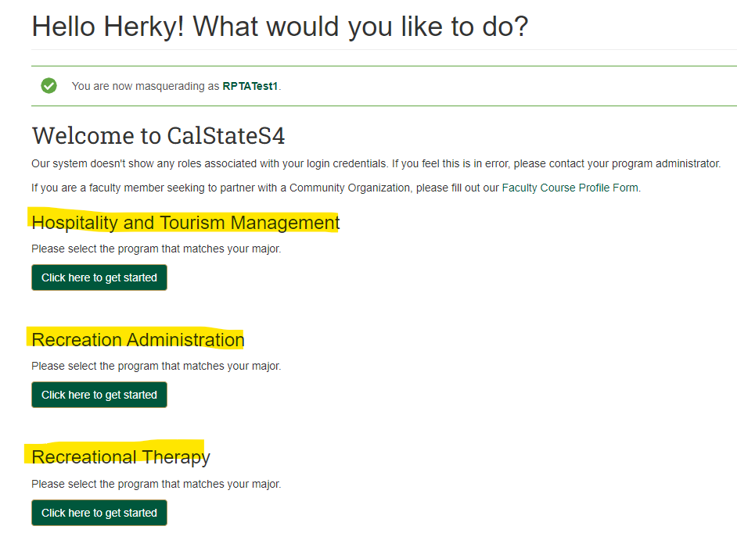

- Enter required fields
- Check the box to “confirm”
- Click on “Update my account” button

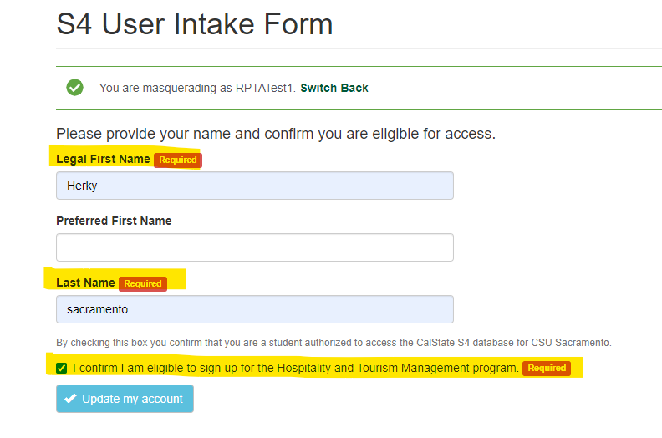

- Click on the “Place” button
  - Do Not click “browse”. If you accidentally click” browse”, you will have to go to “Homepage”, then click on the “Place” button

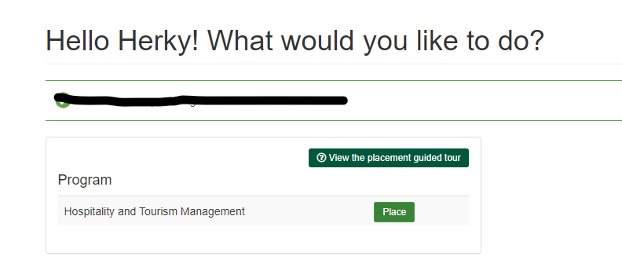

- Click “Search by Site” button
  - Note: “site” in this case indicates you are selecting your placement major program within CEC Connect to access RPTA internship forms. This does not mean you are selecting an internship site/agency location.
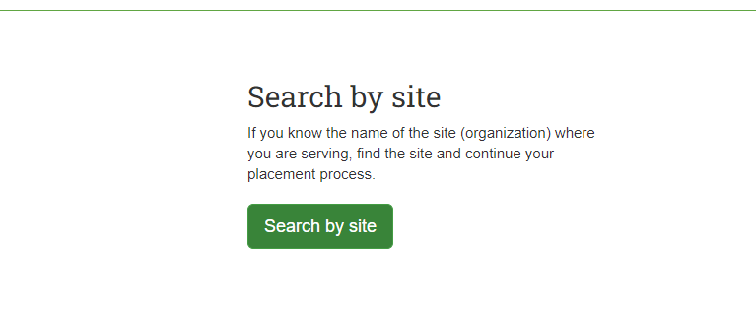

- Search for RPTA Intake Forms
  - In “Site Name” box type RPTA
- Click the “Apply Filter” button
- Click on “RPTA Intake Forms” (green font)

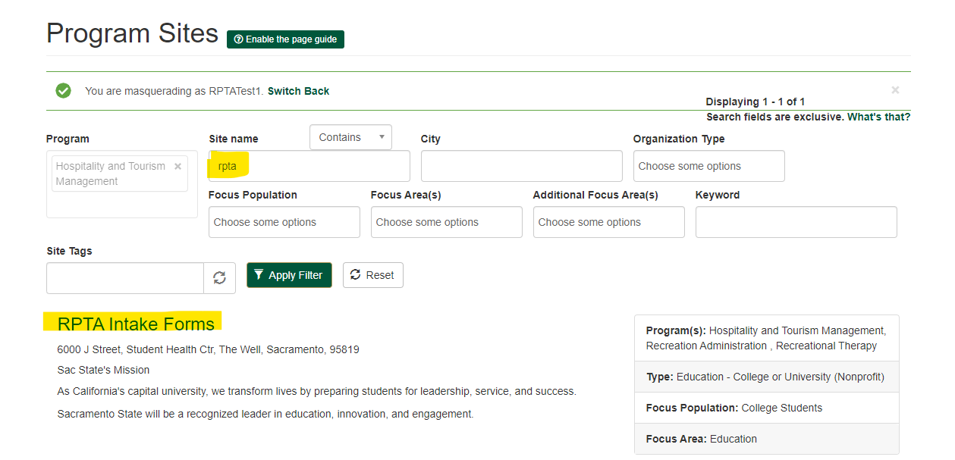
- Click on the “Select this site” button
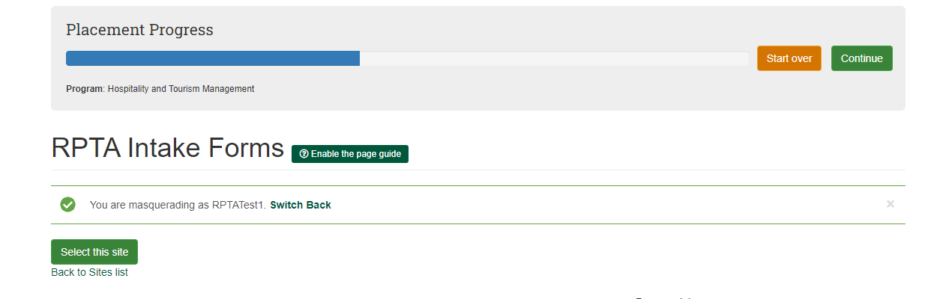
- Type the term and year that you plan to do your internship in the “Term” box
- Type the anticipated number of hours you will need for your internship in the “hours” box (
  - example: 400 hours for RA & HTM, 560 hours for RT
- Click on the “Next” button.
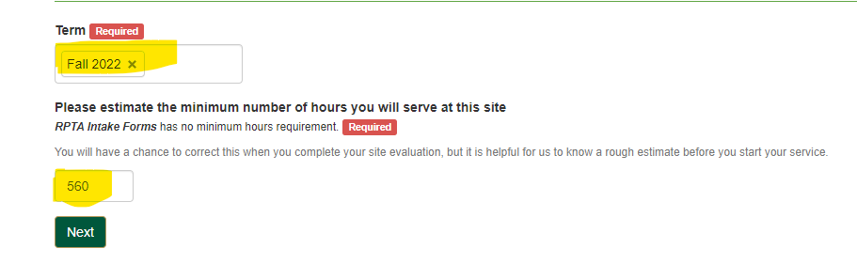

- Click on the “Finish Placement” button

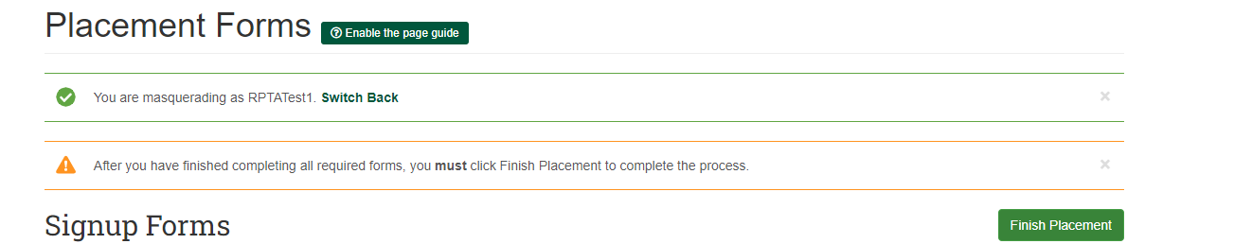

- Placement to your “RPTA Intake Forms” is now complete
- A “Placement” number is assigned for your program in CEC Connect
- Use this “Placement” number to access, complete and submit your internship forms
  - If you plan to complete and submit your forms later, go to Step 3: Returning Users/Getting Familiar with CEC Connect to find your internship forms again

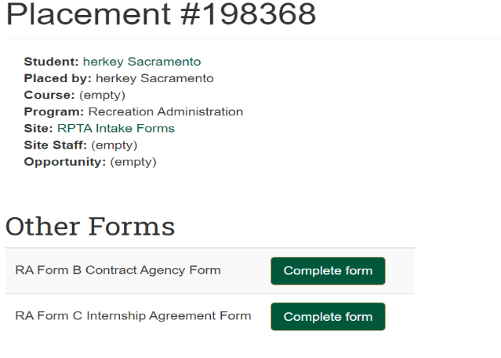

Step 3: Returning Users/Getting Familiar with CEC Connect

If you have already created a CEC Connect account and added the RPTA Intake Forms, you can view your “placement” and internship forms by following these steps:
- Go to “Home” page
- Scroll down and click on “View my placements” (green font)
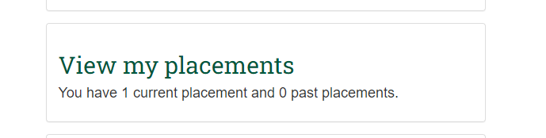
On the following page, you can view all your placements for each term. Things to check for:
- That you have one major placement number
  - If you have more than one, your account will need to be updated prior to submitting any internship forms
  - If you do not have any RPTA major placements, go back and follow the instructions on Step 2: New CEC Accounts & Major Placements
- That your placement number is under the term that you plan to do your internship
  - If your term is not correct, your account will need to be updated prior to submitting any internship forms
  - To update your account email: mavie.marquez@csus.edu

If you have already checked the two items above, continue to view your RPTA Major Placement and access your internship forms
- Click on your RPTA major placement number to access your internship forms (green font)

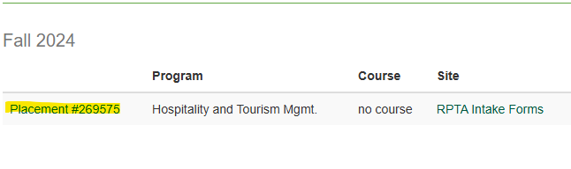
- On the following page, you will see the current term internship forms
  - Internship Agreement Form C (RA & HTM majors)
  - Internship Agreement Form D (RT majors only)
  - Agency Contract Form B

Step 4: Completing and Submitting Internship Forms
- Click “Complete form” for the forms you want to submit
  - You can save a draft of a form you started and come back to complete it later by clicking on the “Save Draft” button at the bottom of your form
    - To access an already started draft email: mavie.marquez@csus.edu
    - Do not create multiple placements or open multiple drafts for the same form
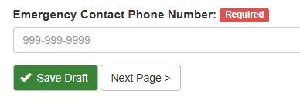
- Prior to submitting forms, ensure that all information is complete and correct
  - Incomplete or incorrect forms may not be processed
  - If you need to update information on a submitted form, email: mavie.marquez@csus.edu for further assistance

