CECConnect Instructions for Access to RPTA Internship Forms

Some students created a CECConnect account when taking RPTA 106 and did service learning.
If you have previously created an account or used CEC Connect but NEVER accessed RPTA Intake Forms, skip to Step 3. If you are not sure if you have accessed RPTA Intake Forms, please check by following instructions on Step 4. DO NOT PLACE YOURSELF MULTIPLE TIMES. If you need assistance please email: rpta@csus.edu
If you already have a CECConnect account & have ALSO accessed RPTA Intake Forms before, Skip to Step 4.
If you have NEVER created a CECConnect account START HERE STEP 1…
Step 1: Create a CECConnect Account
- Go to the CEC website https://www.csus.edu/experience/anchor-university/community-engagement-center/
- Click on CEC connect. This will route you to Welcome Page.
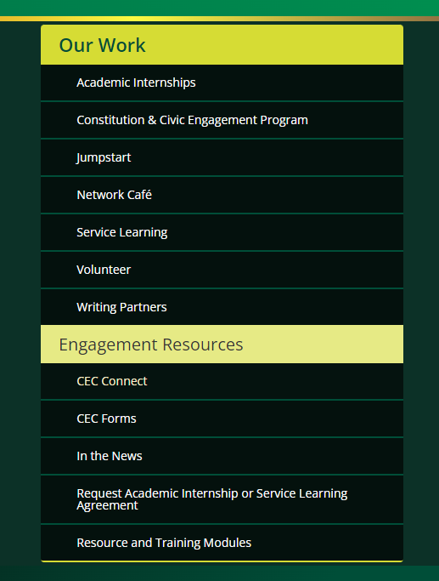

- On the welcome page click on Student/ Faculty Log in.
- You will be prompted to answers a couple of questions.

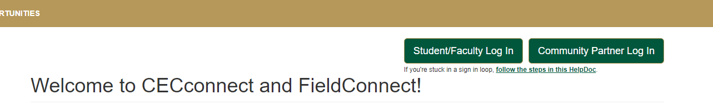
Step 2: Brand new account for CEC Connect
- When logged in for the first time you will see 3 options to choose from.
- Click on the option that “matches” your degree.
Note: if you plan to change your major, choose the option for the major that you plan to intern in.
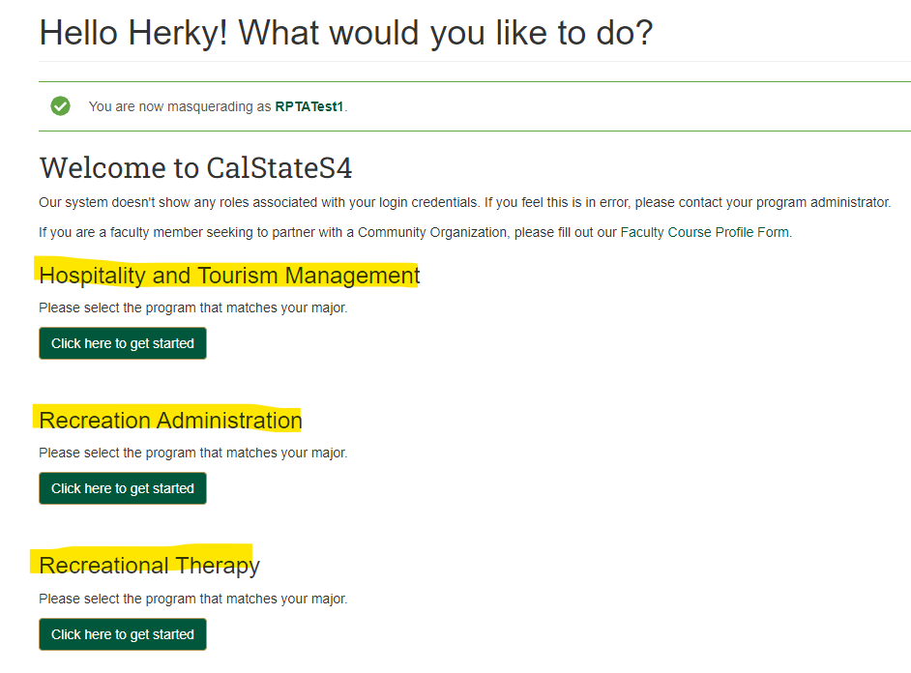

- Enter required fields, check that you confirm and click Update my account.
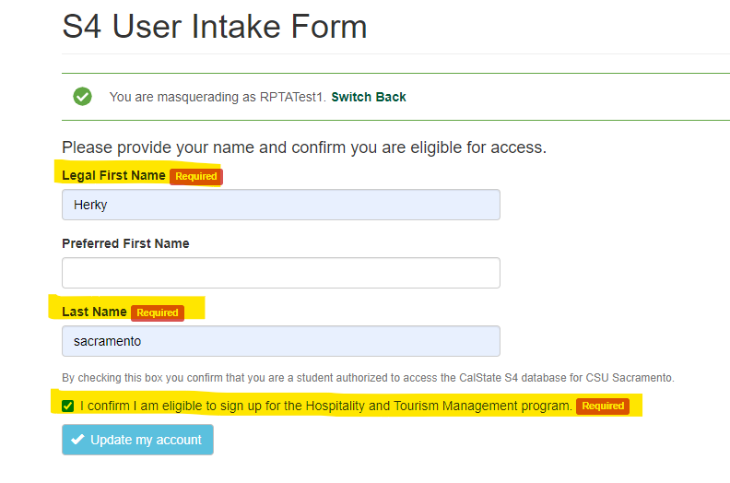
- Click “Place” (DO NOT click “browse”. If you accidentally clicked on” browse”, you will have to go to “HOME”, then you can click “Place”.)
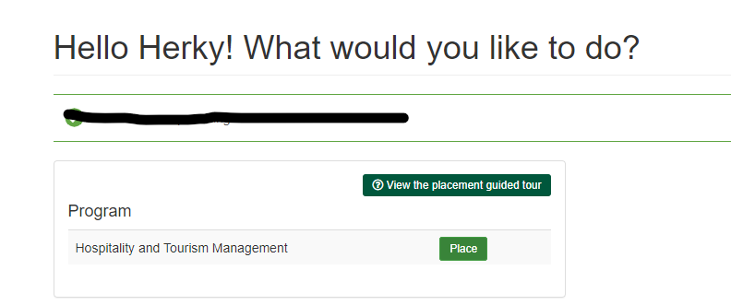

- Click “Search by Site”
Note: “site” in this case indicates you are selecting your placement program in CEC Connect to access RPTA internship forms. This DOES NOT mean you are selecting an internship site location. At the appropriate time, the department administrator will place you at your agreed internship site location.
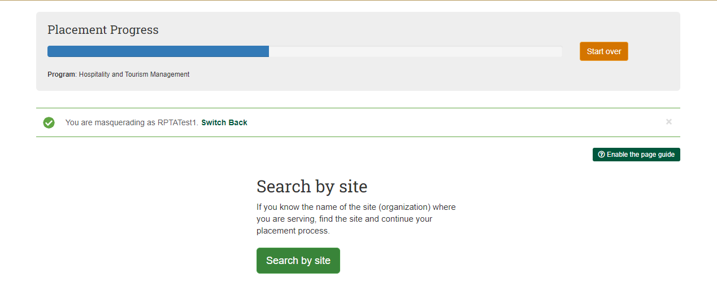

Step 3: Accessing RPTA Intake Forms
Previous Users: Some of you may have previously “placed” to access your RPTA Intake forms. To check if you already have access to the RPTA Intake forms skip to Step 4.
If you just now created an account or have previously created an account but NEVER accessed your RPTA Intake forms follow these steps:
- Click on the “Sites” Tab at the top of your “Dashboard”
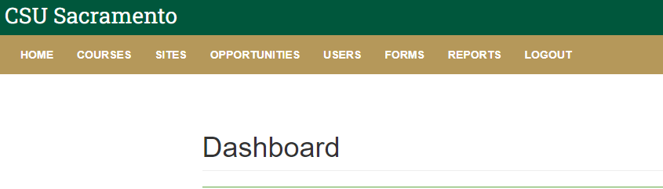

You will need to search for RPTA Intake Forms
- In “Site name” type RPTA.
- Click apply filter, this will bring up “RPTA Intake Forms”.
- Click on “RPTA Intake Forms”.
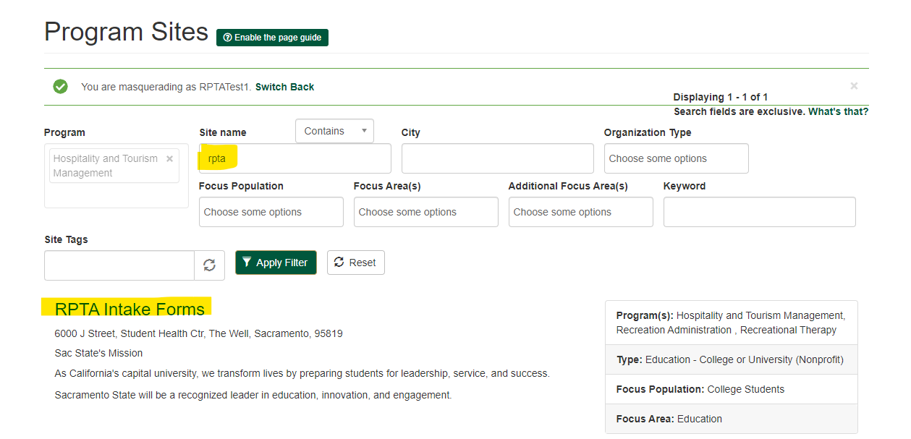
- Click “Select this site”

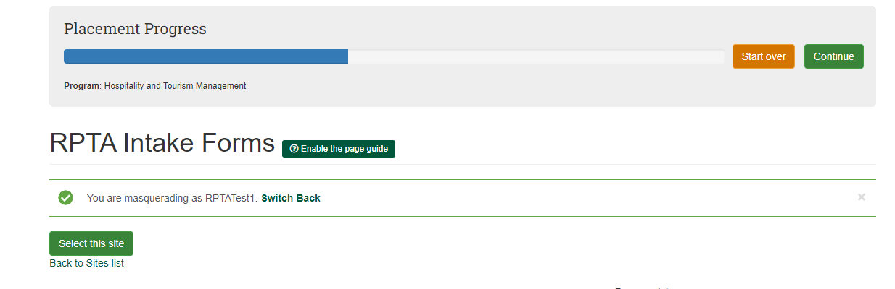

- On the “Dates of Placement” page select the term and year that you plan to do your internship.
- Put in your anticipated number of hours you will need to complete your internship. (400 for RA & HTM, 560 for RT)
- Click on the “Next” button.

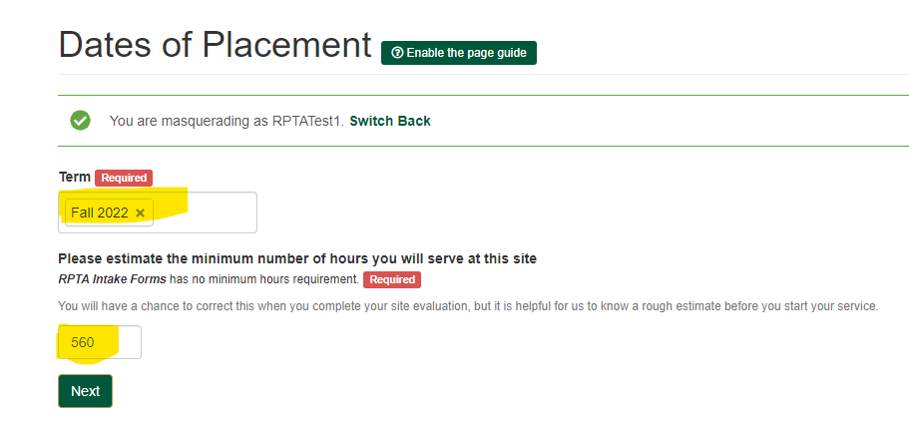

- On the “Placement Forms” page, click on “Finish Placement”
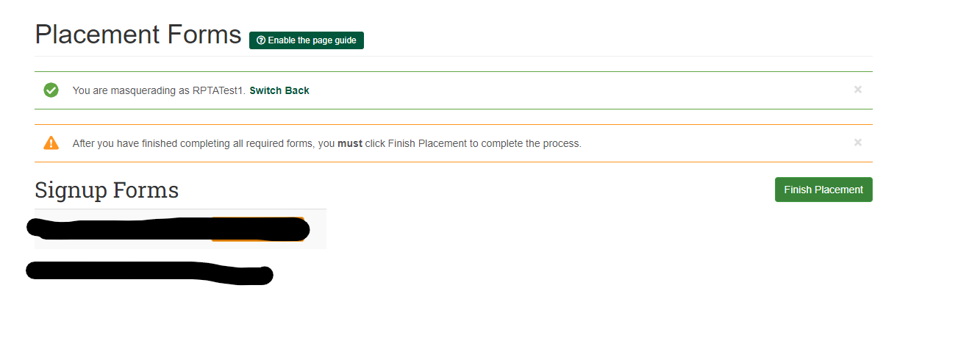
- Placement to your “RPTA Intake Forms” is now complete. You will be assigned a placement # to access to your form B and C. This placement # will be useful, to access or submit your forms at a future date.

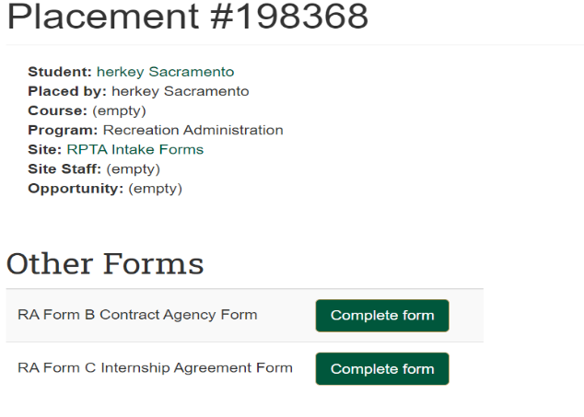

DO NOT fill out internship forms until you have completed the list below:
- Identified where you will be doing your internship.
- Completed or are in the process of completing your pre-internship hours (form A).
- Discussed your form A and your upcoming internship with your RPTA Academic Advisor.
- Received approval to fill out internship forms from your RPTA Academic Advisor.
If you receive approval from your RPTA Academic Advisor at a later date, follow instructions on Step 4 to access and submit your internship forms.

Step 4: Checking/Accessing your RPTA Intake Forms for Returning CECConnect Users

- Once you’ve logged on and are on your “Home” page, scroll down and click on “View my placements” (green font)
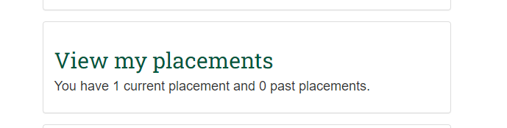
You should be able to view all your placements on the following page.
If you do not have “RPTA Intake Forms Placement”, go back and follow instructions on Step 3.
If your “RPTA Intake Forms” site doesn’t have the correct semester date in which you will do your internship or doesn’t match your current major program, please contact the RPTA Dept: rpta@csus.edu for additional instructions.
Otherwise, follow the instructions below:
- Look for the placement that corresponds to your Major Program and internship semester date then click on that “Placement #” (green font)
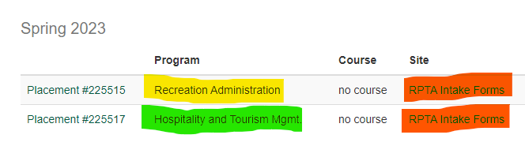
Now you will have access to Form B and Form C for RA or HTM; or Form B and Form D for RT
- Click “Complete form” next to the form you are wanting to submit.
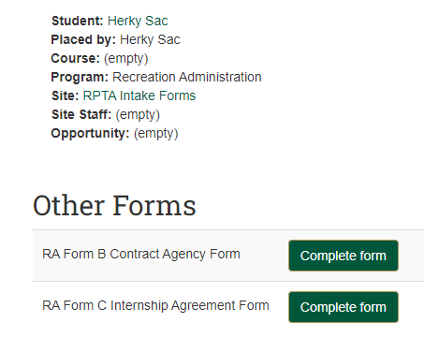
- When filling out a form, double check that all the information is correct. Incorrect or incomplete forms will not be processed. If you have submitted the form and then realize you need to make changes, please contact the RPTA Dept: rpta@csus.edu for further instructions.
DO NOT fill out internship forms until you have completed the list below:
- Identified where you will be doing your internship.
- Completed or are in the process of completing your pre-internship hours (form A).
- Discussed your form A and your upcoming internship with your RPTA Academic Advisor.
- Received approval to fill out internship forms from your RPTA Academic Advisor.

