How to schedule an advising appointment through EAB:
Log in to your My Sac State Student Center.
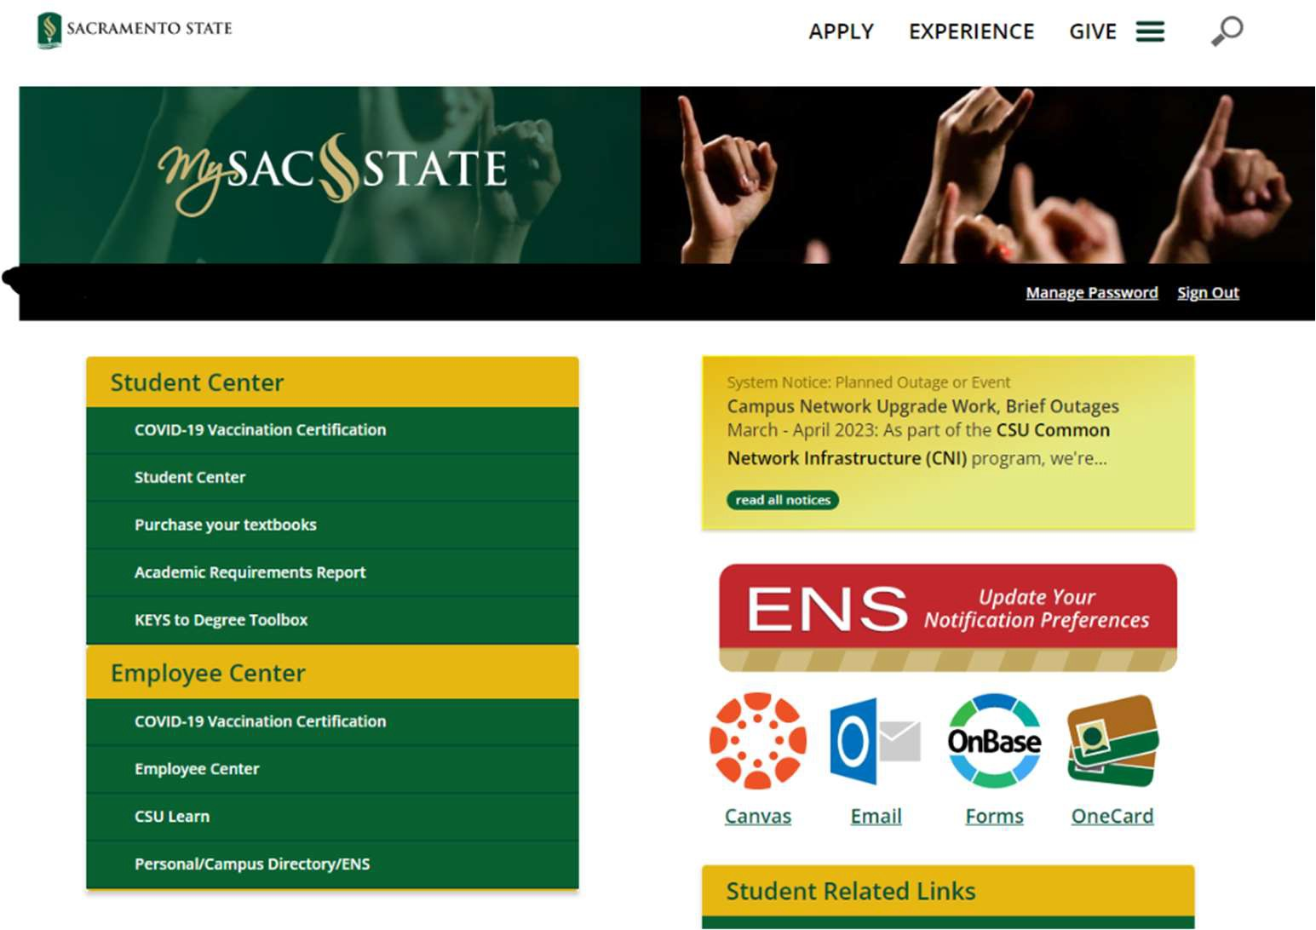

Scroll down to the "Student Related Links" and click on "EAB Navigate - Advising Appointment Scheduling".

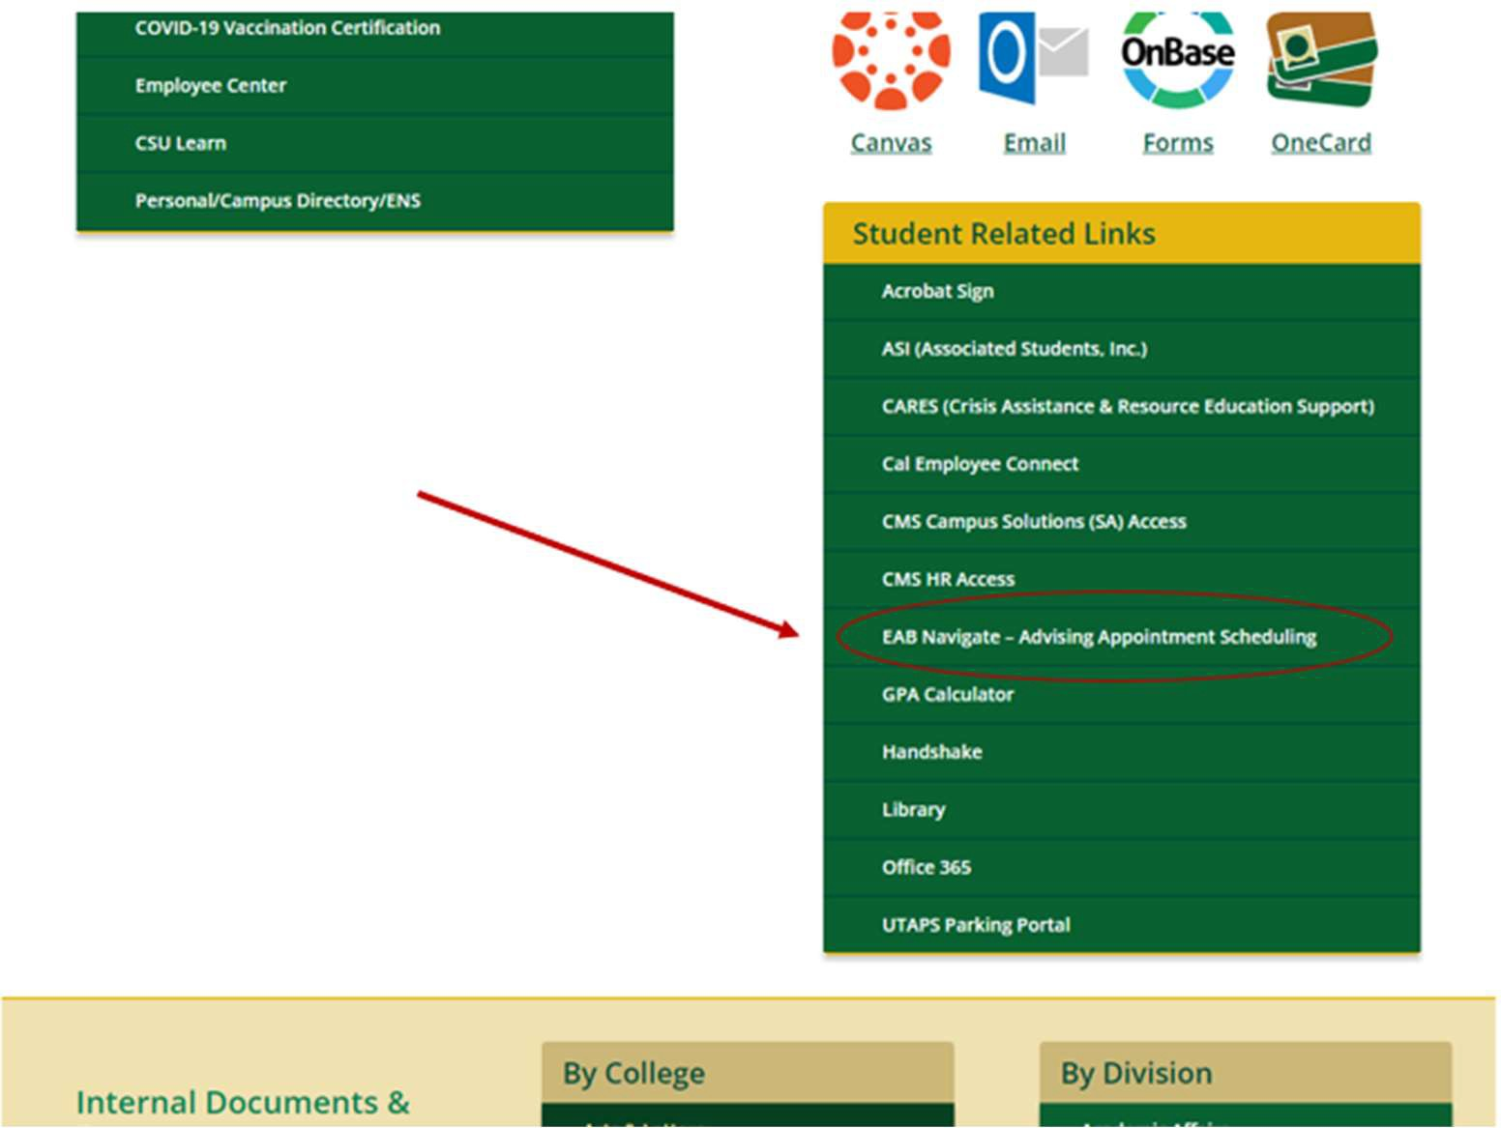
Click the blue “Get Assistance” button on the right side of the page.
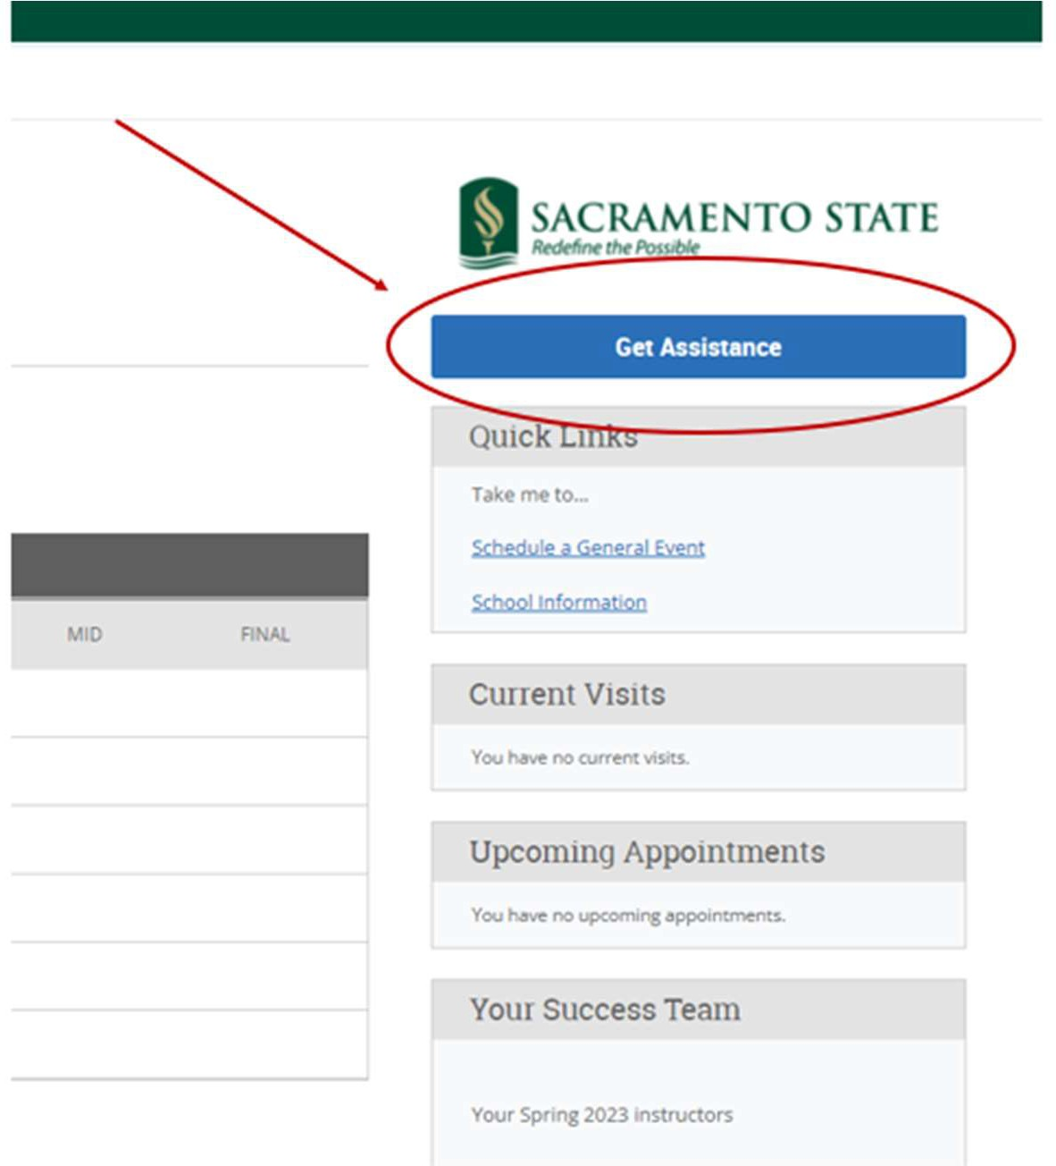

Select “Advising” for type of appointment.
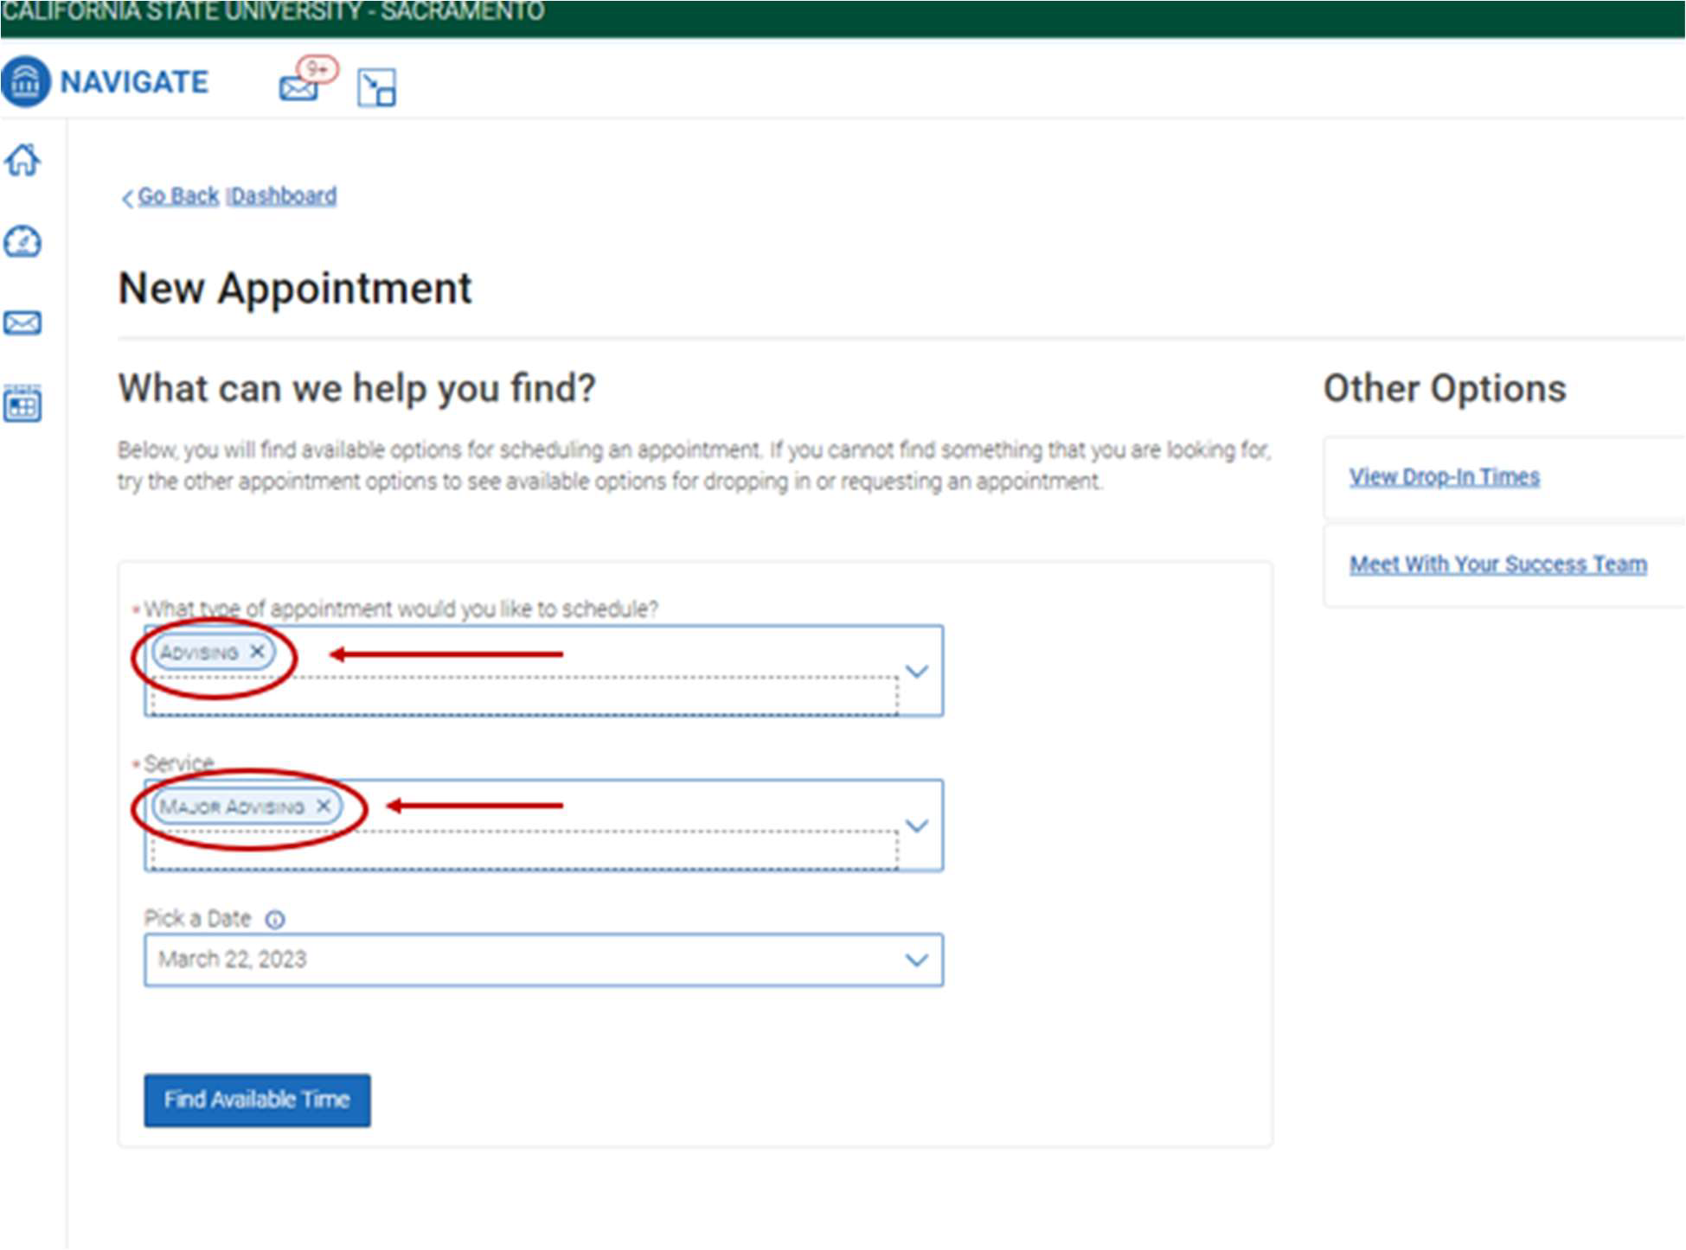
Select “Major Advising” under College of SSIS Student Success Center for type of service.
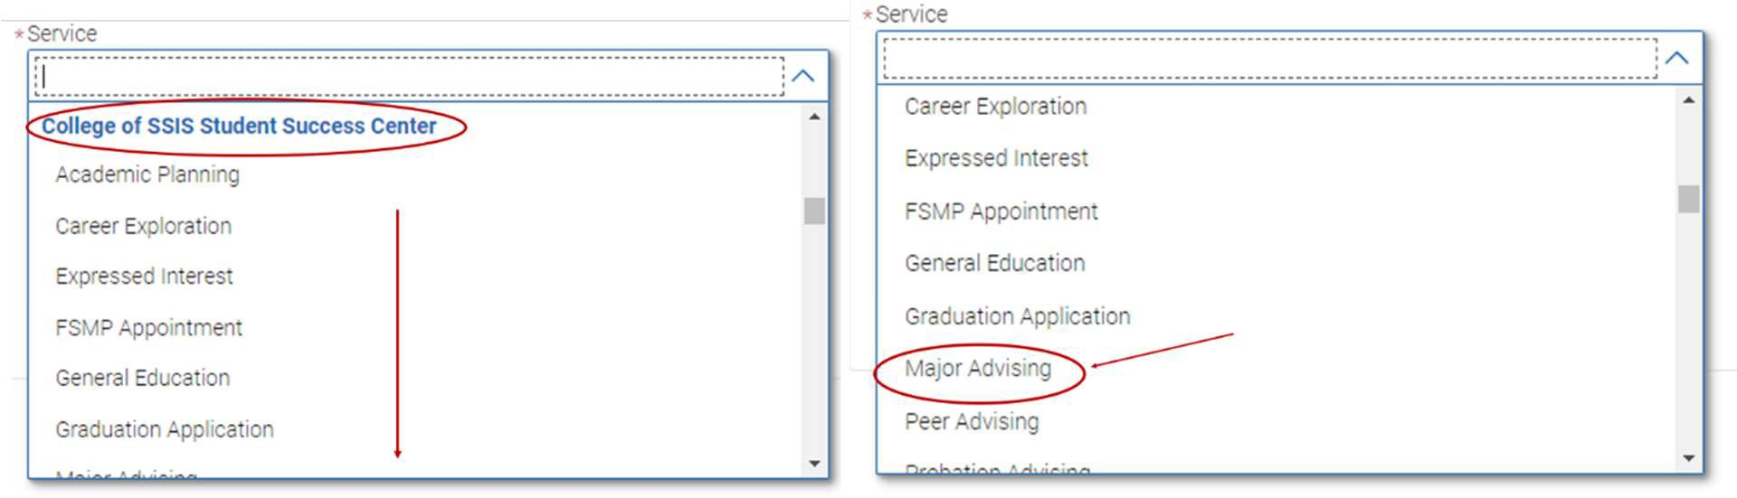
Pick a date and time that works for you.

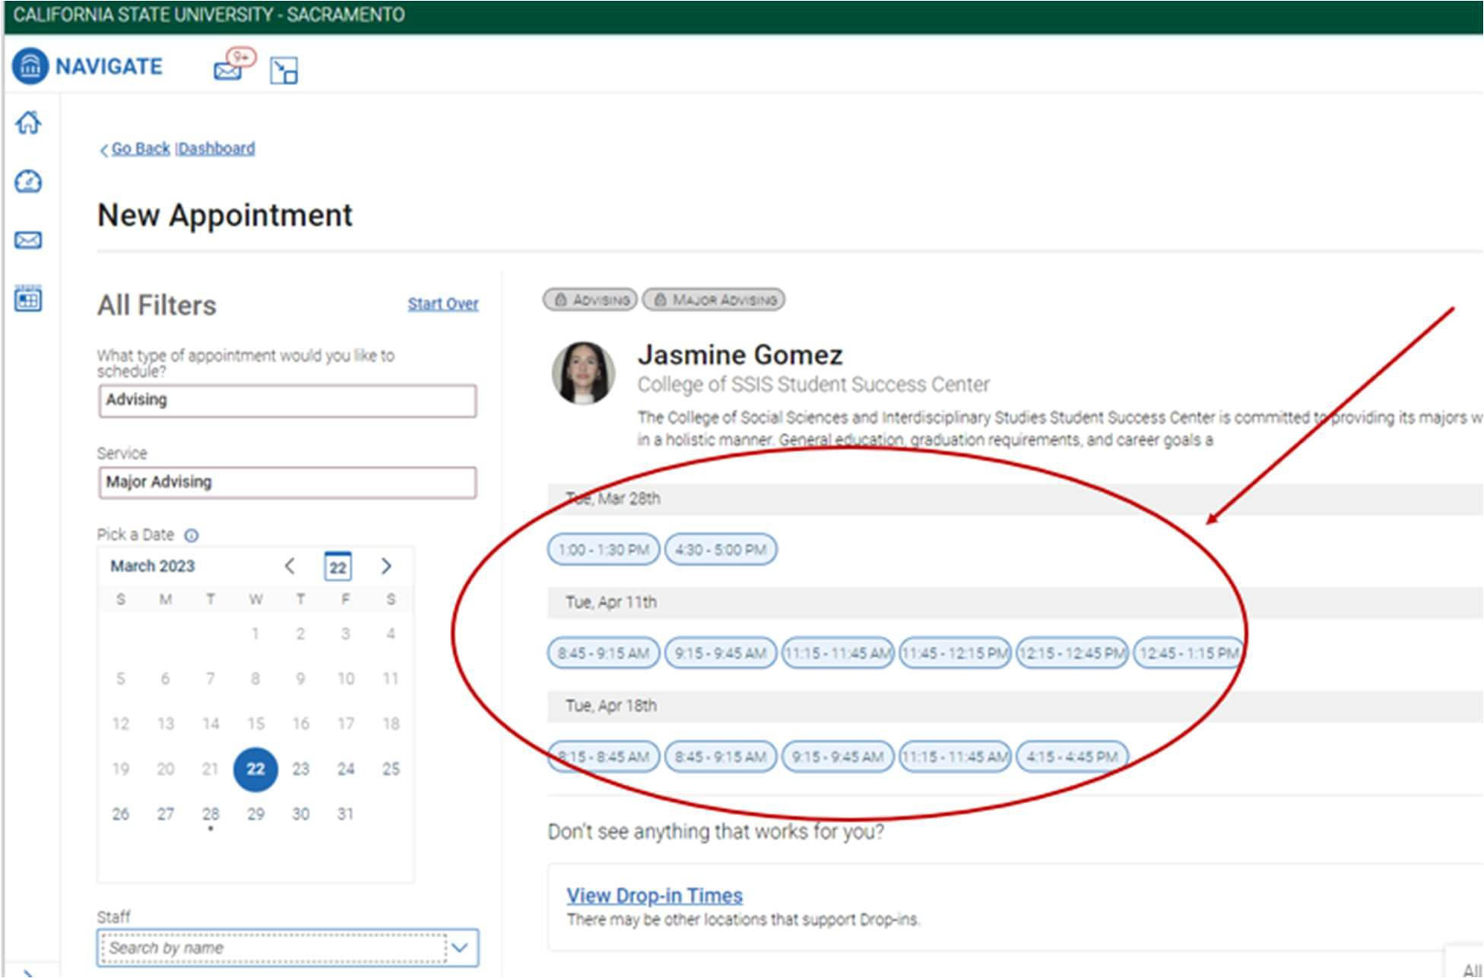
You can filter out how you would like to meet, location, course, and staff.
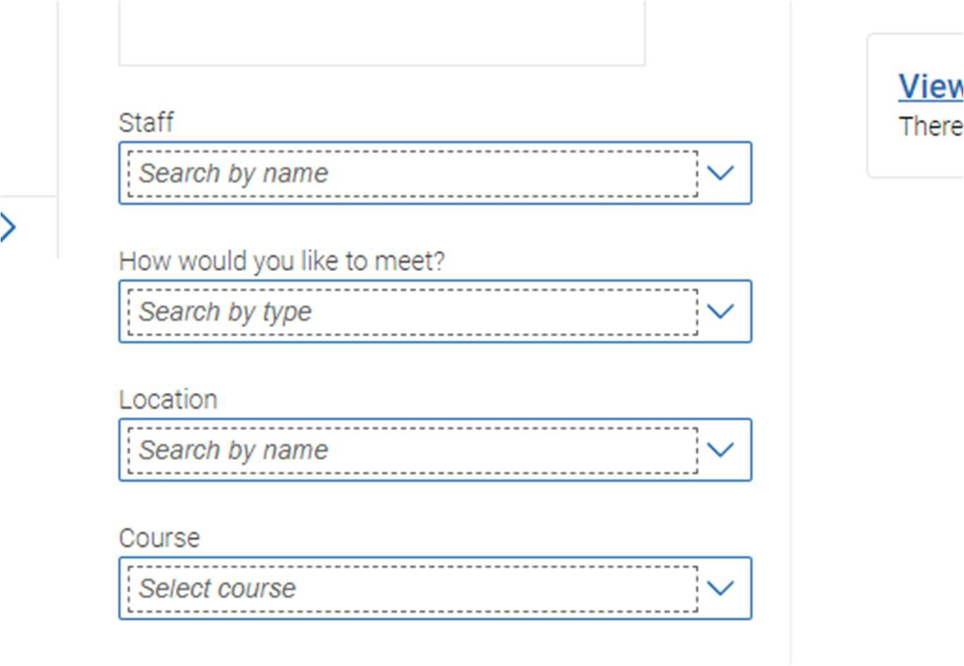
Once you pick a time and date for your appointment, review your appointment details and confirm.

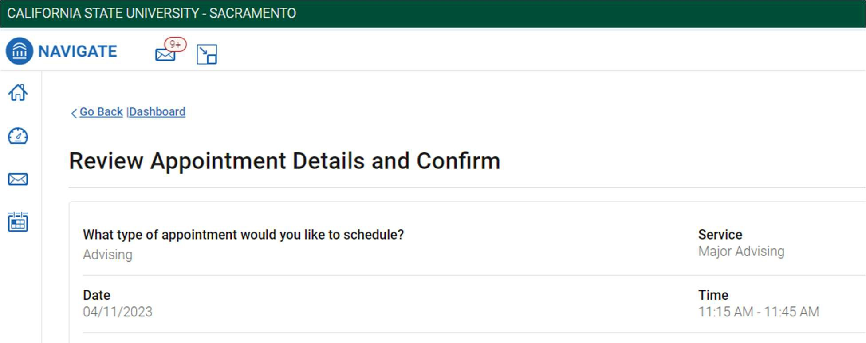
Pick how you would like to meet, add any comments if necessary and schedule your appointment.
