About
The student success team is comprised of professional advisers, graduate interns, peer success leaders, and Faculty Fellows working collaboratively to help students through an advising model that is proactive, comprehensive, and holistic.

Available Services
- Course options
- Smart Planner help
- Major exploration
- Finding internships
- Campus resources
- and more!
Contact info: 916 278 3846 • ssis_studentsuccess@csus.edu•

Zoom appointments and drop-in hours are available!

Please visit our website for current advising hours.




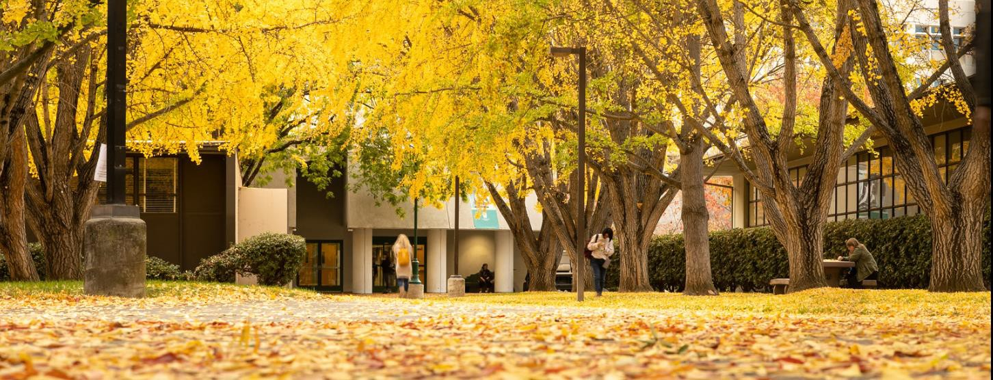


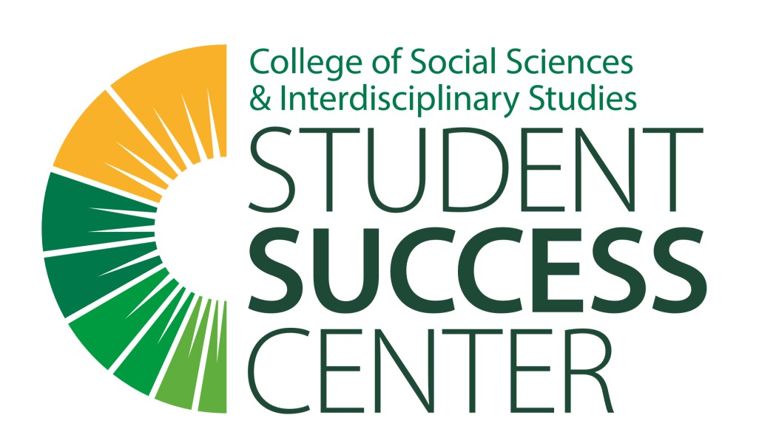
www.csus.edu/college/social-sciences-interdisciplinary-studies/student-success-center/

Like, Follow, Connect

Student Success Center Directory
ssis_studentsuccess@csus.edu 916.278.3846
Front Desk
First Name | Last Name | Email | Phone | Role
Carmen | Palma | ssis_studentsuccess@csus.edu | 278-3846 | Front Desk - Student Assistant
Vincent | Cabanting | ssis_studentsuccess@csus.edu | 278-3846 | Front Desk - Student Assistant
Advisors
First Name | Last Name | Email | Phone | Role
Mayrose | Acob | macob@csus.edu | 278-2773 | Graduation & Retention Coordinator
Sharon | Sahagun | sharoncrystalsa@csus.edu | 278-3865 | Integrated Advisor
GCIs and PSLs
First Name | Last Name | Email | Phone | Role
David | Cole | ssis_studentsuccess@csus.edu | 278-3846 | Peer Success Leader
Janayla | Rosco Wysinger | ssis_studentsuccess@csus.edu | 278-3846 | Graduate Counselor Intern
Jasmine | Gomez | ssis_studentsuccess@csus.edu | 278-3846 | Peer Success Leader
Jezelle Monique | Nelson | ssis_studentsuccess@csus.edu | 278-3846 | Graduate Counselor Intern
Micaela | Guerrero | ssis_studentsuccess@csus.edu | 278-3846 | Peer Success Leader
Wendy | Mok | ssis_studentsuccess@csus.edu | 278-3846 | Graduate Counselor Intern
Faculty Fellow
First Name | Last Name | Email | Phone | Role
Anne | Luna | luna@csus.edu | 278-7961 | Sociology (summer 2020 only)
Catheryn | Koss | koss@csus.edu | 278-4341 | Gerontology
Denys | Brand | denys.brand@csus.edu | na | Psychology
Jacqueline | Carrigan | carrigan@csus.edu | 278-6801 | Sociology
Rachel | Flamenbaum | flamenbaum@csus.edu | 278-2915 | Anthropology (starts fall 2020)
Seunghee | Wie | wie@csus.edu | 278-7108 | Family & Consumer Science
Ta-Chen | Wang | tachen.wang@csus.edu | 278-7112 | Economics
Young-Im | Lee | young-im.lee@csus.edu | 278-7090 | Political Science (starts fall 2020)
Visit our website for current drop-in advising hours or to schedule an appointment:
www.csus.edu/college/social-sciences-interdisciplinary-studies/student-success-center/

