Application Checklist
MS program in Nutrition and Food
Sacramento State
Step 1
- Review the CalState Apply Graduate Application Guide Handbook
- Create a CalState Apply account
- Watch this video on how to complete the MS in NUFD CalState Apply application
- Select the “Nutrition and Food” Program in Cal State Apply
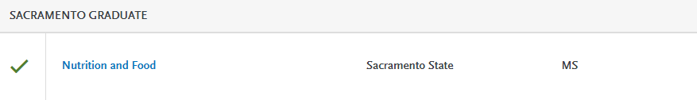
Step 2
- Complete CalState Apply application
  - Personal Information
  - Academic History
  - Supporting Information
  - Program Materials
    - Documents
      - Updated resume highlighting your nutrition & research related experiences
      - Professional statement including interest in the program, relevant experience, and research interests (500-750 words max)
      - Unofficial transcripts for all college level coursework*
        - International applicants must have WES evaluation
    - Two Graduate Program Recommendation Forms from academic and/or professional references
    - Question
Answer the question about your interest in applying to the combined MS and Dietetic Internship. If you are interested in applying to the MS/DI (must have DPD verification), you need to exit this application and complete the DICAS application by January 15. Visit the Sac State Dietetic Internship website for more information www.csus.edu/facs/dietetic-internship
- Submit the CalState Apply on-line application by January 15 for the Priority Deadline, and Feb. 1st to meet the Final Deadline
*Once an offer of admission has been given, mail or email one set of official transcripts from all colleges and universities attended, other than Sacramento State; official electronic transcripts sent directly from colleges/universities to gradtranscripts@csus.edu or sealed official hard copy transcripts sent to:
Office of Graduate Studies
California State University, Sacramento
Riverfront Center, Room 215, MS 6112
6000 J Street
Sacramento, CA 95819
Additional Checklist Items
When you’re ready to complete your application in Cal State Apply, be sure you have these items on hand:
- Social Security number, if you have one.
- Citizenship status
- Method of payment. You can pay the application fee by credit card.
- Annual income

Minimum Admission Requirements*
- Possess a bachelor’s degree from a regionally-accredited institution. If the degree was obtained outside of the United States, the degree conferring institution must be recognized by the home country’s ministry of education and degree coursework must be WES evaluated.*
- Complete prerequisite courses or their equivalent, including:
  - Nutrition and Metabolism (NUFD 113);
  - Nutrition: Preconception Through Childhood (NUFD 115) or Nutrition: Adolescence Through Older Adulthood (NUFD 119);
  - Community Nutrition (NUFD 117) or Nutrition Education;
  - Communication, and Counseling (NUFD 107);
  - Food Service Management (NUFD 116) or Food Production and Sustainability (NUFD 110); and
  - Introduction to Statistics (STAT 1) or Research: Methods and Application in Nutrition and Food (NUFD 100)

- Have a GPA of 3.0 in the last 60 semester units
*Note: Information for International students can be found here.

If you are interested in the combined MS and Dietetic Internship, you will need a DPD Verification Statement. You will submit your application via DICAS. Please visit this website for complete details about the additional admission requirements.

