MPPA Promotional Film Culminating Project

Jake Linn
jakeblinn@csus.edu

A Culminating Project Presented to the Department of Public Policy and Administration
at California State University, Sacramento in Fulfillment of the Requirements for the Degree of Public Policy and Administration

May 2023

Advisor: Robert Wassmer, PhD

Executive Summary
This promotional film aims to showcase California State University, Sacramento (CSU, Sacramento) Master of Public Policy and Administration (MPPA) program through highlighting the perspectives and work of two alumni, students, and professor​​s.
The origin of this project came from requests by Dr. Wassmer, Ph. D. (PPA Vice-Chairperson and Professor) and the Graduate Association of Students in Public Policy and Administration (GASPPA). Dr. Wassmer desired to showcase student, alumni, and professor research. GASPPA wanted additional films to bring additional students, differentiate from competitors, and attract donors to support the MPPA program.
CSU, Sacramento’s MPPA program’s largest competitors are California State University, Chico (CSU, Chico), University of the Pacific Sacramento Campus at the McGeorge School of Law (McGeorge), and University of Southern California Price School (USC).
CSU, Sacramento must create new promotional materials, such as films, to attract students into its MPPA program. If the MPPA program does not do so, it risks losing potential students to competitors, which could eventually lead to the program shutting down if it fails to attract enough students.
This paper will discuss the processes I have learned during my five years of promotional/informational film experience while incorporating research to back up my methodology, including my initiative Disability in Hollywood and previous films where I was hired by the nonprofits - Steinberg Institute and Arts of Life (Arts of Life, 2019; Disability in Hollywood, 2023; Rabiger, p.17, 1987; Steinberg Institute, 2019).
Section I, Introduction, provides the layout for my paper.
Section II, Steps/Outline, provides an overview of my project which allows my interviewees and advisor to know where I am in the filmmaking process. It also provides a timeline holding me accountable.
Section III discusses the differences between CSU, Sacramento’s MPPA Program and the programs offered by its competitors. I also discuss how I will home in on the MPPA program’s strengths to create three types of films of varying lengths to draw more prospective students and donors to the MPPA program.
Section IV shares the importance of creating a committee for this project to appease stakeholders and navigate CSU, Sacramento’s media policy. I will also delve into which groups and people are participating in this committee.
Section V goes over the establishment of stakeholder criteria used to select interviewees, a figure showing this process, and consequent candidates selected.
Section VI explores my process of editing and review to build trust and cultivate relationships essential to continue partnerships for myself and separately, within the MPPA program.
Section VII discusses how I will not be releasing the films, but providing one of my committee groups with everything they need to release the films.
Section VIII is my conclusion to this project, entailing stakeholder thoughts along with the unexpected twists and turns that came along during the filmmaking process.
Table of Contents

Executive Summary……………………………………………………………………….2-3
Table of Contents………………………………………………………………………….4
Section I: Introduction……………………………………………………………………..5
Section II: Steps/Outline…………………………………………………………………..5-7
Section III: Research Competitors……………………………………………………….7-10
Section IV: Creating a Committee………………………………………………………..10
Section V: Finding Interviewees………………………………………………………….11-12
Section VI: Interviewing Process………………………………………………………...12-15
Section VII: Editing/Review Stage……………………………………………………….15-16
Section VIII: Marketing Plan……………………………………………………………...16-17
Section IX: Conclusion/Unexpected Twists…………………………………………….17-18
References………………….………….………….………….………….………….…….19-21

List of Figures

Table I: Basic Production Outline/Schedule Timeline…………………………………6
Table II: Student Interviewee Selection………………………………………………...13
Table III: Professor Interviewee Questions…………………………………………….13
Table IV: Alumni Interviewee Questions……………………………………………….14

Section I: Introduction
My culminating project entails thirteen films with the aim of increasing donors, prospective students, and interested faculty into the MPPA program. There is also a written portion to go along with it. This written portion provides a step-by-step framework detailing how I went about creating these films which can be used for future students’ research or interest on how to create a promotional/informational film using research methods. My project, like the incentivize of all films created, was prompted by the request of a client(s). In this case, my clients were Dr. Wassmer and GASPPA who wanted the creation of these films but lacked funding. This created a window of opportunity, which I took advantage of. My written portion discusses this opportunity along with the selection of interviewees, production process, and post-production process using committee review and marketing tactics to pull off a successful promotional campaign for the MPPA program.
Section II: Steps/Outline
Over time, I have created an outline on how to create a promotional film, seen in Table I. This was provided to my advisor through my larger film proposal. A film proposal is industry standard providing reasoning, budget, and steps on completing a film, also recognized as “a device to sell a film” (Rosenthal & Eckhardt, p.30, 2016; MasterClass, p.2, 2021). A proposal varies in length (Rosenthal & Eckhardt, p.32, 2016; MasterClass, p. 2, 2021). I decided to have a length of six pages to provide an in-depth overview that I could use in this written portion of my thesis.

Table I: Basic Production Outline/Schedule Timeline
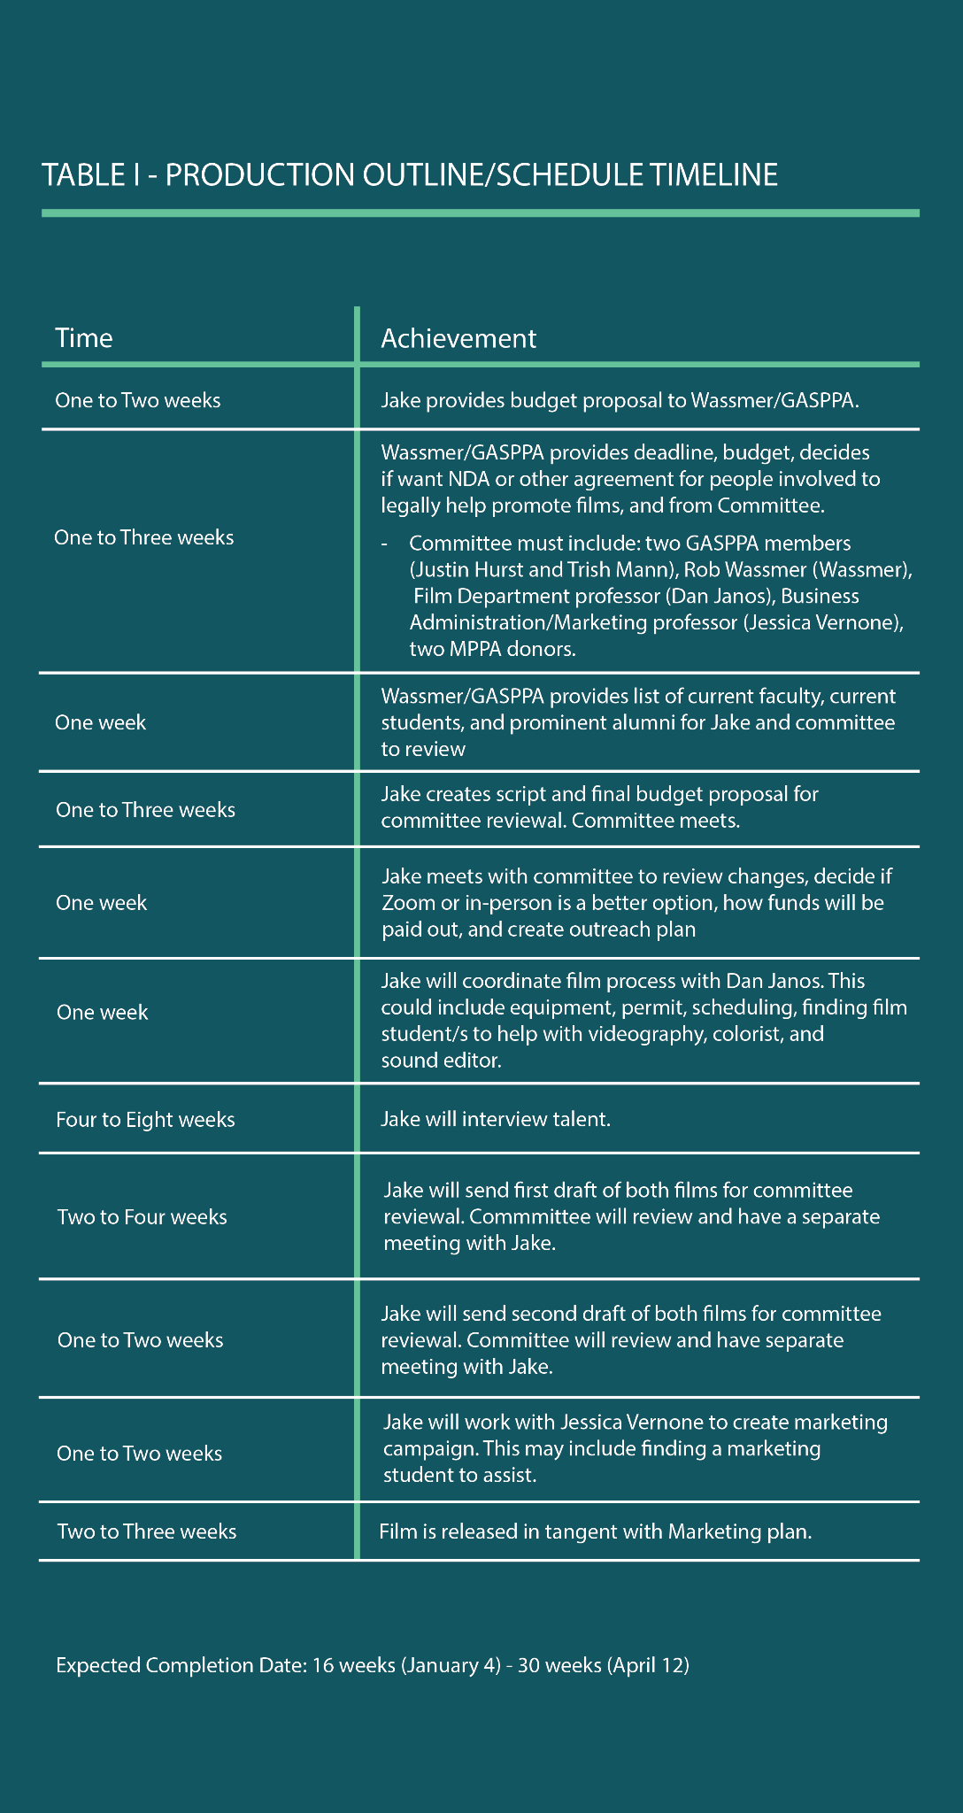

The finishing date of my project is dependent on how long response time takes, with the earliest completion date being January 4th and the latest being April 12th.
Section III: Research Competitors
The first step to create a research/promotional film is to conduct in-depth research which includes scrutinizing competitors (Rosenthal & Eckhardt, p.60, 2016; Fitzgerald Lowe, p.3, 2020 & Lowe; Rabiger p. 27, 1987).
This is because they are the largest threat to the program’s ability to continue. In this case, California State University, Chico (CSU, Chico); University of the Pacific Sacramento Campus at the McGeorge School of Law (McGeorge); and University of Southern California Price School (USC Price) are the biggest competitors. However, none of these universities have a combined Public Policy and Administration program, instead offering Public Administration or Public Policy programs.
CSU, Chico’s MPA program is a competitor to CSU, Sacramento’s MPPA program due to the following factors (California State University, Chico, 2023):
- Relatively close to Sacramento
- Roughly the same cost as the MPPA program
- Students can choose their own majors through electives comprising the MPA program
- Accredited by the Washington D.C Network of Schools of Public Policy, Affairs and Administration
- Students receive a designated advisor
- Course schedule in the daytime, appealing to a younger often inexperienced cohort
- Thoroughly teaches diversity and inclusion
Meanwhile, McGeorge is a large competitor that used to work collaboratively with CSU, Sacramento’s MPPA program where students could get a law degree through McGeorge while attending the MPPA program. However, the partnership dissolved when McGeorge created its own two separate programs - Public Policy (PP) and Public Administration (PA). What makes McGeorge competitive are its law-based PP and PP program with notable alumni, including former Supreme Court Justice Anthony Kennedy (University of the Pacific McGeorge School of Law, n.d.).
Lastly, USC Price is another large competitor of CSU, Sacramento’s MPPA program because (USC Sol Price School of Public Policy, 2021):
- World-renowned as a West Coast Ivy League
- Allows students to move between their LA and Sacramento campuses while offering opportunities to travel abroad
- Takes one year to complete
- Works with professionals’ schedules by offering night classes rather than day classes
Compared with the other three university’s programs, CSU Sacramento’s MPPA program is not yet accredited and lacks a large selection of electives. Additionally, there is not a way to get an additional major, new to integrating diversity and inclusion practices, and is not world-renowned. However, what is working in favor of CSU, Sacramento is the following:
- Two degrees in one program
- Most affordable
- Meant for full-time workers
- Main and satellite campus located around the State Capitol
- Professors are practitioners not solely researchers.
This is what I plan to highlight in my project to ensure the MPPA program stands out from the competition. According to Grewal and Levy’s Marketing (2020) text, this is called “sustainable competitive advantage” (Grewal & Levy, p.31, 2020; Ghemawat, p. 55, 2014), where a firm, in this case university program, builds out a marketable advantage by leaning into its strengths, now my project, and cannot easily be replicated, therefore, maintained over a long period of time. To further sustainable competitive advantage, I plan on showcasing the program through imagery of the interviewees in their workplace, providing evidence the MPPA program is essential for any career. Most importantly, interviewees will be prominent in their field, have a diverse background, and carry a captivating voice/demeanor.
Regarding length, I will create three different lengths of films. The reasoning for the difference in length is because a shorter film will be used for social media, grabbing attention of initial prospective students and donors, and lead up to longer films as an incentive to visit the MPPA website for further information, creating more chances to donate or apply to the program. This process is meant to “excite customers with relevant offers, educate them about the offering, [and] help them experience products” (Grewal & Levy, p.8, 2020; Rabiger, p.7, 1987).” Lengthwise, there will be six 10-15 second shorts, six 1:30 films, and one 2:30 film. The 10-15 second shorts are meant for social media platforms designed primarily for short videos (i.e., TikTok and Twitter, etc.) and garner enough interest to convince viewers to watch the longer 1:30 films. The 1:30 films will show more personal narratives fit for YouTube and Instagram whose audiences desire to see longer films and are long enough for interviewees to give a basic overview of who they are and how the MPPA program has impacted them. These are personal, more dramatized stories, “lead[ing] to the spectator identifying with the characters and the story context” (Mathisen & Prevensen, p.8, 2013), and cultivate enough interest to go to the 2:30 film on the MPPA website. The 2:30 minute film is a true promotional/informational film where all interviewees are present. Since this film is only seen on the website, viewers are forced to look over the website for further information, allowing more time to gain interest in the MPPA program to the incentivizing point of further donations or serious prospective students applying.
Section IV: Creating a Committee
I am not the only stakeholder creating this film. Additionally, there are certain university processes I am not aware of. That is why I create committees for any film I make. For this project, I brought in a committee comprising of Dr. Wassmer, head of the MPPA program and my advisor; GASPPA, who are current MPPA students advocating for the student body; Prof. Dan Janos to help navigate the film insurance/permitting process; Jessica Vernone to ensure the films fit within CSU, Sacramento’s standards; and one to two donors to gauge if the films would further increase their donations. I consider these committee members to be “supportive clients” who will assist me in navigating processes while having a decision power on what will be shown in the film. Dr. Wassmer and GASPPA will be more hands-on throughout the filmmaking process whereas the other committee members will help during production, editing/review stage, and the marketing plan.
Section V: Finding Interviewees
One of the decision powers the committee was establishing criteria for selecting interviewees. Dr. Wassmer requested there to be a large range of diversity (one person from each ethnicity) and a balance of men/women interviewees since women comprise most students. Meanwhile, my criteria were oriented towards marketing and viewership with interviewees needing an interesting job, camera/media experience, and a bubbly conduct.
At the time of creating these criteria, there were over 400 students and alumni to filter out. Because I did not have contact information for these prospective interviewees, I requested Dr. Wasmer to filter through and provide a list of 100 top choices according to his criteria. Then, I created a spreadsheet where Dr. Wassmer, GASPPA, and I ranked our desired interview candidates (MPPA professors, alumni, and students) numerically or with a check placed in a box. Collectively, we decided the following would participate:
Student
- Nicole Cropper, Deputy Director of Justice, Equity, Diversity, and Inclusion Division under the California Natural Resources Agency
- Nathaly Teran, Legislative Director for Assemblymember Avelino Valencia
Alumni
- Puneet Bhullar, Senior Program Officer at California Council on Science and Technology (CCST)
- Eric Guerra, Sacramento City Council Member
MPPA Professors
- Ted Lascher, Professor
- Amal Kumar, Assistant Professor
Section VI: Interviewing Process
The interview process started with me choosing questions to ask each category of participants - professors, alumni, and students. This was sent to interviewees before their interview to ensure participants could rehearse and promote their best selves (Rosenthal & Eckhardt, p. 183, 2016; Rabiger p. 59 & 61, 2016).
Although some questions like basic introductory information were inquired to all interviewees, there were differences in other questions asked to the various categories. Professors were asked about their research, students were asked about their experiences and how PPA teaching translates into their jobs, and alumni were asked how the MPPA program helped their career endeavors. To loosen up the interviewees and show audience an outgoing and kind persona, basic questions were asked first before transitioning into harder questions which is what I did with Disability in Hollywood and a promotional film I made with filmmaker Matt Salvo for the Steinberg Institute (Disability in Hollywood, 2023; Rosenthal & Eckhardt, p. 191, 2016; Disability in Hollywood, 2023; Steinberg Institute, 2019). This is seen in Table II though Table IV.

Table II: Professor Interviewee Questions
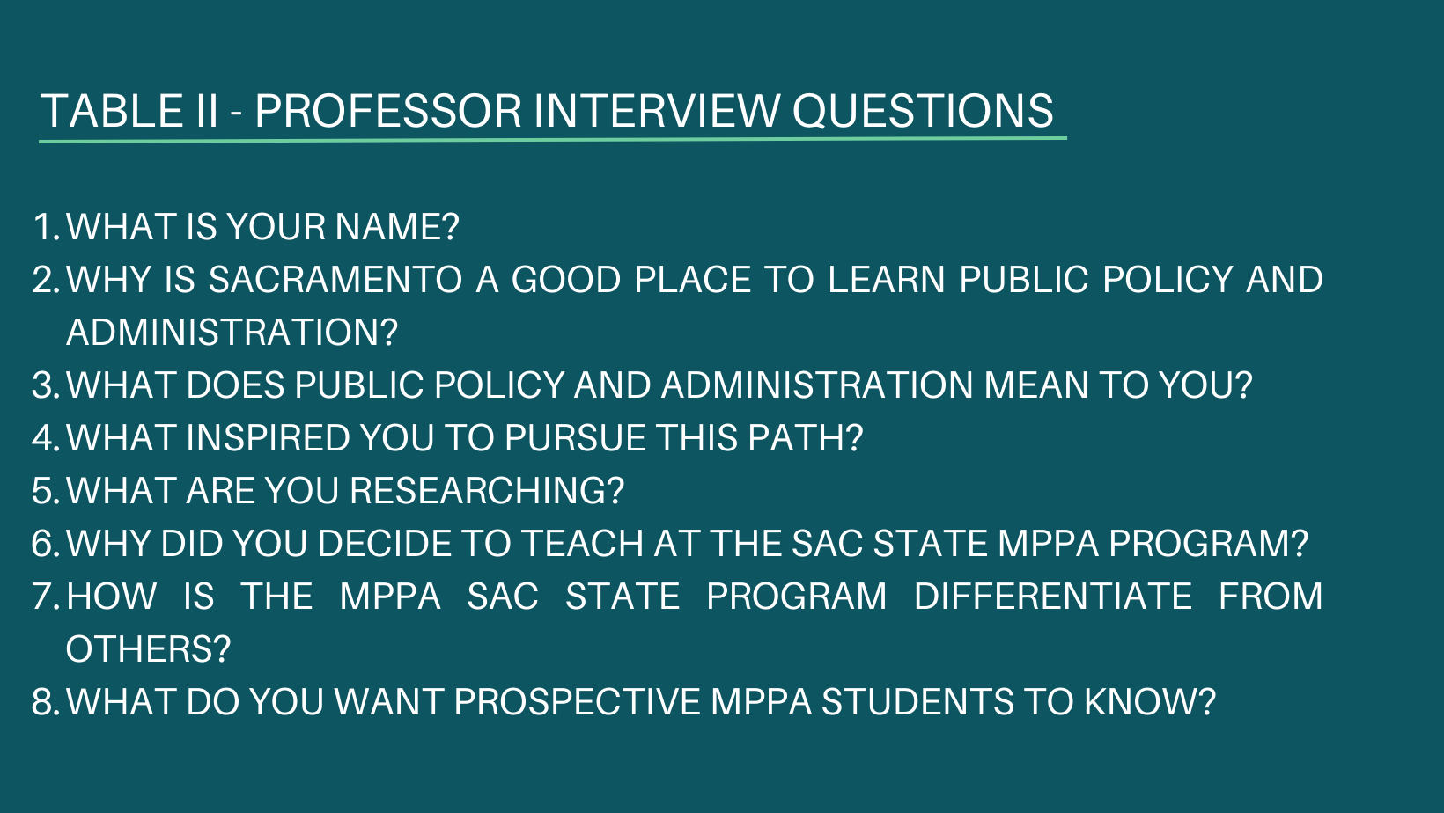
Table III: Alumni Interviewee Questions
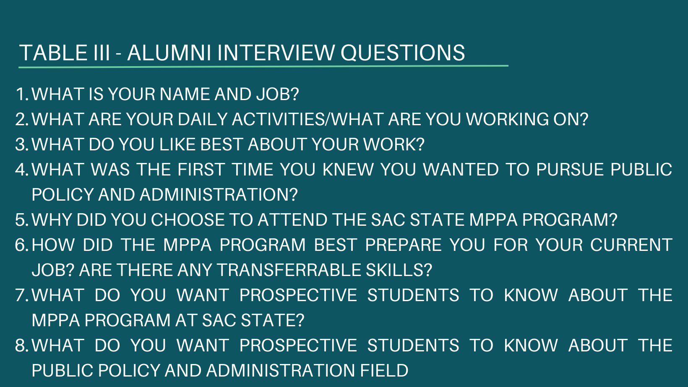

Table IV: Student Interviewee Questions
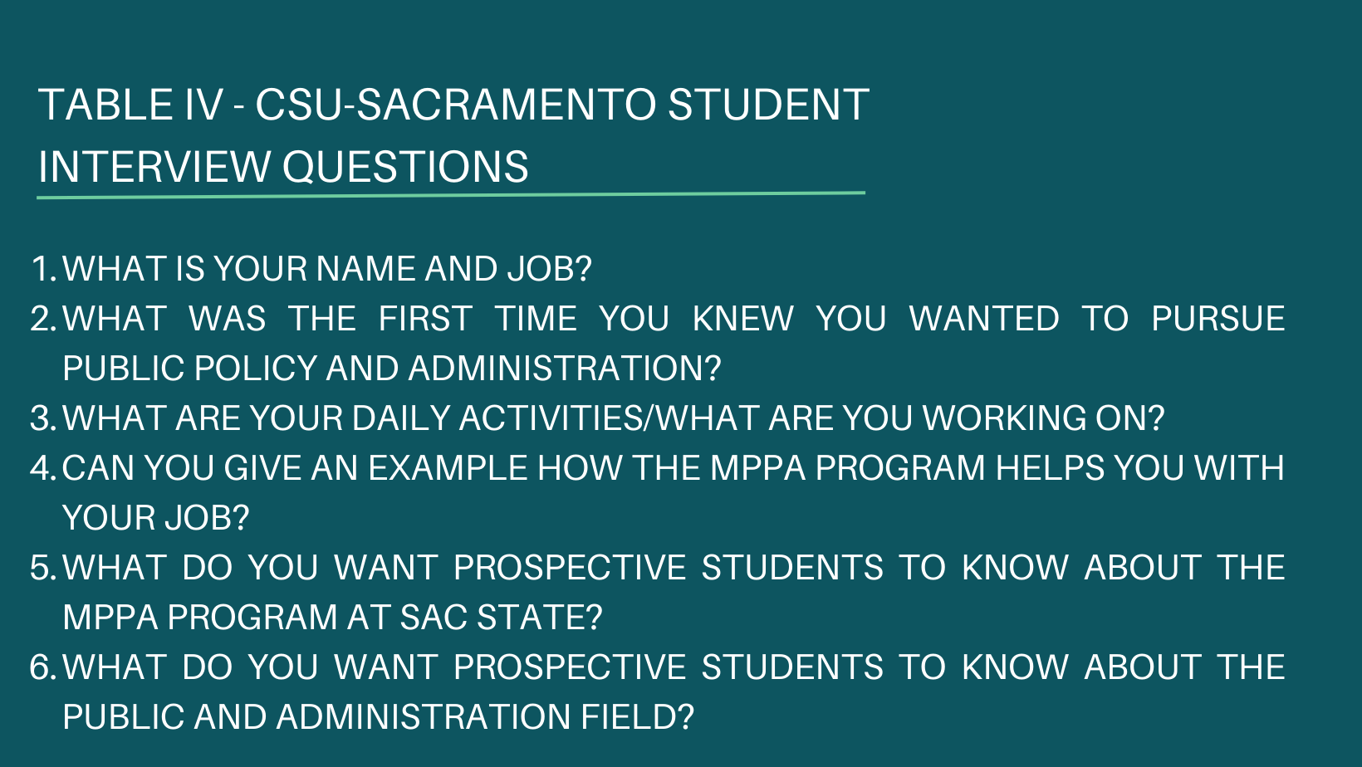
I decided to use Zoom to interview because I was familiar with this method and it allowed the process to be under 30 minutes, enabling more busy participants to participate while also feeling more “at ease” since they are in familiar surroundings (Rosenthal & Eckhardt, p. 184, 2016; Disability in Hollywood, 2023).
This method also provided cost savings and minimized COVID-19 risk for all participants. Additionally, post-COVID-19 interviews via Zoom have been more accepted with news outlets, content creation, and promotional films (CNBC, n.d.; Disability in Hollywood, 2023).
However, I filmed in-person for B-Roll as this was the only way to showcase the interviewee’s work and was most maximum naturalism (Cassinari, p.4, 2018; Paar, p.10, 2007; Rosenthal & Eckhardt, p. 197, 2016). B-Roll is imagery used to overlay the main film to increase viewer interest (Cassinari, p.2, 2018; Perrault, p.1, 2018; Paar, p.4, 2007). My in-person shooting started after the Zoom interview to ensure my time and money for permitting and insurance was not wasted. I used a Canon EOS 500 DSLR.
After mapping out the filming process, I reached out to participants and interviewed them, ensuring all signed a Talent Release Form in accordance with CSU, Sacramento’s filming policy.
Section VII: Editing/Review Stage
My style of editing is finding the most captivating parts of an interview and editing them into a story format in correspondence with what interviewees were originally highlighting based off the list of questions or Table III through Table IV. Even more simply, “the results of the shoot are tidied up and put together into a pleasant movie show. The editor reconstructs pieces of the picture taken by the cameraman and determines the dramatic side” (Crittenden, p. 79, 1995; Ranangsari & Fuquan, p. 210, 2020; Rosenthal & Eckhardt, p. 209, 2016). A successful example of this is my initiative Disability in Hollywood where I also built relationships, trust, and interviewed more than 80 prominent people with disabilities collectively having 20+ million followers on social media (Disability in Hollywood, 2023).
This process requires two review and editing stages. The first edit/review is where I send interviewees their films without B-Roll whenever their likeness is shown aka rough cut (Chapman, p.136, 2007). B-Roll is not shown because talent could make requests where the section of B-Roll was not necessary. For this project, that includes six 1:30 films pertaining to a respective interviewee and 2:30 minute main film combining messages from the six interviewees. When I receive requests for edits, I implement these changes and send them back for final written approval. This process builds trust as talent learn the filmmaker (me) does not want to tarnish their reputation (Rosenthal & Eckhardt, p. 182 & 194, 2016; Disability in Hollywood, 2023). In turn, this creates more willingness to work with me and/or the program, if the opportunity arises.
The second edit/review stage is conducted after B-Roll footage and any other CSU, Sacramento required components are placed into the films. These pre-finalized versions are sent to Dr. Wassmer, GASPPA, two MPPA donors, Jessica Vernone, Prof. Dan Janos, and interviewees to review. In industry-terms, this is called test screening (Rosenthal & Eckhardt, p. 226, 2016). I have conducted and participated in this test screening process in a promotional film I helped make for the nonprofit Arts of Life and in my initiative Disability in Hollywood (Arts of Life, 2019; Disability in Hollywood, 2023). For my test screening, I provided a week for my committee to review using a Google Doc. This allows busy committee members and interviewees to efficiently provide comments in a way that can build-up from the previous reviewer. If any comment is confusing, I can reach out separately. I will continue revising until all parties agree the films are suitable to show. Once changes are agreed upon, I will create the shorter 10-15 second films from the longer films to post on social media platforms like Snapchat, Twitter, Instagram, TikTok, etc.
Section VIII: Marketing Plan
Once all films are created, I will work with GASPPA to determine the best methods of releasing the films. This includes creating the description, timeline of release, and where each film will be released. I will not be releasing the films, but GASPPA will be provided with all materials created up to that point. For the most part, the films do the marketing themselves as they can “influence customers—that is, to inform, to generate positive affections, and/or to induce choice and behavior by creating favorable images by using [this] marketing tool” (Mathisen & Prevensen, p.2, 2013; Rabiger, p.23, 1987).
Section IX: Conclusion/Unexpected Twists
The film process is tumultuous and often what is expected becomes the unexpected and vice versa. Some unexpected ups and downs:
- I did not know I was not allowed to get funding help to support the creation of the film, forcing me to apply to scholarships to cover the cost.
- With a previous film, I paid $1,500 for insurance, but I met with the Sacramento Film Commissioner who provided a different resource called Thimble, where I was able to get insurance for $67.
- During the week of shooting, it unexpectedly rained, and I had to cancel some shoots due to safety concerns.
- Two interviewees never got back to me on filming them for B-Roll even after communicating with them for months about this process.
- I did not have enough B-Roll nor music, so I reached out to alumni for their images/videos and spent $67 on a website titled Storyblocks, which offers royalty-free stock footage and music.
- Two months into the project, I had medical issues that limited my mobility for approximately 12 weeks, making it impossible to meet the expected minimum deadline. There was no way around this.
Overall, interviewees, alumni whose photos were requested, the committee, and I were pleased with the films and are excited to see how they assist with the growth of the MPPA program.

References
Arts of Life. (2019). Arts of Life Intro. YouTube. Retrieved March 22, 2023, from
https://www.youtube.com/watch?v=ajwMjom5UZQ.
California State University, Chico. (2023). 2022-2023 university catalog. Public
Administration MPA | California State University, Chico. Retrieved March 5, 2023, from https://catalog.csuchico.edu/colleges-departments/college-behavioral-social-sciences/political-science-criminal-justice/mpa/#text
Cassinari, J. (2018, December). Let B-Roll Be Your Guide. Videomaker, 33(6), 48+.
https://link.gale.com/apps/doc/A563458294/AONE?u=csus_main&sid=bookmark-AONE&xid=af4f9615
Chapman, J. (2007). Documentary in practice: Filmmakers and production choices.
Polity.
CNBC. (n.d.). CNBC. CNBC YouTube Channel. Retrieved March 22, 2023, from
https://www.youtube.com/user/cnbc
CRITTENDEN, R. (1995). Film and video editing. Blueprint.
Disability in Hollywood. (2023). Interviewees. DISABILITY IN HOLLYWOOD. Retrieved
March 5, 2023, from https://disabilityinhollywood.weebly.com/interviewees.html
Fitzgerald, A., & Lowe, M. (2020). Acknowledging documentary filmmaking as not only
an output but a research process: A case for quality research practice. International Journal of Qualitative Methods, 19. https://doi.org/10.1177/1609406920957462
Ghemawat, P. (2014, August 1). Sustainable advantage. Decision Making and Problem
Solving. Retrieved March 22, 2023, from https://hbr.org/1986/09/sustainable-advantage.
Grewal, D., & Levy, M. (2020). Marketing. McGraw-Hill Education.
MasterClass. (2021, September 7). Proposals and treatments: Why are they necessary
for filmmakers? - 2023. ARTS & ENTERTAINMENT. Retrieved March 22, 2023, from https://www.masterclass.com/articles/why-are-proposals-and-treatments-necessary-for-filmmakers.
Mathisen, L., & Prebensen, N. K. (2013). Dramatizing an event through a promotional
film: Testing image effects. Journal of Travel & Tourism Marketing, 30(7), 672–689. https://doi.org/10.1080/10548408.2013.827545
Paar, M. (2007, June). Plan A: B-roll: don't be caught without cover. Your B-roll should
be Top Priority. Here are some tips to enhance your A-list video project by planning your B-roll better. Videomaker, 21(12), 67+. https://link.gale.com/apps/doc/A163940109/AONE?u=csus_main&sid=bookmark-AONE&xid=045a5d65
Perrault, E. K. (2018). Adding multimedia cues to medical providers’ online biographies:
Do pictures, video, and B-roll matter? Journal of Health Communication, 23(5), 462–469. https://doi.org/10.1080/10810730.2018.1465492
Rabiger, M. (1987). Directing the documentary (1st ed.). Focal Press.
Ranangsari, K. A., & Fuquan, Q. (2020). Production of documentary film driving
awareness. Capture: Jurnal Seni Media Rekam, 11(2), 83–95. https://doi.org/10.33153/capture.v11i2.3166
Rosenthal, A., & Eckhardt, N. (2016). Writing, directing, and producing documentary
films and Digital Videos. Southern Illinois University Press.
Steinberg Institute. (2019). The Steinberg Institute is increasing the effectiveness of
mental health policy-making in California. YouTube. Retrieved March 22, 2023, from https://www.youtube.com/watch?v=u1nMO27Q1z8.
University of the Pacific McGeorge School of Law. (n.d.). Master of public policy - MPP.
McGeorge MPA & MPP Programs. Retrieved March 22, 2023, from https://law.pacific.edu/law/mpa-and-mpp/mpp.
USC Sol Price School of Public Policy. (2021, March 18). Apply for master of public
administration in Sacramento. USC Sol Price School of Public Policy. Retrieved March 5, 2023, from https://priceschool.usc.edu/programs/sacramento/masters/.

