CalFresh Gone Stale:
CalFresh Administration Failures and Opportunities to Improve Participation Rates

Alexandra Kimberly Grubbs
agrubbs@csus.edu

A Culminating Project Presented to the Department of Public Policy and Administration at California State University, Sacramento in Fulfillment of the Requirements for the Degree of Master of Public Policy and Administration

December 2023

Advisor: Edward Lascher, Jr. PhD

Acknowledgements
I am so grateful to everyone who supported me throughout my time in graduate school.
To my mom and dad, thank you for raising me to always find ways to serve my community. Dad, thank you for showing me so much of what I love in this world. Mom, you are my north star.
To my partner Colin, thank you for always being there to make me laugh and talk me down from final papers-induced ledges.
To my Allie, thank you for always listening to my CalFresh ramblings.
To my coworkers and clients at Sacramento Food Bank & Family Services, thank you for the privilege to fight against hunger and learn from the lived experiences of those facing food insecurity
To my culminating project advisor Ted, thank you for your unerring support throughout my writing and the program as a whole.
And to my MPPA cohort and professors, you have taught me so much about all the different ways we can affect change in our communities. Each and every one of you inspire me!

Table of Contents
Introduction ………………………………………………………………………………………………….……... 1
Section 1: Background …………………………………………………………………………………….…….. 2
Nature of the CalFresh Program …………………………………………………………………….……….. 2
Who Experiences Food Insecurity? ………………………………………………………………….……… 2
Who Pays for and Administers the Program? …………………………………………………….…….. 4
Eligibility and Benefits …………………………………………………………………………………….…….. 5
Section 2: Problem Context …………………………………………………………………………….……… 7
California’s Low Participation Levels ………………………………………………………………….……. 7
Alternative Participation Rate Metrics ……………………………………………………………….……. 8
Section 3: Recent Policy & Administrative Efforts …………………………………………………... 12
COVID-Era Program Changes …………………………………………………………………………….…. 12
CFAP Efforts to Reach Immigrant Populations ………………………………………………………… 13
Section 4: Factors Impacting Program Participation ………………………………………………. 14
Non-Administrative Factors …………………………………………………………………………………. 14
Administrative Successes in Oregon ………………………………………………………………………. 15
Administrative Failures in California ……………………………………………………………………… 17
Section 5: Recommendations to Improve CalFresh Administration ………………………….. 19
Recommendations for State Administrators ……………………………………………………………. 19
Application Streamlining ……………………………………………………………………………………….. 19
Cross-Programmatic Eligibility ………………………………………………………………………………. 21
Cross-Programmatic Referrals ……………………………………………………………………………….. 21
Recommendations for County Administrators ………………………………………………………… 23
Increased Staffing …………………………………………………………………………………………………. 23
Targeted Outreach ………………………………………………………………………………………………… 23
CBO Capacity Building ………………………………………………………………………………………..... 24
Recommendations for Lawmakers ………………………………………………………………………… 25
Income Limit Adjustment ……………………………………………………………………………………… 25
CalFresh as a UBI …………………………………………………………………………………………………. 26
CalFresh Incentivizing Options …………………………………………………………………………..….. 27
Section 6: Conclusion ……………………………………………………………………………………….…. 28
References …………………………………………………………………………………………………………. 30
Introduction
CalFresh is the California version of the Supplemental Nutrition Assistance Program (SNAP), otherwise known as food stamps, which can help put food on the table for households experiencing food insecurity. However, participation rates in the CalFresh program are strikingly low given California’s food insecurity rates and the potential benefits that program participation offers. As such, I will be exploring the following research questions: what are the causes of lower CalFresh participation rates, and what can CalFresh administrators do to increase participation rates? This issue is significant to the study of administration as CalFresh’s low participation rates can in part be attributed to administrative procedures. A better understanding of the failures of these procedures would allow us to improve the service provision of CalFresh while also providing critical insights for other programs which support the welfare of the public, a key tenant of public administration.
I will first analyze the existing literature on food insecurity and SNAP participation nationwide. Next, I will drill down on why we must address the issue of California’s participation rates, noting that rates vary depending on the participation measurement index utilized. I will address recent changes to CalFresh which impact current and future program administration. I will then draw comparisons between the successes and failures of California’s CalFresh program and the SNAP programs in states such as Oregon and Illinois, which boast much higher rates of program participation. Finally, I will draw from these comparisons and existing literature to recommend administrative improvements to extend the reach of CalFresh to more Californians in need.

Section 1: Background
Nature of the CalFresh Program
CalFresh is the largest nutrition assistance program in the state of California. CalFresh is an entitlement program that aids in alleviating food costs for low-income families in California (Hammond et al., 2020). As an entitlement program, everyone found eligible should receive benefits without a limit to the number of yearly participants. Without CalFresh, about 700,000 additional Californians would be below the poverty line (Danielson & Tan, 2020).
CalFresh also stimulates the economy by freeing up income of low-income individuals to be spent on other essentials. Oftentimes without SNAP benefits, households need to make a tradeoff between food costs and other expenses, like utilities, transportation, medical care, housing, and education. When CalFresh benefits are utilized to buy groceries, that household can spend their money that would have gone to groceries on those other expenses (Feeding America, n.d.). A $1 billion increase in benefits could raise GDP by $1.54 billion (Danielson & Tan, 2020). Each $1 billion in benefits spent supports about 13,560 new jobs (Hammond et al., 2020).
Who Experiences Food Insecurity?
In assisting low-income Californians with paying their food costs, CalFresh provides a crucial buffer against food insecurity. Food insecurity is defined as the lack of access, at times, to enough food for an active, healthy life for all household members and limited or uncertain availability of nutritionally adequate foods (Feeding America, 2023). Food security is not just about having enough food to meet dietary needs, but also having access to a variety of nutritious and culturally appropriate foods. Food insecurity can lead to many negative outcomes other than hunger, including Type 2 diabetes, high blood pressure, heart disease, obesity, and poor academic & behavioral outcomes for children (Feeding America, n.d.). It is crucial to address food insecurity to avoid such negative outcomes for Californians.
As of 2021, there were over 4.1 million food insecure people in the state of California, with over 1.1 million of those being children (Feeding America, 2023). That is over 10% of the state’s population that either cannot afford or cannot access an adequate amount of food. However, 42% of those individuals have incomes above the income limit for CalFresh (Feeding America, 2023). Low-income populations, African Americans, Latinos, and Native Americans are more likely to be food insecure in California (Feeding America, 2023). Additionally, rural areas in California tend to experience food insecurity at a higher rate, as seen in Figure 1 (Feeding America, 2023). This does not mean urban areas are immune to food insecurity- Los Angeles County is home to the highest number of food insecure people in the country (Feeding America, 2023). Unequal access to food for a healthy life is especially jarring in a state known as the breadbasket of the country.
A key measure of food insecurity is the budget shortfall, the gap between the income someone has and the money they need to feed their family (Danielson & Tan, 2020). As of 2021 nationwide, food insecure individuals need $53 more per month to bridge the gap of their budget shortfall. (Feeding America, 2023). That nationwide average does not account for the particularly heightened cost of living in California. CalFresh benefits aim to address that budget shortfall to move people towards food security but are falling short as millions of Californians still experience food insecurity, whether they are accessing CalFresh or not.
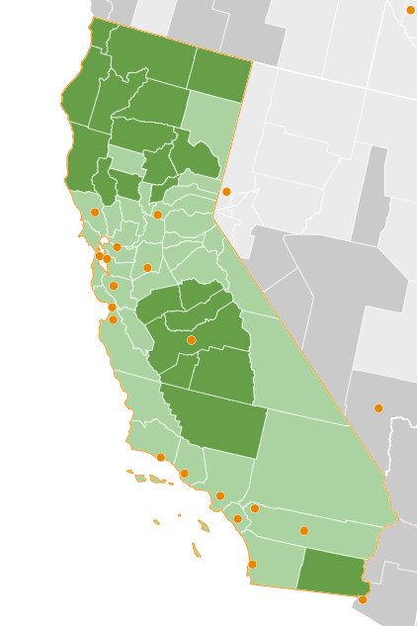
Figure 1: California Food Insecurity Rate by County (Feeding America, 2023)
Who Pays For and Administers the Program?
SNAP regulations and policy guidelines are set by the Food and Nutrition Service within the U.S. Department of Agriculture. There are certain administrative options left up to individual states, including simplified reporting systems, expanded eligibility guidelines, and the choice to offer transitional benefits (LSNC, 2023). In California, CalFresh is administered by the California Department of Social Services, and at the county level by county welfare departments. Counties have less control over broader CalFresh policies but can greatly impact application rates by setting office hours and location, determining eligibility, and determining the breadth of program outreach (LSNC, 2023). California is one of only 10 states sharing SNAP administration with county agencies (SNAP, 2018).
The USDA pays for the full cost of benefits and half of the administrative costs for SNAP, with state and county governments responsible for the remaining costs (LSNC, 2023). However, the state is not penalized for low participation rates, which could impact why the state is not as vigorously pursuing outreach to those not enrolled in the program (Schanzenbach, 2009). CalFresh’s relatively low participation rates compared to other states’ food stamps programs and other California welfare programs highlight the need for further research into the cause of these rates and potential improvements to the program's administration and outreach efforts.
Eligibility and Benefits
To qualify for CalFresh benefits, individuals must complete an application that includes completion of a form, an interview, and document submission to prove that the household meets the income eligibility requirements (Danielson & Bohn, 2021). Gross income must generally be less than 200% of the Federal Poverty Level (FPL), while net income after allowed deductions like housing, childcare, and medical expenses must be less than 100% FPL (LSNC, 2023). Most non-citizens are ineligible for CalFresh due to SNAP guidelines (LSNC, 2023). However, non-citizens may qualify for the CFAP program, which I will discuss more in depth in Section 3. A common precursor to program application is a large drop in household income, often taking place after a change in household composition, such as a divorce (Bhattarai et al., 2005). Program participation rates are highest among non-white, non-elderly households, and households with children (Bhattarai et al., 2005).
Monthly CalFresh benefits are delivered via an electronic benefits transfer (EBT) card for use to buy groceries (Danielson & Bohn, 2021). The benefit amount varies depending on household size and income- the more people in a household, the higher the maximum benefit and 30% of the household’s net income is subtracted from that maximum benefit to decide on the final monthly allocation (LSNC, 2023). The average individual benefit in 2020 was $166 per month (Danielson & Tan, 2020). 80% of benefits are spent within two weeks of receipt, and 97% of benefits are spent within one month of receipt, demonstrating that these benefits are of immediate assistance to recipients (Hammond et al., 2020). In July 2023, CalFresh issuances totaled $871,740,408 to 2,759,946 households (CDSS, 2023). The total value of distributed CalFresh benefits runs about $6 billion per year, but varies yearly as seen in Figure 2 (LSNC, 2023).
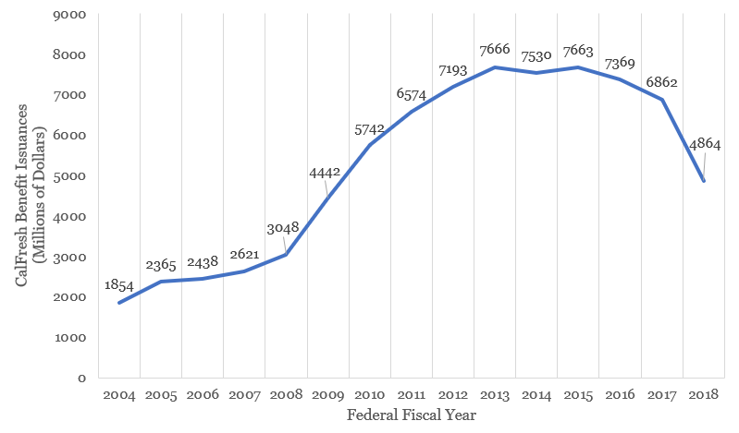
Figure 2: CalFresh Benefit Issuances by FFY (2004-2018) (CDSS, 2022)

Section 2: Problem Context
California’s Low Participation Levels
In 2022, CalFresh served a monthly average of 2,795,730 households, up from 2,481,627 in 2021. In July 2023, CalFresh received 187,477 applications (123,576 of which were online) and approved 96,612 applications (CDSS, 2023). While those statistics vary monthly, the program serves on average only 70% of those who are likely income eligible, meaning about 2 million individuals who meet the income requirements for the program are not accessing its benefits (Danielson & Tan, 2020). This lack of participation means that many families who could derive more food security from CalFresh are not able to do so. In fact, California is consistently one of the lowest ranked states in the country in terms of food stamps participation rates, as seen in Figure 3 (Gorman & Rowan, 2018). About 28% of food insecure individuals in the state are unable to access CalFresh due to being above the income threshold for the program (Feeding America, 2023).
As of 2018, the USDA only ranked California above 5 other states- Wyoming, North Dakota, Arkansas, North Carolina, and Kansas- in participation rates for all income eligible individuals (USDA, n.d.). California shares few characteristics, demographically or politically, with these states, making the state’s position in participation ranking more confusing. In contrast, several states report serving 100% of likely eligible residents, including Illinois, Delaware, Oregon, and Washington (USDA, n.d.). Such participation rates are hard to believe in the face of the literature of factors limiting program participation, including program churn, immigration status, and language barriers, as discussed in Section 4. It is likely that these high percentages stem from differing metrics for likely eligible individuals, as evidenced by the clarification provided by metrics such as the Program Access Index and Program Reach Index.
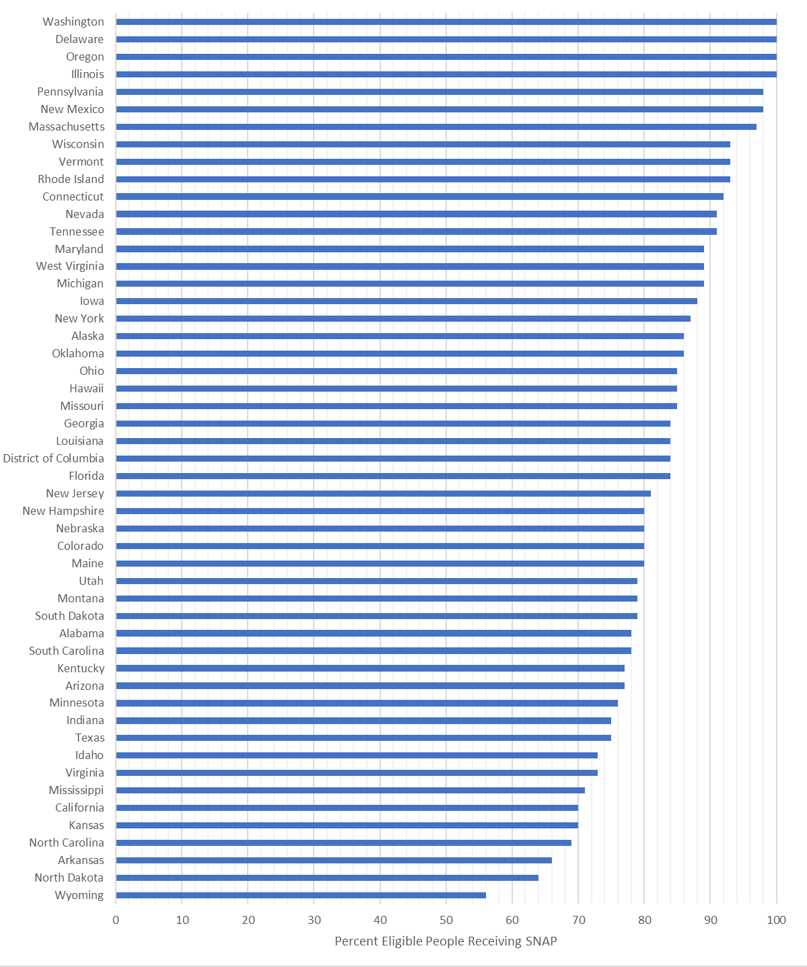
Figure 3: SNAP Participation Rates by State, All Eligible People FY 2023 (USDA, n.d.)
Alternative Participation Rate Metrics
An alternative metric utilized by the USDA to measure the success of SNAP implementation is the Program Access Index (PAI) (USDA, 2015). This index is primarily utilized by the USDA’s Food and Nutrition Service (FNS) to provide incentives for states whose low-income populations have the best and most improved access to SNAP (USDA, 2015). By basing its rates on those receiving SNAP below the income threshold, the PAI has a quicker turnaround than other metrics which utilize more precision in estimating those likely eligible for the program (USDA, 2015). While this metric is admittedly more clunky than the traditional measure of participation rates or more complex state measures, it allows for ranking of states’ improvement in participation in addition to participation rates themselves. Utilizing PAI, in 2021 California ranked 31st in the country, with a PAI of 70.9 and 23rd in participation improvement, up almost 8% from 2019, as seen in Figure 4 (USDA, 2023). While this measure places California at a similar percentage to the traditional SNAP participation performance indicator, it does place California slightly higher in the national rankings.
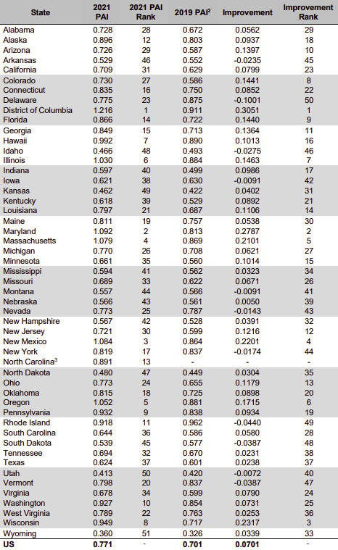
Figure 4: SNAP Program Access Index 2021 (USDA, 2023)
The traditional participation rates reported by the USDA placing California 5th to last in participation nationally are based on all individuals who fall within the income guidelines for SNAP. However, there are a number of reasons why an individual otherwise income eligible for the program may be ineligible for the program overall. Many individuals living below the income threshold in California are ineligible to receive CalFresh due to their immigration status (lack of U.S. citizenship or qualified legal immigrant status), others due to conviction for drug felonies or status as a college student (CDSS, 2017). Additionally, until 2019 individuals receiving SSI were also ineligible to receive CalFresh (CDSS, 2017). To account for the influence of these factors, CDSS created an alternative metric called the Program Reach Index (PRI) to measure CalFresh participation among those who meet CalFresh eligibility requirements, excluding individuals ineligible due to factors such as their immigration status (CDSS, 2017).
2019 is the most recent year of statewide PRI calculation available at time of writing. This complicates the PRI measurement as June 2019, when PRI would typically be estimated, is also the month that individuals receiving SSI were able to begin utilizing the CalFresh program (CDSS, 2023). This means that the PRI calculated for that year exists as a range, from a calculation including SSI recipients at 64.2% participation and excluding SSI recipients at 70.4% (CDSS, 2023). As the program reaches more individuals receiving SSI, we will still likely see numbers within this range, as evidenced by county measures reflected in Figure 5. This metric again does not provide much improvement for California’s participation rates against the traditional measure, but this metric does prove particularly useful in gauging the administrative successes and failures of the program PRI is also measured at the county level, and even further provides information on program administration successes and failures at the census-tract level (CDSS, 2017).
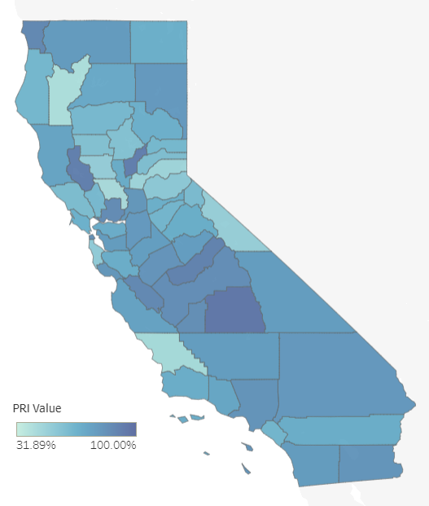
Figure 5: California Program Reach Index by County, 2021 (CDSS, 2023)

Section 3: Recent Policy & Administrative Efforts
COVID-Era Program Changes
The COVID-19 pandemic saw historic decreases in food insecurity likely partially brought about by changes to CalFresh and SNAP, along with other public welfare efforts such as stimulus checks (Feeding America, 2023). Many people experienced loss of income during the COVID-19 pandemic, and so The Families First Coronavirus Response Act passed by the federal government increased benefits received by participants through emergency allotments- in California, the emergency allotment consisted of the maximum benefit per household per month (LSNC, 2023). These benefits ended in February 2023 (LSNC, 2023). Increased benefit levels not only helped people to afford more food and increase food security in a time of crisis, but also likely incentivized program participation along with eased stringency for administrative factors.
Due to the nature of a pandemic, many factors involved in the traditional in-person administration of the CalFresh application and recertification process became unsafe for applicants and local agency staff. As such, the USDA allowed for states to enact certain waivers to ease these difficulties with the application process. Changes were made to interviews, signatures, certification periods, and periodic reporting requirements. At the beginning of the pandemic, the certification period for households whose recertification came due March-May 2020 was extended by 6 months, to a total of 1 year (USDA, 2023). Starting March 2020, California did not require applicants to complete an interview before approval or for recertification through August 2020, nor did they conduct any face-to-face interviews during application or recertification periods through October 2020, utilizing other methods of identity verification (USDA, 2023). During this time, California was also able to accept telephonic signatures through May 2021, wherein applicants could attest to the validity of their information verbally over phone rather than providing a physical signature (USDA, 2023). While many of these changes intended to address the dangers of face-to-face interaction during COVID-19, Section 4 will argue that such administrative changes should be utilized more broadly to increase CalFresh participation rates.
CFAP Efforts to Reach Immigrant Populations
It is apparent that CalFresh low participation rates are impacted by our high share of immigrants- 27% of the state’s population are foreign-born, the highest share of any state in the country (PPIC, 2023). Of that foreign-born population, 23% hold a legal status other than naturalized citizenship while 22% are completely undocumented (PPIC, 2023). To meet the food security needs of this population, California has begun to implement and expand the California Food Assistance Program (CFAP) (CDSS, n.d). To participate in this program, individuals must have been legally residing in the United States as a legal permanent resident non-citizen before August 22, 1996, have been battered or abused, be otherwise qualified no longer federally eligible under a federal program time limit, 0r be otherwise eligible except for having been sponsored into the United States on or after August 22, 1996 and either their sponsor has died is disabled (CDSS, n.d.). In 2022, the program was expanded to include all income-eligible people over the age of 55 regardless of immigration status (CDSS, n.d.). This program will help to meet the food security needs of undocumented Californians, but expansion of CalFresh to this population would also achieve this while increasing state participation rates.
Section 4: Factors Impacting Program Participation
Non-Administrative Factors
Across states, one identified cause for lower participation rates in CalFresh is that eligible individuals are not applying for the program due to personal factors. Some individuals may genuinely not need the benefits offered due to other support systems. Those who knew themselves to be eligible but did not apply were significantly less likely to have experienced food insecurity in the past year- in a 2004 survey, 70% of eligible non-applicants who said that they would not apply were considered food secure (Bartlett et al., 2004). Many eligible households may feel as though they don't need the benefit, or that others may be more in need of it than they are (Kaiser, 2008). Similarly, some individuals erroneously believe themselves to be ineligible for the program (Kaiser, 2008). In a 2009 survey, 40% of people who had never applied for SNAP before did not believe themselves to be eligible (Schanzenbach, 2009). In a 2004 survey, 35% of potentially eligible non-participant households believed themselves to be ineligible, while 18% were unsure of their potential eligibility, mainly due to their earned income. 69% of respondents to that survey said they would apply if they knew for certain that they were eligible (Bartlett et al., 2004).
Additionally, pride and perceived stigma surrounding program participation and receipt of government benefits are frequently cited as factors deterring individuals from applying for SNAP (Gorman & Rowan, 2018; Kaiser, 2008; Bhattarai et al., 2005). A desire for personal independence was cited by 91% of non-applicants in a 2004 survey (Bartlett et al., 2004). Research on the extent to which stigma is limiting participation is limited by the nature of the topic- those who feel that participation in SNAP or a need for government assistance are shameful are also likely less predisposed to respond openly to questions on the topic. An adjacent factor is a fear of impact on citizenship application status (Bourbonnais, 2013; Gorman & Rowan, 2018; Kaiser, 2008; Bartlett et al., 2004).
Previously, the public charge rule meant that receipt of certain government benefits could damage an immigrant’s chances of obtaining American citizenship, and while this rule now does not apply to receipt of nutrition benefits such as CalFresh, the fear has not completely diminished. Language barriers can also prevent individuals from applying for the program, especially when applications and application assistance are not available in an applicant’s native language (Bourbonnais, 2013; Kaiser, 2008; Holcomb et al., 2003). Finally, lack of transportation can make it difficult for individuals to access CalFresh offices and apply for the program should an office visit be necessary (Gorman & Rowan, 2018; Kaiser, 2008).
Administrative Successes in Oregon
In keeping with the aforementioned literature, it is surprising to hear that multiple states report delivering SNAP benefits to 100% of eligible residents. However, one such state, Oregon, can serve as a foil to illuminate why California's SNAP/CalFresh participation rates are so low. California and Oregon are similar in their political and cultural attitudes towards welfare recipients, both more liberal West Coast states with a history of pro-welfare program agendas (Elkaramany, 2023). This tends to nurture a more positive public opinion towards welfare and not create participation deterring stigma that other states with low SNAP participation that lean much more politically conservative may experience. A key difference influencing SNAP participation rates that emerges between California and Oregon is diversity, particularly the proportion of foreign-born residents, many of whom are ineligible to participate in SNAP. At least 27% of California’s population is foreign-born, the highest share of any state in the country, with 45% of that group holding a legal status other than naturalized citizenship (PPIC, 2023). Compare this to Oregon, with just 10% of their population having been born outside the United States, with 55% of that population holding a legal status other than naturalized citizenship (AIC, 2020). This relatively small number of foreign-born residents can help to explain in part why Oregon is able to provide SNAP to more of their income-eligible population than California, as many non-naturalized immigrants are ineligible to participate in SNAP.
Certain administrative factors are also at play in Oregon achieving 100% SNAP participation. First, their government established a collaborative governance regime, the Oregon Hunger Task Force to "promote community awareness, compile research, develop proposals for government action, and conduct outreach to expand participation in federal nutrition programs” (Elkaramany, 2023). This Task Force brought together government and nonprofit entities to establish SNAP access as a statewide priority, and its nonprofit action wing, Partners for a Hunger-Free Oregon, has been particularly successful in training community-based organizations in SNAP outreach with special focus on groups who often struggle with SNAP enrollment, like Hispanic communities (Elkaramany, 2023). An additional difference between California and Oregon’s administration of SNAP is that Oregon administers the program at the state-level, while California delegates much of its administration to the counties, which may contribute to variances in administrative effectiveness across communities (USDA, 2023). While I still believe it highly unlikely that every single person within the income limits of SNAP is receiving benefits in Oregon, we can at least take away some lessons from their success in the administration of CalFresh.
Administrative Failures in California
The CalFresh application itself is often cited as a high barrier to entry for many otherwise eligible for the program, and as such is likely responsible for both lower application rates and lower rates of application approval. The application itself can take households upwards of two hours to complete, including a four-page form and an interview (Unrath, 2021). This lengthy application process has been shown to reduce chances of participation by 3% compared to a shorter application (Bhattarai et al., 2005). In a 2009 survey, 15.5% of prior program applicants and 8.5% of those who had never applied reported that the application process was not worth the hassle (Schanzenbach, 2009) Confusion about required documentation and the application process can prevent individuals from successfully applying for the program (Bourbonnais, 2013; Kaiser, 2008; Bhattarai et al., 2005). When asked to provide documentation, participants were six times more likely to not follow through on the application process (Unrath, 2021). In a 2004 survey, 64% of those who thought themselves eligible but did not apply cited time & effort costs like the burden of paperwork and providing documentation as a reason for not applying (Bartlett et al., 2004).
CalFresh applicants are required to interview at the time of application and every year thereafter, as well as to recertify their information every six months. These requirements lead many individuals to either not complete the application or discontinue the program at the time of reporting (Gorman & Rowan, 2018; Bourbonnais, 2013). This can lead to a high dropout rate during the recertification period, with many eligible individuals choosing not to reapply for the program. Many who leave the program due to recertification requirements are still otherwise eligible for the program (55-75%), contributing to the high rates of non-participants who may still otherwise be in need (Unrath, 2021). Finally, a lack of cross-programmatic eligibility may also be a hindrance to increasing CalFresh participation rates. While CalFresh participation can make a child eligible for free school meals, the reverse is not the case. While CalFresh participation serves as proof of income eligibility for those applying for the Women, Infants, and Children (WIC) program, again the reverse is not true (Danielson & Bohn, 2021).
In addition to the challenges of the application itself, the administrative procedures surrounding the process may also discourage people from applying for CalFresh and limit application approval rates. In counties where phone and online application options are less accessible, long lines at county welfare offices and a lack of flexibility in setting appointment times at county offices can contribute to low participation rates (Gorman & Rowan, 2018). Heads of households who work full-time are less likely to participate in CalFresh, likely because they cannot visit county welfare offices operating during normal business hours to apply for the program (Kaiser, 2008; Bhattarai et al., 2005). The need to take time away from work, dependent care responsibilities, and the difficulty of getting to the food stamp office are reasons for not applying according to 64% of those who thought themselves eligible but did not apply (Bartlett et al., 2004). Once the initial application is submitted, the wait to have benefits approved can be lengthy and discourage those in need of immediate assistance. Phone hold times of up to an hour and a half and application processing times averaging 24-30 days can hinder applicants from continuing the process (Mizes-Tan, 2020). Poor communication and follow-up from CalFresh staff are also a factor in non-application- when missed appointments aren’t rescheduled and notifications of upcoming documentation deadlines are neglected, applicants are less likely to see their benefits approved (Kaiser, 2008).
Section 5: Recommendations to Improve CalFresh Administration
Recommendations for State Administrators
Application Streamlining
To address the deterrent effects of the CalFresh application as it exists, changes to the application process are needed. Many such changes are not possible at the state level and would require federal action. However, the state has some leniency in the form of waivers from the USDA to streamline the process. The application process should be streamlined, making it easier and faster for individuals to apply for benefits (Fricke, et al, 2015). This could involve simplifying the application form, minimizing the documentation & staff contact requirements, and reducing the amount of information that applicants are required to provide (Unrath, 2021). An example of the introduction to the current online CalFresh application is pictured in Figure 6. Implementing a "one and done" policy for phone applications, where applicants can complete their application, interview, and provide a telephonic signature all within one phone call, could also help to streamline the process (Hammond et al., 2020). Across the board, CalFresh administrators should continue to utilize new technology to speed up the processing of applications, such as allowing for telephonic signatures and emphasizing use of the online application (Bourbonnais, 2013). This could help to reduce the time it takes to complete the application process and get benefits approved, making it more appealing for potential applicants.
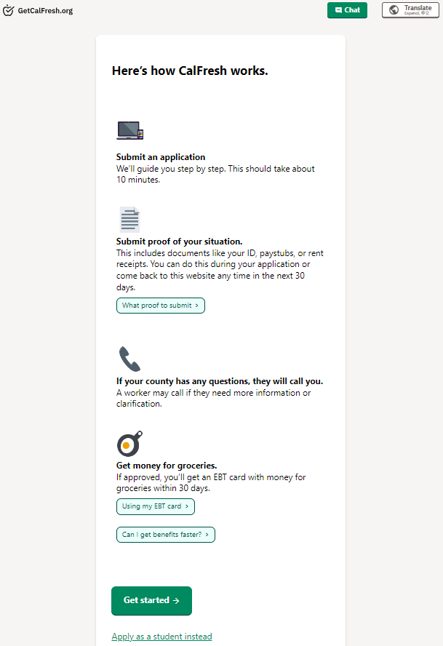
Figure 6: CalFresh Online Application Introduction
To address administrative burdens impacting CalFresh participation rates, the literature suggests a few changes, which would require higher level government action to implement. One potential intervention is to allow for more flexibility in scheduling interviews, which is currently one of the highest barriers to completion of the application process (Unrath, 2021; Hammond et al., 2020). Allowing applicants to schedule interviews according to their own schedule and allowing for interviews to be conducted over the phone, instead of only in person, can help to make the process more convenient and accessible for applicants (Hammond et al., 2020). This change would ease the application process for those with transportation limitations, especially in rural counties where the CalFresh office may be prohibitively far from applicants, as well as those whose work schedules do not allow them the flexibility to be available for an in-person interview at a CalFresh office.
Cross-Programmatic Eligibility
Utilizing cross-programmatic eligibility can also help to increase participation in CalFresh. For example, Medi-Cal beneficiaries and individuals already accessing services from other government organizations and CBOs that signal potential eligibility could be guided through the application process to save on administrative costs and reach more individuals (Gorman & Rowan, 2018). 20 other states have a joint application and processing procedure for all Medicaid and SNAP applicants (SNAP, 2018). Similarly, families phasing out categorical eligibility for WIC could be pulled into CalFresh (Kaiser, 2008, Hammond et al., 2020). Available administrative data sources should be used to confirm eligibility to simplify the application process and reduce the documentation burden on applicants (Unrath, 2021). By targeting outreach and assistance efforts to these individuals, the application process can be made more efficient and more likely to result in successful enrollment in the program.
Cross-Programmatic Referrals
In the absence of cross-programmatic eligibility processes, administrators should build systems to refer recipients of Medi-Cal, free & reduced school lunch, and WIC to assist with the CalFresh enrollment process. While eligibility overlap between these programs is not a perfect circle, it is enough that such efforts to bring people from one program into another could help introduce CalFresh to those who may have not applied previously due to concerns about their eligibility (Gorman & Rowan, 2018). While those individuals may still run into the hurdle of CalFresh’s required yearly interview and biannual information update that causes much program churn, such efforts could be effective in helping get money for food to people who have not had prior contact with the CalFresh system (Gorman & Rowan, 2018). Other than the costs needed to set up the referral systems between these programs, this intervention could save on costs that have been going towards recruitment methods that have not been effective. CalFresh has some of the lowest rates in the country for eligible individuals enrolled, while Medi-Cal, free & reduced school lunches, and WIC have significantly higher enrollment rates (Gorman & Rowan, 2018; Danielson & Bohn, 2016). Utilizing these other programs enrollment successes could prove effective for helping CalFresh reach those individuals, as well as ease the application process for those people who otherwise may be put off by the repetitive nature of applying to social safety net programs.
The CalFresh application system is already overstressed following increased demand during COVID-19, leading to average application processing times of over a month, which does not help the people applying for help feeding themselves today (Mizes-Tan, 2020). Introducing even more applicants to the CalFresh program could lead to less people in total receiving assistance if the program does not increase application processing capabilities in tandem with such efforts. This would likely be the least costly option, as well as the most politically feasible. While the administrative efforts required may increase, increases in application processing capacity could solve such issues. California would not be alone in such an endeavor- 20 other states already operate joint Medicaid and SNAP application processes (SNAP, 2018). This intervention may not reach as many Californians as other options might, but it would be effective in targeting groups in need of CalFresh assistance through their participation in similar safety net programs. This means that efforts put into this intervention would be more likely to have an impact on food insecure individuals and help to improve not only their lives and outcomes, but those of the whole state.
Recommendations for County Administrators
Increased Staffing
A crucial intervention to better participation rates is to increase staffing of county eligibility caseworkers, who are responsible for conducting interviews and processing applications (Fricke, et al, 2015). Increasing staffing levels can help to reduce the workload on individual caseworkers, making the process more efficient and increasing the likelihood that applicants will be able to successfully enroll in the program. However, limited funding makes such an intervention difficult, especially in smaller counties many of whose county general funds are stretched thin as-is. A possible solution to this problem is focusing state funding assistance for increased staffing on counties identified as most in need of intervention by use of the Program Reach Index.
Targeted Outreach
Another suggestion to increase participation in CalFresh at the county level is targeted outreach efforts, including print and media messaging, as well as in-person outreach and application assistance (Hammond et al., 2020). This approach can help to decrease stigma around program participation by increasing community awareness about the program and its benefits (Fricke, et al, 2015; Hammond et al., 2020; Schanzenbach, 2009). For example, outreach can highlight that CalFresh can help families purchase healthier diets and can also be used by the working poor, low-income seniors, and struggling families, not just those experiencing extreme poverty or times of economic crisis (Kaiser, 2008). It is also important to tailor outreach messages to different subpopulations, using culturally relevant messaging to increase effectiveness (Hammond et al., 2020). Messaging should attempt to overcome common myths about CalFresh, such as the idea that the benefit is too small to justify the costs of the application process (Hammond et al., 2020). By highlighting the average benefit and the potential for CalFresh to improve family nutrition, outreach efforts can be more effective in encouraging participation in the program. Lastly, it has been found that outreach which avoids stigmatized terms such as “food stamps” is more likely to have favorable response from possible applicants (Schanzenbach, 2009).
CBO Capacity Building
A key aspect of targeted outreach is to train and build capacity for community-based organizations (CBOs) such as local health clinics, schools, tax preparation offices, and churches to conduct outreach and assist with the CalFresh application process (Bourbonnais, 2013; Kaiser, 2008; Hammond et al., 2020; Schanzenbach, 2009; Holcomb et al., 2003). Research shows that the more assistance an applicant receives with the application process, the more likely they are to successfully enroll in CalFresh (Schanzenbach, 2009). Providing staff with awareness of all possible deductible expenses can help to ensure that applicants receive the highest benefit possible, which can increase their willingness to apply for CalFresh (Schanzenbach, 2009; Hammond et al., 2020).

Recommendations for Lawmakers
Income Limit Adjustment
An adjustment of the income limit for the CalFresh to better reflect the cost of living in California through the California Poverty Measure (CPM), rather than basing it on a Federal Poverty Level (FPL) would certainly allow the program to reach more individuals. Currently, the income limit for CalFresh is 100% of the FPL after certain allowed deductions- in 2020, that came to about $26,000 in annual income for a family of 4 (Danielson & Tan, 2020). Based on the federal poverty rate, California has higher than average statewide poverty, but when regional cost of living is considered, that amount of poverty becomes even higher than the rest of the country (PPIC, 2006). The CPM accounts for the same factors as the FPL, but also includes regional cost of living, along with family needs and resources (Bohn, et al, 2023). Utilizing this measure, a family of four would need to make, on average, $35,600 per year to meet their basic needs as of 2019- notably, this is $10,000 per year higher than the current income limit for inclusion in CalFresh (Bohn, et al, 2023). With 28% of food insecure people currently above the income threshold, changing from FPL to CPM could bring over 1 million people into CalFresh eligibility (Feeding America, 2021).
So, there is a large contingent of food insecure Californians not being helped by CalFresh due to the program’s reliance on Federal measures of poverty. However, while adjusting from FPL to CPM may be very effective in better serve food insecure Californians, much of the authority to decide on income thresholds lies in the Food and Nutrition Act and the Farm Bill, with some categorical eligibility and reporting choices left up to states (LSNC, 2023). Any state specific changes would need to come about through a waiver granted by the USDA or federal changes to the Farm Bill, which brings up concerns of political feasibility of such efforts (LSNC, 2023). Additionally, the cost of providing benefits to those additional people made eligible by an income threshold increase would be high, although national analysis found that increasing SNAP benefits by $1 billion would raise GDP by $1.54 billion, a return on investment beyond just the additional food on hungry families’ tables (Danielson & Tan, 2020). The benefits of such an action are apparent, but the fiscal and political realities likely mean that such a change would be dead on arrival.
CalFresh as a UBI
An aspirational option is that of CalFresh as a Universal Basic Income (UBI) program. This idea comes from the work food insecurity and supplemental nutrition researcher, Professor Craig Gundersen. Using a national model, he found that expanding food stamp benefits by about 25% and universally administering them to all households up to 400% FPL could reduce food insecurity by about 98% (Gundersen, 2021). Universally providing these increased benefits to all under the increased threshold would allow us to address the food access needs of those who are food insecure but currently above the income limit for CalFresh. This would also help reach those within the income limits who do not apply for benefits due to difficulties with the application & interview process, as they would not need to apply to receive benefits (Gorman & Rowan, 2018). CalFresh as a UBI would guarantee all recipients the same benefit amount regardless of net income- the current maximum benefit with the addition of the average food budget shortfall.
However, on a national scale, the average cost per person made food secure would be around $16,308 (Gundersen, 2021). This gives us an estimated cost of over $64 billion to implement within California, which is no small order when the total state budget is about $200 billion. To pay for the program, Gundersen suggests taxes proportional to the current distribution of taxes, with higher taxation of households with little-to-no-risk of food insecurity (Gundersen 2021). The total cost and subsequent raise in taxes, as well as the controversy surrounding most UBI programs, could make it so that the other alternatives would better succeed in moving through the policy-making process.
CalFresh Incentivizing Options
To further incentivize program participation, several actions can be taken. California state legislators can pass the CalFresh Minimum Benefit Adequacy Act (SB600). This would utilize state funding to require CDSS to provide additional CalFresh allocations to bring all participating individuals to a minimum monthly benefit of $50, up from the federal minimum monthly benefit of $23 (Menjivar, 2023). States like New Jersey are already implementing increases to their minimum monthly benefit to as much as $95 per individual (Menjivar, 2023). The Thrifty Food Plan (TFP) is determined by the USDA which influences the minimum allotment of SNAP benefits but does not account for the fact that cost of living in California is 46.8% higher than the national average and the third highest of any state in the country (Walters, 2023). An increase to the monthly minimum benefit would go a long way to bridging households’ budget shortfall of $53 per month (Feeding America, 2023). By increasing the minimum benefit, individuals will be more motivated to go through the application process and keep up with the recertification process if the possible benefit is higher. However, the costs of this are difficult to determine as the number of individuals receiving CalFresh fluctuates month-to-month, though a basic estimate places it in the billions of dollars annually, making the eventuality of such an option unlikely due to the state’s annual budgets.
An important policy for incentivizing CalFresh participation is maintaining and expanding the CalFresh Market Match program, which matches every dollar spent with CalFresh at around 270 sites in the state of California, typically farmer’s markets or their equivalent (Ecology Center, 2021). This policy option is the most in line with behavioral economic principles, as CalFresh recipients have incentive to spend their money at farmer’s markets on fruits and vegetables, which not only supports the recipient’s health, but also benefits local farmers, bringing $3 of benefit to the local economy for every $1 spent on the program (Ecology Center, 2021). However, currently in California only .06% of CalFresh benefits are spent at farmer’s markets, due to the small scope and lack of public knowledge of the program (Thilmany, et al, 2021). Lawmakers can expand funding to this program to both increase the amount matched and to improve outreach and public knowledge of the program.
Section 6: Conclusion
While the suggested interventions are backed by research and the experiences of those familiar with CalFresh, further research is needed to determine which would be the most effective. By evaluating the impact of these interventions on participation rates, policymakers can determine which approaches are the most effective in increasing enrollment in the program. Such research could also aid in the administration of similar social welfare programs. I would hope in future research to examine pilot programs of suggested interventions and see if participation rates are affected following implementation. This research would be complicated by the fact that some of these suggestions may take significantly longer to see results, and different regions may see varying success based on external factors.
It is crucial that we learn from the administrative failings of CalFresh, the successes of other states, and the findings of existing research to increase program participation rates. An entitlement program such as CalFresh should be serving all eligible households, not just 2/3 across metrics, particularly when these benefits do so much good for the households they are delivered to. With many signs pointing to an impending recession and the food insecurity that it will cause, prompt action to broaden the reach of this proven program is crucial.

References
American Immigration Council (2020, August 6). Immigrants in Oregon. Retrieved November 14, 2023, from https://www.americanimmigrationcouncil.org/ research/immigrants-oregon.
Bartlett, S., Burstein, N., & Hamilton, W. (2004). Food Stamp Program Access Study Final Report. Economic Research Service, Food Assistance & Nutrition Research Program. Retrieved November 14, 2023, from https://www.ers.usda.gov/ webdocs/publications/43390/30283_efan03013-3_002.pdf?v=0
Bhattarai, G. R., Duffy, P. A., & Raymond, J. (2005). Use of food pantries and food stamps in low-income households in the United States. Journal of Consumer Affairs, 39(2), 276– 298. https://doi.org/10.1111/j.1745-6606.2005.00015.x
Bohn, S., Danielson, C., & Malagon, P. (2023, October). Poverty in California. Public Policy Institute of California. Retrieved November 14, 2023, from https://www.ppic.org/publication/poverty-in-california/.
Bourbonnais, N. (2013). (rep.). Feeding California: An Examination of Efforts to Decrease Food Insecurity by Increasing CalFresh Participation Rates (pp. 31– 38). Berkeley, CA: University of California, Berkeley.
California Department of Food and Agriculture. (2021). California Agricultural Production Statistics. CDFA. Retrieved from https://www.cdfa.ca.gov/ Statistics/.
California Department of Social Services. (2022, November 30). CalFresh Data Dashboard. Retrieved October 25, 2023, from https://public.tableau.com/app/ profile/california.department.of.social.services/viz/CFdashboard-PUBLIC/ Home?publish=yes
California Department of Social Services (n.d.). California Food Assistance Program (CFAP). Retrieved November 1, 2023, from https://www.cdss.ca.gov/ inforesources/calfresh/california-food-assistance-program
California Department of Social Services. (2017, March). Methodology for Measuring Neighborhood Access to CalFresh. Retrieved October 25, 2023, from https://www.cdss.ca.gov/Portals/9/DSSDB/Dashboards/CalFresh/ Program_Reach_Index_(PRI)_Methodology_Writeup.pdf
CalRecycle. (2021, January 12). Food recovery in California. CA.gov. Retrieved from https://www.calrecycle.ca.gov/organics/slcp/foodrecovery.
Danielson, C., & Bohn, S. (2021, August 28). Improving California children's participation in Nutrition Programs. Public Policy Institute of California. Retrieved from https://www.ppic.org/publication/improving-california-childrens-participation-in-nutrition-programs/.
Danielson, C., & Tan, D. (2020, September 22). The CalFresh Food Assistance Program. Public Policy Institute of California. https://www.ppic.org/publication/the-calfresh-food-assistance-program/.
Ecology Center. (2021). Market Match Supports Food Security & Sustains Local Economy During Pandemic. Market Match. Retrieved November 14, 2023 from https://marketmatch.org/wp-content/uploads/2021/05/Market-Match- Statewide-Impact-One-Pager-FINAL.pdf.
Elkaramany, M. (2023). Ahead of the Curve: How Oregon Succeeded in Enrolling All Eligible Households in the Supplemental Nutrition Assistance Program (SNAP). Journal of Hunger & Environmental Nutrition. https://doi.org/10.1080/19320248.2023.2211973
Elkaramany, M. (2022). State Policy Effects on the Suppression of CalFresh Participation Rates. Journal of Poverty. https://doi.org/https://doi.org/10.1080/10875549.2022.2065560
Feeding America. (2023). Food Insecurity in California. Map the Meal Gap.
https://map.feedingamerica.org/county/2019/overall/california.
Feeding America (n.d.). Effects of Hunger. Retrieved November 14, 2023 from https://www.feedingamerica.org/hunger-in-america/impact-of-hunger
Feeding America (n.d.) Importance of Nutrition on Health in America. Retrieved November 14, 2023 from https://www.feedingamerica.org/hunger-in -america/impact-of-hunger/hunger-and-nutrition
Fricke, H. E., Hughes, A. G., Schober, D. J., Pinard, C. A., Bertmann, F. M., Smith, T. M., & Yaroch, A. L. (2015). An examination of organizational and statewide needs to increase Supplemental Nutrition Assistance Program (SNAP) participation. Journal of Hunger & Environmental Nutrition, 10(2), 271–283. https://doi.org/10.1080/19320248.2015.1004217
Gorman, A., & Rowan, H. (2018, May 1). Why millions of Californians eligible for Food Stamps don't get them. NPR. https://www.npr.org/sections/thesalt/2018/05/01/606422692/why- millions-of-californians-eligible-for-food-stamps-dont-get-them.
Gundersen, C. (2021). Viewpoint: A proposal to reconstruct the Supplemental Nutrition Assistance Program (SNAP) into a universal basic income program for food. Food Policy, 101. https://doi.org/10.1016/j.foodpol.2021.102096.
Hammond, R., Li, J., McKinnon, R., & Munoz, J. (2020). (rep.). CalFresh Expansion to SSI Recipients: A Case Study on SNAP Accessibility. San Francisco-Marin Food Bank. Retrieved December 3, 2022, from https://www.sfmfoodbank.org/wp- content/uploads/2020/05/CalFresh-Expansion-Report.pdf.
Jetha, R. (2023, June 19). How fresh will CalFresh be? Food benefits on the table in state budget talks. CalMatters. Retrieved October 20, 2023 from https://calmatters.org/politics/2023/06/california-food-benefits/
Kaiser, L. (2008). Why do low-income women not use food stamps? findings from the California Women’s Health Survey. Public Health Nutrition, 11(12), 1288–1295. https://doi.org/10.1017/s1368980008002528
Legal Services of Northern California. (2023). Benefit Increases Because of COVID-19. LSNC Guide to CalFresh Benefits. Retrieved from https://calfresh.guide/benefit-increase-because-of-covid-19/
Legal Services of Northern California. (2023). How the CalFresh program is structured. LSNC Guide to CalFresh Benefits. Retrieved from https://calfresh.guide/how-the-calfresh-program-is-structured/
Legal Services of Northern California. (2023). Summary of basic eligibility. LSNC Guide to CalFresh Benefits. Retrieved from https://calfresh.guide/summary-of-basic-eligibility/
Legal Services of Northern California. (2023). What is the CalFresh program and how does it work? LSNC Guide to CalFresh Benefits. Retrieved December 4, 2022, from https://calfresh.guide/what-is-the-calfresh-program-and-how-does-it- work/
Menjivar, Caroline. (2023, February 16). Senator Menjivar pursues increase in nutrition assistance with Calfresh Minimum Benefit Adequacy Act of 2023. Caroline Menjivar California State Senator 20th District. https://sd20.senate.ca.gov/news/senator-menjivar-pursues-increase-nutrition-assistance-calfresh-minimum-benefit-adequacy-act
Mizes-Tan, S. (2020, September 15). Long Waits, delays for food, health care benefits in Sacramento County during pandemic. CapRadio. Retrieved December 3, 2022, from https://www.capradio.org/articles/2020/09/15/long-waits-delays-for-food-health-care-benefits-in-sacramento-county-during-pandemic
Office of the Assistant Secretary for Planning and Evaluation, Holcomb, P., Tumlin, K., Koralek, R., Capps, R., & Zuberi, A., The Application Process For TANF, Food Stamps, Medicaid and SCHIP (2003). The Urban Institute. Retrieved December 3, 2022, from https://aspe.hhs.gov/sites/default/files/migrated_legacy_files/ 40011/report.pdf
Perez, C.A., Mejia M.C., Johnson, H. (2023, January). Immigrants in California. Public Policy Institute of California. https://www.ppic.org/publication/immigrants-in- california
Public Policy Institute of California. (2006, May 11). Are federal poverty estimates valid for California? Public Policy Institute of California. Retrieved from https://www.ppic.org/press-release/are-federal-poverty-estimates-valid-for- california/.
Schanzenbach, D. W. (2009). Experimental Estimates of the Barriers to Food Stamp Enrollment. Institute for Research on Poverty. Retrieved December 3, 2022, from https://irp.wisc.edu/publications/dps/pdfs/dp136709.pdf.
Thilmany, D., Bauman, A., Love, E., & Jablonski, B. B. R. (2021, January). The economic contributions of Healthy Food Incentives. Market Match. Retrieved from https://marketmatch.org/wp-content/uploads/2021/02/Economic_ Contributions_Incentives.pdf.
Unrath, M. (2021, January). Pushed out by paperwork: Why eligible Californians leave CalFresh. California Policy Lab. Retrieved December 3, 2022, from https://www.capolicylab.org/wp-content/uploads/2021/02/Pushed-out-by- paperwork-why-eligible-Californians-leave-CalFresh.pdf
U.S. Department of Agriculture (2023, October 2). California: COVID-19 Waivers and Flexibilities. Food and Nutrition Service. Retrieved November 1, 2023 from https://www.fns.usda.gov/disaster/pandemic/covid-19/california#snap
U.S. Department of Agriculture (2015, January). Calculating the Supplemental Nutrition Assistance Program (SNAP) Program Access Index: A Step-by-Step Guide for 2013. Food and Nutrition Service. Retrieved October 25, 2023, from https://www.cwda.org/sites/main/files/file-attachments/pai2013.pdf ?1455134856
U.S. Department of Agriculture (n.d.). SNAP participation rates by state, all eligible people (FY 2018). Food and Nutrition Service. Retrieved October 25, 2023, from https://www.fns.usda.gov/usamap
U.S. Department of Agriculture (2023, May 10). SNAP Program Access Index: 2021. Food and Nutrition Service. Retrieved October 25, 2023 from https://www.fns.usda.gov/snap/qc/pai
U.S. Department of Agriculture (2023, October). State Options Report (2018). Food and Nutrition Service, SNAP Program Development Division. Retrieved November 14, 2023 from https://fns-prod.azureedge.us/sites/default/files/resource- f iles/snap-15th-state-options-report-october23.pdf
Walters, Dan (2023, April 23). High living costs solidify California’s two tier economy. CalMatters. Retrieved October 23, 2023, from https://calmatters.org/ commentary/2023/04/california-two-tier-economy/

