An Ecological Examination of California’s Dual Education Crises: Addressing California’s Teacher Shortage and Chronic Student Absenteeism
Juliet Athena Terry

A Culminating Project Presented to the Department of Public Policy and Administration
at California State University, Sacramento in Fulfillment of the Requirements for the
Degree of Master of Public Policy and Administration
December 1, 2023
Advisor: Ahrum Chang, PhD

Executive Summary
The very foundations of California’s public schools are beginning to crumble under the weight of two co-occurring education crises. California is battling a historic teacher shortage that has schools desperately trying to fill a 35,000-teacher deficit while also trying to address a 30 % state-wide chronic student absenteeism rate. These dual crises are debilitating public schools across the state and forcing policy experts and school system stakeholders to ask, “What is driving students and teachers away from schools and what can we do about it?”. To answer this question, this report uses Urie Bronfenbrenner’s (1979) ecological systems theory to conduct an ecological and whole systems case study analysis of these two crises. Bronfenbrenner’s ecological model guides the boundaries of this analysis and final policy recommendation to one that is comprehensive, equitable and cost-feasible.
Literature review findings reveal an array of shared and interacting causal drivers behind the crises within the ecological systems framework. Findings revealed clear strategies to concurrently ameliorate these issues which include mental health and wellbeing support, increased cross-system support services, specialized staff, and resources for students and families, the rebuilding of foundational trusting relationships between school community stakeholders, improving school cultures and environments, increased administrative support and collaboration, and integrating the school community into the larger community context. Based on these findings the report recommends a two-fold expansion of the California Community Schools Partnership Program which is a comprehensive policy solution that acts as strategic container for a multitiered and customizable approach to reduce rates of chronic absenteeism and improve teacher retention.
Table of Contents
Executive Summary 2
Table of Contents 3
Acknowledgements 4
Section I: Introduction 5
Section II: Issue Background and Literature Review 9
Bronfenbrenner’s Ecological Systems Theory 9
Defining the Dual Crises 15
California’s Teacher Shortage 15
Chronic Student Absenteeism 24
Section III: Methods 31
Section IV: Findings 33
Section V: Policy Analysis and Recommendation 45
Section VI: Conclusion 53
References 56

Acknowledgements
My arrival at the end of my graduate school journey is an accomplishment that words cannot properly describe. The gratitude that I have for all those who have loved and supported me, those that have fortified my spirit and mind through this process is immeasurable, from the bottom of my heart, thank you.
Thank you to my mother Nicloe Lambo for instilling in me a spirit of undying commitment to being a force for love and humanity in a challenging but beautiful world. You told me I could do anything I wanted in this life, and I am here because of you.
Thank you to my aunt, Felecia Faulkner, who has been a rock of love, support, and guidance through every step of my higher education journey.
Thank you to my partner Mikias, who opened my eyes to my own possibilities and power in academia and as a citizen of the world. Thank you for never letting me give up on my dreams.
Thank you to my mentor Kayla Nick-Kerney, who convinced me to apply to this program. Your pep talks, guidance, and belief in me made this degree possible. Your commitment to seeing me succeed in every way possible in school and life means the world to me.
Thank you to all my classmates and 2021 cohort. You all are brilliant, caring, and powerful people. I have learned so much from you all and look forward to shining our light together in this world.
Finally, thank you to all the MPPA faculty: Dr. Rob Wassmer, Dr. Ted Lascher, Dr. Sara McClellan, Dr. Ahrum Chang, Dr. Amal Kumar, and Christian Griffith. I have grown so much because of your wisdom, expertise, guidance, and support. I deeply value your insights and willingness to challenge me to be the best student and agent for change I can be.
Section I: Introduction
In a post-pandemic world, California’s public schools struggle to combat the dual crises of a historic teacher shortage and widespread chronic student absenteeism. These crises have left classrooms void of their two main actors and education policy experts pondering the question “What is driving students and teachers away from schools and what can we do about it?”. Teacher shortages, while historically a persistent issue, have become a national crisis since the COVID-19 pandemic, leaving thousands of classrooms void of qualified teachers, and in some extreme cases being staffed by the National Guard (Nguyen et al. 2022). Currently, California lacks at least 35,000 teachers to properly staff classrooms (Johnson, 2023). Since the start of the pandemic, chronic student absenteeism in California has doubled with at least 30% of students being chronically absent in the last school year (Jordan, 2023). Chronic absenteeism severely impacts student success and schools’ financial stability, as school funding is calculated using daily attendance rates. Both teacher shortages and chronic absenteeism in California schools have, among other things, led to lower student achievement and a deterioration of the foundational relationships between teachers, students, and community members that hold school communities together.
The very foundations of California’s public school system are beginning to crumble under the weight of these dual crises. Inequities continue to be a large concern in California’s public school system, as these dual crises are disproportionately impacting and hindering the lives and futures of California’s most underserved and underrepresented teachers, students, and their families (Hahnel & Baumgardner, 2022; Johnson, 2023). Serious financial investment and intervention from the government and school system stakeholders are needed to repair and reimagine how California’s school system can overcome these two immense challenges to best serve both students and teachers.

Purpose of Report.
The purpose of this policy report is to use a whole systems approach to formally investigate, analyze, and present one comprehensive policy solution for two case studies of large and complex public sector issues that reside within the same system, the teacher shortage and chronic student absenteeism. A policy solution is presented to encourage state policymakers, education system administrators, and stakeholders to consider a whole systems approach to ameliorating two extremely complex and intertwined issues. This report creates an intentional dialog between these two co-occurring issues to encourage more research and discussion of public issues and systems from a whole systems perspective. In doing so, public policy professionals and stakeholders acknowledge that many issues within public systems often affect each other, both within and outside of their shared system, and that effective solutions to complex public issues require a comprehensive approach that targets as many causal factors as possible.
The guiding analytical framework that this report is grounded in is Urie Bronfenbrenner’s (1979) ecological systems theory of human development and socialization. This theory applies a whole systems perspective to examine all the multifaceted, layered, and intersecting systems, relationships, and environments that contribute to the root causal factors behind these two crises. By using this theory to analyze these dual crises, this report illustrates how public sector issues are not just influenced by factors within one public system but are issues that are also embedded into the many structures that make our collective society, and therefore must be addressed holistically. The objective of this policy report’s analysis is to present a holistic policy solution that will comprehensively, equitably, and sustainably decrease student chronic absenteeism and increase the retention of teachers already working in California. While the teacher shortage crisis is investigated in its entirety in this study, the scope of analysis for this report is purposefully limited to presenting a policy solution that is focused on improving teacher retention and student attendance. The need for comprehensive solutions to these dual crises is urgent. Not only are both issues threatening the very foundation of our public school system, but they are harming students and teachers from marginalized communities the most in the process (Hahnel & Baumgardner, 2022; Johnson, 2023).

What is Included in This Report
Section II: Issue Background and Literature Review provides background information and theoretical discussion on the current state of California’s teacher shortage crisis and the statewide spike in rates of chronic absenteeism. The literature review works to identify key causal forces and barriers to success in these co-occurring issues in the hopes of finding intersections to target comprehensive policy solutions. Finally, the literature review section examines Bronfenbrenner’s ecological systems theory (1979) as it applies to both students and teachers and grounds the researcher’s understanding of causal forces behind key issues from a holistic ecological systems perspective.
Section III: Methods describes the methods used in this report to analyze both the core causal drivers of these dual issues and to assess and recommend a policy solution that comprehensively addresses the crises. This section details how Bronfenbrenner’s (1979) ecological systems theory is applied to guide both the boundaries of this report and the evaluative criteria applied to the proposed policy solution.
Section IV: Findings presents a summary of findings derived from the literature review and content analyses on the causal factors for the teacher shortage and chronic student absenteeism and creates visible intersections between both issues. This section also presents a summary of findings from a review of the literature on emerging and promising solutions in the field to address the two crises. Section IV also briefly describes what the state of California is currently doing to address these issues.
Section V: Policy Analysis and Recommendation presents a policy solution that comprehensively addresses the most significant causal factors for the dual crises of teacher shortages and chronic student absenteeism. This policy solution is analyzed using Bronfenbrenner’s (1979) ecological systems theory as a guiding framework. Additionally, the proposed policy recommendation is analyzed and justified using supplemental evaluative criteria of equity and cost-effectiveness.
Section VI: Conclusion summarizes the methods and findings of the report. The section also summarizes and justifies the final policy recommendation for the dual crises and describes possible barriers to policy success and the limitations of the study.

Section II: Issue Background & Literature Review
Guiding Framework: Bronfenbrenner’s Ecological Systems Theory
Urie Bronfenbrenner was a prominent American developmental psychologist who developed a revolutionary new lens for examining human development and socialization, the ecological systems theory. The ecological systems theory places human development and socialization within the context of the multiple overlapping and interacting systems and environments that individuals are a part of (Härkönen, 2007). The whole of these interactions, relationships, systems, and environments creates each individual’s personal ecology (Härkönen, 2007). The concept of ecology for this report is defined by the interactions between individuals, their environments, and the systems they are a part of, as well as their interpersonal and systemic relationships, and how those interactions affect the individual and the systems they are a part of (Härkönen, 2007).
Interpersonal and intersystem relationships and interactions are foundational to understanding how and why the dual crises discussed in this report happen. The ecological systems model enables an in-depth discussion of these issues that simultaneously addresses a complete array of relevant factors thought to be responsible for driving these public system crises. The concept of student and teacher ecological systems is a guiding framework for this report because it creates important theoretical linkages between the common systems and environments that both actors occupy and are deeply influenced by. By employing this framework, the report directs its proposed policy solution towards comprehensive and multitiered approaches that reach all relevant aspects of student and teacher ecologies.

Student’s Ecological Systems
Specifically for students, Bronfenbrenner’s (1979, p.21) ecological systems model examines the "settings in which the developing person lives [which] is affected by relationships between these settings and the larger contexts in which the settings are embedded". The layers of interacting systems, environments, and relationships that create the ecological systems model can be seen below in Figure 1. While Figure 1 presents an interpretation of the ecological systems model that focuses on how it can be applied specifically to Black youth, this same model also applies generally to all youth within their specific identity contexts. Each part of a youth’s ecology is displayed within concentric circles of layered and interacting settings where each system is contained by the larger systems at play.
There are the five layered systems within the ecological model that influence not just youth’s development, but a great number of things like academic performance, school attendance, and ultimately the trajectory of their adult lives. The five systems are defined as such (Bronfenbrenner, 1979; Härkönen, 2007):
- The Microsystem: the innermost layer of the model is the context that is closest to the individual and encompasses interpersonal relationships, and direct interactions with immediate surroundings such as home, school, classmates, teachers, spiritual community, and so on.
- The Mesosystem: includes interactions and relationships between various aspects of the microsystem. For example, the relationship and interactions between a student’s family and school, or neighborhood peers and family, workplace, and school, etc. One can call the mesosytem a system made of microsystems.
- The Exosystem: encompasses the linkages and processes taking place between two or more settings that don’t contain the developing person, but when events occur can influence the settings that the person is immediately in. For example, the wider school system is in this layer, and when policy changes are made to the school system these changes can affect the immediate environment of the student, within their classrooms and perhaps homes. The exosystem contains a very wide range of systems that interact with each other to influence a student’s learning, development, well-being, and more.
- The Macrosystem: is the system that contains social or cultural ideologies and beliefs that affect an individual’s environment or direct setting. Public policy lives in the macrosystem as well as systemic racism, community culture, and so on. This system can be thought of as a societal blueprint for a particular culture, subculture, or broader social context (Härkönen, 2007).
- The Chronosystem: is a description of the evolution, development, or stream of development of external systems in time, which can span either a short or long period of time (Härkönen, 2007).

Figure 1: Bronfenbrenner’s Ecological Systems Model. (Stern et al.,2021)
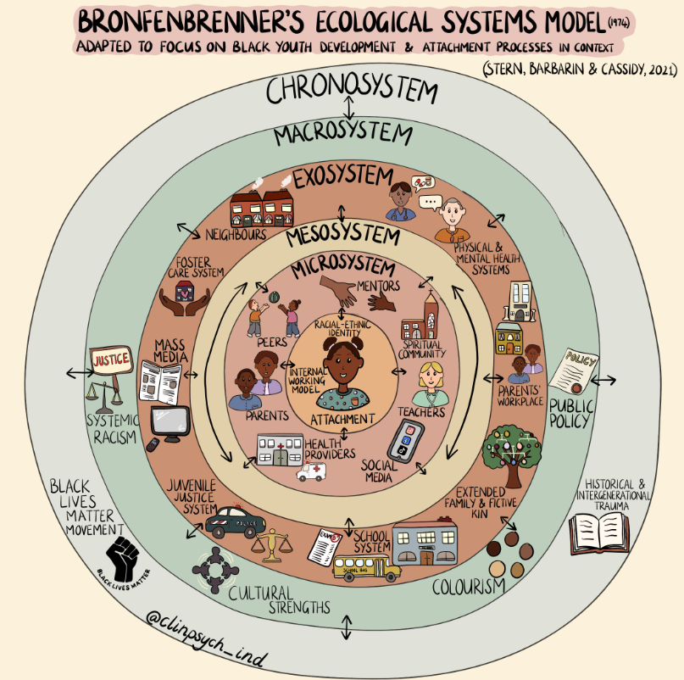
Teacher’s Ecological Systems
Over time, the ecological systems model has been broadened and used by researchers across an array of fields to help understand the multifaceted and interactive effects of personal and environmental factors that determine individual behavior (Zavelevsky & Lishchinsky 2019). Recently researchers have applied and adapted this model to specifically center on teachers to examine the forces that affect teachers’ lives, daily work, and the factors attributed to their workforce retention (Zavelevsky & Lishchinsky 2019). As displayed in Figure 2 the layers of a teacher's ecology mirror the layers in the student-centered ecological model. Instead of having the microsystem, mesosystem, exosystem, and macrosystem layers, the teacher's ecological model contains the individual, interpersonal, organizational, community, and policy system layers. Figure 2 visualizes what is included in each layer of the teacher's ecological model. Like the student-centered model, layers of teachers’ ecologies are nested within each other and influence and interact with each other. The five layers of the teacher-centered ecological systems model are defined as such (Zavelevsky & Lishchinsky, 2019):
- Individual: Like Bronfenbrenner’s microsystem, the individual layer holds the qualities of the individual teacher. These qualities include age, gender identity, professional training, or qualifications. This layer holds the environments that teachers are directly involved in, like their community, the school, and so on.
- Interpersonal: This layer is like the mesosystem in Bronfenbrenner’s model, where the multitude of systemic and personal interactions reside. These include things like relationships between family, peers, students, colleagues, and so on.
- Organizational/ Institutional: Much like the Bronfenbrenner’s exosystem, the organizational/ institutional layer of a teacher’s ecology reflects the relationships and interactions between teachers and their school administration or institution. Influential factors in this layer include practices that influence how teachers are guided and supported by administrators, opportunities for mentorship, how the school system is structured, how teachers are placed in teaching assignments, how much autonomy teachers have, and the general culture of the school system.
- Community: This layer describes relationships between the teachers and their students' families, and the community at large.
- Policy: The policy layer, much like Bronfenbrenner’s macrosystem, contains the societal and cultural aspects that influence all settings and interactions within the ecological model. These include regulations, laws, public policy, social norms, and so on.
Figure 2: Teacher Centered Ecological Systems Model (Zavelevsky & Lishchinsky 2019)
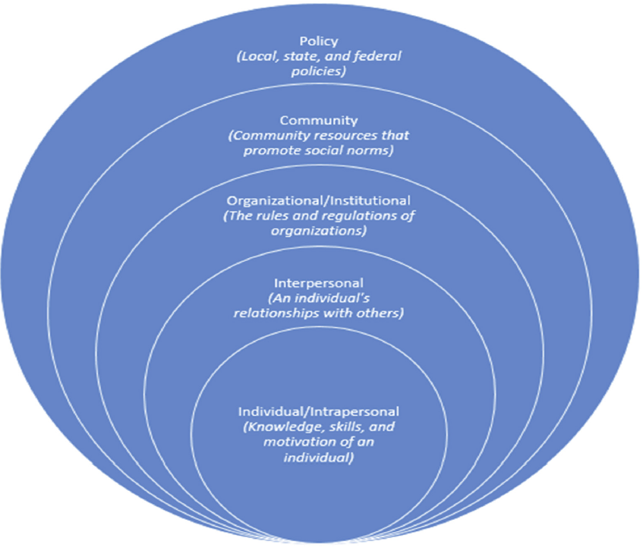
Researchers found that for their sample of teachers, the most influential ecological layer affecting retention was the organizational layer, indicating that education administrators are very influential over teacher retention and working conditions (Zavelevsky & Lishchinsky 2019). While the organizational layer was extremely influential all layers within the system are important due to the connected nature of ecological systems. When one layer is negatively impacting teachers’ experience, other layers are sure to be affected or may be the source of the negative influence. For example, if the administration at a school places teachers in subject areas they aren’t trained in, both the students and teachers can suffer negative impacts. Teachers from the stress of teaching outside of their subject area, and students from getting poor instruction from an underprepared teacher. Both these effects can affect teacher retention and student attendance in the long run through the interactions of their ecological relationships within their shared systems and settings.
Defining The Dual Crises
California’s Teacher Shortage Crisis
Teacher shortages have been an issue plaguing public schools across the state and nation for decades, but when the COVID-19 pandemic hit, teacher shortages went from being a difficult issue to grapple with to a full-blown crisis. At the height of the pandemic, shortages were so severe that many states, including California, applied new emergency exemptions to the requirements for certified and substitute teachers. This led to calling on retired teachers to return to work, using administrators for teaching duties, asking parents to support classrooms, and in the extreme case, calling in the National Guard to staff classrooms (Nguyen et al. 2022). As of 2022, national estimates of the teacher shortage reached 36,000 vacant positions and at least 163,000 positions being actively held by underqualified and uncertified teachers (Nguyen et al. 2022). Additionally, with COVID-19 pandemic emergency relief funds experiencing this year, schools are now facing an uphill battle to find enough teachers to fill classrooms and support quality education for California’s students.

Quantifying the Shortage in California.
As of the 2021-22 school year in California, there were over 267,759 public school teachers serving about 5.8 million students (Learning Policy Institute,2023). As of the 2022-23 school year, there were at least 10,000 vacancies left unfilled by teachers across the state (Johnson,2023). Spikes in retirements, partially driven by the impacts of COVID-19, are intensifying the need for new teachers to enter the field, with the rate of retirements spiking by 26% in 2020 alone (Johnson,2023). Districts reported another contributing factor to the shortages from 2020 onward has been the addition of new positions that were created and funded by federal COVID relief dollars to schools (Carver-Thomas et al., 2022). This meant that while schools were tasked with replacing the vacancies driven by their normal teaching staff, they were also tasked with filling brand new vacancies created during the pandemic for additional teachers, assistant teachers, and other support staff positions.
The addition of Transitional Kindergarten (TK) as a new public school grade, available universally to all four-year-olds in California starting in the 2025-26 school year, has driven the need for new teachers to new levels. The state needs to bring in an additional 15,600 lead teachers and 19,700 assistant teachers to adequately staff TK classrooms. This brings the total need for new staff to enter the school system up to at least 35,300 (Johnson,2023). Given this data, California’s demand for teachers alone nearly doubles current estimates of total national demand. Finally, in a recent survey of a representative sample of school districts across the state, researchers found that shortages were most severe in high-need areas of teaching (special education, STEM, bilingual education) and in the most high-needs schools, including schools in low-income communities and in small and rural districts (Carver-Thomas et al., 2021). These concentrations of shortages disproportionately affect students who are nonwhite and come from low-income households.
Filling the Gap with Underprepared Teachers.
With the mass amount of teacher shortages that have intensified since 2020, schools have no other choice but to employ underprepared and under-certified teachers to ensure that classrooms are adequately staffed and that students receive ongoing instruction. In the 2020-21 school year, it is estimated that at least 27,475 teachers were actively teaching in schools without being fully certified to teach in that assignment (Franco & Kemper-Patrick, 2023). This means that either interns or those teaching on a one-year emergency permit are fulfilling the duties of what should be a fully certified or credentialed teacher. These teachers typically have had little or no student teaching, and many have not yet taken any courses on how to teach diverse learners, create a curriculum, or evaluate learning.
The number of substandard teaching credentials and permits issued in California nearly tripled from 2012 to 2020, with more than 13,000 permits and emergency credentials being issued annually. What was once seen as an emergency last resort resource has turned into a significant portion of the active teaching population in California. Interestingly, fewer teachers are achieving their fully credentialed status via traditional program pathways than in the past, and the use of internships and on the job pathways to credentialing has risen. Only 53% of new credentials issued in 2018–19 went to teachers prepared through traditional pathways, and 25% of new credentials went to teachers prepared through an internship, up from 13% in 2012–13(Carver-Thomas et al., 2021).
Research in California shows that the more underprepared teachers a district employs, the lower its students’ achievement, an effect that is even more pronounced for Black/African American and Latinx students (Carver-Thomas et al., 2021). Additionally, teachers with substandard credentials and permits are generally concentrated in schools that serve more students of color and students from low-income backgrounds (Carver-Thomas et al., 2021). An average of 40% of underprepared teachers leave the field within their first 3 years (Carver-Thomas et al., 2022). This heavy reliance on underqualified teachers to fill the gap is hurting retention rates and ultimately doing very little to resolve the mass shortages, all the while simultaneously damaging the learning and achievement of California’s most historically underserved student populations.
Inflow of New Teachers to the Field.
With the demand for new teachers to enter the field so high, California must have an adequate handle on how many people are currently pursuing entry into the field. Historically, enrollment in teacher preparation programs in California has been in steep decline since 2001, with a 75% drop in enrollment between 2001 and 2014 (Carver-Thomas et al., 2022). In the 2020-21 school year, California saw 39,616 people currently enrolled in teacher preparation programs, which is a 10.5% increase since the 2016-17 school year (Learning Policy Institute, 2023). The number of teacher preparation program enrollees who completed their program in 2021 was 15,245 (Learning Policy Institute, 2023). While these are promising numbers, serious inquiry into identifying any remaining barriers to entry and completion of these programs must be pursued to ensure that those who are motivated enough to enter this field will be given adequate support to do so.
Barriers to Entry for Aspiring Teachers.
The Learning Policy Institute has issued several reports examining the teacher shortage issue and has compiled data on the main barriers to entering the field for aspiring teachers. Top barriers include the prohibitive cost of teacher preparation programs, lack of student aid, and the number of licensure exams (Carver-Thomas et al., 2021). At least 40% of those interested in teaching were waylaid by exam difficulty level and the cost of the exam (Carver-Thomas et al., 2021). Further, aspiring teachers reported that the low rate of compensation for the teaching profession lessened motivation to enter the field, as well as grappling with the notion that to achieve full certification teachers in training would need to work many hours at no or little pay while acquiring field hours as student teachers (Johnson, 2023). Additional barriers have been identified for aspiring teachers who are nonwhite, citing lower feelings of motivation to enter the field due to financial stress, discouraging feedback, and the required teacher candidate assessments, which many believe to be racially biased (Johnson,2023).
Retention of Existing Workforce.
By itself, the supply of new teachers to the field is not happening at a pace that will solve the current crisis. It has been a long-time recommendation by teacher workforce experts that there should be an increased focus on creating school systems and environments that make teacher retention a top priority if there is any hope of emerging from mass shortages (Audrain et al., 2022; Daniel,2017). It is a well-researched fact that in the U.S. 44% of new teachers leave the field within their first five years of teaching and 50% to 70% of new teachers leave the school where they began working within their first five years (Zavelevsky & Lischinksy, 2019). Nationally it is estimated that 8% of the workforce leaves the profession altogether every year, and 8% change schools every year (Audrain et al.,2022). Nonwhite teachers face even higher turnover rates of 24% compared to white teachers (Audrain et al.,2022). Clearly identifying and addressing the causal factors that contribute to such high rates of attrition, particularly for novice teachers (those in the first five years of their career) and nonwhite teachers, is essential to building improved systems that support a sustained and high-quality workforce.
Causal Factors for Teacher Resignations.
The canon of academic research on teacher retention is vast and spans almost a century. This report focuses on identifying not just the historical set of driving forces to teacher attrition, but the very new and unique conditions that teaching in a post-pandemic world has brought upon our schools. The existing causal factors that teachers have been grappling with before the pandemic are still affecting the retention of teachers today. One of these causal factors is a lack of autonomy which 52% of teachers in California reported feeling (i.e. lacking control over lesson content, textbooks, class materials, teaching pedagogies, evaluation of students, discipline, and homework) (Learning Policy Institute, 2023). As well there are pressures from testing accountability and large class sizes. California has some of the highest teacher-to-student ratios in the nation with an average of twenty-two students to every teacher, the average teacher-to-student ratio in New England area states is twelve students to every teacher (Learning Policy Institute, 2023).
Teachers also reported a lack of administrative support, dissatisfaction with teaching assignments, too few opportunities for advancement in the profession, and inadequate salaries (Audrain et al.,2022). In California, the starting average salary for a teacher is $46,450, and teachers earn only 82.4% of what the average college graduate earns (Learning Policy Institute, 2023). At least 10.7% of teachers work additional jobs to make ends meet. All California teachers pay an average of $570 a year out of their personal finances to supplement needed teaching supplies not provided by schools (Learning Policy Institute, 2023).
Additionally, the structure of public school places teachers in daily isolation and this is an ecological factor that drives some teachers out of the profession. Teachers are left alone in their own classrooms with their students with very little support or opportunities for collaboration, and this dynamic is particularly difficult for novice teachers to navigate while being expected to achieve the same student outcomes as their more experienced coworkers (Audrain et al., 2022). Overall, the teaching profession has always been an extremely complex practice that requires teachers to occupy many roles that are multi-dimensional and unpredictable (Audrain et al., 2022). Not only does the job require expert-level interdisciplinary skill sets, and extensive and expensive academic preparation, but it also yields very low salaries and even lower social status and professional regard in the United States. Teachers are expected to balance “work and life, academic learning, human development, and social justice” (Audrain et al., 2022, p. 355).
Teaching Conditions in a Post-Pandemic World.
If the profession of teaching wasn’t hard enough, add in a global pandemic, and the tasks of ensuring students are engaged, learning, and growing both in their social-emotional development and in their academic pursuits, become a herculean feat. National data indicated that 77% of teachers are working more than they did before the pandemic, 60% are enjoying teaching less, and 85% reported lower school morale (Audrain et al.,2022). The general conditions of teaching shifted significantly with the pandemic. Remote and hybrid instruction along with co-occurring shifts in pedagogies (meant to create more holistic and culturally affirming learning environments) made novice teachers out of every teacher, and these conditions led many teachers who were nearing retirement to retire early (Audrain et al.,2022). Mounting needs from COVID safety measures for in-person learning and financial burdens for filling the gap for needed classroom health supplies and fearing the risks to their own and their family’s health led teachers to feel immense stress during this time.
Teacher mental health declined during pandemic era schooling along with student mental health (Carver-Thomas et al., 2021). Teachers seeking to support the mental health needs of all students especially higher-needs students (students with disabilities, unhoused and foster youth students, and low-income students) faced huge barriers reaching those students and faced difficulties forming relationships with families and teaching peers (Audrain et al., 2022). Many of the tasks that teachers were saddled with before the pandemic intensified during the pandemic, such as having to assume tasks normally handled by school social workers, psychologists, counselors, and nurses. With so much mounted pressure on teachers, the decline in personal mental health and well-being was common, and the likelihood of burnout increased significantly (Audrain et al., 2022). Home pressures during the pandemic were especially intense for female-identifying teachers, who are 76% of the entire teaching workforce nationally and are two-thirds more likely to be the primary caregivers for family members (Audrain et al.,2022). In sum, society’s structural inequities already affected many teachers and the pandemic intensified these for both teachers and students. These conditions in combination with existing stress and pressure led many teachers to the point of burnout and leaving the profession altogether.
School System Impacts.
An unstable workforce causes issues in any sector, but when the sector relies intensely on these professionals to maintain the main function of the system (teach and support students), then the entire school system becomes unstable when teacher shortages are extreme. California has a constitutional commitment to deliver a high-quality education to all school-age children in the state, therefore the state must take accountability for the severe impacts this shortage is having on the entire school system and students. As of the 2020-21 school year, 8.4% of California teachers reported being extremely unsatisfied with their jobs and were looking for new opportunities, and 7.3% planned to leave to field as soon as possible (Learning Policy Institute, 2023). School sites are paralyzed by this issue and in some cases are forced to close schools when they fall short of staff to simply supervise students, let alone provide high-quality instruction (Calabrese, 2021).
The impact that this shortage has had on students is immense and hard to parse apart from the web of ill effects that the pandemic has had on student learning, achievement, and well-being. Currently, the major metric being used to measure the state of student achievement is testing scores, which have limitations on accurately measuring learning and achievement. As of 2023, average student testing scores are poor, with only 46.6% of students meeting state standards for English, and just 34.6% of students meeting state math standards, these statistics show very little to no improvement since 2022 (Fensterwald & Willis, 2023). Many aspects of student ecologies are at play when trying to surmise what is impacting achievement, but researchers do know that student engagement is key to student achievement. One of the most important ways that teachers can engage students, particularly historically underserved students, is to build strong and authentic relationships with them and their families. Having a high rate of teacher turnover in a school makes this next to impossible. Further, the amount of under-certified and underprepared teachers that are holding the school system together is very damaging to student achievement (Carver-Thomas et al.,2021). As mentioned previously these underprepared teachers are concentrated the most in schools that serve a majority of low-income students who are nonwhite, many of whom are also English language learners, possibly involved in the foster care system, unhoused, or have a disability (Carver-Thomas et al.,2021). The equity concerns for this teacher shortage and its impact on students are incredibly serious, and if California wants to make good on its promise of providing equitable access to a quality public education, salient solutions need to be put into practice as soon as possible to avoid further damage to students.

Chronic Student Absenteeism
Chronic absenteeism has become an intensifying issue and topic of serious academic inquiry in the last few decades. Chronic absenteeism is defined as a student missing 10% or more of school days, which in California amounts to eighteen or more days (Blad,2022). Chronic absenteeism is distinct from truancy which is defined within California as missing three days without a valid excuse or being late three times to class by thirty minutes without a valid excuse (Attendance Works, 2016). It is notable that while the federal government requires states to track truancy data, it is left up to each state to create its own definition of truancy, which means different states may have vastly differing definitions of truancy, making this national phenomenon difficult to quantify.
Chronic student absenteeism has far-reaching effects ranging from immediate impacts on student engagement and achievement to long-reaching lifetime impacts on earning potentials and overall physical and mental health (Kim & Gentle-Genitty, 2020). While absenteeism was certainly a concern for schools before the pandemic, it has become a crisis in post-pandemic schooling, where in California at least 30% of all students were chronically absent in the last school year (Jordan, 2023). When students were forced into distance and hybrid learning once the COVID-19 pandemic hit, absences became a difficult constantly moving target for schools to track and address. This is due in part to inadequate and variable definitions of what counts as an absence, variable and inadequate data systems, and the multitude of causal factors behind absenteeism.
Quantifying Chronic Absenteeism in California.
Chronic absenteeism rates have spiked nationally and in California since the beginning of the COVID-19 pandemic. Nationally, pre-pandemic rates of chronic absenteeism were hovering around 15% in the 2018-19 school year and in California, rates were slightly lower at 13.5% (Dee ,2023; Tadayon, 2023). Today both the national and California rate of chronic absence among students is at a staggering 30%, meaning in California over 2 million students were chronically absent in the 2021-22 school year (Jones, 2023). In California, rates of average daily attendance (ADA), which school funding is based on, also dipped from 95.9% in the 2019-20 school year, to 92.5% in the 2022-23 school year (Tadayon, 2023).
Detailed high-quality data on chronic absenteeism is still hard to gather both nationally and for California. California’s State Department of Education (CDE) only started collecting data on chronic absenteeism in its interactive data portal (DataQuest) in 2017, allowing the state to gather data on any absence not just unexcused absences that counted towards truancy rates (Seize the Data Opportunity in California, N.D). It is notable that due to the pandemic, data for chronic absenteeism and other key state indicators for the 2019-20 school year was not collected by CDE. Currently, California tracks ADA, chronic absence, truancy, and attendance data. California does not have a statewide data system in place to collect detailed information on reasons for absences, although some local education agencies (LEA) may elect to use extra data and tracking systems such as Early Warning Systems, to gather more detailed information on attendance. Experts working on this issue cite a great need for the nation and California to develop a unified effort to collect clear and well defined and classified data on attendance and drivers of absenteeism (Blad, 2022).
Absenteeism Trends.
With the available statewide data, trends in chronic absenteeism have shed light on existing and increasing inequities driving certain groups of students to have much higher rates of chronic absence than the state average. Los Angeles Unified School District (LAUSD), the largest LEA in the state and the second largest district in the nation, saw some of the highest rates of chronic absenteeism since the pandemic with half of all students being chronically absent (Bald, 2022). Black/ African American, Latinx, and unhoused LAUSD students saw disproportionately high chronic absenteeism rates coming in at 57%,49%, and 62% respectively (Bald, 2022). These disparities reflect statewide trends, which Table 2 displays. Historically since California started gathering data on chronic absenteeism, disparities for certain racial and ethnic groups and other student subpopulations have remained clear. Black/ African American, Native American, Latinx, and Pacific Islander students all see rates of absenteeism much higher than the state average, and significantly higher rates than their Asian American, Filipino, and White peers (Hahnel & Baumgardner, 2022). The most recent data collected by CDE on the 2021-22 school year indicates deep disparities in the rate of chronic absenteeism for historically underserved students. These rates are displayed in Table 1. Please note for gender identity breakdown, male and female identifying students had the same average rate of absenteeism as the statewide average, 30% (EdData, 2023).

Table 1: Chronic Absenteeism Rates in California by Student Population for 2021-22 School Year
Student Group | Chronic Absenteeism Rate
All Students | 30%
English Language Learners | 34.7%
Migrant Students | 32.9%
Socioeconomically Disadvantaged Students | 37.2%
Foster Involved Youth | 46.5%
Students Experiencing Homelessness | 46.1%
Students with Disabilities | 40.6%
Nonbinary Students | 43.3%
Note: This table is drawn from EdData (2023)

Table 2: Chronic Absenteeism Rates Over Time in California by Student Race/ Ethnicity
Race/ Ethnicity | 2018-19 | 2019-20 | 2020-21 | 2021-22
American Indian or Alaska Native | 21.8% | N/A | 26.9% | 46.3%
Asian | 4.3% | N/A | 3.9% | 11.4%
Black or African American | 22.5% | N/A | 26.8% | 42.5%
Filipino | 6.2% | N/A | 4.2% | 15.5%
Hispanic or Latino | 13.4% | N/A | 17.1% | 35.4%
Native Hawaiian or Pacific Islander | 20.2% | N/A | 22.4% | 42.8%
None Reported | 13.5% | N/A | 14.9% | 30.4%
Two or More Races | 11% | N/A | 10.9% | 24.4%
White | 9.9% | N/A | 10% | 23.2%
Note: This table is drawn from EdData (2023)

Causal Factors.
The driving forces behind chronic absenteeism are nearly as varied as each individual student themselves, which makes systemically addressing this issue a very difficult task. However, recent research and data collection efforts, have been able to compile available information on key causal factors and categorize them into broad themes and frequently cited issues. The reasons for student absences typically fall into four broad categories, barriers, aversion, disengagement, and misconceptions. Figure 3 displays examples of the most common causal forces behind chronic absenteeism and organizes them into one of the four categories.

Figure 3: Root Causal Factors of Chronic Student Absenteeism (Attendance Works, 2022)
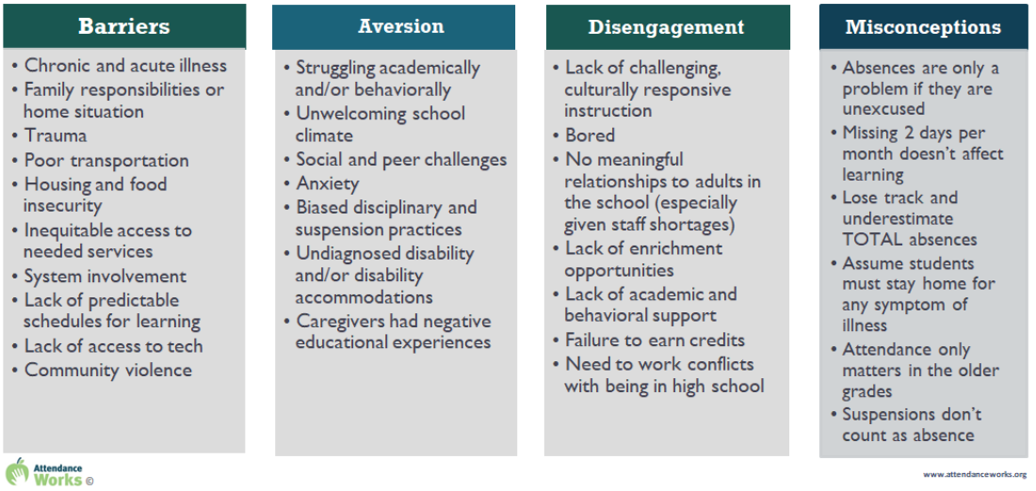
Other literature reviewed for this study supported all the causal forces identified in Figure 3. Some of the most frequently cited reasons for absences seemed to stem not so much from personal motivation but from forces within students’ family lives, communities, and our broader society. The COVID-19 pandemic certainly intensified existing challenges for historically underserved students, particularly for students from low-income backgrounds (Blad, 2022). Frequently cited reasons for absence included a lack of reliable transportation, older children having to assume child care or other caregiving duties, having to work, a lack of clean clothes, and a lack of funds for clothes and school supplies (Blad, 2022; Jones, 2023). Also, given that the data collected on chronic absenteeism only reached up until the 2021-22 school year, researchers cited major health risk concerns as a core driving force to keep students at home, given the ongoing concern for COVID-19 infections. Attendance Works cited illness as the number one reason for absence, and asthma has caused 14 million missed days of school alone (Jordan, 2023). Some studies state that parents are being overly cautious and keeping students at home at any sign of illness or if they are feeling any hesitation about COVID-19 exposure or other health risks associated with attendance (Kostyo et al., 2018; Jones, 2023). Before the pandemic as well as today, student mental health has been identified as a key driver of absences. Anxiety, stress, depression peer and social challenges, and fear of bullying are other root causes that keep students out of school (Tadayon,2023).
Impact on Students & Schools.
Missing enough school to be chronically absent has been studied to have a wide range of effects on students. Top among these effects is a negative impact on students’ school performance and high school graduation rates (Kostyo et al.,2018). One study found that by 9th grade, a student’s chance of graduating from high school drops by 20% for every week of school they miss (Jordan, 2023). Also given that rates of absenteeism are the highest in elementary school and particularly in Kindergarten the impact that absenteeism has in the earlier grades can be very profound and severely impact student success in later grades (EdData , 2023; Kostyo et al.,2018). The pandemic had clear negative impacts on overall student engagement and learning, and the increase in absences due to the pandemic and sustained absenteeism trends today are painting a bleak picture for student achievement. There is an observable negative impact that absenteeism has and Math and English Language Arts (ELA) test scores, with elementary and middle school students seeing the most severe declines in test scores in these areas due to chronic absenteeism (among other factors) (Santibañez & Guarino, 2020). Poor test scores for chronically absent students are the most severe for historically underserved students including low-income students, English Language Learners (ELL), students with disabilities, foster youth, and students experiencing homelessness.
Beyond academic achievement, chronic absenteeism can have many far reaching effects on students’ socioemotional development and well-being. First, a 2020 study on chronic absenteeism found that better socioemotional learning (SEL) leads to better academic outcomes for all students and any factors that lower SEL can lower student achievement (Santibañez & Guarino, 2020). Secondly, the same study also found that chronic absenteeism has negative effects on students’ socioemotional outcomes including, growth mindsets, social awareness, self-efficacy, and self-management (Santibañez & Guarino, 2020). Third, chronic absenteeism has been found to increase the likelihood that students will internalize their problems, leading them to increased isolation and disengagement (Gottfried, 2014). Researchers also found that chronic absenteeism leads to negative impacts on a student’s eagerness to learn (Gottfried, 2014). As discussed in the previous section disengagement is a key causal driving force behind absenteeism and is also seen as a compounding outcome of absenteeism as well.
Lastly, chronic absenteeism has negative impacts on school systems. First, a school’s success is measured most heavily by the success of its students. If chronic absenteeism is getting in the way of a large portion of students’ learning, growth, and development, then schools are in a difficult position where need to find and utilize resources for extra support and effective strategies to overcome this issue. Financially, declines in attendance will have negative impacts on school site funding given that school funding is based in part on average daily attendance rates (Jones,2023). With the state of California losing at least $2.1 billion annually due to chronic absenteeism, the stability of school site budgets and ongoing funding for much needed student support that could help reduce chronic absenteeism rates is a great concern to both LEAs and the state of California.
Section III: Methods
Primary Policy Objective
Using Bronfenbrenner's (1979) ecological system theory, this report takes a case study approach to address two complex public issues that co-occur within a shared public system. Both mass teacher shortages and chronic student absenteeism are two wicked public issues that benefit from being addressed with a whole systems perspective. The primary objective of this case study analysis and proposed policy solution is to sustainably decrease student chronic absenteeism and increase the retention of teachers already working in the field in California. Given the magnitude of these dual issues, the level of interaction they have with each other within their shared setting, and the dire need to find effective solutions to both issues, this holistic ecological systems approach is the best lens to bring about an effective policy solution.
The report focuses only on the retention of current teachers in the field because this policy goal provides more immediate and cost-effective policy options that can improve the labor experience of California teachers. By prioritizing teacher retention as a policy goal, this report aims to provide a policy solution that improves teacher experience to the point of possibly enticing more new teachers to enter the field, therefore helping to alleviate both the issue of teacher resignations and increasing the supply of new teachers. Further, given the scope of analysis as guided by the ecological systems framework, policy solutions will focus on interventions immediately within the reach of school systems. Creating policies to entice new teachers to the field is outside of this report’s analytical scope.

Guiding Analytical Framework: Ecological Systems Theory
Bronfenbrenner’s (1979) ecological systems model provides one main evaluative criterion, comprehensiveness, for the analysis of a proposed policy option. The ecological model’s scope requires the researcher to examine issues and their proposed solutions with a comprehensive and multidimensional lens so that policy interventions are constructed to adequately address the multitude of layered and interacting root causal factors behind both issues. This approach also acknowledges that teachers and students are dependent on each other to some extent to achieve success in their individual roles within the school system. For these reasons, comprehensiveness is the most important criterion for any proposed policy solution to these dual issues and guides the researcher toward a holistic and broadly effective strategy. While comprehensiveness is the main criterion used, the proposed policy solution will be assessed using supporting criteria including improving equity and cost feasibility.
Scope and Reach of Analysis
The analysis of these dual crises, their varying and intersecting causal forces, and a possible solution are grounded in the ecological model’s required scope of analysis. The ecological framework provides clear boundaries to the reach of any public policy solution that is enacted by the state government and local education agencies (LEAs) or school systems. Therefore, the ecological systems framework limits just how far policy solutions can go to address both issues comprehensively and effectively within their ecological contexts. For this report, the ecological framework will limit the reach of a proposed policy solution to one within reach of the public school system, which stops at the exosystemic layer where public policies are administered.

Section IV: Findings
The findings section presents a summary of research findings on the root causes of both the teacher shortage and the chronic absenteeism crises. Next, a brief discussion of the intersections of root causal factors between the two crises is provided to show how students’ and teachers’ ecological systems overlap and interact, and to make visible the opportunities for comprehensive policy options that can ameliorate both issues. From there a brief description of proposed solutions from the field for both issues and their intersections are presented and categorized by the causal factors they address. Finally, the section concludes with a discussion of the current state-level approaches California is taking to address these issues.
Summary of Root Causal Factors-Teacher Shortage
The teacher shortage crisis in California is affected by a myriad of causal forces that exist within various layers of the ecological systems that teachers are part of. Research findings on the main causal drivers for this issue resulted in four main categories of causes. The first is the increase in the number of vacancies driven by retirements, the creation of new positions, and a new school grade (TK) (Carver-Thomas et al., 2022; Johnson, 2023). This causal driver is situated within the policy layer of teachers’ ecologies as it is driven by policy choices and factors removed from individual teachers. The second category of driver is the increase in vacancies caused by an overreliance on underprepared teachers, a workforce known for chronically high turnover rates (Carver-Thomas et al., 2022). This driver is situated within both policy and organizational/ institutional layers of teachers’ ecologies, as both state and local regulations influence the use of underprepared teachers. The third category of causal factor is barriers to workforce entry, which includes education costs, licensing requirements, and lack of financial or professional support (Carver-Thomas et al., 2021; Johnson,2023). This category occupies all five layers of teacher ecologies, policy, community, organizational/ institutional, interpersonal, and individual. This is because forces in policy can reduce or increase these barriers, and community-level resources, organizational-level requirements and resources, and possible support from interpersonal relationships can all play a role in reducing or fortifying workforce entry barriers. The fourth and perhaps most influential driver for this issue broadly and for teacher retention, is workplace conditions, job duties scope, and the school environment (Audrain et al.,2022; Carver-Thomas et al., 2021; Learning Policy Institute, 2023). This causal driver is situated in the interpersonal, organizational/ institutional, and community layers, with some possible indirect interactions happening in the policy layer to influence school regulations and resources.
Summary of Root Causal Factors-Chronic Absenteeism
Students who are chronically absent experience a very wide range of factors that significantly contribute to their poor attendance status. These factors exist within almost every layer of a student’s ecological system, and fall into four main categories, as previously displayed in Figure 1: Root Causal Factors of Chronic Student Absenteeism (Attendance Works, 2022). The first category of causal factors is barriers to attendance, with influences such as poverty, health issues, transportation, housing stability, and more, these factors exist in Bronfenbrenner’s (1979) exosystem and macrosystem. The second category of causal factors is drivers that can cause an aversion to attendance, with such influences as individual academic and behavioral struggles, a negative or less inclusive school climate, mental health issues, racial bias, and more, this category of drivers exists primarily within the exosystem and macrosystem of student ecologies. The fourth and very influential driver category for absenteeism is disengagement which can come from things such as unchallenging or nonculturally responsive instruction, a lack of meaningful relationships with adults at school, the need to work conflicting with being in high school, and more (Jordan,2023). The factors within the disengagement category largely exist inside of the micosystem and mesosystems of student ecologies but can branch out into the exosystem. The last category of causal drivers for absenteeism is misconceptions which are rooted in not understanding the impact or scope of absenteeism. This category exists in the microsystem and mesosystem layers of student ecologies. Despite these identified drives it is extremely important to keep in mind that current data systems generally do not track reasons for absences and improved comprehensive data systems are needed to pinpoint the most significant causal factors for individual students and larger student populations.
Intersection of Root Casual Factors.
The purpose of analyzing and discussing these two co-occurring crises in public education is to provide a case study of how to find holistic solutions to wicked issues within the public sector that affect each other. Acknowledging that this dynamic exists for many public issues means that finding the intersections between causal factors for multiple issues is a mandatory process for comprehensive solutions to emerge. From the findings discussed above, California’s student absenteeism and the teacher shortage crises share a multitude of systems, and these crises are driven by some common factors that influence each other.
For example, one of the best ways researchers have identified to boost student attendance and engagement is forging strong interpersonal relationships with positive peer mentors and teachers (Jordan, 2023). However, building relationships is difficult unless students are in school, and teachers are consistently present and engaged in the lives of students and their families. The teacher shortage crisis is a direct barrier to using interpersonal relationships and engagement as a strategy to improve chronic absenteeism. In this context, a comprehensive policy solution includes a strong and stable teacher workforce that works to improve student attendance, and in turn, improved student attendance helps to alleviate some of the heavy workloads of teachers dealing with extremely disengaged students, therefore improving teacher experience.
Another example of how trusting relationships between educators, administrators, students, and families prove to be a protective factor against absenteeism comes from the true story of a school principal at one California elementary school. When an immigration customs enforcement (ICE) van appeared two blocks away from an elementary school in California, parents who were in the process of dropping their children off at school refused to leave school grounds while other parents refused to bring their children to class. The principal of this school, knowing the needs and barriers faced by students and their families, took matters into her own hands, and put the entire school campus on lockdown to protect any undocumented children and families from ICE agents. The principal alerted her team of community liaisons to warn other families of the presence of ICE and then teamed together with school staff to personally transport children and families safely to their homes (Jordan, 2023). This is a great example of how educators and administrators, through their built relationships and knowledge of the families they serve, can collaboratively create positive school cultures and communities that are safe havens for students, which fosters better attendance and student engagement (Jordan, 2023).
This report suggests that both the teacher shortage and student absenteeism can be lessened by factors that are both inside and outside of the reach of the public school system, as indicated by where they are located within student and teacher ecologies. To create comprehensive policy options, this report focuses on the causal forces for both issues and pinpoints where they are co-located within the reach of the education system. Figure 4 displays which causal factors for both issues reside inside and outside of the reach of the school system.

Figure 4: Boundaries of School System Reach to Causal Drivers
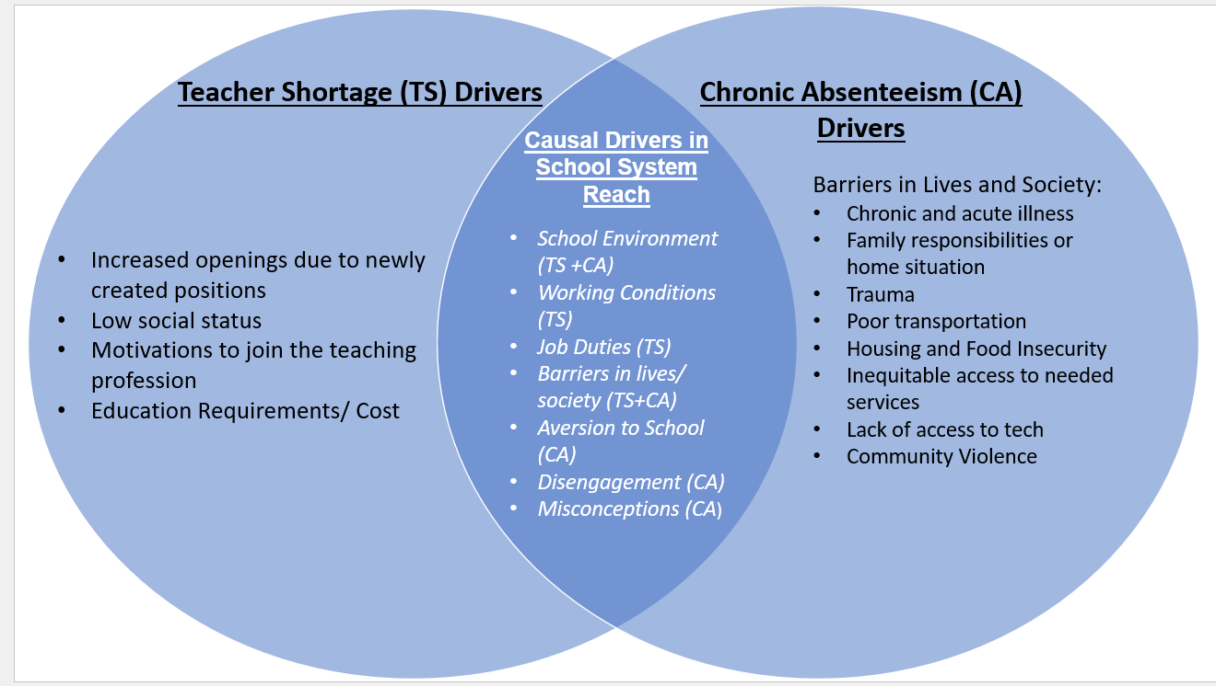

As Figure 4 shows, there are many causal drivers for both issues that are co-located within reach of the school system that could be alleviated by comprehensive and ecological systems-minded policy options. Given the goal of creating policy solutions that are within the reach of the public school system, defining the boundaries of that reach is essential. While some researchers may simply place that boundary around the physical school walls, an ecological systems perspective dictates that there are several causal drivers behind both issues that exist in the exosystemic and macrosystemic levels of teacher and student ecologies and these factors exist outside of school walls. For example, all the causal factors for absenteeism that fall under the category of “barriers” are driven by forces outside of the public school system. Yet, they can be addressed in some way by the school system through intentional linkages to services and resources both within and outside of the school’s walls. When viewed through the ecological systems lens, there is a wealth of root causes that school systems can reach by working in collaboration with community partners and other public systems to provide the needed support and resources.

Current Solutions Proposed by the Field
Teacher Shortage Solutions
Because so many different factors drive the teacher shortage crisis, current proposed solutions to address this issue are varied and mostly target individual drivers of the crisis rather than comprehensively addressing several factors. A summary of findings from research on current proposed solutions to this crisis is displayed in Table 3 below. Solutions have been marked by which causal drive category they address to display how comprehensive the proposed solution is. Given that root causal factors intertwine and involve multiple stakeholders, comprehensive solutions will go beyond some current approaches. It is notable that none of the solutions address the driver of a large increase in open positions due to retirements, newly funded positions, and positions created by the new public school grade of TK.

Table 3: Summary of Proposed Solutions to the Teacher Shortage
Solution | Affected Causal Driver Category
Grow Your Own (GYO) programs that create supported pathways for local community members, and current classified school staff to become credentialed teachers | 3
Increased Compensation | 3,4
Increase Federal funding to financially support teachers; income tax credits, housing subsidies and support, and debt forgiveness. | 3,4
Teacher mentorship and collaborative communities of practice to increase retention, ease workloads, leverage varied knowledge, skill sets, backgrounds and experiences, and reduce isolation. | 2,4
Improved work conditions to support teacher retention  - sustainable teacher workloads  - professional support & guidance,  - professional development  - Wellbeing and mental health support  - increased autonomy | 4
Build a holistic and healthy school culture, community and ecology that is conducive to the retention of all teachers and produces positive:  - organizational practices/ administrative supports  - supportive leadership  - authentic involvement in school decision making  - peer communication and collaboration,  - interactions with the community at large | 3,4
Hire and retain support staff to ease the job duty burden on teachers (interventionists, academic support counselors, psychologists, social workers, instructional coaches, and assistant principals) | 3,4
Fund and create more Community Schools that offer avenues to comprehensively improve teachers’ working environment and conditions | 3,4
Causal Driver Category Key*: 1= increases in the number of positions to fill, 2=overreliance on underprepared teachers, 3=barriers to workforce entry, 4= workplace conditions, job duties scope, and school environment
Sources: (Audrain et al.,2022; Carver-Thomas et al., 2021; Carver-Thomas et al., 2022; Johnson,2023; Learning Policy Institute, 2023)

Chronic Absenteeism Solutions.
The need to find solutions to chronic absenteeism has intensified since the COVID-19 pandemic doubled national and state rates. While there are many diverse and intersecting causal drivers behind a student’s absenteeism, providing strategies to address key drivers of absenteeism can and should happen at multiple levels and can be applied both universally (to the whole school community) and to the individual student (Jordan, 2023). Below Table 4 provides a visual summary of the range of solutions, strategies, and best practices that are proven to improve rates of attendance. The table is organized to mark each proposed solution by the category of causal driver it addresses, as well as the tier of intensity of the solution, ranging from foundational universal solutions to early interventions once a student is chronically absent, to intensive interventions for severely chronically absent students (Jordan, 2023).
Intersection of Solutions.
Several salient solutions and strategies have emerged from the research findings that have the potential to address multiple causal drivers of the two crises across multiple ecological systems layers. From an ecological systems standpoint, these solutions work to improve the immediate conditions for teaching and learning within the microsystem/ mesosystems or individual and interpersonal layers of student and teacher ecologies and to improve conditions happening outside of the boundaries of school sites within the exosytem or community layers of teacher and student ecologies. The most salient common proposed solutions to the dual crises are (Audrain et al.,2022; Carver-Thomas et al., 2021; Carver-Thomas et al., 2022; Johnson,2023; Jordan, 2023; Learning Policy Institute, 2023).:
- Increasing mental/ physical health and well-being support for teachers and students
- Increasing cross-system support services, specialized staff, and resources for students and families
- Rebuilding foundational trusting relationships between school community stakeholders, particularly between teachers and students
- Improving school cultures and environments
- Increasing administrative support and collaboration
- Integrating the school community into the larger community context

Table 4: Summary of Proposed Solutions for Chronic Absenteeism

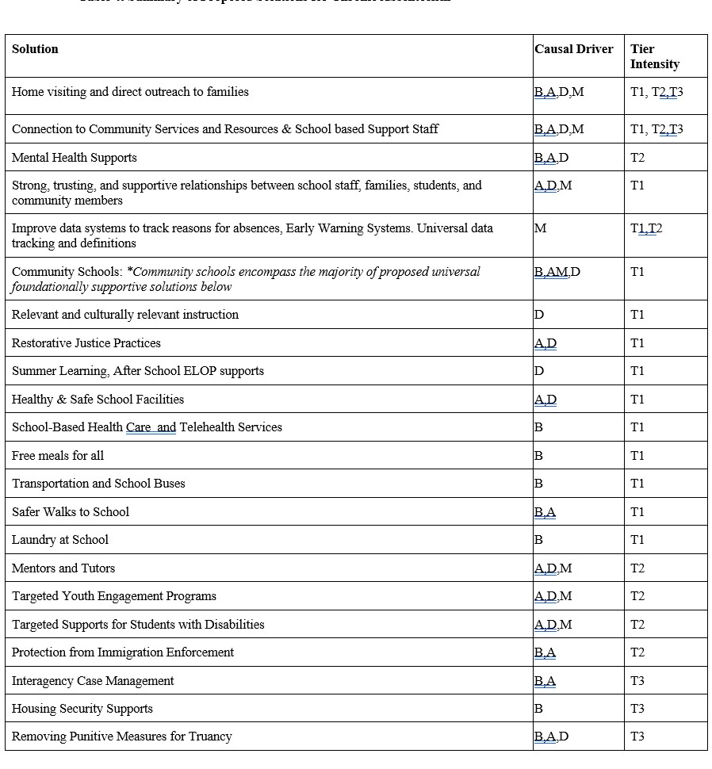Note: Causal Driver Category Key: B=Barriers, A= Aversion, D=Disengagement, M=Misconceptions
Intervention Intensity Teir Key: T1= Foundational, Universal Supports, T2 =Early Intervention targeting Chronically Absent Students, T3= Intensive Interventions
California’s Current Approach
Teacher Shortage
The teacher shortage crisis has many people's attention and deep concern, from schools all the way up to the state capitol. The most recent state budget makes it clear that this issue is a top legislative priority with large investments that mostly target new teacher recruitment strategies over retention solutions. In the 2021-22 state budget, one billion dollars was allocated to go toward comprehensive teaching pathways and one billion dollars went to concentration grants that are awarded to high-needs districts for hiring additional teaching and support staff (Carver-Thomas et al., 2022). Overall current state-level investments in the teacher shortage crisis focus mainly on new teacher recruitment and supportive educational and training grants, like the Golden State Teacher Grant Program, and grants to train classified employees as accredited teachers (Carver-Thomas et al., 2022; Hong, 2022). Since 2015, California has invested $4.8 billion in teacher recruitment, retention, and training efforts. The majority of that funding has gone towards grants, which school administrators say are helpful, but if people are still not entering the field then the workforce entry grants do little to no good (Hong, 2022) Administrators say that they desperately need ongoing funding for salaries and not just short term funding for grants that place high administrative burns on schools (Hong, 2022).
On the local level, school districts are using available funds to increase compensation for teaching positions, mostly focusing on increasing wages for substitutes, and adding stipends and signing bonuses to positions in hard to recruit areas, such as rural communities (Carver-Thomas et al., 2022). Districts are also hiring extra support staff whenever possible, this approach aims to ease the stress and workload on teachers, lower student to teacher ratios, and shift an overwhelming amount of duties currently hoisted on teachers to the appropriate staff such as interventionists, academic support counselors, psychologists, social workers, instructional coaches, and assistant principals (Carver-Thomas et al., 2022). Finally, districts are investing in increased recruitment and hiring capacity to up teacher and support staff supply as fast as possible (Carver-Thomas et al., 2022).
Chronic Absenteeism
California enjoys one of the largest economies in the world (Winkler,2022) and has the capacity to allocate almost half of its annual state budget to fund public education. However, given the sheer size of California’s school-age population, almost 6 million students, a tremendous amount of money is needed to be allocated and managed to adequately meet the diverse and intense needs of its students. The recent spike in absenteeism is causing alarm for both student outcomes and school budgets (Jones,2023). With the expiration of billions of dollars of Federal relief funds that could help target absenteeism drivers occurring as this report is being written, the state legislature is rightfully turning its attention to the issue of chronic student absenteeism. Implementation of the Federal Every Student Success Act (ESSA) in 2015 and California’s Local Control Funding Formula in 2013, required schools to integrate chronic absenteeism into their accountability plans. Recently in preparation for possible future state policy solutions, the state legislature requested a study to be conducted by Policy Analysis for California Education (PACE) examining the full impacts of chronic absenteeism (Jones, 2023). In the spring of 2023, CDE and the California Department of Public Health worked to revise isolation and quarantine guidelines for COVID-19 in hopes of reducing unnecessary absences due to exposure or illness (Hill & Prunty, 2023).

Section V: Policy Analysis and Recommendation
This report presents a two-fold expansion of the California Community Schools Partnership Program (CCSPP) as a policy solution to the dual crises of California’s mass teacher shortage and high rates of chronic student absenteeism. First, the CCSPP base funding should be expanded to meet the needs of all schools experiencing high levels of teacher turnover and student absenteeism. Secondly, the CCSPP framework should be expanded to include core features to specifically focus on improving teacher retention by improving working conditions and support. The author defines what a community school program is, and how this program is currently being used in California and identifies funding opportunities to sustain the proposed program expansion. Finally, the author offers justification for this policy solution based on it satisfying the foundational criterion of being comprehensive and supporting criteria of being able to advance equity and being cost-feasible. The development and use of the supporting evaluative policy criteria are informed by rational policy analysis tools used by policy professionals across the field (Meltzer & Schwartz, 2019).
Policy Solution: Expand the California Community Schools Partnership Program
What is a Community School?
Community schools are a well-researched school improvement strategy and model that engages all members of a school community to work in collaborative partnerships to strengthen conditions for student learning and healthy development. Community schools leverage and build strong community partnerships to offer an array of programs, supports, and resources to students and their families to feed the needs of the whole child (CDE, 2022). Community schools foster a positive school climate that is built on strong trusting relationships between students, educators, families, and community members. Community schools' features and functions are tailored by each school to meet the unique needs of their school community, but all community schools share four key features of integrated supports and services, expanded learning opportunities, collaborative leadership practices for educators and administrators, and family and community engagement (CDE, 2022). Since 2021 California has invested $4.1 billion in program grants to the CCSPP so that every high-poverty school can have access to funds for planning and implementing more community school models (Burns et al., 2023; CDE, 2023). The current program is funded through 2031 to provide qualifying schools with $200,000 in two-year planning grants, $500,000 in implementation grants for up to five years, and $100,000 in one-year coordination grants for existing community schools (Maier & Neibuhr, 2021).
Proposed CCSPP Expansion
This policy proposal would expand the base funding for this program so that it is adequate to additionally fund all schools that are experiencing high levels of chronic absenteeism and issues with teacher retention. Given that community schools have been shown to lead to improved student attendance, expanding funding for all schools with high absenteeism rates is a trusted approach to decreasing rates of absenteeism (Burns et al., 2023). Further, community schools inherently improve school culture and community, which is a key solution to increasing teacher retention and student attendance (Audrain et al., 2022; Mullen et al.,2021). The integration of services and supports for students provided by this model not only helps to address the root causes of student absenteeism but also greatly eases the job duty burdens caused by intensified student needs and puts them in the hands of the appropriate professionals.
Further, this policy proposal includes an additional core feature to be added to the CCSPP framework that specifically focuses on improving teacher retention via improvements to overall working conditions. The community school model is an identified strategy to boost teacher retention, and enhanced teacher support can easily be integrated into the CCSPP model to improve working conditions and experiences for teachers. (Daniel, 2017). While each community school would need to work in partnership with its teachers to identify their unique needs and supports, some general key supports could include increased well-being and mental health resources and increased professional development opportunities. Community schools provide ongoing opportunities for teacher voices to be heard because they are an integral partner in the collaborative functions of the entire school community (Zavelevsky & Lishchinsky,2019). This gives teachers the opportunity to be authentically involved in school decision-making, to have their needs heard and met by administrators, and for teachers to have more autonomy in their work (Audrain et al.,2022).
Given the collaborative nature of community schools, this policy includes structurally integrating collaborative educator communities of practice for teachers within school communities to the CCSPP framework. This feature offers opportunities for professional support and mentorship for all educators by leveraging the diverse skill sets, backgrounds, and experiences of teachers. This feature would decrease teacher isolation, build networks for professional and emotional support, and enhance professional skills, particularly for novice teachers who leave the field at higher rates than other teachers (Audrain et al.,2022).
Supporting Evaluative Criteria
Comprehensiveness.
The degree to which this policy solution satisfies the criterion of comprehensiveness is assessed by the number of root causal factors that the policy can address. Overall, this policy solution satisfies this criterion extremely well as it can address nearly all root causal factors for both issues. Community schools are a strategy that has been identified as a comprehensive solution for both student absenteeism and teacher retention by researchers across the field of study (Audrain et al.,2022; Carver-Thomas et al., 2021; Carver-Thomas et al., 2022; Johnson,2023; Jordan,2023; Learning Policy Institute, 2023).
For teachers, this policy solution addresses many root causes for poor teacher retention including the very influential causal factor of poor workplace conditions, poor school climate, and overly burdensome job duty scope. Additionally, the root causal factor of vacancies caused by underprepared teachers leaving the field would be addressed by this model via the integration of communities of practice for educators. Increased peer support and professional development opportunities offered by this policy solution should help novice and underprepared teachers to be more effective educators and should help them stay in the profession.
For students, this solution is extremely comprehensive because it can touch on every category of causal factor behind chronic absenteeism, including issues associated with school aversion, disengagement, and misconceptions. The community school model can even reach issues categorized as societal barriers that occur outside of the walls of the school site. This is done via connected partnerships with community services, public agencies, social workers, and additional resources. This approach addresses core barriers to attendance such as food and housing insecurity, justice system involvement, lack of access to transportation, familial needs with caregiving for elders or young children, and so much more. The wide reach of this policy solution for chronic absenteeism is particularly effective as current data is not being collected on the reasons for individual students’ absenteeism, making targeted policies difficult to create.
The community school solution is extremely compelling for the issue at hand because it offers a breadth of universal and foundational support options as well as high-intensity interventions to meet the needs of any student struggling with attendance. The community school model goes far beyond the reach of school walls to ensure children and families have access to every available community support and resource they need to thrive. With built-in multi-tiered levels of support and intervention for both teachers and students, expanding the CCSPP as a policy solution is extremely comprehensive and offers a holistic policy option for policymakers and stakeholders to consider.
Enhancing Equity.
Enhancing equity is a critical supporting criterion for this report’s analysis given the longstanding disproportionate impacts that these two issues have on historically marginalized and underserved students and teachers. Students and teachers from historically underserved communities see disproportionately higher rates of absenteeism, and higher barriers to attendance, as well as higher barriers to workforce entry and more difficulty with job retention (EdData, 2023; Hahnel & Baumgardner, 2022; Johnson,2023). The equity criterion aims to ensure that those most impacted by these issues are the most assisted by the offered policy solution. Community schools have been shown to advance equity and researchers deem community schools an extremely promising approach to recovering from the negative and disproportionate effects of the COVID-19 pandemic (Burns et al., 2023). National programs that target equity issues in our society while offering comprehensive networked community support inspired the community school model that is used today.
The community school model mirrors many effective aspects of its theoretical sibling, the National Head Start program. The National Head Start program is a long-standing federal child development program that was co-founded by Bronfenbrenner to comprehensively address societal inequities affecting low-income children and their families. Head Start was built upon the theory of the ecological systems model and purposefully centers students and their families within their community context, which includes their school or early care environment. By bridging social services, health services, high-quality education, and family engagement, the Head Start program has been reducing inequities in low-income and underserved communities since 1965. Programs like Head Start and community schools have impacts that extend from a student’s early years into adulthood by improving overall academic achievement, school engagement, mental and physical health, well-being and economic security for students and their families (Johnson, 2011).
The very foundations of community schools and programs like it center on equity. By integrating the proposed teacher support additions to CCSPP models, teachers from lower-income backgrounds and from underserved communities can gain greater access to the support they need to succeed in their profession and stay within their roles in schools. Lastly, equity is placed at the core of the CCSPP expansion proposal because it specifically targets schools that have students and teachers who are being affected the most by these two issues, which happen to also be some of California’s most historically underserved teachers and students ( students of color, low-income students, foster and justices system involved students, unhoused students, English language learners, students with disabilities).
Cost Feasibility.
Cost feasibility was chosen as a supporting criterion because this report aims to provide a policy recommendation that is realistically feasible in California’s current fiscal climate. Given that California has a longstanding commitment to bettering its education system, political buy-in is of little concern for education policies that aim to assist teacher and student success. The largest legislative barrier to achieving education policy advancement within the California legislature is cost and budgetary constraints. Therefore, the proposed policy solution must be financially feasible within the current fiscal climate.
The 2023-24 state budget was the first state budget in several years that faced economic declines in state revenues and had to work to solve an over $20 billion deficit (Patek,2022). At the time of this report, economic conditions for the year ahead remain uncertain, yet it is likely that the state will continue to face constrained budget conditions into 2024. With these conditions in mind, any policy that is presented to the legislature on large-scale issues must be financially feasible for the state both in the short term and long term. Despite economic downturns in the last fiscal year, the state legislature shows a continued commitment to improving funding for education and is particularly keen on integrating efforts across the education system to improve workforce stability, academic achievement, and attendance levels back to pre-pandemic levels or better. This policy solution is reasonably cost-feasible, given that it is not seeking to establish new programs or funding streams but to simply increase funding and expand the scope of the current CCSPP framework.
Ongoing Funding Options.
The CCSPP fund is currently allocated $4.1 billion in one-time Proposition 98 funds, which is set to last through 2031 (Burns et al.,2023). To sustain and expand the scope of the program as proposed by this policy solution, at least $2 billion to $4 billion needs to be invested into the CCSPP grants program to satisfy the expanded scope of the program for teacher support and to expand eligibility to all schools with high rates of teacher turnover and chronic absenteeism. Notably, despite a seemingly high price tag, the return on investment from this policy solution could be equal to or more than the initial investment amount. Because school funding is driven by attendance rates, if student attendance improves significantly, then the current financial loss to schools from high levels of absenteeism, currently topping at least $2 billion annually, could be avoided. Additionally, the state will certainly save money if there are high levels of improved teacher workforce retention because retaining more teachers in their current positions is less costly than the funding needed for ongoing recruitment and hiring for vacant positions (Carver-Thomas et al., 2022).
In the long term, other state and federal funding sources should be strategically leveraged as well, so that schools can blend and braid funds to fulfill the range of services that a full-service community school will need to be effective. The Learning Policy Institute has proposed that increased technical assistance should be made available to schools pursuing this model so they can leverage additional funding options outside of CCSPP to sustain ongoing funding (Burns et al., 2023). Examples of other funding stream options outside of the Proposition 98 based CCSPP grants include the federal full-service community schools program grant, expanded learning opportunities funding, Medi-Cal, behavioral health initiatives funds, educator effectiveness block grants, and more (Burns et al., 2023).

Section VI: Conclusion
This report used Bronfenbrenner’s (1979) ecological systems theory to conduct a whole systems case study analysis of California’s dual education crises. This analysis revealed core causal drivers behind the teacher shortage and chronic absenteeism and made visible how teacher and student ecologies interact with each other across settings and systems. Research findings revealed a multitude of intersecting causal drivers between the two crises and positioned each causal driver within its appropriate ecological system layer. The most prominent shared drivers of the crises included the need for more mental health and wellbeing support, the need for increased cross system support services, specialized staff, and resources for students and families, the rebuilding of foundational trusting relationships between school community stakeholders, the need to improve school cultures and environments, the need for administrative support and collaboration, and the need for the school community to be integrated into the community context at large.
From an analysis of proposed solutions across the field, a comprehensive policy solution emerged that contains a multitude of individual solutions within one strategy. The two-fold expansion of the California Community Schools Partnership Program is a flexible, comprehensive, equitable and cost-feasible solution that targets a wide range of causal factors driving student absenteeism and issues with teacher retention. By expanding funding access to all schools with high rates of student absenteeism and teacher turnover, and by integrating new core features to the CCSPP to focus on improving teacher retention, California’s dual education crises could see significant improvements. This solution provides a cross-system strategy that has the potential to improve students’ attendance, achievement, and overall futures. This solution also provides teachers with the holistic support and tools needed to reduce the chances of burnout, build professional skills, and ultimately stay in the profession of teaching. This policy solution will help to rebuild the foundational relationships schools need to function and will save the state money in the long run.
Potential Barriers to Policy Success
While the presented policy solution is a promising comprehensive approach to ameliorating California’s dual education crises, there are possible barriers to its success. First, ongoing funding from the state and other funding sources in the face of tightening national economic conditions may stunt the reach of this program expansion, despite it being a relatively cost-effective approach that already has government buy-in. Second, the CCSPP requires individual schools to apply for these grants and take the initiative at the school site to move towards a community school framework. This may be an administratively daunting task for LEAs, especially if they do not have the technical assistance or support to upstart the program and navigate the various funding options needed to sustain the program. These barriers may cause schools to avoid the CCSPP altogether.
Limitations and Suggestions for Further Research
While this policy report attempted to generate the most comprehensive analysis and solution to California’s dual education crises possible, there remain limitations on the reach of this analysis and policy solution. First, a lack of unified definitions of attendance and a lack of data systems that gather student-level data on the reasons for absences made a targeted analysis of chronic absenteeism drivers out of reach. Inadequate data on the individual causal factors behind teacher turnover and workforce issues in the California context also remain out of reach. Further research and policy solutions should be pursued to correct the information and data gap on both issues so more targeted solutions can be created to fit the needs of specific student and teacher populations in California. Second, due to the nature of the ecological systems analysis, a comprehensive policy option that included significant resources for new teacher recruitment to the field was outside of the reach of this report. This element of the teacher shortage should be seriously pursued to create new policy solutions and continued research.
Further, a significant causal factor behind the teacher shortage, low wages, was not addressed by the CCSPP policy solution, and policy options to solve this causal driver should be pursued further. In the 2023 legislative session, Assembly Bill 938 (Muratsuchi) proposed raising teacher wages by fifty percent over the course of seven years to close the wage gap between teachers and similarly educated college graduates in other fields (Del Castillo, 2023). This report encourages policies like this to be pursued to address this core driver of the teacher shortage.
Finally, while this report maintains that policy solutions should strive to comprehensively address as many intersecting issues and causal drivers as possible, it acknowledges that one solution cannot solve every issue within a public system and the systems they touch. Solving California’s teacher shortage and chronic absenteeism crisis will require an ongoing comprehensive, multitiered, and multipolicy approach. Expanding the California Community Schools Partnership Program is an effective, equitable and comprehensive start toward solving two of the largest and most complex issues in the history of public education. By using this policy solution, California will be on the correct path towards using more whole systems approaches to engage with the array of stakeholders, ecological factors, and interactions that are involved in these immediately pressing issues and issues that may arise in the future.

References
Attendance Works. (2022, September). Root causes. Attendance Works. https://www.attendanceworks.org/chronic-absence/addressing-chronic-absence/3-tiers-of-intervention/root-causes/
Attendance Works. (2016, January 12). What’s the difference between chronic absence and truancy? https://www.attendanceworks.org/whats-the-difference-between-chronic-absence-and-truancy/
Audrain, R. L., Weinberg, A. E., Bennett, A., O’Reilly, J., & Basile, C. G. (2022). Ambitious and Sustainable Post-pandemic Workplace Design for Teachers: A Portrait of the Arizona Teacher Workforce. Springer International Publishing. https://doi.org/10.1007/978-3-030-81500-4
Blad, E. (2022). Chronic Absenteeism Spiked During COVID. Here’s What Schools Can Do About It. Education Weekly, 41(31).
Bronfenbrenner, U. (1979). The Ecology of Human Development: Experiments by Nature and Design. Harvard University Press.
Burns, D., Griffith, M., & Maier, A. (2023). Funding Community Schools in California. Learning Policy Institute.

California community schools partnership program (California Department of Education). (2022). Retrieved 13 November 2023, from https://www.cde.ca.gov/ci/gs/hs/ccspp.asp
Calabrese, J. (2021, November 10). ‘Severe’ staff shortages forcing school districts to close or go online. 10tv.Com. https://www.10tv.com/article/news/nation-world/school-staff-shortages/507-8e825039-be27-4373-aaa0-ccfa1b4a914b
Carver-Thomas, D., Leung, M., & Burns, D. (2021). California Teachers and COVID-19 How the Pandemic Is Impacting the Teacher Workforce. Learning Policy Institute. https://learningpolicyinstitute.org/product/ california-covid-19-teacher-workforce.
Carver-Thomas, D., Burns, D., Leung, M., & Ondrasek, N. (2022). Teacher shortages during the pandemic: How California districts are responding. Learning Policy Institute. https://doi.org/10.54300/899.809.
Daniel, J. (2017). Strong Collaborative Relationships for Strong Community Schools. Boulder, CO: National Education Policy Center. Retrieved [date] from http://nepc.colorado. edu/publication/leadership
Dee, T. S. (2023, August 10). Higher Chronic Absenteeism Threatens Academic Recovery from the COVID-19 Pandemic. https://doi.org/10.31219/osf.io/bfg3p
Del Castillo, L. (2023). California Senate Committee on Appropriations Bill Analysis :AB 938 (Muratsuchi)—Education finance: Local control funding formula: Base grants: Classified and certificated staff salaries . California State Senate.
EdData. (2023, November). Chronic absenteeism. https://www.ed-data.org/article/Chronic-Absenteeism
Fensterwald, J., & Willis, D. J. (2023, October 18). Flat test scores leave California far behind pre-Covid levels of achievement. EdSource. https://edsource.org/2023/flat-test-scores-leave-california-far-behind-pre-covid-levels-of-achievement/698895
Franco, M., & Patrick, S. K. (2023). State teacher shortages: Teaching positions left vacant or filled by teachers without full certification. Learning Policy Institute. https://learningpolicyinstitute.org/product/state-teacher-shortages-vacancy (Gottfried, 2014).
Hahnel, C., & Baumgardner, C. (March 2022). Student count options for school funding: Trade-offs and policy alternatives for California [Report]. Policy Analysis for California Education. edpolicyinca.org/publications/studentcount-options-school-funding
Härkönen, U. (2007). The Bronfenbrenner ecological systems theory of human development. Scientific Articles of V International Conference PERSON.COLOR.NATURE.MUSIC.
Hill, L., & Prunty, E. (2023, April 4). Implications of chronic absenteeism for student learning. Public Policy Institute of California. https://www.ppic.org/blog/implications-of-chronic-absenteeism-for-student-learning/

Hong, J. (2022, March 17). Short-term fixes won’t really solve California’s teacher shortage. CalMatters. http://calmatters.org/education/k-12-education/2022/03/california-teacher-shortage/

Johnson, R.C. (2011). School-quality and the long-run effects of Head Start; Unpublished paper. (link)

Johnson, I. (2023). California State Senate Committee on Education Bill Analysis: SB 765 (Portantino) Teachers: Retired teachers: Teacher preparation: Student financial aid. California State Senate.
Jones, C. (2023, September 7). Soaring chronic absenteeism in California schools is at ‘pivotal moment’. CalMatters. http://calmatters.org/education/k-12-education/2023/09/soaring-chronic-absenteeism-in-california-schools-is-at-pivotal-moment/

Jordan, P. (2023). Attendance Playbook: Smart Strategies for Reducing Student Absenteeism Post-Pandemic. Attendance Works.
Kim, J., & Gentle‐Genitty, C. (2020). Transformative school–community collaboration as a positive school climate to prevent school absenteeism. Journal of Community Psychology, 48(8), 2678–2691. https://doi.org/10.1002/jcop.22444

Kostyo, S., Cardichon, J., & Darling-Hammond, L. (2018). Making ESSA’s Equity Promise Real: State Strategies to Close the Opportunity Gap Eliminating Chronic Absenteeism. Learning Policy Institute .

Learning Policy Institute. (2023). The state of the teacher workforce: A state-by-state analysis of the factors influencing teacher shortages, supply, demand, and equity [Interactive map]. https://learningpolicyinstitute.org/product/state-of-teacher-workforce-interactive

Maier, A., & Niebuhr, D. (2021). California Community Schools Partnership Program: A Transformational Opportunity for Whole Child Education. Learning Policy Institute. https:// learningpolicyinstitute.org/product/cacommunity- schools-partnership.

Meltzer, R., & Schwartz, A. F. (2019). Policy analysis as problem solving: A flexible and evidence-based framework (1 Edition). Taylor and Francis.

Mullen, C. A., Sheilds, L. B., & Tienken, C. H. (2021). Developing Teacher Resilience and Resilient School Cultures. AASA Journal of Scholarship and Practice, 18(1), 8–19.

Nguyen, Tuan D., Chanh B. Lam, and Paul Bruno. (2022). Is there a national teacher shortage? A systematic examination of reports of teacher shortages in the United States. (EdWorkingPaper: 22-631). Retrieved from Annenberg Institute at Brown University: https://doi.org/10.26300/76eq-hj32

Patek, G. (2022). The 2023-24 Budget: California’s Fiscal Outlook. Legislative Analyst’s Office.

Santibañez, L., & Guarino, C. (2020). The Effects of Absenteeism on Academic and Social-Emotional Outcomes Lessons for COVID-19. Policy Analysis for California Education.

Seize the Data Opportunity In California: Using Chronic Absence to Improve Educational Outcomes. (n.d.). Attendance Works.

Stern, J. A., Barbarin, O., & Cassidy, J. (2021). Working toward anti-racist perspectives in attachment theory, research, and practice. Attachment & Human Development. Advance online publication. https://doi.org/10.1080/14616734.2021.1976933

Tadayon, A. (2023, April 17). California districts see more chronic absenteeism than before pandemic. EdSource. https://edsource.org/2023/california-districts-still-see-more-chronic-absenteeism-than-before-pandemic/688787

Winkler, M. A. (2022, October 24). California poised to overtake germany as world’s no. 4 economy. Bloomberg.Com. https://www.bloomberg.com/opinion/articles/2022-10-24/california-poised-to-overtake-germany-as-world-s-no-4-economy

Zavelevsky, E., & Lishchinsky, O. S. (2019). An ecological perspective of teacher retention: An emergent model. Proceedings of the 2020 AERA Annual Meeting. 2020 AERA Annual Meeting. https://doi.org/10.3102/1573483

These numbers are conservative estimates as the Federal government doesn’t have a system to adequately track teacher shortages, and many states also lack this resource (Nguyen et al. 2022).
Note: The estimate of a $2.1 billion annual loss in funding due to absenteeism is a rough calculation done by the author since research yielded no results. This was calculated using an average of daily base ADA funding per pupil across grade levels (excluding supplemental and concentration grants) multiplied by the average of 2 million chronically absent students missing a minimum of 18 days of school in the 2021-22 school year.

