WATER CAPTURE AND RETENTION TECHNOLOGY:

A PUBLIC POLICY ASSESSMENT

by

David Christopher Couto

California State University, Sacramento
May 2nd, 2021

Executive Summary
This policy report assesses three approaches for capturing and retaining precipitation in California. Water sources are dwindling, and precipitation is becoming more infrequent. As new water distribution plans face strong opposition, utility providers need to find more ways to meet water demand. Accordingly, I consider costs, benefits, and implementation of promising new approaches. Fossil-fuel energy’s social cost from pollution is pushing society toward renewable energy sources. With that, floating solar panels generate energy and prevent water from evaporating. Although capital requirements are high, desalination plants treat polluted water and can recycle water before it returns to the ocean. Lastly, valuable rainwater capture systems save energy, capture precipitation, and reduce pollution.
Based on my analysis, I offer a number of recommendations. I endorse permitting floating solar panel installations, subsidizing desalination plants, and incentivizing rainwater capture systems. The state and utility providers with rights to water sources can permit and create floating solar panel installations. Subsidizing the development of desalination plants can provide a cost and energy efficient addition to water supplies. Tax exemptions, rebates, and technical help can increase proliferation of rainwater capture systems. California’s water providers should seek to implement these recommendations to retain precipitation and address the growing issue of water scarcity.

Introduction
The State of California struggles to meet water demand. According to the Department of Water Resources’ website at The California Water System, three-quarters of the state’s precipitation occurs north of Sacramento but most of the water demand comes from the southern part of the state. With opposition to new water distribution channels and reservoirs, it is key for California cities to pursue their own means for capturing precipitation. For this paper, the research question is “What programs can assist in capturing and retaining precipitation in California?”
In this paper, I propose three recommendations to help municipal water providers utilize and retain precipitation for water supply. Initially, I discuss issues with California’s water demand. Then, I explain each of the three recommendations. Finally, the paper analyzes costs, benefits, and implementation considerations for each recommendation. These recommendations can aid cities dealing with water scarcity as demand increases.

The Ongoing Challenge of Water Demand in California
California uses more water than any other state, according to the U.S. Geological Survey. Currently, California produces a third and two-thirds of all the United States’ vegetables and fruits, respectively (Holthaus, 2014). According to the State, agriculture uses 80 percent of all water used after allocation to different interests (2014). This is about 10 trillion gallons in total; an amount which acquaints to the drinking water of 100 million families for an entire year, based on PPIC’s evaluation of California’s water use (Mount and Hanak, 2019). Yet agriculture is not the sole culprit for water scarcity in dry years; other users also have responsibility.
The problem with scarcity is so dire that the Colorado River has failed to reach the Gulf of California for two decades (Sabalow, 2018). Half of California’s population uses the Colorado River for tap-water but Lake Mead, which feeds the river, is continuing to shrink. This is causing political strife and the Federal government to order California to restrain itself (Bergquist, 2003). Following suit, the state set permanent water restrictions in 2018 since years of drought are becoming more frequent. Conservation practices are not sufficient in some areas. Scarcity is driving cities to overdraw from existing bodies of water, but still face difficulty reaching demand.
One example is the City of Woodland. According to the City of Woodland 2015 Urban Water Management Plan, total estimated supply for Woodland in 2020 is 20,450 acre feet of water, while projected use by 2025 is 18,970 acre feet. The city will not have new potable water resources until 2035. Cities across California are attempting to meet demand, but cities in the southern part of the state are most in need.
Cities, like Los Angeles and San Diego, in Southern California are leading the push to acquire water from the North. As water sources shrink, Southern California continuously lobbies government and private entities. Northern areas, such as the San Joaquin Delta, have water resources they can contribute to the rest of the state. Nevertheless, there is an array of issues surrounding such an arrangement. The California Department of Water Resources (DWR) is actively attempting to approve and implement a new water conveyance project. With significant public backlash to the two tunnel WaterFix project, the DWR is focusing on developing a single tunnel water conveyance project.
Despite the supposed benefits of a new water tunnel, Northern Californians and “Not in My Backyard” sentiment (NIMBYism) are preventing timely creation of new water distribution channels. Stakeholders consistently deem inadequate distribution as a main cause for water scarcity. For example, farmers are suing the State Water Resources Control Board’s over water flow standards (Boxall, 2020). However, environmentalists and locals argue against creating new distribution networks like California WaterFix. Dams and the reservoirs they create inundate thousands of acres of land with water. These new bodies of water change the habitat for wildlife and reduce the potential utility of the area. There is a new plan for a single tunnel to transport water south, but the environmental impact analysis is not complete. Without greater distributive capabilities, southern municipalities must continue acquiring alternate water sources.

An Untapped Resource
The alternative to relying on channeling water from Northern California is to capture and retain precipitation in local areas. To quote Mark Gold, Director of the Ocean Protection Council at the California Natural Resources Agency, “When you look at the Los Angeles River being between 50% and 70% full during a storm, you realize that more water is running down the river into the ocean than what Los Angeles would use in close to a year” (Fry, 2019). The conclusion is that California does not utilize enough technology to increase and retain water supply.

Recommendations
Multiple recommendations can tackle the issue of capturing and retaining precipitation. Solar photovoltaic panels above waterways and lakes can prevent evaporation, as well as produce electric power. Desalination plants can treat brackish water and seawater. Lastly, rainwater capture systems can provide a valuable source of water for irrigation and drinking water. The three recommendations I will be discussing include permitting state agencies or municipal utility providers to install solar panels on state-controlled water sources, subsidizing the development of desalination plants, and requiring the development of rainwater capture systems.

Solar Panel Covered Waterways
Floating solar panels can provide multiple benefits like preventing evaporation, preventing particulate pollution, and reducing algae growth (Sahu, Yadav, Sudhakar, 2016). Cost is the most prohibitive issue for floating solar plants as capital expenses are about 25% higher than ground solar plants (Gorjian, et al., 2020). There are increasingly innovative designs which attempt to address this issue. For example, Carpentieri, Skelton, and Fraternali (2017) propose a minimal mass solar panel structure for water canals – reducing cost by reducing material requirements.

Desalination Plants
Conventional desalination plants are effective and efficient. Although desalination plants work well, energy cost and initial capital requirements for building desalination facilities are high. Municipalities are hesitant to pay hundreds of millions of dollars on average for facilities which will not cover the entire water demand of their constituents. Transitioning to renewable energy sources at these facilities can provide water as well as electric power, reducing the burden of desalination plants and running costs. Modified double stage humidification-dehumidification water desalination systems can potentially produce up to 350 liters of water per hour (Fouda, et al., 2018). Solar powered membrane distillation, electro-dialysis, and reverse osmosis are all types of desalination (Shatat, Worall, and Riffat, 2013).

Rainwater Capture Systems
Numerous studies prove rainwater capture systems effectively contribute to water supplies. Pervious pavement systems can filter water to a level suitable for irrigation, but not for drinking water or reintroduction to natural water stores (Nnadi, et al., 2015). In the case of Australia, between 1998 to 2006, rainwater tanks on single-family dwellings were responsible for an increase in reservoir water supplies of 15% (Knights and Wong, 2008). In terms of cost, rainwater tanks are more efficient than conventional desalination plants in areas where desalination is the greatest source of water, except when desalination facilities are operating full-time without halts. However, energy demand for conventional desalination plants is high and the difference of $1.55 AUD per kiloliter to rainwater tanks’ $2.20 AUD per kiloliter is not great (2008).

Solar Panel Covered Waterways
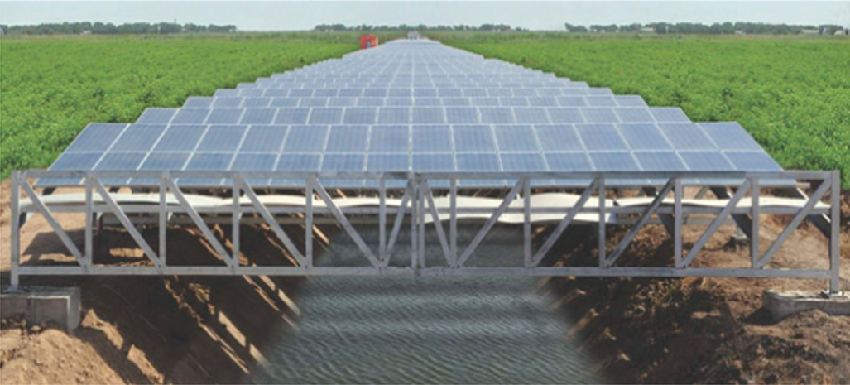
Figure 1- Sahu, Yadav, Sudhakar, 2016
Placing solar panels above water sources is an innovative new concept. This idea means to address two key issues: solar panels take up precious land space and water evaporation. Covering waterways and water sources with solar panels can address both issues, along with providing several other benefits. Floating solar panels directly on surface water can bring beneficial aspects to large water sources like reservoirs. There are concerns for cost and the environmental impact of such solar plants. This section will address these concerns and the benefits of solar panels over water; briefly discussing cost, electrical generation, environmental impact, and move onto the aspects relevant to this report, namely evaporation.

Cost
The cost of solar plants is the most prohibitive aspect for new solar installations. Initial costs for solar plant installation are high in comparison to fossil fuel powerplants (Sahu, Yadav, Sudhakar, 2016). With the phasing out of fossil fuel use, this cost comparison will lose salience. Instead, power generation cost comparisons will be between renewable energy sources and nuclear power. For instance, floating solar plants average 25% higher capital expenses in comparison to ground-based solar plants (Gorjian, et al., 2020).
The main reason for higher cost is in the physical structure of a floating solar panel installation. 25% of the cost for floating solar panels is in the support structure (Sahu, Yadav, Sudhakar, 2016). There are increasingly innovative designs which attempt to address this issue. For example, Carpentieri, Skelton, and Fraternali (2017) propose a minimal mass solar panel structure for water canals – reducing cost by reducing material requirements.
One factor in favor of floating solar panels is if a solar project requires the acquisition of land. Capital expenses may be less for floating solar panels in areas where the cost of land is high. Ground-based plants also require significant civil engineering and seismic-proof foundations (Sahu, Yadav, Sudhakar, 2016). Aside from capital expenses, maintenance is the only other relevant aspect of solar plant cost.
Maintenance for floating solar plants may at first seem difficult or costly, but several factors may prove otherwise. Water for cleaning the floating panels is readily available, the panels may require less cleaning since they will not corrode in freshwater, vegetation growing above the panels is not an issue, and water provides a cooling element to preserve solar panels (Sahu, Yadav, Sudhakar, 2016).
Environmental Impact
Environmental impact is another valid concern for floating solar panels. Issues include a potential negative impact on protected species (biodiversity), protected environments, and electrical accidents (Sahu, Yadav, Sudhakar, 2016). There is insufficient evidence to conclude floating solar panels will cause such an impact on an environment and further scientific investigation is necessary. Currently, the only known negative environmental impact of solar panels is in the manufacturing of solar panels (Gorjian, et al., 2020). With constant innovation in solar panel manufacturing, the impact will decrease over time. Figure 2 shows the visual impact of floating solar installations. One possible impact on aquatic life is the reduction of algae.

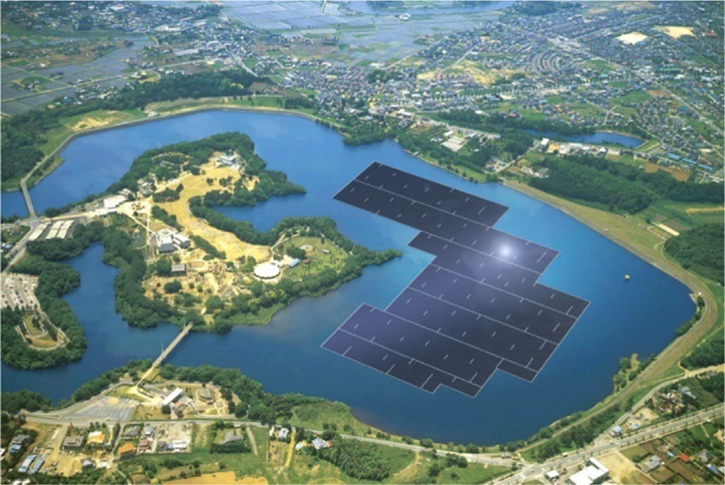
Figure 2- Sahu, Yadav, Sudhakar, 2016

Reducing Algae Growth
Floating solar panels can provide multiple benefits such as preventing evaporation, preventing particulate pollution, reducing collisions with birds, enhancing water quality, and reducing algae growth (Sahu, Yadav, Sudhakar, 2016, and Gorjian, et al., 2020). This section will discuss the latter two qualities of floating solar panel installations.
Reducing algae growth can pose a serious issue for aquatic species which mainly consume algae or consume insects and microbes that thrive on algae. However, much of the state and the country is battling with harmful algae growth (cyanobacteria). The California Water Board maintains a website which documents incidences of cyanobacteria accessible at https://mywaterquality.ca.gov/habs/where/freshwater_events.html. In this case, floating solar panels may prove capable of prohibiting cyanobacteria proliferation.
The State of California concerns itself with the danger of harmful algae to the point of utilizing non-native species for mitigation. The Grass Carp is a non-native species, but unlike with other non-native species, the Department of Fish and Wildlife prohibits Grass Carp capture. Grass Carp consume algae and provide a valuable addition to water environments. Yet it underscores the importance of the algae problem if the Department goes to the point of sanctioning a non-native species to address it. It is thus necessary to reduce algae growth in much of California’s water sources to improve water quality. Floating solar panels can also accomplish this task.
Floating solar panels can reduce algae growth and improve water quality in reservoirs (Gorjian, et al., 2020). It is also important to maintain a modest approach to utilizing floating solar panels for algae reduction by limiting the solar panels covering a water source. This will allow for some algae to grow so as not to harm an entire ecosystem. The solar panels can protect habitat and protect water sources.

Generating Power and Preventing Evaporation
Solar panels over water provide two key benefits: generating energy and preventing water evaporation. Floating solar panel projects are still rare, but various studies exist estimating the potential of such systems. Farfan and Breyer (2018) find solar panels provide three times the power of a hydroelectric dam when the reservoir above a dam has 25% panel coverage. The authors calculate this using the total size of the world’s hydroelectric dams, the total size of reservoir water surface, and the power generating capacity of floating solar panels.
One study on Lake Mead of Nevada finds great potential in several levels of solar panel coverage. Table 1 indicates the potential benefits at various stages. At 10% coverage, foam-backed solar panels can produce more than enough energy for all the homes in Las Vegas, Henderson, and Reno (Hayibo, et al., 2020). At 50% coverage, the water which solar panels prevent from evaporating can serve 5 million people for a year, or about 50 gallons per person per day (Hayibo, et al., 2020).
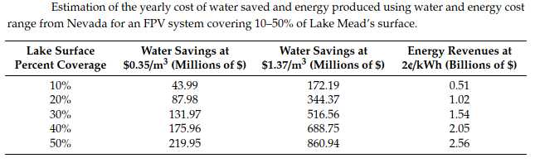
Table 1- Hayibo, et al., 2020
Such estimates on the potential of floating solar panels are not an overstatement. Evaporation declines by up to 90% when water is under solar panels (Rosa-Clot, et al., 2017). However, variation in estimates indicate weather and other factors may influence evaporation differently. Taboada, et al. (2017) find in some cases, solar panels reduce evaporation by over 60% at most. Figure 3 illustrates their findings, with the gray dotted line indicating evaporation from uncovered water and the other lines indicating evaporation from water fully covered by solar panels.
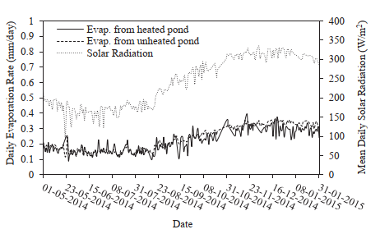
Figure 3 - Water evaporation in ponds and solar radiation - Taboada, et al., 2017

Conclusions for Permitting Floating Solar Panels
California should permit municipal utility providers to install solar panels over state water sources. The numerous benefits of floating solar panels make these innovations quite attractive. Reducing algae growth, improving water quality, generating power, and preventing evaporation are all some of California’s policy goals. Improving water quality and preventing evaporation are the two most relevant to this report. Floating and water-covering solar panels will require pioneering policy. This recommendation reflects the beginning of this innovative use of solar panels.
Developers will need permission to construct any solar projects on water. The State of California retains the rights to most bodies of water within the state. This recommendation is to simply permit municipal utility providers to build solar panel systems on specific bodies of water with approval from state agencies. However, implementation is not so simple.
Permitting municipal utility providers to undertake such projects will require much deliberation with various stakeholders. Developers will need permission from the Department of Water Resources, the State Water Resources Control Board, Fish and Wildlife, Food and Agriculture, the Public Utilities Commission, and locally oriented agencies. These stakeholders will require environmental impact analyses to determine the safety of affected ecosystems.
Utilizing solar panels on waterways can be a boon for Californians. Although municipal utility providers will incur the costs of installing floating solar plants, there are a few possible incentives for the utility providers. First, installing solar panels on water will not require the normal costs associated with acquiring land. Secondly, space will be easy to find as many reservoirs already have sections which are off limits to recreation. Lastly, saving water from evaporation is a primary point for California’s water plans and subsidizing development of floating solar panels can help achieve this goal.
Before the state distributes funds for floating solar, there first needs to be permission. The state can grant permission contingent upon an evaluation of project impacts on waterways. The purpose of such evaluation is to validate concerns and benefits prior to initiating floating solar panel installations.

Desalination Plants
One of the issues with retaining precipitation is that much of it is occurring within cities rife with pollution. The precipitating water absorbs these pollutants. Desalination facilities can filter salt water as well as polluted brine. With that in mind, desalination is not only useful to communities close to saltwater, but also where water sources have high levels of contaminant, or where there is plenty of wastewater. Most desalination plants are fossil-fuel powered Reverse-Osmosis membrane facilities, but many are beginning to utilize alternative energy sources. The process involves heating, cooling, and transporting water through a membrane filter system.
The main issue with desalination plants is their high initial capital requirements. Also, desalination requires treatment chemicals and large amounts of energy, causing concern for the environment. By subsidizing desalination facilities, making them economically feasible, and addressing environmental concerns, California cities can utilize more of the precipitation which occurs in their vicinity. This section will describe the costs, environmental issues, and the potential for desalination to increase the amount of water California cities retain.

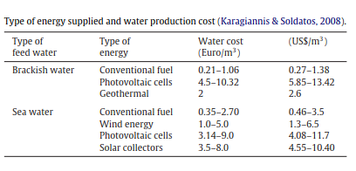
Table 2- Shatat, et al., 2013

Cost
Table 2 compares the cost differences between types of energy input for desalination facilities. Costs of solar desalination plants are considerably higher than for plants using conventional fossil-fuels (Shatat, et al., 2013). Wind energy is closer in cost to conventional fuels (Shatat, et al., 2013). The conclusion to draw from the high cost of solar desalination is that science must develop more economical solar technology. Figure 4 indicates the energy efficiency improvements of fossil-fuel Reverse-Osmosis desalination over time. However, this figure does not compare types of energy input. If fossil-fuel desalination efficiency can improve so dramatically over time, solar desalination may have significant room for improving efficiency. Cost reductions are imperative for making desalination plants economically and politically feasible. Environmental concerns affect the political feasibility of desalination plants as well.
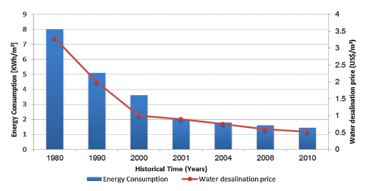
Figure 4 – Energy consumption and cost in reverse-osmosis desalination over time – Shatat, et al., 2013

Environmental Impact
Desalination plants pose several problems for local environments. First, water intake systems can capture or entrap various types of marine life (Lewis, p.3, 2010). Larger wildlife may not travel through intake systems, but the intake flows may trap larger species on intake screens. As well, intake systems can trap smaller wildlife and microbial species, killing them in the desalination process.
There are ways to reduce and prevent environmental harm from water intake systems. Decreasing water intake velocity and utilizing different screens are two solutions to the problem, but the best solution is to locate intake systems separate from where wildlife concentrates (Lewis, p.5, 2010). Designing intricate intake systems which are subsurface or subterranean, effectively filters out most wildlife before intaking water.
Second, desalination produces a mineral laden waste byproduct known as brine. Also, the membrane filters for the process require cleaning chemicals which can put the local environment at risk to harmful pollution (Lewis, p.4, 2010). Most of this discharging byproduct is salt and can increase salinity to fatal levels for ocean life in the vicinity (p.3, 2010). Adequately spreading out or discharging brine in specific locations can prevent harm to the environment (p.5, 2010). There are various ways to dispose of discharge as Alameddine and El-Fadel (2017) describe from releasing discharge into surface water, sewage treatment plants, deep wells, irrigation, evaporation ponds, and other effluent systems.
Third, increasing water supplies through desalination can exacerbate pollution and increase agricultural development. The main concerns with this are that new desalination plants can increase the use of fossil-fuels and agricultural development can lead to eutrophication of the environment (Lewis, p.4, 2010). Nitrate pollution is an issue California struggles to contain (Wang, Tyau, and Ybanez, 2017).
These issues are part of the impetus for the California Coastal Act of 1976. This act establishes the Coastal Commission which continues to oversee California’s coastal zone and development within it. Under the mandates of the California Environmental Quality Act (CEQA), the Coast Commission will study potential environmental changes from a desalination project and file an Environmental Impact Report (EIR) (Lewis, p.7, 2010). Any desalination project will have to show adequate mitigation of the risks to the environment before the Coastal Commission grants permission to begin developing a desalination plant. CEQA also provides that the presiding agency, in this case the Coast Commission, will provide support to mitigate environmental changes. The Coastal Commission helps in the development process by planning and offering insightful solutions for reducing environmental harm (p.5-6, 2010). To date, the Coast Commission has not disapproved of any desalination project (p.6, 2010). With the Coastal Commission’s help, environmental problems from desalination are surmountable.
The environmental concerns are reasons social opposition occurs against desalination or recycling. For example, in Santa Cruz, opponents opposed new desalination or water recycling in favor of conservation (Badiuzzaman et al., p.9, 2017). It is proving successful, with consumption decreasing dramatically just in Santa Cruz (p.9, 2017). However, this is not the case for every city as higher levels of conservation become more difficult to attain as cities eliminate blatant unnecessary uses for water. Much of the remaining demand for water is out of necessity, making conservation a sacrifice for people.

Benefits
Conserving water demands people sacrifice some of their water use for their main needs. Increasing water storage capacity can alleviate the need to conserve, but some localities are averse to sacrificing precious land for new reservoirs. Thankfully, desalination plants use a few acres of land, while new reservoirs cover thousands of acres. Desalination and water recycling offers an alternative to three problems with water distribution: the high costs of importing water, the inability to utilize polluted water sources, and the burden of water distribution on the electrical energy infrastructure. For this section, I will analyze these costs and the energy burden in a comparison with desalination.
Cost Comparison
Coastal and Southern California cities rely heavily on importing freshwater to satisfy demand. Badiuzzaman et al. (2017) find the average cost of importing water ranges from $875/AF to $975/AF for Southern Californian cities. The average costs of ocean desalination range from $1500/AF to $3000/AF (Badiuzzaman et al., p.7, 2017). It is immediately apparent that desalination costs are prohibitive compared to importing water from the dwindling sources in the southeast like the Colorado River, and Northern California. However, recall that desalination plants can filter and treat polluted brine wastewater.
Municipal water recycling facilities utilize the same methods, primarily reverse osmosis filtration, to treat wastewater. These facilities are different from desalination plants since the recycling systems are not equipped to deal with heavy mineral deposits, but the idea is the same. On the other hand, desalination plants can recycle water and much more. Desalination plants can filter not only ocean water and wastewater, but also brackish groundwater.
The cost of brackish groundwater desalination ranges from $500/AF to $900/AF (Badiuzzaman et al., p.8, 2017). For municipal water recycling through reverse osmosis, the costs range from $300/AF to $1300/AF (p.8, 2017). Here are the primary benefits of desalination and reverse osmosis. In most cases, the costs of recycling water and treating brackish groundwater are less than importing water (Badiuzzaman et al., p.8, 2017). The costs of recycling can be less than half of the cost of importing the same amount of water.
In instances where water recycling facilities are incapable of treating particularly heavy or polluted effluent, desalination plants can filter it. As Californians continue to deplete precious groundwater basins, some groundwater sources go untouched because of their polluted and brackish consistency. These dirty water sources are not in danger of depletion. Desalination facilities can treat groundwater basins close to the ocean which are high in salinity or in polluted basins in the interior of the state.
Lastly, wastewater discharge is a major concern in any part of the state. Wastewater recycling systems are the only way to deal with the effluent from cities and agriculture. Desalination plants can catch and filter wastewater before it reaches the ocean. Environmental groups support wastewater recycling because of the impact on pollution (Williams, p.858, 2018). Recycling wastewater can also reduce pollution by requiring less energy to support water demand.

Energy Burden
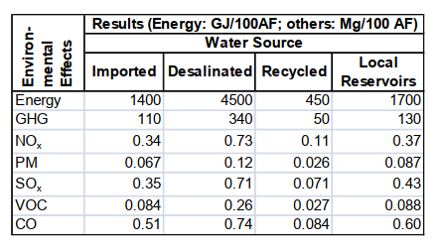
Table 3 – Energy Use and Emissions by Water Source - Horvath and Stokes, p.24, 2011
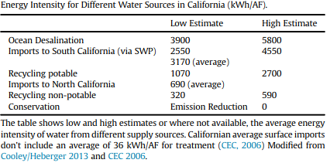
Table 4 – Energy Intensity Range of Water Sources - Badiuzzaman et al., p.9, 2017

Water distribution is an energy-intensive task. Tables 3 and 4 show estimates of how much energy use goes into producing and distributing an acre-foot of water. These figures use gigajoule and kilowatt-hours per acre-foot as the energy measurements, with megagram (metric ton) per 100 acre-feet as the pollution measurement. Clearly, ocean desalination requires the largest amount of energy to produce potable water. These figures corroborate the earlier findings indicating the high cost of ocean desalination in comparison to importing water. What is notable here is the large reduction in energy use and pollutants when recycling water. Also, these figures do not account for recycling wastewater or treating brackish groundwater with desalination facilities.
In most cases, recycling requires less than half of the energy as importing water or utilizing local water (Badiuzzaman et al., p.9, 2017). Recycling water reduces greenhouse gas, nitrous, particulate matter, sulfur, volatile carbonates, and carbon dioxide by over 50% for each pollutant (Horvath and Stokes, p.24, 2011). It has yet to be determined if recycled water can be as bountiful as other water sources. The current wastewater treatment facilities cannot treat all the water cities use and discharge. Nevertheless, recycling wastewater before it is discharged into the ocean is a cost and energy efficient way to supply water to California cities.

Conclusions for Subsidizing Desalination and Reverse Osmosis Facilities
Desalination and treating brine water are solutions for retaining rainwater that would normally flow out to the ocean or be sequestered underground. California can incentivize municipal water providers to build desalination facilities by subsidizing new development.
Although the running costs of solar powered desalination are considerably higher than fossil-fuel powered desalination, the cost structure will change over time. Fossil-fuel use will become more prohibitive for efficient desalination and as solar power technology improves; the cost of renewable energy powered desalination will decline. Continuing to subsidize renewables through tax exemption and other means, will make solar powered desalination more efficient.
Desalination facilities pose significant risks to marine life, but the California Coastal Commission does not permit desalination developments without adequate measures undertaken to mitigate those risks. There are various methods to reduce risk to habitat and marine life. Subsidizing development can further efforts to reduce environmental harm. Addressing environmental concerns is key for desalination projects to overcome legal challenges.
The major environmental concern of wastewater pollution is one issue desalination plants can address. Ocean desalination is costly in comparison to importing water, but recycling wastewater through reverse osmosis reduces pollution, is less expensive and requires less energy. Desalination plants can also treat non-potable brackish groundwater for less than the cost of importing water. Ultimately, treating wastewater discharges and outflows from cities will help retain precipitation while utilizing less resources than current water distribution practices.
In cities like Los Angeles where rainwater flows directly out into the ocean, desalination facilities can take advantage of this precious escaping resource. Los Angeles is not the only community with this issue and coastal communities struggle to fill their demand for water with local sources. Subsidizing the development of solar desalination facilities can provide a viable alternative to the increasing costs of importing water, ease the burden on the local energy grid, and recycle vast amounts of contaminated water.

Rainwater Capture Systems
Consumers can use captured precipitation for some of the same purposes as recycled water. Toilets, irrigation, air-conditioning, and fighting fires are potential uses of captured rainwater. In this section, there will be a discussion of rainwater capture policies, a short cost-benefit analysis, and a recommendation requiring the installation of rainwater capture systems.
California is already beginning the process of enabling rainwater capture throughout the state. The City of San Diego is pioneering residential rainwater capture and the city began regulating systems prior to an extensive state law. At first, the State Water Resources Control Board held authority over the use of captured precipitation (Slater and Davis, 2013). San Diego worked with water authorities to enable residents to harvest rainwater. With the passing of the Rainwater Capture Act of 2012, the rules and regulations are set for the entire state to install capture systems.
The act permits installing rainwater capture systems on private commercial and residential property under the authority of the California Building Standards Commission (Mader, p.1, 2012). The commission does not regulate systems with capacities under 360 gallons except if water is for potable use (Mader, p.1, 2012). All other systems require filtration and disinfection devices (Mader, p.8, 2012). Local jurisdictions regulate any indoor water use (Mader, p.8, 2012). Other legislation is incentivizing capture system installation.
Tax relief and rebate programs are beginning to roll out. The passing of Proposition 72 in 2018 exempts rainwater capture systems from the taxable value of properties. Also, the City of San Diego facilitates a rebate program for installing rainwater capture systems (new_gutter_rebate_guidlines_2.pdf (sandiego.gov). These incentives can make a policy requiring rainwater capture systems plausible and future studies will need to consider these incentives in the calculation of installation cost.

Cost
For rainwater capture to be economically viable, installation costs will need to be comparable to current municipal water prices. One study in the southeastern U.S., where water scarcity is not as much of a concern, found the costs to implement a rainwater harvesting system outweigh potential water savings (Dallman, et al., p.4416, 2016). Also, the researchers do not consider stormwater and pollution reduction in the analysis.
In another study on potential energy savings, researchers find an average energy savings of up to 120 kilowatt hours per household (Dallman, et al., p.4417, 2016). Dallman, et al. (2016) find this figure to be negligible, but 120 kilowatt hours is the equivalent of running an average home gas furnace for a total of 24 hours. Since California’s electricity production puts out carbon dioxide and particulate pollution (Dallman, et al., 4417, 2016), energy savings are valid considerations for utilizing rainwater harvesting systems.
In Dallman, et al.’s (2016) own case study of the Ballona Creek watershed in southern California, the findings are significant. The area receives water from the State Water Project and the Colorado River. When water prices remain constant, the only scenario with positive net benefits is for the smallest rainwater harvesting systems and for water use to be outdoor only (Dallman, et al., p.4424, 2016). In this situation, the net benefit for 224,876 residential and commercial buildings is $64.8 million.
In the scenario of water prices rising by 5%, all sizes of rainwater harvesting systems become economically beneficial with outdoor and indoor water use (Dallman, et al., p.4424, 2016; Gomez and Teixeira, p.63, 2017). The only exception is for one size up from the smallest tank capacity, 379 liters, which has positive benefits from outdoor use only. Figure 5 below shows these results with a considerable change in net benefits when the price of water increases.
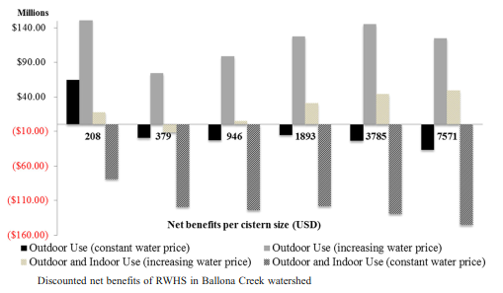
Figure 5 – Discounted net benefits of rainwater harvesting systems in Ballona Creek watershed – Dallman, et al., p.4425, 2016

Benefits
Using captured rainwater can save precious potable water. People can use mostly untreated rainwater for landscape irrigation, or for toilets and laundry. Instead of using it for landscaping, people can utilize captured rainwater and reduce the amount of pollution rainwater carries to water sources (Dallman, et al., p.4416, 2016). As Dallman, et al. (p.4416, 2016) mention, half of potable water in Southern California goes toward landscape irrigation. Reducing demand for potable water reduces greenhouse gas emissions by reducing the energy demand of water treatment and distribution (Dallman, et al., p.4416, 2016).
In Dallman, et al.’s (p.4423, 2016) study, residents of Ballona Creek can save enough potable water to provide for over 31,000 homes when 50% of residential and commercial buildings utilize rainwater harvesting systems. Larger tanks for rainwater capture can reduce stormwater flow by up to 24% (Dallman, et al., p.4423, 2016; Gomez and Teixeira, p.56, 2017). In certain areas where water channels are not prepared for significant flows, rainwater harvesting systems can aid drainage infrastructure (Gomez and Teixeira, p.56, 2017). Also, stormwater runoff poses a pollution risk to the local environment as it runs through city streets. Capturing rainwater can potentially reduce levels of runoff (Gomez and Teixeira, p.56, 2017).

Conclusions for Requiring the Development of Rainwater Capture Systems
Utilizing rainwater capture systems serves a similar purpose to desalination facilities. Just as desalination facilities treat water to utilize it safely and prevent water outflow before it escapes to the ocean, rainwater capture prevents outflow by retaining precipitation for future use. Experts concur on the increasing infrequency and severity of storms, making rainwater capture a high priority. Requiring the development of rainwater capture systems reinforces the importance of this aspect of our changing climate and can bring the entire state in on the initiative to capture precipitation.
Capturing precipitation and storing it, on a residential or commercial scale, can alleviate the stress of demand on water sources. Although potable water sources have strict use requirements, much of individual water use does not require potable water. Non-potable rainwater can supplement most of individual and agricultural water demand.
Rainwater capture becomes costly in small scale residential systems but is economical in large water sequestration systems. Minor increases in the price of water cause future benefits to overtake upfront costs in a shorter time period, increasing the net present value of rainwater capture systems. New developments and vacant land can utilize space to capture fleeting rainwater. The state may require a mandate to have developers create these capture systems. For residential areas, intricate rainwater capture systems can be costly but some systems, such as simple open barrels, are great ways to reduce the use of drinking water for landscaping. Californians need to capture and utilize the precipitation they receive. Simple rainwater capture systems will improve overall water supply, while reducing reliance on water imports.

Concluding Remarks
To increase the state’s water supply and reduce negative externalities with water distribution, Californians should look to secure the main source of freshwater – precipitation. What programs can assist in capturing and retaining precipitation in California? Answering this question will help Californians manage when water is scarce.
Scarcity and an incredible demand for water--well over 10 trillion gallons per year (USGS)--are causing significant environmental issues. Lakes, rivers, and groundwater sources are diminishing. Cities are reaching supply limits, especially in the southern part of the state. Conventional solutions, such as creating new reservoirs and distribution systems, face significant backlash. Reservoirs can only hold so much water and shifting strategies to retain precipitation can help increase available water.
Three recommendations are pertinent to the task of saving the precipitation California receives. Permitting solar panels over water sources, subsidizing the development of desalination or reverse-osmosis filtration facilities, and requiring the installation of rainwater capture systems are all programs that can assist in retaining precipitation.
Solar panel covered waterways can retain water by preventing evaporation. Although capital expenses are higher than ground-based solar plants, floating solar requires little land space and solar panel technology is improving. Also, maintenance may be less expensive as water keeps panels cool and large vegetation is far away. There are potential negative impacts on water environments, wildlife, and electrical accidents, but these events are unproven. The only known detrimental impact of floating solar panels is the greenhouse gases the manufacturing process emits. Considering floating solar panels can prevent evaporation, reduce particulate pollution of water, have less bird collisions in comparison to ground-based solar, enhance water quality, and reduce harmful algae growth; the benefits outweigh potential risks. With the ability to drastically reduce water evaporation and generate electrical power, permitting floating solar panel installations is an enticing policy.
Alternatively, water suppliers can actively treat water before it escapes to the macroenvironment. Desalination and reverse-osmosis filtration can clean storm runoff and polluted water. The trouble is, capital requirements are considerable and these facilities consume immense amounts of energy. Currently, solar powered desalination costs more per acre foot of water than fossil-fuel desalination. However, with technological progress, solar and other renewable energy sources are becoming more economically feasible. The other issue with desalination plants is the environmental impact. Intake systems harm wildlife, mineral laden byproducts flow from desalination facilities, and new water sources attract development. Desalination systems can overcome these impacts with the help of the Coastal Commission, an agency tasked with helping water projects come to fruition. The fruit of these facilities is potable water. Desalination and reverse-osmosis plants may be expensive, but they can recycle water efficiently. They are a less costly alternative to importing water, can clean up pollution, and relieve the electrical burden of distributing water over vast distances. California should subsidize desalination and reverse-osmosis filtration facilities to reduce pollutant-rich wastewater in the environment and to utilize a less costly water source by recycling water before it escapes to the ocean.
Like recycled water, rainwater capture systems can supplement water for irrigation, indoor use, and other purposes. Rainwater capture is beginning to proliferate in California as new policies incentivize commercial and residential systems. Water savings are not necessarily significant, but there are energy savings and in turn, less pollution. For consumers, if water prices are constant, only the smallest residential rainwater capture systems have economic benefits. If water prices rise, which prices consistently do, then all types of rainwater capture systems become economically beneficial. These systems save potable water, reduce polluting runoff, reduce water flows during storms, and save energy. With a changing climate, California should require development of rainwater capture systems. Capturing and storing precipitation directly addresses the problem of escaping water. Tax exemptions, rebates, and other subsidies are valid incentives for requiring rainwater capture systems.
California should: continue making rainwater capture economically viable through incentivizing policies, continue learning the impact of solar panels on water sources, continue transitioning to renewable energy sources to reduce water filtration costs, and continue pushing policies to capture fleeting precipitation.

References
Alamdari, N., Sample, D. J., Liu, J., & Ross, A. (2018). Assessing climate change impacts on the reliability of rainwater harvesting systems. Resources, Conservation and Recycling, 132, 178–189. https://doi.org/10.1016/j.resconrec.2017.12.013
Alameddine, I, & El-Fadel, M. (2007). Brine discharge from desalination plants: a modeling approach to an optimized outfall design. Desalination, 214(1), 241–260. https://doi.org/10.1016/j.desal.2006.02.103
Badiuzzaman, Pierre, McLaughlin, Eoin, & McCauley, Darren. (2017). Substituting freshwater: Can ocean desalination and water recycling capacities substitute for groundwater depletion in California? Journal of Environmental Management, 203(Pt 1), 123–135. https://doi.org/10.1016/j.jenvman.2017.06.051
Bergquist, C. (2003). Sucking California Dry. Science World, 59(11), 6. Retrieved from https://search-ebscohost-com.proxy.lib.csus.edu/login.aspx?direct=true&db=ulh&AN=9171101
Bergquist, Allison M, Choe, Jong Kwon, Strathmann, Timothy J, & Werth, Charles J. (2016). Evaluation of a hybrid ion exchange-catalyst treatment technology for nitrate removal from drinking water. Water Research (Oxford), 96, 177–187. https://doi.org/10.1016/j.watres.2016.03.054
Bocanegra-Martínez, A., Ponce-Ortega, J. M., Nápoles-Rivera, F., Serna-González, M., Castro-Montoya, A. J., & El-Halwagi, M. M. (2014). Optimal design of rainwater collecting systems for domestic use into a residential development. Resources, Conservation and Recycling, 84, 44–56. https://doi.org/10.1016/j.resconrec.2014.01.001
Boxall, B. (2020, January 23). Newsom Pledged to Fix California Water Politics. Now He's Bogged Down in the Delta. Los Angeles Times. https://www.latimes.com/environment/story/2020-01-23/newsom-water-policy-sacramento-san-joaquin-delta.
Cagle, S. (2020, February 27). Everything you need to know about California's historic water law. https://www.theguardian.com/environment/2020/feb/27/california-groundwater-sgma-law-what-does-it-mean
California Natural Resources Agency, California Environmental Protection Agency, & California Department of Food and Agriculture. (2020). California Water Resilience Portfolio.
Carpentieri, G., Skelton, R. E., & Fraternali, F. (2016). A minimal mass deployable structure for solar energy harvesting on water canals. Structural and Multidisciplinary Optimization, 55(2), 449–458. https://doi.org/10.1007/s00158-016-1503-5
Dallman, S., Chaudhry, A. M., Muleta, M. K., & Lee, J. (2016). The Value of Rain: Benefit-Cost Analysis of Rainwater Harvesting Systems. Water Resources Management, 30(12), 4415–4428. https://doi.org/10.1007/s11269-016-1429-0
Desalination in California: Should ocean waters be utilized to produce freshwater? (2006). The Hastings Law Journal, 57(6), 1343.
Dumit Gómez, Yapur, & Teixeira, Luiza Girard. (2017). Residential rainwater harvesting: Effects of incentive policies and water consumption over economic feasibility. Resources, Conservation and Recycling, 127, 56–67. https://doi.org/10.1016/j.resconrec.2017.08.015
Edalat, Arian, & Hoek, Eric M. V. (2020). Techno-Economic Analysis of RO Desalination of Produced Water for Beneficial Reuse in California. Water (Basel), 12(7), 1850. https://doi.org/10.3390/w12071850
Farfan, J., & Breyer, C. (2018). Combining Floating Solar Photovoltaic Power Plants and Hydropower Reservoirs: A Virtual Battery of Great Global Potential. Energy Procedia, 155, 403–411. https://doi.org/10.1016/j.egypro.2018.11.038
Fernandes, Suélen, Bonfante, Mariele Canal, de Oliveira, Carla Tognato, Maldonado, Mauricio Uriona, & Campos, Lucila M. S. (2020). Decentralized Water Supply Management Model: A Case Study of Public Policies for the Utilization of Rainwater. Water Resources Management, 34(9), 2771–2785. https://doi.org/10.1007/s11269-020-02575-8
Fry, H., & Reyes-Velarde, A. (2019, February 20). California Wastes Most of its Rainwater, Which Simply Goes Down the Drain. Retrieved January 25, 2021, from https://www.latimes.com/local/lanow/la-me-rainwater-lost-wet-winter-california-20190220-story.html
Fouda, A., Nada, S. A., Elattar, H. F., Rubaiee, S., & Al-Zahrani, A. (2018). Performance analysis of proposed solar HDH water desalination systems for hot and humid climate cities. Applied Thermal Engineering, 144, 81–95. https://doi.org/10.1016/j.applthermaleng.2018.08.037
Gies, E., & Lohan, T. (2017, August 24). California Towns Tackle Nitrate Pollution With Local Solutions. Retrieved from https://www.newsdeeply.com/water/articles/2017/08/24/california-towns-tackle-nitrate-pollution-with-local-solutions
Gorjian, S., Sharon, H., Ebadi, H., Kant, K., Scavo, F. B., & Tina, G. M. (2021). Recent technical advancements, economics and environmental impacts of floating photovoltaic solar energy conversion systems. Journal of Cleaner Production, 278, 124285. https://doi.org/10.1016/j.jclepro.2020.124285
Gómez, Y. D., & Teixeira, L. G. (2017). Residential rainwater harvesting: Effects of incentive policies and water consumption over economic feasibility. Resources, Conservation and Recycling, 127, 56–67. https://doi.org/10.1016/j.resconrec.2017.08.015
Hayibo, K. S., Mayville, P., Kailey, R. K., & Pearce, J. M. (2020). Water Conservation Potential of Self-Funded Foam-Based Flexible Surface-Mounted Floatovoltaics. Energies, 13(23), 6285. https://doi.org/10.3390/en13236285
Heck, Nadine, Paytan, Adina, Potts, Donald C, & Haddad, Brent. (2016). Coastal residents' literacy about seawater desalination and its impacts on marine ecosystems in California. Marine Policy, 68, 178–186. https://doi.org/10.1016/j.marpol.2016.03.004
Holthaus, E. (2014, May 14). 10 Percent of California's Water Goes to Almond Farming. That's Nuts. Retrieved from http://www.slate.com/articles/technology/future_tense/2014/05/_10_percent_of_california_s_water_goes_to_almond_farming.html
Horvath, A., Stokes, J., University of California, Berkeley. Department of Civil Environmental Engineering, author, & California Energy Commission. Energy Research Development Division, issuing body. (2011). Life-cycle energy assessment of recommendation water supply systems in California: final project report. California Energy Commission.
Imteaz, M. A., Shanableh, A., Rahman, A., & Ahsan, A. (2011). Optimisation of rainwater tank design from large roofs: A case study in Melbourne, Australia. Resources, Conservation and Recycling, 55(11), 1022–1029. https://doi.org/10.1016/j.resconrec.2011.05.013
Knights, D., & Wong, T. (2008). Drought proofing cities: Desalination versus rainwater tanks – a challenge to water supply managers. Australasian Journal of Water Resources, 12(2), 101–109. https://doi.org/10.1080/13241583.2008.11465338
Lewis, Matthew C. (2010). Thirsty for change: desalination as a practical and environmentally friendly answer to California's growing water shortage. University of San Francisco Law Review, 44(4), 933.
Mader, R. P. (2012). Calif, mulls another rainwater capture bill. Contractor Magazine, 59(7), 1–8.
Mankad, Aditi, & Gardner, John. (2016). The role of personal experience in frequency of rainwater tank maintenance and policy implications. Local Environment, 21(3), 330–343. https://doi.org/10.1080/13549839.2014.959907
Mount, J., & Hanak, E. (2019, May 19). Water Use in California. Public Policy Institute of California. https://www.ppic.org/publication/water-use-in-california/.
Nnadi, E. O., Newman, A. P., Coupe, S. J., & Mbanaso, F. U. (2015). Stormwater harvesting for irrigation purposes: An investigation of chemical quality of water recycled in pervious pavement system. Journal of Environmental Management, 147, 246–256. https://doi.org/10.1016/j.jenvman.2014.08.020
Rosa-Clot, M., Tina, G. M., & Nizetic, S. (2017). Floating photovoltaic plants and wastewater basins: an Australian project. Energy Procedia, 134, 664–674. https://doi.org/10.1016/j.egypro.2017.09.585
Sabalow, R. (n.d.). I killed the Colorado River – and so did you. Retrieved from https://www.sacbee.com/opinion/california-forum/article207641174.html
Sahu, A., Yadav, N., & Sudhakar, K. (2016). Floating photovoltaic power plant: A review. Renewable and Sustainable Energy Reviews, 66, 815–824. https://doi.org/10.1016/j.rser.2016.08.051
Sample, D. J., & Liu, J. (2014). Optimizing rainwater harvesting systems for the dual purposes of water supply and runoff capture. Journal of Cleaner Production, 75, 174–194. https://doi.org/10.1016/j.jclepro.2014.03.075
Sharma, Ashok, & Gardner, Ted. (2020). Comprehensive Assessment Methodology for Urban Residential Rainwater Tank Implementation. Water (Basel), 12(2), 315. https://doi.org/10.3390/w12020315
Shatat, M., Worall, M., & Riffat, S. (2013). Opportunities for solar water desalination worldwide: Review. Sustainable Cities and Society, 9, 67–80. https://doi.org/10.1016/j.scs.2013.03.004
Slater, S., & Davis, C. (2013, February 4). California's Rainwater Recapture Act Lets State Residents Capture, Use Harvested Rainwater. LexisNexis® Legal Newsroom. https://www.lexisnexis.com/legalnewsroom/top-emerging-trends/b/emerging-trends-law-blog/posts/california-s-rainwater-recapture-act-lets-state-residents-capture-use-harvested-rainwater.
Taboada, M. E., Cáceres, L., Graber, T. A., Galleguillos, H. R., Cabeza, L. F., & Rojas, R. (2017). Solar water heating system and photovoltaic floating cover to reduce evaporation: Experimental results and modeling. Renewable Energy, 105, 601–615. https://doi.org/10.1016/j.renene.2016.12.094
Thomas, R. B., Kirisits, M. J., Lye, D. J., & Kinney, K. A. (2014). Rainwater harvesting in the United States: a survey of common system practices. Journal of Cleaner Production, 75, 166–173. https://doi.org/10.1016/j.jclepro.2014.03.073
Vieira, A. S., Beal, C. D., Ghisi, E., & Stewart, R. A. (2014). Energy intensity of rainwater harvesting systems: A review. Renewable and Sustainable Energy Reviews, 34, 225–242. https://doi.org/10.1016/j.rser.2014.03.012
Viers, J.H., et. al. (2012) Nitrogen Sources and Loading to Groundwater. Technical Report 2 in: Addressing Nitrate in California’s Drinking Water with a Focus on Tulare Lake Basin and Salinas Valley Groundwater. Report for the State Water Resources Control Board Report to the Legislature. Center for Watershed Sciences, University of California, Davis. Retrieved from http://groundwaternitrate.ucdavis.edu/files/139110.pdf
Walsh, T. C., Pomeroy, C. A., & Burian, S. J. (2014). Hydrologic modeling analysis of a passive, residential rainwater harvesting program in an urbanized, semi-arid watershed. Journal of Hydrology, 508, 240–253. https://doi.org/10.1016/j.jhydrol.2013.10.038
Walton, Andrea, & Gardner, John. (2015). Community acceptance of policy options for managing the maintenance of rainwater tanks. Local Environment, 20(5), 565–580. https://doi.org/10.1080/13549839.2014.884554
Wang, J., Tyau, N., & Ybanez, C. R. (2017, August 16). Farming activity contaminates water despite best practices. Retrieved from https://publicintegrity.org/environment/farming-activity-contaminates-water-despite-best-practices/
USGS. (n.d.). Water Q&A: Which States Use the Most Water? (n.d.). https://www.usgs.gov/special-topic/water-science-school/science/water-qa-which-states-use-most-water?qt-science_center_objects=0#qt-science_center_objects.
Weiser, M. (2018, June 20). California Limits Daily Personal Water Use to 55 Gallons – Kind Of. Retrieved from https://www.newsdeeply.com/water/articles/2018/06/20/california-limits-daily-personal-water-use-to-55-gallons-kind-of
Welle, Paul D, Medellín-Azuara, Josué, Viers, Joshua H, & Mauter, Meagan S. (2017). Economic and policy drivers of agricultural water desalination in California’s central valley. Agricultural Water Management, 194, 192–203. https://doi.org/10.1016/j.agwat.2017.07.024
Williams, Joe. (2018). Diversification or loading order? Divergent water-energy politics and the contradictions of desalination in Southern California (1935-2018). Water Recommendations, 11(3), 847–865.
Zhou, L., Wang, H., Zhang, Z., Zhang, J., Chen, H., Bi, X., Dai, X., Xia, S., Alvarez-Cohen, L., & Rittmann, B. E. (2020). Novel perspective for urban water resource management: 5R generation. Frontiers of Environmental Science & Engineering, 15(1), 1–12. https://doi.org/10.1007/s11783-020-1308-z

