A Student Service Model Approach to Disbursing Financial Aid

By

Ryan Stewart McElhinney

A culminating project submitted to the graduate faculty in partial fulfillment of the requirements for the degree of MASTER OF PUBLIC POLICY AND ADMINISTRATION with California State University, Sacramento.

Culminating Project Advisor: Robert Wassmer, PhD.

Submitted: December 1, 2022.

Acknowledgments: First and foremost, my degree would not have been possible without my parents – Doug and Carol McElhinney. Thank you to both for your endless amount of patience and support, I also want to thank Adriana Garzón Audor for helping me to push this thing through. This report would not have been possible without Linda Williams of Sierra College, Michael Dear of MiraCosta College and Tammera Shinar of Butte College. Finally thank you to my academic advisors Rob Wassmer, Su Jin Jez and Andrea Venezia. Thank you for sticking with me!

\

Executive Summary

This report, which serves as a culminating project for my Masters's Degree in Public Policy and Administration at Sac State, identifies a problem for community college students and their institutions: eligible students for federal and state financial aid not receiving financial aid. This is a critical problem as these students could use these dollars to be more academically successful, meeting several goals that have been set for community colleges. Additionally, the report shows how a new funding formula will incentivize colleges to increase the number of students who receive financial aid awards on campus.
The report finds overly burdensome administrative policies and procedures that make it more difficult to obtain financial aid, to make it easier for eligible students to receive their awards. It also acknowledges that campuses implement these policies and procedures to protect the taxpayer from fraudulent financial aid award applicants and colleges from getting sanctioned by the United States Department of Education
The report recolonizes the complex government structure for California’s community colleges. While many different entities have a role in the governance of California's community colleges – the statewide central office, legislators, students, and others -this report focuses on actional items for elected community college trustees and CEOs to take. This is done for two reasons. First, the idea behind this report is policies and procedures that colleges can adopt on their own without the need for outside intervention. The second is that while the focus of this report is on improving financial aid services, these policies and procedures will require a campus-wide commitment to achieve. Thus, leadership from across the campus will be required to achieve the goals of this report.
The report then utilizes a comparative analysis between the academic research on various reasons why students might not receive financial aid and professional development materials provided by the National Association of Student Financial Aid Administrators to develop findings on policies and procedures colleges should consider moving to a smoother financial aid disbursement process. Specifically, the report identifies the following items a college should consider:
- How a college verifies a student’s income.
- Standards are created to ensure a student is making satisfactory academic progress.
- Counseling a student to utilize a Pell or Cal Grant throughout their academic career.
The report then concludes with a series of recommendations around the above topics. In general, it recommends colleges adopt a student-service focused financial aid disbursement model, which it defines as removing as many administratively burdensome procedures as possible, while also maintaining the goal of protecting taxpayer resources. The report pairs these recommendations with a suggestion that the financial aid offices and others provide regular updates to college leadership on various financial aid metrics that will help them craft student-centered policies while at the same time providing early indicators of fraud.

- Introduction

A significant portion of low-income California community college students qualify for federal and state financial aid, yet do not receive it due to administrative burdens created to minimize the risk of financial aid fraud (Cochrane, 2021). While well-intentioned, these policies have resulted in a reduction of available financial aid awards for low-income students and reducing the funding of community colleges (Lamanque, 2010). This report, which serves as a culminating project for my Master’s Degree in Public Policy and Administration at Sac State, will provide an overview of this issue and policy recommendations that community colleges should consider on how to create more student-centered financial aid policies. This section will serve as an introduction to this issue.
Increasing the financial aid available to California’s community colleges is critical if California is to meet its workforce needs in the future. In 2009 the Public Policy Institute of California estimated that California was on track to be short 1.1 million bachelor’s degrees in 2030 (Johnson & Batt, 2009). Another group – California Competes – projected that California would need to increase the number of students receiving a bachelorette degree by 2.3 million by 2025 in 2012 (Shireman, 2012). Both of these goals were founded based on projected workforce needs that will be central to making California’s economy move forward in the future (Johnson & Batt, 2009; Shireman, 2012).
Recent performance goals relating to degree completion and expectations around closing equity gaps were set in the 2022-23 state budget for the University of California (UC), and California State University (CSU). With two-thirds of the state’s college students at a California community college (Steinhausen, 2019), California’s community colleges are essential to meeting these four-year graduation goals. Finally, the California Community College system itself has created an ambitious strategic plan focused on closing achievement gaps and increasing transfer rates (Fried, 2017).
There are many ways that the federal and state systems of financial aid could be reformed to better serve community college students. Community colleges have urged that the levels of the award of the Cal Grant B – for community college students set at $1,656 a year and Pell Grants currently set at $6,895 - be increased (Galizio, 2022). The Free Application for Federal Student Aid (FASFA) could be simplified. Currently, the FASFA is an extensive list of questions, many of which could be automated via data reported via the Internal Revenue Service. (Bame, 2020). However numerous advocacy groups have worked but failed to make these changes due to either the significant expense of these forms of aid or political gridlock in Washington, DC.
California's community college system has a complex governance structure. While it does have a central governing board like the UC and CSU, California’s community colleges are largely governed by locally elected trustees and hired CEOs. Thus, most of the crafting of policies, procedures, and ultimately accountability for a college’s performance occurs at the district or college level (Smith, 2017). As noted below, many of the recommendations within this report require additional resources to implement, collaboration amongst various departments on campus, or both.
Thus, I have written this report to focus on policies and procedures that a California community college or district’s leadership can consider to increase the number of low-income students that receive financial aid. It is focused on the following constituencies within the community college system, both of whom have critical roles when considering financial aid policies:
- Elected Trustees: Every community college is governed by a board of trustees elected by the community. They are responsible for setting broad policy goals for the college in general.
- Community College Presidents, Superintendents, and Chancellors: Collectively called the CEOs, they are the leaders on campus directly hired by the board of trustees. It is their responsibility to implement policies and procedures that reflect the broad policy goals set by the elected trustees.
While student loans are an important part of helping students and their families afford higher education, this report focuses on increasing the number of students who receive financial aid grants and the levels of their awards. The goal is to maximize available tax-payer resources that are free for students, not student loans which they will have to start paying back after their college career. Thus, for this report terms such as financial aid or other ways of supporting low-income students, it is referencing grant aid unless otherwise stated.
Utilizing the results of the comparative analysis and considering the policymaking landscape, this report recommends moving toward a student-service centered model of financial aid disbursement. This report defines a student-service centered model as one that recognizes that there should be as few barriers as possible for students when applying for financial aid.
This definition comes after an analysis of potential reasons why community college students may not be fully accessing the federal financial aid they are eligible for. In general, it recommends aligning district financial aid disbursement policy as closely as possible with the United States Department of Education. A crosswalk summarizing what the researchers suggest, materials created by NASFAA, and this report’s recommendations are in Appendix A.
Specifically, it recommends the following actions around the below policies:
- Data Tracking: A college should annually track various metrics relating to its students.
- Income Verification: The United States Department of Education requires colleges to verify the income of a certain percentage of students or their parents. A college should not verify the income of students beyond what the United States Department of Education requires.
- Satisfactory Academic Progress (SAP): A college must certify that its students are making progress towards their degree. A college's SAP standard should match the Department of Education and be the same standard as those who are not receiving financial aid.
- Pell and Cal Grant Counseling: A college should, in general, counsel students to utilize their Pell and Cal Grants during their time there.
Section 2 of this report begins with an introduction to the history of why the implementation of administrative burdens when accessing financial aid, and why moving towards a student-centered financial aid disbursement policy is important to both students and colleges. Section 3 provides a comparative analysis of the academic research into the barriers for students to receive financial and professional development materials provided by the National Association of Student Financial Aid Administrators, the national association that provides professional development to financial aid officers. Section 4 concludes with a series of policy recommendations that consider the background of this issue and the findings of the comparative analysis.
- Financial Aid Disbursement Policy: An Overview
Historically the operations of a financial aid office have not been a priority to the leadership of a campus. Unlike their University of California (UC) or California State University (CSU) peers, California’s community colleges do not rely on a significant amount of tuition-based aid from either the state or the federal government to run their operations (Kurlaender, 2021). This is due to their relatively low tuition-based funding model (Johnson, 2010). Therefore, community colleges have not had much of an institutional incentive to increase the number of low-income students on campus who receive financial aid Linden (2018).
In addition to having a different funding model, financial aid offices are significantly under-resourced compared to their UC or CSU peers. California community college financial offices generally receive half of the funding available to CSU offices and about 25% of their colleagues at the UC relative to their share of the equivalent of full-time students (Cochrane, 2010). This has resulted in significantly lower staffing levels and antiquated equipment that makes it difficult for community college financial aid offices to serve low-income students.
As a major disburser of federal and state taxpayer resources, colleges are responsible for providing financial aid to low-income students. If a student claims to need financial aid but does meet eligibility requirements, a college is responsible for preventing them from receiving those awards and returning the disbursed award to the federal government. If not, the college could owe a significant sum of money to the government or lose eligibility for their students to receive financial aid in general.
The historical lack of investment in CA community college financial aid offices has resulted in a culture on many campuses within financial aid offices that is focused on avoiding potential sanctions by the federal government, as opposed to being more effective at servicing students Lamanque (2010). Many students who would otherwise be eligible for financial aid awards have not received them. For example, the Wheelhouse: Center for Community College and Leadership and Research found that in 2017 nearly one in five community college students eligible for a Pell Grant Award did not receive one, leaving close to 130 million dollars in federal resources on the table per semester. This report speculated many policies could be responsible for this, ranging from being too stringent as defined by the college's income-verification policies to the lack of clear guidelines on when a student utilizes their Pell or Cal Grants.
While the political and policy-making environment has favored a sanction-focused approach when it comes to financial aid policy, two critical changes could get a college to start rethinking its financial aid policies. The first is a growing recognition of the critical basic needs of low-income students in general, the other is a new funding formula for California’s community colleges.
As the current student body at a California community college grows more socio-economically diverse, there is a better understanding of the barriers that low-income students face to attending school full-time or being more academically successful. With the community college system serving the highest number of low-income students, this is particularly important for California’s community colleges. For a chart showing the differences amongst the income groups that each system of higher education serves, see Figure 1 included below. It demonstrated the difference among socio-economic groups served by each system.
Numerous reports, studies, or issue briefs have come out in recent years demonstrating the challenges a significant portion of community college students face when obtaining basic needs like food, housing, or transportation. For example, the Student Experience Expenses and Resources Survey conducted by the California Student Aid Commission (2018) found that one in three college students has experienced housing insecurity, defined as not having the ability to plan where they will sleep for at least two weeks during the semester. Another study, conducted by the California Community College Chancellor’s Office conducted in 2018 found that over half of community college students were food insecure, defined as not being able to afford food at least two days in the last month. As policymakers and community college stakeholders continue to focus on increasing academic success rates and closing achievement gaps, an emphasis will be on a college’s ability to support those basic needs (Restmeyer,2018). Expanding both the number of students receiving financial aid grants and the size of those awards could be helpful to meet these goals.
In addition to an emphasis on addressing basic needs, the current funding formula for community colleges places a major emphasis on financial aid award recipients. While before community colleges were funded on an attendance model, the new formula considers now factors in both the number of low-income students a college serves and the success rates of its students. Below are the following components of the new formula and their allocated percentages (Patek, 2022):
- Base Allocation (70%:) The raw number of students a college serves.
- Supplemental Allocation (20%): The number of students who receive a College Promise Grant, a Pell Grant, or is undocumented.
- Student Success Allocation (10%): Various success metrics related to transfer, associate degree, and certificate completion rates.
The goal of the supplemental allocation element of the formula is to direct resources to colleges that disproportionately serve low-income students (Harvey, 2019). Additionally, state policymakers hope that it will give colleges an institutional incentive to increase the number of students who receive financial aid rewards Harvey (2019). Indeed, a preliminary analysis of these metrics has found a small increase in the number of awards provided after the implementation of the formula. While this number varies across colleges, in general, the new formula could be responsible for a 3 – 5% increase in number of awards (Linden, 2018).
This has created an opportunity for colleges to rethink how they disburse financial aid awards to colleges. Under the prior formula, colleges did not get “credit” for the number of financial aid awards they provided to students. Under the new formula, community college financial aid offices can now almost be looked upon as revenue generators for the institution. By providing more awards, colleges can both help their low-income students succeed and increase the amount of revenue they obtain via the state. But as emphasized below, it is important to also consider the thinking that has led colleges to be risk-averse in their financial award actions
- Comparative Analysis
To craft specific policy recommendations for California’s community colleges on how to move towards a student-centered service model, this report conducts a comparative analysis between what the academic literature says would be the most beneficial to community college students relating to financial aid disbursement policy and professional development materials distributed by the National Association of Student Financial Aid Administrators (NASFAA), a leading professional development provider for financial aid administrators and institutions. The goal of this analysis is to identify where practitioners and academic researchers disagree or agree on how to disburse financial aid awards.
This report has identified the following three areas where financial disbursement policy will have a significant impact on the number of low-income students who will receive a financial aid award. They are the following:
- Income Verification
- Satisfactory Academic Progress
- Pell and Cal Grant Counseling
The first two items – income verification and satisfactory academic progress – are required policies by the federal government. Pell and Cal Grant counseling, on the other hand, are procedures in which colleges have full discretion on how to implement.
Income Verification
Income verification is the process in which the United States Department of Education requires colleges to verify a certain percentage of the parent income of a student (DOE, 2021). Every year the United States Department of Education randomly selects students who have applied for financial aid (DOE, 2021). This serves as an important function, as colleges are responsible for ensuring that students applying for financial income meet the income eligibility requirements. Unfortunately, this process is administratively burdensome for both the college and the student, as it requires colleges and students to resubmit nearly all their application paperwork (Cochrane, 2010).
For example, (Cochrane, 2010) analyzed the verification records of students from 13 colleges and found that only 70% of eligible students flagged for verification completed the process. While the verification process provided by the federal government is certainly necessary to protect taxpayer funds, in that same analysis, Cochrane found that Colleges flagged more students for verification than required by the federal government. Additionally, all colleges within the sample size required additional documents than required.
In a survey of college financial aid administrators, (Friedman and Martorell, 2019) found that 38% of the respondents did not believe that their college had the discretion to determine what the required information is in the verification process, and 30% believed their college had no discretion in whom to flag for verification. See Figure 2 below with a chart detailing their results. This is discretion provided by the United States Department of Education, which is responsible for both setting up verification procedures for students and enforcing sanctions (DOE, 2021)
The same survey identified misperceptions in a college’s ability to determine which documents to require and the number of students whom the college verifies as key barriers to disbursing financial aid. This contrasts with Department of Education guidelines, which state that while colleges can create additional verification requirements, colleges only need to verify the specific students selected for verification (DOE, 2021).
A self-study guide focused on helping financial aid administrators who would like to obtain a NASFAA certification in verification rules covered various aspects of the program (Futrell, 2022). The self-study guide teaches financial aid administrators about how and when the United States Department of Education flags students, the process in both the school and the student flagged for verification must go through, and the various required documents. In general, these documents demonstrate a student’s family income and eligibility for financial aid. Colleges have the discretion of how to determine what those documents are from a list provided by the United States Department of Education. Examples of these are documents demonstrating identification, tax returns, W-2s, and others (Futrell, & Vaughan 2022).
There is a significant emphasis on the penalties that a college might incur if the United States Department of Education finds that too many of their financial aid applicants are fraudulent. Additionally, it demonstrated where colleges have flexibility on how many applicants or who a college might be able to verify above the ones above have the Department of Education flagged. A presentation given in October 2022 on changes to Department of Education 2023-24 guidelines was along similar lines (Futrell & Vaughan, 2022).
Satisfactory Academic Progress
To ensure that students are moving forward in their academic careers while utilizing federal financial aid, colleges must certify that students meet a standard of what is known as satisfactory academic progress (SAP). While the Department of Education creates guidelines on how to determine this status, colleges have some discretion in this matter (DOE, 2021). For example, while the United States Department of Education requires a student to maintain satisfactory academic progress, a college has the flexibility to determine when a college calculates a GPA to demonstrate progress, how many units a student must take to maintain eligibility, and how a college structures the appeals process if a student loses their SAP (DOE, 2021).
This has resulted in a patchwork of standards. In semi-structured interviews with Pell-eligible students who both made SAP and those who did not, (Ocean, 2021) found that SAP standards disproportionately impacted people of color and those with lower expected family incomes. The interviews cited a lack of information about SAP standards and resources to help them as a major reason why they failed the SAP standard.
Utilizing disaggregated data from the Cal-PASS Plus system (Ramos, 2021) found that the SAP standards disproportionately impacted students of color. Additionally, the success rates for the appeals process were disproportionately lower for students of color. Ramos also demonstrated that those with experience in the foster care system had the highest failure rate among the tracked groups. The same report (Ramos, 2021) demonstrated that colleges have significant discretion on when and how students to deem to have failed their SAP. For example, colleges can determine a student’s GPA based on the end of a term, each payment period, or annually (DOE, 2021).
Like verification procedures, NASFAA publishes a self-study guide (Futrell, 2022) for financial aid professionals interested in getting a professional certification in SAP procedures. It outlines the various definitions of SAP, and the flexibility a college has in defining its standards and reporting requirements to the federal government. While NASFAA does not suggest an ideal SAP standard a college should adopt, it does emphasize the necessity of making sure that all financial aid recipients meet SAP standards, or the college may face sanctions.
Pell and Cal Grant Counseling
The primary financial aid programs that support students – Pell (federal) and Cal (state) grants have lifetime eligibility limits. Students have up to six years to use their Pell Grant and four for their Cal Grant. As only about half of degree-seeking students transfer to a four-year institution or receive their degree within six years of starting at a college (Student Success Scorecard, 2019), students need to decide when to utilize their Pell or Cal Grant during their college career. Using it during their initial years at college would be immediately beneficial, but it could mean a loss of financial aid eligibility if they exhaust their time limit before graduating (Lamanque, 2010).
Kurlaender, Martorell & Friedmann (year) found in a regression analysis of completion rates for community college students, that those that utilized their Pell or Cal Grants were more academically successful than eligible students who did not. Goldrick-Rab, Kelchen, Harris, and Benson showed in an analysis of a private scholarship program for low-income students in 13 public universities in Wisconsin that beneficiaries of the program were more likely to persist than their low-income peers.
A survey of 103 California community college financial aid directors representing 86 colleges showed that there is a wide variance amongst the system on suggesting when community college students should utilize their Pell and Cal Grants (Futrell, & Vaughan 2022). It found 28% of financial aid directors advise students in their first year of community college to decline the Pell Grant. See Figure Three for a complete result of their survey on when financial aid administrators recommend students utilize their Pell Grants.
NASFAA does not publish professional development materials nor programs on Pell Grant Counseling (as a national association, it would not be in their scope to have a program focused on a California program). Neither does the California Community College Financial Aid Administrators Association (CCCFSAA), NASFAA’s California community college counterpart offer professional development on Cal Grants. After reviewing both their websites and speaking with representatives of their organizations, it appears both NASFAA and CCCFSAA focus on the technical aspects of implementing Department of Education or California Student Aid Commission rules and regulations.
Overall, the academic research and the professional development materials from NASFAA have different focuses. Researchers were more focused on the impact of financial aid disbursement policies and procedures on students. NASFAA on the other hand went into granular details on how to follow Department of Education rules and regulations. These materials talk about the flexibility colleges have in how to implement those rules and regulations. However, they also go into detail on how the United States Department of Education has the power to impose penalties if too many financial aid recipients are fraudulent. Below are specific findings on the above topics:
Income Verification:
While both the NASFAA and academic researchers agree there is flexibility within the Department of Education rules and regulations, the survey results (Friedman & Martorell, 2019) found mixed opinions on the flexibility a college has when considering verification procedures. They found that 38% of financial aid administrators strongly disagreed or disagreed that their college has discretion in verification procedures.
Verifying the income of students or their parents can be administratively burdensome for both students and the college. Requiring students to resubmit and colleges to process numerous documents is time-consuming for both students and the colleges and at times is impossible. Minimizing the number of verifications over the amount required by the Department of Education would increase the number of students receiving financial, reduce administrative costs for colleges while at the same time putting them at risk of sanctions by the federal government. For example, while the United States Department of Education provides a college with a list of documents that can verify a student’s income, many are duplicative. Thus, identifying parts of required documents that are redundant will save time for the college and make it easier for a student to finish the verification process.
Satisfactory Academic Progress
It appears that the issues around income verification policies are like SAP standards. The Department of Education publishes rules and regulations that provide colleges flexibility in crafting SAP standards. NASFAA materials show this flexibility yet also emphasize the risk that colleges take when crafting their standards. On the research side, researchers urge colleges to implement flexible SAP policies with an equity-minded focus.
In addition to the specific SAP standards, colleges theoretically should develop early warning and support systems to intervene if a student is in danger of losing their financial aid award. While such systems could be costly to maintain, a college will probably lose significantly more funding from the state if that student either reduces the number of courses they take or drops out entirely. The new funding formula for community college students provides a significant per-pupil funding increase for students receiving either a Pell Grant or a California Promise Program recipient (Linden, 2018).
Pell and Cal Grant Counseling
Perhaps the most interesting finding is that NASFAA, in the case of Pell Grants and CCCFSAAA for Cal Grants, is not in the business of providing professional development materials on when a student should utilize their Pell or Cal Grant. This contrasts with the researchers who point to counseling students not to utilize their Pell or Cal Grant as a major reason why eligible students may not be receiving financial aid.
Based on the researchers' recommendations, organizations like NASFAA and CASFAA may want to establish clear standards on when students should utilize their Pell or Cal Grant in their academic careers. These standards should recognize that every student’s financial and academic situation is different and thus there cannot be a uniform policy on exactly when a student should utilize their Pell or Cal Grant throughout their career. Additionally, colleges will need to consider the availability of resources such as staff time or funding to effectively implement these policies.
#. Conclusion: Moving Towards a Student-Centered Financial Aid Policy Benefits Students, Colleges, and Taxpayers
After reviewing the current policy-making environment for California community college financial aid offices, this report concludes that moving towards a student-centered financial aid policy disbursement model would benefit students and colleges. By increasing both the level of financial aid awards and the number of financial aid recipients, colleges would help students be more academically successful (Page & Scott-Clayton, 2016). Colleges would benefit via the metrics within the Student-Centered Funding Formula that reward colleges for serving students who Pell Grant or California Promise Grant (Linden, 2018).
It is also understandable that the college’s role as a gatekeeper for federal tax dollars gives them the incentive to create strict financial aid policies to prevent fraud. If a fraudulent financial aid applicant receives an award, a college is liable to pay that money back to the Department of Education (DOE, 2021). If the college provides too many fraudulent awards, the college risks losing its student's ability to obtain federal financial aid.
This does increase the risk that colleges are open to sanctions from the Department of Education. Therefore, a college should carefully monitor the impact of these policies on its students. This way it can ensure these adopted new policies have the desired impact while at the same time not putting the college at risk for sanctions from the Department of Education.
While not in the academic literature nor the professional development materials provided by NASFAA, it is clear throughout the research conducted for this report that colleges should collect campus-level data on financial aid recipients and report to campus leadership. Campus leadership should be aware of how their policies are affecting their students, if there is any disproportionate impact on socio-economic groups and if policy changes have resulted in their intended outcomes. Additionally, it will help campuses mitigate the risk of sanctions by the Department of Education, as colleges could utilize data collection to identify early indicators of increased risk of fraud.
Student Service Financial Aid Policy: Specific Recommendations
Recommendation: Have an annual presentation to the trustee board by the financial aid office and the head of the student services department. Colleges already compile much of this data to maintain eligibility for financial aid (DOE, 2021), and college leaders must understand where colleges are on critical financial aid metrics. Therefore, the report should contain the following:
- The number of students who receive financial aid.
- The number of students who were eligible for financial aid but did not receive awards.
- Common characteristics, themes, or reasons why those students did not receive those awards.
- Proposed policy changes that could address the above item.
After exploring the financial aid data on low-income students within the district, a college should implement policies and procedures that do not go beyond what the Department of Education requires. With the understanding that each district is different and there might be reasons for more stringent policies, this report also provides potential policy questions to consider on each item:
Income Verification:
Recommendation: Attempt to minimize the number of students who get flagged for income verification.
- Is your college verifying the income of students beyond what the Department of Education requires? If so, why?
- What is the cost to your institution for verifying student income beyond what the Department of Education requires?
- The percentage of students who get flagged for verification at the college.
Satisfactory Academic Progress (SAP):
Recommendation (1): Create aggressive early warning and intervention programs for students in danger of losing their SAP.
Recommendation (2): Craft SAP standards and appeals process with an equity-minded focus.
- Is there any disproportionate impact on socio-economic groups who lose their financial
aid due to failing to make SAP?
- Does the campus provide warnings to students who are in danger of losing their SAP in enough time for them to make academic progress?
- What kind of academic or other support systems does the college provide to students who are in danger of losing their SAP?
This recommendation will require collaboration from across the college. Data from both the financial aid office and the academic side of the college. The instructional office will need to craft tutoring policies that students in danger of losing their SAP can utilize. The collaborative nature of this recommendation thus requires campus leadership to get involved to ensure each department collaborates.
Pell and Cal Grant Counseling:
Recommendation: In general counsel students to utilize their Pell and Cal grants during their time at your college.
- Every student’s financial needs are different so while it is important to have this as a standard, financial aid administrators should take into individual financial needs.
- How many students who are eligible for Pell Grant or Cal Grant defer to receive those grants?
- What are the success rates of students who defer those grants relative to low-income students who have received those grants?

Figure 1: Share of low-income students by a system of higher education
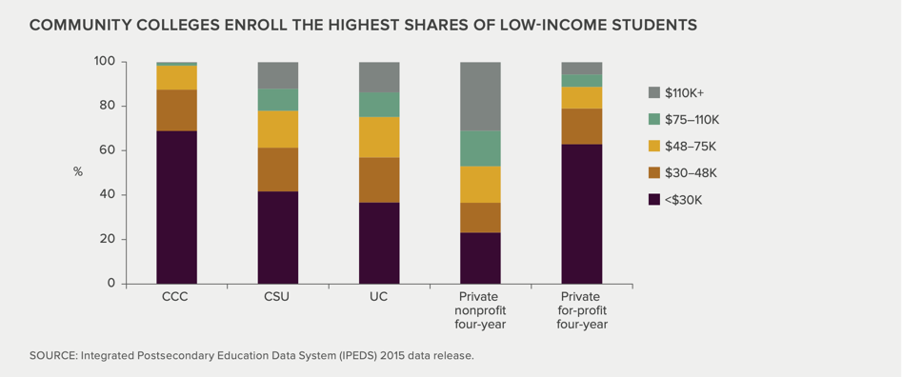

Source: Public Policy Institute of California
Figure Two: Survey of Financial Aid Administrators on Various Aspects of Income Verification
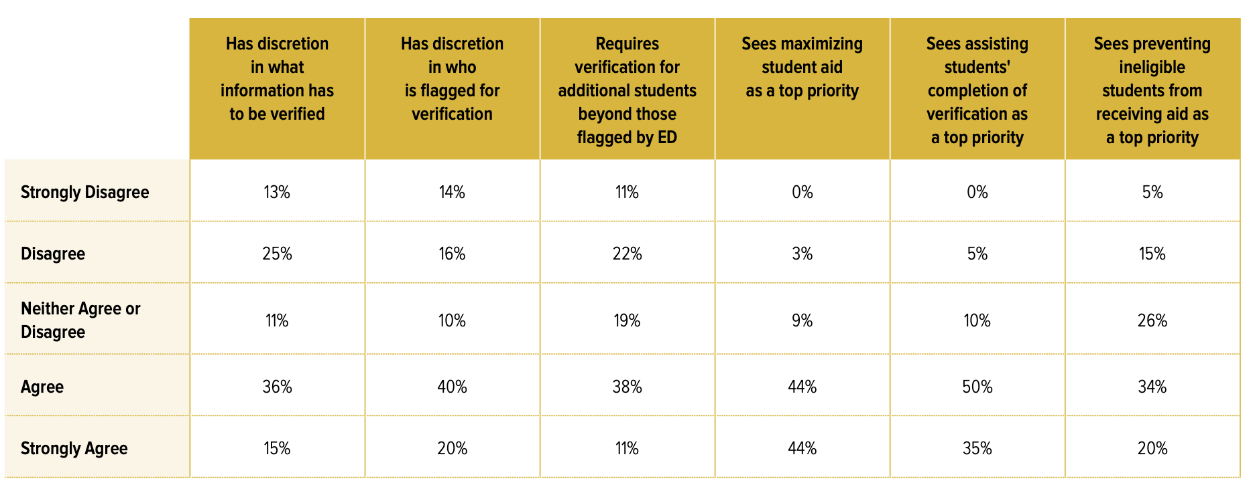
Source: UC Davis Wheelhouse: The Center for Community College Leadership
Figure Three: Survey of Financial Aid Administrators on Pell Grant Counseling
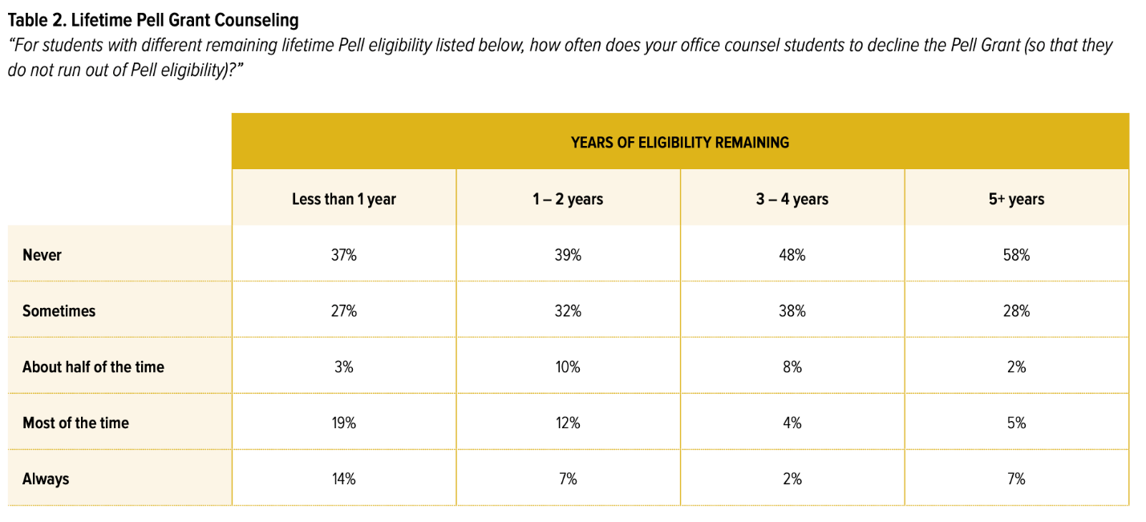
Source: UC Davis Wheelhouse: The Center for Community College Leadership

Appendix A: A Crosswalk of Recommendations by Researchers, NASFAA, and this Report

Policy | Researchers | National Association of Financial Aid Administrators | Student-Centered Service Model
Income Verification | Only verify the income of students flagged for verification by the federal government. | Colleges can verify the incomes of additional students beyond who the DOE flags and should be wary of DOE sanctions. | Colleges should only verify the required number of students.
Satisfactory Academic Progress (SAP) | Utilize flexibility in crafting SAP standards that maximizes the number of students who maintain financial aid. | Colleges have the flexibility to craft their own SAP standards but should be wary of DOE sanctions. | Colleges should craft early warning and intervention policies for students in danger of losing their SAP. Colleges SAP policies should craft polices with an equity minded focus but also ensure they meet DOE guidelines.
Pell and Cal Grant Counseling | In general, colleges should counsel students to utilize their Pell or Cal Grants at a community college. | N/A | In general, colleges should counsel to utilize their Pell or Cal Grants at a community college.

Reference List:

2019 Student Success Scorecard. 2019 student success scorecard. (n.d.). Retrieved November 13,
2022, from https://scorecard.cccco.edu/scorecardrates.aspx?CollegeID=000#home
Bame, D. FAFSA Simplification Act—Title VII of CRRSA. American Association of
Community Colleges.
Baldassare, M., Bonner, D., Dykman, A., & Lopes, L. (2018, November). Californians & Higher
Education.
Cochrane, D. (2021) Despite Progress, Hundreds of Millions of Federal Pell Grant Dollars

Remain Untapped by California Community College Students The Institute for College

Access and Success

Cook, K., & Jackson, J. (2021) Keeping College Affordable for California Students. Public

Policy Institute of California

Garcia, M. (2019). 2018–19 Student Expenses and Resources Survey. California Student Aid

Commission (CSAC), 4.
Goldrick-Rab, S., Kelchen, R., Harris, D., & Benson, J. (2016). Reducing Income Inequality in
Educational Attainment: Experimental Evidence on the Impact of Financial Aid on College
Completion1. American Journal of Sociology, 121(6).
Kurlaender, M. Martorell, P, Friedmann, E,. (2021) Research to Inform Policy: Financial Aid for

California Community College Students. UC Davis Wheelhouse: The Center for

Community College Leadership and Research, 1 -6
Fried, S., Esch, C., & Supinger, A. (2017). Vision for Success. California Community College
Chancellor’s Office.
Futrell, D. (2022). NASFAA Self-Study Guides – Satisfactory Academic Progress. National
Association of Student Financial Aid Administrators.
Futrell, D. (2022). NASFAA Self-Study Guide - Verification. National Association of Student
Financial Aid Administrators.
Futrell, D., & Vaughan, K. (2022) Verification 2023-24 (Extended Edition). National
Association of Student Financial Aid Administrators.
Johnson, H., & Batt, R. (2009). Closing the Gap: Meeting California’s Need for College
Graduates. Public Policy Institute of California.
Lamanque, A. (2010) After the FAFSA- How Red Tape Can Prevent Eligible Students from

Receiving Financial Aid. The Institute for College Access and Success, 2-17

Linden, R. (2018). Funding Incentives for California Community Colleges. 9.
Financial Aid Facts at California's Community Colleges. (2010). The Institute for College Access
and Success (TICAS)
Friedman, E., & Martorell, P. (2019) Why do Some Students Fail to Receive Pell Grants? UC

Davis Wheelhouse: The Center for Community College Leadership and Research, 4(2)
Galizio, L. (2022, February 8). Community College Budget Proposal.
Goldrick-Rab, S., & Cochrane, D. (2019) Addressing the Basic Needs of California Community

College Students The Institute for College Access & Success

Linden, R. (2018) Understanding the Student-Centered Funding Formula. 9.
Oakley, E. (2018). Basic Needs Survey Report. California Community College Chancellor's
Office.
Patek, G. (2022, January). The 2022-23 Budget: Overview of the Governor’s Higher Education
Budget Proposals.
Restmeyer, N. (2018). College Ready, Hungry, and Homeless. Speaker's Office of Research and
Floor Analysis.
Harvey, D. (2019). Student-Centered Funding Formula frequently asked questions. 6.

Ramos, L. (2021) The Overlooked Obstacle How Satisfactory Academic Progress Policies

Impede Student Success and Equity. John Burton Advocates for Youth, 15-27
Shireman, B. (2012). The Road Ahead: Higher Education, California's Promise and our
Future Economy. Oakland, CA: California Competes.
Steenhausen, P. (2019). California’s Education System. Legislative Analyst's Office.
Smith, C. (2017). Trustee Handbook. Community College League of California.

Szabo, L. (2020) Bearing the Burdens of College Costs A Look at College Affordability by

Student Race and Income at California’s Public Two- and Four-Year Colleges and

Universities The Institute for College Access and Success
United States Department of Education (DOE). (2021). Verification, Updates, and Corrections.
In 2021-2022 Federal Student Aid Handbook. essay.
United States Department of Education (DOE). (2021). Program Reviews, Sanctions, &
Closeout. In 2021-2022 Federal Student Aid Handbook. essay.

