Mitigating the Immigrant Health Paradox for Undocumented Immigrants with Medi-Cal
by
Analisa Isabel Quintero
A culminating project submitted to the graduate faculty in partial fulfillment of the requirements for the degree of MASTER OF PUBLIC POLICY AND ADMINISTRATION with California State University, Sacramento.

Culminating Project Advisor:
Robert Wassmer, PhD.

Submitted:
December 2nd, 2022

Executive Summary
California recently enacted legislation that greatly affects the lives of undocumented immigrants in the state. With the final expansion of Medi-Cal, California plans to expand their ACA healthcare system to include all eligible Californians, regardless of immigration status. In my research, I found that access to health insurance and healthcare was one of the variables linked to mitigating the immigrant health paradox that undocumented immigrants deal with. In this thesis, I describe the previous expansions and the issues related to health that undocumented immigrants face in California, with the end goal being an analysis of policy alternatives that will help mitigate the immigrant health paradox for undocumented immigrants in California.
In the introduction of this thesis, I present information about the current status of Medi-Cal and the population of undocumented immigrants in California. I also discuss the importance of policies impacting this population, more specifically, the recent Medi-Cal expansions that are affecting undocumented people of all ages.
After the introduction, I provide a more in-depth discussion of what policies have led to the current state of Medi-Cal, as well as the history of healthcare use by undocumented immigrants in California. In the history section of this paper, I will also discuss the issues that the previous expansions of Medi-Cal faced regarding implementation or administration. This information is necessary to understand the context surrounding the issues presented in the rest of the paper.
The following section of this thesis is a discussion of the process of policy adoption that the Medi-Cal program expansion was a part of. In this section, I describe the arguments for and against the expansion as well as the reasons why Governor Newsom eventually adopted the policy. Another important part of this section is the discussion of why exactly government intervention was necessary for the issue of the immigrant health paradox.
After the discussion of the necessity of government intervention, I include a section in which I describe relevant literature. In this section, I describe the concepts necessary to understand the context of the immigrant health paradox and what closely related aspects of immigrant health are commonly attributed to this concept as possible causes. This section is useful to understand what the focus of mitigation tactics should be.
In my analysis, I use a Criteria-Alternative Matrix (CAM) analysis to describe and score the policy alternatives I describe. I first start this section with a detailed description of the kind of analysis I use and how it is commonly used by others. I then lay out my policy alternatives and analyze them using the CAM analysis. This analysis is used to provide qualitative and quantitative support for the recommendations I provide.
The findings of my analysis show that an assessment of Medi-Cal’s ability to enroll undocumented immigrants and the health outcomes of those newly eligible participants could help to mitigate the health paradox they face. My second alternative, an incentive program aimed at boosting undocumented enrollment in Medi-Cal, is also effective, but would be more difficult to find funding for. At the end of my analysis, I describe an implementation plan that uses both alternatives to best mitigate the immigrant health paradox for undocumented immigrants in California via increasing Medi-Cal enrollment.

Introduction
Immigrants make up a sizable portion of the population of California, so it makes sense that numerous scholars and policy advocates alike are interested in ensuring the health of immigrants statewide. As of 2019, about 27%, or just under eleven million Californians are foreign born, making it the state with the largest immigrant population in the country (Johnson et al., California’s Population, 2022). Immigrant health outcomes have been a topic of research for many years, especially as the access to and availability of health insurance and health care has increased in areas of the United States due to the Covid-19 pandemic.
Undocumented immigrants make up about 22% of the immigrant population, which means that until recently, a little over 2.3 million undocumented individuals in California were not eligible for any form of Medi-Cal due to their immigration status (Johnson et al., 2021). The previous expansions of Medi-Cal for eligible undocumented children, young adults, and senior individuals have succeeded in providing thousands of California residents with free or low-cost health coverage. Medi-Cal plans to complete its expansion to include all eligible undocumented immigrants regardless of age beginning in 2024 (Petek, 2022). A population of uninsured Californians less than age 64, estimated to number around 1.27 million, will be eligible thanks to the new expansions (Figure 1).
Undocumented immigrants are one of the most vulnerable population groups in the state. Their health outcomes and quality of life greatly depend on their ability to access emergency, preventative, and specialty healthcare at a cost that will not place them in debt for the rest of their lives. In order to ensure their long-term health, California’s undocumented immigrants need efficient and comprehensive healthcare to combat the immigrant health paradox.
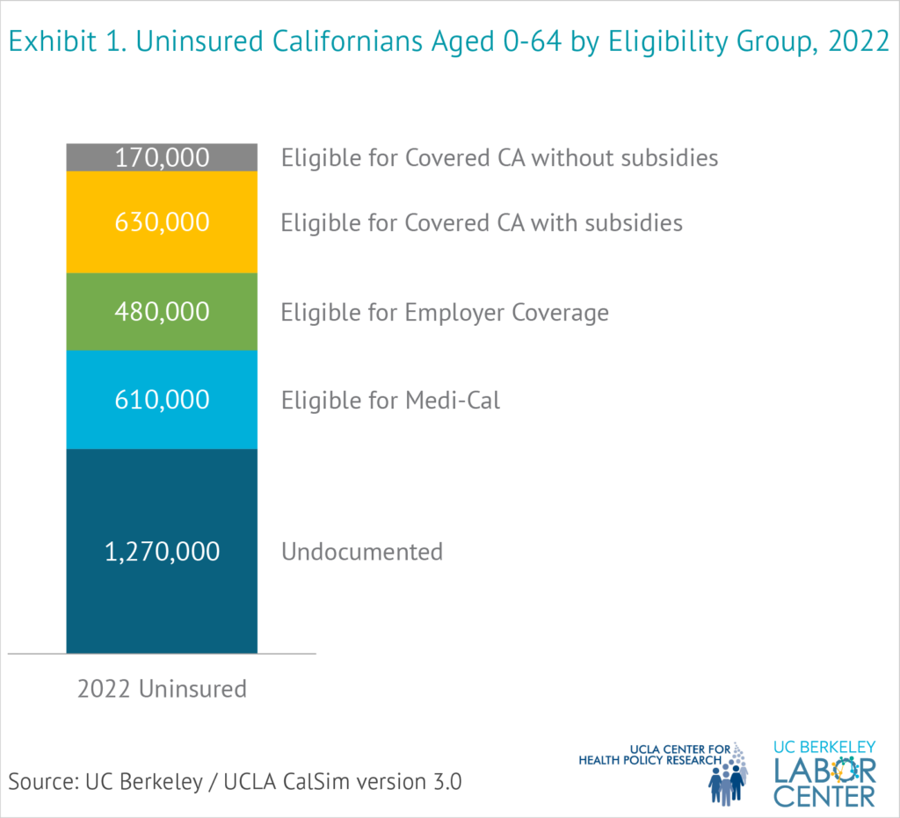
Figure 1: “Uninsured Californians Aged 0-64 by Eligibility Group, 2022” (Dietz et al., 2021).
In this report, I examine the history and literature about the possible impact this Medi-Cal expansion will have on undocumented immigrants in California, as well offer tools to ensure the effectiveness of this policy change. In the following section, I will be discussing the history of health care for undocumented immigrants and background information on the policies and concepts that influence immigrant health and immigrant communities in California. In the third section, I will discuss the arguments for and against the Medi-Cal expansion, as well as why the expansion eventually came to fruition. In the fourth section I will outline the policy alternatives I have decided on to best attempt to mitigate the health paradox for undocumented immigrants in California. Next, I will move on to a description of the style of analysis I use and the analysis of the policy alternatives I provided in the previous section. In the sixth section, I will provide my recommendation regarding the future of the implementation of these alternatives as well as summarize and conclude my analysis. Finally, I will conclude my essay with a brief summary of the contents of my paper and what I suggest for future researchers and policy analysts to focus on as the implementation of this final expansion of Medi-Cal moves forward.

History of Comprehensive Health Care for CA Undocumented Immigrants
In this section I will provide background information on what policies have led to the current state of Medi-Cal, as well as the history of healthcare use by undocumented immigrants in California. This information is necessary to understand why and how healthcare access could mitigate the issues that undocumented immigrants face related to their health in California.
One of the most prominent issues regarding immigrant healthcare that continues to grow in importance is the accessibility to comprehensive preventative and specialized healthcare. Without the ability to gain employer-sponsored or publicly funded healthcare coverage, many undocumented immigrants face severe issues related to their health, and the costs associated with preventative and emergency health care (Cha & Collins, 2022). As the average age of large immigrant populations increases, we could see an increased need in healthcare and less worker availability in key industries, like agriculture (Cha & Collins, 2022).
Before the expansions to Medi-Cal, one large impact on the necessity of emergency care use for undocumented immigrants was their ineligibility for Medi-Cal. Out-of-pocket care costs prevented many individuals from seeking care before any health concern became an emergency (Artiga & Diaz, 2019). It is also important to note that emergency-focused healthcare, which is the default for many undocumented families due to lack of coverage, is more costly for the families who need the care and the program that provides coverage for emergency care, the Emergency Medical Treatment and Labor Act (Bustamante et al., 2021).
The first expansion of Medi-Cal in January of 2016 included all children under 19 years of age in California without enrollment limitations due to citizenship status Prior to the first expansion, undocumented children participated in a few various kinds of healthcare, including Medi-Cal emergency coverage, and county programs (Lweit, 2015). Local programs, including county health programs, and statewide programs were all providing separate plans of coverage for undocumented children (Lweit, 2015). After the expansion, Medi-Cal merged these separate means of coverage into a comprehensive statewide program. In April of 2017, a report showed over 180,000 new enrollees in Medi-Cal since the expansion, less than one year after the program expanded (Odeh, 2017).
The Health4All Coalition has successfully worked to provide Medi-Cal services to undocumented children and young adults ages 19-25 (Health4AllKids, 2017). The largest group of the California population that lacks health insurance is undocumented immigrant adults (Lucia, 2019). These initiatives, if expanded to all low-income individuals in California, would offer 1.1 million undocumented adults healthcare coverage (Lucia, 2019). This program included the 19-25 adult age group in its second expansion. With the first two expansions to include undocumented children and young adults in Medi-Cal, there were some key administrative and implementation issues that policymakers and administrators need to consider.
One implementation issue raised by groups is the transition in coverage and programs. With transitions of care, the continuance of care and collaboration between healthcare groups is particularly important. Transitions in health insurance coverage are even more common for young adults than other age groups (Tilley, Yarger, & Brindis, 2018). These transitions between insurance plans are very damaging to immigrant populations, especially when considering the low rates of medical visitation (25% for annual dental visits) for the undocumented children of undocumented mothers (Ybarra, Ha, & Chang, 2017). Gaps in coverage can negatively impact health of individuals long-term, which is why continuance of care is a necessary focus when expanding coverage (Ybarra, Ha, & Chang, 2017). Some of these gaps in coverage are due to individuals misunderstanding how to maintain or gain access to health insurance, including low rates of health insurance literacy (Ybarra, Ha, & Chang, 2017).
In 2021, there were an estimated 30,000 undocumented seniors (65+) who did not have any health care coverage or plan (Dietz et al., 2021). In general, this group should mostly be eligible for Medi-Cal, as 61% of undocumented adults have an income within the Medi-Cal eligibility range (Dietz et al., 2021). This presents a large population that will require outreach efforts, knowledge workshops, language trainings, and many other resources. This population is likely larger than this, however, since a recent analysis showed 1.27 million undocumented individuals aged 0-64 should now be eligible for Medi-Cal starting in 2024 (Dietz et al., 2021).
The issue of resource allocation also impacted previous expansions. Medi-Cal administrators had to develop plans, allocate staff, and distribute funding. This was necessary to give each level (state, county, city) the resources to provide services without burdening the families who required services. Medi-Cal recipients reported lower health outcomes than Californians with employer-sponsored insurance (ESI) or individual market (IM) coverage (Ponce et al., 2021). This is likely due to the eligibility requirements Medi-Cal has in place, which researchers found to be the cause of issues with equity and care access for Medi-Cal recipients (Ponce et al., 2021). So, it stands that based on past expansions’ failure to address the care access and affordability gap, future expansions will require more comprehensive planning to allocate resources accordingly.

Why is This Issue Worth Government Intervention?
With this final expansion to Medi-Cal, California is the first state in the nation to offer ACA healthcare to all eligible undocumented immigrants regardless of immigration status. This means that it is likely that if other states begin to consider expanding their own programs, they will look to the information our state provides when compiling information to support their policy changes. This is also important for California, as the future cost-benefit analysis of this expansion should show that the preventative healthcare benefits provided by this expansion are worth more than the added cost and other inputs of the program. While it is unlikely that the state will rescind this expansion, it is still pertinent that this program is successful in providing healthcare to the undocumented population of California to show the value of similar programs elsewhere. In this section I will provide details on the political aspects of this program expansion, the arguments for and against the expansion, as well as why Governor Newsom ultimately signed the bill.

Arguments for Medi-Cal Expansion
California undocumented immigrants’ quality of life is a matter of equity. Undocumented immigrants make up a significant amount of the state’s population and workforce, and yet they have some of the lowest health outcomes and education levels in the state. Without access to healthcare, immigrant workers face burdens of health issues and expensive healthcare costs. Their work may protect their pay and safety, but when they do not, the costs are astounding. Without access to information about what their labor rights are, many immigrant workers suffer unfair labor practices in silence (Kalish, 2022). When their work exposes immigrant workers to pesticides and does not provide them with the means to clean themselves, their clothes, or their equipment before leaving work, their health and the health of their families suffer (California Department of Pesticide Regulation, 2020). One examples of how workplace hazards affect immigrant workers more often than other groups of workers is shown in a recent study, which saw that immigrants made up about 60% of coronavirus-related deaths in California’s industries that had highest rate of pandemic-related deaths (Montalvo, 2022). This equity issue requires the intervention of the markets and our government working together to provide a more equitable quality of life for immigrant workers in California.
There are also negative externalities, which are negative consequences or effects, that impact immigrant worker communities and all other California residents. Rising healthcare costs for all Californians is one negative externality of our current healthcare system. Lower worker productivity rates are common in populations without health insurance, which will negatively affect production in the state (Lucia, 2019). Along with these externalities, we have seen higher rates of disease transmission in immigrant worker populations, as is the case with the Novel Coronavirus 2019 (COVID-19) (Ball State University, 2020).
There is a large economic impact to consider when discussing immigrant quality of life. Immigrants make up a substantial portion of California’s workforce, and most also pay income taxes for many services they cannot use (California Immigrant Data Portal, 2020). Studies have shown that immigrant workers contribute over 180 billion dollars to California’s economy each year (Thomas & Coleman, 2020). Along with that, the spending power of immigrant-led households was over $290 billion in 2018 (Figure 2). Protecting the lives and improving the quality of life for this population is not only an equity issue, but also necessary to ensure the future of California’s immigrant populations, and their contributions to our economy.

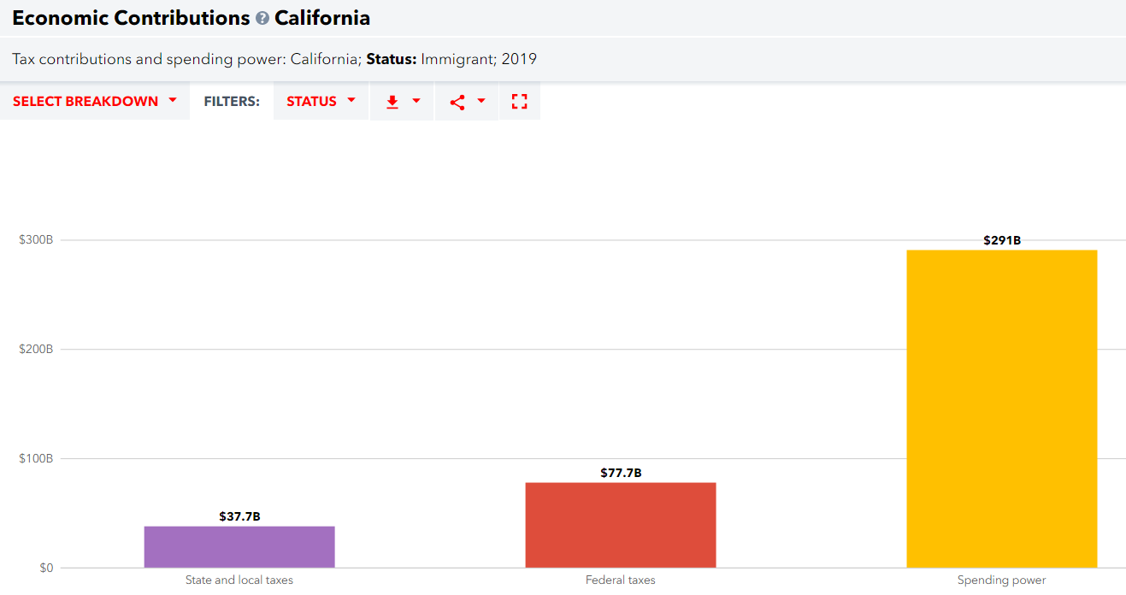
Figure 2: “Economic Contributions in California by Undocumented Status, 2019”, (California Immigrant Data Portal, 2020).

Arguments against Medi-Cal Expansion
One argument against the expansion of Medi-Cal includes the increased cost of providing care for the newly eligible residents. The estimated cost of the final expansion is $614 million general fund costs and an ongoing administrative cost of $2.2 billion general funds, starting in the fiscal year 2023-2024. While this is a considerable sum of money, the current budget for general fund Medi-Cal allocation is $36 billion. This new ongoing cost listed on the Governor’s budget makes up just 6% of the total Medi-Cal general fund allocation.
Another argument against the expansion of Medi-Cal was a belief in the stricter and now outdated public charge rule that was in effect. The public charge rule currently in effect states that the United States may block non-citizens from admission into the county, immigration status change, or a visa receipt if at any time during their stay they become a “public charge” via receiving public benefits, such as food benefits or disability benefits. A common misconception of the public charge rule is that it applies to all immigrants in the United States, this is not true. The public charge rule applies to immigrants applying for lawful permanent residency, a visa, or citizenship, not immigrants who do not plan to apply for an immigration status change. Related to the public charge rule is the belief that immigrants should not be eligible for public benefits at all. Prior to the Medi-Cal expansions, undocumented immigrants were only eligible for emergency medical services coverage on a case-by-case basis (Ibarra, 2022). Undocumented and even documented immigrants are still unable to use or access many programs in California due to program limitations. A few examples of this are Cal Fresh, Social Security, and even unemployment benefits (Montalvo, 2022).

Why did the pro-side prevail?
The approval for final expansion of Medi-Cal was due to a few different political streams coming together. One of the focus points for Governor Newsom’s office has been moving towards universal healthcare in the state. The previous expansions, with exception of the first, Governor Newsom has signed directly into law, rather than the state legislature. However, these policies have also shown up in the state legislature often, and with major support from non-profits and community-based organizations. Since the first expansion of Medi-Cal, non-profits and community groups have placed pressure on lawmakers to pass further expansions, this combined with the governor’s plans and support led to the eventual completion of expanding Medi-Cal to all eligible undocumented individuals.
Due to the level of impact this issue has had on undocumented immigrant populations in California, this problem warrants government intervention. If California is interested in protecting its economic health, it needs to protect its most vulnerable workers. If the state is interested in making a stand for human rights, such as access to healthcare, then it needs to provide affordable, comprehensive healthcare for its most vulnerable residents.

Literature Review
Studies, research, and data informs most sound policies. This literature review will provide background information on concepts, policies, and study results that will show the impact of immigration status on all aspects of life, but especially on health outcomes. I will be describing and analyzing some of the most relevant literature on immigrant acculturation, self-reported health, the immigrant health paradox, and the compounding nature of these topics. I will also use this section to outline some key areas for lawmakers to address with the options I plan to use in the policy alternatives sections of this essay.

Acculturation and Immigrant Communities
Acculturation is a process that immigrants go through as they spend more time in their new country. Acculturation is the process of adapting to the culture of their new environment, whether it be by learning the language, adapting to the different cultural activities, and changing their diet and lifestyle habits. Acculturation tends to be correlated with lower self-rated health (Lommel & Chen, 2016). One study reported that immigrants who had been in the United States more than 15 years were 6.61 times more likely to report a worse change in health than those who had been in the U.S. for less than a year, when controlling for other factors (Lee et al., 2013). The relationship between acculturation and specific minority immigrant groups in the United States is not something researchers have focused on extensively (Lommel & Chen, 2016).
It is important to consider acculturation as a factor when discussing the health outcomes of undocumented immigrants in California. The longer that these populations stay in the United States, the worse off their health is on average. Access to medical services in this context could be the difference between a long, healthy life and one spent sick or in pain.

Self-Reported/Self-Rated Health and the Immigrant Health Paradox
Self-reported or self-rated health is an indicator of health used in health studies and surveys. It is a measure used by many organizations in health studies to indicate individual health status (Gandhi et al., 2020). Researchers and policy analysts have used self-reported and self-rated health in public policy and public health research, and clinical practice. Studies have shown it to be a reliable predictor of future health status and health and social factors impact self-reported health as well (Gandhi et al., 2020).
Immigrant populations in the United States have been a group of interest when exploring self-reported health due to the pattern of lower rates of harmful health behaviors, like heavy drinking and cigarette smoking, and worse self-reported health, otherwise known as the “immigrant health paradox” (Lommel & Chen, 2016). Researchers have linked this paradox to many specific immigrant groups in the United States, but a lot of research links this paradox with Hispanic/Latino communities (Lommel & Chen, 2016). Studies have shown a link between lower-self-reported health and chronic conditions and multimorbidities (Gandhi et al., 2020). Lower self-reported health also impacts risk of depression and current depression diagnoses in individuals of diverse racial and ethnic backgrounds (Lommel & Chen, 2016). This paradox directly translates into more negative health outcomes for immigrants in the United States. While this population tends to live their lives with lower rates of harmful health behaviors, they still tend to have worse health outcomes over time than US-born individuals (Lommel et al., 2019). This leads to the next section of discussion, which is the intersection of these topics as compounding issues that immigrants face.
Acculturation, the Immigrant Health Paradox, and Healthcare Access
Healthcare access is one of the few associated characteristics that studies have shown to have a direct relationship to health status over-time. In one study, uninsured immigrants had a stronger association between their amount of time within the United States and worse change in health status compared to others in the study who had health insurance (Lee et al., 2013). With the recent expansions to Medi-Cal, the possibility of more eligible undocumented immigrants enrolling in and accessing healthcare services has increased substantially. The new access to services could help in the long-term to mitigate not only the habits that may stem from acculturation, such as worse eating habits, but could also mitigate more serious illnesses with access to preventative and specialty healthcare.
The immigrant health paradox is an issue that plagues immigrant communities in the United States as a whole. In California, with increasing availability and access to healthcare, our healthcare system is more capable than ever of mitigating this health paradox for undocumented immigrants. I will now use this literature to analyze the ongoing issue further. The overall purpose of this thesis not only to review the history of the issue and previous literature related to it, but to use all of this information to create and analyze policy options that may mitigate this issue in California.

A Consideration of Options Based Upon a Criteria-Alternative-Matrix Evaluative Method
In this section I will describe three separate alternatives which the Medi-Cal program could implement in order to better ensure that the program is mitigating the immigrant health paradox and other negative externalities that undocumented immigrants suffer from. As I stated in the previous section of this essay, access to health insurance and healthcare is one of the most crucial factors for mitigating the immigrant health paradox, therefore, two of the options I will outline in this section focus on the enrollment of newly eligible undocumented immigrants in the Medi-Cal program. The other alternative is of similar importance, as education regarding preventative health and maintaining healthy habits also impacts the immigrant health paradox and its’ continuance in California. The state can use this time while implementing the new expansion as an opportunity to ensure the livelihood of undocumented immigrants by providing them with support to mitigate the health paradox that faces them. The descriptions I provide of these policy options are preliminary outlines I will analyze these alternatives in the following section and discuss the best option moving forward in the recommendations section of this essay.

Cam Analysis
When analyzing an issue, you must follow a path of analysis to find which alternatives you will present. Once you have chosen alternatives to present, you must analyze those alternatives to find which is the most desirable for your client(s). One method of analysis is based on choosing criterion to compare the most important aspects of each alternative, otherwise known as Criteria Alternative Matrix (CAM) analysis (Meltzer & Schwartz, 2019, p. 134). To start a CAM analysis, you must first have a problem statement. The problem statement I will use is as follows: California’s undocumented immigrants need efficient and comprehensive healthcare to combat the immigrant health paradox. Once you have your problem statement, you must define the objective and the criteria which you will use to analyze of the policy alternatives you have created. The objective for my alternatives is the mitigation of the immigrant health paradox. My criteria are all similar to the suggested generic criteria of equity, feasibility, cost, and efficiency. Following the decision on criteria, you must create a matrix in which you can qualitatively describe and quantitatively weigh and score each criterion. Each criterion should be weighed according to which criterion is deemed by the analyst to be most to least important. The matrix is where you plug your policy alternatives into to begin the analysis, starting with a qualitative analysis of the options and their ability to meet each criterion. After the qualitative analysis, you can use the quantitative analysis weights you created before to score and then complete your analysis. In this section, I will describe the three criterion I have chosen to use for my CAM analysis, and what weight these criteria will have in the following analysis.
Medi-Cal Assessment
In order to ensure that California is mitigating the immigrant health paradox, an assessment of the expansion(s) of Medi-Cal thus far may be necessary. This alternative includes a program assessment one year after implementation of the final expansion and five years after the program implements the most recent expansion. The purpose of this assessment is to ensure that the program is meeting the goals of the expansion: to provide more coverage to undocumented immigrants and to increase the overall health outcomes of undocumented immigrants in California.

Incentives to Increase Enrollment
Another method of mitigating the immigrant health paradox could be to increase the enrollment numbers in the newly expanded Medi-Cal program. Similar to vaccine incentives during the Covid-19 pandemic, this alternative includes small monetary incentives given to new Medi-Cal enrollees. This alternative program should focus on getting many newly eligible person(s) to apply to Medi-Cal but the program can also be open to new Medi-Cal eligible applicants as well. During the Covid-19 vaccine incentive program, those who got their vaccine during certain time periods were eligible to receive $50.00 from the state for their participation (California for All, 2022). For this program, I suggest a $25.00 incentive for each new child, adult and senior enrollee. In order to use this program in the most effective way, would suggest offering this incentive for the first 25,000 enrollees, with the possibility of expanding the number of slots available if engagement is high. These values would give the program and estimated cost of $625,000.00

Preventative Health Education Program
The last method for mitigating the immigrant health paradox that I will offer is to create an education program that provides preventative health education. The curriculum of this education program includes discussion of healthy habits and preventative healthcare in order to reduce the likelihood of the immigrant health paradox affecting participants. This program would be open for all undocumented and documented immigrants to participate in. It should also include resources for connecting to healthcare insurance and healthcare providers. The main outcomes of this program would be mitigating the immigrant health paradox as well as lowering the costs of future healthcare use for immigrants. The estimated cost of this program is a starting cost of 1.5 million dollars and an ongoing administrative cost of $500,000.00 each year.

Methodology

Criterion & Weight Reasoning
The first criterion that I will be using is cost efficiency (Meltzer & Schwartz, 2019, p. 197). I am using this criterion with one major modification. I will not be focusing on the cost efficiency of the alternatives; I will be focusing on the cost effectiveness. I will be determining whether an alternative has enough positive output to justify the cost input. For each of these alternatives, I will be qualifying what the capital costs, or large, fixed expenses are. I will also be describing what the operating costs, or ongoing costs like labor and services are. For this criterion, I will describe who will incur the costs discussed, and how those costs might change over time. In addition to the above, I have the issue of cost effectiveness to cover. In the context of my issue topic, this means I will determine how cost effective the alternatives are at raising the quality of life for immigrant workers in California. To best understand the cost effectiveness, I will be looking at how much the above costs affect the quality-of-life outcomes.
For the second criterion, I will be measuring the equity of each of the alternatives presented. To do this, I will be determining whether each of the alternatives will affect gender equally. I will also be assessing whether the alternatives are going to serve immigrant populations with the same focus regardless of what race and/or ethnicity the person(s) belong to. I will use the outcomes of these alternatives to measure the equity of each of the alternatives. The purpose of having a criterion that focuses on equity is to examine whether proposed policies or programs will favor or harm certain populations to a greater extent than others (Meltzer & Schwartz, 2019, p. 198). This measure of equity is necessary as immigrant populations are not homogenous. There are different ethnicities, races, and gender identities within each of these populations. Previous research has shown that inequities in policies and programs disproportionately affect women of color (Thukral, 2010). I must consider participant gender and race/ethnicity as they create implications about individual’s life outcomes when analyzing alternatives for a policy or program issue. (Thukral, 2010).
The third and last criterion is that of the administrability, or ease of implementation of an alternative (Meltzer & Schwartz, 2019). With this criterion, I will be examining the feasibility of each alternative. I will measure the feasibility of each alternative as whether organizations and providers involved can implement each alternative. Secondly, I will be determining whether the providers and organizations have the capacities to overcome barriers which could stop them from achieving their policy or program goals. Ease of implementation is an important criterion as programs and policies are less likely to achieve their goals when there are many or daunting implementation challenges in the way (Meltzer & Schwartz, 2019). This measure of administrability is closely related to my measure of effectiveness. In this analysis I will also determine each alternatives implementation style, which includes who will be implementing the alternative and for how long. If an alternative relies too much on one individual or external partners, this may cause the administrability of the alternative to suffer (Meltzer & Schwartz, 2019).
For my analysis, I have chosen to weigh each of these criteria as a decimal so that they add up to one. Due to our country’s current economic state, I have chosen to weigh the cost effectiveness the highest, at 0.40. Secondly, I have weighted equity at 0.35 because the equity of these alternative outcomes is essential for their success within such a diverse population. Finally, I have weighted administrability at 0.25 as this measure is closely linked to my cost effectiveness measure.
In conclusion, I will use the criterion to analyze and compare each alternative. Once I complete this analysis, I will determine which of the alternatives I have provided is the most cost-effective, equitable, and implementable. In the analysis that will follow, I will confront each alternative’s inputs, projected outcomes, and trade-offs (Meltzer & Schwartz, 2019).

Alternative Analysis
Table 1 Policy Alternatives Offered as Possibilities to Raise California Immigrant Quality-of-Life
 | Alternative | Brief Description
I | Medi-Cal Program Assessment | Program assessment after the first year and 5 years after the year of implementation.
II | Incentives to Increase Enrollment | Program creation using incentives to increase Medi-Cal enrollment in undocumented populations.
III | Preventative Health Education Program | Program creation of preventative health education program for immigrants in California.

Table 2 Relative Weights Applied to Each Criterion Used to Evaluate Alternatives
Criterion | Weight
Cost effectiveness | 0.40
Equity | 0.35
Administrability | 0.25
Total | 1.00

Table 3 Key for Interpreting the Likert Scale Extremes (1–10) Rating Applied to Satisfaction of a Criterion by an Alternative
Criterion | Interpretation of Ratings
 | “10”– Very Strong | “1”– Very Weak
Cost effectiveness | Alternative is extremely cost-effective. Immigrant population’s positive quality of life changes equal or exceed alternative’s associated costs. | Alternative is not cost-effective. Immigrant population quality-of-life positive changes are not equal or above alternative’s associated costs.
Equity | Alternative is inclusive and equitable. Alternative does service gender, racial, and ethnic groups equally. Program does not harm or exclude one group from services. | Alternative is not equitable or inclusive. Alternative does not service gender, racial, and ethnic groups equally. Alternative excludes and/or harms one or more groups.
Administrability | Alternative has ease of implementation. Organizations and providers have sufficient ability to overcome barriers to program success. Alternative can continue with changing partners and leaders. | Alternative is not feasible; providers and organizations do not have capacity to overcome barriers to program success. Alternative may also extensively rely on one individual or external partners.

Table 4 Qualitative Criteria Alternative Matrix (CAM)
 | Criterion 1:  Cost Effectiveness | Criterion 2:  Equity | Criterion 3:  Administrability
Alternative I:  Medi-Cal Program Assessment | Alternative indirectly impacts quality-of-life for immigrant workers and their families. Alternative should have a relatively low administrative cost. Effectiveness is very high. Funding could be difficult to secure due to economic recession. Alternative may not effectively raise quality of life for immigrants. | Alternative is equitable. Program assessment will affect most of the immigrant population in California. Information asymmetry may continue due to the difficulty of assessing exact population size for undocumented persons(s). | This alternative is feasible for the organization. Previous expansions have been successful, and an assessment of these expansions is implementable. Alternative could be used on a short-term or long-term basis as needed.
Alternative II:  Incentives to Increase Enrollment | Alternative directly impacts quality-of-life for immigrant person(s). Alternative should have a relatively low per-person cost. Program could be partially subsidized if law permits. Effectiveness is very high. Funding could be difficult to secure due to economic recession. Alternative would very effectively raise quality of life for immigrants. | This alternative is equitable. Eligible persons(s) would receive payment or other incentive benefits for applying for Medi-Cal. Health insurance may still exclude certain gender(s) and population groups. | Alternative is fairly administrable. This initiative’s success will depend on whether federal immigration policy would deter immigrants from enrolling in healthcare programs like Medi-Cal due to fear of consequences. Organizations involved can overcome barriers. Does not seem to rely on any specific person/group.
Alternative III:  Preventative Health Education Program | Alternative directly impacts quality-of-life for immigrant person(s). Alternative should have a relatively low per-person cost. Program could be partially subsidized by federal funding. Effectiveness is very high. Funding could be difficult to secure due to economic recession. Alternative would very effectively raise quality of life for immigrants. | Alternative is equitable. Effects of the program depend on the number of undocumented immigrant participants. Education program could be offered to all immigrant populations to promote equity of education. | Alternative is administrable. This program’s success will depend on whether immigrants feel safe participating in the program. Organizations involved can overcome barriers. Does not seem to rely on any specific person/group.

Table 5 Quantitative Criteria Alternative Matrix
 | Criterion 1: | Criterion 2: | Criterion 3: | Total Score
Alternative I: | Rating: 0.40  Weight: 9  Total: 3.6 | Rating: 0.35  Weight: 9  Total: 3.15 | Rating: 0.25  Weight: 8  Total: 2 | 8.75
Alternative II: | Rating: 0.40  Weight: 8  Total: 3.2 | Rating: 0.35  Weight: 9  Total: 3.15 | Rating: 0.25  Weight: 7  Total: 1.75 | 8.10
Alternative II: | Rating: 0.40  Weight: 9  Total: 3.6 | Rating: 0.35  Weight: 9  Total: 3.15 | Rating: 0.25  Weight: 8  Total: 2 | 8.75

The first alternative presented is a more indirect approach to ensuring that undocumented immigrants are enrolling in Medi-Cal if they are now eligible. The cost effectiveness of this alternative is high, as there is very likely a program assessment within Medi-Cal that takes place on a regular basis. This alternative could be as simple as a new area of focus within the usual program assessment that Medi-Cal already completes. The inputs of this alternative include time, administration costs for the program assessment, and personnel costs. The projected outcome of this alternative includes further information about enrollment patterns for undocumented immigrants, which Medi-Cal can then use to increase their outreach efforts if needed. One trade-off of this alternative is the fact that it does not directly mitigate the health paradox that undocumented immigrants face. However, this trade-off may not be an issue if the assessment gives the program new information that they can use to increase enrollment or healthcare outcomes for undocumented immigrants.
The second alternative is an incentive program, so cost effectiveness is slightly lower. The inputs of this program include administration costs, personnel costs, time, and special funding. This alternative would directly impact enrollment numbers for undocumented immigrants, which helps mitigate the health paradox as outlined previously. One trade-off for this alternative is that it may be difficult to find funding for incentives, even with the projected outcomes in mind. Incentives for the Covid-19 vaccine might have been an example of something usually very difficult to do pushed ahead due to necessity. It is unclear to me who exactly would fund this program besides Medi-Cal and given these new expansions and an upcoming state deficit, funding for an incentive program may be difficult to come by.
The third alternative is an education program that directly impacts the immigrant population, so it is very cost-effective when considering long-term costs. The inputs of this program include administration costs, personnel costs, time, and special funding. This alternative would not directly impact the number of enrollees in Medi-Cal but would still mitigate the immigrant health paradox through education. One trade-off for this alternative would be the difficulty in securing long-term funding. Medi-Cal may again be the program that would ultimately provide most of the funding for this alternative program.

Recommendations
In this section I will provide recommendations regarding the alternatives I previously outlined. My recommendation of an alternative is based on the scoring of each alternative within the CAM analysis I conducted. Part of this section will include a discussion of a possible course of action which could implement all three alternatives instead of just one.

Recommended Alternative
The alternative I recommend, due to the results of my CAM analysis, is the Medi-Cal Program Assessment. The program analysis alternative did better overall in the CAM analysis but is also a much easier alternative to implement. It is also very cost-effective and may provide unexpected benefits to the Medi-Cal program based on the data it can gather from participants, which could further shed a light on the inequities undocumented immigrants face within the Medi-Cal program as well.

Optional Alternative Implementation
The biggest issue with the other alternative is the difficulty related to finding program funding. However, as stated in the analysis, this alternative would be relatively cost effective, equitable, and administrable. The main argument for this alternative is that is directly impacts the population of interest, in a way that ensures access to comprehensive healthcare. My optional plan for alternative implementation includes implementing all the given alternatives. If the Medi-Cal one-year assessment shows that enrollment for undocumented immigrants is not at the expected levels, then the program can implement the second alternative to ensure better enrollment numbers. The third and final alternative can be implemented at any time after the assessment if it shows enrollment below expected levels or can be implemented before the assessment as well as it can operate as a standalone program as well.

Conclusion
This final Medi-Cal expansion should have an overwhelmingly positive impact on undocumented immigrants in California. With the alternatives and background information I have provided in this essay, I have analyzed how to increase the effectiveness of this new Medi-Cal expansion and what further steps the program can take to ensure it meets the goals I outlined.
I have provided a more in-depth discussion of what policies have led to the current state of Medi-Cal, as well as the history of healthcare use by undocumented immigrants in California. I also discussed the issues that the previous expansions of Medi-Cal faced regarding implementation. In this paper I also included a discussion of the process of policy adoption that the Medi-Cal program expansion was a part of, including the arguments for and against the expansion. Along with the discussion of why Governor Newsom adopted the expansion policy, I have provided a discussion of why government intervention was necessary for the mitigation of the immigrant health paradox.
In this paper, I have included a discussion of literature relevant to the issue of the immigrant health paradox. I have also described the concepts closely related to immigrant health paradox and aspects that are commonly attributed to this concept as possible causes of the paradox. I used a Criteria-Alternative Matrix (CAM) analysis to describe and score the policy alternatives I provided. This analysis was useful for my recommendation section in which I used the results of my analysis to recommend two separate courses of action that include implementing one or more of the options I presented in this essay.
Future research on this topic could focus on the relationships between various parties involved in the administration of these expansions as they are implemented. State and county implementation could be another aspect to analyze the effectiveness of. One area of my research that was lacking was information on the effectiveness of Medi-Cal as a program. Data on Medi-Cal was difficult to find, and I was unable to pinpoint any specific numbers on the cost of these expansions per plan recipient.

References
Artiga, S., & Diaz, M. (2019, July). Health Coverage and Care of Undocumented Immigrants. Retrieved from Kaiser Family Foundation: https://www.kff.org/racial-equity-and-health-policy/issue-brief/health-coverage-and-care-of-undocumented-immigrants/
Bustamante et al., A. (2021, July). Health Policy Challenges Posed by Shifting Demographics and Health Trends Among Immigrants to the United States. Health Affairs, 1028-1037. doi:https://doi.org/10.1377/hlthaff.2021.00037
California Department of Pesticide Regulation. (2020, April). Survey Results form the California Pesticide Illness Surveillance Program 2017. Retrieved from California Department of Pesticide Regulation: https://www.cdpr.ca.gov/docs/whs/pisp/2017/2017summary.pdf
California for All. (2022, January). Vax for the Win. Retrieved from COVID19.CA.GOV: https://covid19.ca.gov/vax-for-the-win/
California Immigrant Data Portal. (2020). Economic Contributions: Immigrant Californians ar building up the fifth largest eocnomy in the world. Retrieved from California Immigrant Date Portal: https://immigrantdataca.org/indicators/economic-contributions#/?breakdown=tax-contributions-and-spending-power
Cha, P., & Collins, J. (2022, April). Health Care Access among California's Farmworkers. Retrieved from Public Policy Institute of California: https://www.ppic.org/publication/health-care-access-among-californias-farmworkers/
Dietz et al., M. (2021, April). Undoucmented Californians Projected to Remain the Largest Group of Uninsured in the State in 2022. Retrieved from UC Berkeley Labor Center: https://laborcenter.berkeley.edu/undocumented-californians-projected-to-remain-the-largest-group-of-uninsured-in-the-state-in-2022/
Gandhi et al., K. (2020). Racial-ethnic disparities in self-reported health status among US adults adjusted for sociodemographics and multimorbidities. Ethnicity & Health. doi:10.1080/13557858.2017.1395812
Health4AllKids. (2017, April). Health4AllKids Progress Update: New Community Survey Results. Retrieved from Health4AllKids: https://www.health4allkids.org/wp-content/uploads/2018/01/H4AK-SurveyUPDATE_4_25_17FINAL.pdf
Ibarra, A. (2022, February). California is expanding Medi-Cal - but hundreds of thousands of immigrants will still be left behind. Retrieved from CalMatters: https://calmatters.org/health/2022/02/medi-cal-expansion-immigrants/
Johnson et al., H. (2021, March). Immigrants in California. Retrieved from Public Policy Institute of California: https://www.ppic.org/wp-content/uploads/jtf-immigrants-in-california.pdf
Johnson et al., H. (2022, January). California’s Population. Retrieved from Public Policy Institute of California: https://www.ppic.org/wp-content/uploads/JTF_PopulationJTF.pdf
Kalish, L. (2022, July). Study says California employers fail to keep food, farm workers safe from COVID. Retrieved from CalMatters: https://calmatters.org/california-divide/ca-divide-workplace/2022/07/food-farm-workers-covid/
Lee et al., S. (2013, October). Change in Self-Reported Health Status among Immigrants in the United States: Associations with Measures of Acculturation. PLoS ONE. doi:http://dx.doi.org.proxy.lib.csus.edu/10.1371/journal.pone.0076494
Lommel, L., & Chen, J.-l. (2016, April). The Relationship Between Self-Rated Health and Acculturation in Hispanic and Asian Adult Immigrants: A Systematic Review. Journal of Immigrant and Minority Health. doi:10.1007/s10903-015-0208-y
Lucia, L. (2019, February). Towards Universal Health Coverage: Expanding Medi-Cal to Low-Income Undocumented Adults. Retrieved from Center for Labor Research and Education: http://laborcenter.berkeley.edu/medi-cal-undocumented-adults
Lweit, E. (2015). Major Transition with Minor Transition: Moving Undocumented Children from Healthy Kids to Full-Scope Medi-Cal. Retrieved from The California Health Care Foundation: https://www.chcf.org/wp-content/uploads/2017/12/PDF-MajorTransitionUndocumentedChildren.pdf
Meltzer, R., & Schwartz, A. (2019). Policy Analysis as Problem Solving: A Flexible and Evidence-Based Framework. New York: Routledge.
Montalvo, M. (2022, April). California's new benefits for undocumented immigrants are not enough, workers say. Retrieved from CalMatters: https://calmatters.org/california-divide/2022/04/california-undocumented-immigrants/
NBC (Director). (2020). On the Border of Death: Temporary Farmworkers Exploited Under H-2A Visa Program [Motion Picture].
Odeh, M. (2017, April). Progress on Health4AllKids. Retrieved from Health4AllKids: https://www.health4allkids.org/wp-content/uploads/2018/01/H4AK-SurveyUPDATE_4_25_17FINAL.pdf
Petek, G. (2022, February). The 2022-23 Budget: Analysis of the Medi-Cal Budget. Retrieved from Legilative Analyst's Office: https://lao.ca.gov/reports/2022/4522/medi-cal-budget-020922.pdf
Ponce et al., N. (2021, August). Measuring Up? Access to Care in Medi-Cal Compared to Other Types of Health Insurance. Retrieved from California Health Care Foundation: https://www.chcf.org/wp-content/uploads/2021/08/MeasuringUpAccessMediCalComparedOtherInsurance2018.pdf
Thomas, O., & Coleman, R. (2020, March 31). RE: Health4All Elders: Full-Scope Medi-Cal for Low-Income Undoucmented Elders (Ages 65+). Retrieved from https://health-access.org/wp-content/uploads/2020/04/Expedited-Health4All-Elders-Letter-4-8-20.pdf
Thukral, J. (2010). Race, Gender and Immigration in the Informal Economy. Race/Ethnicity: Multidisciplinary Global Contexts. Retrieved from https://www.jstor.org/stable/10.2979/racethmulglocon.2010.4.1.65
Tilley, L., Yarger, J., & Brindis, C. (2018, August). Young Adults Changing Insurance Status: Gaps in Health Insurance Literacy. Journal of Community Health. doi:10.1007/s10900-018-0469-1
Ybarra, M., Ha, Y., & Chang, J. (2017). Health insruance coverage and routine health care use among children by family immigration status. Child and Youth Services Review. doi:https://doi-org.proxy.lib.csus.edu/10.1016/j.childyouth.2017.05.027

