Abstract

of

**Equity and Walkability in the Sacramento Region**

by

**To Lan Mong Phin**

***Introduction***

Pedestrian walkability provides health and environmental benefits by encouraging individuals to exercise and rely less on automobiles for local mobility. Yet the City of Sacramento ranked 19th among the 30 largest metropolitan areas in the United States for pedestrian friendliness (Loh, Leinberger, & Chafetz, 2019). As a case study, this report focuses on the Franklin Boulevard Neighborhood in Sacramento to evaluate policy alternatives to increase walkability.

***Method***

The structure of this report follows the form of a five-step rational policy analysis to recommend a policy alternative to increase walkability in disadvantaged neighborhoods and suggest actions for the Sacramento Area Council of Governments (SACOG) to promote initiatives that increase pedestrian-friendly streets in such neighborhoods. The lack of walkability should be a concern for SACOG as strategies for regional planning contain goals relating to equity, climate friendliness, and encouraging a healthier lifestyle.

***Literature Review***

The literature review highlights the finding of previous quantitative research that higher property values are associated with higher neighborhood walkability as measured by a higher Walk Score. My own regression-based research on this topic showed that for every one-unit Walk Score increase, the selling price of a Sacramento Area home increased by about $500. A review of the previous qualitative literature found that individuals consistently express interest in walkable neighborhoods, but higher income households are far more likely to live in them.

***Promising Practices***

I pay particular attention to the City of Seattle’s initiatives to increase walkability, which encompasses successful strategies employed in other large U.S. cities. A summary of these practices is included along with the City of Seattle’s development of a strategic blueprint along with performance measures called the Pedestrian Master Plan (PMP). Of note, and summarized, is Seattle’s use of a data-driven approach to leverage existing resources and funding.

***Criteria and Alternatives***

The two alternatives considered to improve the walkability of existing neighborhoods, include the development of pedestrian refuge islands and a strategy to nudge individuals to walk such as establishing partnerships with Safe Routes to School (SRTS) to teach children about the benefits of walking or sharing accurate information through a pedestrian wayfinding system.  The criteria used to evaluate and decide the final recommendations to SACOG for the Franklin Boulevard Neighborhood included an account of the equity, political acceptability, administrative acceptability, and cost-efficiency of the alternatives.

***Recommendations***

Based on my analysis, I conclude that ensuring the safety of pedestrians is the most desired policy intervention to generate greater walkability and recommend the implementation of a pedestrian refuge island for a crosswalk along Franklin Boulevard. In addition, I conclude that SACOG could better support city and county pedestrian-friendly initiatives in existing neighborhoods through a refinement of their funding application category where selection is not entirely based on a Benefit/Cost Ratio, but instead points given for increasing walkability due to the project.

_______________________, Committee Chair

Robert W. Wassmer

__May 3, 2021_____________________

Date

This report addressed ways in which the Sacramento region could be more pedestrian friendly through a case study of a Sacramento neighborhood along Franklin Blvd. that could benefit from increased walkability. In addition, this report gives recommendations for the Sacramento Area Council of Governments (SACOG). Neighborhood walkability is a highly desirable trait that offers benefits to the individuals living in such an area. These benefits include the opportunity for individuals to have social interactions and maintain a healthy life, which are components for thriving and sustainable cities. The society, environment, and the state of California also benefit from neighborhoods where individuals can rely less on vehicles to get to work or access amenities, like groceries and entertainment. Much of Sacramento does not qualify as truly walkable as the city scores near the bottom one-third of 30 major metro areas in the U.S. (Loh, Leinberger , & Chafetz, 2019). Disadvantaged neighborhoods and Black Indigenous and People of Color (BIPOC) communities are often located in areas where city planning is not prioritized. This report provides an equitable solution to increase walkability as SACOG and the state of California address the demands for more housing, tackle chronic diseases, and reduce Greenhouse Gas Emissions (GHG).

The primary focus of this report is the evaluation of separate and specific policy alternatives to increase walkability on Franklin Blvd, the least walkable neighborhood in the City of Sacramento. Recognizing this, the City has obtained funding for the development of a Complete Street Project on Franklin Blvd, which could incorporate methods to make the area walk-friendly. The case study will serve as an example for other areas in the region that seek to improve walkability for the people and businesses located in the neighborhood. Thus, it can serve as important background material for SACOG when considering approaches to address inequities. SACOG is responsible for transportation planning and funding for the region. As such, SACOG would be interested in increasing pedestrian-friendly streets as less reliance on vehicles would reduce GHG emissions.

The structure of this report roughly followed a five-step rational policy analysis framework as described by Meltzer and Schwartz (2019, pp. 20-23). This report begins with Step One, describing why increasing walkable neighborhoods is a relevant topic for SACOG that deserves government intervention to maintain walkability as a public good. For Step Two, I included a literature review on property values and walkability and information on promising practices from the City of Seattle. These are used to offer potential policy options to improve walkability. In Step Three, I decided upon the criteria to evaluate the policy alternatives. In the analysis portion of this report, Step Four, I assessed the outcomes of those policy alternatives in consideration of the criteria. Finally, in Step Five, I concluded with the recommended alternative for the case study, Franklin Blvd. along with actions that SACOG could consider doing differently to encourage cities and counties to pursue projects that would increase walkability.

**Step One: Defining the Problem**

In a 2019 report on the United States top 30 largest metropolitan regions called *Foot Traffic Ahead*, Sacramento was ranked in the lower-middle third tier for walkable urbanism (Loh, Leinberger, & Chafetz, 2019). Out of 30 cities, Sacramento ranked number 19. According to the report, for a city population of 2.26 million individuals, Sacramento has 6 walkups, which means there is 1 walkup for every 378,001 people. Walkups consist of locations with offices and retail stores, a walk score value of 70 or greater, and visual screening for removal of auto dependent land use locations. In total, only 12 percent of Sacramento’s offices and retail stores are located in walkups. If walkability is limited to specific locations in the Sacramento region, then it is concerning that the majority of the population would not have access to the benefits. Yet, increasing walkability in streets located in disadvantaged neighborhoods, should also not displace residents. As has been shown in other neighborhoods such as Oak Park, gentrification of areas can increase the cost of living to make homes unaffordable to low-income individuals and limit affordability for local businesses. Oak Park, a neighborhood rich in African American history, has seen housing values triple (Egel, 2020). Though this neighborhood was once considered a food desert, the development of new restaurants has encouraged individuals with a higher income to live in Oak Park (Egel, 2020). In a report by the City of Sacramento, the average apartment rental rate in the Central City Specific Plan (CCSP) area has increased by 32 percent since 2008 (Anti-Displacement/Gentrification Study, 2018). In addition, 53 percent of the CCSP households were low-income. The study recognized that in order to combat gentrification and displacement, the city of Sacramento will need to continue seeking workforce development, anti-displacement policies and programs (Anti-Displacement/Gentrification Study, 2018). Although the report focused on residents living in the central city, the Sacramento region as a whole would benefit from similar ideas and policies when increasing walkability projects for Black Indigenous and People of Color (BIPOC) communities. Walkable streets will be defined in this paper using Walk Score, an app that measures an address’ distance to nearby amenities by providing a numerical value between 0 to 100. The higher the walk score value is to 100 denotes the address as less car reliant and more accessible to amenities. To measure pedestrian-friendliness, Walk Score evaluates population density and road metrics using data sources from Google, Factual, Great Schools, Open Street Map, the U.S. Census, Localeze and entries by walk score users.

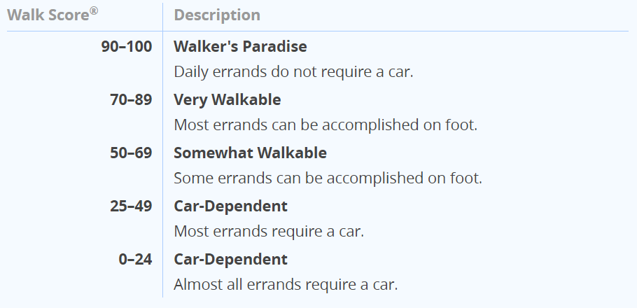**Table 1: How Walk Score is Measured**

Source: (Walk Score, 2021)

**Table 2: Walk Score for Each City in Sacramento County**

|  |  |
| --- | --- |
| City | Walk Score |
| Sacramento | 45 |
| Rancho Cordova | 41 |
| Elk Grove | 32 |
| Citrus Heights | 43 |
| Folsom | 30 |
| Galt | 31 |
| Isleton | 37 |

Source: (Walk Score, 2021)

**Table 3: Map of the Sacramento Region with Walk Score Ranges**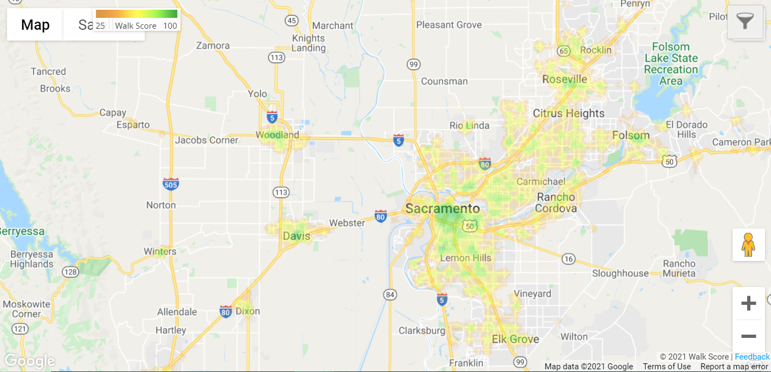

Source: (Walk Score, 2021)

***About SACOG and its Interest in Walkability***

SACOG is an association of local governments in the six-county Sacramento region. Members of SACOG include the counties of El Dorado, Placer, Sacramento, Sutter, Yolo, Yuba, and the 22 cities within. SACOG provides transportation planning for the region by preparing the region’s long-range transportation plan, approving affordable housing, assisting in transit planning, creating bicycle networks, clean air, and airport land use (SACOG, 2021).

**Table 4: Map of SACOG’s Planning Area**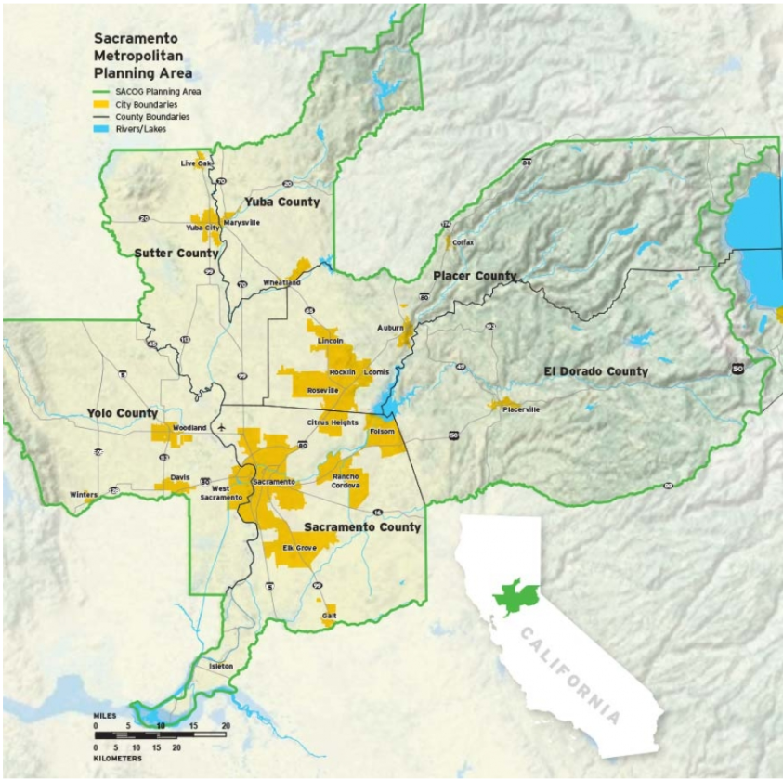

Source: (SACOG, 2021)

SACOG has initiatives that promote walkable neighborhoods as strategies developed in regional plans. Several regional plans including the Sacramento Region Blueprint and 2020 Metropolitan Transportation/Sustainable Communities Strategies Plan (MTP/SCS) have initiatives that support walkability goals. For example, Green Means Go Green Zones aims to lower green GHG emissions by reducing and electrifying vehicle trips and accelerating infill development (SACOG, 2021).

SACOG’s regional goals addresses the region’s land use, air quality, and transportation needs. In 2002, the SACOG Board of Directors created the Sacramento Region Blueprint Project to tackle congestion in the Sacramento region. The organization anticipated that without further action, congestion could increase to over 50 percent by 2025 (SACOG 2021). The Sacramento Region Blueprint is a smart growth vision with a list of principles that encourages better use of land and transportation planning to promote housing options closer to employment, social activities, and alternatives for people to walk, bike and take public transportation. In the 2020 MTP/SCS report, SACOG also included the Regional Bicycle, Pedestrian, and Trails Master Plan, which strategizes how to promote healthy living and active communities.

Increasing pedestrian-friendly neighborhoods is a policy concern for SACOG because the organization is responsible for maintaining the vitality of cities and the sustainability of all communities. Since the state of California passed the Sustainable Communities and Climate Protection Act of 2008 (also known as SB 375) the California Department of Air Resources Board (CARB) is required to set the regional targets for GHG emission reduction from vehicles. SACOG and other regional Metropolitan Planning Organizations (MPO) are required to develop a Sustainable Communities Strategy (SCS) every four to five years to describe how emission targets will be achieved. As directed by CARB, SACOG needs to ensure that transportation and land use patterns can reduce GHG emissions by 19 percent. SACOG recognizes the importance of anticipating regional changes in its planning and has described in the Sacramento Region Blueprint as well as in similar plans that the development and design decisions made by a community do have strong implications, whether positive or negative, on regional development patterns (SACOG, History Blueprint). SACOG has projected that the region will expect to see an increase in congestion if current land, housing, and transportation practices remain the same. The region expects to see a population increase by 620,000 people by 2040, which means over 2.9 million individuals. The association will need to encourage the development of enough homes, expand job opportunities, and continue to attract innovative individuals.

Changing existing streets to become more pedestrian-friendly could mean changing the built environment if individuals can access parks, groceries, amenities, and nearby transit systems. With the shortage of affordable homes, individuals unable to pay the hiked price may have to choose to live further away from work and will continue to rely on vehicles as their primary mode of transportation. Vehicles have been shown to increase the output of GHG emissions in California by 30 percent (SACOG 2020 MTP/SCS Report, 2020). It also means lost time for individuals to pursue other activities.

What makes the lack of available walkable neighborhoods even more concerning for SACOG is how the issue has become a public health equity concern. In a report by the UCLA Center for Health Policy Research that obtained data from the National Health and Nutrition Examination Survey and the California Health Information Survey, 46 percent of California adults are prediabetic or have undiagnosed diabetes and 9 percent of individuals already have diabetes. This means that there are currently 13 million individuals who are in the stage directly before a full-blown diabetes diagnosis and do not yet know and 2.5 million who already have the chronic condition. In Sacramento County for example, there are 55 percent of individuals who either already have diabetes, or are prediabetic. The California Department of Public Health (CDPH) reports that lifestyle changes that can encourage physical activity can reduce the risks of getting diagnosed with type 2 diabetes (Babey et. al, 2016). Maintaining and increasing walkable neighborhoods are strategies that can eliminate barriers for healthy communities in the Sacramento region.

***Why Does the Issue Need Government Intervention?***

Too few walkable neighborhoods in the Sacramento region are an equity and public good issue that deserve attention from SACOG, because the challenge requires long-term planning and guidance from a collaboration of local governments. Now that local city government officials anticipate an epidemic of chronic illnesses, the region is at risk of more individuals unable to pay for medical health insurance bills. Along with that comes work absences that impacts the region’s level of productivity. For this reason, when individuals are unable to afford living in a neighborhood that is accessible to groceries, recreational parks, and sidewalks, their health is at risk and this becomes an equity concern for the state of California. Diabetes is an expensive cost not only for the individuals but for the state government of California. The government, however, could help metropolitan planning organizations such as SACOG by increasing the county focus on pedestrian walkability.

Too few walkable neighborhoods mean individuals will continue to rely on their vehicles, which would hinder the government’s functioning role at providing quality public service goods such as access to clean air. As individuals have to choose driving as a primary mode of transportation for errands over walking, there will be additional costs not factored into driving such as the price society has to pay for air pollution emitted from vehicles, the time lost due to congestion, and noise levels. There is a price to pay for individuals who can choose to live in walkable neighborhoods. Based on my preliminary research, home values increase when homes are identified as walkable. Essentially, individuals who are unable to afford walkable homes will have to move further away from central locations where homes have lower value and individuals rely on vehicles.

SACOG’s regional plans show how the association is pursuing initiatives that promote walkability, however the limitation for SACOG is the inability to sponsor specific projects. The association can provide funding to local cities or counties to implement projects that could increase walkability. SACOG has the ability to influence local city land use and transportation planning through a funding application process. The process allows the local city governments to submit a project proposal, SACOG board members review and select the proposals, and the local city governments to receive funding from SACOG. The association has established that maintaining healthy and sustainable communities is a value for the region, however, while SACOG has the ability to influence local city land use, it does not have the authority over local land use and whether cities are truly achieving regional goals established in the MTP/SCS plan. SACOG’s funding limitations means the board members have to decide which cities to fund. This report offers value by informing SACOG of the best alternative to increasing walkable neighborhoods and other funding approaches to award recipients. In the next section, I discuss the literature review and preliminary research and analysis.

**Step Two: What the Research Has Shown and the Viable Alternatives**

***Previous Research***

Studies have shown that having walk-friendly streets can increase home values. One report explained that home values in the United States increased by 23.5 percent in walkable neighborhoods compared to homes in car-dependent locations, which suggests homes accessible to amenities are attractive to individuals (Katz, 2020). According to Rauterkus & Miller (2011), population growth has been shown to drive up demand and developers have increased profit from land value by making smaller lot sizes. Homebuyers then move away from amenities for larger lots, where the price of property is lower. As a result, walkability is said to also have an impact on land value, especially for properties closer to central business districts, established communities, and universities.

My preliminary research aimed to understand if the findings would be consistent to the research that home values are higher in walkable neighborhoods. In the analysis, I obtained the walk score value of homes using a walk score indicator from four out of the seven cities in Sacramento County, which totaled to 2,807 residential properties. I used Sacramento County’s Multiple Listing Survey data from 2013 as housing data to look at factors that would impact selling price such as property characteristics, selling characteristics, and neighborhood characteristics. The walk score value was included as part of neighborhood characteristics where I controlled for differences between the characteristics.

Based on the preliminary ordinary least square regression analysis, the log-linear functional form and linear-quadratic functional form models showed two interesting relationships between walk scores and selling values. The log-linear functional form model showed that for every one-unit increase in walk score value, the value of the selling home decreased -$0.00077 at a 99 percent confidence level. Instead of observing a positive relationship which would show an increase in home values as the walk score value increases by one-unit, the log-linear functional form showed a higher walk score correlated with a lowered selling value. On the other hand, the linear-quadratic functional form model showed that for every one-unit increase for walk score, the selling price increased by $501.09. This happened until the walk score reached a numerical value of 32 at a 99 percent confidence interval. I also conducted a preliminary survey and interview protocol and found that although individuals perceived the benefits of homes with access to places to walk, choosing a home that was affordable was the deciding factor.

Although my analysis on the relationship between home values and walk scores are not representative of the entire SACOG region, the possible implications based on the findings are that walkability as a public good may not be as accessible to all income brackets. The preliminary research showed that the Sacramento region should continue to improve streets that lack walkability.

As there continues to be ongoing challenges to ensure everyone has access to clean air, places to socialize, and walk, other researchers have raised the question on whether walkability is inclusive. Riggs (2014) agreed with Gilderbloom et. al (2014), Rauterkus & Miller (2011) and Pivo & Fisher (2011) that walkability provides important social and economic resources to a neighborhood. Riggs (2014) conducted a study to evaluate the attributes of walkable neighborhoods in San Francisco. The study aimed to understand if low-income individuals and minority individuals face pressures to move to less walkable neighborhoods. The quantitative results showed that in neighborhoods with a higher Black population, house ownership was confined to mainly the suburbs, where there is less walkability. Based on the qualitative study, Riggs found that minority populations mainly moved to less walkable areas because of income, and social factors such as preference to live near friends and family, and housing characteristics influence their decisions. In the next section, I will discuss notable lessons and practices, which aimed to increase walkability and accessibility in the city of Seattle.***Viable Alternatives to Increase Walkability***

This section explored notable practices used to increase walkability in the City of Seattle such as the creation of a pedestrian blueprint plan with performance measures and the leverage of resources using a data-driven approach. The Seattle Department of Transportation (SDOT) created the Seattle Pedestrian Master Plan (PMP), a 20-year blueprint to make Seattle the most accessible and walkable city in the United States. Seattle’s PMP goals are relevant because the plan encompassed walkability strategies from cities such as New York, San Francisco, Boston, Philadelphia, Chicago, Sydney, and Vancouver (PMP Update July 2015). PMP was built on SDOT’s vision to increase walkability by incorporating existing city goals and resources for a strategic and comprehensive plan. SDOT’s goals focus on safety, equity, vibrancy and health. Safety means the reduction in number and severity of crashes involving pedestrians. Equity is viewed as the approach to create a walkable city through public engagement, service delivery, capital investments, and accessibility. The goal to make Seattle vibrant means a connected pedestrian environment that sustains healthy communities and supports a vibrant community. The last goal focuses on health, which aims to improve health and increase mobility. The city of Seattle has identified natural and artificially built environment barriers that need improvement for people with disabilities, older residents, and children. Along with the goals, the PMP used a data driven approach to identify places where people walk, locations that served the most people in need, and streets with high pedestrian and motor vehicle traffic. To prioritize pedestrian-friendly projects and make it a sustainable practice for SACOG, the organization could consider a strategic plan that works as a PMP to identify and leverage existing planning efforts and funding to help streamline local city coordination efforts.

The city of Seattle found that the strategies to fund and meet the PMP’s goals included leveraging existing city resources and expertise. One of the important strategies to increasing walkability in Seattle was by developing performance measures that built on existing and new plans. The PMP consisted of Seattle’s Comprehensive 2035 plan, which included Seattle’s broad goals and location of job growth. Other regional plans include Move Seattle, Modal Master Plan which includes a transit master plan, Vision Zero, and the Climate Action Plan. The Complete Streets Policy is implemented into PMP through a form of a checklist. The Right of Way Improvement manual was included in PMP to provide design guidance to property owners, developers and architects to address access and mobility needs of everyone who uses the right of way. Currently, SACOG has regional plans that incorporate strategies to increase neighborhood walkability. However, developing a pedestrian blueprint with a framework would help inform local cities and partners.

A strategic PMP could serve to evaluate available funding resources from all entities, which would streamline and maximize the benefit of projects. The city of Seattle created an asset and management database, which identified organizations that followed the PMP’s prioritization framework, or worked independently to increase walkability. Programs in Seattle that are funded independently, but rely on PMP to increase walkability through pedestrian safety and infrastructure include Safe Routes to School (SRTS), Vision Zero, and the Neighborhood Greenways Program. The City of Seattle evaluated projects against PMP and all public and private efforts for pedestrian projects. As identified in the image below, projects guided by PMP are marked solid and projects independent of PMP are indicated with a dash.

**Table 5: How the City of Seattle Has Identified Projects** 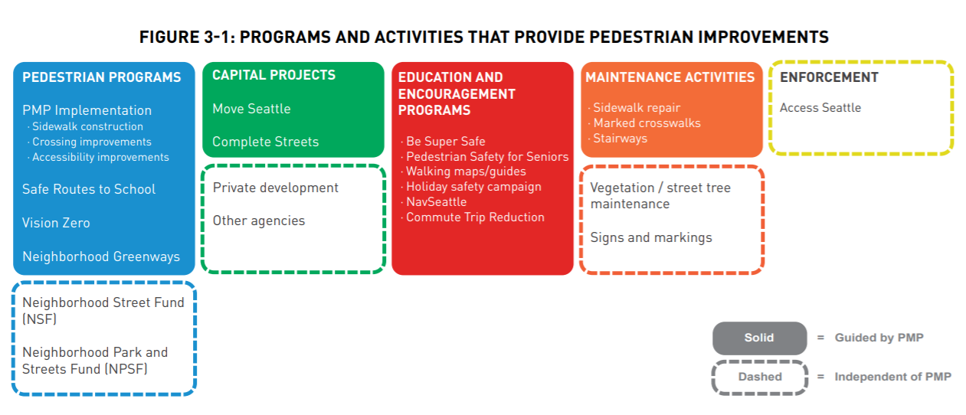

Source: (Seattle Department of Transportation City of Seattle Pedestrian Master Plan, 2017)

SACOG could create a PMP with performance measures that are similar to the one implemented by the city of Seattle.

**Step Three: Criteria to Evaluate the Alternatives**

Before I discuss each of the recommended alternatives, this section defined each of the criteria used to explain my final recommendation, which includes equity, political acceptability, administrative acceptability, and cost-efficiency. As discussed earlier, when it comes to the lack of walkability in the Sacramento region and the individuals who are unable to access pedestrian-friendly streets, the final recommendation will be based on the alternative that is equitable for our case study example, Franklin Blvd.

***Equity***

To ensure that projects will benefit low-income and people of color is currently a concern and an ongoing challenge for the region when considering the impact of projects on communities of color. Understanding whether the alternative is equitable is important because projects that aim to increase walkability should increase access to cleaner air, a healthier lifestyle and promote safe and thriving cities in the long term. Neighborhoods in the Sacramento region that are car-dependent and less walkable overlap with areas where lower income individuals live. Increasing walkability in the Sacramento region will have to be inclusive to communities of color, disadvantaged communities as well as people’s abilities.

***Political Acceptability***

Eugene Bardach explained that political acceptability is an alternative that is not unacceptable (Bardach, 2012). As described by Bardach, political unacceptability could either mean there is too much opposition, or too little support. As described in this report, increasing walkability is a part of SACOG’s strategy to reduce GHG emissions and the state of California’s goal to address the growing health disparities. Thus, the alternatives should be politically acceptable to SACOG.

***Administrative Acceptability***

Similar to the criteria discussed above, administrative acceptability means the alternative would need to be feasible for SACOG. SACOG’s Board of Directors has the ability to award funding to cities that meet the grant application criteria. As a result, the alternative should be acceptable to the current priorities and grant application guidelines set by SACOG’s Board of Directors.

***Cost Efficiency***

According to Bardach, cost-effectiveness is assessing the nature and quantity of the desired output. The alternative should increase walkability with the fixed resources such as funding and SACOG’s capacity to improve cost-efficiency.

**Step Four: Assess the Outcomes of Policy Options Using Criteria**

***Improve Pedestrian Safety on Crosswalks***

A built environment that improves pedestrian safety while on crosswalks will help to encourage people’s confidence to walk. An interview with an individual from the non-profit, *Walk Sacramento* reported that in surveys, residents of the city of Sacramento and Sacramento County identified high speed and high-volume roadways as unsafe obstacles for walking (Brown, 2021). Safety is a concern for individuals because pedestrians who cross busy streets where vehicles are traveling at higher speed limits are at risk of severe injuries from crashes. Standardized plans have been designed in a way that assumes individuals are adult and able-bodied, yet designs can change to encourage safety for everyone. Plans for walkability should include the safety of people of all ages, people with impairments, and the elderly.

Current practices to improve crosswalks can be done through multiple strategies such as providing pedestrians time to cross and ensuring that pedestrians are visible to drivers. Changing the built environment to include refuge islands on the center of roadways can make walking safer for pedestrians. Refuge islands shorten the crossing distance for pedestrians, serve as a barrier from vehicles, and allow pedestrians to be more visible. Practices found that extending the time to cross can allow pedestrians sufficient time to cross roads. Depending on the strategy, the built environment can be reconfigured to promote walkability, but the methods will vary in cost and efficacy. Extending the time for pedestrians will be more cost saving, but creating refuge islands has the most efficacy.

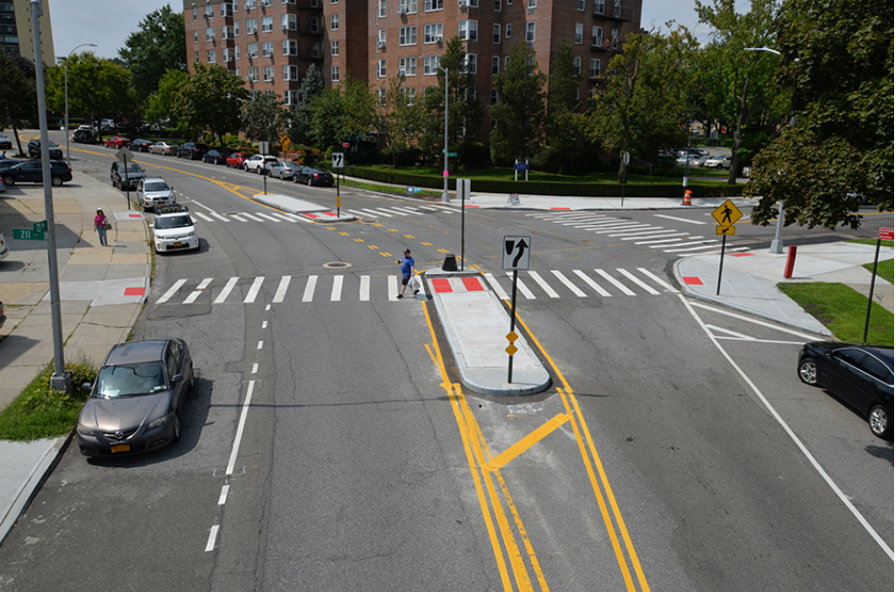**Table 6: Example of Median Refuge Island**

Source: (New York City Department of Transportation Street Design Manual, 2020)

The intersection between Franklin Boulevard and Sutterville road could benefit from an improved built environment that makes crossing safer for pedestrians with the introduction of a refuge island on the center of the crosswalk. Franklin Boulevard is a four-lane arterial road with a crosswalk that requires pedestrians to walk a long distance. A refuge island on the center of the road would allow pedestrians to feel safer and confident about walking. In a survey that was developed by the City of Oakland, respondents felt more confident with the refuge islands (CITE). The sources have shown that 49 percent of Sacramento pedestrian collisions have occurred on crosswalks and 30 percent while crossing outside of crosswalks. Pedestrians are also 10 times more likely to be killed from injuries (Vision Zero Sacramento, 2018). Disadvantaged communities are often more impacted by the risks involved when walking to amenities that may be further away. People with disabilities also tend to live in lower socioeconomic neighborhoods where there is a need for a built environment that improves the safety of crosswalks. Table 6 shows how Vision Zero Sacramento has identified Franklin Blvd. as a high injury network.

**Table 7: Map of Franklin Blvd. High Injury Network and Disadvantaged Community**

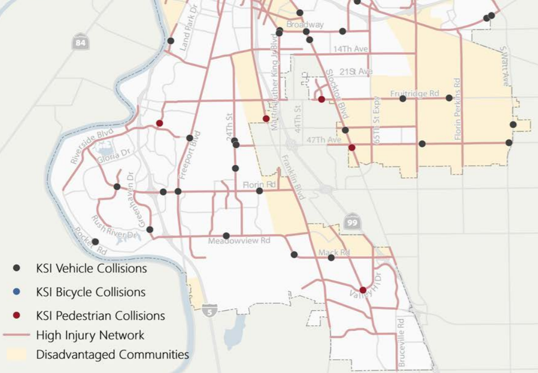

Source: (Vision Zero Sacramento, 2018)

**Table 8: Graph of Sacramento’s Collisions by Mode**

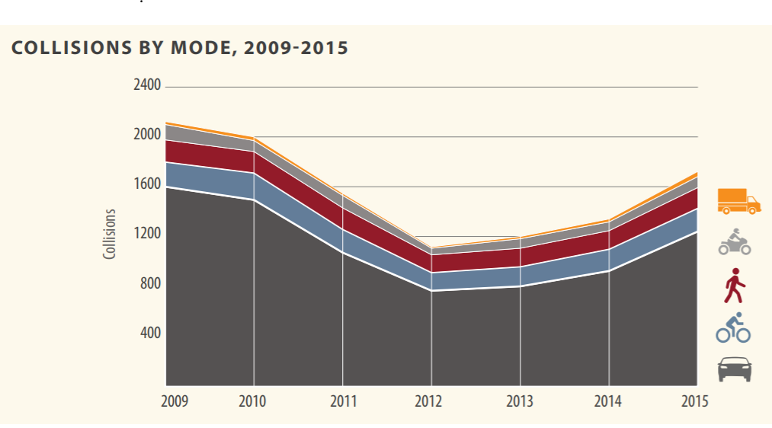

Source: (Vision Zero Sacramento, 2018)

***Nudge People to Walk***

Another strategy that could increase walkability is to ensure that cities are educating individuals about how to walk safely and promoting accurate information about pedestrian rights. In the City of Seattle example, the local government has leveraged their partnerships with organizations such as Safe Routes to School (SRTS) to encourage youth to walk. SRTS used the PMP framework, collision data and equity data to identify schools in need of safety improvement. SRTS taught children how to walk safely and provided them with maps for safe routes to walk to school. In collaboration with Seattle’s public schools and the Cascade Bicycle Club, SRTS created the program, “Let’s Go,” where third, fourth and fifth grade public school students receive training to walk safely and ways to avoid collisions. SRTS plans to make the program available for students with disabilities and expand the course to middle school students. SRTS aims to provide children with the skills to begin walking at an early age and drivers with information to encourage safe driving.

SRTS also developed Learning Landscapes which is an initiative to encourage children to have fun learning while walking to and from school on sidewalks. The concept comes as a result of ways to address inequality of access to quality preschools by supplementing learning through rethinking the use of public spaces. This initiative is done in partnership with the Seattle Department of Education and Early Learning. The activities are incorporated onto sidewalks in proximity to schools. To develop the designs onto sidewalks, SRTS started by identifying what teachers would like to highlight from the curriculum, and then the idea was developed into an engaging sidewalk activity. Teaching the public about safety and walking also occurs during the back-to-school season. The education campaign included mailing postcards in several languages with information on where and when to drive 20 mph, as well as information on social media ads on Facebook and Instagram.

**Table 9: Example of Sidewalk Installations for Learning Landscapes**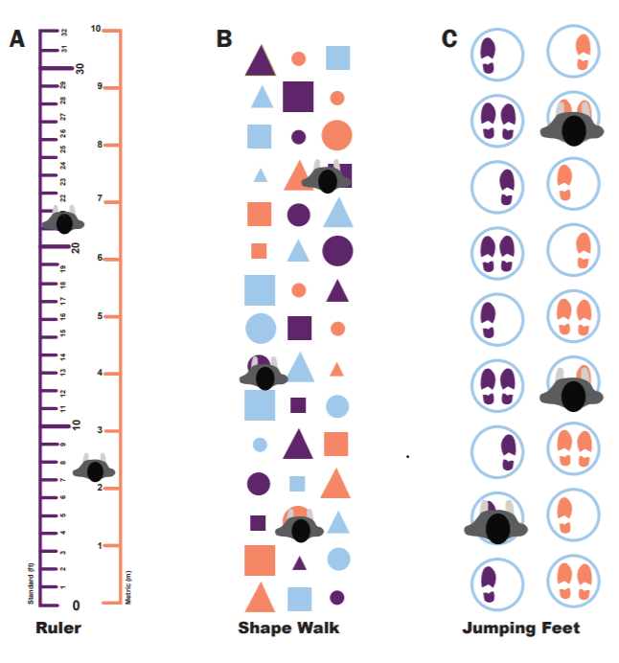

Source: (Seattle Department of Transportation, 2021)

In addition to educating individuals about how walking can be done safely, providing individuals with accurate information about walking could increase the confidence of pedestrians. Some of these ideas can include pedestrian friendly signs that can inform pedestrians of ways to navigate and plan routes. Legible London, a program by Transport for London created a pedestrian wayfinding system to help people feel confident about traveling. As described by Transport for London, wayfinding consisted of two phases, planning and navigating (Legible London the birth of modern city wayfinding, n.d.). In a pedestrian survey report, there was a 5 percent measurable increase in walking, 60 percent decrease in people feeling lost, 66 percent increase of Legible London user knowledge of the surroundings increased, and 16 percent time-savings improvement for pedestrians (Legible London the birth of modern city wayfinding, n.d.). The ideas from Legible London have become the design standard and have now been incorporated in over 50 cities, including New York and Seattle. As part of the strategies developed for PMP, the city of Seattle started Seamless Seattle, which aimed to standardize a plan for a pedestrian wayfinding system. Key design features included heads up mapping on street signs to help orient pedestrians, illustrations that showed accessible entrances to transit, proper contrast for legibility, integration of languages in specific areas, and recognizable design for identification.

***How Nudging Could Work in Franklin Blvd’s Example***

Ways to shift people’s attitude towards walking on Franklin Blvd. could mean continuing with methods to educate and increase people’s confidence about walking. Currently, SRTS has developed partnerships in several cities in Yolo and Sacramento County. Elementary and middle schools near Franklin Blvd. now have 880 students who received safe walking and biking skills, 1600 individuals who participated in walk and bike school days, 3 citywide policy wins for safety and mobility, and 35 adults received walking school bus training. Increasing people’s confidence about walking on Franklin Blvd. could include wayfinding signs that direct pedestrians to local businesses. Franklin Blvd. is reported to have over 600 businesses and many of them are restaurants and local businesses. Wayfinding signs could help to promote information and places useful for pedestrians. Wayfinding signs do not have to mean that pedestrians have to learn new rules. In New York City for example, the wayfinding system became an extension of the existing road and community; the font and color of the design was similar to New York City’s subway maps. Similar to New York City’s case, Franklin Blvd. could create a wayfinding system that builds on existing knowledge of the public transit system.

**Table 10: Examples of Wayfinding Systems in New York City**

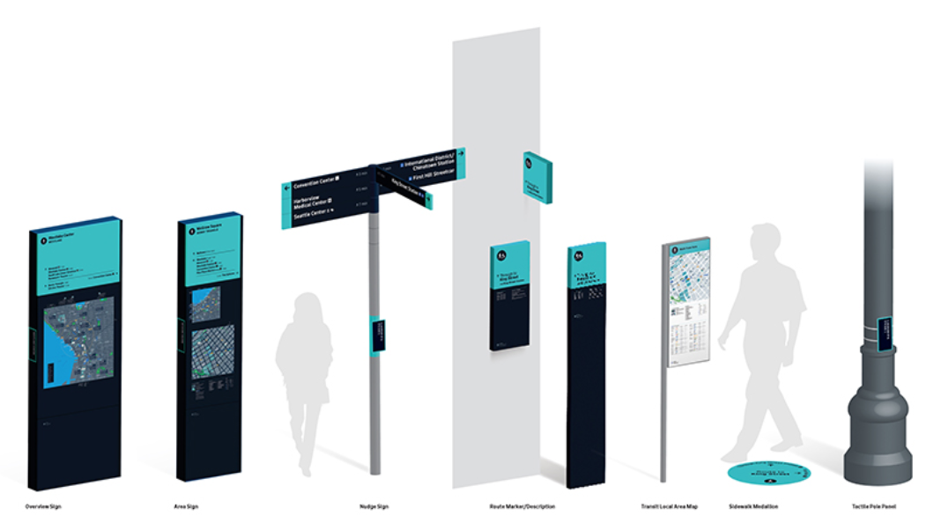

Source: (New York City Department of Transportation Street Design Manual, 2020)

**Step Five: Final Recommendation for Franklin Blvd.**

Increasing the walkability of streets can have benefits that extend beyond improving the neighborhood, the people and the environment in the long term. Based on the recommendations and the criteria used to examine the alternatives, prioritizing the safety of pedestrians by implementing median refuge islands would be the most equitable approach to ensure people with disabilities, children and older residents are able to safely walk. Individuals who do not have the choice but to walk are more likely to be lower income. Safer crosswalks will reduce the disproportionate number of pedestrian fatalities that occur in BIPOC neighborhoods, which would also make walking a reliable mode of transportation to go to work, for leisure activities, and to access amenities. The recommendation would be politically acceptable since median refuge islands have already been implemented as a traffic calming strategy in Sacramento. As mentioned earlier, SACOG would not be able to administer median refuge islands. However, the City of Sacramento could apply for funding from SACOG, or find external funds to increase walkability. In comparison to the alternatives that would nudge individuals to walk, median refuge islands would be a cost-effective choice in terms of benefits because projects are not limited to locations near schools, but streets with a higher rate of injuries. In addition, increasing the safety of crosswalks where disadvantaged communities may walk longer distances to amenities could help to improve people’s perception of walking and accessing crosswalks, thereby establishing equity in walkability. Median refuge islands have been shown to reduce pedestrian crashes by up to 46 percent (America Walks). New York’s Safe Routes to School projects on the other hand, showed a 44 percent decline in child pedestrian injuries. It is interesting to note however, that although SRTS programs in New York cost $10 million, the estimated reduction in health costs for injury, disability and death was $221 million (Active Living Research, 2015). Projects focused on increasing walkability by improving the safety for pedestrians will cost more, but to ensure walking is a public good should mean considering projects for more than the traditional benefits. The myriad benefits of increasing walkability include access to cleaner air, ability to maintain healthier lifestyles, access to social networks, and job opportunities. These benefits will be difficult to measure, but would address long-term city planning inequity issues that could be exasperated in the region.

While SACOG can support strategies to increase walkability by providing funds to local cities and counties, there also needs to be organizational changes to support walkability in disadvantaged neighborhood, such as considering regional plans not only as a means to obtain federal and state funding, but to prioritize goals, leverage available resources, and provide performance measures. As discussed earlier regarding the costs and benefits, projects aiming to achieve equity should be measured and approached on the basis of need. SACOG has the ability to do these things and has explored changing the funding application requirement. For example, SACOG has set aside funds to develop the Non-Competitive Category for the 2021 Regional and Community Design Programs, which allows cities and counties between $100,000 and $500,000 for projects. The category allowed cities and counties to apply for projects based on jurisdictional needs so the cities and counties could later compete for larger funds. Setting aside funds for the Non-Competitive Category, however, is not sustainable for the long term. Application requests are still measured against the project’s Benefit/Cost Ratio (BCR) and the limited funding set aside for recipients will mean project ideas will have conservative changes. An example of a California state program that offers funding for programs and does not require a BCR is the Caltrans Highway Safety Improvement Program (HSIP). HSIP has two application categories, the first requires a BCR. The second, called Funding Set-asides (SA), does not require BCR. In HSIP’s 2020 Cycle 10 Call for Projects (HSIP, 2020), SA included projects seeking funds for pedestrian crossing enhancements. Similarly, to HSIP, SACOG should consider an application category that is not based on a BCR to fund cities and counties.

***Conclusion***

Rethinking neighborhood planning to encourage walkability is important as the population continues to increase in the Sacramento region. While the region will need to continue to build more homes to address population growth, existing, less walkable neighborhoods should not be left behind. It is true that SACOG is unable to administer projects that increase walkability and has explored various methods to fund cities and counties. Changing the way SACOG funds recipients to rely less on the BCR as part of the selection criteria, however, will help cities and counties have the opportunity to address street planning inequities. Although it will take time to increase walkability for disadvantaged communities such as Franklin Blvd, SACOG’s decisions now will serve as an example and guide for other MPOs in the region.

**References**

*About Us*. The Franklin Neighborhood Development Corporation. Retrieved from <https://www.franklinblvddistrict.com/about>.

Applied Information Group. n.d. *Legible London the birth of modern city wayfinding*. [online] Retrieved from https://www.appliedinformation.group/projects/legible-london.

Austin Boyle, Charles Barrilleaux, & Daniel Scheller. (2014). Does walkability influence housing prices? Social Science Quarterly, 95(3), 852-867.

Babey, S. H., Wolstein, J., Diamant, A. L., & Goldstein, H. (2016). Prediabetes in California: nearly half of California adults on path to diabetes. *Policy brief (UCLA Center for Health Policy Research)*, (PB2016-1), 1–8.

Bardach, E., 2012. *A practical guide for policy analysis*. 4th ed. Thousand Oaks: Sage Publications.

Brookfield, K. (2017). Residents' preferences for walkable neighborhoods. Journal of Urban Design, 22(1), 44-58.

C40. (2020). *C40 annual report 2020*. Retrieved from https://c40-production-images.s3.amazonaws.com/other_uploads/images/2827_C40_annual_report_2020_16April2021.original.pdf?1618575743.

Dovey, Kim, & Pafka, Elek. (2020). What is walkability? The urban DMA. Urban Studies (Edinburgh, Scotland), 57(1), 93-108.

Duncan, Dustin T, Aldstadt, Jared, Whalen, John, Melly, Steven J, & Gortmaker, Steven L. (2011). Validation of walk score for estimating neighborhood walkability: an analysis of four U.S. metropolitan areas. International Journal of Environmental Research and Public Health, 8(11), 4160-4179.

Dustin T. Duncan, Jared Aldstadt, John Whalen, Kellee White, Marcia C. Castro, & David R. Williams. (2012). Space, race, and poverty. Demographic Research, 26(17), 409-448.

Egel, B. (2020). As gentrification spreads, how new restaurants are fighting for the soul of Oak Park. The Sacramento Bee. Retrieved from https://www.sacbee.com/news/local/sacramento-tipping-point/article238333098.html.

Gilderbloom, John I, Riggs, William W, & Meares, Wesley L. (2015). Does walkability matter? An examination of walkability’s impact on housing values, foreclosures and crime. Cities, 42, 13-24.

Loh, T., Leinberger, C. and Chafetz, J., 2021. *Foot traffic ahead*. [online] The George Washington University School of Business & Smart Growth America. Retrieved from https://smartgrowthamerica.org/wp-content/uploads/2019/06/Foot_Traffic_Ahead_FINAL-compressed.pdf.

Oregon Metro. (2016). *Strategic plan to advance racial equity, diversity and inclusion* [Ebook]. Retrieved from <https://www.oregonmetro.gov/sites/default/files/2017/10/05/Strategic-plan-advance-racial-equity-diversity-inclusion-16087-20160613.pdf>.

*Pedestrian crossing islands*. America Walks. (2021). Retrieved from https://americawalks.org/pedestrian-crossing-islands/.

Pivo, Gary, & Fisher, Jeffrey D. (2011). The walkability premium in commercial

real estate investments. Real Estate Economics, 39(2), 185-219.

Population health, place, and space: spatial perspectives in chronic disease research

and practice. (2019), *16*(E123). Retrieved from

https://www.cdc.gov/pcd/collections/pdf/GiS_collection.pdf.

*Redfin News, 2020. How much does walkability increase the value of a home?. [online]* Retrieved from https://www.redfin.com/news/how-much-does-walkability-increase-home-values/.

Robinson, J. (2019). *Philadelphia playful learning landscapes: sealing strategies for a playful learning movement* [Ebook]. Center for Universal Education at Brookings. Retrieved from https://www.brookings.edu/wp-content/uploads/2019/10/PPLL-FINAL-REPORT-web.pdf.

Sacramento Area Council of Governments. (2020). *SACOG racial equity audit*. [online] Mckensie Mack Group. Retrieved from <https://www.sacog.org/sites/main/files/file-attachments/sacog_racial_equity_audit_.pdf?1605908504>.

Sacramento Area Council of Governments. (2019). *MTP/SCS metropolitan transportation plan sustainable communities strategy*. [online] Retrieved from https://www.sacog.org/sites/main/files/file-attachments/2020_mtp-scs.pdf?158033099.

Schwartz, A. and Meltzer, R., 2018. *Policy analysis as problem solving: a flexible and evidence-based framework*. New York: Routledge.

Seattle Department of Transportation. (2018). *Learning landscapes Northgate Elementary* [Ebook]. Retrieved from <https://www.seattle.gov/Documents/Departments/SDOT/SRTS/Final_LL_Packet.pdf>.

Seattle Department of Transportation. (2019). *Pedestrian wayfinding strategy* [Ebook]. Retrieved from http://www.seattle.gov/Documents/Departments/SDOT/UrbanDesignProgram/PedestrianWayfindingProgram/Wayfinding%20Strategy_July2019_SDOT%20Edit.pdf.

Seattle Department of Transportation. (2021). *Seamless Seattle Pedestrian Wayfinding Program*. Retrieved from http://www.seattle.gov/transportation/projects-and-programs/programs/urban-design-program/pedestrian-wayfinding.

*South Sacramento safe routes to school 2018-2019 program highlights*. Walk Sacramento. (2020). Retrieved from <https://www.walksacramento.org/wp-content/uploads/2020/02/2018-19-SRTS-Program-Highlights.pdf>.

Stafford, Lisa, & Baldwin, Claudia. (2018). Planning walkable neighborhoods. Journal of Planning Literature, 33(1), 17-30.

Suarez-Balcazar, Yolanda, Early, Amy R, Garcia, Claudia, Balcazar, Daniel, Arias, Dalmina L, & Morales, Miguel. (2020). Walkability safety and walkability participation: A Health Concern. Health Education & Behavior, 47(3), 430-438.

*The Burden of Diabetes in California*. American Diabetes Association. (2021). Retrieved from http://main.diabetes.org/dorg/PDFs/Advocacy/burden-of-diabetes/california.pdf.

Transport of London. (2007). *Yellow book a prototype wayfinding system for London* [Ebook]. Retrieved from <https://content.tfl.gov.uk/ll-yellow-book.pdf>.

U.S. Department of Transportation. (2020). *Local Highway Safety Improvement Program Cycle 10 Call for Projects*. [Ebook]. Retrieved from <https://dot.ca.gov/-/media/dot-media/programs/local-assistance/documents/hsip/2020/hsipcycle10announcement.pdf>.

Victoria State Government. (2017). *Plan Melbourne 2017-2050*. Retrieved from https://www.planmelbourne.vic.gov.au/__data/assets/pdf_file/0007/377206/Plan_Melbourne_2017-2050_Strategy_.pdf.

Walk Score. n.d. *Living in Sacramento*. [online] Retrieved from https://www.walkscore.com/CA/Sacramento.

Won, Jaewoong, Lee, Chanam, & Li, Wei. (2018). Are walkable neighborhoods more resilient to the foreclosure spillover effects? Journal of Planning Education and Research, 38(4), 463-476.