WHY CAN’T LIBERAL CALIFORNIA ABOLISH THE DEATH PENALTY?
by

Sara Elizabeth Nickerson

California State University, Sacramento

Culminating Experience: Policy Brief

Master of Public Policy and

Administration

Spring 2021

Contents
EXECUTIVE SUMMARY 3
INTRODUCTION 4
Focus Audience 5
What does the literature suggest about why California might retain the death penalty? 6
Approach 8
BACKGROUND: THE TREND AWAY FROM CAPITAL PUNISHMENT AND CALIFORNIA’S RECENT CONSIDERATION OF THE TOPIC 9
HOW LIBERAL LEANING IS CALIFORNIA IN GENERAL AND WITH RESPECT TO THE DEATH PENALTY? 13
Partisanship and Ideology in California 14
The contradictory statewide ballot initiative votes on sentencing and the death penalty. 16
Statewide survey findings about voter attitudes toward the death penalty. 18
CALIFORNIA’S BALLOT INITIATIVE PROCESS AND IMPACT TO THE DEATH PENALTY 20
COLORADO COMPARISON AND HOW THEY ABOLISHED THE DEATH PENALTY THROUGH LEGISLATION 25
CONCLUSION and RECOMMENDATIONS 28
REFERENCES 30

EXECUTIVE SUMMARY
Each year, more and more states are abolishing the death penalty and instead replacing it with life in prison without the chance of parole. However, liberal leaning California still has yet to abolish the death penalty. In this policy brief I attempt to determine why California has not abolished the death penalty despite the national trend in other states. In order to do so, first I gathered and analyzed data from existing public opinion polls and surveys to measure just how liberal Californians are, especially when asked about the topic of the death penalty. Next, I researched California’s history and unique use of the ballot initiative process, that I also claim is related to California’s struggles to abolish the death penalty. Finally, I compared California to Colorado because of their many similarities, and due to Colorado’s successfully passing death penalty repeal legislation.
Regarding the liberalism of Californians, I found that a large portion of residents identified themselves as middle of the road to somewhat conservative. Moreover, on the topic of the death penalty, Californians were more supportive of reducing sentencing terms in nonviolent criminal conviction, but less supportive of abolishing the death penalty as a whole through the ballot initiative process.
Regarding the option of addressing the death penalty at the ballot box, in theory, the ballot initiative, as a form of direct democracy, is a way for voters to express citizen representation; however historically and in practice, California’s ballot initiative process is incredibly expensive, usually results in unintended consequences, and is inflexible with respect to amendments once measures are enacted. And historically, ballot initiatives have more often been used to limit minority rights, instead of progressing more social equality in California. This does not bode well for abolishing capital punishment by ballot initiative.
Finally, in comparing Colorado to California I found that the two states are very similar in the areas of political ideology, the distinct rural-urban division, and having a robust ballot initiative process. However, in 2020, Colorado managed to abolish the death penalty through legislative action. The main factors that contributed to Colorado’s legislative success were the fiscal concerns, which were especially impacted by the COVID-19 pandemic. Prosecutors, many in rural counties, supported the abolishment of the death penalty for the cost savings, and a successful outreach campaign to victims’ families and strong witness testimony during the legislative process also contributed to the legislation’s success.
Ultimately, the information in this policy brief and analysis provided sheds some light on various root causes as to why California struggles to abolish the death penalty. It may also provide a direction for lawmakers and/or advocates to get the death penalty abolished in California in the near future.

INTRODUCTION
California is one of 27 states and the U.S. Military that has continued to maintain capital punishment (death penalty) as a legitimate punishment for serious crimes. Currently, there are 23 other States and the District of Columbia that have abolished the death penalty over the decades. Since revisiting this area of research, from almost three years ago, three other States have managed to abolish the death penalty before California: New Hampshire (2019), Colorado (2020), and even more recently the first southern state, Virginia (2021). Moreover, all did so by acts of the legislature and signed by their respective governors.
However, California is not without its accomplishments in this area of criminal justice reform. California is currently one of three states that has a gubernatorial moratorium on executions. Furthermore, California also has the highest population of death row inmates, over 700, but is one of 11 states that has not performed an execution in over a decade. Historically, there were zero executions performed in California between 1968 and 1991, and the last execution performed in California was in 2006. Therefore, if California has not performed an execution in over a decade and continues to place a moratorium on executions, why has it been such a struggle for California, a predominantly liberal leaning state, to abolish the death penalty? To look further into this question, I would need to first identify and speak with individuals that have not only worked and/or advocated for the abolishment of the death penalty in California, but also, I would have to determine what audience would greatly benefit from this policy research and analysis.
Focus Audience
The focus audience that this policy brief is targeted towards is any current lawmakers and/or staffers that have been active in past and current legislation within the area of criminal justice reform. For example, Assembly Member Mark Stone has reintroduced AB 2512 to the 2020-2021 legislative session, which would essentially update California’s status to the US Supreme Court’s ruling that a person with intellectual disabilities cannot be sentenced to death. Furthermore, Assembly Member Marc Levine has proposed a California Constitutional amendment, ACA 2, that would prevent prosecutors from seeking the death penalty as a sentencing option. And just recently, Assembly Member Levine also introduced AB 1224. This bill would make all 711 death row inmates in California eligible for resentencing by a judge to life in prison according to special circumstances, such as age when first incarcerated, behavior while incarcerated, and current mental and physical health. Beyond lawmakers, other focus audiences would be advocacy groups, such as the ACLU of Northern California: Death Penalty Policy, California NAACP, Center of Restorative Justice Works, and California Crime Victims for Alternatives to the Death Penalty.
Ultimately, both California lawmakers and death penalty repeal advocacy groups will have to seek where California voters’ attitudes lean in order to gauge the feasibility of completely abolishing the death penalty, either through standard legislation or voter approval through the ballot initiative process. Alternatively, they may seek to repeal the death penalty as a punishment option through the Federal and/or California State Supreme Court system. Moreover, in order to understand the current climate and attitudes towards the death penalty; one first has to delve into what we already know about California and its interaction with the death penalty as a historical form of legitimate punishment.
What does the literature suggest about why California might retain the death penalty?
There has been a considerable amount of research conducted over past decades on the topic of capital punishment in the United States. Many of these studies look into how various states approach, implement, enforce or eliminate capital punishment laws. However, when it comes to California’s interaction with capital punishment laws, many past studies have run the gamut on California’s seemly cognitive dissidence approach to abolishing and then reversing legislative and judicial rule. Therefore, a few examples of past research that have suggested different ideas about why a state like California might avoid abolishing the death penalty include the following. Minker (2013) asked the very same question of why California seems to struggle abolishing the death penalty when Minker wrote about the failure of 2012 California Proposition 34, a repeal of the death penalty. In the article Minker noted the shift in national and California public opinions on the abolishing of the death penalty and how the end of it is due to come. Alarcón and Mitchell (2011) addressed the idea of using single-subject rule and prohibition on constitutional revisions, that were achieved from Senate of California v. Jones in 1999, and for their potential use against voter ballot initiatives like those upholding the death penalty.
More recently, Mathews (2019) wrote about the values of the death penalty in California and how death row inmates are less forgotten, and it keeps media attention on our prison systems. Young (1991) studied racial differences in attitudes toward the death penalty. Findings suggest that many black and white respondents supported the death penalty, but they do so for differing reasons. Kaufman-Osborn, T. V. (2006), addressed the difficulty of abolishing the death penalty, due to the historical view of it being a legitimate form of punishment in the U.S. and in various States. Lastly, Barry (2017) explained that the U.S. is in a period of de facto abolition due to human rights concerns and that potentially the U.S. Supreme Court may not want to act against shifting public opinions towards the use of capital punishment.
With the cumulation of past research, it is clear that when it comes to California’s, history with the death penalty—and the history within the United States generally--it has not only been contentious, but contradictory. However, what a majority of the research touch on is the emotional aspects that surround the heinous crimes committed that would result in a death penalty sentence and the emotional impact of victims’ families. Therefore, it is important to continue looking into alternate avenues to approach abolishment of the death penalty and into what areas of legislation and/or advocacy campaigns would have the most effective impact.
Approach
I consider existing research that has analyzed abolishing the death penalty in the following areas: public policy, public opinions of the death penalty over time, liberalism and the attitudes towards the death penalty, the impact of geography on death penalty public policy, and California’s history with the ballot initiative process, and a state comparison between California and Colorado and how Coloradans achieve death penalty abolishment. From this research, I can further perform analysis to tease out and patterns that may present themselves in the back-and-forth struggle about death penalty agendas and ideology over time.
Moreover, I will look into research that has been conducted by advocacy groups and other organizations that are against the death penalty. The following are some examples of past sources that I will look further into and analysis for this policy brief: Gallup polls, Public Policy Institute of California surveys, Field Polls, Institute of Governmental Studies polls, and policy proposals such as California ballot propositions and legislation that have tried to abolish or maintain the death penalty. I will also draw on personal interviews, news articles, and Federal/State surveys and poll data.
My working hypothesis framework is that regardless of how liberal California may seem; I claim that it is California's unique ballot initiative process and the strong emotional perspective on capital punishment that keeps California from abolishing the death penalty. Furthermore, this research can be broken down into three parts:
- Ideology of liberalism and the State of California. How liberal is California? And how strongly is liberalism linked to specific support for the death penalty?
- Process and impact of California’s death penalty ballot Initiatives.
- Comparative analysis with Colorado and how that state abolished the death penalty through SB20-100 in 2020.

BACKGROUND: THE TREND AWAY FROM CAPITAL PUNISHMENT AND CALIFORNIA’S RECENT CONSIDERATION OF THE TOPIC
Since the United States was colonized, capital punishment law has been the norm. Over time, change in law had more to do with how executions were preformed, not so much arguing to abolish the death penalty, on a federal, state, and local level. That changed as a result of one of the first cases to constitutionally challenge capital punishment in the highest court of law. The event that led the way for the United States to reexamine the need for capital punishment occurred in 1972 when the U.S. Supreme Court abolished the death penalty under Furman v. Georgia. The ruling deemed capital punishment as cruel and unusual punishment, discriminatory, and arbitrary due to the 8th and 14th amendment. However, the U.S. Supreme Court quickly reversed its decision in 1976, allowing States to again decide. In 1972, the California Supreme Court deemed the death penalty as unconstitutional under People v. Anderson. However, voters reinstated the death penalty in Proposition 17, but also made the death penalty only subject to a legislative amendment or repeal by statute, initiative, or referendum (California Constitutional code). This pattern of back and forth has been going on in California ever since.
Regarding the shifting of National public opinion on the death penalty, since 1937 Gallup has been tracking America’s opinions on capital punishment (death penalty). A recent Gallup poll indicated that, for the first time, prison without parole had more public opinion support than did the death penalty (Jones, 2019).
Figure 1
National Trend in Support of the Death Penalty vs. Life Imprisonment
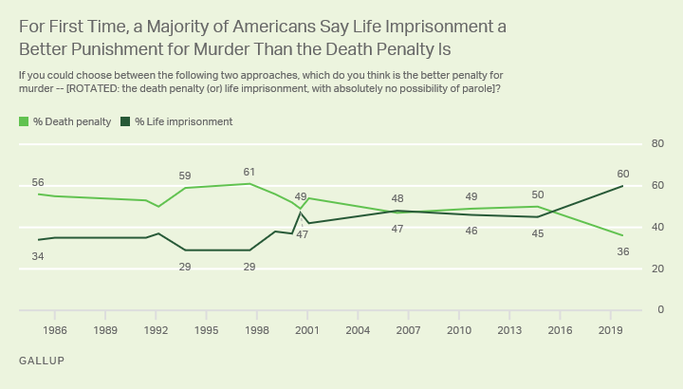
Source: Gallup News 2019
Moreover, this opinion trend is on par with the 2012 Public Policy Institute of California (PPIC) Statewide Survey, where voters were more likely to support life in prison rather than the death penalty for first degree murder charges.
Table 1
Support for the Penalty vs. Life Imprisonment in California
“Which of the following statements do you agree with more? The penalty for first-degree murder should be the death penalty; or the penalty for first degree murder should be life imprisonment with absolutely no possibility of parole.”
 | All adults |  | Party |  | Likely voters
 |  | Dem | Rep | Ind
Death penalty | 38% | 28% | 57% | 43% | 42%
Life imprisonment, no parole | 55 | 67 | 33 | 45 | 50
Don’t know | 7 | 5 | 10 | 12 | 8
Source: PPIC Statewide Survey Report 2012
Also, in 2012, Proposition 34 asked voters to end the death penalty, which failed 48% to 52% (Ballotpedia 2019). Then by 2014, the United States District Court ruled again that the death penalty was unconstitutional, based on mounting delays and arbitrary reasoning which created cruel and unusual punishment. However, on the 2016 November 8 ballot, two death penalty ballot initiatives were put to California voters. Proposition 62 was to repeal the death penalty and Proposition 66 was to limit the amount of time death penalty convictions can be challenged in a court of appeals and petitions procedures. As featured in Table 2 and in Table 3, it is evident from the mixed results that not only do Californian’s want to speed up the death penalty legal process and not repeal the death penalty, but also how potentially confusing it is to have two ballot initiative dealing with the same issue, with very different and impactful outcomes.
Table 2
November 8th, 2016 California Voter Ballot results on Proposition 62, Repeal of the Death Penalty Initiative
 | California Proposition 62
Result | Votes | Percentage
No * | 7,218,625 | 53.15%
Yes | 6,361,788 | 46.85%
Source: Ballotpedia 2016
Table 3
November 8th, 2016 California Voter Ballot results on Proposition 66, Death Penalty Procedures Initiative
 | California Proposition 66
Result | Votes | Percentage
Yes * | 6,626,159 | 51.13%
No | 6,333,731 | 48.87%
Source: Ballotpedia 2016
Perhaps as a result of these two ballot initiatives, California Governor Newsom, in 2019, placed a moratorium on the death penalty, which placed a stay on over 700 inmates awaiting executions, but does not halt the death penalty as a sentencing option. However, when explaining this decision, Governor Newsom said it was due to the “ineffective, irreversible and immoral,” nature of the death penalty (Bollag 2019). More driving factors to abolish the death penalty are due the number of wrongfully convicted death row inmates being exonerated through DNA evidence, racial disparities in sentencing practices (mainly impacting Africa American and Latino men), and the shortage, expense, and the inhumane concerns over lethal injection drugs and procedures that are currently in use to perform an execution. However, the largest argument against the death penalty involves the massive statewide costs in order to maintain the death penalty, which is estimated at around 5 billion in taxpayer funds since California reinstated the death penalty in 1978 (Alarcón and Mitchell 2011). All of these factors have not only shifted the political and legal view of the death penalty but has shifted the public's opinion on the need for the death penalty as well (Jones 2019). However, California still seems to continually fall short in achieving the complete abolishment of the death penalty, like most other liberal leaning States have.

HOW LIBERAL LEANING IS CALIFORNIA IN GENERAL AND WITH RESPECT TO THE DEATH PENALTY?
California is often viewed as being a bastion of liberalism and a Democratic stronghold. However, when it comes to certain geographic areas of California and what issues voters are asked to participate in, there is far more nuance in what Californians’ claim as their ideology and how they actually vote on issues. Within this section I will analyze how citizens tend to vote and consider themselves, in general, politically in California. Next, I will look into how Californians tend to vote on death penalty ballot initiatives compared to other sentencing ballot initiatives. Lastly, I will present some poll results on California’s attitudes towards the death penalty from 2012 to recent poll data. Partisanship and Ideology in California
It is true, in general, California is a Democratic stronghold. Democrats are the statewide elected officials across the board, from the U.S. Senate to the Governor and constitutional officers. Democrats also hold a supermajority in both the State Senate and State Assembly. However, prior to the 1990s California voted for a Republican President many times and Democrats were not the dominating party and thought to be decreasing in numbers (Korey and Lascher 2006). However, that never came to pass. Currently, there are still many areas in California that vote strongly Republican. In the 2016 general election, per land area, California was fairly divided between red (Republicans dominate) and blue (Democrats dominate).
Figure 2
November 8th, 2016 Presidential Election, Percentage of Votes for the Democratic Candidate (Hillary Clinton) by California County.
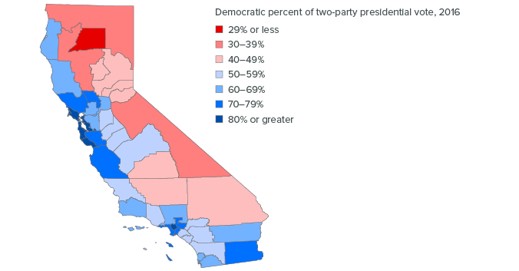
Source: PPIC 2020, California Statewide Database
While the coastal areas around the major cities of San Francisco and Los Angeles are designated blue, the inland areas, up north along the Oregon border, and down the border of Nevada are dominantly red. However, if you factor in the number of 2016 Presidential voters and their party affiliation, you will find that the voting population in California is dominated by the Democratic voters along the relatively populous coastal areas and within the higher population density cities of San Francisco and Los Angeles.
Figure 3
November 8th, 2016 Presidential Election, Counties Weighted by Number of Eligible Voters

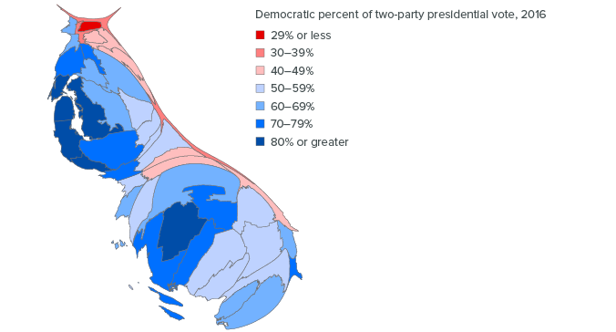
Source: PPIC 2020, California Statewide Database
Democrats by far outnumber Republicans due to the higher population areas, and in turn, the state tends to vote for candidates identifying themselves with the majority party. However, this does not necessarily mean that voters dominantly identify as liberals, even though Democratic elected officials tend to support liberal causes. Indeed, when we examine the ideology of voters the picture is decidedly mixed. As shown in Table 4, a large portion of California voters (nearly 1/3) identify as middle of the road rather than somewhat liberal and very liberal, and fully one out three identify as being at least somewhat conservative.
Table 4
PPIC Statewide Survey: Californians and their Government, May 2019

Next, would you consider yourself to be politically:
15% very liberal
19% somewhat liberal
31% middle-of-the-road
20% somewhat conservative
14% very conservative
2% don’t know
Source: PPIC 2019, California Statewide Survey
Therefore, in general, Californians are far less likely to identify as “very liberal” than the stereotypical view may suggest. So how do these political ideals play out when California residents asked about more specific topics, such as the death penalty and other criminal sentencings practices?
The contradictory statewide ballot initiative votes on sentencing and the death penalty.
Over the decades, the topic of the death penalty, and other criminal sentences reform, have been placed on ballot initiatives for the California voters to decide. The outcomes of these ballot initiatives, over time, not only show that Californians’ fail to act in a consistently liberal fashion when it comes to the death penalty, but also act in contradictory ways on criminal sentencing ballot initiatives that have come up for a vote. As mentioned before, in recent years, abolishing the death penalty failed in multiple ballot initiatives including Proposition 34 in 2012 and in Proposition 62 in 2016. However, within those years, other criminal sentencing ballot initiatives had been presented for and sometimes secured voter approval. The most notable of those ballot initiatives are Proposition 36, Proposition 47, Proposition 57, Proposition 20:
Proposition 36, 2000: Permanently changed state law to allow certain defendants who have been convicted of nonviolent drug possession offenses to receive a probationary sentence instead of being incarnated. This ballot initiative passed with 61% for Yes and only 39% for No.
Proposition 47, 2014: Changed and resentenced certain crimes as misdemeanors instead of felony crimes, unless the defendant has priors for any violent crimes. This ballot initiative passed with 60% for Yes and only 40% for No.
Proposition 57, 2016: Allowed increasing parole for good behavior for felons convicted of non-violent crimes and allows judges, not prosecutors, the discretion to try some juveniles as adults. This ballot initiative passed with 65% for Yes and only 35% for No.
Proposition 20, 2020: This would have made certain crimes like fraud and theft be charged as a misdemeanor or felony, instead of just a misdemeanor. It would also have required the collection of DNA evidence for some misdemeanor crimes. Ultimately, this initiative would have reversed much of what Proposition 47 and Proposition 57 achieved. This ballot initiative failed with only 38% for Yes and 62% for No.
What the four ballot initiative results discussed above may show is that California voters approve of criminal sentencing reform for certain types of crime, mainly nonviolent ones. However, when it comes to violent crimes, where prosecutors would seek the death penalty, Californians are not quite ready to soften penalties on what are usually horrendous crimes that invoke very emotional feelings. These crimes not only directly impact victims’ families, but indirectly impact communities and society overall. Furthermore, ballot measure results are similar to the findings from opinion polls showing that Californians’ attitudes have varied and are inconsistent towards the death penalty overtime.
Statewide survey findings about voter attitudes toward the death penalty.
I previously noted the PPIC, 2012 Statewide Survey indicating that voters at that time were more likely to support life in prison without parole rather than the death penalty for first degree murder charges. However, in a more recent poll, conducted by the Institute of Governmental Studies at the University of California Berkeley (2019, June 17), Californians polled supported Governor Newsom’s moratorium on executions, but also supported keeping the death penalty as a punishment for serious crimes.
Table 5
Berkley IGS Polls, Californians narrowly back Newsom’s moratorium on executions, but oppose abolishing the death penalty out right as a punishment for serious crimes.
California voter views about Governor Newsom’s executive order imposing a moratorium on executions while he is in office (among California registered voters)
 | Support % | Oppose %
Total registered voters | 52 | 48
Party registration
Democrat | 72 | 28
Republican | 15 | 85
No Party Preference/other | 53 | 47
Political ideology
Very conservative | 15 | 85
Somewhat conservative | 24 | 76
Moderate | 46 | 54
Somewhat Liberal | 70 | 30
Very Liberal | 88 | 11
Source: Berkeley IGS Poll#2019-04 Monday, June 17, 2019
Table 6
Berkley IGS Polls, Californians narrowly back Newsom’s moratorium on executions, but oppose abolishing the death penalty out right as a punishment for serious crimes.
California voter views about keeping the death penalty as a punishment for serious crimes (among California registered voters)
 | Keep as a punishment for serious crimes % | Do away with the death penalty%
Total registered voters | 61 | 39
Party registration
Democrat | 46 | 53
Republican | 86 | 14
No Party Preference/other | 63 | 37
Political ideology
Very conservative | 88 | 12
Somewhat conservative | 85 | 15
Moderate | 70 | 30
Somewhat Liberal | 47 | 53
Very Liberal | 25 | 75
Source: Berkeley IGS Poll #2019-04 Monday, June 17, 2019
What the poll results show is that Californians’ attitudes towards abolishing the death penalty are complex, and do not suggest automatic support for a future ballot measure to eliminate the death penalty. This may be mainly due to the moderate leaning California voters. There is clearly a distinct political ideology divide with voters who are very liberal supporting the abolishment of the death penalty and voters who are very conservative wanting to keep the death penalty as legitimate punishment. However, in order to truly abolish the death penalty in California through a ballot initiative, any such measure would need to appeal to the roughly one in three voters who express a moderate leaning. And as Table 6 indicates, at present most of such moderates currently support maintaining capital punishment.

CALIFORNIA’S BALLOT INITIATIVE PROCESS AND IMPACT TO THE DEATH PENALTY
When it comes to the ballot initiative, California has a long and unique history with this form of direct democracy. From the 1990’s and on, California’s various stakeholders and sponsored lawmakers have brought upwards of 60 different ballot initiatives to the California voters (Smith and Tolbert).
Figure 4
History of Ballot Initiatives and Referendum in California by Decade

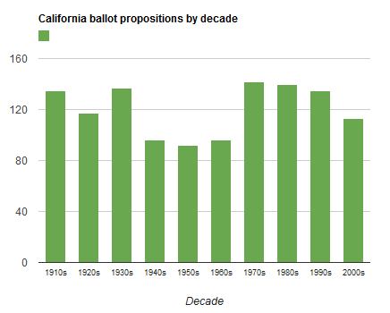
Source: Ballotpedia 2021
However, now more than ever, political organizations and political entrepreneurs view California’s ballot initiative process as a way to advance political agendas. This is also true of elected officials that use this form of direct democracy as a way to campaign and demonstrate what issues they may strongly support or strongly oppose (Caron 2021).
According to Caron’s longitudinal analysis (2021), the overall purpose of direct democracy is for the ability to “foster policy representation” (pg.101). However, also according to Caron (2021), more states that have a direct democracy also maintain the death penalty. This is due to the historical pattern of a majority of voters tend to favor the idea of the death penalty as a legitimate punishment. However, the key term is to maintain the death penalty, but not actually act on execution orders. As previously shown in Table 5 and 6, more Californians favor the moratorium on executions, but still support keeping the death penalty as a punishment for serious crimes. Therefore, for voters and lawmakers alike, there is a perceived objection to the practice of executing death row inmates. This may be primarily due to the concerns over racial bias, costs incurred to maintain the death penalty, the inconsistency in executions drugs, lack of citizen’s attention to the practice, and the rarity of it being performed. By taking all the factors mentioned above in consideration, two questions remain: Would another ballot initiative be a successful way for California to finally abolish the death penalty? Or would it have to be done through other avenues, such as only through a legislative constitutional amendment or through California’s Supreme Court system?
Therefore, to attempt answering the above questions, it would require looking deeper into the disadvantages to the ballot initiative process, but also considering how successful abolishing the death penalty through a legislative constitutional amendment would be. A notable problem with the ballot initiative process, according to Carson Bruno of the Hoover Institution (2016), is “While California’s initiative system is often romanticized, its inflexibility often leads California down a path ripe with unintended consequences and few options for fixing past mistakes.” This essentiality means that California’s ballot initiative process, in theory, is to create policy change in areas that were not successful in going through the legislative route and/or may be deemed too controversial for lawmakers to tackle. Also, the ballot initiative process is viewed as a way to mobilize voter engagement so voters can feel as if they have a hand in bringing awareness to a problem and making direct changes to their government. However, in practice, California’s ballot initiatives often are inflexible (Bruno 2016) and create constitutional changes that go without certain checks and balances. That is, ballot initiatives do not have to go through the same legislative committee process as do legislative bills and cannot be amended after introduction. The ballot initiative’s development also requires a massive amount of funding, in order to gather enough signatures for eligibility and to fund a promotional campaign. This indicates that only certain groups of privileged and connected individuals are able to get a ballot initiative on the ballot to let voters decide. Moreover, despite what is believed about direct democracy being a form of citizen representation, in actuality, according to Dyck and Lascher (2019), ballot initiatives commonly do not reflect real public concerns. Furthermore, more often than not, the ballot initiatives in California tend to limit minority rights. As Dyck and Lascher also address, “initiatives are commonly used to attempt to undermine minority rights and are rarely used to advance them” (2019 pg. 39).
In the case for California, one of the struggles with abolishing the death penalty would have to do with the makeup of who is more likely to be sentenced with the death penalty and who is going to the ballot box on this issue. Currently, California has 711 inmates on death row, 257 are identify as Black, 233 as White, 184 as Latino, 9 as Native American, and 28 are Asian (Death Penalty Information Center October 2020). Furthermore, as shown in Figure 5, racial disparities in terms of who is sentenced to die have significantly increased over the past decade or so. Moreover, the portion of people of color incarcerated and on death row vastly surpasses the population of people of color in society at large.

Figure 5
States with the fastest increasing racial disparity on death row.
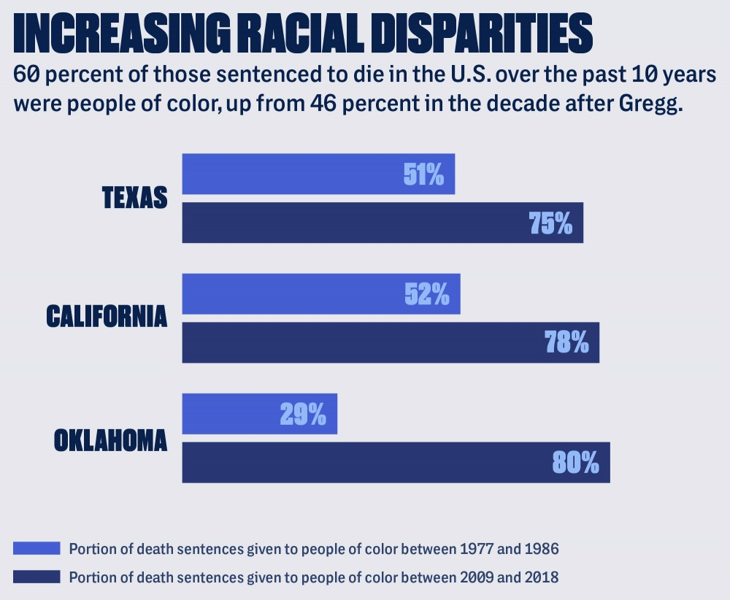
Source: The Intercept 2019
Ultimately, community members, advocacy groups, and interested lawmakers may want to rethink if California’s ballot initiative process is the best path to take to finally abolish the death. Unless there are significant changes in the characteristics of those voting on ballot initiatives, and/or still more adamant evidence of the problems mentioned previously, it is questionable whether the initiative process is the best route for change. Therefore, perhaps it is worth looking towards how other states, similar to California, have successfully abolished the death penalty without resorting to direct democracy.

COLORADO COMPARISON AND HOW THEY ABOLISHED THE DEATH PENALTY THROUGH LEGISLATION
Colorado, like California, is now also perceived as a liberal leaning state. Moreover, in Colorado like California, there is a noticeable rural conservative and urban liberal political ideology divide. Additionally, like most western states, Colorado has an active ballot initiative process (Figure 6). However, what is currently more significant about Colorado is the fact that in 2020, Colorado accomplished abolishing the death penalty through Senate Bill 20-100.
Colorado, only in the last few years or so, has been perceived as more liberal leaning (Marshall, 2019). Except, according to the 2018 Colorado Political Climate Survey, liberal ideology has decreased over the past few years, while conservatism has increased.
Table 7
Colorado Political Ideology Survey Question: When it comes to politics, do you usually think of yourself as...
Political Ideology by Year
 | 2016 | 2017 | 2018
Liberal | 39% | 39% | 34%
Moderate | 32% | 30% | 29%
Conservative | 29% | 31% | 37%
Observations | 1003 | 799 | 800
Source: Colorado Political Climate Report 2018
However, this wavering of ideologies is reflective of the times, not just in Colorado, but in the nation as well. Additionally, what is telling about the political ideology in Colorado and similar to California, is the distinct rural-urban division. Enns and Koch (2013) “regional and community groupings generally move together (or stay the same) in opinion.” Meaning that public opinions, in particular political ideologies, tend to be rather homogenous with the other people they are surrounded by and interact with on the daily. Moreover, Colorado, comparable to California, showcases the rural-urban division between conservative and liberal in voting on ballot initiatives.
Figure 6
Overtime shifts in ideology by state: Focused on Colorado and California
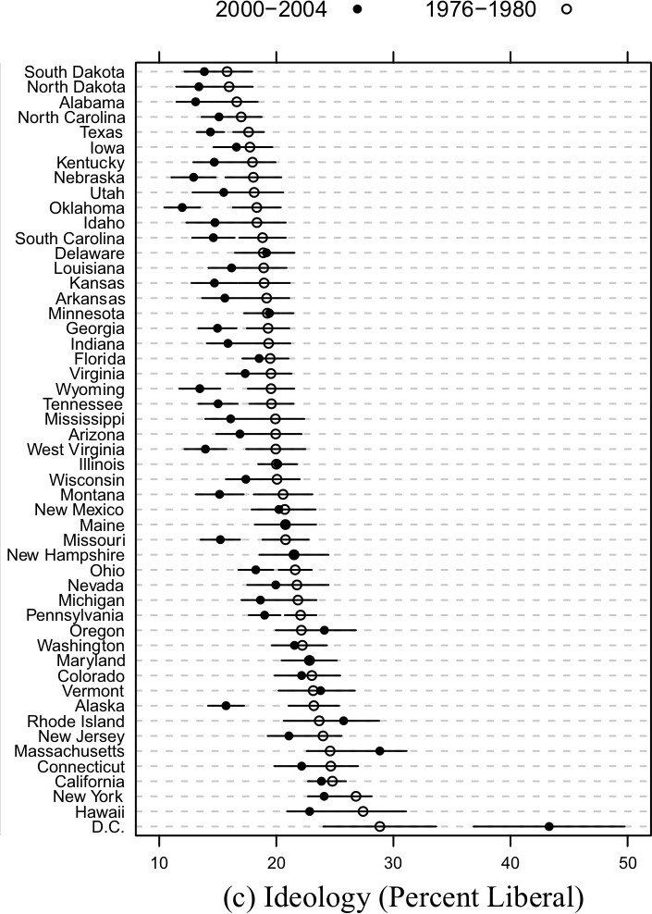
Source: Enns & Koch, 2013.
Since the 1980’s, Colorado has had over 47 constitutional changes due to ballot initiatives (Hazelhurst 2010). And since 1880, a total of 213 ballot initiatives have been adopted in Colorado (Colorado Legislative Staff 2021). Among those 213 ballot initiatives, issues ranged from legislative term limits, lobbying reform, gambling, and school finance to more controversial issues such as abortion, gay rights, and welfare reform (Polhill 1996).
Figure 7
States that have the ballot initiative process.
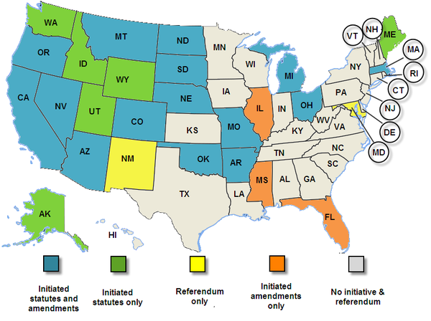
Source: Ballotpedia 2021
However, when it comes to the contentious topic of the death penalty in Colorado, lawmakers are becoming aware of the public’s shifting support to life imprisonment without the chance for parole, the discriminatory practices of death penalty sentencing, the massive cost to maintain the death penalty, especially during a fiscal downturn, and the ineffectiveness of the policy since there has not been an execution performed in Colorado for 20 years and currently only 3 inmates are on death row. Therefore, with bipartisan support, the bill passed by 19-13 in the Senate and by 38-27 in the House of Representatives (Death Penalty Information Center March 2020).
On March 23, 2020, Governor Jared Polis of Colorado signed, SB20-100: Repeal the Death Penalty into law. The law states that on or after July 1, 2020, “the death penalty is not a sentencing option for a defendant convicted of a class 1 felony in the state of Colorado”. However, SB20-100 did not impact any persons who were sentenced to the death penalty before July 1, 2020. Therefore, to accompany the signing of SB20-100, Colorado Governor Polis also commuted the sentences of the three persons who were currently on death row. The implementation of this law essentially made Colorado the 22nd State in the United States to abolish the death penalty. However, this was not Colorado’s first attempt at trying to abolish the death penalty. Like California, Colorado did try to pass legislation to abolish the death penalty in 2009. The bill passed in the Colorado House of Representatives but failed in the Senate. If the bill had been successful, the state would have shifted nearly 1 million dollars a year in state funds that were used to maintain the death penalty and use it towards the solving of cold cases in Colorado (Death Penalty Information Center 2021).

CONCLUSION and RECOMMENDATIONS
California is certainly lagging behind the trend as more and more states--now even a historically southern conservative state like Virginia--are accomplishing complete death penalty abolishment. To determine why California is still struggling with abolishing the death penalty, the main focus of this policy brief has been on determining just how liberal is California, especially when it comes to the issue of abolishing the death penalty. I also have assessed the current and historical process and impact of California’s death penalty ballot initiatives and public opinion polls. Lastly, I considered the how and why Colorado, a state with similarities to California, successfully abolished the death penalty.
My analysis showed that California is not the bastion of liberalism as it is perceived to be. This is especially the case with the emotional issue of abolishing the death penalty. Also, there seems to be a continuing contradiction in how Californian’s perceive the death penalty as a legitimate punishment that should be abolished and how the voters are voting when asked to make this decision at the ballot box.
The Colorado case provides lessons about the types of concerns and political activity that may propel a state to eliminate the death penalty. The following are circumstances, changes, and actions that helped create an opportunity for a policy window to repeal of the death penalty in Colorado:
- Concerns over the high cost of death penalty appeal cases to the State. Also, during a time of massive concerns over State funds due to the COVID-19 pandemic.
- Well organized outreach campaign to victims’ families. And the resulting strong witness testimonies of victims’ families. Most notably, families impacted by the Aurora, CO shooting.
- Support from county prosecutors, many from rural areas where, again, fiscal concerns was the driving motivation.
However, the current pressing question that California lawmakers and advocacy groups are facing now is what would be the most effective direction to take to finally abolishing the death penalty in California? While taking in consideration the lessons learn from Colorado’s success at passing death penalty repeal legislation; California should reemphasis the cost saving aspect of abolishing the death penalty. Where Colorado will shift nearly 1 million dollars a year in state funds that were used to maintain the death penalty, it will now go to solving cold cases. Therefore, California could shift a significant amount of state funds to solving cold cases as well. This could minimize the emotional hold that Californians tend to have and why the support for keeping the death penalty is so strong. Congruently, the well-organized outreach program to victims’ families, I believe, really pushed Colorado over the edge in order to accomplish the abolishment of the death penalty. It is hearing from the most impacted groups of people that may convince lawmakers or voters to reconsider the need to continue maintaining the death penalty in California. Ultimately, whether it be in the form of a constitutional amendment or another attempt at a ballot initiative, Californians’ could succeed in abolishing the death penalty, as Colorado and 22 other states and the District of Columbia have, or keep continuing to fall behind the national trend.

REFERENCES
Alarcón, A. L., & Mitchell, P. M. (2011). Executing the will of the voters? A roadmap to
mend or end the California Legislature's multi-billion-dollar death penalty §
debacle.(Special Issue: Rethinking Death Penalty in California). Loyola of Los
Angeles Law Review, 44(2), S41-S224.

American Politics Research Lab, University of Colorado, Boulder. (2019, January).
Colorado Political Climate Survey 2018 Election Report. Retrieved from
https://www.colorado.edu/lab/aprl/sites/default/files/attached-
files/2018_colorado_political_climate_report_election_full_report_1.12.pdf

Baldassare, M., Bonner, D., Petek, S., & Shrestha, J. (2012, September). PPIC
Statewide Survey: Californians and Their Government. Public Policy Institute of California. Retrieved from https://www.ppic.org/publication/ppic-statewide
-survey-californians-and-their-government-september-2012/.

Baldassare, M., Bonner, D., Dykman, A, and Lawler, R. (2019,
September). California’s Exclusive Electorate: A New Look at Who Votes and Why It Matters. Public Policy Institute of California. Retrieved from https://www.ppic.org/publication/californias-exclusive-electorate-a-new-look-at-who-votes-and-why-it-matters/.

Baldassare, M., Bonner, D., Dykman, A, and Ward, R. (2019, May). PPIC
Statewide Survey: Californians and Their Government. Public Policy Institute of California. Retrieved from https://www.ppic.org/publication/ppic-statewide-survey-californians-and-their-government-may-2019/.

Bollag, S. (2019, March 12 & 14). Ineffective, irreversible and immoral:’ Gavin Newsom
halts death penalty for 737 inmates. Sacramento Bee, Retrieved from
https://www.sacbee.com/news/politics-government/capitol-
alert/article227489844.html.

Bruno, C. (2016, August 30). Issue 1604 California’s Crowded, November Initiative
Slate Part 1: Is it time to reconsider California’s Initiative System? Hoover Institution,
Stanford University, Retrieved from https://www.hoover.org/research/it-time-
reconsider-californias-initiative-system.

California legislative information. (2021). California law, sec, 27 article i declaration of

rights [section 1 - sec. 32]. Leginfo.ca.gov. Retrieved from https://leginfo.legislature.

ca.gov/faces/codes_displaySection.xhtml?lawCode=CONS&sectionNum=SEC.%2027.&article=I.

California Proposition 34. (2019). Ballotpedia.Com. Retrieve from
https://ballotpedia.org/California_Proposition_34,_the_End_the_Death_Penalty_
Initiative_(2012).

California Proposition 62. (2019). Ballotpedia.Com. Retrieve from
https://ballotpedia.org/California_Proposition_62,_Repeal_of_the_Death_Penalty_(2 016).

California Proposition 66. (2019). Ballotpedia.Com. Retrieve from
https://ballotpedia.org/California_Proposition_66,_Death_Penalty_Procedures_(2016

Colorado Legislative Staff (2021). Statewide Ballot Measures by Type, Origin, and
Outcome. Colorado General Assembly. Retrieved from
https://leg.colorado.gov/node/966016/.

Caron, C. (2021). Public Opinion and Death Penalty Policy Under Direct
Democracy Institutions: A Longitudinal Analysis of the American States. American Politics Research, 49(1), 91–105. https://doi.org/10.1177/1532673X20943560.

Hazlehurst, J. (2010, March 5). Colorado's Future exploring initiative process. The
Colorado Springs Business Journal. Retrieved from https://link.gale.com/apps/doc/
A220886729/AONE?u=csus_main&sid=AONE&xid=e8cd34bc.

Death Penalty Information Center. (2021). Colorado: History of the Death Penalty
Death Penalty Information Center. Retrieved from https://deathpenaltyinfo.org/state-
and-federal-info/state-by-state/Colorado.

Death Penalty Information Center. (2020, March 24). Colorado Becomes 22nd State to
Abolish the Death Penalty. Death Penalty Information Center. Retrieved from
https://deathpenaltyinfo.org/news/colorado-becomes-22nd-state-to-abolish-death- penalty#:~:text=On%20March%2023%2C%202020%2C%20Colorado,life%20without%20possibility%20of%20parole.

Death Penalty Information Center. (2020, October 1). Racial Demographics. Death
Penalty Information Center. Retrieved from https://deathpenaltyinfo.org/death-
row/overview/demographics.

DiCamillo, M. (2019, June 17). Californians narrowly back Newsom’s moratorium on
executions, but oppose abolishing the death penalty outright as a punishment for
serious crimes. Berkeley IGS Poll In statute of Governmental Studies. Retrieve from
https://escholarship.org/uc/item/4z69m39g.

Enns, P.K. and Koch, J. (2013, September 12). Public Opinion in the U.S. States: 1956
to 2010. State Politics & Policy Quarterly. 13(3), 349–372. https://doi.org/10.1177/
1532440013496439.

Hindi, S. (2020, March 23). Colorado abolishes death penalty; governor commutes
sentences of 3 on death row. Denver Post. Retrieve from https://www.denverpost.com/2020/03/23/colorado-abolish-death-penalty/.

Jones, J.M. (2019, November 25). Americans Now Support Life On Prison Over Death
Penalty. Gallup Politics, Retrieved from https://news.gallup.com/poll/268514/
americans-support-life-prison-death-Penalty.aspx.

Kaufman-Osborn, T. V. (2006). A critique of contemporary death penalty abolitionism.
Punishment & Society, 8(3), 365-383.

Korey, J.L. & Lascher, E.L (2006). Macropartisanship in California. Public Opinion
Quarterly, 70(1), 48–65. https://doi.org/10.1093/poq/nfj01.1

Lewis, D. (2020). Secondary Effects by Dyck, J.J. and Lascher, E. L. Agenda Setting
under the Initiative Process. Initiatives without Engagement: A Realistic Appraisal of
Direct Democracy’s (pp. 23-49). University of Michigan Press, 2019.
Retrieved from https://doi.org/10.1002/polq.13046.

Marshall, L. (2019, January 24). Is Colorado really blue? Not necessarily, new survey
shows. CU Boulder Today. Retrieved from https://www.colorado.edu/today/
2019/01/24/colorado-really-blue-not-necessarily-new-survey-shows.

Mathews, J. (2019, March 24). Joe Mathews: Why the death penalty has value to
California. The San Francisco Chronicle. Retrieved from https://www.sfchronicle.com/opinion/article/Joe-Mathews-Why-the-death-penalty-has-real-value-13710765.php.

Matsusaka, J. G. (2018). Public policy and the initiative and referendum: a survey with
some new evidence. Public Choice, 174(1-2), 107-143. http://dx.doi.org.proxy.lib.csus.edu/10.1007/s11127-017-0486-0.

Minsker, N. (2013). Proposition 34 and the Future of California’s Death Penalty. Federal
Sentencing Reporter, 25(4), 260-262.

Okpara, C., Hendricks, A.E., & Cobb, L. (2021). Beyond Aggravating and Mitigating
Factors: The Analysis of Colorado's Death Penalty Cases (1999-2010). Justice
Evaluation Journal, 1–35. https://doi.org/10.1080/24751979.2021.1877090.

Polhill, D. (1996, October 24). Are Coloradans Fit to Make Their Own Laws? A
Common-Sense Primer on the Initiative Process. The Independence Institute.
Retrieved from http://www.iandrinstitute.org/reports-papers.cfm.

Romero, M., & Keidan, G. (2017). California's 2014 Ballot Initiative Transparency Act
(BITA) and its Impact on Public Involvement in the Ballot Initiative Process. California Journal of Politics and Policy, 9(2), 0_1,0_2,1-16. http://dx.doi.org.proxy.lib.csus.edu/10.5070/P2cjpp9234891.

Smith, D. A., & Tolbert, C. J. (2001). The Initiative to Party: Partisanship and Ballot
Initiatives in California. Party Politics, 7(6), 739–757.

Young, R. (1991). Race, Conceptions of Crime and Justice, and Support for the Death
Penalty. Social Psychology Quarterly, 54(1), 67-75.

