**Fall 2025 Syllabus**

**for PHIL.122: *Political Philosophy***

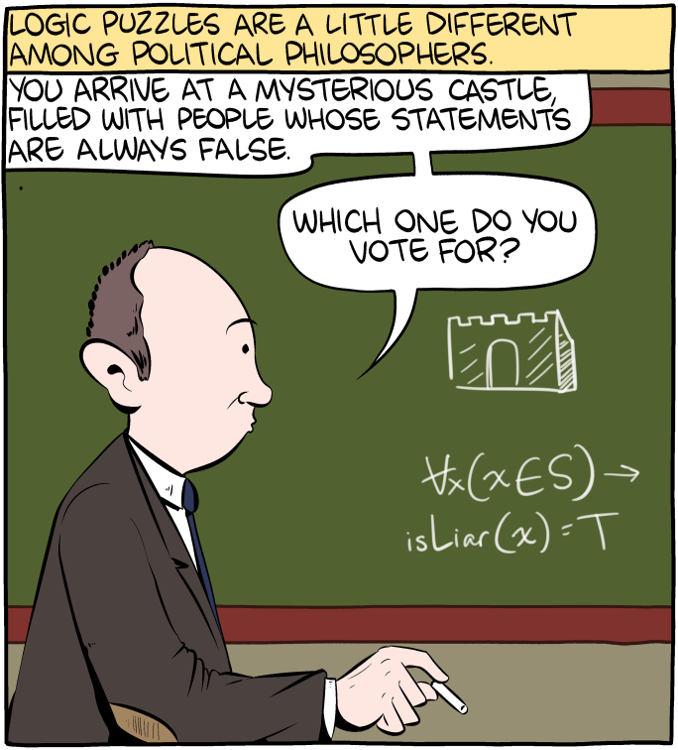

# THE POINT OF THIS COURSE

*Here’s a problem*: People must share the planet with one another. Unfortunately, they have very different ideas regarding how we should go about doing that. Most people inherit their ideas without critically examining them or giving any serious consideration to the alternatives. Ego, inertia, and tribalism determine our politics far more often than reason, principle, or morality.

Of course, everyone thinks that’s true of other people, but not themselves.

Maybe there is no way to escape this fact about human nature. But we can at least try.

This course is designed to help you try.

Class time and location: TuTh 1:30-2:45pm

Instructor: Dr. Garret Merriam

Office Location: Mendocino 3028

Office hours: TuTh 9-10:30 am (and by appointment) [and via Zoom](https://csus.zoom.us/j/81930212378).

Email Address: merriam@csus.edu

Office Phone:  916-278-7588

**Course Description**: A philosophical examination of the individual, the community, and rights; the conflict between individual rights and the common good; various conceptions of justice, equality, liberty and the public good; and the relationship of politics to ethics, economics, law; war and peace.

**Required Textbook:** [*An Introduction to Political Philosophy*, 3rd edition, Jonathan Wolff](https://www.amazon.com/Introduction-Political-Philosophy-Jonathan-Wolff/dp/0199658013/ref=sr_1_1?crid=244503Q38KVB5&keywords=introduction+to+political+philosophy+wolf&qid=1674436527&sprefix=introduction+to+political+philosophy%2Caps%2C287&sr=8-1). This book will be our textbook for the first part of the course and **must be purchased as an ebook through Perusall** (see Canvas). The readings for the remaining weeks will be available on Canvas.

**Learning Objectives:** Upon completion of the course students should be able to:

1. Identify key concepts and arguments pertaining to competing political philosophies.
2. Analyze those arguments from multiple perspectives, finding both strengths and weaknesses.
3. Develop your own ideas and arguments in response to those we cover in class.
4. Challenge those ideas, considering them from competing viewpoints.
5. Express your ideas and arguments, both verbally and in writing, in a manner that is clear, coherent and compelling.

This course satisfies the Humanities (Area C2) General Education/Graduation requirement. For more info, [click here](http://www.csus.edu/acaf/ge/ge%20assessment/area%20c2%20learning%20outcomes.pdf).

**Assessments:**

**Reading Quizzes:** Each week there will be short quizzes on the readings. Each quiz will be 5 questions long, worth 2 points each for a total of 10 points. The purpose of the quiz is to make sure you’ve done the reading, and will focus on the basic facts in the reading. The quizzes are open book, open notes. You will have 15 minutes to complete the quiz.

**Perusall Discussion**: To make sure you are paying attention to the readings, as well as to prepare you for our in-class discussion, you will need to make THREE comments on each reading using Perusall. One comment should be an observation, something that you found interesting or thought provoking and why. Another comment should be a question, something that either doesn’t make sense to you, or that challenges the ideas presented in the lecture. Lastly, you will need to reply to another student’s post, either answering their question, or responding to their ideas with questions of your own. Short perfunctory replies (“This is interesting, thanks for the comment, I had the same question”, etc.) will get no credit. You need to engage substantively with what the other students say for credit. For instructions on how to use Perusall, see Canvas.

**In-Class Discussion**: This is a discussion-based class. A good amount of our in-class time will be of our in-person time will be dedicated to discussion, which means you need to come to class prepared. To be able to participate effectively you must watch the recorded lectures and participated in the comments Perusall (see above). To get full credit you to talk at least once a week. As with the Perusall threads you need to make thoughtful, substantive points to get credit. Ask thoughtful questions, answer the questions asked by others, show me that you are thinking about the material (even if you don’t understand it).

**Oral examination**: In lieu of a traditional long paper, each of you will meet with me one-on-one in my office to discuss one of the topics we cover in class. You will pick the topic, articulate a thesis, make an argument in support of it, and consider and reply to objections. Notes will be allowed, but the format will be a discussion, not simply reading your notes to me. More detail will be given in class.

| Learning Activities | Due | Value (pt) | Percentage (%) | Letter Grading |
| --- | --- | --- | --- | --- |
| **Quizzes** | 2X Weekly | 20 per week | 30 | A = 93-100% |
| **Perusall Discussion** | 2X Weekly | 20 per week | 30 | A- =92-90% |
| **Class Participation** | Weekly | 15 per week | 195 | B+ = 89-87% |
| **Oral Exam** | End of semester | 205 | 205 | B = 86-83% |
| Total Points |  | 1000 | 100 | Etc. |

**Attendance Bonus and Penalty:** To give you an incentive to show up, each one of you starts with 60 bonus points (out of 1000) that will be attributed to your final grade.  Every time you miss a class without a documented excuse, I take 30 points away from your grade.  Hence, you can miss two classes before your extra points run out; after that, it starts eating into your earned points.

**AI and Academic Misconduct:** Using an AI text generator for any class assignments, unless the instructor specifically instructs otherwise is dishonest and will be considered a violation of the CSUS Academic Honesty policy here.Submitting any course assignments or prompts to an AI text generator and then submitting the results or any altered form of the results for credit for the assignment in class unless specifically instructed to do so by the instructor will be considered plagiarism, and it could be subject to the full range of sanctions outlined in the university policy.

You may think there is no way you could get caught. That’s what the 40 of the 96 students in a recent class I taught thought, too, but nonetheless, I caught all 40 of them.

**Should you be caught cheating (with AI or any other method) on a paper, quiz, discussion post or an exam, this is grounds for your immediate failure of the course**. ALL incidents of cheating and plagiarism will be reported both to the Department Chair and to the Judicial Officer in the Office of Student Affairs for possible further administrative sanction, up to and including expulsion from the university.

**Late Work Policy:** I am willing to give short extensions on assignments, provided the request is made BEFORE the due date. Otherwise, no late assignments will be accepted.

To prove that you read the syllabus: Beneath the syllabus posting on Canvas there is a tab labeled “Did you read the syllabus?” Click on it and attach a picture of a pet (cat, dog, etc.) I will not grade any of your assignments until you complete this task.

**Reasonable Accommodations:** If you have a documented disability (visible or invisible) and require accommodation or assistance with assignments, tests, attendance, note taking, etc., please see the instructor by the end of the third week of semester so that arrangements can be made. Failure to notify and consult with the instructor by this date may impede my ability to offer you the necessary accommodation and assistance in a timely fashion. Also be sure to consult with the [Services to Students with Disabilities](http://www.csus.edu/sswd/index.html)) to see what other campus services and accommodation options are available for you. Students with other types of accommodation requirements, such as English as a second language, are invited to discuss them with the instructors to facilitate understanding and the best learning experience for all. All information will remain confidential.

**Student Health & Counseling Services:** Due to the current and ongoing events faced by many during this public health crisis and era of civil unrest, the University recognizes that many of you may be in need of support.  Please be aware that [Health and Counseling Services](https://www.csus.edu/student-life/health-counseling) staff are available for virtual and in-person services.

     Additionally, if you are experiencing any COVID-like symptoms (fever, cough, sore throat, muscle aches, loss of smell or taste, nausea, diarrhea, or headache) or have had exposure to someone who has tested positive for COVID contact **Student Health & Counseling Services (SHCS) at 916-278-6461** to receive guidance and/or medical care. You are asked to report any possible COVID-related illnesses or exposures to SHCS via this link [COVID-19 Illness/Exposure Report Form](https://sacstateshcs.wufoo.com/forms/covid19-illnessexposure-report/). You should expect a call from SHCS within 24 hours.

**Contact Information for the Chair of the Department:** If you have a problem with either the class or with me I would appreciate it if you talked to me about it first. But if you feel you cannot talk to me for some reason, you can talk to my department Chair, Dr. Russell DiSilvestro at rdisilv@csus.edu.

**Reading Schedule** (Subject to revision.)  
  
The Readings for the first six weeks are from *An Introduction to Political Philosophy* by Jonathan Wolff. All subsequent readings will be posted on Canvas.

Week of 8/25: Introduction

* Intro: Opening and Greetings (No Assignment)
* Syllabus, Course Overview (Read the Syllabus)

Week of 9/1: Chapter 1: The State of Nature

* Intro, Hobbes (P. 6-17)
* Locke, Rousseau, Anarchism, Conclusion (P. 17-33)

Week of 9/8: Chapter 2: Justifying the State

* Intro, The Social Contract (P. 34-48)
* Utilitarianism, The Principle of Fairness, Conclusion (P. 49-61)

Week of 9/15: Chapter 3: Who Should Rule?

* Introduction, Plato Against Democracy, (P. 62-77)
* Rousseau & the General Will, Representative Democracy, Conclusion (P. 77-103)

Week of 9/22: Chapter 4: The Place of Liberty

* Mill on Liberty, Justifying the Liberty Principle (P. 104-125)
* Problems with Liberalism, Conclusion (P. 125-133)

Week of 9/29: Chapter 5: The Distribution of Property

* The Problem of Distributive Justice, Property and Markets, (P. 134-153)
* Rawls’ theory of justice, Rawls and his critics, conclusion (P. 153-178)

Week of 10/6: Chapter 6: Justice for Everyone, Everywhere?

* ’Oversights of justice’, Justice for Everyone? (P. 179-203)
* Justice Everywhere?, Final Word (P. 203-215)

(Subsequent Weeks will be added after the class votes on the topics you want to cover.)