Spring 2023 Syllabus
for PHIL.122: Political Philosophy
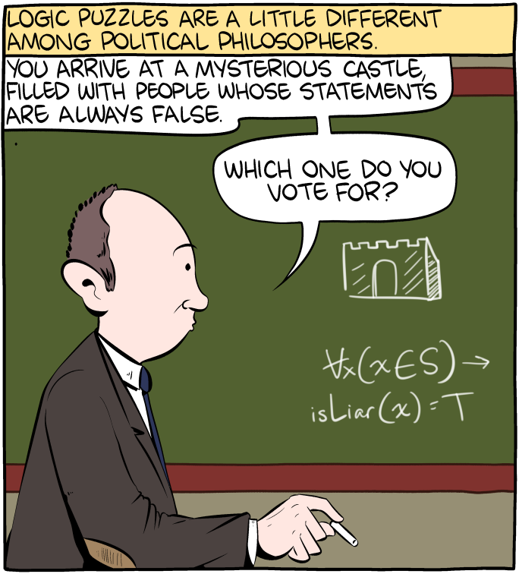

Class time and location: MW 1:30-2:45 pm in Douglass Hall 208
Instructor: Dr. Garret Merriam
Office Location: Mendocino 3028
Office Phone: 916-278-7588
Office hours: MW: 3-4 pm and By Appointment, in person, and via Zoom.
Email Address: merriam@csus.edu

Course Description: A philosophical examination of the individual, the community, and rights; the conflict between individual rights and the common good; various conceptions of justice, equality, liberty and the public good; and the relationship of politics to ethics, economics, law; war and peace.

Required Textbook: An Introduction to Political Philosophy, 3rd edition, Jonathan Wolff. This book will be our textbook for the first part of the course. The readings for the remaining weeks will be available on Canvas.

Learning Objectives: Upon completion of the course students should be able to:
- Identify key concepts and arguments pertaining to competing political philosophies.
- Analyze those arguments from multiple perspectives, finding both strengths and weaknesses.
- Develop your own ideas and arguments in response to those we cover in class.
- Challenge those ideas, considering them from competing viewpoints.
- Express your ideas and arguments, both verbally and in writing, in a manner that is clear, coherent and compelling.

This course satisfies the Humanities (Area C2) General Education/Graduation requirement. For more info, click here.
Grading:
Assignment | Due | Value (pt) | Percentage (%) | Letter Grading
Reading Quizzes | Weekly | 250 | 25 | A- =92-90%
1st Paper Rough Draft | 3/10 | 100 | 10 | B+ = 89-87%
1st Paper Final Draft | 3/31 | 200 | 20 | B- = 82-80%
2nd Paper Rough Draft | 4/21 | 150 | 15 | C+ = 79-77%
2nd Paper Final Draft | 5/12 | 300 | 30 | C- = 72-70%››
Total Points |  | 1000 | 100 | Etc.
TOTAL: 1,000 points

Reading Quizzes: Each week there will be short quizzes on the readings. Each quiz will be 5 questions long, worth 2 points each for a total of 10 points. The purpose of the quiz is to make sure you’ve done the reading, and will focus on the basic facts in the reading. The quizzes are open book, open notes. You will have 15 minutes to complete the quiz.

Paper Drafts: A rough-draft of your long paper. It does not have to be polished, but it should be complete. That is, it should have all of the five following components (1) your thesis statement, (2) a short summary of the reading(s) you’re responding to, (3) your own original argument in response to the reading(s), (4) a charitable objection to your argument as a counterpoint, and (5) your response to that objection.

Long Paper: Your final draft must be 1,200 words (about 4 pages, double-spaced), ideally (but not necessarily) revised from your rough draft. You will need to demonstrate both an understanding of what you’ve read and an ability to think about it and criticize it in your own terms. There will be a lecture dedicated to how to write a philosophy paper.

Attendance Bonus and Penalty: To give you an incentive to show up, each one of you starts with 60 bonus points (out of 1000) that will be attributed to your final grade. Every time you miss a class without a documented excuse, I take 30 points away from your grade. Hence, you can miss two classes before your extra points run out; after that, it starts eating into your earned points.

AI and Academic Misconduct: Using an AI text generator for any class assignments, unless the instructor specifically instructs otherwise is dishonest and will be considered a violation of the CSUS Academic Honesty policy here. Submitting any course assignments or prompts to an AI text generator and then submitting the results or any altered form of the results for credit for the assignment in class unless specifically instructed to do so by the instructor will be considered plagiarism, and it could be subject to the full range of sanctions outlined in the university policy.

In addition to using TurnItIn, this course may use rapidly evolving technology (like this) to help detect when student writing has been assisted by AI technology (like Chat GPT). Improper use of AI technology can be grounds for a charge of plagiarism or other academic misconduct, leading to academic penalties (like failing a course) and administrative penalties (like expulsion from the university), regardless of when the academic misconduct is discovered. It is likely that, in the arms race that is digital technology, what seems like today’s detection-proof AI writing tool will be easy to detect by tomorrow, or next week, or next month.

Should you be caught cheating on a paper, quiz, discussion post or an exam, this may be grounds for your immediate failure of the course. ALL incidents of cheating and plagiarism will be reported both to the Department Chair and to the Judicial Officer in the Office of Student Affairs for possible further administrative sanction.

Everyone must complete the Plagiarism Tutorial here before I will grade your papers and have a copy of your results sent to me.

Late Work Policy: I am willing to give short extensions on assignments, provided the request is made BEFORE the due date. Otherwise, no late assignments will be accepted.
To prove that you read the syllabus: Beneath the syllabus posting on Canvas there is a tab labeled “Did you read the syllabus?” Click on it and attach a picture of a pet (cat, dog, etc.) I will not grade any of your assignments until you complete this task.

Reading Schedule (Subject to revision.)
The Readings for the first six weeks are from An Introduction to Political Philosophy by Jonathan Wolff. All subsequent readings will be posted on Canvas›››.

Week of 1/23: Introduction
- Intro: Opening and Greetings (No Assignment)
- Syllabus, Course Overview (Read the Syllabus)

Week of 1/30: Chapter 1: The State of Nature
- Intro, Hobbes (P. 6-17)
- Locke, Rousseau, Anarchism, Conclusion (P. 17-33)

Week of 2/6: Chapter 2: Justifying the State
- Intro, The Social Contract (P. 34-48)
- Utilitarianism, The Principle of Fairness, Conclusion (P. 49-61)

Week of 2/13: Chapter 3: Who Should Rule?
- Introduction, Plato Against Democracy, (P. 62-77)
- Rousseau & the General Will, Representative Democracy, Conclusion (P. 77-103)

Week of 2/20: Chapter 4: The Place of Liberty
- Mill on Liberty, Justifying the Liberty Principle (P. 104-125)
- Problems with Liberalism, Conclusion (P. 125-133)
Week of 2/27: Chapter 5: The Distribution of Property
- The Problem of Distributive Justice, Property and Markets, (P. 134-153)
- Rawls’ theory of justice, Rawls and his critics, conclusion (P. 153-178)

Week of 3/6: Chapter 6: Justice for Everyone, Everywhere?
- ’Oversights of justice’, Justice for Everyone? (P. 179-203)
- Justice Everywhere?, Final Word (P. 203-215)
(Subsequent Weeks will be added after the class votes on the topics you want to cover.)

Reasonable Accommodations: If you have a documented disability (visible or invisible) and require accommodation or assistance with assignments, tests, attendance, note taking, etc., please see the instructor by the end of the third week of semester so that arrangements can be made. Failure to notify and consult with the instructor by this date may impede my ability to offer you the necessary accommodation and assistance in a timely fashion. Also be sure to consult with the Services to Students with Disabilities to see what other campus services and accommodation options are available for you. Students with other types of accommodation requirements, such as English as a second language, are invited to discuss them with the instructors to facilitate understanding and the best learning experience for all. All information will remain confidential.

Student Health & Counseling Services: Due to the current and ongoing events faced by many during this public health crisis and era of civil unrest, the University recognizes that many of you may be in need of support. Please be aware that Health and Counseling Services staff are available for virtual and in-person services.

Additionally, if you are experiencing any COVID-like symptoms (fever, cough, sore throat, muscle aches, loss of smell or taste, nausea, diarrhea, or headache) or have had exposure to someone who has tested positive for COVID contact Student Health & Counseling Services (SHCS) at 916-278-6461 to receive guidance and/or medical care. You are asked to report any possible COVID-related illnesses or exposures to SHCS via this link COVID-19 Illness/Exposure Report Form. You should expect a call from SHCS within 24 hours.

Contact Information for the Chair of the Department: If you have a problem with either the class or with me I would appreciate it if you talked to me about it first. But if you feel you cannot talk to me for some reason, you can talk to my department Chair, Dr. Russell DiSilvestro at rdisilv@csus.edu.

