Phil 2: Introduction to Ethics
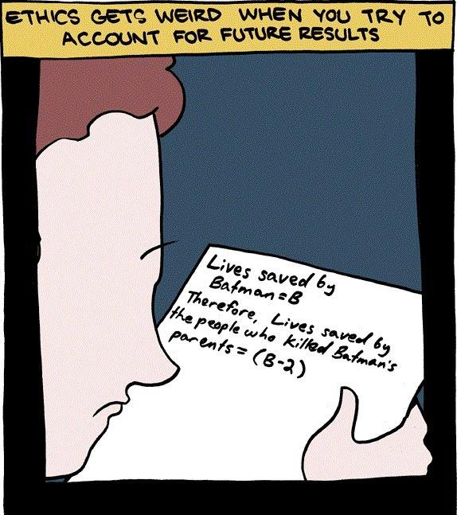
Phil.2 | 3 Credit Hours | Fall 2023
Instructor Information
Instructor | Email
Dr. Garret Merriam | merriam@csus.edu
Class time and Location: TuTh: 10:30-11:45pm, Douglas Hall 110
Drop-In Hours and Location: TuTh: 2-3:15 pm (and by appointment), Mendocino 3028
Communication Expectations: Email is the most reliable way to contact me. I check my email multiple times a day. I should respond to any emails within 24 hours. If I don’t get back to you in 24 hours, assume I haven’t received your message, and email me again.
Course Description: Examination of the concepts of morality, obligation, human rights, & the good life. Competing theories about the foundations of morality will be investigated. This course explores the major problems and questions of moral philosophy by applying various ethical theories and principles to historical and contemporary moral dilemmas.
Prerequisite(s): None

Learning Objectives: Upon completion of the course, each student should be able to:
- Identify key concepts & arguments related to major moral theories & controversies.
- Apply those moral theories to novel circumstances.
- Contrast strengths/weaknesses of major arguments on controversial topics.
- Develop creative solutions to novel, challenging moral problems.
- Question/Challenge their own ideas about moral controversies.
- Debate core points of moral controversies.

This course satisfies Humanities (Area C2) General Education/Graduation requirement.
Readings: All readings will be posted on Canvas in PDF or DOC format.
Assessments
Reading Responses: Each week you will have to pick one of the readings and write a short post on Canvas addressing three points: (1) What do you take (one of) the main arguments in the paper to be? (2) What is a potential problem or challenge to that argument? And (3) ask a question about the reading (either something you don’t understand about it, or something the reading made you wonder.) Posts will be due the night before we begin our discussion of the reading.

Reading Quizzes: Each week there will be short quizzes on the readings. Each quiz will be 5 questions long, worth 2 points each for a total of 10 points. The purpose of the quiz is to make sure you’ve done the reading, and will focus on the basic facts in the reading. The quizzes are open book, open notes. You will have 15 minutes to complete the quiz.

Four Sentence Papers: These are two short writing assignment designed to prime you for writing the argumentative paper. You will pick one of the readings and write a paper based on the following template: “They say…; I say…; One might object…; I reply…”

Midterm: The midterm will give you a sense of how well you have been following the material in the course. It is a relatively low-stakes exam that will hopefully let you know how well you’ve been absorbing and remembering the content. It will also give you a preview of the final exam.

Oral examination: In lieu of a traditional long paper, each of you will meet with me one-on-one in my office to discuss one of the topics we cover in class. You will pick the topic, articulate a thesis, make an argument in support of it, and consider and reply to objections. Notes will be allowed, but the format will be a discussion, not simply reading your notes to me. More detail will be given in class.

Final: The final will be relatively difficult will require not only familiarity with the material but the ability to use the material to draw practical conclusions from it. You will be expected to have read and studied the readings as well the lectures. There will be a final review beforehand to help you study.

Grading
Learning Activities | Due | Value (pt) | Percentage (%) | Letter Grading
Reading Responses | Weekly | 150 | 15 | A = 93-100%
Quizzes | 2X Weekly | 250 | 25 | A- =92-90%
4-Sentence Papers | 10/3 & 11/7 | 50 (each) | 10 (total) | B+ = 89-87%
Midterm | 10/13 | 100 | 10 | B = 86-83%
Oral Examination | 12/1 | 200 | 20 | C+ = 79-77%
Final Exam | Week of 12/11 | 200 | 20 | C = 76-73%
Total Points |  | 1000 | 100 | Etc.
Course Policies
- Weekly Assignments: Most weeks will have two assigned readings. For every reading there will be two key assignments you need to do. (1) Read the essay (~5-10 pages per reading). (2) Take the reading quiz for the essay.

- Applied Topics: The class will vote on which applied topics you want to cover in this course. I will post a poll on Canvas with the options. The 5-6 topics with the most votes will be the ones we cover in class.

- Attendance Bonus and Penalty: To give you an incentive to show up, each one of you starts with 60 bonus points (out of 1000) that will be attributed to your final grade. Every time you miss a class, I take 30 points away from your grade. Hence, you can miss two classes before your extra points run out; after that, it starts eating into your earned points.

- AI and Academic Misconduct: Using an AI text generator for any class assignments, unless the instructor specifically instructs otherwise is dishonest and will be considered a violation of the CSUS Academic Honesty policy here. Submitting any course assignments or prompts to an AI text generator and then submitting the results or any altered form of the results for credit for the assignment in class unless specifically instructed to do so by the instructor will be considered plagiarism, and it could be subject to the full range of sanctions outlined in the university policy.
In addition to using TurnItIn, this course may use rapidly evolving technology (like this) to help detect when student writing has been assisted by AI technology (like Chat GPT). Improper use of AI technology can be grounds for a charge of plagiarism or other academic misconduct, leading to academic penalties (like failing a course) and administrative penalties (like expulsion from the university), regardless of when the academic misconduct is discovered. It is likely that, in the arms race that is digital technology, what seems like today’s detection-proof AI writing tool will be easy to detect by tomorrow, or next week, or next month.

Everyone must complete the Plagiarism Tutorial here and submit a copy of the results on Canvas to me before I will grade your papers.

- ‘Study Websites’ and Academic Misconduct The use of websites, such as Chegg, Quizlet, and Course Hero are prohibited. If you are discovered using them (and it is not as hard to discover as you might think) you will be reported both to the Department Chair and the Office of Student Conduct for possible further administrative sanction.

Should you be caught cheating on a paper, quiz, discussion post or an exam, this may be grounds for your immediate failure of the course. ALL incidents of cheating and plagiarism will be reported both to the Department Chair and to the Judicial Officer in the Office of Student Affairs for possible further administrative sanction.
- Reasonable Accommodations: If you have a documented disability (visible or invisible) and require accommodation or assistance with assignments, tests, attendance, note taking, etc., please contact me by the end of the third week of semester so that arrangements can be made. Failure to notify and consult with the instructor by this date may impede my ability to offer you the necessary accommodation and assistance in a timely fashion. Also be sure to consult with the Services to Students with Disabilities in Lassen Hall to see what other campus services and accommodation options are available for you. Students with other types of accommodation requirements, such as English as a second language, are invited to discuss them with me to facilitate understanding and the best learning experience for all. All information will remain confidential.

- Late Work Policy: Writing assignments: I am willing to give short extensions, no questions asked, provided the request is made BEFORE the due date. If a request is made after the due date a documented excuse, such as a doctor’s note, will be required.

Quizzes: If you know you will miss a quiz notify me in advance and we can make arrangements for a makeup at a later date. Otherwise, no late work will be accepted. You have a full week to complete these, so having a problem after waiting until the last minute, or simply forgetting the due date is not an excuse.

Beneath the syllabus posting on Canvas there is a tab labeled “Did you read the syllabus?” Click on it and attach a picture of a pet animal. It can be your cat, dog, bird, etc., or one you got from the internet, as long as it’s a picture of a pet. I will not grade any of your assignments until you complete this task.

- If You’re Having Difficulty: I’m available to give help to anyone who needs and wants it. You must, however, let me know that you want the extra help. You’re not imposing or inconveniencing me all; I am here to help you learn, and you are entitled to ask for that help. Email me, drop into my Zoom office hours, let me know you need help.
- Reading Schedule for the first weeks (will be updated after applied topics are voted on):
Week of 8/28—Intro and Utilitarianism
- Opening and Greetings; Syllabus, Course Overview
- “How to Be Perfect (Introduction)”—Michael Schur

Week of 9/4—Virtue Ethics and Utilitarianism
Kantianism and Virtue Ethics
- “Should I Punch My Friend in the Face for No Reason?”—Michael Schur
- “Should I Let This Runaway Trolley I’m Driving Kill Five People, or Should I Pull a Lever and Deliberately Kill One (Different) Person?”—Michael Schur
Week of 9/11—Utilitarianism and Metaethics
- “Should I Lie and Tell My Friend I Like Her Ugly Shirt?”—Michael Schur
- “Relativism in Ethics”—William Shaw

Week of 9/18—Metaethics: Divine Command Theory
- “Morality, Religion and Conscience”—John Arthur

Student Health & Counseling Services

Due to the current and ongoing events faced by many during this public health crisis and era of civil unrest, the University recognizes that many of you may be in need of support. Please be aware that Health and Counseling Services staff are available for virtual and in-person services.

Additionally, if you are experiencing any COVID-like symptoms (fever, cough, sore throat, muscle aches, loss of smell or taste, nausea, diarrhea, or headache) or have had exposure to someone who has tested positive for COVID contact Student Health & Counseling Services (SHCS) at 916-278-6461 to receive guidance and/or medical care. You are asked to report any possible COVID-related illnesses or exposures to SHCS via this link COVID-19 Illness/Exposure Report Form. You should expect a call from SHCS within 24 hours. As an FYI, the Sac State Mobile App also has a self-assessment tool, in case you would like to screen yourself for symptoms of COVID-19. Feel free to utilize it, especially if you plan on going somewhere where others may be exposed (such as going to campus). The app will also have information on the University’s latest on-campus protocols.

Contact Information for the Department Chair: If you have a problem with either the class or with me I would appreciate it if you talked to me about it first. But if you feel you cannot talk to me for some reason, you can talk to my department Chair, Dr. Russell DiSilvestro at rdisilv@csus.edu.

