**Phil 2: Ethics, Fall 2025 (Online)**

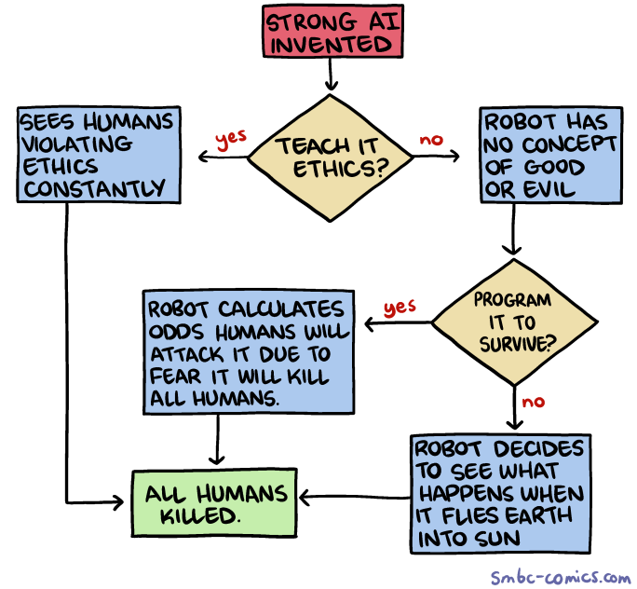

The Purpose of This Course:  
  
Lots of ‘moral problems’ in courses like this are contrived sci-fi thought experiments designed to clarify some abstract moral principle. But most of the time ethics isn’t so fanciful. In real life, ethics is about the human heart at war with itself, and the hearts of others. Outside the classroom, there is no author making formal arguments, no professor carefully guiding you through your options.

This is a problem. Because someday a friend is going to ask you to tell a very big lie for them. A stranger is going to beg you for help that could put you in danger if you decide to give it. Your boss is going to tell you to do something that goes against your conscience.

You won’t have to justify your decision in an essay. No one is going to be grading you. No AI or LLM will be there to tell you what to do. The only assessment will be your ability to live with yourself after making the choice.

The purpose of this class is to help prepare you to make that choice.

**IInstructor Information**

| **Instructor** | **Email** |
| --- | --- |
| Dr. Garret Merriam | merriam@csus.edu |

Office Hours and Location: Tu, Th: 9:00-10:30 am (and by appointment), MND 3028

and over Zoom ([link here](https://csus.zoom.us/j/81930212378).)

Communication Expectations: Email is the most reliable way to contact me. I check my email multiple times a day. I should respond to any emails within 24 hours. If I don’t get back to you in 24 hours, assume I haven’t received your message, and email me again.

Course Description: Examination of the concepts of morality, obligation, human rights, & the good life. Competing theories about the foundations of morality will be investigated. This course explores the major problems and questions of moral philosophy by applying various ethical theories and principles to historical and contemporary moral dilemmas.

Prerequisite(s):None

Learning Objectives:Upon completion of the course, each student should be able to:

1. Identify key concepts & arguments related to major moral theories & controversies.
2. Apply those moral theories to novel circumstances.
3. Contrast strengths/weaknesses of major arguments on controversial topics.
4. Develop creative solutions to novel, challenging moral problems.
5. Question/Challenge their own ideas about moral controversies.
6. Debate core points of moral controversies.

This course satisfies [Humanities (Area C2) General Education/Graduation requirement.](http://www.csus.edu/acaf/ge/ge%20assessment/area%20c2%20learning%20outcomes.pdf)

Readings: All readings will be posted on Canvas in PDF or DOC format.

Weekly Assignments: Most weeks will have **two assigned readings**. For every reading there will be **four key assignments** you need to do. (1) **Read** the essay (~5-10 pages per reading). (2) Take the **reading quiz** for the essay. (3) Watch the **video lecture** for the essay. (4) Participate in the **Perusall discussion** for the week (covers both readings.)

**Assessments**

**Reading Quizzes:** Each week there will be short quizzes on the readings. Each quiz will be 5 questions long, worth 2 points each for a total of 10 points. The purpose of the quiz is to make sure you’ve done the reading, and will focus on the basic facts in the reading. The quizzes are open book, open notes. You will have 10 minutes to complete the quiz.

**Perusall Lecture Discussion**: Since this isa fully online course, you will need to spend about two hours each week watching recorded lectures. To make sure you are paying attention you will need to make THREE comments on each lecture using Perusall. One comment should be an observation, something that you found interesting or thought provoking and why. Another comment should be a question, something that either doesn’t make sense to you, or that challenges the ideas presented in the lecture. Lastly, you will need to reply to another student’s post, either answering their question, or responding to their ideas with questions of your own. Short perfunctory replies (“This is interesting, thanks for the comment, I had the same question”, etc.) will get no credit. You need to engage substantively with what the other students say for credit. For instructions on how to use Perusall, see Canvas.

**Four Sentence Papers**: These are two short writing assignment designed to prime you for writing the argumentative paper. You will pick one of the readings and write a paper based on the following template: “They say…; I say…; One might object…; I reply…” A more detailed explanation of the assignment will be posted on Canvas.

**Midterm**: The midterm will give you a sense of how well you have been following the material in the course. It is a relatively low-stakes exam that will hopefully let you know how well you’ve been absorbing and remembering the content. It will also give you a preview of the final exam.

**Long Paper:** You must write be at least 1200 words (about 4 pages, double-spaced), ideally building off of the outline above. You will need to demonstrate both an understanding of what you’ve read and an ability to think about it and criticize it in your own terms. There will be a lecture dedicated to how to write a philosophy paper. There will be sign-ups for the precise due date.

**Final:** The final will be relatively difficult will require not only familiarity with the material but the ability to use the material to draw practical conclusions from it. You will be expected to have read and studied the readings and will be tested on the material in them, as well as issues that come up in the lectures. There will be a final review beforehand to help you study.

**Grading**

| Learning Activities | Due | Points | Percentage (%) | Letter Grading |
| --- | --- | --- | --- | --- |
| **Discussion (Perusall)** | Weekly | 300 | 30 | A = 93-100% |
| **Quizzes** | 2X Weekly | 30 | 30 | A- =92-90% |
| **4-Sentence Papers** | TBD | 25 (each) | 5 (total) | B+ = 89-87% |
| **Midterm** | Week of 2/24 | 50 | 5 | B = 86-83% |
| **Long Paper** | 5/2 | 100 | 10 | C+ = 79-77% |
| **Final Exam** | Week of 5/12 | 200 | 20 | C = 76-73% |
| Total Points |  | 1000 | 100 | Etc. |

**AI and Academic Misconduct:** Using an AI text generator for any class assignments, unless the instructor specifically instructs otherwise is dishonest and will be considered a violation of the CSUS Academic Honesty policy here.Submitting any course assignments or prompts to an AI text generator and then submitting the results or any altered form of the results for credit for the assignment in class unless specifically instructed to do so by the instructor will be considered plagiarism, and it could be subject to the full range of sanctions outlined in the university policy. The use of assistive technologies and websites, such as Chegg, Quizlet, and Course Hero are also prohibited.

You may think there is no way you could get caught. That’s what the 40 of the 96 students in a recent class I taught thought, too, but nonetheless, I caught all 40 of them.

*This is an ethics class, people.* If you cheat in this class I can only conclude that you know nothing about ethics and there is nothing I can teach you about it. Accordingly, **should you be caught cheating (with AI or any other method) on a paper, quiz, discussion post or an exam, this is grounds for your immediate failure of the course**. ALL incidents of cheating and plagiarism will be reported both to the Department Chair and to the Judicial Officer in the Office of Student Affairs for possible further administrative sanction, up to and including expulsion from the university.

**Late Work Policy**: I am willing to give short extensions on assignments, provided the request is made BEFORE the due date. No justification is required, just email me asking for an extension before the deadline and you can have one. Otherwise, no late assignments will be accepted without documented excuse (e.g.—a doctor’s note.)

To prove that you read the syllabus: Beneath the syllabus posting on Canvas there is a tab labeled “Did you read the syllabus?” Click on it and attach a picture of a pet (cat, dog, etc.) I will not grade any of your assignments until you complete this task.

Reasonable Accommodations**:** If you have a documented disability (visible or invisible) and require accommodation or assistance with assignments, tests, attendance, note taking, etc., please contact me by the end of the third week of semester so that arrangements can be made. Failure to notify and consult with the instructor by this date may impede my ability to offer you the necessary accommodation and assistance in a timely fashion. Also be sure to consult with the [Services to Students with Disabilities in Lassen Hall](http://www.csus.edu/sswd/index.html)  to see what other campus services and accommodation options are available for you.

Students with other types of accommodation requirements, such as English as a second language, are invited to discuss them with me to facilitate understanding and the best learning experience for all. All information will remain confidential.

**Contact Information for the Department Chair:** If you have a problem with either the class or with me I would appreciate it if you talked to me about it first. But if you feel you cannot talk to me for some reason, you can talk to my department Chair, Dr. Russell DiSilvestro at [rdisilv@csus.edu](mailto:rdisilv@csus.edu).

**Reading Schedule for the first weeks** (will be updated after applied topics are voted on):

Week of 8/25—Introduction

● Opening and Greetings; Syllabus, Course Overview

Week of 9/1—Virtue Ethics

● “How to Be Perfect (Introduction)”—Michael Schur

● “Should I Punch My Friend in the Face for No Reason?”—Michael Schur

Week of 9/8—Utilitarianism & Kantianism

● “Should I Let This Runaway Trolley I’m Driving Kill Five People, or Should I Pull a Lever and Deliberately Kill One (Different) Person?”—Michael Schur

● “Should I Lie and Tell My Friend I Like Her Ugly Shirt?”—Michael Schur

Week of 9/16–Metaethics: Relativism and Divine Command Theory

● “Relativism in Ethics”—William Shaw

● “Morality, Religion and Conscience”—John Arthur