**Phil 2: Introduction to Ethics, Fall 2025**

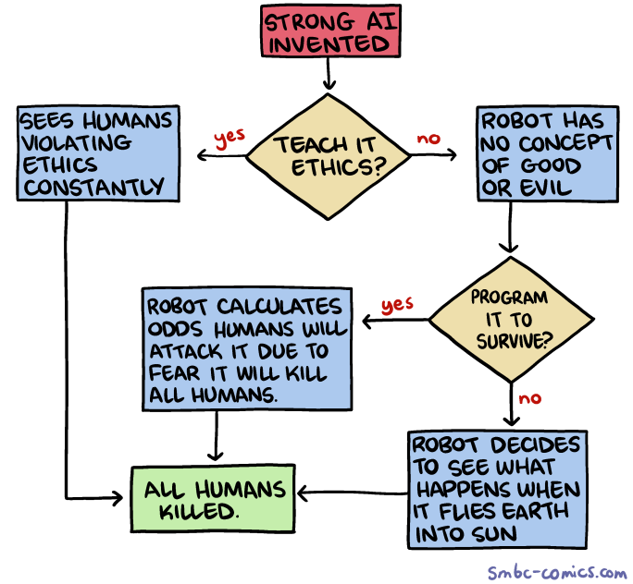

The Purpose of This Course:  
  
Lots of ‘moral problems’ in courses like this are contrived sci-fi thought experiments designed to clarify some abstract moral principle. But most of the time ethics isn’t so fanciful. In real life, ethics is about the human heart at war with itself, and the hearts of others. Outside the classroom, there is no author making formal arguments, no professor carefully guiding you through your options.

This is a problem. Because someday a friend is going to ask you to tell a very big lie for them. A stranger is going to beg you for help that could put you in danger if you decide to give it. Your boss is going to tell you to do something that goes against your conscience.

You won’t have to justify your decision in an essay. No one is going to be grading you. No AI or LLM will be there to tell you what to do. The only assessment will be your ability to live with yourself after making the choice.

The purpose of this class is to help prepare you to make that choice.

**Instructor Information**

| **Instructor** | **Email** |
| --- | --- |
| Dr. Garret Merriam | merriam@csus.edu |

Class time and Location: Tu, Th: 10:30-11:45 am, Mendocino 3009

Tu, Th: 12:00–1:45 am, Mendocino 3009

Office Hours and Location: Tu, Th: 9:00-10:30 am (and by appointment), MND 3028

and over Zoom ([link here](https://csus.zoom.us/j/81930212378).)

Communication Expectations: Email is the most reliable way to contact me. I check my email multiple times a day. I should respond to any emails within 24 hours. If I don’t get back to you in 24 hours, assume I haven’t received your message, and email me again.

Course Description: Examination of the concepts of morality, obligation, human rights, & the good life. Competing theories about the foundations of morality will be investigated. This course explores the major problems and questions of moral philosophy by applying various ethical theories and principles to historical and contemporary moral dilemmas.

Prerequisite(s):None

Learning Objectives:Upon completion of the course, each student should be able to:

1. Identify key concepts & arguments related to major moral theories & controversies.
2. Apply those moral theories to novel circumstances.
3. Contrast strengths/weaknesses of major arguments on controversial topics.
4. Develop creative solutions to novel, challenging moral problems.
5. Question/Challenge their own ideas about moral controversies.
6. Debate core points of moral controversies.

This course satisfies [Humanities (Area C2) General Education/Graduation requirement.](http://www.csus.edu/acaf/ge/ge%20assessment/area%20c2%20learning%20outcomes.pdf)

Readings: All readings will be posted on Canvas in PDF or DOC format.

**Assessments**

**Reading Quizzes:** Each week there will be short quizzes on the readings. Each quiz will be 5 questions long, worth 2 points each for a total of 10 points. The purpose of the quiz is to make sure you’ve done the reading, and will focus on the basic facts in the reading. The quizzes are open book, open notes. You will have 15 minutes to complete the quiz.

**Perusall Reading Discussion**: To make sure you are paying attention to the readings, as well as to prepare you for our in-class discussion, you will need to make THREE

comments on each reading using Perusall. One comment should be an observation,

something that you found interesting or thought provoking and why. Another comment

should be a question, something that either doesn’t make sense to you, or that challenges

the ideas presented in the lecture. Lastly, you will need to reply to another student’s post,

either answering their question, or responding to their ideas with questions of your own.

Short perfunctory replies (“This is interesting, thanks for the comment, I had the same

question”, etc.) will get no credit. You need to engage substantively with what the other

students say for credit. For instructions on how to use Perusall, see Canvas.

**In-Class Participation:**  A good amount of our in-person time will be dedicated to discussion, which means you need to come to class prepared. To be able to participate effectively you will need to do the readings and participate in the Perusall discussion for the reading (see above). To get full credit you need to talk at least once a week. As with the Perusall threads you need to make thoughtful, substantive points to get credit. Ask thoughtful questions, answer the questions asked by others, show me that you are

thinking about the material (even if you don’t understand it).

**Final:** The final will be relatively difficult and will require not only familiarity with the material but the ability to use the material to draw practical conclusions from it. You will be expected to have read and studied the readings as well the lectures. There will be a final review beforehand to help you study.

**Grading**

| Learning Activities | Due | Value (pt) | Percentage (%) | Letter Grading |
| --- | --- | --- | --- | --- |
| **Quizzes** | 2X Weekly | 20 per week | 30 | A = 93-100% |
| **Perusall Discussion** | 2X Weekly | 20 per week | 30 | A- =92-90% |
| **Class Participation** | Weekly | 15 per week | 20 | B+ = 89-87% |
| **Final Exam** | Week of 12/8 | 200 | 20 | B = 86-83% |
| Total Points |  | 1000 | 100 | Etc. |

**Course Policies**

Weekly Assignments: Most weeks will have **two assigned readings**. For every reading there will be **two key assignments** you need to do. (1) **Read** the essay (~5-10 pages per reading). (2) Take the **reading quiz** for the essay.

Applied Topics: The class will vote on which applied topics you want to cover in this course. I will post a poll on Canvas with the options. The 5-6 topics with the most votes will be the ones we cover in class.

Attendance Bonus and Penalty:To give you an incentive to show up, each one of you starts with 60 bonus points (out of 1000) that will be attributed to your final grade. Every time you miss a class, I take 30 points away from your grade. Hence, you can miss two classes before your extra points run out; after that, it starts eating into your earned points.

AI and Academic Misconduct:Using an AI text generator for any class assignments, unless the instructor specifically instructs otherwise is dishonest and will be considered a violation of the CSUS Academic Honesty policy here.Submitting any course assignments or prompts to an AI text generator and then submitting the results or any altered form of the results for credit for the assignment in class unless specifically instructed to do so by the instructor will be considered plagiarism, and it could be subject to the full range of sanctions outlined in the university policy.

You may think there is no way you could get caught. That’s what the 40 of the 96 students in a recent class I taught thought, too, but nonetheless, I caught all 40 of them.

*This is an ethics class, people.* If you cheat in this class I can only conclude that you know nothing about ethics and there is nothing I can teach you about it. Accordingly, **should you be caught cheating (with AI or any other method) on a paper, quiz, discussion post or an exam, this is grounds for your immediate failure of the course**. ALL incidents of cheating and plagiarism will be reported both to the Department Chair and to the Judicial Officer in the Office of Student Affairs for possible further administrative sanction, up to and including expulsion from the university.

Reasonable Accommodations**:** If you have a documented disability (visible or invisible) and require accommodation or assistance with assignments, tests, attendance, note taking, etc., please contact me by the end of the third week of semester so that arrangements can be made. Failure to notify and consult with the instructor by this date may impede my ability to offer you the necessary accommodation and assistance in a timely fashion. Also be sure to consult with the [Services to Students with Disabilities in Lassen Hall](http://www.csus.edu/sswd/index.html)  to see what other campus services and accommodation options are available for you. Students with other types of accommodation requirements, such as English as a second language, are invited to discuss them with me to facilitate understanding and the best learning experience for all. All information will remain confidential.

Late Work Policy: I am willing to give short extensions on almost all assignments, no questions asked, *provided the request is made BEFORE the due date*. If a request is made after the due date a documented excuse, such as a doctor’s note, will be required.

To prove that you read the syllabus: Beneath the syllabus posting on Canvas there is a tab labeled “Did you read the syllabus?” Click on it and attach a picture of an animal. It can be your cat, dog, bird, etc., or one you got from the internet, as long as it’s a picture of an animal. I will not grade any of your assignments until you complete this task.

If You’re Having Difficulty:I’m available to give help to anyone who needs and wants it. You must, however, let me know that you want the extra help. You’re not imposing or inconveniencing me all; I am here to help you learn, and you are entitled to ask for that help. Email me, drop into my Zoom office hours, let me know you need help.

Contact Information for the Department Chair:If you have a problem with either the class or with me, I would appreciate it if you talked to me about it first. But if you feel you cannot talk to me for some reason, you can talk to my department Chair, Dr. Russell DiSilvestro at [rdisilv@csus.edu](mailto:rdisilv@csus.edu).

**Reading Schedule for the first weeks** (will be updated after applied topics are voted on):

Week of 8/25—Introduction

● Opening and Greetings; Syllabus, Course Overview

Week of 9/1—Virtue Ethics

● “How to Be Perfect (Introduction)”—Michael Schur

● “Should I Punch My Friend in the Face for No Reason?”—Michael Schur

Week of 9/8—Utilitarianism & Kantianism

● “Should I Let This Runaway Trolley I’m Driving Kill Five People, or Should I Pull a Lever and Deliberately Kill One (Different) Person?”—Michael Schur

● “Should I Lie and Tell My Friend I Like Her Ugly Shirt?”—Michael Schur

Week of 9/16–Metaethics: Relativism and Divine Command Theory

● “Relativism in Ethics”—William Shaw

● “Morality, Religion and Conscience”—John Arthur