Spring 2014 Ethnoecology Class ENVS 163
Environmental Studies Department
T Th 1 :30-2 :45
Class Location Amador 240

Instructor Dr. Michelle Stevens
Office 555B Amador Hall
Office Hrs. T 3-5pm, Th 3-4pm, or by apt.
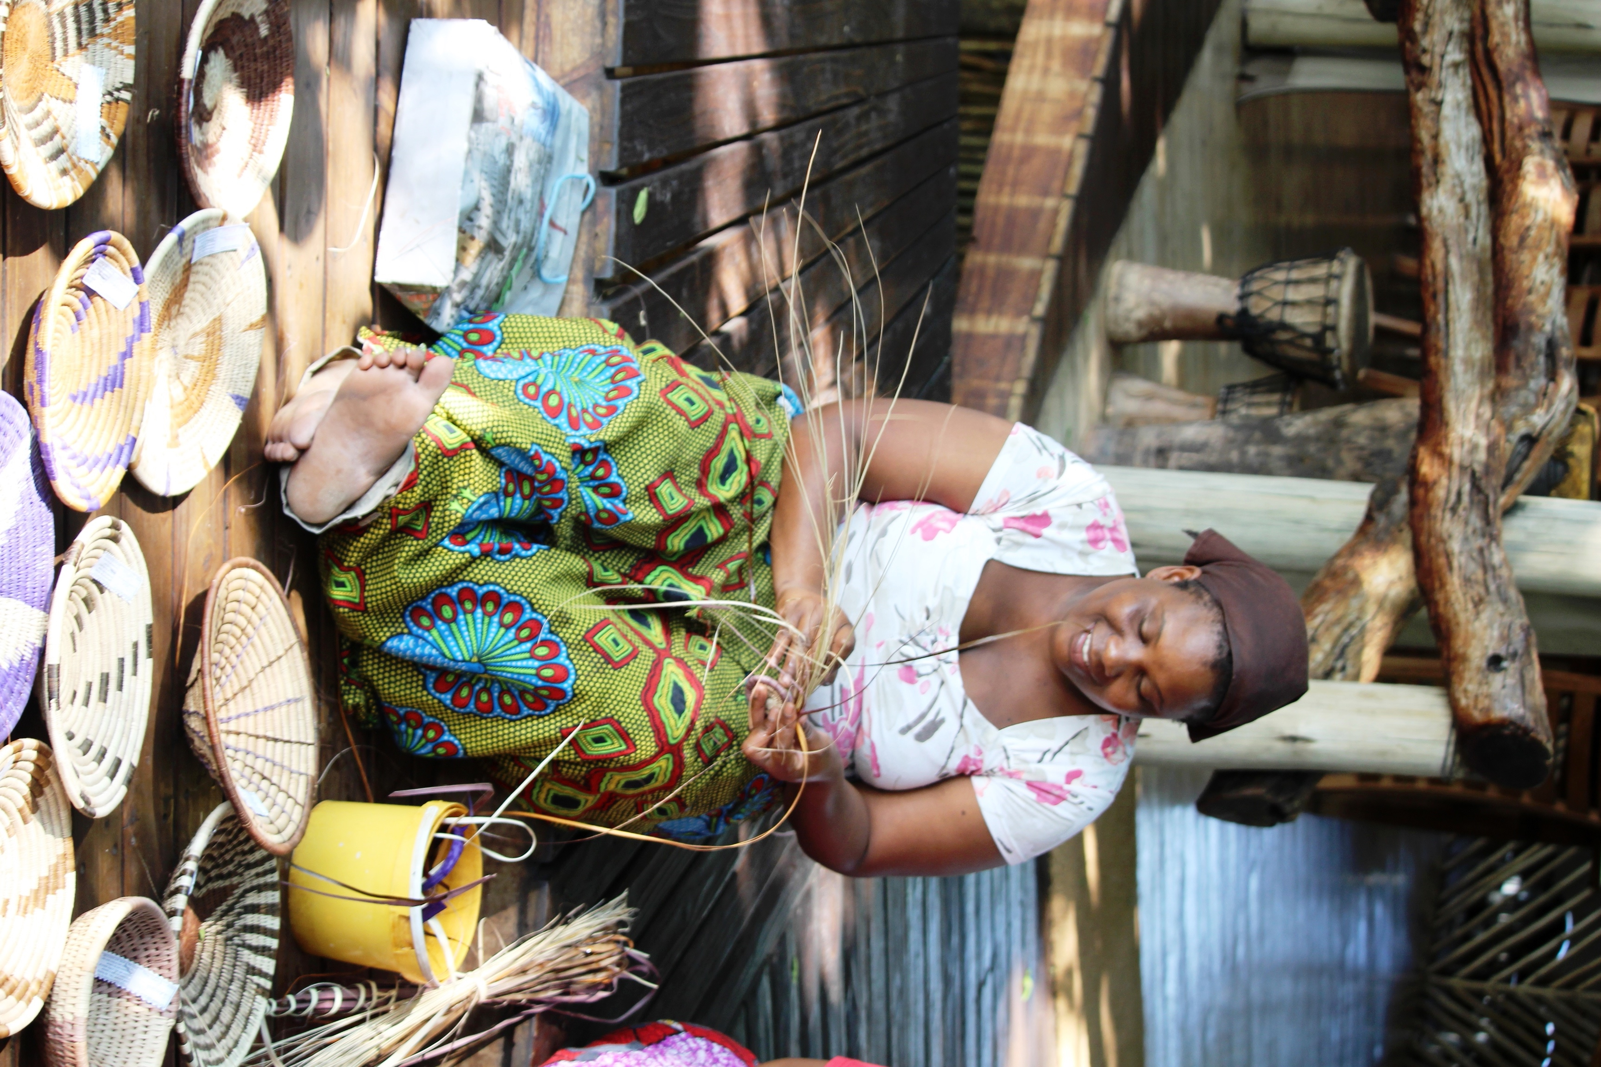
Email stevensm@csus.edu
Cell Phone 765-7397 (important only)
Env Studies Office 278-6620

Required Text
- Anderson, E.N., D.M. Pearsall, E.S. Hunn, and N.J. Turner, 2011, Ethnobiology, Wiley-Blackwell
- Martin, Gary. 2007. Ethnobotany: A Methods Manual Vol 7. Earthscan (Sac CT 9.1)
- Assigned reading on Sac CT

Course Description This course will evaluate sustainable management of ecosystems by local and indigenous people. Students will become acquainted with the approaches, methods and analyses used by ethnoecologists and ethnobiologists who are research contemporary issues in biocultural diversity and sustainable resource management. The goal of this course is to familiarize students with the fields of ethnobiology, ethnoecology, Traditional Ecological Knowledge (TEK) and Traditional Resource Management (TRM). TEK is “a cumulative body of knowledge, practice, and belief, evolving by adaptive processes and handed down through generations by cultural transmission, about the relationship of living beings (including humans) with one another and with their environment. An attribute of societies with historical continuity in resource use practice.” (Berkes, F. 1999. Sacred Ecology: Traditional Ecological Knowledge and Resource Management. Taylor & Francis.)

The course will have one Required Field Trip - Sat April 30, Indian Grinding Rocks State Park.
Student Learning Objectives
- Ability to write and speak clearly and persuasively To improve writing skills from multiple perspectives: a) finding your own voice through weekly journal entries and essays; b) to conduct and synthesize information from peer review and scientific literature; c) to incorporate oral traditions and ethnographic interviews into writing; and d) to incorporate, integrate and communicate diverse cultural, ecological and spiritual perspectives.
- Ability to carry out independent research tasks appropriate to analyzing, evaluating and providing holistic solutions to environmental problems
- Ability to identify, understand, and critically evaluate competing perspectives on environmental issues.
- Ability to assess environmental problems and solutions by applying both western scientific concepts and indigenous and local knowledge systems.
- Ability to understand community based conservation, Traditional Ecological Knowledge, and Traditional Resource Management and the pros and cons of application to biodiversity conservation, cultural resiliency, eco-cultural restoration, and sustainable land management.
- To better understand poverty, population, resource scarcity, ethnicity, gender, and socio-economic status as facts involved in international environmental problems. This includes the contribution of men and women and people of various ethnicities and socio-economic groups make in dealing with international environmental problems. (GE criteria D2/D,F)

Teaching Philosophy : In this class you will experience different personalities; ways of thinking and expressing yourself; different backgrounds, cultures and ideas. All of your ways of being are embraced in my class, and evaluated through critical thinking skill development. Many of you love to play video games and are linear thinkers. This is particularly true if you are an engineer or engage in quantitative analyses as part of your major. Consider the differences between Powerpoint and Prezzi. Linear thinkers are analogous to Powerpoint. I am more similar to Prezzi. I will pull a lot of different ideas together in a circular way of thinking and integrate them all at the end. Some of you will have this same thinking style. Be aware that if you lose the thread of my lecture or argument, you are welcome to ask for clarification. Also be aware that I encourage and enjoy alternative points of view, and different ways of expressing and experiencing the world. We’ll look at this in class, it should be fun!

Secret to Success - Build Rapport and Build Community
If you find that you have any trouble keeping up with assignments or other aspects of the course, make sure you let your instructor know as early as possible. Please come to office hours or email me at stevensm@csus.edu, I am here to help you as best I can. As you will find, building rapport and effective relationships are key to becoming an effective professional. Make sure that you are proactive in informing me if difficulties arise during the semester so that I can help you find a solution.

Important Dates
- Class Begins January 26
- Spring Break March 20-25
- No Class Cesar Chavez Day March 31
- All Day Mandatory Field Trip April 30
- Final Thursday May 19 12:45-2:45

COURSE POLICIES

Sac State's Academic Honesty Policy & Procedures Students are expected to be familiar with and abide by the CSUS Policy of Academic Honesty. For this class, all writing will be turned in to Turnitin to detect plagiarism in student papers. Failure to abide by the policy – i.e. cheating, plagiarism, or other forms of academic dishonesty – may result in a failing grade on the assignment or even in the course at the discretion of the professor. Any form of academic dishonesty, including cheating and plagiarism, may also be reported to the office of student affairs. “The principles of truth and honesty are recognized as fundamental to a community of scholars and teachers. California State University, Sacramento expects that both faculty and students will honor these principles, and in so doing, will protect the integrity of academic work and student grades.” Read more about Sac State's Academic Honesty Policy & Procedures http://www.csus.edu/umanual/AcademicHonestyPolicyandProcedures.htm

At Sac State, “cheating is the act of obtaining or attempting to obtain credit for academic work through the use of any dishonest, deceptive, or fraudulent means.” “Plagiarism is a form of cheating. At Sac State, “plagiarism is the use of distinctive ideas or works belonging to another person without providing adequate acknowledgement of that person’s contribution.” Source: Sacramento State University Library
Turnitin To a limited degree, I plan to use a tool called Turnitin to compare a student’s work with multiple sources. The tool compares each student’s work with an extensive database of prior publications and papers, providing links to possible matches and a ‘similarity score’. The tool does not determine whether plagiarism has occurred or not. Instead, the instructor must make a complete assessment and judge the originality of the student’s work. All submissions to this course may be checked using this tool. Students should submit papers to Turnitin assignments without identifying information included in the paper (e.g. name or student number), the system will automatically show this info to faculty in your course when viewing the submission, but the information will not be retained by Turnitin.

Late Work Policy Be sure to pay close attention to deadlines—there will be a penalty of up to 50% for late assignments, and no late work accepted without a serious and compelling reason and instructor approval. I do not accept emailed assignments. All assignments will be collected at the beginning of class on the day they are due. Assignments can be turned in early to my office in Amador 555B or mailbox in Amador 554B.

Disability Information I am very sensitive to students with diagnosed learning disabilities; please discuss with me privately. If you have a documented disability and verification from the Office of Services to Students with Disabilities (SSWD), and wish to discuss academic accommodations, please contact me at the beginning of class. “It is the student’s responsibility to provide documentation of disability to SSWD and meet with a SSWD counselor to request special accommodation before classes start”. SSWD is located in Lassen Hall 1008 and can be contacted by phone at (916) 278-6955 (Voice) (916) 278-7239 (TDD only) or via email at sswd@csus.edu.

Course Expectation This course will be equivalent to a writing intensive course. Attendance and participation are required. We all will be challenged to consider and think about new ideas and perceptions; compare and contrast cultural and ecological concepts; and to give due consideration to things that you have not been exposed to before. Please come to class with an open and inquiring mind.
E-mail Please email me with questions about the class or assignments directly at stevensm@csus.edu, I am happy to help you!
Free Help With Writing For free, one-on-one help with writing in any class; visit the University Reading and Writing Center in Calaveras 128. The Reading and Writing Center can help you at any stage in your reading and writing processes: coming up with a topic, developing and organizing a draft, understanding difficult texts, or developing strategies to become a better editor. To make an appointment or a series of appointments, visit the Reading and Writing Center in CLV 128. We also offer tutoring for one unit of academic credit through ENGL121. For current Reading and Writing Center hours and more information, visit the website at www.csus.edu/writingcenter.

Course Requirements
- CLASS PARTICIPATION – Class attendance, including being on time, is heavily weighted in this grade.
- PERSONAL REFLECTION JOURNAL –You must make entries to this journal once per week suggested on the date due. I have posted the journal prompts. These are personal narratives, and may contain content of a scientific, creative, spiritual or personal nature. These are private, only I read them.
- FIELD TRIP – We will have one all day field trip to see our local Mewuk cultural heritage to Chawse, Indian Grinding Rocks State Park. During the trip, you will be privileged to meet elders in my Mewuk community, and to try making fiber, pine nut necklaces or soap stone.
- Ethnobotany Group Project Students will complete on ethnobotanic group project– Individually or in groups, students will conduct ethnographic surveys and write up their results. Students will design questions in small groups, and conduct interviews at local farmers markets, markets of other ethnic/cultural groups, herbal shops, etc. The questionnaire will be written up in a small report and shared with the class only.
- Ethnobotany Group Presentation. Students will present the project results to the class.
- Group presentation. Students will lead one class discussion based on assigned rreading. Once you sign up, if you miss your time slot for presentations, you will receive a grade of zero on the presentation – there are no opportunities for re-scheduling.
- Short Essays, Quizzes, Homework, Reading responses– Students will turn in a (minimum of) one-to-two page paper evaluating and integrating required readings. There are two types of essays: 1) reflective essays where you think through and comment from a first person narrative perspective; and 2) scientific or policy evaluations of readings with references and more formal scientific writing approach
- Midterm and final exams – An in class comprehensive midterm and take home final will be used to review and gauge your understanding of the course content. A midterm and final review sheet will be handed out before the exam for study purposes.
- ETHNOECOLOGY TERM PAPER This is the capstone project for the course; you will write one essay on a topic of Traditional Resource Management and Traditional Ecological Knowledge
- Culture, Spirit and Tradition Project – Final sharing in class at final – poem, drawing, art, final project sharing, music

Course Grading & Assignments
Grading scale: The grading scale for final grades is as follows: A = (92-100%), A- =(91-90), B+ =(88-89%), B = (82-87%), B- =(81-80%), C+ = (78-79%), C = (72-77%), C- = (70-71%), D+ = (68-69%), D = (62-67%), D- = (60-61%), < 60 = F.

Weighting: Course components are weighted as follows:
- Class Participation 10%
- Personal Reflection Journal 10%
- Field Trip – Indian Grinding Rocks State Park 10%
- Ethnobotany Group Project 10%
- Ethnobotany Group Presentation 5%
- Class presentation on reading 5%
- Homework, Quizzes and Other Assignments 10%
- Midterm exam 10%
- Ethnoecology final project 20%
- Final Take Home ESSAY 5%
- “Culture, Spirit and Traditional Project” 5%
Feb 11 Spring 2014 Ethnoecology Class ENVS 163
Environmental Studies Department
T Th 1 :30-2 :45
Class Location Amador 240

Instructor Dr. Michelle Stevens
Office 555B Amador Hall
Office Hrs. T 3-5pm, Th 3-4pm, or by apt.
Email stevensm@csus.edu
Cell Phone 765-7397 (important only)
Env Studies Office 278-6620

Class Schedule
Final Note: Information contained in the syllabus is subject to possible modification. Any changes will be announced in advance in class. It is your responsibility to be aware of these changes.

DATE | TOPIC |  | Feb 11 Reading | Assignment
Jan 26 | Introduction of ethnobotany and ethnoecology |  | Reading Chapter 1: Ethnobiology: Overview of a Growing Field pp1-14
Jan 28 | Movie: The Shaman’s Apprentice |  | Reading Chapter 9: Ethnobotany: Study of People-Plant Relationships, pp133-148
Feb 2 | Plant Morphology and Floral Structure |  | Reading: Gary Martin, Ethnobotany, Intro and Chapter 1, Data Collection and Hypothesis Testing, Sac CT | *Reflective Journal Entry 1  *HW – Chapter 1 and 3 key points of movie√
Feb 4 | Plant Taxonomy, Folk Classification and Nomenclature  Guest Speaker: Dr. Dan Potter√, UC Davis |  | Reading Gary Martin, Ethnobotany, Chapter 2, Botany, Sac CT
Feb 9 | Grocery Store Ethnobotany  Begin Group Ethnobotany Project |  | Reading * SAC CT Lectures on Botany | *Reflective Journal Entry 2  *HW – Grocery Store Botany√
Feb 11 | Ethnobotanic Data Collection and Hypothesis Testing |  | Reading: *Gary Martin, Chapter 4, anthropology – Talking to Local People, Sac CT | In Class Group – draft ideas for Ethnobotany Project
Feb 16 | Ethnobotany: Talking With People – In Class Student Interviews and Surveys |  | Conduct ethnographic interviews in class with other students and record  HW – Chapter 1 and 2 History of Ethnobotany (due Feb 23) | *Reflective Journal Entry 3  *Prepare thnobotanic Interview questions  *Turn in scope of  Ethnobotany Project
Feb 18 | History of Ethnobiology  Ethnographic Interviews (cont.)  Class Group Time – Ethnobotany Project |  | Reading - Chapter 11 – Reconstructing Past Life-Ways with Plants II: Human-Environmental and Human-Human Interactions | - HW: Write up In Class Interview or Survey  - Quiz on Martin Chapter 1, 2 and 4 Methodology
Feb 23 | Ethnobiology and Traditional Foods & Ethnoecology |  | Reading Chapter 15 Assessment of Indigenous Peoples” Traditional Food and Nutrition Systems and Ch 18 – Ethnobiology and Agroecology | *Reflective Journal Entry 4  *HW Ch 1 and 2 Due  *Student Presentations Ch 15 and Ch 18
Feb 25 | Ethnobotany and the Material  Culture  Movie: Julia Roberts, CA Basketweaver |  | Reading: Sac CT  *Anderson, Kat. 1999. The Fire, Pruning, and Coppice Management of Temperate Ecosystems for Basketry Material by California Indian Tribes. Human Ecology, Vol. 27(1): 79-113  * Stevens, M.L. Ethnoecology of Selected California Wetland  Plants and White Root (Carex  barbarae) | *Draft Proposal Ethnobotany Group Project
March 1 | History of Ethnobotany |  | Reading **Chapter 2 – History of Ethnobiology pp 15-26 | Reflective Journal Entry 5
March 3 | Ethnobiology and Ethnomedical Research |  | Sac CT Paper – Bellon. 1991. The Ethnoecology aof Maize Variety Management: A Case Study From Mexcio. Ecology 19(3): 389-418.  * Chapter 14: Ethnoecological Approaches to Integrating Theory and Method in Ethnomedical Research | *Student Presentation Maize Paper and Ch 14
March 8 | Plants that Heal  Dr.Mary McCarthy Hinz√, CSUS Chemistry Dept., |  | Reading *Gary Martin, Chapter 3, Ethnopharmacology and related fields, Sac CT | Reflective Journal Entry 6
March 10 | The Other World: Ritual and Spiritual Plants  Midterm Review |  | Reading Chapter 5: The World  According to Is’a: Combining  Empiricism and Spiritual  Understanding in Indigenous Ways of Knowing  MOVIE – Salt Songs | Student Presentation Ch 5
March 15 | In Class Midterm |  | Midterm | *Reflective Journal Entry 7  Midterm
March 17 | Introduction of Ethnoecology  Hand out Ethnoecology Term Project and Discuss |  | Reading TBA  Homework: Ethnoecology, TRM and TEK (due March 29) | *Ethnobotany Final Project Due
March 20-25 | Spring Break |  |  | No class
March 29 | Salmon as Cultural Keystone Species  Guest Speaker: Dr. Ron Yoshiyama√, UC Davis |  | Reading: Sac CT. Yoshiyama, R.M. Long Time Past: Bair Station and the McCloud Wintu. Fisheries 26(3):6-22  Homework: Historic Ecology and Fisheries (due April 7) | *Reflective Journal Entry 8  HW – Ethnoecology, TRM and TEK
March 31 | No Class – Cesar Chavez Day |  |  | Cesar Chavez Birthday
April 5 | Student Ethnobotany Presentations |  | Reading TBA | *Reflective Journal Entry 9  *Student Ethnobotany Presentations  *Homework Due: Historic Ecology and Fisheries
April 7 | Ethnoecology and Biodiversity |  | Reading TBA
April 12 | Student Ethnobotany Presentations |  | Reading TBA | Student Ethnobotany Presentations
April 14 | Student Ethnobotany Presentations |  | Reading TBA | *Reflective Journal Entry 10  *Student Ethnobotany Presentations
April 19 | Guest Speaker: Sage La Pena, First Nation Knowledge Holder |  | Reading: TBA  Homework: Traditional Resource Management and Landscapes (Due April 26) | *Draft Ethnoecology Paper DUE for Mandatory Peer Review
April 21 | Historic Ecology, Restoration and Ethnoecology |  | Reading SacCT Stevens, M.L. and E. Zaloza. 2015. Fire, Floodplains and Fish: the Historic Ecology of the Lower Cosumnes River Watershed. Edited by Pei Lin Yu, In Rivers, Fish and the People. Tradition, Science and Historical Ecology of River Fisheries in the American West. University of Utah | *Reflective Journal Entry 11
April 26 | Ethnoecology and Traditional Knowledge |  | Reading: Ch 16 Ethnoecology and Landscapes  Ch 17 Traditional Resource and Environmental Management | Student Presentations Ch 16 and Ch 17  Homework Due: TRM, TEK and Landscapes
April 28 | Community Based Conservation: Indigenous Peoples Knowledge Systems | Reading: Kimmerer Sac CT: Restoration and Reciprocity: the Contributions of Traditional Ecological Knowledge  Movie: Grazing and traditional knowledge - Turkey |  | *Reflective Journal Entry 12  Student Presentation: Kimmerer Paper  * Preparation and Notes for Discussion
April 30 | Chawse Indian Grinding Rocks Field Trip |  |  | Mandatory All Day Field Trip
May 3 | Protected Areas and First Nation Earth Stewardship | Reading: TBA |  | *Final Ethnoecology Paper Due
May 5 | Ethnoecology and Climate Change – Climate Justice | Reading: TBA |  | *Reflective Journal Entry 13  *Reflective Essay on Debate 500 words
May 10 | International Conventions on Rights of Indigenous Peoples – Local Knowledge, Common property | Reading: TBA |  | *Take Home Final Handed Out
May 12 | Ethnoecology: Paradigm for the Future | Reading: Sac CT Salmon, Enrique. 2000. Kincentric ecology: indigenous perceptions of the human-nature relationship. Ecological Applications 10(5): 1327-1332 |  | Field Trip Write-up Due  * Personal Reflection Final Reflective Essay Due
May 19 | MANDATORY FINAL May 19 12:45-2:45 | Culture, Spirit and Tradition Project and Potluck |  | *Take Home Final Essay Due  *Culture, Spirit and Tradition Due

