Key to Mueller-Ward Model of AMOEBA

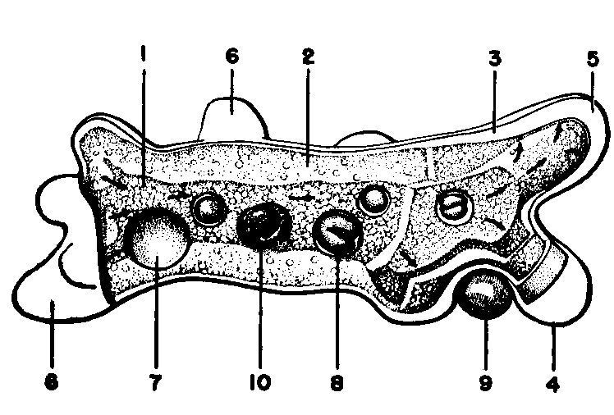

1. Plasmasol (orange)
2. Plasmagel (yellow)
3. Hyaline layer (blue)
4. Plasmalemma (white)
5. Hyaline cap
6. Pseudopodia (many are shown)
7. Contractile (excretory) vacuole
8. Food vacuoles (four are shown)
9. Food particles being engulfed to form food vacuole
10. Nucleus

This is a generalized model and is not intended to represent any particular species of Amoeba. The animal is represented as moving from left to right. The arrows indicate the internal flowing process by which it moves.

Ward’s Natural Science Establishment, Inc. Rochester, New York
PARAMECIUM (1000 X)

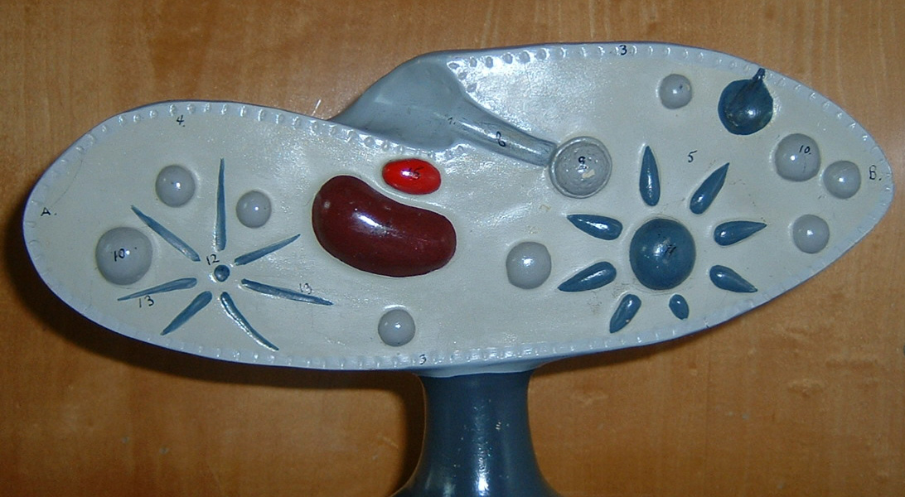

- Anterior end
- Posterior end

- Pellicle
- Cilia
- Ectoplasm
- Trichocysts
- Endoplasm
- Oral groove
- Cytostome
- Gullet (Cytopharynx)
- Food vacuole (dissected)
- Food vacuole
- Contractile vacuole (expanded)
- Contractile vacuole (contracted)
- Radiating canals
- Macronumcleus
- Micronucleus
- Anal pore

CARE OF TURTOX LATEX MODELS
If this model becomes soiled, wash it with lukewarm water containing a small amount of mild soap or borax. Do not use ammonia, strong alkaline soaps, gasoline or similar cleaning reagents.

EUGLENA

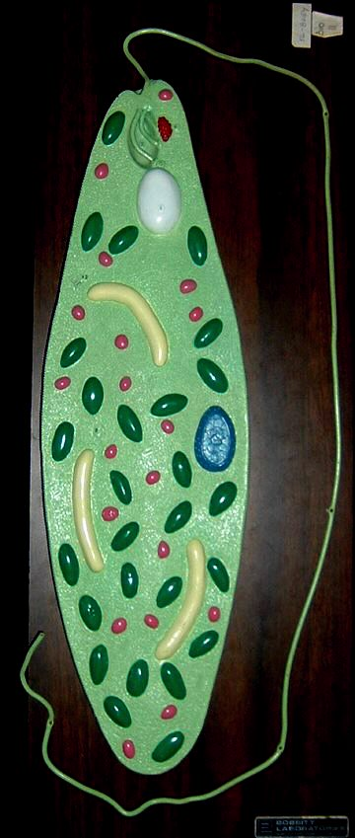
56-8254
EUGLENA

This organism is a chloroplast- bearing flagellate which shows a distinct trend in the direction of animal organization. For this reason it is claimed taxonomically by both zoologist and botanists.
The inclusions in the model, such as the nucleus, chloroplast, vacuoles, etc. are shown in high relief on a longitudinal section through the body of the organism. The cytopharynx and contractile body are shown in section and the origin of the flagellum is depicted.
On the lower half of the model, the complex structure of the pellicle is carefully presented. This structure consists of alternating bands of hard rings and flexible membranous strips. The hard rings probably slide into one another as in a collapsible cup as the body of the organism flexes.

- Pellicle
- Cytopharynx
- Flagellum
- Rudimentary flagellum
- Blepharoplast = basal body
- Stigma
- Contractile vacuole
- Cytoplasm
- Paramylum
- Chloroplast
- Mitochondrion
- Endoplasmic reticulum
- Nucleus
- Nucleolus
Key to Mueller-Ward Model of Hydra – Principle Cell Types
MW123
(approximate magnification 1000x)

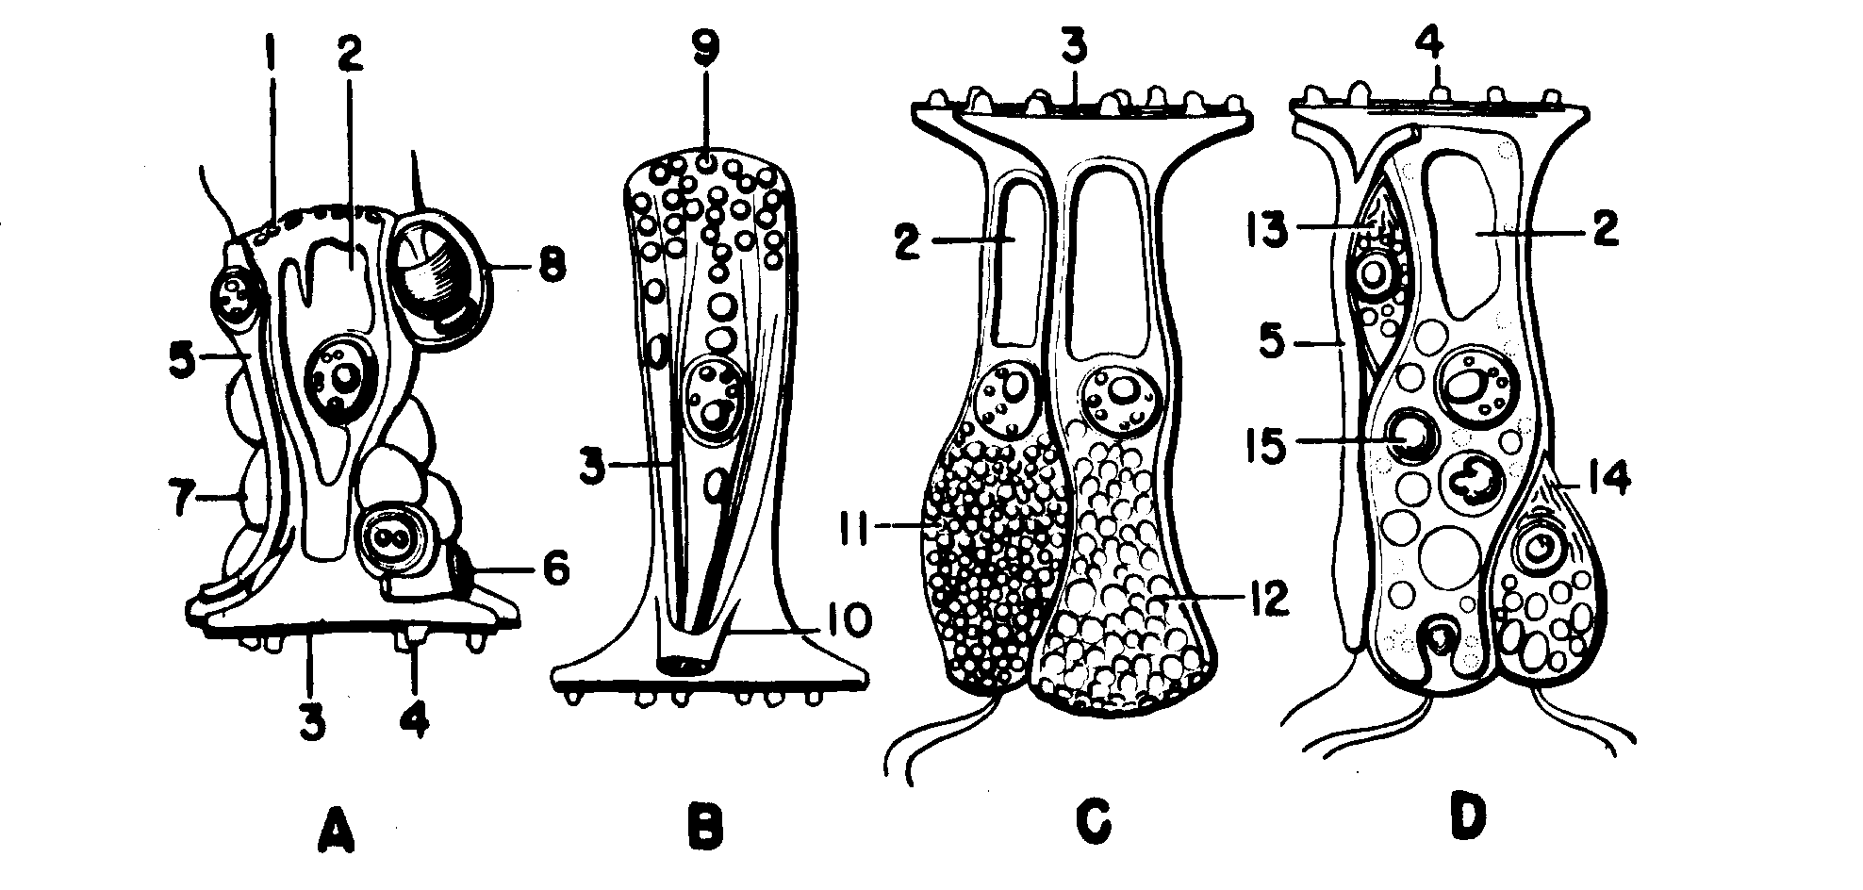
- Protective-muscular, or epidermal supporting cell, from stomach region, with associated cells.
- Glandulo-muscular epidermal cell from pedal disk.
- Mucous gland cells from gastrodermis of hypostome.
- Nutritive-muscular cell from gastrodermis of stomach, with associated cells.

The colors are the same as on model MW 121, and will serve to locate the cells with reference to position in the animal

- Granular border or limitans.
- Vacuole
- Muscle processes or myonemes. In each case the sarc has been removed to expose the contractile elements. These muscle processes pass longitudinally in the epidermal cells, vary in number from one to five per cell in different regions. They are much more delicate in the gastrodermal cells, and here pass in a circular direction. In the pedal disk cells two series of myonemes are present, one passing radially on the mesoglea, and the other passing vertically through the cell bodies.
- Insertions of muscle processes into mesoglea
- Sensory cells
- Nerve cells
- Mesenchyme cells, sometimes called interstitial cells.
- Cnidoblast enclosing nematocyst. Four types occur in hydras. This is a penetrant or stinging cell. The projecting bristle is the cnidocil.
- Secretory granules, storage form of the sticky substance produced by the foot.
- Accessory root through which vertical myonemes attach to the mesoglea. These myonemes bring about a “knee-action” in the cell, and probably account for the ability of hydra to creep upon its disk.
- Secretory granules of mucous gland cell in the resting phase.
- Vacuoles of liquefied secretion in the productive phase.
- Young enzymatic gland cell showing mitochondrial and secretory granules.
- Active enzymatic gland cell. Cells of this general type are also encountered with a spongy structure similar to 12. Whether these represent a worn-out cell, or a different type of gland cell is undetermined.
- Food vacuole. A food vacuole is represented as newly forming at the tip of the cell.

Presence of flagella on individual cells appears to be variable. Sensory cells usually have a single flagellum. The other gastrodermal cells usually have either two or none. Other cell types also occur in hydra, but are variants of the foregoing. The highly vacuolated lining cells of the tentacles and stalk, and the granular gastrodermal cells of the pedal disk are variants of D. The battery cells of the tentacles, and the empty, plant-like epidermal cells of the stalk are variants of A. In higher animals, with well developed organ systems, the cells are permitted to specialize in a single direction. Because of the very simplicity of the organ and tissue systems of hydra, the cells are forced to differentiate in several directions simultaneously, and hence are more complicated than those of higher animals.

Ward’s Natural Science Establishment, Inc. Rochester, New York
Key to Mueller-Ward Model of Hydra – Section and Coelenteron
MW121
(approximate magnification 125x)
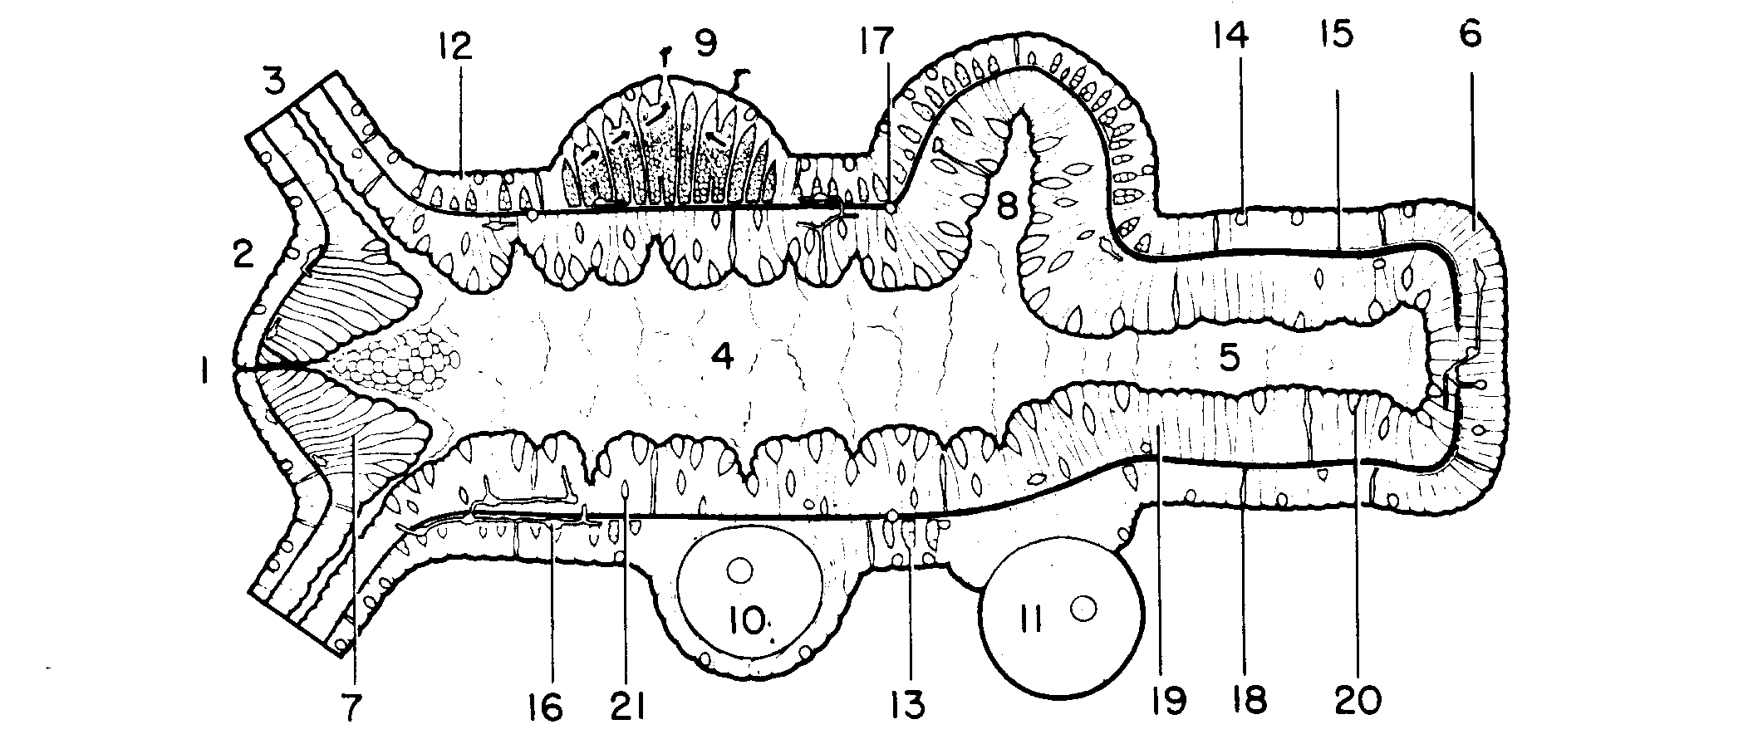
Ectodermal derivatives, except nervous system, blue. Endoderm yellow to orange. Mesenchyme and derivatives pink. Nervous system white. Regions of histological differentiation indicated by shades of color. The gastrodermis is either smooth or thrown into folds depending upon the state of contraction

- Mouth
- Hypostome
- Tentacles. Only basal portion shown.
- Stomach or digestive-reproductive region. Swallowed prey is confined to this part of the gut while its lining effects both extra-cellular and intra-cellular digestion. It is the body region where sexual and asexual reproduction are carried on. The mesenchyme is limited to this region and the nematocysts are produced here.
- Stalk. A region specialized for movement: extension, contraction, bending, etc.
- Pedal disk. The adhesive secretion of its glandular epidermis attaches the animal to the substrate. It executes creeping movements, can secrete a gas bubble to float the animal to the surface. Some hydras appear to discharge particulate waste matter through the central part of the disk.
- Radial folds composed of mucous gland cells. Food must be exposed to secretion of these cells while being swallowed, or it cannot be digested in the stomach.
- Bud. All layers of the parent enter into its formation.
- Ripe testis. The spermatogonia are derived from mesenchyme cells. The ripe sperm collect at the apex. The supporting cells are modified protective-muscular cells (12). Several of these cells have been cut away to show the continuity of the cavity. Arrows indicate the path of escaping sperms.
- Ripe ovary. The egg arises from a single mesenchyme cell which enlarges by engulfing others. For early stages see model MW 122.
- Mature egg, ready for fertilization. It has burst forth from the ovary, but remains attached to the parent by a cushion of the cells which formerly covered it.
- Protective-muscular or supporting cells. These cells form the other covering of the body and enclose the other elements. Their bases have longitudinal muscle processes which are rooted into the mesoglea.
- Mesenchyme or interstitial cells. They are produced and stored only in the epidermis.
- Cnidoblast or stinging cell. Each encloses a nematocyst. Four kinds occur in hydra. They are produced in the epidermis of the stomach region, migrate to their location In tentacles, stalk and hypostome.
- Mesoglea. A jelly-like layer in which the muscle processes of the epidermal and gastrodermal cells are rooted.
- Portion of the nerve plexus. Nerve cells occur in both epidermis and gastrodermis. The fibers of the epidermal nerve cells terminate either (1) on the muscle processes of the protective-muscular cells, (2) in synapse with each other, or (3) pass through the mesoglea to join the gastrodermal plexus. Though often referred to as a “nerve net” the elements are not continuous.
- A cnidoblast or a mesenchyme cell migrating through the mesoglea.
- Sensory cell. These are modified nerve cells, occurs in both epidermal and gastrodermal layers.
- Nutritive-muscular cell. These cells are variously modified in different regions of the coelenteron. They posses two flagella, engulf food particles from the stomach cavity, carry on intra-cellular digestion, and store reserve materials. Their bases contain myonemes which pass in a circular direction.
- Enzymatic gland cells. Most abundant in the stomach region, sparse in stalk, lacking in tentacles and central portion of hypostome. Secrete enzyme for extracellular digestion. Short, pyriform, wedges between outer ends of nutritive-muscle cells, not attached to mesoglea.
- Young enzymatic gland cell. These are said to stem from mesenchyme cells, move outward to replace worm-out cells.

Ward’s Natural Science Establishment, Inc. Rochester, New York
Key to Mueller-Ward Model of Hydra – Body Layers
MW122
(approximate magnification 125x)

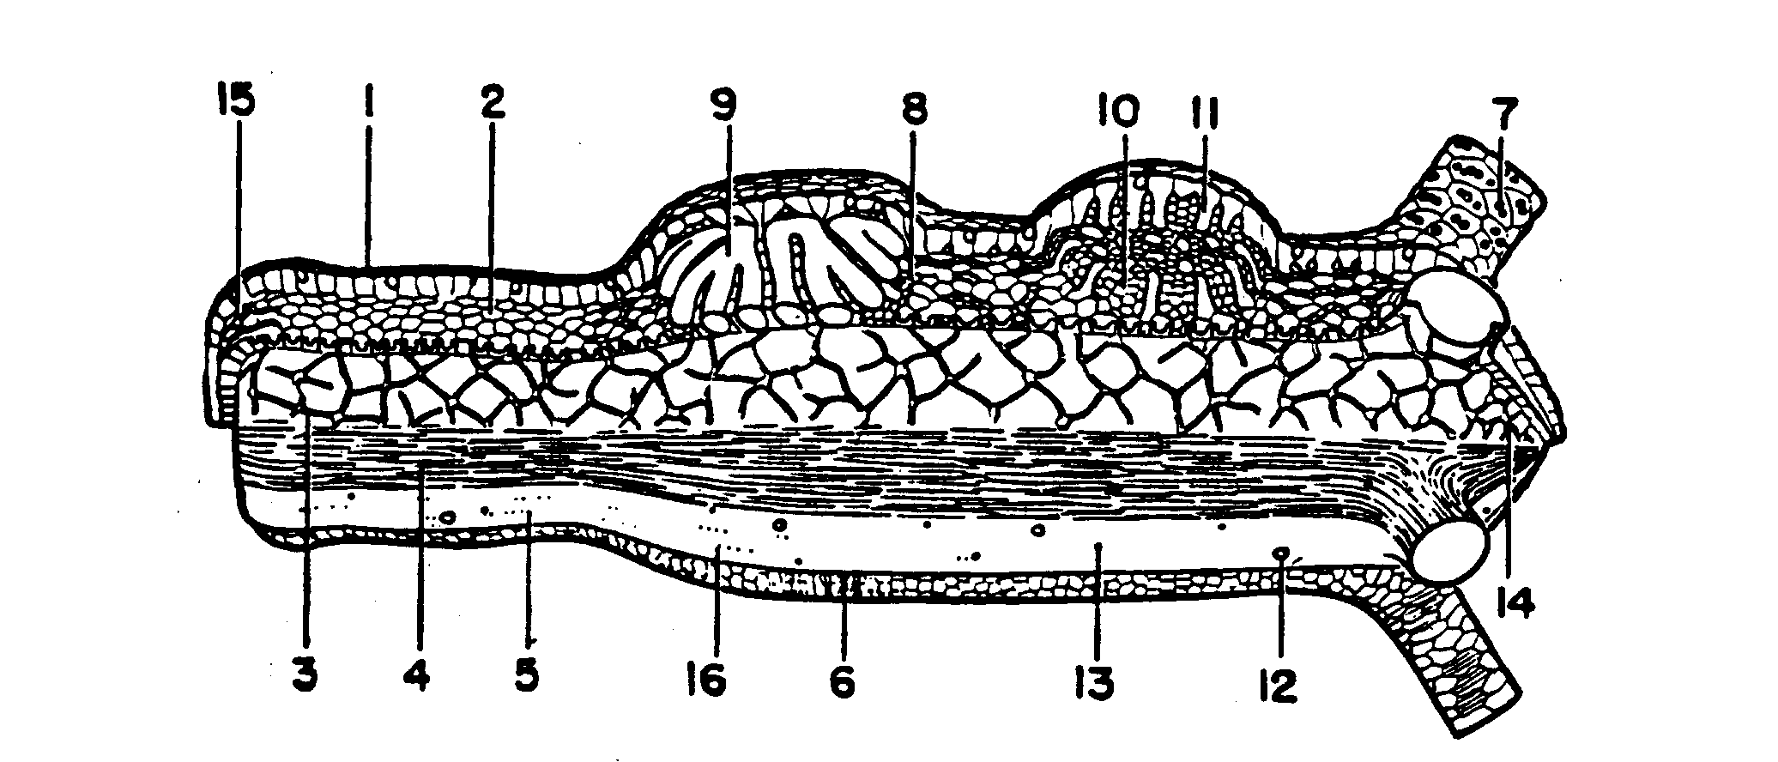

- External surface
- Mid-level of epidermis, showing vacuolated character of supporting cells and distribution of mesenchyme.
- Epidermal nerve plexus. Lies between the columns and just exterior to the muscle processes of the supporting cells. The external nerve plexus has connections through the mesoglea with the internal plexus. The latter lies between the cells of the gastrodermis and is not shown here. Free nerve endings terminate on muscle fibers or in synapse with other neurons. Though often referred to as a “nerve net”, the elements of the system are not continuous.
- The muscle processes of the supporting cells, forming the external muscular layer. These fit into grooves of mesoglea.
- Mesoglea. This is the thickest in the basal third of the body. On the pedal disk it is very much roughened externally, and usually has a large central hiatus.
- Muscle bases of the gastrodermal cells. These cells have oval or oblong bases, in contrast to the digitate bases of the epidermal supporting cells. They possess a number of delicate, parallel myonemes passing in a circular direction, quite unlike the rugged and often branching myonemes of the external layer.
- Nematocysts in battery cells of the tentacle. Only basal portion of the tentacles is shown. The battery cells are modified supporting cells. They enclose groups of nematocysts consisting of four different types. Nematocysts attain this position by migration from their place of origin in the truck region.
- Mesenchyme cells. Here shown as being swallowed by the advancing lobes of the ovum.
- Developing ovum in the scalloped or “amoeboid” stage. The ovum arises from a single mesenchyme cell, grows by engulfing others. Being confined to the narrow passages between the supporting cells, which are continuous above, and rooted fast to the mesoglea below, the egg is squeezed into a lobate form.
- Young testis. Mesenchyme cells proliferate locally and transform into spermatogonia. The supporting cells pass as separate columns through the mass from the mesoglea to the outer surface. For later stages of ovary and testis see model MW 121.
- Supporting cells of testis. The pictures in many textbooks, illustrating an epithelial roofing over gonads, completely independent from the mesoglea, are grossly erroneous.
- Cnidoblast, or mesenchyme cell, migrating through the mesoglea.
- Nerve fiber passing through the mesoglea.
- Concentration of nerve plexus on hypostome.
- Concentration of nerve plexus on pedal disk.
- Pits in mesoglea which receive root processes of supporting cells.

Ward’s Natural Science Establishment, Inc. Rochester, New York
Key to Mueller-Ward Model of a Planarian
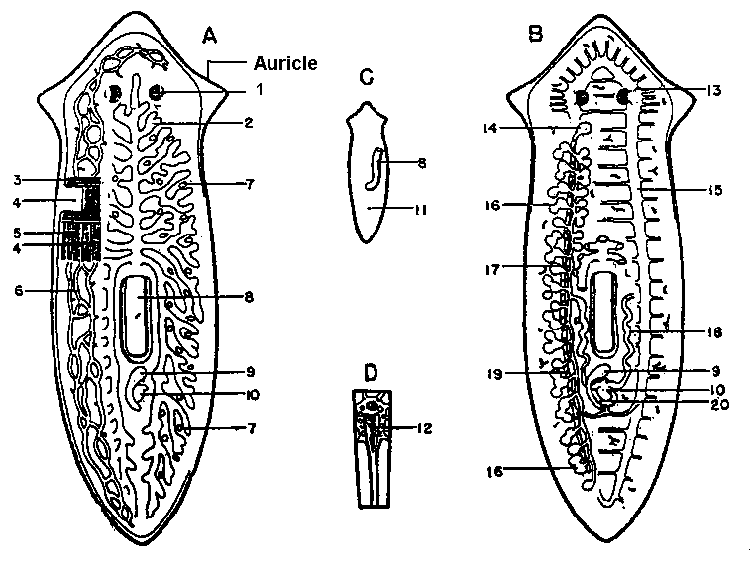
A. Dorsal dissection to level of excretory and digestive systems.
B. Dorsal dissection to level of reproductive and nervous systems.
C. Ventral view of worm showing extruded pharynx and genital Pore.
D. A single flame cell, greatly enlarged: (these lie at the ends of the finest branches of the excretory tubules, scattered throughout the body.)

- Eyespot
- Digestive System
- Transverse muscle layer
- Excretory pores, only two of many are shown
- Longitudinal muscle layer
- Excretory system
- Vitellaria (Yolk glands)
- Pharynx
- Copulatory sac
- Cirrus sac (Sperm sac)
- Genital pore
- “Flame” – pencil of flagella
- “Brain”
- Ovary
- Nerve Cord
- Testes
- Vas deferens
- Seminal vesicles
- Oviduct with stumps of vitellaria, See 7
- Genital atrium

Ward’s Natural Science Establishment, Inc. Rochester, New York
Key to Mueller-Ward Model of Clonorchis sinenesis

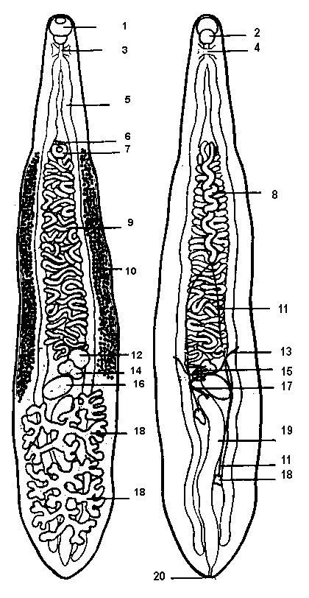
1. Oral Sucker
2. Pharynx
3. Esophagus
4. “Brain” (Nerve Ring)
5. Intestinal crura (Cecum)
6. Genital pore
7. Ventral Sucker (Acetabulum)
8. Vas deferens (Sperm duct)
9. Uterus
10.Vitellaria (Yolk glands)
11.Vasa efferentia
12.Shell gland or Mehli’s gland
13. Transverse yolk duct
14. Ovary
15. Yolk reservoir
16. Seminal receptacle
17. Laurer’s canal
18. Testes
19. Excretory bladder
20. Excretory pore

Ward’s Natural Science Establishment, Inc. Rochester, New York
Key to Mueller-Ward Model of Scolex of Taenia
(based on Taenia pisiformis)

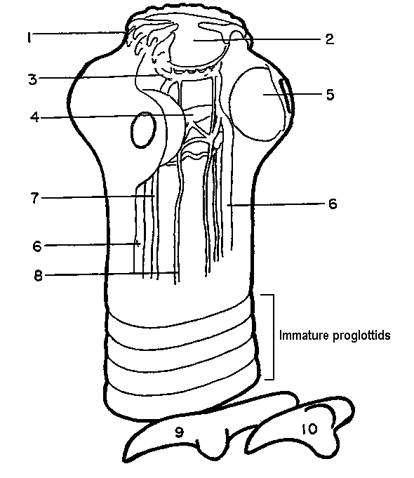

1. Hooks
2. Muscular bulb of rostellum
3. Anterior nerve ring
4. Cephalic ganglion
5. Sucker
6. Lateral nerve cords

7. Excretory vessels
8. Submedian nerve cords
9. One of the anterior circle of hooks, greatly enlarged
10. One of the posterior circle of hooks, greatly enlarged

Ward’s Natural Science Establishment, Inc. Rochester, New York
Key to Mueller-Ward Model of Taenia proglottids
(based on Taenia pisiformis)

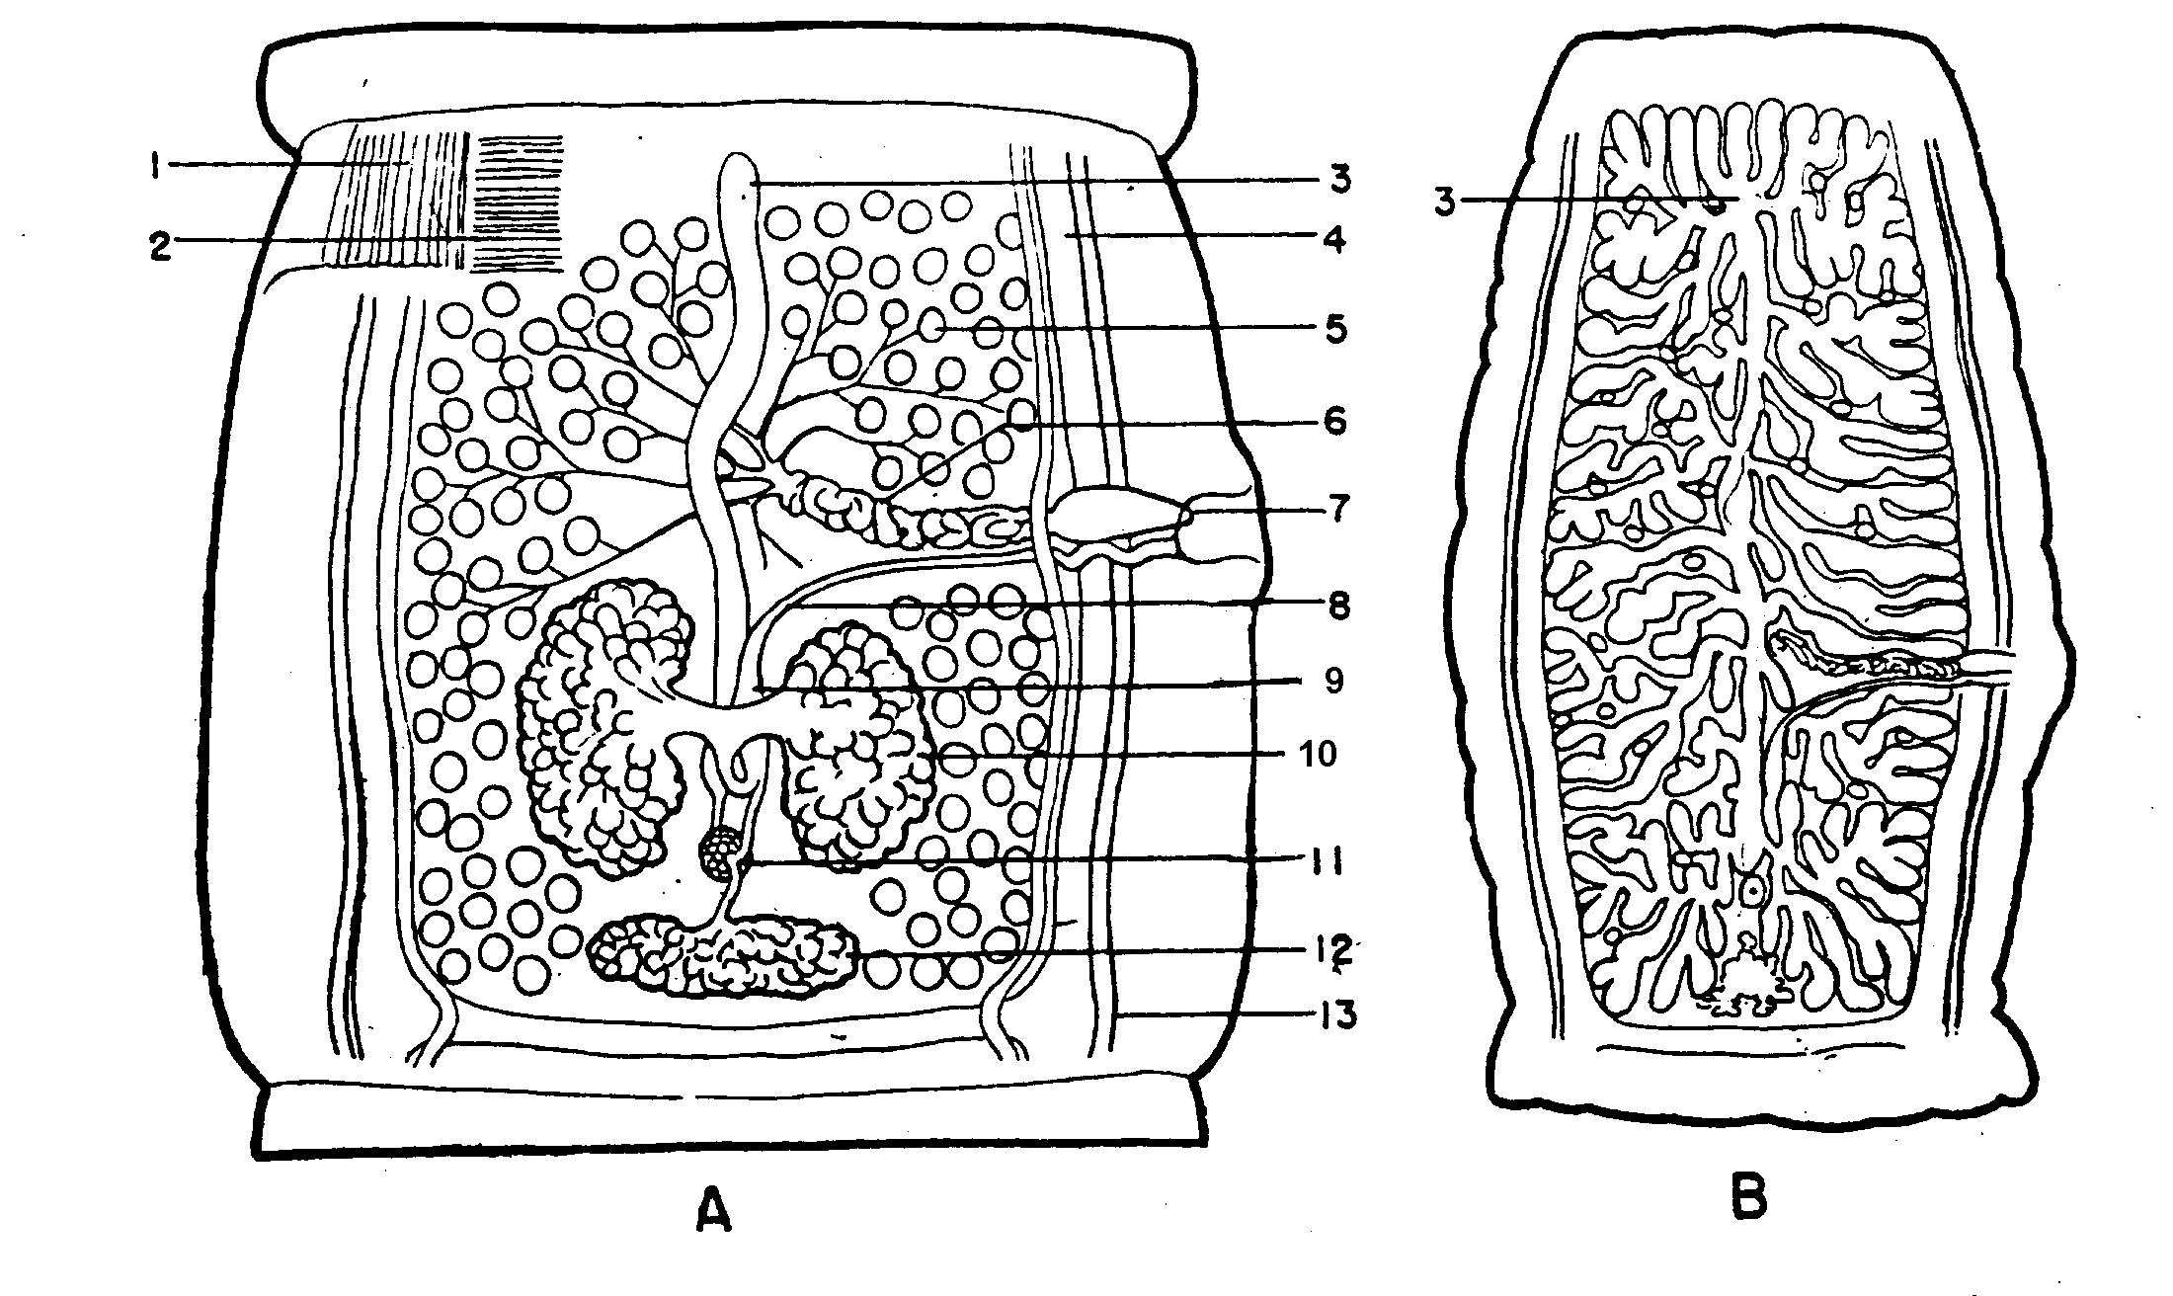

A. MATURE proglottid, from middle of strobila, dissected from ventral surface
B. GRAVID proglottid, from posterior end of strobila, enlarged only about ½ the scale of A

- Longitudinal muscle layer
- Transverse muscle layer
- Uterus
- Large and small longitudinal excretory trunks
- Testes
- Vas deferens
- Cirrus sac
- Vagina
- Seminal receptacle
- Ovary
- Mehli’s gland
- Vitellarium = Yolk gland
- Lateral nerve cord

Ward’s Natural Science Establishment, Inc. Rochester, New York

