Your Name:__________________________________ Lab section:__________

Chemistry 31 – Quantitative Analysis Exam #2, April 22, 2009

Multiple Choice and Short Answer
Circle the one correct answer from the choices listed, enter the correct term or phrase on the blank line, or briefly answer the question as indicated.

1 (4 points). Which of the following expressions will give the pH of a solution:

a. log[H⁺] b. –log[OH⁻]
c. –log(10⁻¹⁴/[OH⁻]) d. 10^{-[H+]}

2 (4 points). The following is always true for the autoprotolysis of water (H₂O ⇄ H⁺ + OH⁻):

a. The number of moles of H⁺ and OH⁻ produced each equal 10⁻⁷.
b. The number of moles of H⁺ and OH⁻ produced from H₂O can be disregarded.
c. The number of moles of H⁺ and OH⁻ produced from H₂O are equal.
d. K_{w} for water is 10⁻¹⁴ only when pure H₂O is considered.

3 (4 points). To a precision of 2 significant figures, what is the pH of a solution containing a concentration of 1.0x10⁻¹²M HCl?

a. 7.0 b. 12
c. 2.0 d. 1.0

4 (4 points). What is the mass balance for the following chemical equation?

Ag₂CrO_{4(s)} ⇄ 2Ag⁺_{(aq)} + CrO₄²⁻_{(aq)}

a. 2[Ag⁺] = [CrO₄²⁻] b. [Ag⁺] = 2[CrO₄²⁻]
c. [Ag⁺] = [CrO₄²⁻]² d. [Ag⁺]² = [CrO₄²⁻]

5 (4 points). Which of the following analytical methods would be most appropriate to analyze a mixture containing analytes with highly volatile compounds (low temperature boiling points).

a. HPLC b. GC
c. complex ion titration d. any of these will work

6 (4 points). Analyte separation in chromatography is affected by which of the following:

a. differential partitioning between the mobile and stationary phases (difference in retention times)
b. band broadening (diffusion) in the column
c. both a and b
d. neither a or b

7 (4 points). When using standard addition, the identity of the standard is:

a. different than the analyte.
b. the same as the analyte.
c. it could be the same or different relative to the analyte.

8 (4 points). The following is true regarding fluorescence spectroscopy:

a. measurement sensitivity is higher.
b. not all compounds fluoresce.
c. both a and b.
d. neither a or b.

9 (4 points). Fill in the blank. Beer's Law states that ___________________ is directly proportional to analyte concentration.

Worked out Problems
It is your responsibility to work out your answers clearly. Unclear, or unreadable work will not be graded. If there is not enough space provided to show your work, continue on the back of the page and clearly mark the problem number. Be sure to show all of your work and report your final answer with the correct number of significant figures and units. Unless otherwise noted, an unreasonable number of significant figures in a final answer will be marked off 2 points. A correct answer without work shown will not receive credit. Circle or draw a box around your final answer.

Equations that may or may not be useful to you:

$x=−\frac{b±\sqrt{b^{2}−4\text{ac}}}{2a};\text{ where }{\text{ax}}^{2}+\text{bx}+c=0$ $\text{pH }={\text{ pK}}_{a}+\text{log}\frac{[\text{base}]}{[\text{acid}]}$

$\text{log}γ=\frac{−0\text{.}\text{51}z^{2}\sqrt{u}}{1+(α{\sqrt{μ}}/{\text{305}})}$ $μ=\frac{1}{2}\sum_{i}{c_{i}z_{i}^{2}}$ M₁V₁ = M₂V₂

dilution factor = volume of original solution / total final solution volume

diluted concentration = dilution factor(original concentration)

$\frac{I_{X}}{I_{S}}=F\frac{[X]}{[S]}$ $\frac{[X]}{[X]+[S]}=\frac{I_{X}}{I_{S+X}}$ A = εbc

A = 2.00-log(%T)

10a (6 points). You are analyzing compound A using absorbance spectroscopy. A standard containing 50.0µg/mL of A gives a transmittance of 0.159. The blank transmittance is 0.972. What is the concentration (µg/mL) of a sample of A that gives a transmittance of 0.478? Data given has not been blank corrected.

10b (4 points). If compound A has a molecular weight of 670g/mol, what is the molar absorptivity (in units of M⁻¹cm⁻¹) of compound A at the wavelength being used for analysis? Assume a pathlength of 1.00cm. (10⁶µg = 1g)

11 (10 points). Accounting for ionic strength, what is the pH of a 0.050M solution of the strong acid HCl in a solution containing 0.050M NaCl? Report your answer correctly to 3 significant figures and show the correct work for credit. See the attached table for activity coefficients.

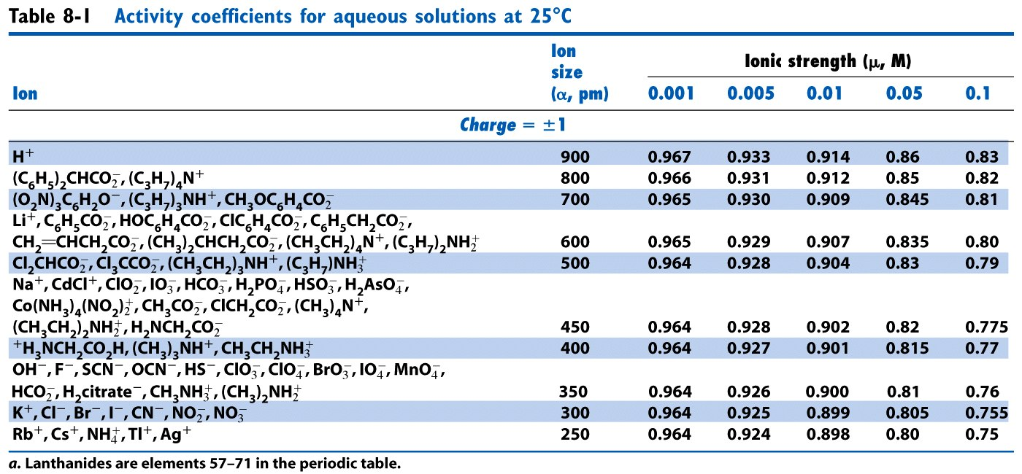

12a (8 points). What is the pH of a solution with a 0.365M formal concentration of hypobromous acid (HOBr)? The pK_{a} for hypobromous acid is 8.63.

12b (4 points) What is the percent dissociation for hypobromous acid at equilibrium in problem 12a above?

13 (16 points). Using the systematic method, determine the concentration of a solution of 8.88x10⁻⁸ M KOH. Report your answer correctly to three significant figures.

14a (8 points). What is the concentration of citrate ion in a buffer solution that contains 6.67x10⁻²M citric acid and has a pH of 3.26? The pK_{a} for citric acid is 3.13.

14b (8 points). Assuming you have 25.0mL of the solution described in 14a, what would the pH be after adding 10.0mL of 0.0550M NaOH?

15 (Must be signed). I did not cheat on this test in any way. Signed _____________________

