Your Name:__________________________________ Lab section:__________

Chemistry 31 – Quantitative Analysis Exam #2, November 22, 2010

Multiple Choice and Short Answer
Circle the one correct answer from the choices listed, enter the correct term or phrase on the blank line, or briefly answer the question as indicated.

1 (4 points). Which of the following expressions will give the pH of a solution:

a. log[H⁺] b. –log(K_{a}K_{b}/[OH⁻])
c. –log[OH⁻] d. 10^{-[H+]}

2 (4 points). Compared to a solution with a pH of 6, a solution with a pH of 3 has an [H⁺]:

a. that is the same.
b. that is 100 greater.
c. that is 1000 times greater.
d. more information is required.

3 (4 points). To a precision of 2 significant figures, what is the pH of a solution containing a concentration of 1.0x10⁻¹⁴ M KOH?

a. 7.0 b. 14
c. 0.0 d. 1.0

4 (4 points). When using a least squares linear regression, it is assumed that:

a. errors in measured y values are insignificant relative to errors in x values.
c. errors in x and y values are the same.
b. errors in x values are insignificant relative to errors in measured y values.
d. No assumptions need to be made.

5 (4 points). Which of the following analytical methods would be most appropriate to analyze a mixture containing analytes with low volatility (high temperature boiling points)?

a. HPLC b. GC
c. acid/base titration d. any of these will work

6 (4 points). Analyte separation in chromatography is affected by which of the following:

a. differential partitioning between the mobile and stationary phases (difference in retention times)
b. band broadening (diffusion) in the column
c. both a and b
d. neither a or b

7 (4 points). When using an internal standard, the identity of the standard is:

a. different than the analyte.
b. the same as the analyte.
c. it could be the same or different relative to the analyte.

8 (4 points). Emission (fluorescence) spectroscopy tends to have higher sensitivity because:

a. emitted light is of a longer wavelength than absorbed light.
b. detection of light is on a zero background.
c. not all compounds fluoresce.
d. both a and b.

9 (4 points). Molar absorptivity is directly proportional to:

a. absorbance
b. pathlength
c. concentration
d. molecular weight.

Worked out Problems
It is your responsibility to work out your answers clearly. Unclear, or unreadable work will not be graded. If there is not enough space provided to show your work, continue on the back of the page and clearly mark the problem number. Be sure to show all of your work and report your final answer with the correct number of significant figures and units. Unless otherwise noted, an unreasonable number of significant figures in a final answer will be marked off 2 points. A correct answer without work shown will not receive credit. Circle or draw a box around your final answer.

Equations that may or may not be useful to you:

$x=−\frac{b±\sqrt{b^{2}−4\text{ac}}}{2a};\text{ where }{\text{ax}}^{2}+\text{bx}+c=0$ $\text{pH }={\text{ pK}}_{a}+\text{log}\frac{[\text{base}]}{[\text{acid}]}$

$\text{log}γ=\frac{−0\text{.}\text{51}z^{2}\sqrt{u}}{1+(α{\sqrt{μ}}/{\text{305}})}$ $μ=\frac{1}{2}\sum_{i}{c_{i}z_{i}^{2}}$ M₁V₁ = M₂V₂

dilution factor = volume of original solution / total final solution volume

diluted concentration = dilution factor(original concentration)

$\frac{I_{X}}{I_{S}}=F\frac{[X]}{[S]}$ $\frac{[X]}{[X]+[S]}=\frac{I_{X}}{I_{S+X}}$ A = εbc

A = 2.00-log(%T)

10 (10 points). You are using the method of standard addition to analyze a sample of river water for mercury (Hg).

Solution A is made by pipeting 5.00 mL of undiluted sample into a 10.00 mL volumetric flask and filling to the mark with DI water.

Solution B is made by pipeting 5.00 mL of undiluted sample and 3.00 mL of 15.00 ppb Hg standard into the same 10.00 mL volumetric flask and filling to the mark with DI water.

Solution A and B are analyzed using atomic absorption spectroscopy and give percent transmittance values of 56% and 33% respectively (not blank corrected).

A blank has a percent transmittance of 96%. What is the concentration (ppb) of Hg in the undiluted sample?

11 (10 points). Accounting for ionic strength, what is the solubility (moles/L) of Pb(BrO₃)₂ in water that also contains 0.0500 M NaCl and 0.0500 M KBr? NaCl and KBr are both fully soluble. The appropriate activity coefficient (γ) for Pb²⁺ is 0.37; you need to find the activity coefficient for BrO₃⁻ in the table below. The K_{sp} for Pb(BrO₃)₂ is 2.1 x 10⁻⁶.

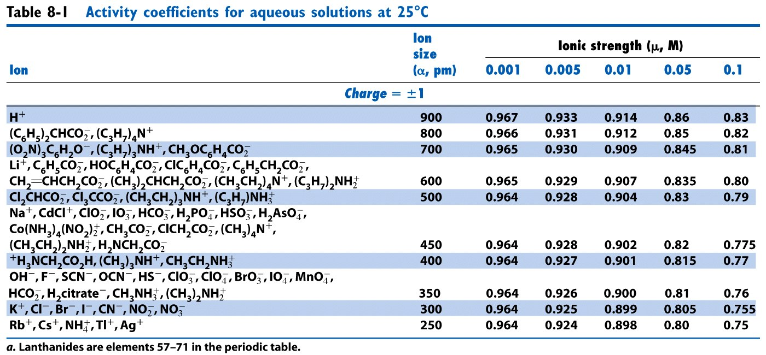
12a (8 points). What is the equilibrium pH of a solution with a 0.365 M formal concentration of aminoethanol (HOCH₂CH₂NH₂)? The pK_{a} for HOCH₂CH₂NH₃⁺ is 9.498.

12b (4 points) What is the percent association for aminoethanol at equilibrium in problem 12a above?

13 (16 points). Using the systematic method, set up the following problem for solving. Give the charge balance, mass balance, equilibrium expressions, and unknowns. Clearly label each. Do not solve. What is the equilibrium pH of a solution made by dissolving 0.088 moles of K₂HPO₄ into 1.000 L of pure water? Hint: there are two different mass balance equations. Consider the following chemical reactions:

$$\begin{aligned}K_{2}{\text{HPO}}_{4(s)}\vec{}2K_{(\text{aq})}^{+}+{\text{HPO}}_{4(\text{aq})}^{2−} \\ {\text{HPO}}_{4(\text{aq})}^{2−}\vec{}H_{(\text{aq})}^{+}+{\text{PO}}_{4(\text{aq})}^{\text{3-}}{\text{ K}}_{a}=4\text{.}\text{22}x{\text{10}}^{−\text{13}} \\ {\text{HPO}}_{4(\text{aq})}^{2−}+H_{2}O_{(l)}\vec{}H_{2}{\text{PO}}_{4(\text{aq})}^{−}+{\text{OH}}_{(\text{aq})}^{−}{\text{ K}}_{b}=1\text{.}\text{58}x{\text{10}}^{−7} \\ H_{2}O_{(l)}\vec{}{\text{OH}}_{(\text{aq})}^{−}+H_{(\text{aq})}^{+}{\text{ K}}_{w}=1\text{.}0x{\text{10}}^{−\text{14}}\end{aligned}$$

14a (8 points). What is the final pH of a solution produced by adding 75.00 mL of 0.0510 M acetic acid to 50.00mL of 0.105 M sodium acetate? The pK_{a} for acetic acid is 4.76.

14b (8 points). Assuming you have 25.0 mL of the solution described in 14a, what would the final pH be after adding 10.0mL of 0.0550 M HNO₃?

15 (Must be signed). I did not cheat on this test in any way. Signed _____________________

