Your Name:__________________________________

Chemistry 31 – Quantitative Analysis Final Exam, December 15, 2010

Multiple Choice
Circle the one correct answer from the choices listed or give the correct short answer.

1 (2 points). To a precision of 2 significant figures, what is the pH of a solution containing a concentration of 1.0x10⁻⁶ M NaOH?

a. 6.0 b. 8.0
c. 7.0 d. 6.9

2 (3 points). What calibration method is generally used for gas chromatography due to variation in sample injection volumes?

a. standard addition c. external standard
b. internal standard d. none of these

3 (3 points). When using a least squares linear regression, it is assumed that:

a. errors in x values are insignificant relative to errors in measured y values.
c. errors in x and y values are the same.
b. errors in measured y values are insignificant relative to errors in x values.
d. No assumptions need to be made.

4 (3 points). Report the following with correct significant figures:

6.475581x10² (± 0.0065)

Answer:_________________________

5 (3 points). Emission (fluorescence) spectroscopy tends to have higher sensitivity because:

a. emitted light is of a longer wavelength than absorbed light.
b. detection of light is on a zero background.
c. not all compounds fluoresce.
d. both a and b.

6 (3 points). When using gas chromatography, separations generally occur according to:

a. polarity. c. molecular weight.
b. boiling point. d. none of these.

7 (3 points). What is the ratio of [A⁻] / [HA] for a buffer solution of HA with a pH of 5 if the pK_{a} = 7 for HA?

a. -2.0 c. 0.1
b. 0.01 d. 100

8 (2 points). When choosing a color indicator for an acid base titration, the pK_{a} of the indicator should match:

a. the pK_{b} of the analyte. b. the pH half way to the equivalence point.
c. the pK_{a} of the analyte. d. the pH at the equivalence point.

9 (3 points). What is the dominant form of aspartic acid (a triprotic acid (H₃A⁺)) at a pH of 2.50 (pK_{a1} = 1.990, pK_{a2} = 3.900, pK_{a3} = 10.002)?

a. H₃A⁺ and H₂A are equal c. H₂A
b. H₃A⁺ d. H₂A and HA⁻ are equal

Refer to the titration curve below for questions 10 through 14.
10 (3 points). The titration curve shown above describes the:

a. titration of a strong acid. c. titration of a strong base.
b. titration of a weak diprotic base. d. titration of a weak diprotic acid.

11 (3 points). After 20.0 mL of titrant have been added, the solution represents a buffer between:

a. A²⁻ and HA⁻ c. A²⁻ and H₂A
b. HA⁻ and H₂A d. the solution is not a buffer.

12 (3 points). What is pK_{b2} for the acid or base being titrated in the figure?

a. 3 c. 6
b. 11 d. 8

13 (3 points). If the original formal concentration (before any titrant has been added) of weak base (A²⁻) was 0.100 M in 10.0mL of solution, what is the formal concentration of the intermediate form (HA⁻) when the intermediate form is at its highest concentration during the titration?

a. 0.100 M c. 0.0274 M
b. 0.0426 M d. cannot be determined

14 (3 points). What is the pH at the first equivalence point?

a. 11 c. 8.5
b. 6 d. 4

Worked out Problems
It is your responsibility to work out your answers clearly. Unclear, or unreadable work will not be graded. If there is not enough space provided to show your work, continue on the back of the page and clearly mark the problem number. Be sure to show all of your work and report your final answer with the correct number of significant figures and units. A correct answer without work shown will not receive credit, and cannot receive partial credit. Circle or draw a box around your final answer.

Equations that may, or may not, be useful:

$x=\frac{−b±\sqrt{b^{2}−4\text{ac}}}{2a}$, where ${\text{ax}}^{2}+\text{bx}+c=0$ $\text{pH }={\text{ pK}}_{a}+\text{log}\frac{[\text{base}]}{[\text{acid}]}$

$[H^{+}]=\sqrt{\frac{K_{1}K_{2}\text{F }+{\text{ K}}_{1}K_{w}}{K_{1}+F}}$ $\text{log}γ=\frac{−0\text{.}\text{51}z^{2}\sqrt{u}}{1+(α{\sqrt{μ}}/{\text{305}})}$ $μ=\frac{1}{2}\sum_{i}{c_{i}z_{i}^{2}}$
15 (6 points). What is the concentration of fluoride (F⁻) in a saturated solution of CaF₂? The K_{sp} of calcium fluoride is 3.2x10⁻¹¹.

16 (6 points). Accounting for ionic strength, what is the equilibrium pH of a 0.100 M solution of the strong acid HCl? See the table below for activity coefficients (to receive full credit, show your work and circle the correct activity coefficient(s) that you use on the table below).

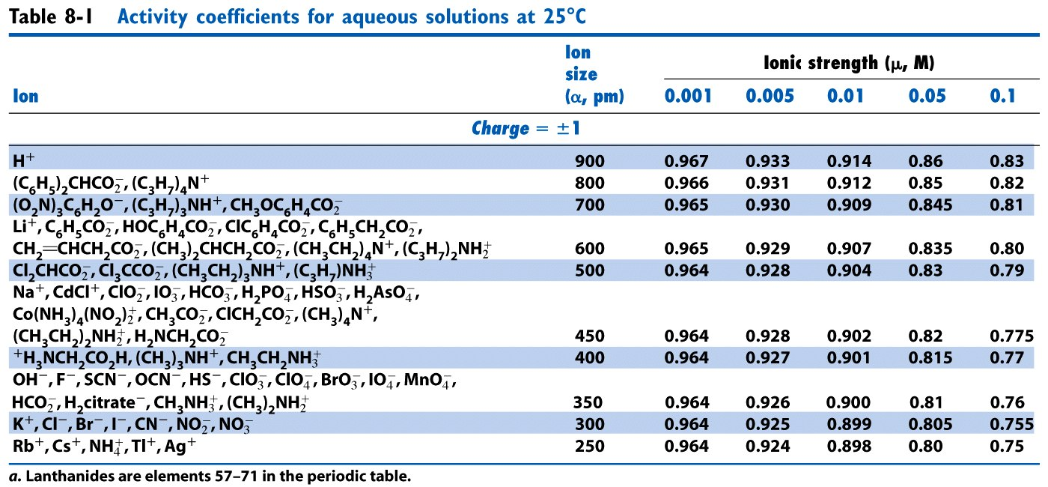

17 (8 points). Ethylenediamine is a diprotic acid with pK_{a1} = 6.848, and pK_{a2} = 9.928. What is the equilibrium pH of a 0.855 M solution of the intermediate form of this acid?

18 (4 points). For the solution described in question 17 (previous page), what is the equilibrium concentration of the acid form of ethylenediamine?

19 (12 points). What is the pH of the final combined solution at equilibrium when 75.0 mL of a solution containing 0.0600 M citric acid (H₃A) is mixed with 25.0 mL of 0.500 M NaOH? citric acid has pK_{a} values of 3.128, 4.761, and 6.396.

20 (12 points). Use the systematic method to determine the equilibrium pH of a 8.85 x 10⁻⁸ M solution of strong base KOH. Report your answer to 3 significant digits.

21 (12 points). The acidic form of the common TRIS buffer (TRIS hydrochloride) has a molecular weight of 157.60 g/mole, and a pK_{a} of 8.07. What mass (g) of TRIS hydrochloride and what volume (mL) of 0.150M strong base is necessary to produce 250 mL of buffer at pH 8.30 and with total acid/base concentration of 0.0350 M ([acid] + [base] = 0.0350 M)?

22 (Must be signed). I did not cheat on this test in any way. Signed ______________________

