Your Name:__________________________________

Chemistry 31 – Quantitative Analysis Final Exam, May 18, 2011

Multiple Choice
Circle the one correct answer from the choices listed.

1 (3 points). What term refers to the ability to distinguish two peaks from one another in a chromatogram?

a. partition coefficient c. capacity factor
b. diffusion d. resolution

2 (3 points). What is the major reason for using an internal standard in chromatography?

a. poor peak separation c. injection volume is imprecise
b. sample matrix interferences d. all of these

3 (2 points). (True or False) Doubling the number of repeated measurements will decrease the value of confidence intervals by a factor of two.

a. True c. False

4 (3 points). What is the absolute uncertainty in the following calculation?

$$\left(\frac{4\text{.}3\left(±2\text{.}5\right)}{4\text{.}6\left(±0\text{.}5\right)×1\text{.}6\left(±0\text{.}8\right)}\right)$$

a. 2.7 c. 0.8
b. 0.5 d. 4.6

5 (3 points). When using Beer’s law for spectroscopy, the molar absorptivity (ε) multiplied by the pathlength (b) represents the ____________ of the calibration curve.

a. slope c. y- intercept
b. x-intercept d. none of these

6 (3 points). The best analytical technique to use for the separation of compounds with high boiling points is:

a. GC c. HPLC
b. acid/base titration d. it doesn’t matter

7 (3 points). What is the ratio of [A⁻] / [HA] for a buffer solution of HA with a pH of 7 if the pK_{a} = 5 for HA?

a. 10 c. 0.1
b. 100 d. 0.01

8 (2 points). The pH of a 10⁻¹⁵ M solution of the strong acid HBr is

a. 15 c. 5.0
b. -1.0 d. 7.0

9 (3 points). What is the dominant form of aspartic acid (a triprotic acid) at a pH of 1.50 (pK_{a1} = 1.990, pK_{a2} = 3.900, pK_{a3} = 10.002)?

a. H₃A and H₂A⁻ are equal c. H₂A⁻
b. H₃A d. HA²⁻

Refer to the titration curve below for questions 10 through 14.

10 (3 points). The titration curve shown above describes the:

a. titration of a strong base. c. titration of a strong acid.
b. titration of a weak acid. d. titration of a weak base.

11 (3 points). The equivalence point occurs at:

a. 7.50 mL titrant added. c. 15.0 mL titrant added.
b. 30.0 mL titrant added. d. 22.5 mL titrant added.

12 (3 points). The titrant is a

a. strong acid. c. weak acid.
b. strong base. d. weak base.

13 (3 points). What is the molarity of H⁺ in solution when 0.00 mL of titrant have been added?

a. 1.2 M c. 1.0 x 10⁻⁷ M
b. 1.6 x 10⁻¹³ M d. 6.3 x 10⁻² M

14 (3 points). When more than 15.00 mL of titrant have been added in the titration curve above, the pH can be determined by assuming there is:

a. a weak base in solution. c. excess strong acid added to solution.
b. a buffer with HA and A⁻. d. excess strong base added to solution.

Worked out Problems
It is your responsibility to work out your answers clearly. Unclear, or unreadable work will not be graded. If there is not enough space provided to show your work, continue on the back of the page and clearly mark the problem number. Be sure to show all of your work and report your final answer with the correct number of significant figures and units. A correct answer without work shown will not receive credit, and cannot receive partial credit. Circle or draw a box around your final answer.

Equations that may, or may not, be useful:

$x=\frac{−b±\sqrt{b^{2}−4\text{ac}}}{2a}$, where ${\text{ax}}^{2}+\text{bx}+c=0$ $\text{pH }={\text{ pK}}_{a}+\text{log}\frac{[\text{base}]}{[\text{acid}]}$

$[H^{+}]=\sqrt{\frac{K_{1}K_{2}\text{F }+{\text{ K}}_{1}K_{w}}{K_{1}+F}}$ $\text{log}γ=\frac{−0\text{.}\text{51}z^{2}\sqrt{u}}{1+(α{\sqrt{μ}}/{\text{305}})}$ $μ=\frac{1}{2}\sum_{i}{c_{i}z_{i}^{2}}$

15 (6 points). The fumarate ion (CH₂(CO₂)²⁻) is an intermediate in the citric acid cycle. What is the equilibrium pH of a 0.0750 M solution of sodium fumarate? The pKa₁ and pKa₂ for fumaric acid are 3.02 and 4.48 respectively.

16 (12 points). Starting with 50.0mL of a 4.80x10⁻²M solution of the diprotic base CO₃²⁻, what volume of 1.20x10⁻¹M HBr must be added to reach a pH of 10.00? For H₂CO₃, pK_{a1} = 6.351 and pK_{a2} = 10.329.

17 (12 points). Accounting for ionic strength, what is the pH of a 0.0200M solution of NaOH that also contains 0.0800M NaNO₃? See the table below for activity coefficients. Circle the appropriate activity coefficient on the table below and report your answer to 3 significant figures.

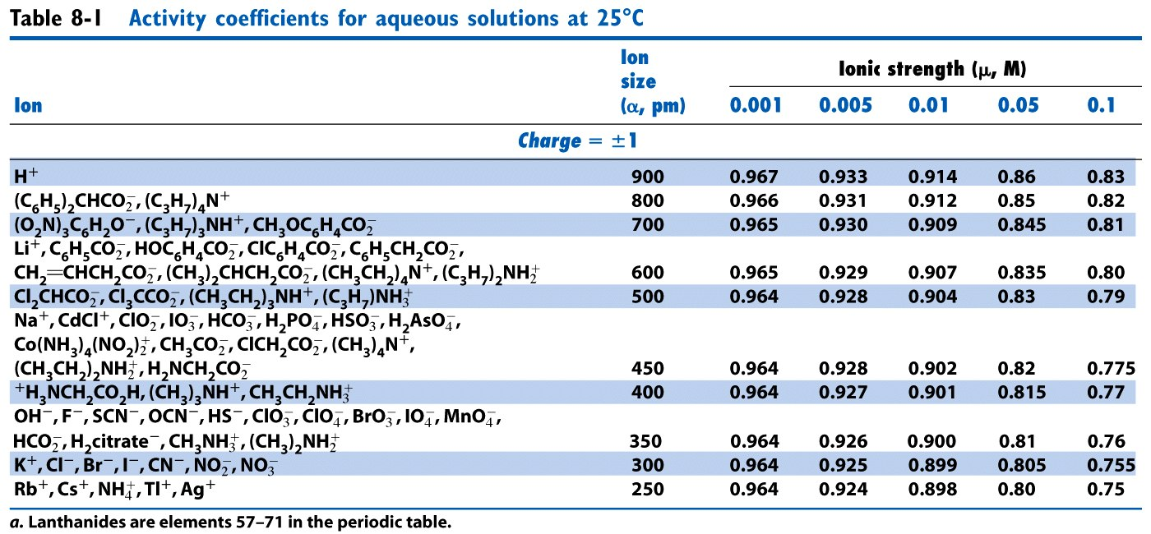

18 (12 points). What is the solubility (M) of SrSO₄ in a solution that already contains 0.0600 M SO₄²⁻? The K_{sp} for SrSO₄ is 3.2 x 10⁻⁷.

19 (12 points). Citric acid is a triprotic acid commonly used to make buffer solutions in the lab. Its pKa values are 3.13, 4.76, and 6.40, and its molecular weight is 192.12 g/mol. What mass (g) of citric acid and what volume (mL) of 1.00 M NaOH is needed to produce 100.0 mL of a buffer with a pH of 6.5 and a weak base concentration of 0.100 M?

20 (6 points). If 25.0 mL of 0.075 M HCl was added to the 100.0 mL of buffer produced through problem 19, what is the resulting pH of the solution?

21 (Must be signed). I did not cheat on this test in any way. Signed ______________________

