Your Name:__________________________________

Chemistry 31 – Quantitative Analysis Final Exam, December 17, 2008

Multiple Choice
Circle the one correct answer from the choices listed.

1 (3 points). When using standard addition as a calibration method, the identity of the standard is:

a. different than the analyte/unknown. c. not known.
b. the same as the analyte/unknown. d. none of the above.

2 (3 points). In chromatography, how is it possible that two analytes can have different retention times, but still not be separated?

a. differential partitioning c. analyte diffusion on the column
b. small capacity factors d. small peak areas

3 (2 points). Beer's law states that:

a. a straight line can describe the relationship between points on a graph.
b. absorbance is proportional to concentration.
c. transmittance is proportional to concentration.
d. molar absorptivity is proportional to concentration.

4 (3 points). Report the answer to the following with the correct number of significant figures (given uncertainties are absolute):

25.6 (±0.9) – 13.9 (±0.7)

a. 11.7 ± 0.7 c. 12 ± 1
b. 11.70 ± 0.06 d. 11.7 ± 1.1

5 (3 points). Can a molecule that has absorbed infrared radiation subsequently emit a photon with a wavelength in the ultraviolet region as a result?

a. yes c. molecules cannot absorb infrared radiation
b. no d. more information is necessary

6 (3 points). Relative to reverse phase HPLC, normal phase HPLC utilizes a stationary phase that is:

a. polar. c. volatile.
b. non-polar. d. need more information.
7 (3 points). What is the ratio of [A⁻] / [HA] for a buffer solution of HA with a pH of 9 if the pK_{a} = 7 for HA?

a. 10 c. 0.1
b. 100 d. 0.01

8 (2 points). When choosing a color indicator for an acid base titration, the pK_{a} of the indicator should match:

a. the pK_{b} of the analyte. b. the pH half way to the equivalence point.
c. the pK_{a} of the analyte. d. the pH at the equivalence point.

9 (3 points). What is the dominant form of aspartic acid (a triprotic acid) at a pH of 5.00 (pK_{a1} = 1.990, pK_{a2} = 3.900, pK_{a3} = 10.002)?

a. HA²⁻ and H₂A⁻ are equal c. H₂A⁻
b. HA²⁻ d. A³⁻ and HA²⁻ are equal

Refer to the titration curve below for questions 10 through 14.
10 (3 points). The titration curve shown above describes the:

a. titration of a diprotic acid. c. titration of a monoprotic base.
b. titration of a diprotic base. d. titration of a monoprotic acid.

11 (3 points). If the titration began with 100.0mL of solution (before titrant is added) and the titrant is 0.100M strong acid or base, what is the concentration of analyte in the original solution?

a. 1.00M c. 0.0100M
b. 0.100M d. 0.00100M

12 (3 points). What is pK_{a1} for the conjugate acid of the base being titrated in the figure?

a. 7.0 c. 4.4
b. 11.0 d. 8.8

13 (3 points). At the first equivalence point in the titration curve above, the pH can be determined by assuming there is:

a. a weak base in solution. c. a buffer with HA⁻ and A²⁻.
b. a weak acid in solution. d. a solution of the intermediate form HA⁻.

14 (3 points). When more than 20mL of titrant have been added in the titration curve above, the pH can be determined by assuming there is:

a. a weak base in solution. c. excess strong acid added to solution.
b. a buffer with HA⁻ and A²⁻. d. excess strong base added to solution.

Worked out Problems
It is your responsibility to work out your answers clearly. Unclear, or unreadable work will not be graded. If there is not enough space provided to show your work, continue on the back of the page and clearly mark the problem number. Be sure to show all of your work and report your final answer with the correct number of significant figures and units. A correct answer without work shown will not receive credit, and cannot receive partial credit. Circle or draw a box around your final answer.

Equations that may, or may not, be useful:

$x=\frac{−b±\sqrt{b^{2}−4\text{ac}}}{2a}$, where ${\text{ax}}^{2}+\text{bx}+c=0$ $\text{pH }={\text{ pK}}_{a}+\text{log}\frac{[\text{base}]}{[\text{acid}]}$

$[H^{+}]=\sqrt{\frac{K_{1}K_{2}\text{F }+{\text{ K}}_{1}K_{w}}{K_{1}+F}}$ $\text{log}γ=\frac{−0\text{.}\text{51}z^{2}\sqrt{u}}{1+(α{\sqrt{μ}}/{\text{305}})}$ $μ=\frac{1}{2}\sum_{i}{c_{i}z_{i}^{2}}$

15 (6 points). What is the pH of a 0.163M solution of benzoic acid. The pK_{a} of benzoic acid is 4.202.

16 (6 points). Accounting for ionic strength, what is the pH of a 0.0100M solution of NaOH that also contains 0.0900M NaNO₃? See the table below for activity coefficients (must show the correct work to receive credit).

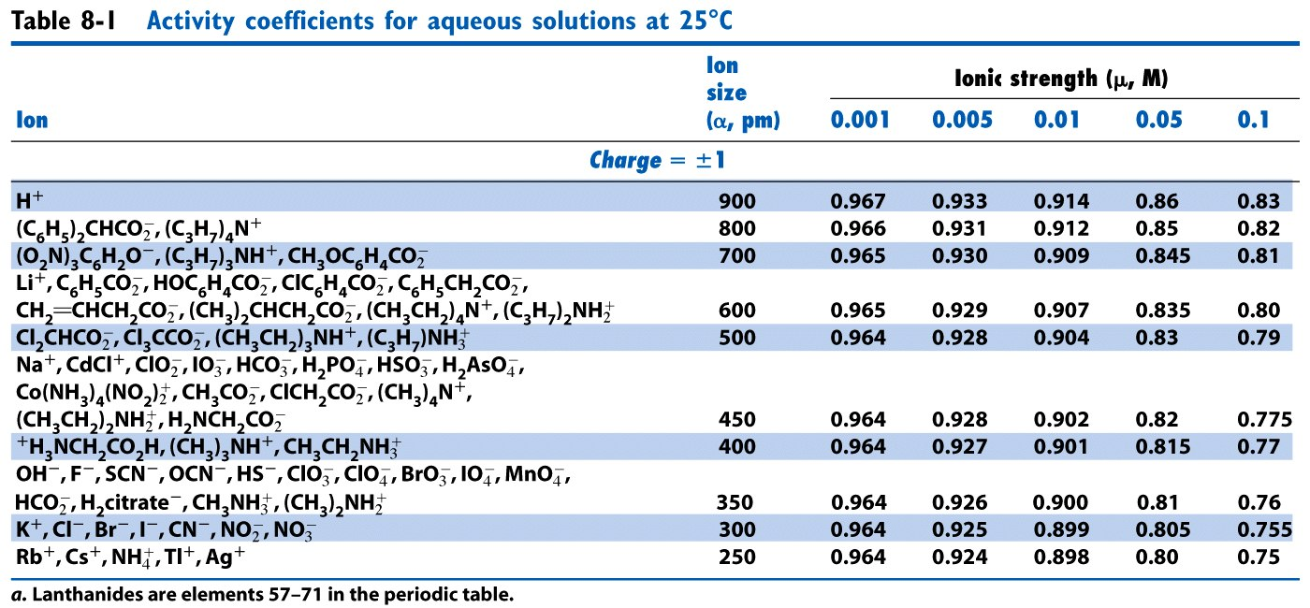
17 (12 points). Starting with 100.0mL of a 3.50x10⁻³M solution of the diprotic maleic acid (H₂A), what volume of 1.20x10⁻¹M KOH must be added to reach a pH of 6.27? For maleic acid, pK_{a1} = 1.92 and pK_{a2} = 6.27.

18 (12 points). Starting with 40.0mL of a solution that contains 0.480M I⁻, what is the concentration of I⁻ in solution after 20.0 mL of 0.672M Pb(NO₃)₂ is added? The K_{sp} for PbI_{2(s)} is 7.9x10⁻⁹. Pb(NO₃)₂ is completely soluble.

19 (12 points). What is the pH of a 7.900x10⁻⁸M solution of the strong acid HI?

20 (12 points). The acidic form of the common TRIS buffer (TRIS hydrochloride) has a molecular weight of 157.60g/mole, and a pK_{a} of 8.07. What mass (g) of TRIS hydrochloride and what volume (mL) of 0.100M strong base is necessary to produce 100mL of buffer at pH 7.04 and with a weak base concentration of 0.0050M?

21 (Must be signed). I did not cheat on this test in any way. Signed ______________________

