Your Name:__________________________________

Chemistry 31 – Quantitative Analysis Final Exam, May 20, 2009

Multiple Choice
Circle the one correct answer from the choices listed or give the correct short answer.

1 (2 points). To a precision of 2 significant figures, what is the pH of a solution containing a concentration of 1.0x10⁻¹³M NaOH?

a. 1.0 b. 13
c. 7.0 d. -13

2 (3 points). What calibration method is generally used for gas chromatography due to variation in sample injection volumes?

a. standard addition c. external standard
b. internal standard d. none of these

3 (3 points). Beer's law states that:

a. a straight line can describe the relationship between points on a graph.
b. absorbance is proportional to concentration.
c. transmittance is proportional to concentration.
d. molar absorptivity is proportional to concentration.

4 (3 points). Report the following with correct significant figures:

29.0075 ± 0.0226

Answer:_________________________

5 (3 points). Fluorescence almost always occurs at a higher or lower energy than absorption of light by the same molecule?

a. higher b. lower

6 (3 points). Relative to normal phase HPLC, reverse phase HPLC utilizes a stationary phase that is:

a. polar. c. volatile.
b. non-polar. d. need more information.

7 (3 points). What is the ratio of [A⁻] / [HA] for a buffer solution of HA with a pH of 7 if the pK_{a} = 7 for HA?

a. 0 c. 0.1
b. 1 d. 10

8 (2 points). When choosing a color indicator for an acid base titration, the pK_{a} of the indicator should match:

a. the pK_{b} of the analyte. b. the pH half way to the equivalence point.
c. the pK_{a} of the analyte. d. the pH at the equivalence point.

9 (3 points). What is the dominant form of aspartic acid (a triprotic acid (H₃A⁺)) at a pH of 3.900 (pK_{a1} = 1.990, pK_{a2} = 3.900, pK_{a3} = 10.002)?

a. HA⁻ and H₂A are equal c. H₂A
b. HA⁻ d. A²⁻ and HA⁻ are equal

Refer to the titration curve below for questions 10 through 14.
10 (3 points). The titration curve shown above describes the:

a. titration of a strong acid. c. titration of a weak base.
b. titration of a strong base. d. titration of a weak acid.

11 (3 points). If the titration began with 100.0mL of solution (before any titrant was added) and the titrant was 0.0100M strong acid, what was the concentration of analyte in the original solution before the titration began?

a. 1.00M c. 0.0100M
b. 0.100M d. 0.00100M

12 (3 points). What is pK_{a} for the acid/base conjugate pair being titrated in the figure?

a. 8.5 c. 5.5
b. 5.0 d. 2.0

13 (3 points). At the equivalence point in the titration curve above, the pH can be determined by assuming there is:

a. a weak base in solution. c. a buffer.
b. a weak acid in solution. d. a solution of pure water.

14 (3 points). What is the pH after 2.5mL of titrant have been added to the solution?

a. 9 c. 5
b. 11 d. cannot be determined

Worked out Problems
It is your responsibility to work out your answers clearly. Unclear, or unreadable work will not be graded. If there is not enough space provided to show your work, continue on the back of the page and clearly mark the problem number. Be sure to show all of your work and report your final answer with the correct number of significant figures and units. A correct answer without work shown will not receive credit, and cannot receive partial credit. Circle or draw a box around your final answer.

Equations that may, or may not, be useful:

$x=\frac{−b±\sqrt{b^{2}−4\text{ac}}}{2a}$, where ${\text{ax}}^{2}+\text{bx}+c=0$ $\text{pH }={\text{ pK}}_{a}+\text{log}\frac{[\text{base}]}{[\text{acid}]}$

$[H^{+}]=\sqrt{\frac{K_{1}K_{2}\text{F }+{\text{ K}}_{1}K_{w}}{K_{1}+F}}$ $\text{log}γ=\frac{−0\text{.}\text{51}z^{2}\sqrt{u}}{1+(α{\sqrt{μ}}/{\text{305}})}$ $μ=\frac{1}{2}\sum_{i}{c_{i}z_{i}^{2}}$
15 (6 points). What is the equilibrium pH of a 0.125M solution of butanoic acid. The pK_{a} of butanoic acid is 4.818.

16 (6 points). Accounting for ionic strength, what is the equilibrium pH of a 0.0700M solution of the strong base NaOH that also contains 0.0300M NaNO₃ (NaNO₃ is fully soluble)? See the table below for activity coefficients (to receive full credit, show the correct work and report your answer to 3 significant figures).

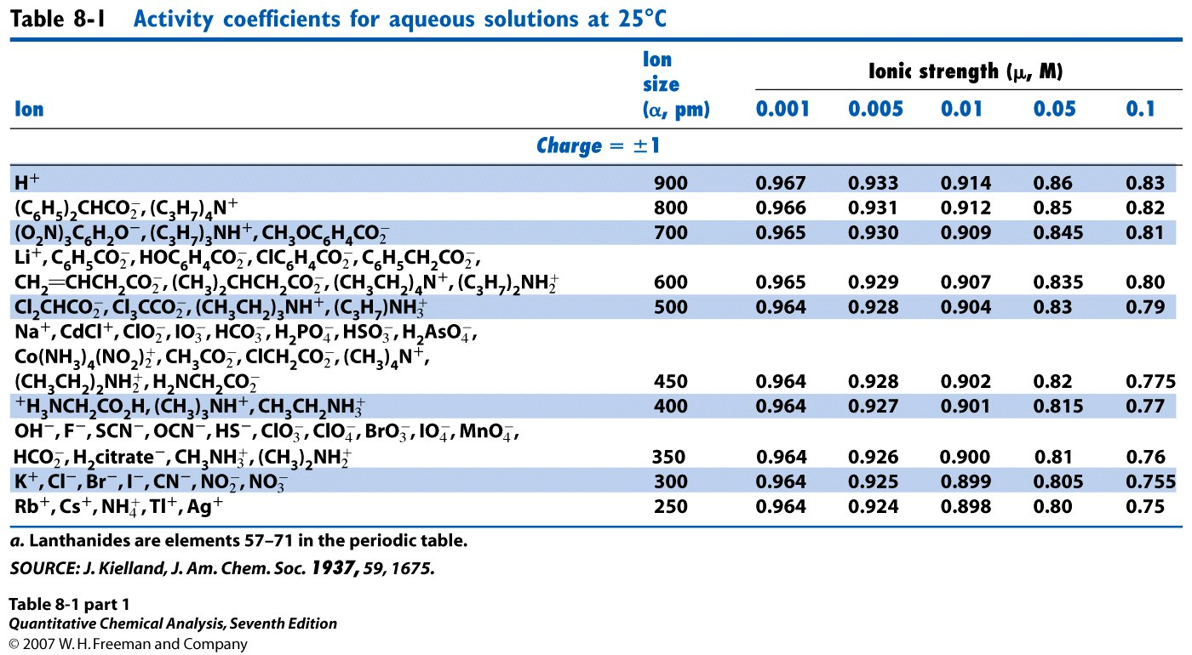

17 (8 points). Ethylenediamine is a diprotic acid with pK_{a1} = 6.848, and pK_{a2} = 9.928. What is the equilibrium pH of a 0.855M solution of the basic form of this acid?

18 (4 points). For the solution described in question 17 (above), what is the concentration of the acid form of ethylenediamine at equilibrium?

19 (12 points). Starting with 30.0mL of a solution containing 0.0769M butanoic acid and 0.0524M butanoate, what is the equilibrium pH after adding 50.0mL of 0.100M NaOH? The pK_{a} for butanoic acid is 4.82.

20 (12 points). Use the systematic method to determine the equilibrium concentration of silver ion (M) when excess (meaning a saturated solution) AgCl_{(s)} is added to 0.10 M NaBr. The K_{sp} of AgCl_{(s)} is 1.8 x 10⁻¹⁰, the K_{sp} of AgBr_{(s)} is 4.9 x 10⁻¹³, and NaBr is fully soluble. (8 points for the set-up, 4 points for the correct silver ion concentration.)

Chemical reactions: NaBr_{(s)} → Na⁺_{(aq)} + Br⁻_{(aq)}

AgCl_{(s)} ⇄ Ag⁺_{(aq)} + Cl⁻_{(aq)}

AgBr_{(s)} ⇄ Ag⁺_{(aq)} + Br⁻_{(aq)}

21 (12 points). The acidic form of the common TRIS buffer (TRIS hydrochloride) has a molecular weight of 157.60g/mole, and a pK_{a} of 8.07. What mass (g) of TRIS hydrochloride and what volume (mL) of 0.150M strong base is necessary to produce 250mL of buffer at pH 7.50 and with a weak base concentration of 0.0050M?

22 (Must be signed). I did not cheat on this test in any way. Signed ______________________

