Carol Irving
Liberal Arts 200B
Dr. Craft
May 23, 2003

Influences of the Organic

The works of Frank Lloyd Wright made him the most famous American architect, and his buildings ushered in a new era of architecture. The breadth of his work, which spanned over seven decades, demanded attention. However, more than pure volume of production underscored his importance to the built environment, both past and present. The mention of Frank Lloyd Wright’s name most likely conjures up visions of “Prairie Houses”, his famous “Fallingwater”, or perhaps, the Guggenheim Museum. While these forms are all very different, they do posses a common denominator, the principle of organic architecture. An examination of Wright’s designs and writings will shed light on the architect’s amazing ability to synthesize an emerging modern world with the natural world through the principles of organic architecture.
Before taking a closer look at the principles of organic architecture, the social climate of the late nineteenth century must be considered. During the late nineteenth century, transformations in the economy, technological advances and a reorientation of social ideals led to changes seen in American architecture. As Clifford Clark wrote in the American Family Home, 1800-1960:
In the years following the Civil War, the expansion of railroads, the establishment of a national telegraph and telephone network, the systematization of the currency, the growth of newspapers and magazines, and the tremendous influx of immigrants, created national markets for products and substantially increased factory production (136).

The rural nature of America began to shift. The expanding railroads made travel more accessible and movement to urban areas easier. By 1900 most Americans felt the influences and affects of urban life, even if they still lived in a rural community. The expansion of industry and technological advances filtered into virtually every aspect of American life. Technological advances began to change the quality of life for many Americans. The invention of gas hot water heaters, indoor plumbing, and mechanical washing machines promised to simplify the everyday life of families. Baking and sewing were no longer everyday chores that required hours of labor. Now, families were able to purchase many goods such as bread and clothes. “The vast array of new consumer products, ranging from clothes and cosmetics to foods and appliances, created an imaginative world offering new opportunities and experiences” (Clark 140). Families were surrounded by more and more accessible goods and services. Capitalizing on a culture of consumption, aggressive advertising campaigns hit newspapers and magazines across the country. For the first time many families were able to partake in luxuries that had usually been reserved for the upper classes.
With the luxuries, however, came disillusionment and uncertainty in the industrialized nation. In 1893, a depression marked the most devastating financial period of the 1800s. Millions of people lost their jobs and labor disputes riddled the steel and rail industries. Looking for the causes of the depression and the corruption of big business drove reformers to question social values and traditional Victorian ideals. Americans from all sectors of society were forced to rethink their values and re-evaluate the American dream. This nationwide movement, referred to as the progressive movement, reflected an optimistic belief that perfection was attainable in all spheres of life. “Its primary contribution was a shift from quantitative to qualitative values. Its base was a yearning for self-respect” (Ovnick 124-125). Americans from all sectors of society were forced to rethink their values and re-evaluate the American dream.
A key element to this American dream was the built environment. Frank Lloyd Wright said In the Realm of Ideas:
…architecture is life; or at least it is life itself taking form and therefore it is the truest record of life as it was live in the world yesterday, as it is lived today or ever will be lived.

Architects’ post-Victorian attitude reflected a belief in their ability to create a better environment, and in turn a better society (Gowans 36). Through the erupting media of popular magazines, housing reformers extolled the virtues of a new style of architecture, an architecture that valued function and its effect on the occupants. These reformers published numerous articles in Better Homes and Garden and Ladies Home Journal, rejecting the ornate and gaudy interiors of the Picturesque styles and declaring them unhealthy and destructive The ostentatious ornament lacked meaning and was seen as a shallow façade that was leading to the demise of America’s moral fiber. The denouncement of excessive and chaotic styles became an underlying message with the growing interest in progressive architecture. Boosted by the efforts of Gustav Stickley and the Prairie House interiors of Frank Lloyd Wright, the Arts and Crafts movement embodied this element of simplicity and gained great popularity. The Beaux Arts also grew in popularity, a style which carefully removed excessive ornament, but its appeal remained generally limited to the wealthy. In contrast, the Progressive style “let ornament be dictated by the nature of the materials and the uses of given buildings” (Gowans 215). Although progressive architects often disagreed on what constituted progressive architecture, a critical response to Victorian social ideals and the Victorian home itself was common to the architecture that began in the late nineteenth century.
Clearly, a new aesthetic began to line the streets of America. Skyscrapers towered above major cities, including New York and Chicago. In Chicago, Frank Lloyd Wright worked for the architectural firm of Sullivan and Adler. Louis Sullivan’s famous quote, “Form follows function” became a central tenet to the “new” architecture that was beginning to be produced in the late nineteenth century (Curtis 114). Since Sullivan’s interests primarily focused on skyscrapers and public buildings, Frank Lloyd Wright handled much of the domestic housing design. Gaining notoriety in the design of homes, Wright left the tutelage of Sullivan and started his own architectural firm. The split from Sullivan marked the beginning of seven decades of creation. The development of Wright’s philosophy ushered in a modern view of architecture and how it was understood.
Understanding organic architecture required the viewers to dismiss the idea of organic architecture as a style. As Wright said, “It is good to have style, but a style is not necessary (Realm, Wright). From the Renaissance to the emergence of Frank Lloyd Wright’s career, the dominant styles of architecture were imitations and revivals of historic forms. Especially true in the United States, buildings were dressed in Revival styles and Picturesque styles which, according to critics, were haphazardly thrown together without consideration for the environment and the people who were to live and work inside the structure. Frank Lloyd Wright took Sullivan’s “form follows function” to another level, asserting “form and function are one” (Curtis 114). Wright’s view of organic architecture provided principles that served as a springboard to a variety of architectural forms.
Of course as the name implied, an understanding and interpretation of nature was critical to organic architecture. The idea of nature as a form of inspiration, however, was not new to architecture. For example, the inspiration for Egyptian columns has been traced back to the lotus and papyrus plant, and the Art Nouveau used leaves and flowers as inspiration by replicating the form in the design (Curtis 30). But nature was not replicated by Wright; instead, he abstracted natural forms. An analogy to this concept can be drawn from the works of Pablo Picasso, who used abstracted forms of known images. The artist forced the audience to look beyond the replication of forms and to develop a new artistic language appropriate to modern times. Similarly, Wright wanted to create a new language of architecture via the organic principles. The following illustrations were taken from A Living Architecture, which provided a variety of visual examples of natural forms and Wright’s translation of them into the built environment. The Nautilus shell pictured below in Figure 1 served as a natural inspiration for the Guggenheim Museum, which is pictured in Figure 2.



Figure 1. Nautilus Shell

Figure 2. The Guggenheim Museum

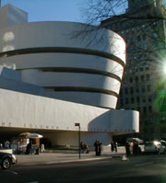
Remembering that Frank Lloyd Wright’s career created seven decades of architecture, the details of organic architecture, which continually evolved, surpassed the scope of this paper, but the basic principles will help to understand the philosophy of Wright’s work. Another dilemma in defining organic architecture was that the very concept defied formulation, but the following from Bruce Brooks Pfeiffer’s A Living Architecture, summarized organic architecture as follows:
- Organic architecture is architecture appropriate to time, place, and people
- Appropriate to time means a building that belongs to the era in which it is created, addresses contemporary life-styles, social patterns and conditions, and employs available materials and new technological methods resourcefully and honestly.
- Appropriate to place means a building in harmony with its natural environment—a building that in its proportions, materials and design, belongs to its site.
- Appropriate to people means a humane architecture, in human scale.
At the core of Frank Lloyd Wright’s ideology was a belief that architecture has an inherent connection with both its site and time (www.pbs.orgfls/legacy). The earliest evidence of this can be seen in Wright’s Prairie School, which reflected his first efforts to invoke new principles of organic architecture. Eschewing Victorian style homes Wright wrote:
What was the matter with the house? Well just for a beginning it lied about everything. It had no sense of unity at all nor any such sense of space as should belong to a free people. It was stuck up in any fashion.

As the name implied, the inspiration came from the prairie lands of the Midwest. Exhibiting a conspicuously low profile and long horizontal lines, the Prairie School alluded to visions of the Midwest prairies. A home that grew from the land produced a harmonious relationship with the environment. The Robie House, Figure 3, exemplified this new abstraction of the organic. “Hence the lengthened horizontal was never a mere imitation of the prairie. It was an idea, a vital abstraction (Hoffman 10). Figure 3. The Robie House
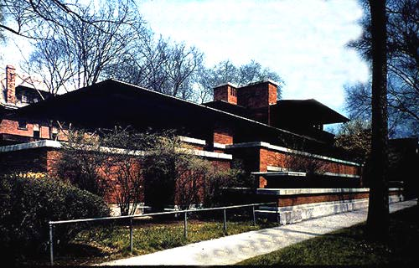

By 1900, the “Prairie School” gained great notoriety and was even published in the popular magazine, Ladies Home Journal. While Frank Lloyd Wright obviously desired to be successful throughout the nation, he continued to stress the importance of building in conjunction with the environment. In other words, a “Prairie School” would not be appropriate to environments outside of the prairies. The dwelling was to be closely connected to the site. Approximately three decades later, Wright’s “Fallingwater” (Figure 4) illustrated this principle in an even more sophisticated nature than the examples from the “Prairie Schools”. Built in 1930, “Fallingwater” appeared to emerge from the landscape. Situated next to tumbling falls, Fallingwater” terraced down the hillside, as if the home was part of the falls. Like many Wright designs, “Fallingwater” was not situated to take advantage of the view, but rather to be a part of the view.
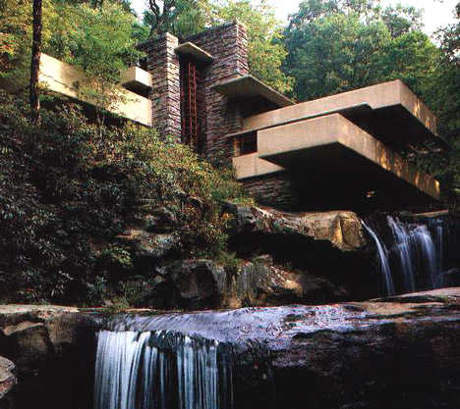
Figure 4. Fallingwater

“The example of “Fallingwater” also brings up a crucial element that Wright embraced within the context of organic architecture, the balance between nature and technology. Frank Lloyd Wright’s employment of steel and concrete, modern materials t seemed very unnatural to many people. Technology often symbolized an impersonal and ugly part of society, both in the social and environmental realms. As America plowed into the twentieth century, the balance between nature and technology became increasingly important in Frank Lloyd Wright’s designs. Wright recognized that the advances of technology were an integral part of the world around us and embraced the opportunity to find harmony between nature and technology. In the Realm of Ideas, Wright articulated:
The machine can do great work-yes-but only when well in the hand of one who does not over estimate its resources, one who knows how to put it to suitable work for human beings (48).

The amazing shapes and forms developed by Frank Lloyd Wright, especially in his later work were possible because of technology, but cultivated by man.
Still, for some observers, the materials used were far from what was usually considered a natural element of the environment. The Craftsman bungalows employed river rock and rough hewn wood. This was natural. But how did the cantilevered concrete of “Fallingwater” or the brick exterior of the Robie House or the swirled cement of the Guggenheim relate to nature? For that answer, Wright once again told the reader to think of nature in an abstract form. He implored readers to look at the nature, the inherent character of the material. Once a person recognized the basic element of wood, brick, and masonry, their nature was recognizable in every application which enabled it to function in the emerging modern world.
Certainly the work of Frank Lloyd Wright has forever changed the landscape of America, and like many built forms his designs reflected the socio-cultural elements of America from 1890-1960. The scope of this paper only scratched the surface of Wright’s work. Venturing inside a Wright design would also be valuable to understanding organic principles, but unfortunately exceeds the scope of this paper. Today many critics have found “flaws” in Wright’s engineering, and his personality, but his undeniable influence on architecture still stands. The character of Frank Lloyd Wright’s buildings prescribed not a style, but an expression of consciousness that inspired reinterpretations of forms in the modern world.

